PROJECT: AWS EVENT-DRIVEN ARCHITECTURE

Integration of S3, SNS & Lambda | File Upload Notification System

By: Kiran Rakh

## 🔍 OBJECTIVE

* Build a serverless, event-driven architecture using AWS services:
* - Uploading a file to S3 → Triggers a Lambda function → Sends a notification using SNS → Delivers email alert to the subscriber.
* Overall Architecture Diagram:

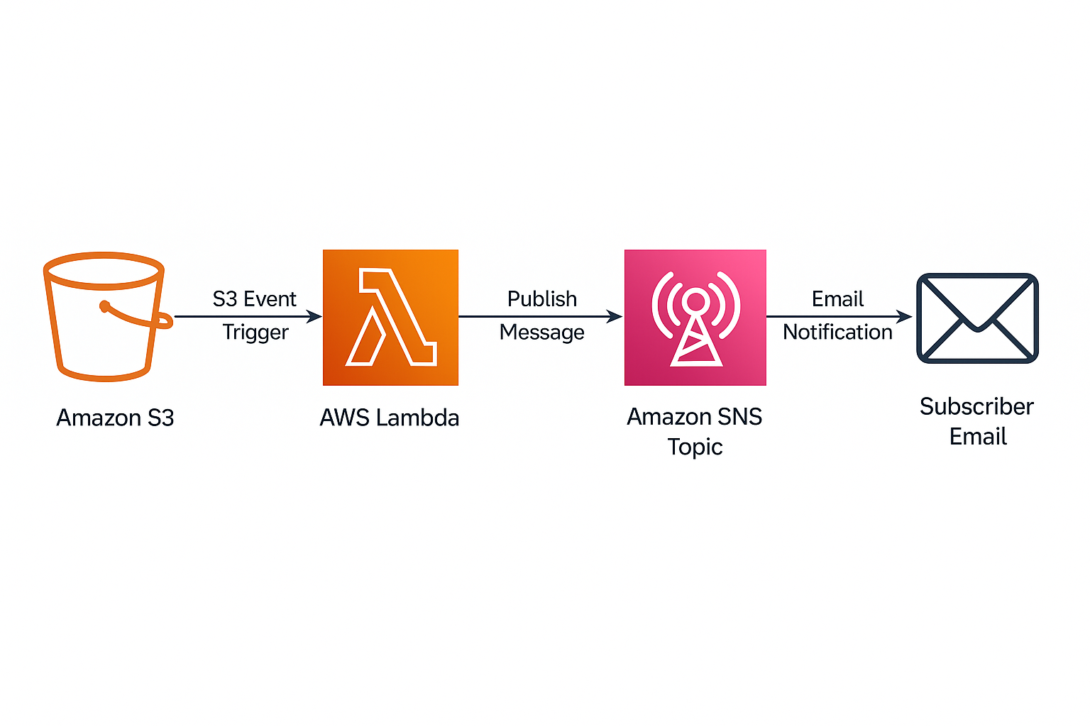

## 🧰 AWS SERVICES USED

* - Amazon S3 (Simple Storage Service)
* - Amazon SNS (Simple Notification Service)
* - AWS Lambda (Python Runtime)
* - AWS CloudWatch (for logs)
* - IAM (Identity and Access Management

## 🚀 STEP-BY-STEP IMPLEMENTATION

## 1️⃣ S3: CREATE BUCKET

* 1. Go to AWS Console → Services → S3
* 2. Click “Create bucket”
* 3. Enter a unique name (e.g., event-driven-kiran-bucket)
* 4. Leave other settings as default
* 5. Click “Create bucket”

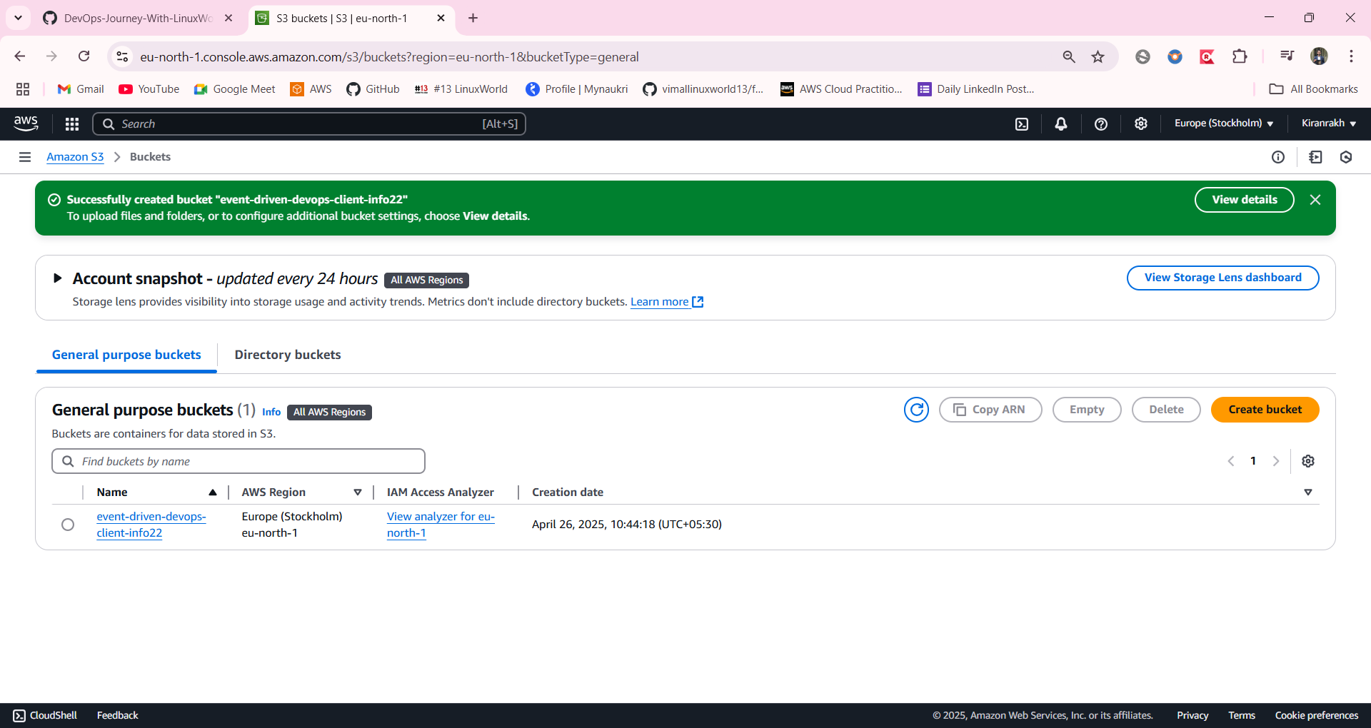

## 2️⃣ SNS: CREATE TOPIC & SUBSCRIPTION

* 1. Go to Services → SNS
* 2. Click “Create topic” → Type: Standard, Name: S3UploadTopic
* 3. Click “Create topic”
* 4. Go to your topic → Click “Create subscription”
* 5. Protocol: Email → Endpoint: kiranrakh155@gmail.com → Click “Create subscription”
* 6. Approve the subscription from your email inbox
* SNS topic and email subscription: 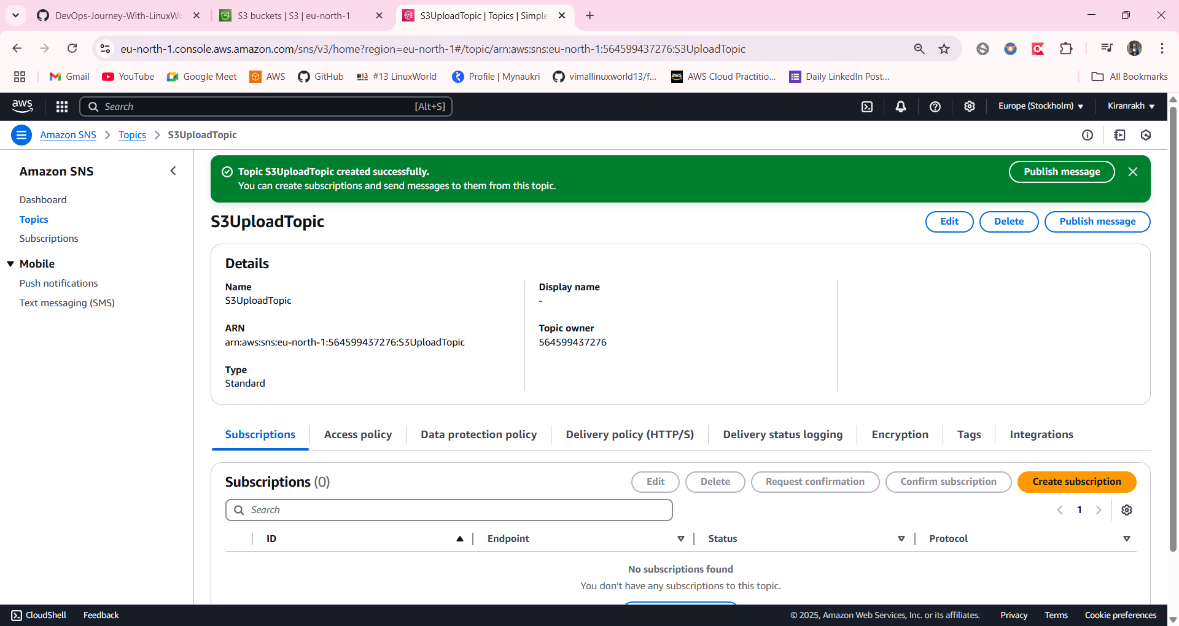

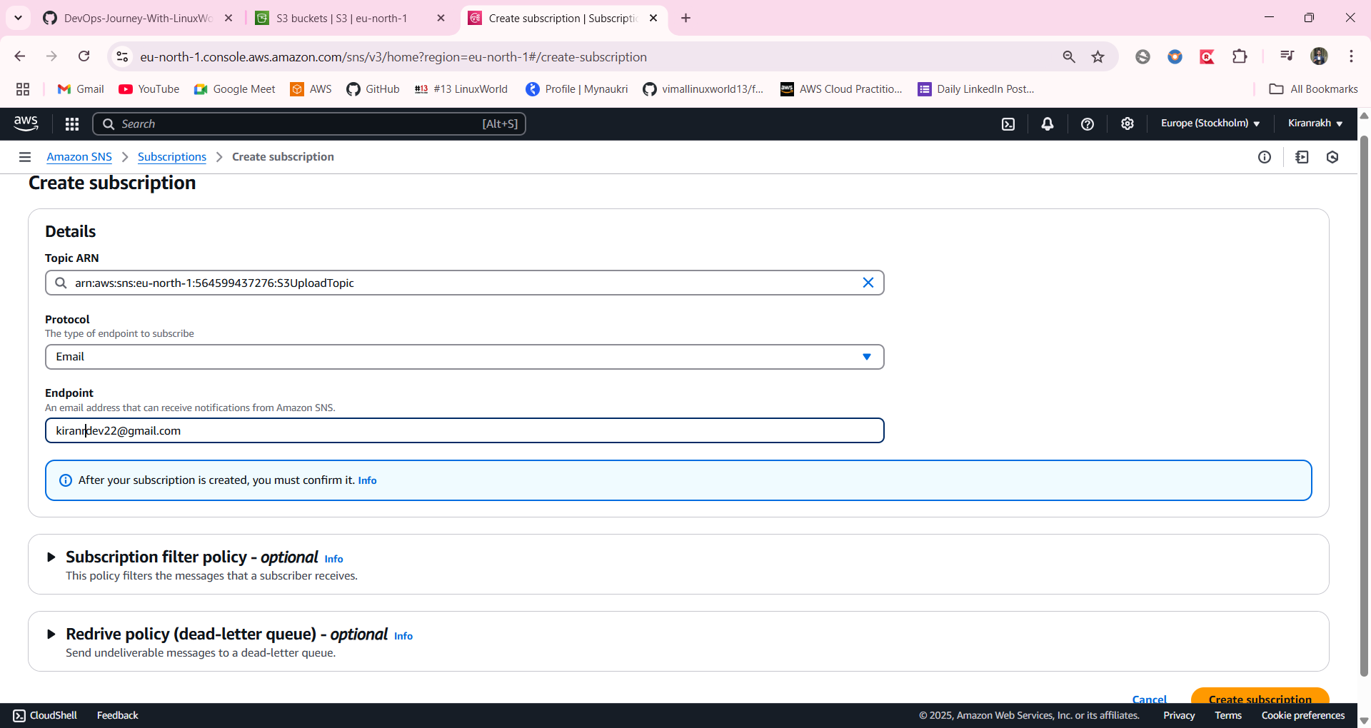

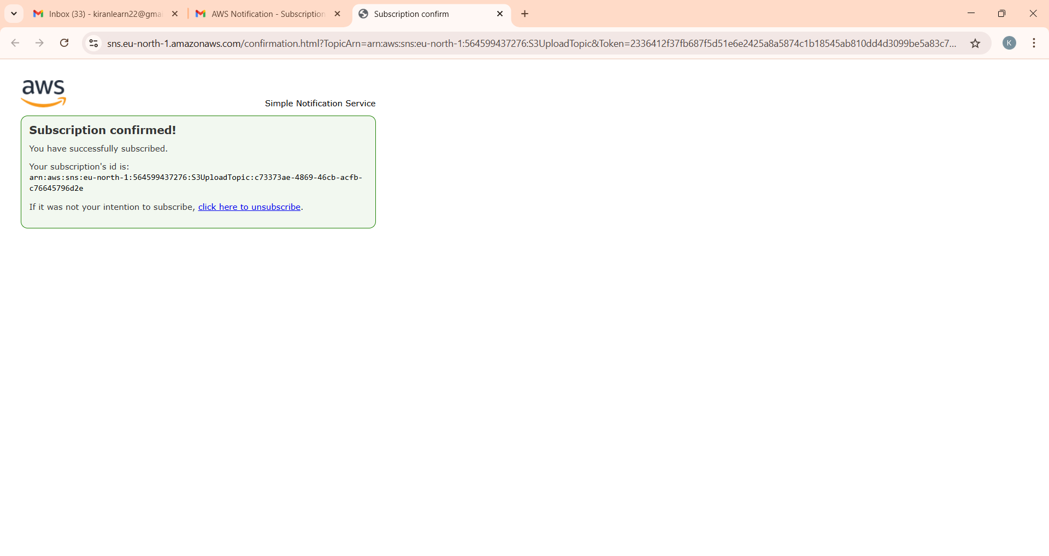

## 3️⃣ LAMBDA: CREATE NEW FUNCTION

* 1. Go to Services → Lambda → Create function
* 2. Name: S3ToSNSNotification, Runtime: Python 3.x
* 3. Click “Create function”
* Lambda function code and configuration: 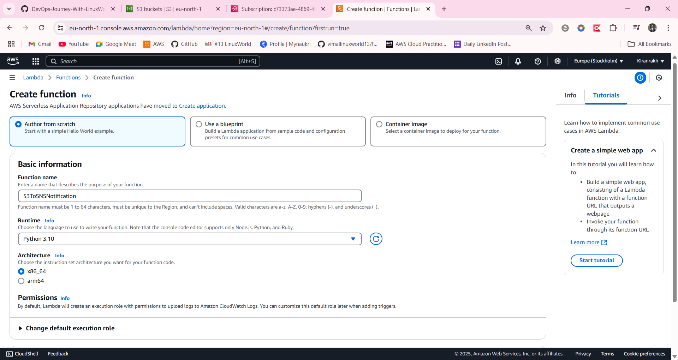

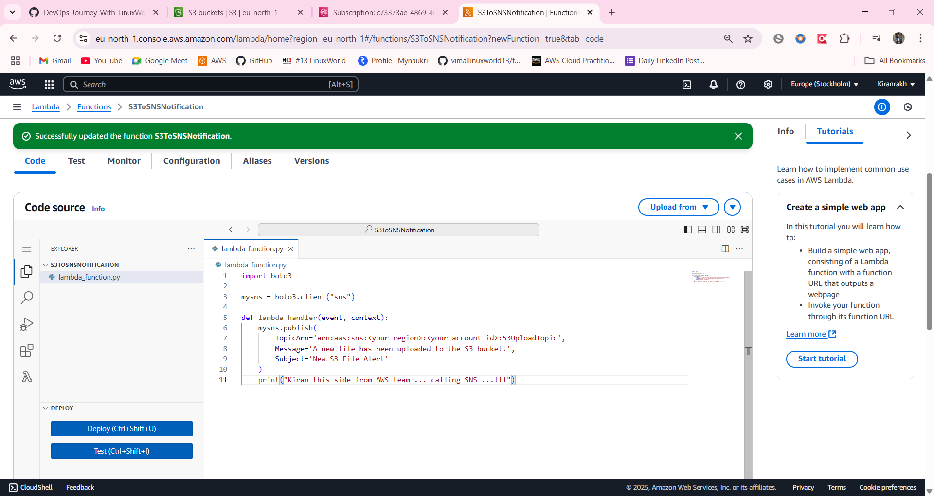

## 4️⃣ IAM: PERMISSION SETUP FOR LAMBDA

* 1. Go to Lambda → Select your function → Configuration → Permissions
* 2. Click the role name → Add permissions → Attach policies
* 3. Search for and attach 'AmazonSNSFullAccess'
* IAM role and policy attachment: 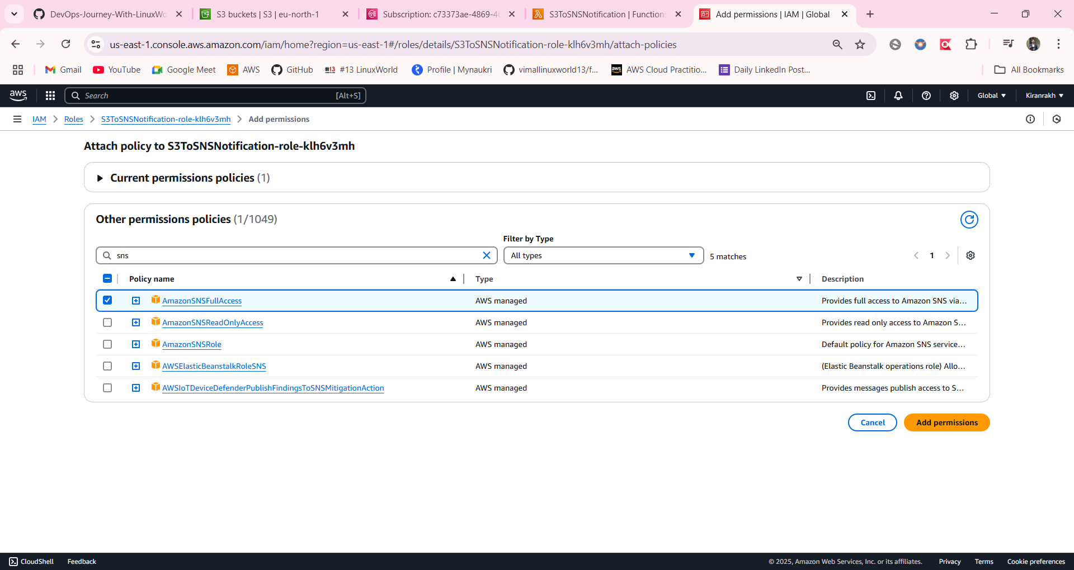

## 5️⃣ LINK S3 TO LAMBDA (EVENT NOTIFICATION)

* 1. Go to S3 → Your bucket → Properties → Event notifications
* 2. Create event notification → Name: TriggerLambdaOnUpload
* 3. Event type: PUT (Object Created)
* 4. Destination: Lambda Function → Choose: S3ToSNSNotification
* 5. Save configuration || S3 event notification setup: 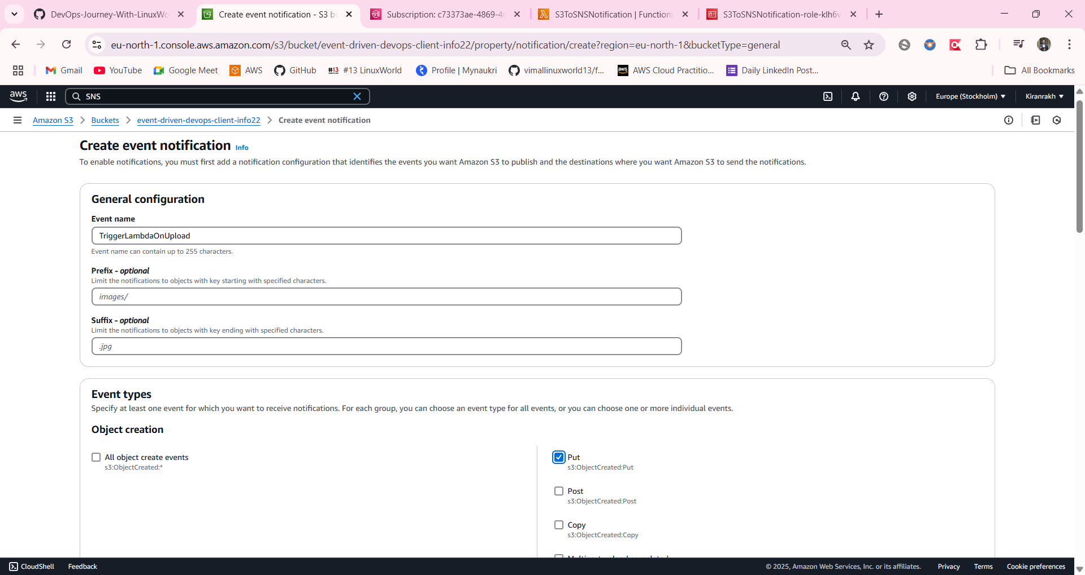

## 6️⃣ TEST IT

* 1. Go to S3 → Your bucket → Upload any file (e.g., test3.txt)
* 2. Lambda should be triggered automatically
* File upload to S3:

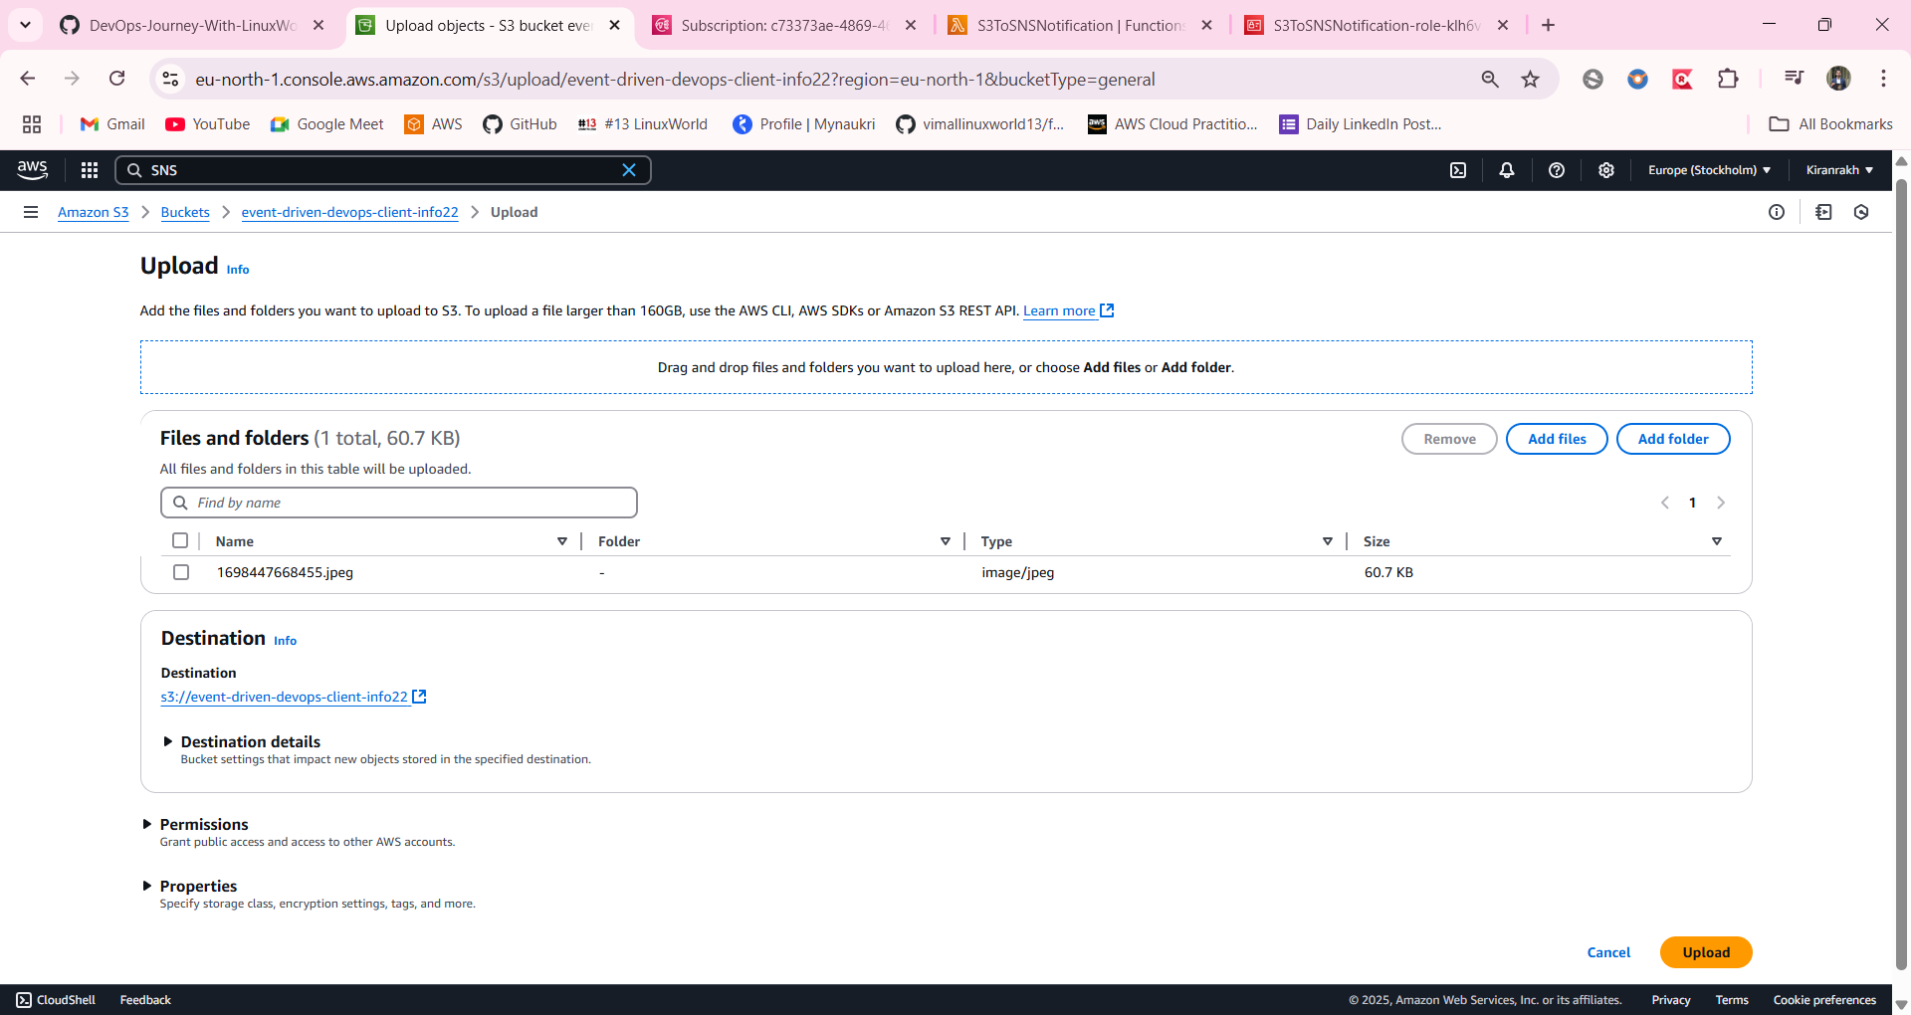

## 7️⃣ VERIFY IN CLOUDWATCH

* 1. Go to Services → CloudWatch → Log groups
* 2. Find log group for S3ToSNSNotification → Open logs
* 3. Check print statements and SNS execution logs
* CloudWatch logs output:

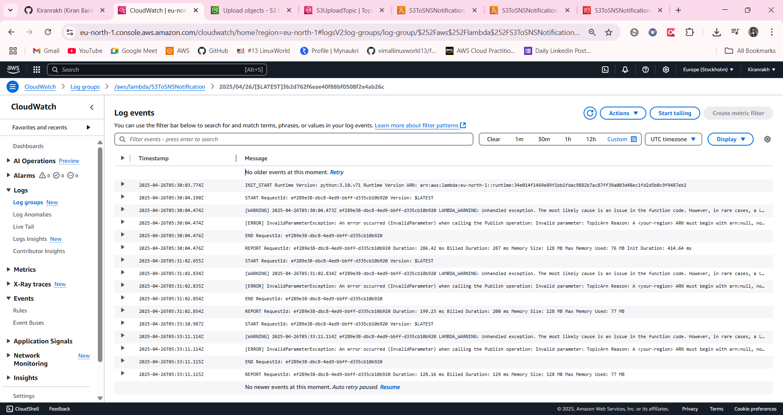

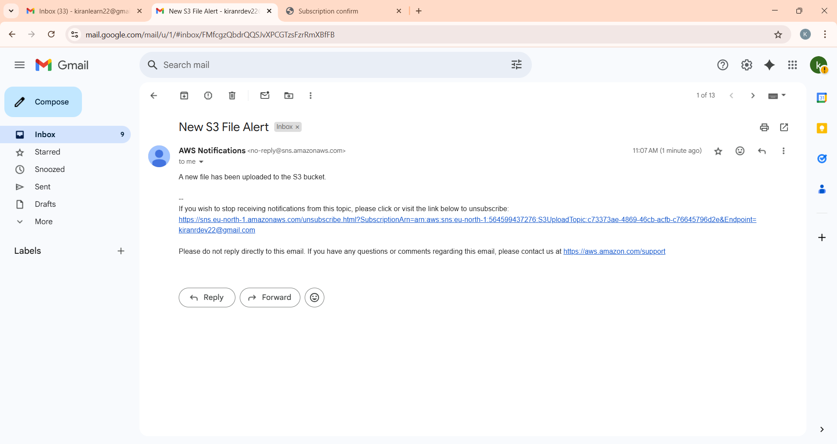

## 📩 FINAL USE CASE

* ✔️ Automatic email notifications for every file uploaded to S3
* ✔️ Use cases: automation pipelines, audit alerts, monitoring
* ✔️ Fully managed serverless stack using AWS-native services

## 📝 EXTRAS / CUSTOMIZATION TIPS

* - You can rename function, bucket, topic, and handler
* - Edit handler in Lambda if function name is changed
* - Customize message in Lambda code
* - Keep all resources in the same region

## 🔐 IAM ROLES & KEYS

* - Lambda role must have AmazonSNSFullAccess
* - S3 automatically gets permission to trigger Lambda during setup
* - No access keys required due to IAM roles