1. Git –version : gives the version of the Git installed on the system

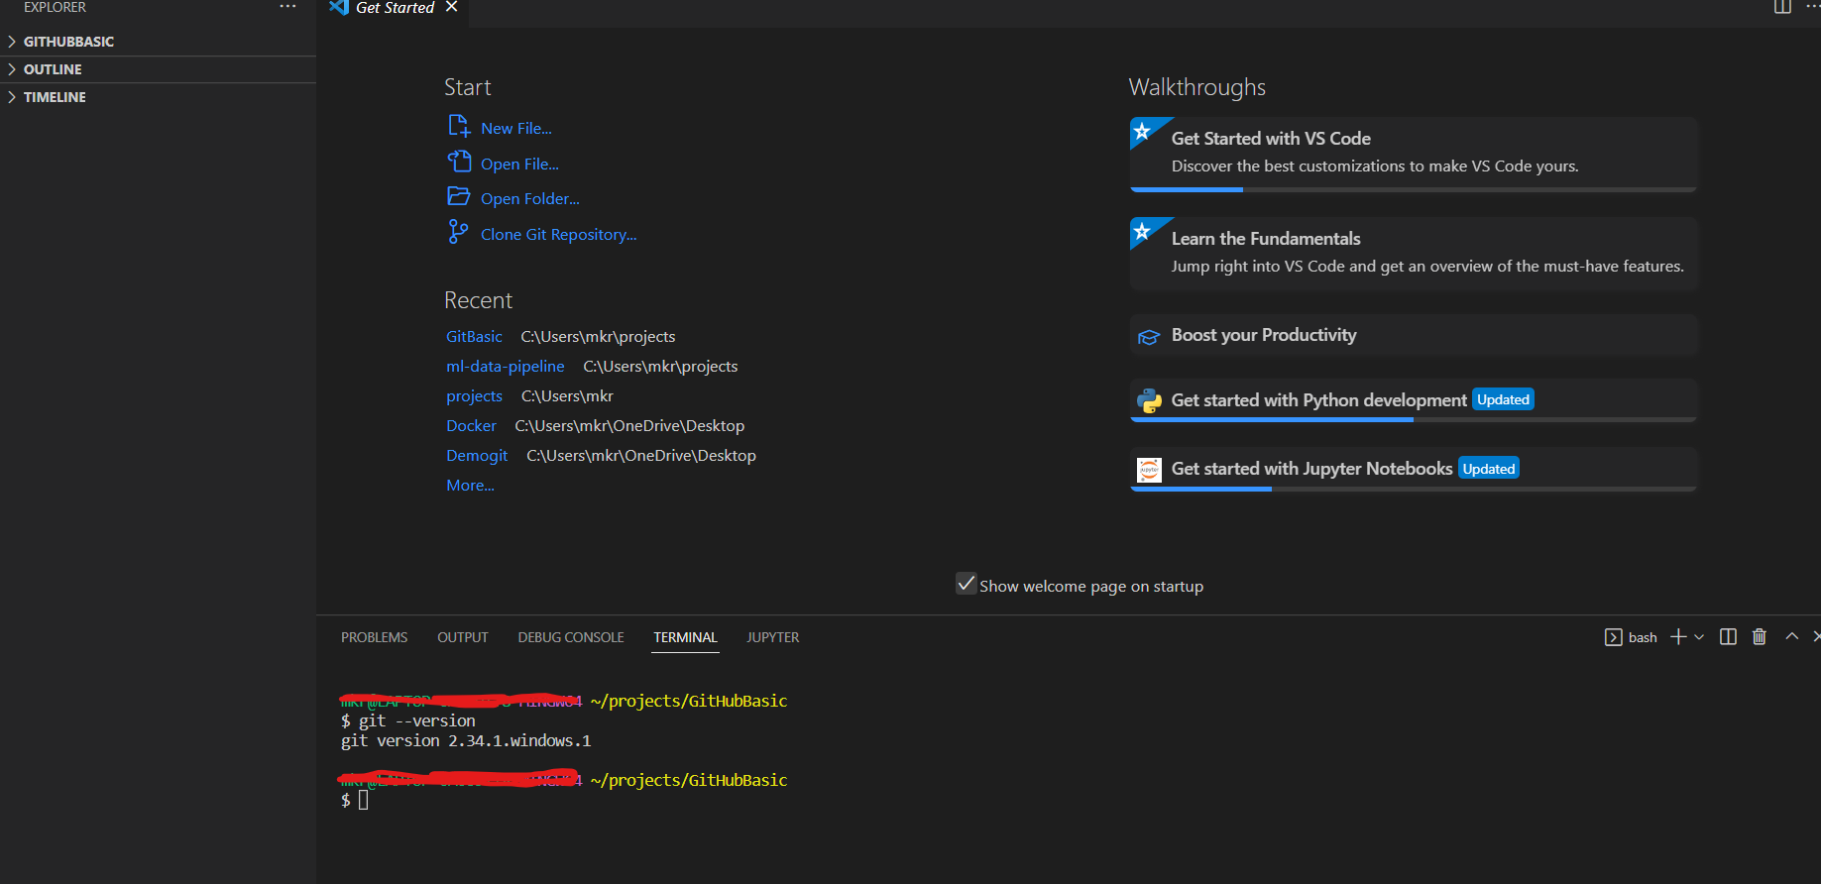

1. Git status does not work until the Git is initialized
2. git init – initializes the git

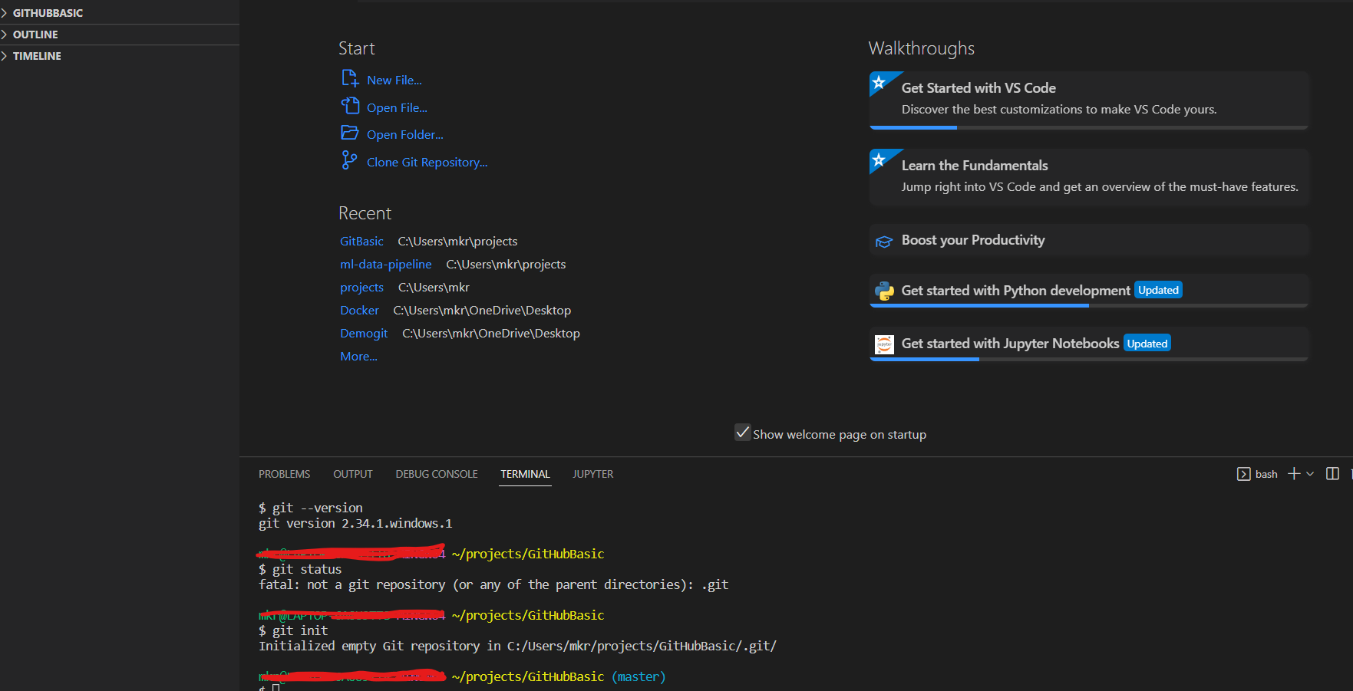

As a 1time activity we use following cmd

Added the file Readme which is not pushed to reps hence

1. Git status

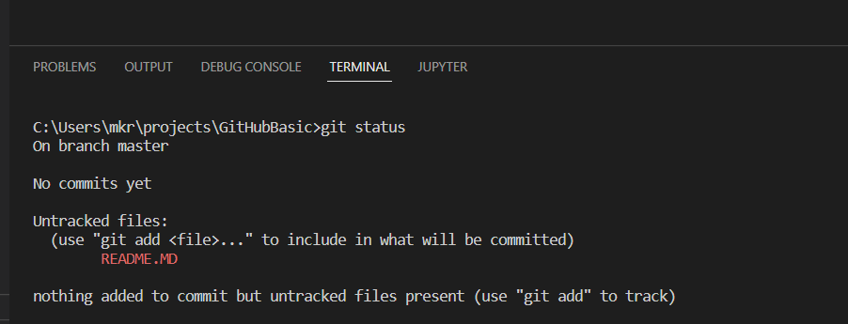

1. If file added it is untracked and

Git add filename tracks the file which is being tracked

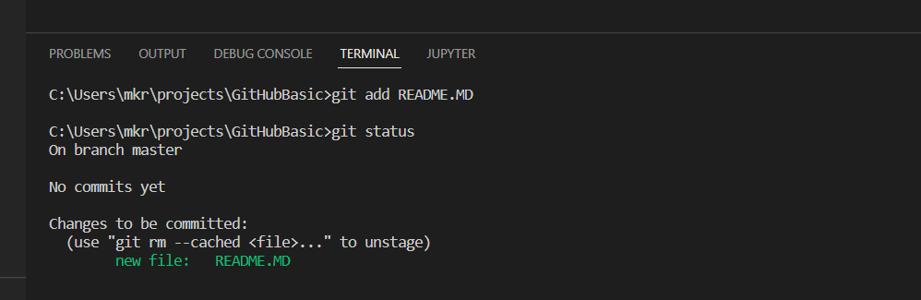

5 b. add another file requiremnents file and use git status

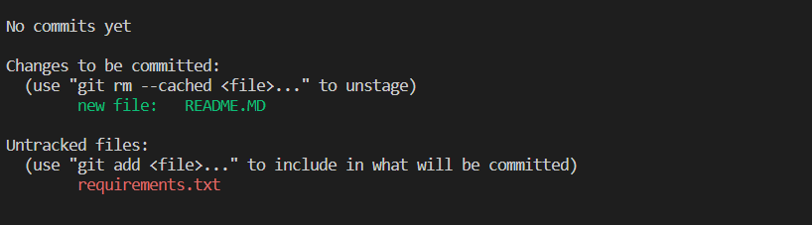

1. Git add tracks the file

Git add .

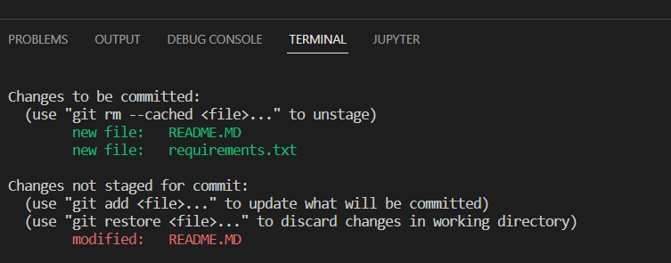

===================================

Send to stating area

1. Git commit -a or git add .
2. Commit a snapshot of all changes in the working directory. This only includes modifications to tracked files

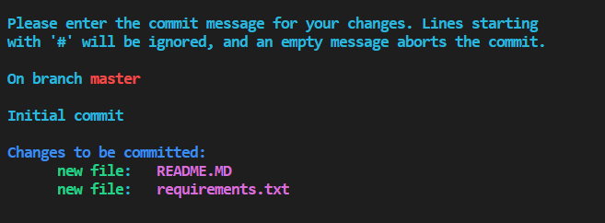

1. After running the above cmd was facing the issue , to overcome this I used following command

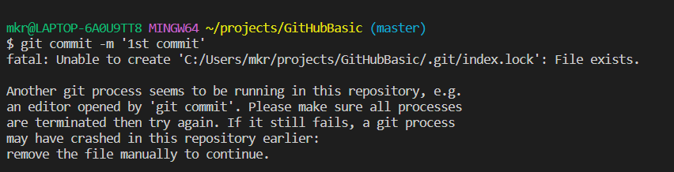

9 a) Such problems generally occur when you execute two git commands simultaneously; maybe one from the command prompt and one from an IDE.

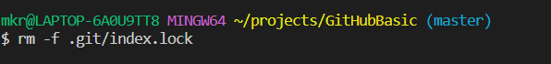

10) git commit -m “1st commit evver”

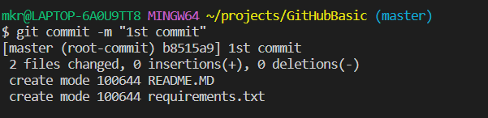

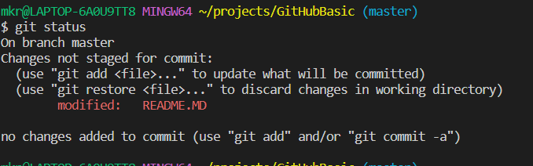

11) git branch : gives the branch name in local

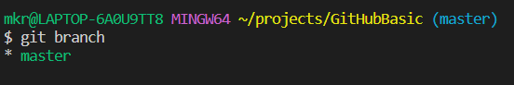

12) git branch -M main

Local is link to remote

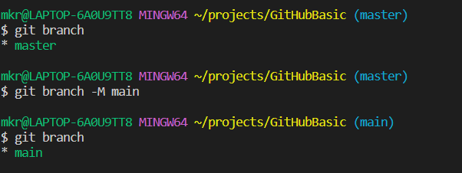

13)

