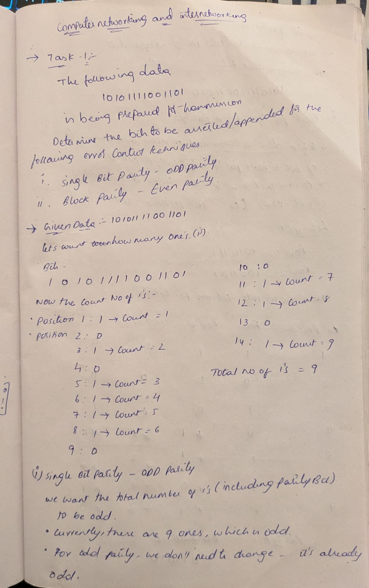
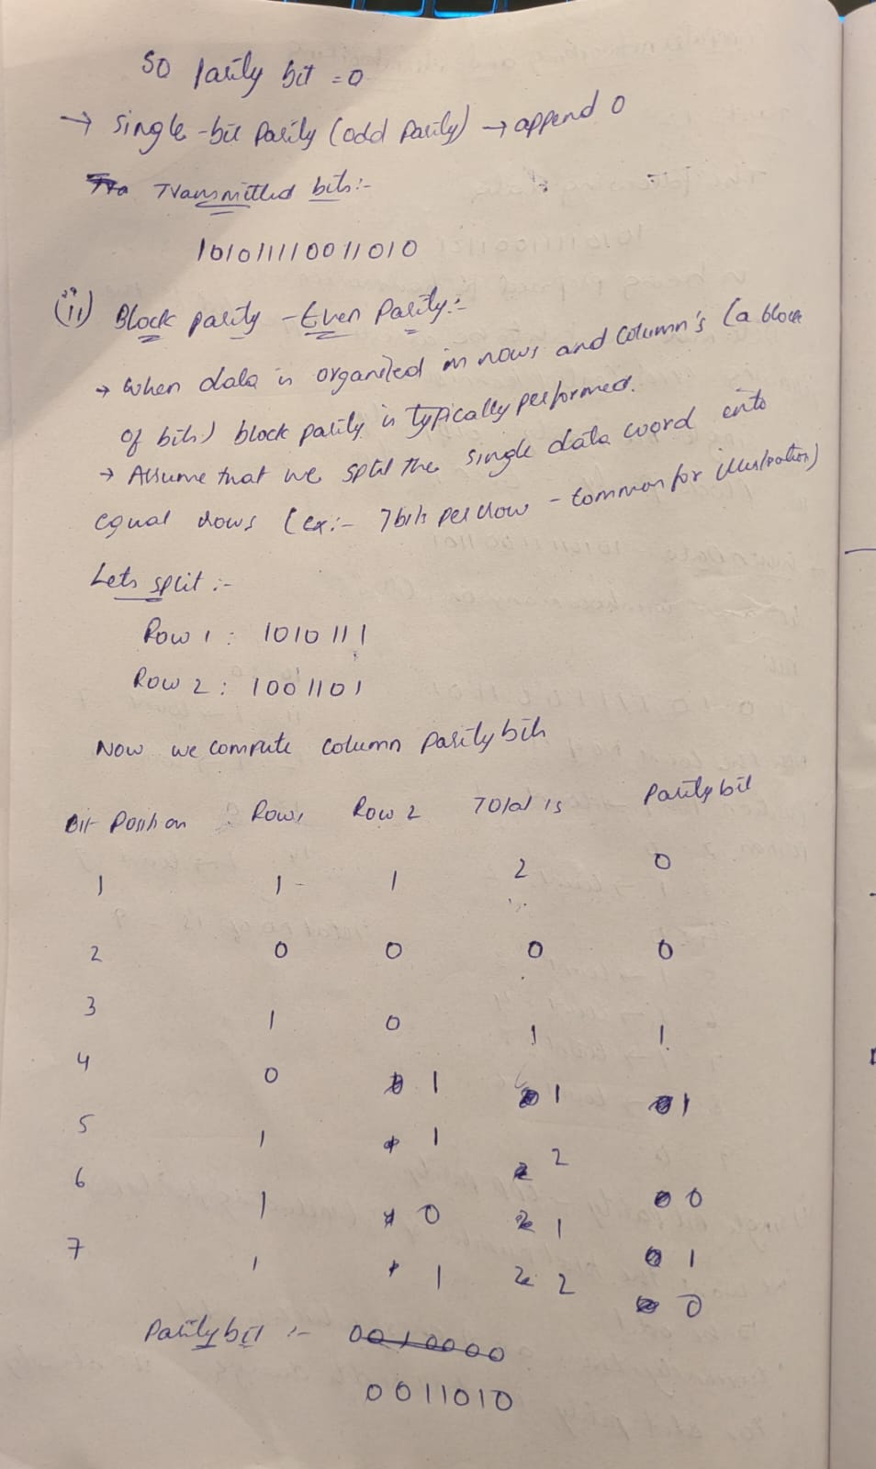
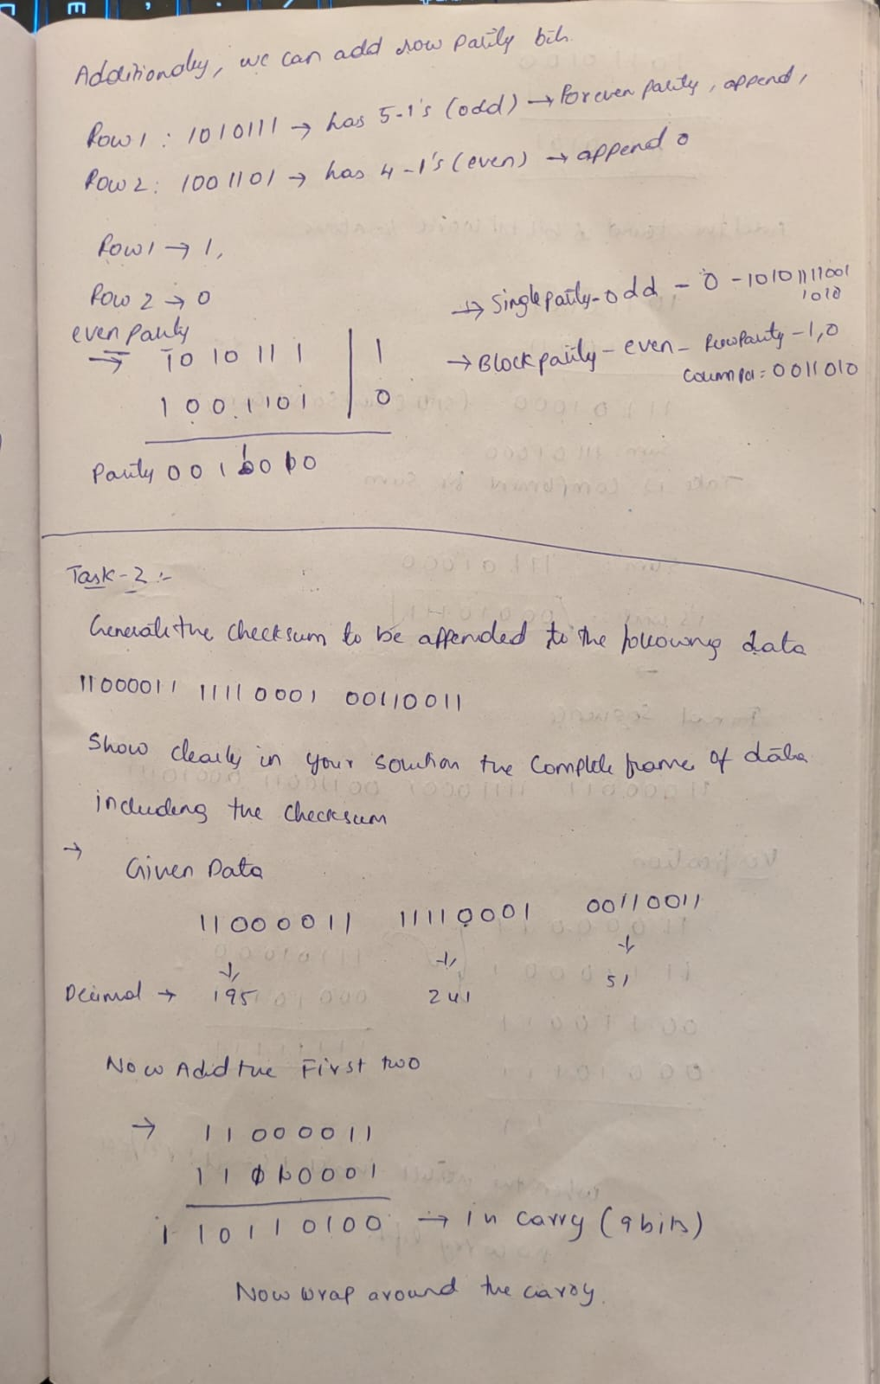
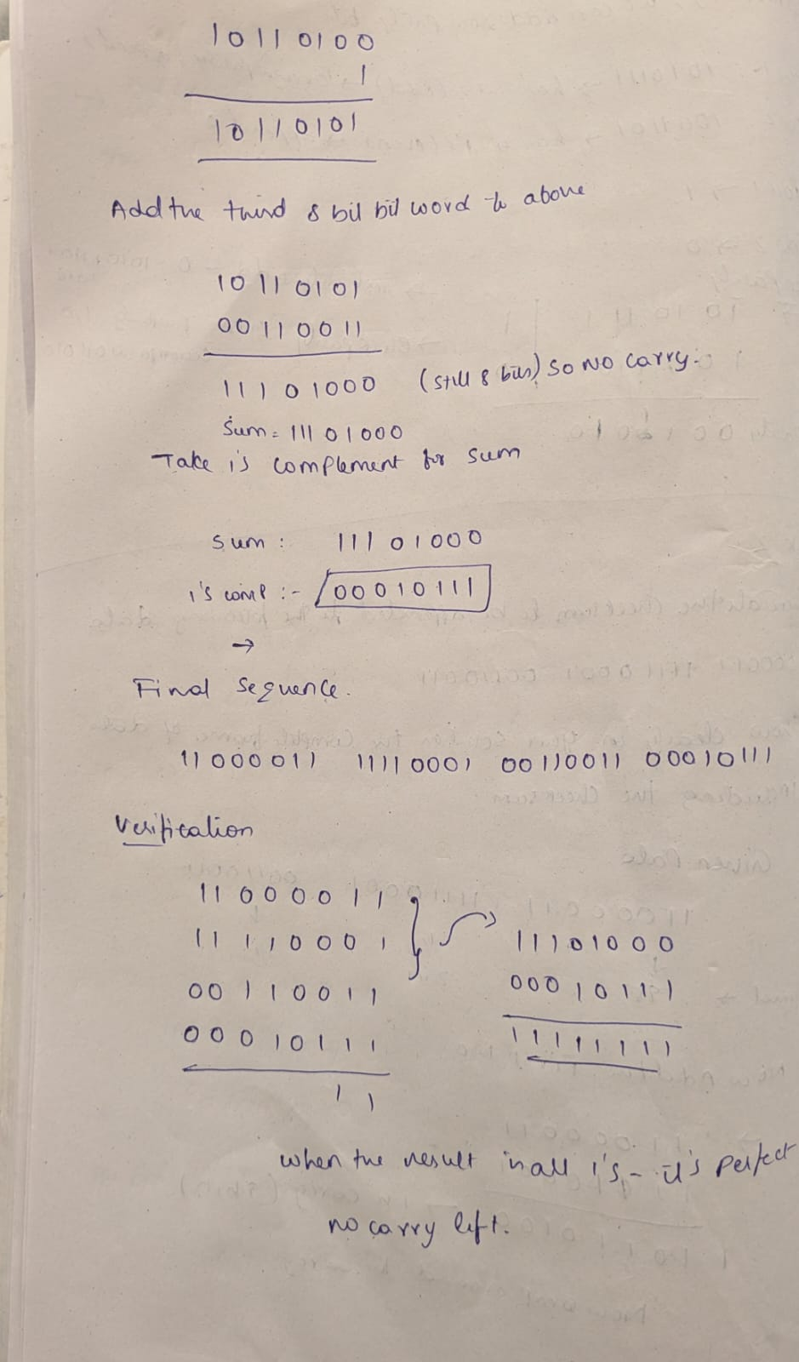
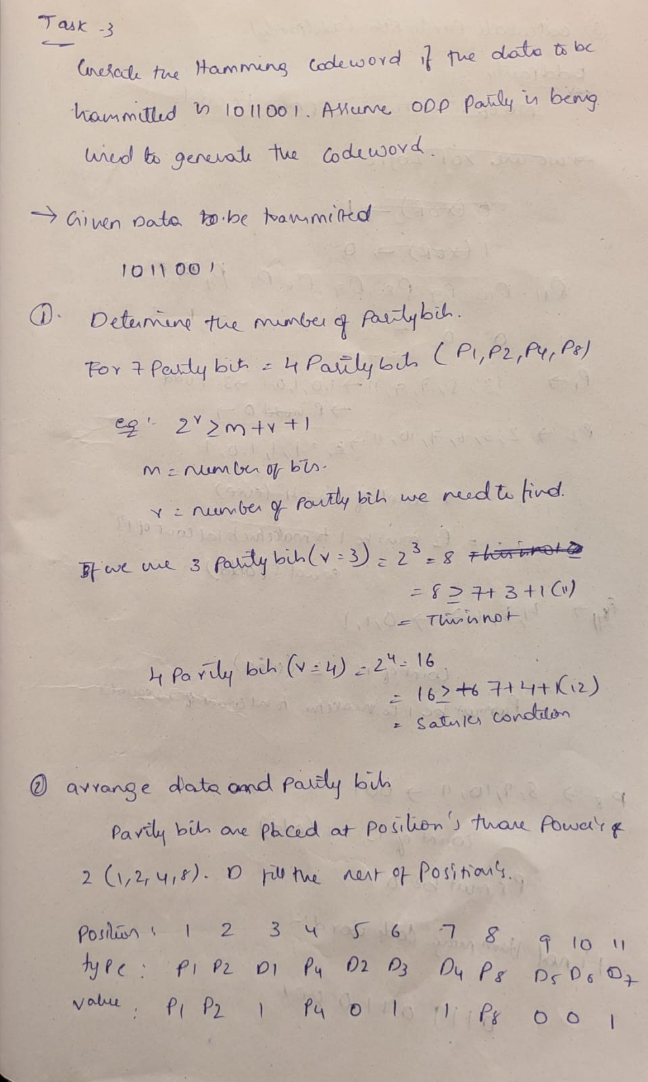
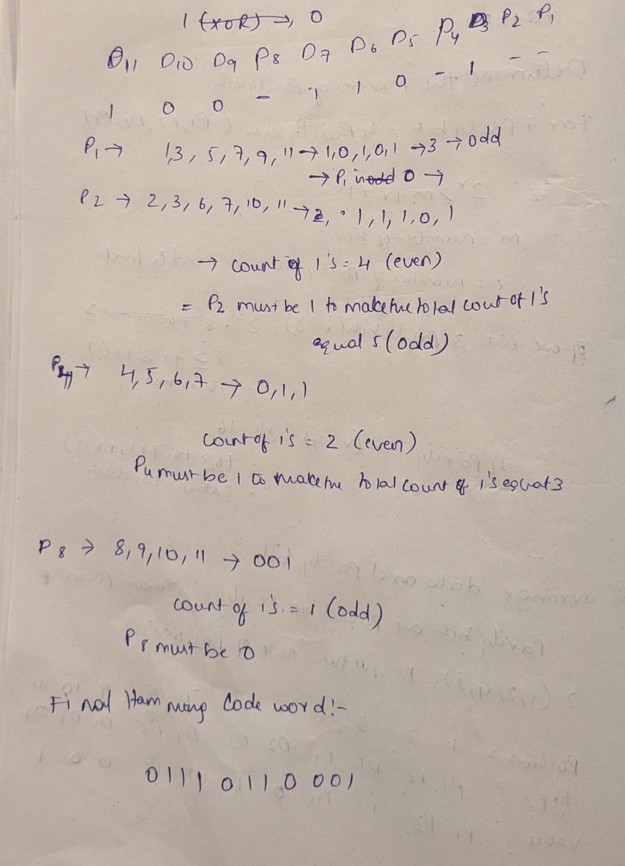
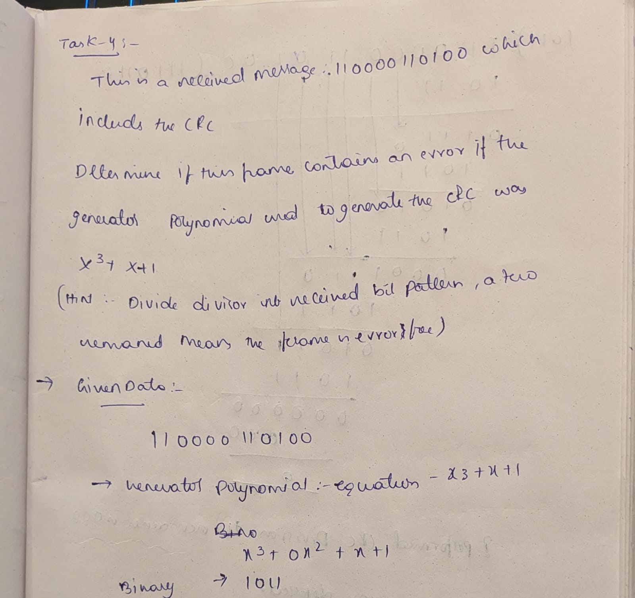
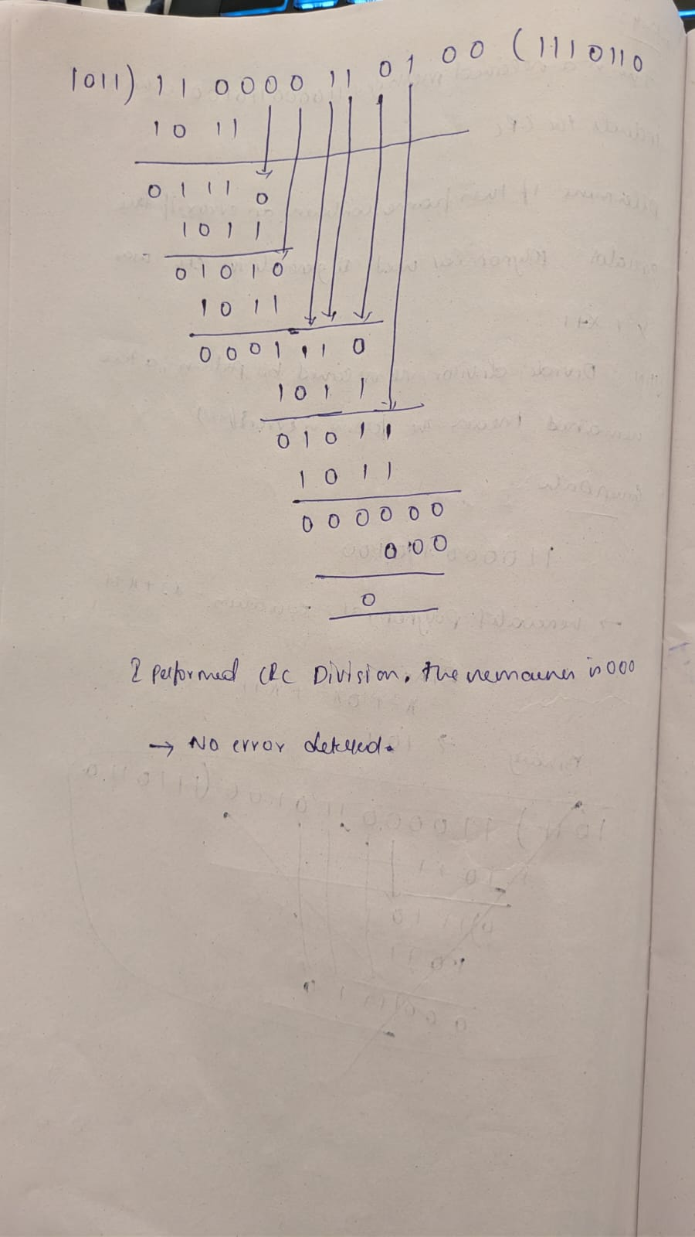

Task : 5
Have error correction/detection techniques evolved recently? Write one to two carefully researched paragraphs that answer this question. All sources of information should be properly cited and referenced.
Yes error Correction and detection techniques have evolved significantly. The demands of 5G and the emergence of artificial intelligence have propelled the evolution of traditional communications. The adoption of Polar codes for 5G control channels marked a significant commercial application of a code that was initially suggested by Erdal Arıkan in 2009 and was shown to achieve channel capacity. In addition, Low-Density Parity-Check (LDPC) codes—which were developed in the 1960s but were not yet feasible—have undergone significant optimization and are now essential to 5G's fast data channels. Neural networks are being used to design or function as decoders for codes in the most recent trend of machine learning integration. This is particularly true for complex, non-linear channels where conventional mathematical models are inadequate (e.g., "transformer-assisted parametric CSI feedback" to predict channel aging).
The evolution in Quantum Error Correction (QEC) is arguably more dramatic. One of the main obstacles to the creation of fault-tolerant quantum computers is this. Errors (both bit-flips and phase-flips) occur much more frequently in quantum bits (qubits) than in classical bits due to their analog nature and extreme fragility. Researchers at Google, IBM, and numerous universities have successfully demonstrated real-time QEC on small-scale systems, bringing recent advances from theory to practice. One "logical qubit" of information is encoded across numerous "physical qubits" by the most popular methods, like surface codes. This keeps the delicate quantum state of the logical qubit intact while enabling the detection and correction of errors (using traditional hardware such as FPGAs and GPUs in a tight feedback loop).
reference links:
https://iontrap.duke.edu/files/2025/03/arxiv_sub_v2.pdf
https://www.researchgate.net/publication/395396191_Quantum_Error_Correction_A_Review_of_Methods_Challenges_and_Advances
https://arxiv.org/html/2502.11053v2
https://www.mdpi.com/2076-3417/15/3/1124

