WEEK 2 INTERNSHIP TASK
HANDS-ON DATA LAB IMPLEMENTATION
Python • Jupyter Notebook • Pandas • NumPy • Data Visualization

Student details | Information
Student name | Jerripothula Kiran Sai
Registration / ID | Kirankiransai56@gmail.com
Course / Program | Data Science / Data Analysis Internship
Submission date | 02/11/2026

Table of Contents
- 1. Assessment overview and learning objectives
- 2. Introduction to the data lab
- 3. Setting up Python and Jupyter Notebook
- 4. Required libraries
- 5. Data manipulation with Pandas and NumPy
- 6. Data visualization
- 7. Sales dataset and basic analysis
- 8. Mini project: Sales Data Analysis
- 9. Conclusion and key learnings
- 10. References
- Appendix A. Objective completion checklist
- Appendix B. How to run and submit the files
Word tip: In Microsoft Word, use References > Table of Contents to insert an automatic page-numbered contents table after opening the document.

1. Assessment overview and learning objectives
The Week 2 task is called Hands-On Data Lab Implementation. It has two main objectives:
- Set up a data science environment using Python, Jupyter Notebook and the required libraries.
- Complete practical exercises in data manipulation, data visualization and basic data analysis.
This report uses simple examples and a simulated sales dataset with 24 orders. The same dataset is used in the analysis and mini-project so that the steps can be followed from beginning to end.

2. Introduction to the data lab
Data analysis means examining information to answer questions. For example, a shop owner may want to know which product sells the most, which month has the highest sales, or which region performs best. Python helps us perform these tasks quickly and repeatably.
A data lab is a working setup where we can write code, load data, clean it, calculate results and create charts. In this task, Jupyter Notebook is the workspace and Python libraries provide useful tools.

3. Setting up Python and Jupyter Notebook

3.1 What is Python?
Python is a programming language. It is popular for data work because its code is readable and many libraries are available for calculations, tables and charts.

3.2 What is Jupyter Notebook?
Jupyter Notebook is an interactive workspace. It lets us write code in small cells, run each cell and see the output below it. It is useful for learning and data experiments.

3.3 Installation steps
- Visit https://www.python.org/downloads/ and download a suitable Python 3 version for your operating system.
- Run the installer. On Windows, select the option to add Python to PATH if it is shown, then complete the installation.
- Open Command Prompt (Windows) or Terminal (macOS/Linux) and check the installation with: python --version. On some systems use: python3 --version.
- Install Jupyter Notebook and the libraries with the pip command shown below.
- Start Jupyter Notebook from the terminal. Your browser should open the notebook interface. Choose New > Python 3 to create a notebook.
python --version
python -m pip install notebook numpy pandas matplotlib seaborn
jupyter notebook
If the command `python` is not recognised on Windows, try `py --version` and `py -m pip install ...`. Installation steps can differ slightly by operating system. These are instructions only; this report does not install software on the student's computer.

3.4 Verify the environment
import sys
import numpy as np
import pandas as pd
import matplotlib
import seaborn as sns
print('Python:', sys.version.split()[0])
print('NumPy:', np.__version__)
print('Pandas:', pd.__version__)
print('Matplotlib:', matplotlib.__version__)
print('Seaborn:', sns.__version__)
print('Environment check completed.')
Expected result: the cell prints the installed version number of Python and each library, followed by “Environment check completed.” The exact version numbers depend on the computer.

4. Required libraries
Library | Purpose | Simple example of use
NumPy | Fast numerical arrays and mathematical operations | Average, sum and array calculations
Pandas | Work with data in rows and columns; clean and summarize tables | Read a CSV file and group sales by region
Matplotlib | Create basic charts and customize chart labels | Line, bar and pie charts
Seaborn | Create statistical charts with simpler plotting commands | Box plots, count plots and heatmaps
import numpy as np
import pandas as pd
import matplotlib.pyplot as plt
import seaborn as sns
sns.set_theme(style='whitegrid')
Run the imports once near the beginning of a notebook. If an import gives ModuleNotFoundError, install the missing package with python -m pip install package_name and restart the notebook kernel.

5. Data manipulation with Pandas and NumPy
A DataFrame is like a spreadsheet: it has rows and columns. A Series is one column. NumPy arrays store values for numerical work.

5.1 Create a DataFrame
import pandas as pd
students = pd.DataFrame({
'Name': ['Asha', 'Ravi', 'Meena'],
'Marks': [85, 72, 91]
})
print(students)
Expected output:
Name Marks
0 Asha 85
1 Ravi 72
2 Meena 91
Explanation: pd.DataFrame() turns the dictionary into a table. Each dictionary key becomes a column name.

5.2 Read a CSV file
sales = pd.read_csv('week2_simulated_sales_dataset.csv')
print(sales.head())
Expected result: the first five records from the supplied CSV file. Keep the CSV file in the same folder as the notebook, or provide its full file path.

5.3 Display first and last five rows
print(sales.head()) # first five rows
print(sales.tail()) # last five rows
head() is useful for a quick look at the beginning; tail() checks the end of the dataset.

5.4 Check shape, columns and data types
print('Shape:', sales.shape)
print('Columns:', sales.columns.tolist())
print(sales.dtypes)
For the supplied dataset, shape is (24, 10): 24 rows and 10 columns. The Order_Date column should be converted to datetime if it was read as text.

5.5 Select rows and columns
print(sales['Product']) # one column
print(sales[['Product', 'Sales']]) # two columns
print(sales.loc[0:2, ['Product', 'Sales']]) # rows by labels
Use one pair of square brackets for a single column and a list inside double brackets for multiple columns. loc selects by labels.

5.6 Filter rows using a condition
high_value = sales[sales['Sales'] >= 10000]
print(high_value[['Order_ID', 'Product', 'Sales']].head())
The condition creates True/False results. Pandas keeps the rows where the condition is True.

5.7 Handle missing values
print(sales.isna().sum())
# Example: fill missing quantities with the median
sales['Quantity'] = sales['Quantity'].fillna(sales['Quantity'].median())
isna() identifies missing cells. fillna() replaces them. Choose a replacement only when it makes sense for the data; do not automatically fill every missing value with zero.

5.8 Remove duplicate records
print('Duplicate rows:', sales.duplicated().sum())
sales = sales.drop_duplicates()
duplicated() identifies repeated rows. drop_duplicates() keeps the first copy by default. For real work, confirm which columns define a duplicate before deleting records.

5.9 Rename columns
sales = sales.rename(columns={'Unit_Price': 'Price_Per_Unit'})
print(sales.columns.tolist())
rename() changes a column label. Use the exact old column name.

5.10 Sort data
sales_sorted = sales.sort_values(by='Sales', ascending=False)
print(sales_sorted[['Order_ID', 'Sales']].head())
ascending=False sorts from largest to smallest.

5.11 GroupBy operation
category_summary = sales.groupby('Category')['Sales'].sum()
print(category_summary)
groupby() makes groups with the same category. sum() adds the sales inside each group.

5.12 Merge two DataFrames
orders = pd.DataFrame({'Order_ID': [1, 2], 'Customer_ID': [101, 102]})
customers = pd.DataFrame({'Customer_ID': [101, 102], 'Customer': ['Asha', 'Ravi']})
merged = pd.merge(orders, customers, on='Customer_ID', how='inner')
print(merged)
Order_ID Customer_ID Customer
0 1 101 Asha
1 2 102 Ravi
merge() combines tables using a common key. An inner merge keeps keys found in both tables. A left merge keeps every row from the left table.

5.13 Basic NumPy array operations
import numpy as np
arr = np.array([10, 20, 30, 40])
print('Array:', arr)
print('Add 5:', arr + 5)
print('Mean:', arr.mean())
print('Maximum:', arr.max())
print('Even values:', arr[arr % 2 == 0])
Array: [10 20 30 40]
Add 5: [15 25 35 45]
Mean: 25.0
Maximum: 40
Even values: [10 20 30 40]
NumPy performs operations on all array values without writing a separate loop for each item.

6. Data visualization
A chart turns numbers into a picture. Use a chart that matches the question. The following examples use the sales DataFrame and Matplotlib/Seaborn.

6.1 Line plot
What it shows / when to use it: Shows change across an ordered sequence, such as months. Use it to see a trend.
monthly = valid.groupby(valid['Order_Date'].dt.to_period('M'))['Sales'].sum()
monthly.index = monthly.index.astype(str)
monthly.plot(marker='o')
plt.title('Monthly Sales'); plt.xlabel('Month'); plt.ylabel('Sales (INR)'); plt.show()
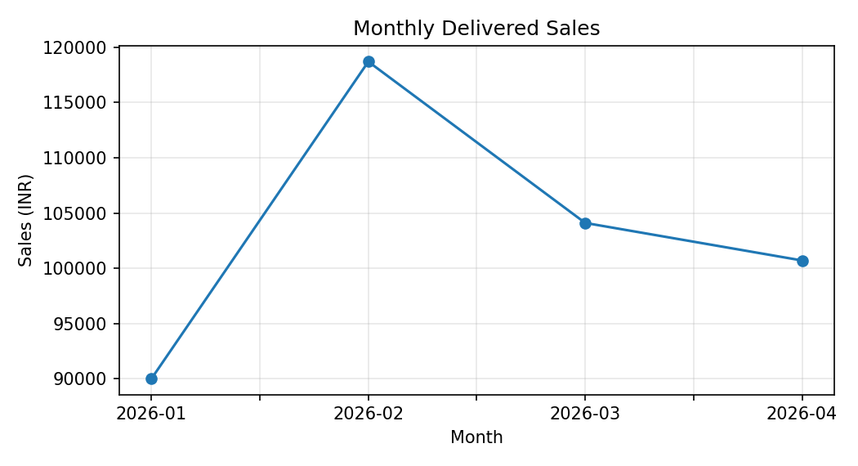
How to interpret: The points show monthly sales; a rising or falling line indicates how sales changed over time.

6.2 Bar chart
What it shows / when to use it: Compares values across groups, such as categories.
valid.groupby('Category')['Sales'].sum().plot(kind='bar')
plt.title('Sales by Category'); plt.xlabel('Category'); plt.ylabel('Sales (INR)'); plt.show()
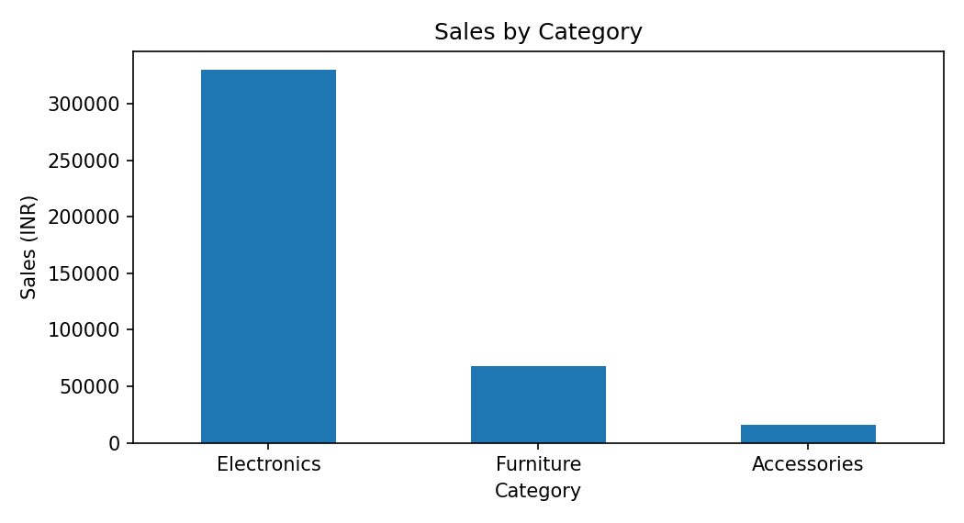
How to interpret: The tallest bar represents the category with the highest delivered sales.

6.3 Histogram
What it shows / when to use it: Shows how numerical values are distributed into ranges. Use it to see where order values are concentrated.
plt.hist(valid['Sales'], bins=8, edgecolor='black')
plt.title('Order Sales Distribution'); plt.xlabel('Sales (INR)'); plt.ylabel('Frequency'); plt.show()
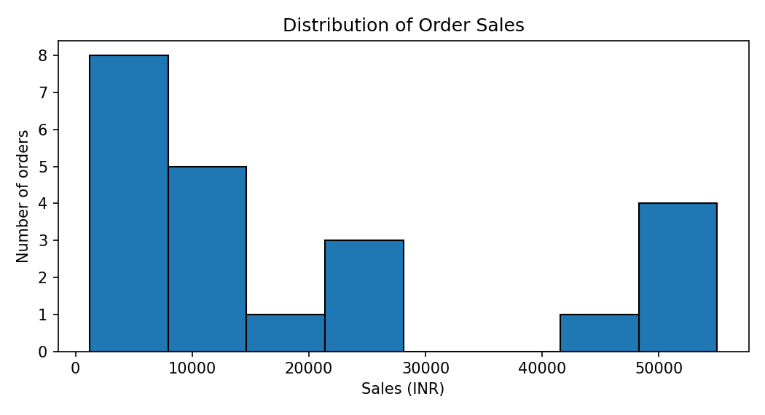
How to interpret: Each bar counts how many orders fall within a sales-value range.

6.4 Pie chart
What it shows / when to use it: Shows how a whole is divided into parts. Use it for a small number of categories.
valid.groupby('Category')['Sales'].sum().plot(kind='pie', autopct='%1.1f%%')
plt.title('Category Share'); plt.ylabel(''); plt.show()
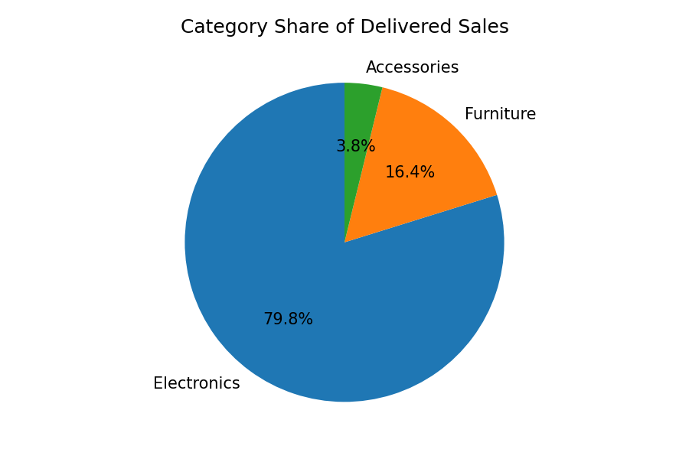
How to interpret: Each slice shows the percentage contribution of a category to total delivered sales.

6.5 Scatter plot
What it shows / when to use it: Shows the relationship between two numerical variables.
plt.scatter(valid['Quantity'], valid['Sales'])
plt.title('Quantity vs Sales'); plt.xlabel('Quantity'); plt.ylabel('Sales (INR)'); plt.show()
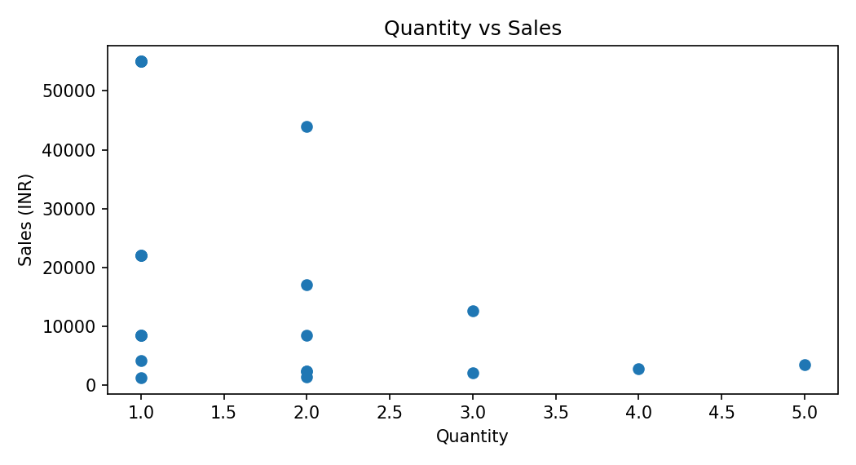
How to interpret: Each dot is an order. The chart helps check whether larger quantities tend to have larger sales values.

6.6 Box plot
What it shows / when to use it: Summarizes the middle spread, median and possible outliers of numerical data.
sns.boxplot(y=valid['Sales'])
plt.title('Order Sales Box Plot'); plt.ylabel('Sales (INR)'); plt.show()
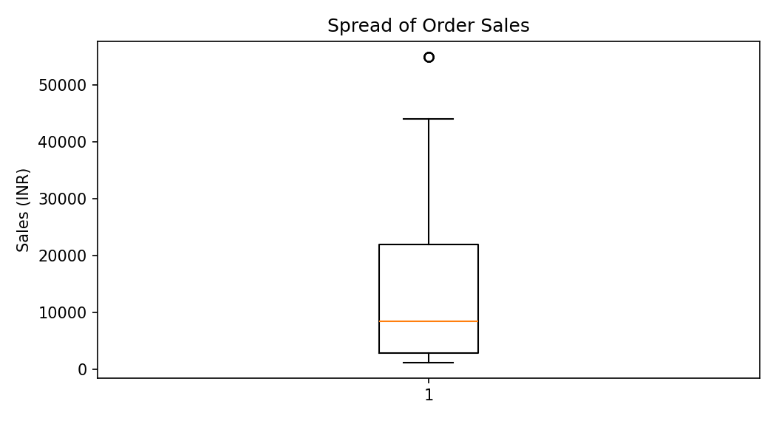
How to interpret: The line inside the box is the median. Points beyond whiskers may be unusual values and should be checked, not automatically deleted.

6.7 Count plot
What it shows / when to use it: Counts how many records belong to each category.
sns.countplot(data=valid, x='Category')
plt.title('Delivered Orders by Category'); plt.xlabel('Category'); plt.ylabel('Number of orders'); plt.show()
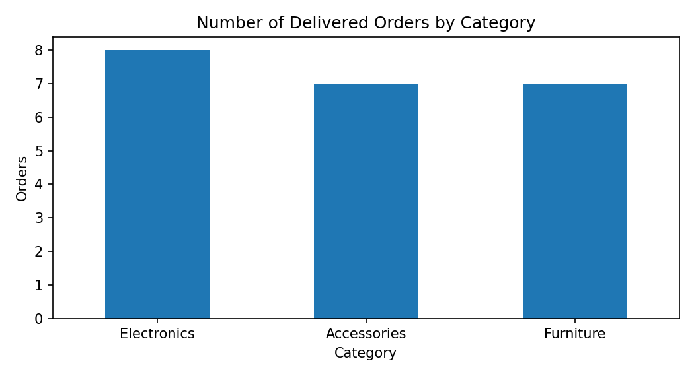
How to interpret: The tallest bar has the largest number of delivered orders; this is order count, not total sales.

6.8 Heatmap
What it shows / when to use it: Uses shades to compare values in a table, often a pivot table.
heat = valid.pivot_table(index='Category', columns='Region', values='Sales', aggfunc='sum', fill_value=0)
sns.heatmap(heat, annot=True, fmt='.0f', cmap='Blues')
plt.title('Category and Region Sales'); plt.show()
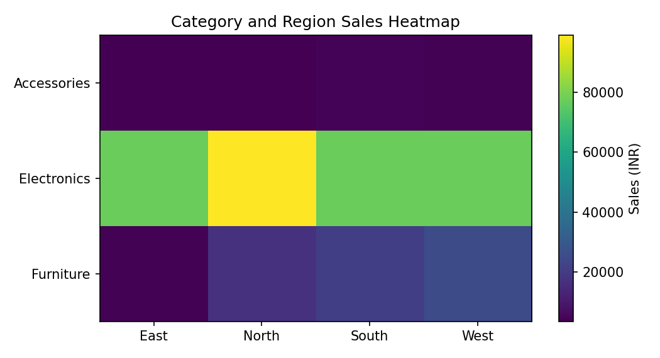
How to interpret: Darker or larger annotated cells indicate higher sales for that category-region combination.

7. Sales dataset and basic analysis
The included CSV contains 24 simulated order records from January to April 2026. Each row represents one order. Sales is calculated as Quantity × Unit_Price. For revenue summaries in this report, only rows with Status = Delivered are included. Cancelled and Returned orders are excluded from delivered sales; this is an explicit reporting assumption, not a universal accounting rule.
Dataset columns: Order_ID, Order_Date, Product, Category, Region, Quantity, Unit_Price, Payment_Method, Status and Sales.
The full dataset is supplied separately as week2_simulated_sales_dataset.csv. The following summary values are calculated from the 22 Delivered rows.
Measure | Verified result
All orders in dataset | 24
Delivered orders | 22
Total delivered sales (INR) | 413,500
Average delivered order sales (INR) | 18,795.45
Highest delivered order sales (INR) | 55,000
Lowest delivered order sales (INR) | 1,200
Total delivered quantity | 39
Average quantity per delivered order | 1.77
Largest quantity in a delivered order | 5
Smallest quantity in a delivered order | 1

7.1 Sales by category
Category | Delivered sales (INR)
Electronics | 330,000
Furniture | 67,700
Accessories | 15,800
Highest sales category: Electronics with INR 330,000.

7.2 Top five products by delivered sales
Rank | Product | Sales (INR)
1 | Laptop | 220,000
2 | Phone | 110,000
3 | Desk | 42,500
4 | Chair | 25,200
5 | Mouse | 9,800

7.3 Monthly delivered sales
Month | Sales (INR)
2026-01 | 90,000
2026-02 | 118,700
2026-03 | 104,100
2026-04 | 100,700

7.4 Sales by region
Region | Delivered sales (INR)
North | 119,500
West | 106,400
South | 102,600
East | 85,000
Best-performing region by delivered sales: North (INR 119,500).

7.5 Analysis code
sales = pd.read_csv('week2_simulated_sales_dataset.csv', parse_dates=['Order_Date'])
sales['Sales'] = sales['Quantity'] * sales['Unit_Price']
delivered = sales[sales['Status'] == 'Delivered'].copy()
print('Total sales:', delivered['Sales'].sum())
print('Average order sales:', delivered['Sales'].mean())
print('Highest order sales:', delivered['Sales'].max())
print('Lowest order sales:', delivered['Sales'].min())
print(delivered.groupby('Category')['Sales'].sum().sort_values(ascending=False))
print(delivered.groupby('Product')['Sales'].sum().sort_values(ascending=False).head(5))
print(delivered.groupby(delivered['Order_Date'].dt.to_period('M'))['Sales'].sum())
print(delivered.groupby('Region')['Sales'].sum().sort_values(ascending=False))
print('Total quantity:', delivered['Quantity'].sum())

7.6 Findings and observations
- The simulated dataset has 24 orders, of which 22 are marked Delivered.
- Delivered sales total INR 413,500; cancelled and returned orders are excluded under the stated assumption.
- Electronics is the leading category by delivered sales.
- Laptop is the top product by delivered sales in this dataset.
- 2026-02 is the strongest month by delivered sales.
- North is the leading region by delivered sales.
- The scatter plot and box plot help inspect the relationship and spread of order values, but a chart alone does not prove why a pattern exists.

8. Mini project: Sales Data Analysis

8.1 Introduction
This mini-project uses Python to study a small simulated sales dataset. It demonstrates how a beginner can load data, inspect it, prepare it for analysis, calculate summary values and communicate results with charts.

8.2 Project objectives
- Load a CSV file using Pandas.
- Check and prepare the columns needed for analysis.
- Calculate order sales using quantity and unit price.
- Summarize sales by category, product, month and region.
- Create charts and write simple findings.

8.3 Complete executable project code
import pandas as pd
import numpy as np
import matplotlib.pyplot as plt
import seaborn as sns
# Load the supplied simulated dataset
sales = pd.read_csv('week2_simulated_sales_dataset.csv',
parse_dates=['Order_Date'])
# Inspect the data
print(sales.head())
print(sales.shape)
print(sales.isna().sum())
print('Duplicate rows:', sales.duplicated().sum())
# Prepare the data
sales = sales.drop_duplicates()
sales['Quantity'] = pd.to_numeric(sales['Quantity'], errors='coerce')
sales['Unit_Price'] = pd.to_numeric(sales['Unit_Price'], errors='coerce')
sales = sales.dropna(subset=['Order_ID', 'Order_Date', 'Quantity', 'Unit_Price'])
sales['Sales'] = sales['Quantity'] * sales['Unit_Price']
# State the business rule: analyze delivered orders only
delivered = sales[sales['Status'].str.strip().str.title() == 'Delivered'].copy()
# Basic analysis
print('Total delivered sales:', delivered['Sales'].sum())
print('Average order sales:', delivered['Sales'].mean())
print('Highest order sales:', delivered['Sales'].max())
print('Lowest order sales:', delivered['Sales'].min())
print('\nSales by category:')
print(delivered.groupby('Category')['Sales'].sum().sort_values(ascending=False))
print('\nTop five products:')
print(delivered.groupby('Product')['Sales'].sum().sort_values(ascending=False).head(5))
print('\nMonthly sales:')
print(delivered.groupby(delivered['Order_Date'].dt.to_period('M'))['Sales'].sum())
print('\nSales by region:')
print(delivered.groupby('Region')['Sales'].sum().sort_values(ascending=False))
print('\nQuantity summary:')
print(delivered['Quantity'].describe())
# Visualizations
monthly = delivered.groupby(delivered['Order_Date'].dt.to_period('M'))['Sales'].sum()
monthly.index = monthly.index.astype(str)
monthly.plot(marker='o', title='Monthly Delivered Sales')
plt.xlabel('Month'); plt.ylabel('Sales (INR)'); plt.tight_layout(); plt.show()
delivered.groupby('Category')['Sales'].sum().plot(kind='bar',
title='Delivered Sales by Category')
plt.xlabel('Category'); plt.ylabel('Sales (INR)'); plt.tight_layout(); plt.show()
sns.scatterplot(data=delivered, x='Quantity', y='Sales', hue='Category')
plt.title('Quantity vs Sales'); plt.tight_layout(); plt.show()
heat = delivered.pivot_table(index='Category', columns='Region',
values='Sales', aggfunc='sum', fill_value=0)
sns.heatmap(heat, annot=True, fmt='.0f')
plt.title('Sales by Category and Region'); plt.tight_layout(); plt.show()
Expected result: the printed summaries should match the verified tables in Section 7 when the supplied CSV is used. The chart cells display a monthly line chart, category bar chart, quantity-versus-sales scatter plot and category-region heatmap.

8.4 Conclusion of the mini-project
The project shows a complete beginner workflow: load a dataset, inspect its quality, calculate a sales column, select the relevant order status, summarize results and use charts to communicate patterns. The results describe only this simulated dataset. A larger real-world dataset may show different patterns.

9. Conclusion and key learnings
Through this task, I learned how Python and Jupyter Notebook can be used as a data analysis workspace. I practiced using NumPy for numerical operations and Pandas for tables, filtering, cleaning, grouping and merging. I also learned how Matplotlib and Seaborn help explain data through charts. The sales mini-project connected these skills in one workflow. I understand that analysis results depend on data quality and on clearly stated assumptions.

10. References
- Python Software Foundation, Python documentation: https://docs.python.org/3/
- Project Jupyter, Jupyter documentation: https://docs.jupyter.org/
- NumPy documentation: https://numpy.org/doc/
- pandas documentation: https://pandas.pydata.org/docs/
- Matplotlib documentation: https://matplotlib.org/stable/
- Seaborn documentation: https://seaborn.pydata.org/
These references are official documentation pages for the tools used. Check the current installation instructions on each official site because software versions and operating-system steps can change.

