**The Book Cart**

***‘the goto book ordering app’***



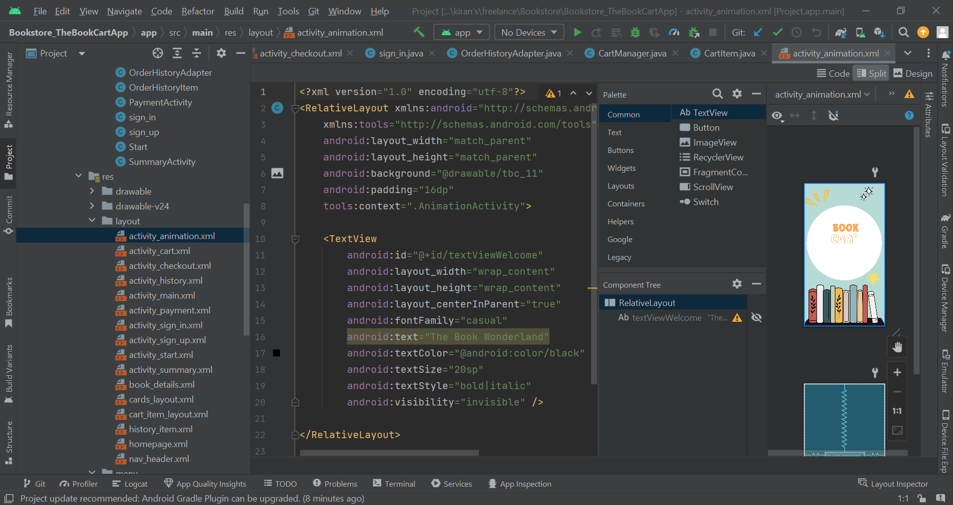

The Book Cart is an application coded on xml and Java, where the user’s favorite book is a click away, you can add the book to your and get it delivered on cash on delivery.

**Language: XML, Java**

This application, ‘the Book Cart ‘ has been coded on Android Studio, XML, and Java. The purpose of it is to make the online shopping of books easy for book lovers, or people who generally like collecting and reading books. The Application comes with an interactive user interface. The features are easy to interact with for any kind of user with their attractive colors and engaging designs.

The essential objective of Book Cart is to simplify and upgrade the process of managing, purchasing, and discovering book-related products, which provides users with a thorough and intuitive platform. In the era of digital, where convenience and efficiency are cardinal, Book Cart addresses the evolving requirements of modern consumers by offering a prosperous set of services designed to make online book shopping more pleasant and accessible. From its initial registration and login processes to its intricate product pages and comprehensive checkout system, every aspect of the application is designed to ensure a seamless and engaging user experience.

For a personalized shopping experience, the Registration Page enables new users to create their accounts efficiently, setting the stage. The Home Page serves as the control center of the application, featuring a visually entrancing card-based design that showcases numerous book products. Navigating to the Detail Page offers users a comprehensive view of their selected book, including detailed descriptions, pricing, and options to select quantities and add items to their cart.

The Book Cart application not only accommodates the technical and functional necessities of a modern e-commerce platform but also sets a new standard for user experience and engagement in the online book shopping domain.

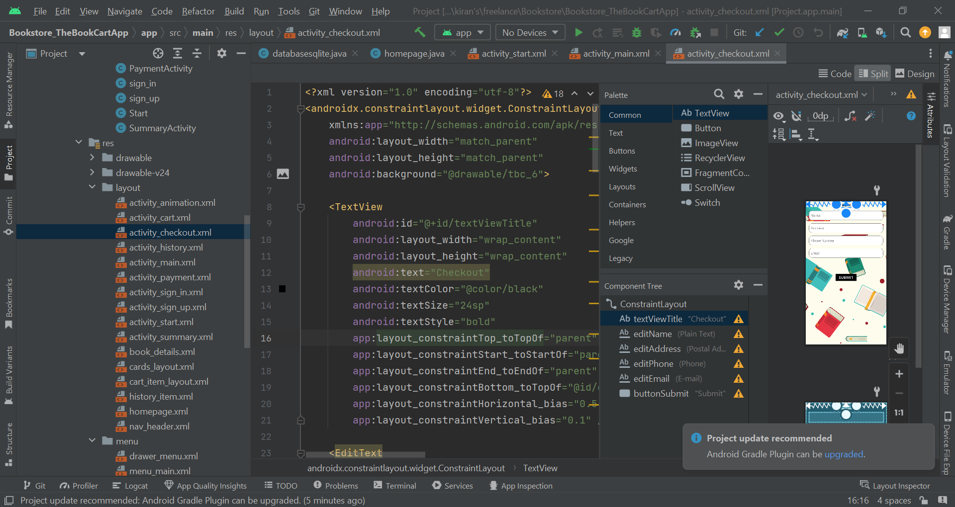

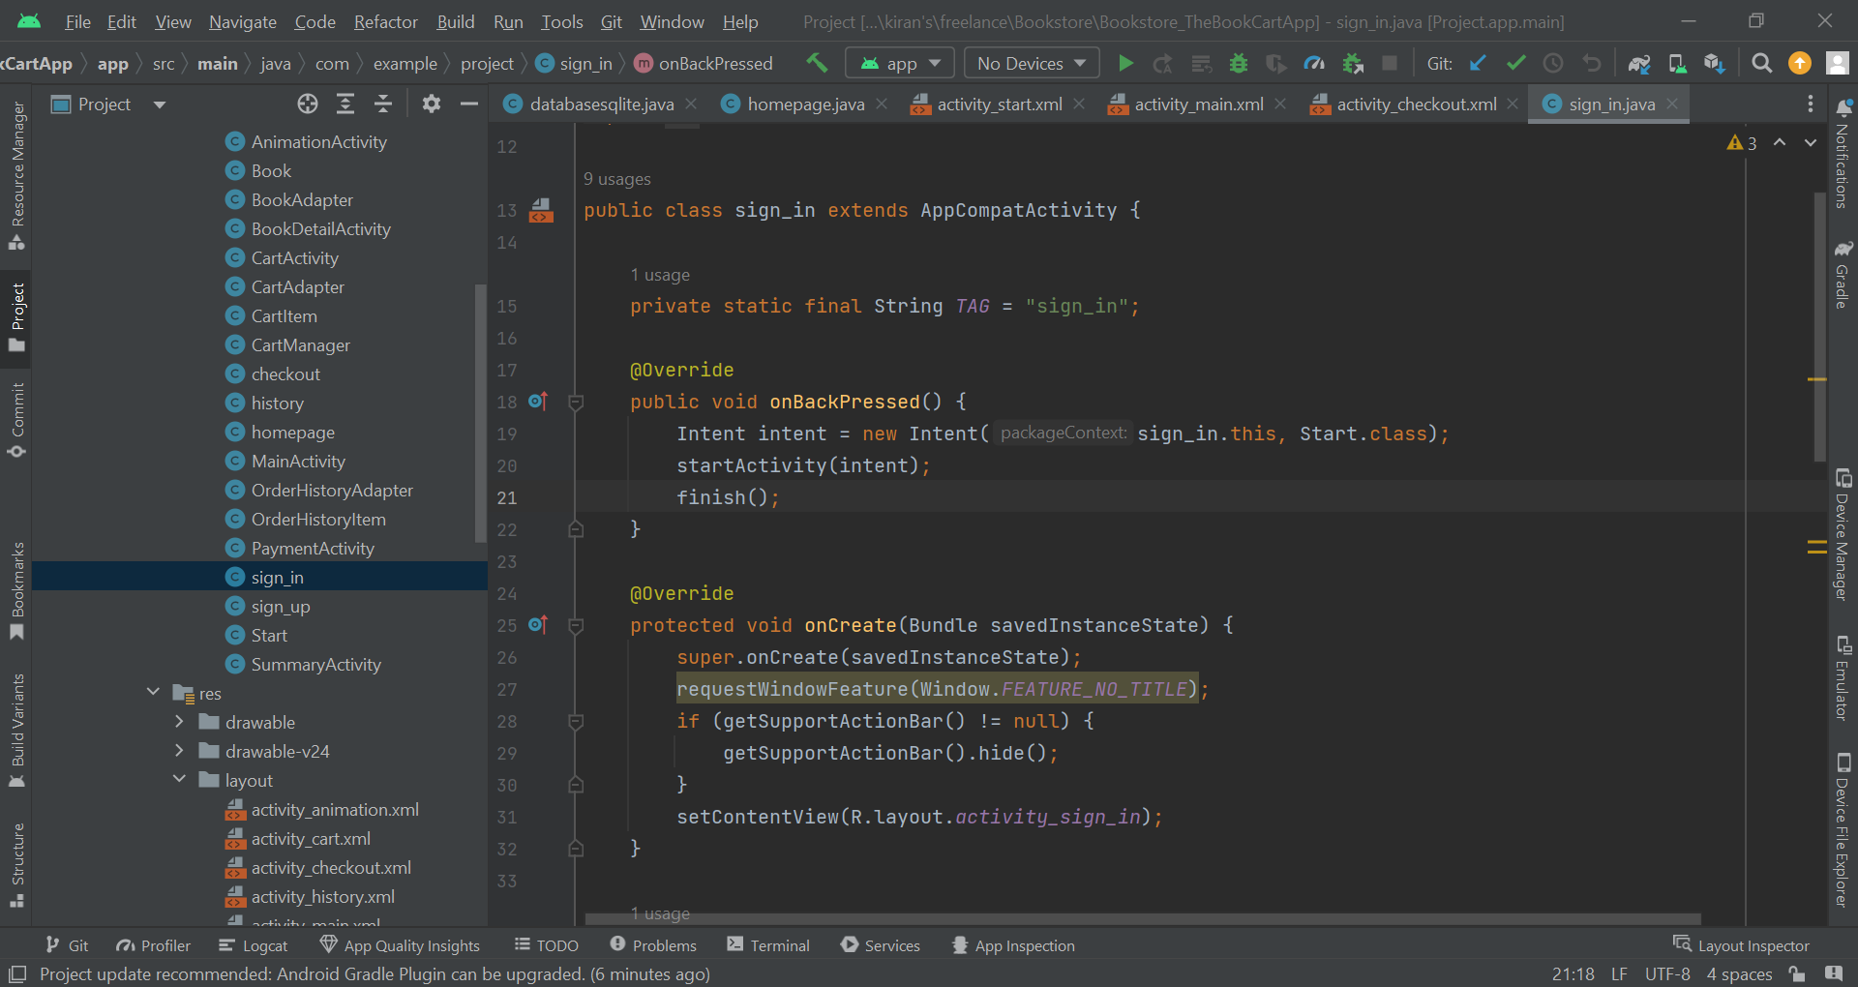

1. **Registration Page**

1. **Login**

The Login Page allows the user to log in to the application, it takes information such as email and password and provides a secure way to enter the application. The names etc are checked from the database, if the data matches, the user is logged in.

1. **Home Page**

The homepage is the middle page, it displays all the books using recycler view, it’s a card-based layout and displays the title and image of the book. The user can click to see more information about the book. The page is scrollable and provides the function to navigate up and down.

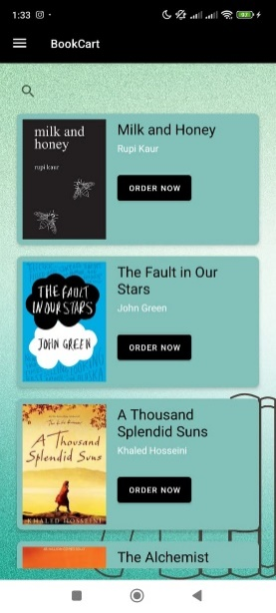

1. **Detail page**

The Detail Page offers comprehensive information about a specific book. It allows users to view detailed descriptions and manage their carts.

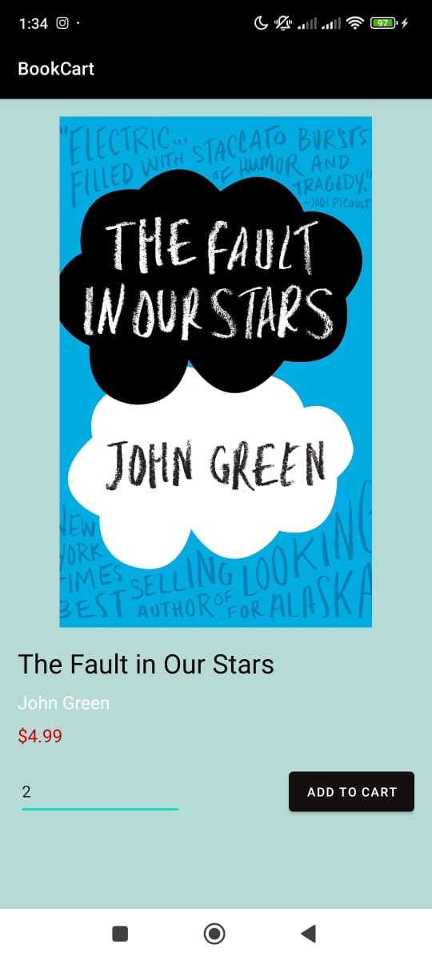

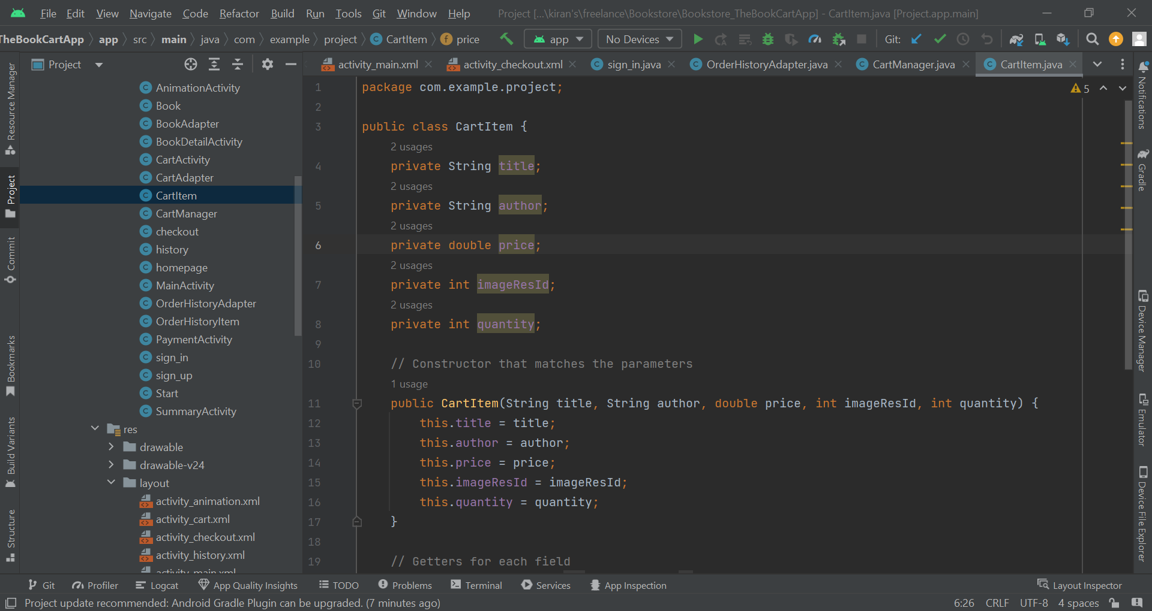

1. **Search**

The Search Page shows the user's specific books or information within the app. It features a type-ahead search bar on the top. The user can search for their favorite book and it will be displayed.

1. **Cart**

The Cart Page shows all items that are added to the user’s cart. It allows users to review their selected products. It shows product details, its quantity, total cost, and also a checkout button. Java Activities like Cart Manager and Cart Adapter are used to build the cart.

1. **Checkout**

The Checkout Page displays shipping information and ensures that users provide all necessary details for delivery such as their Full Name, Address, Phone Number, and Email. Intent() function is used in this Java Activity which carries the information of the user forward.

1. **Purchase History**

User History is an important feature. This way the user knows what book they ordered the last time.

Cards are used to display the history of the purchase. It records the history of the past 6 months. It displays an order list and shows details of all the items that were purchased, their quantity and order status, and order ID as well.

1. **Animation Activity**

In the Animation Activity, the book cart text appears after a few seconds of delay. It is launched when the app is run.

1. **Menu**

The Menu provides access to various sections of the app, including settings, account management, and navigation options.

**Navigation Links:** Quick access to different pages such as Home, Cart, and Purchase History.

The Book Cart application integrates these features to create a comprehensive and user-friendly e-commerce experience for book enthusiasts.

1. **Database**

The database for this application is made using SQLite. It is a relational database. The structure is efficient for data retrieval.

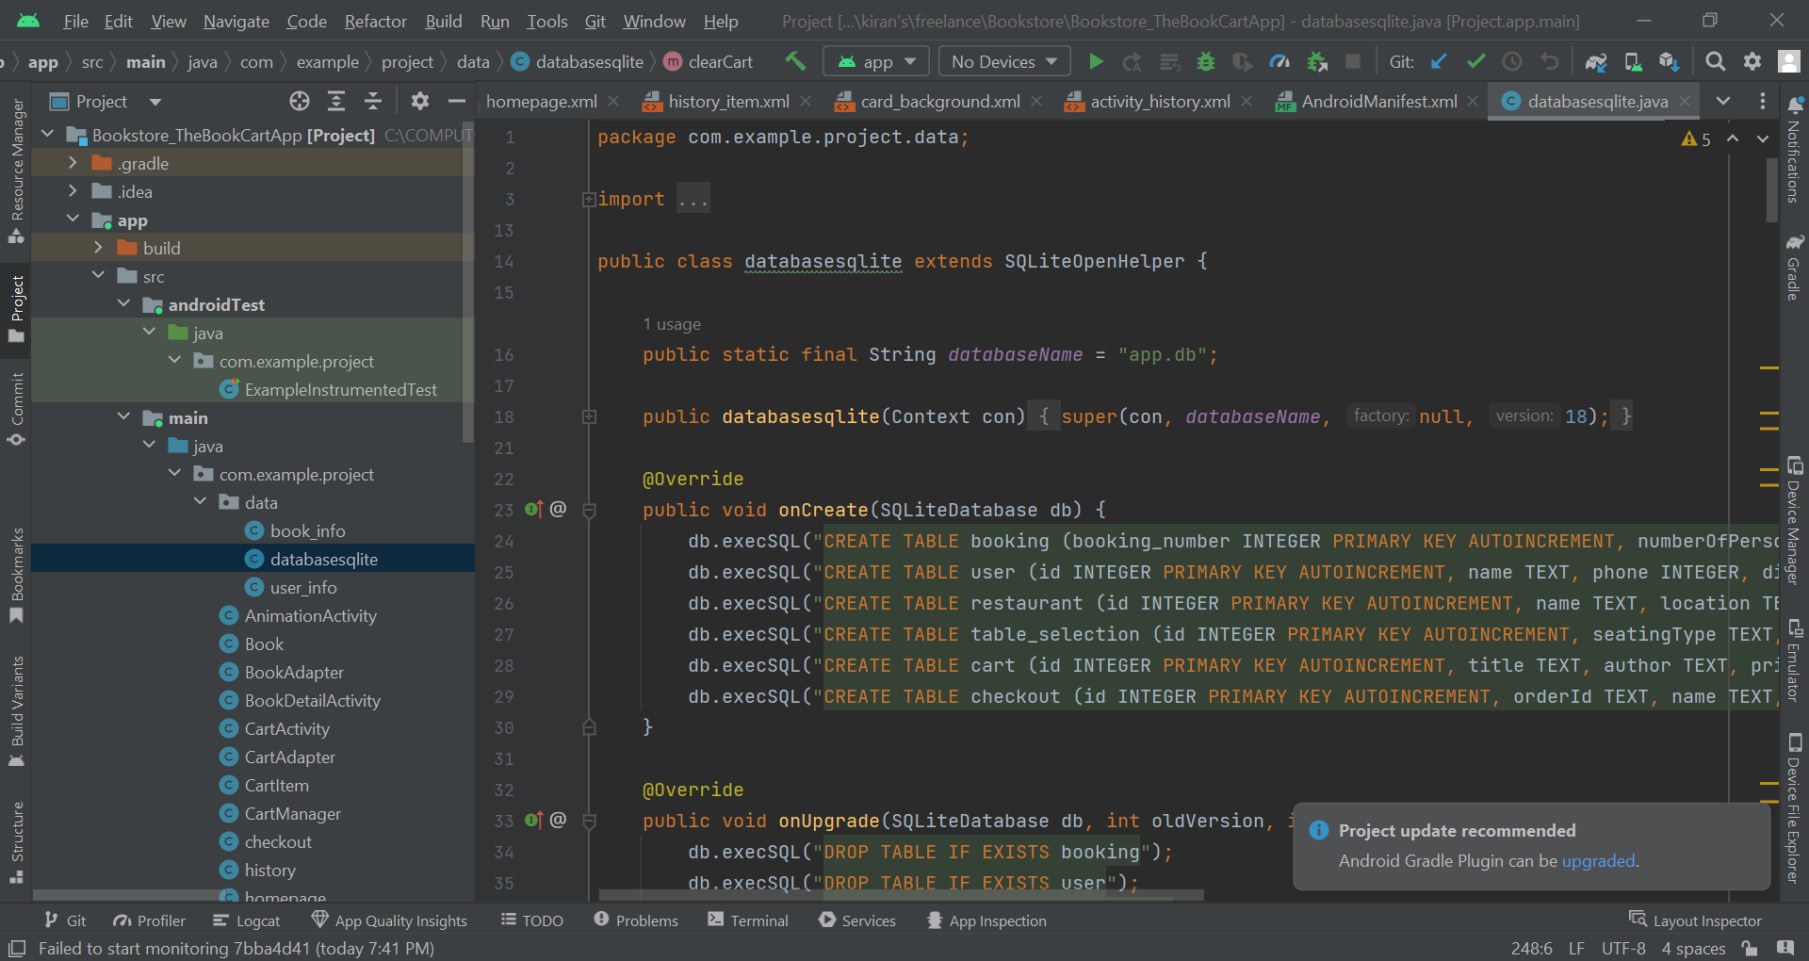

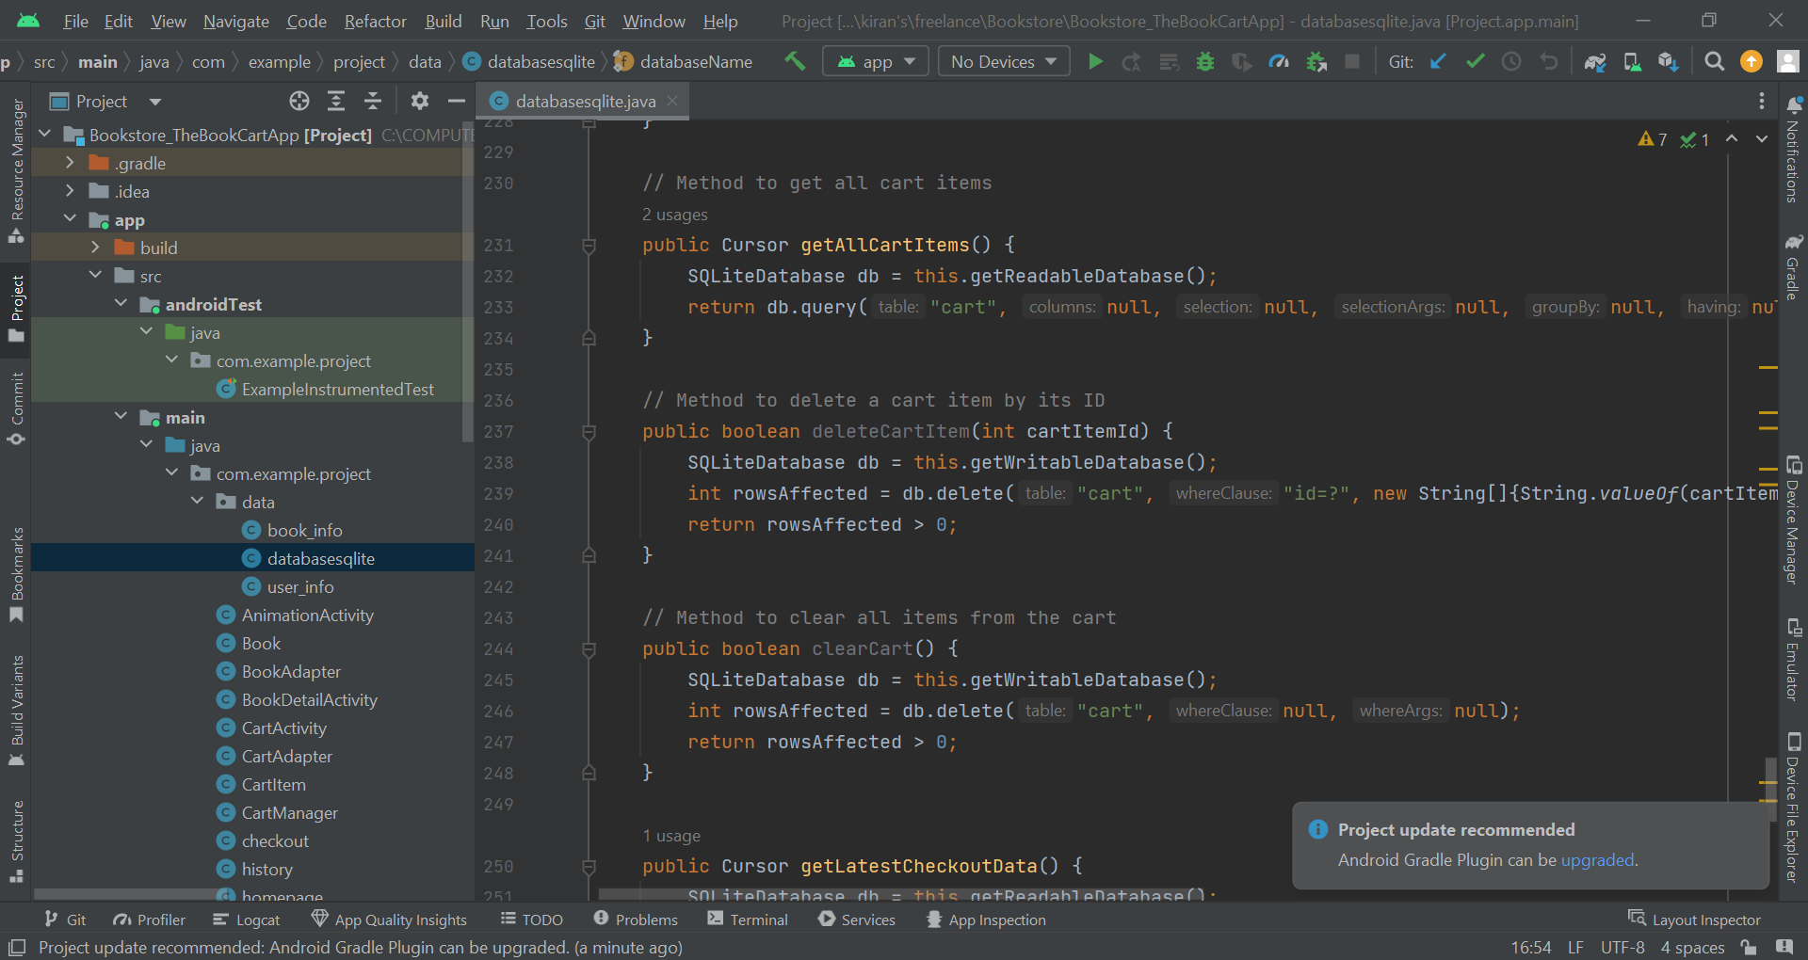

**Tables and Relationships**

1. **Users Table**

The user Table has user_id , username , email , password , full_name, and address.

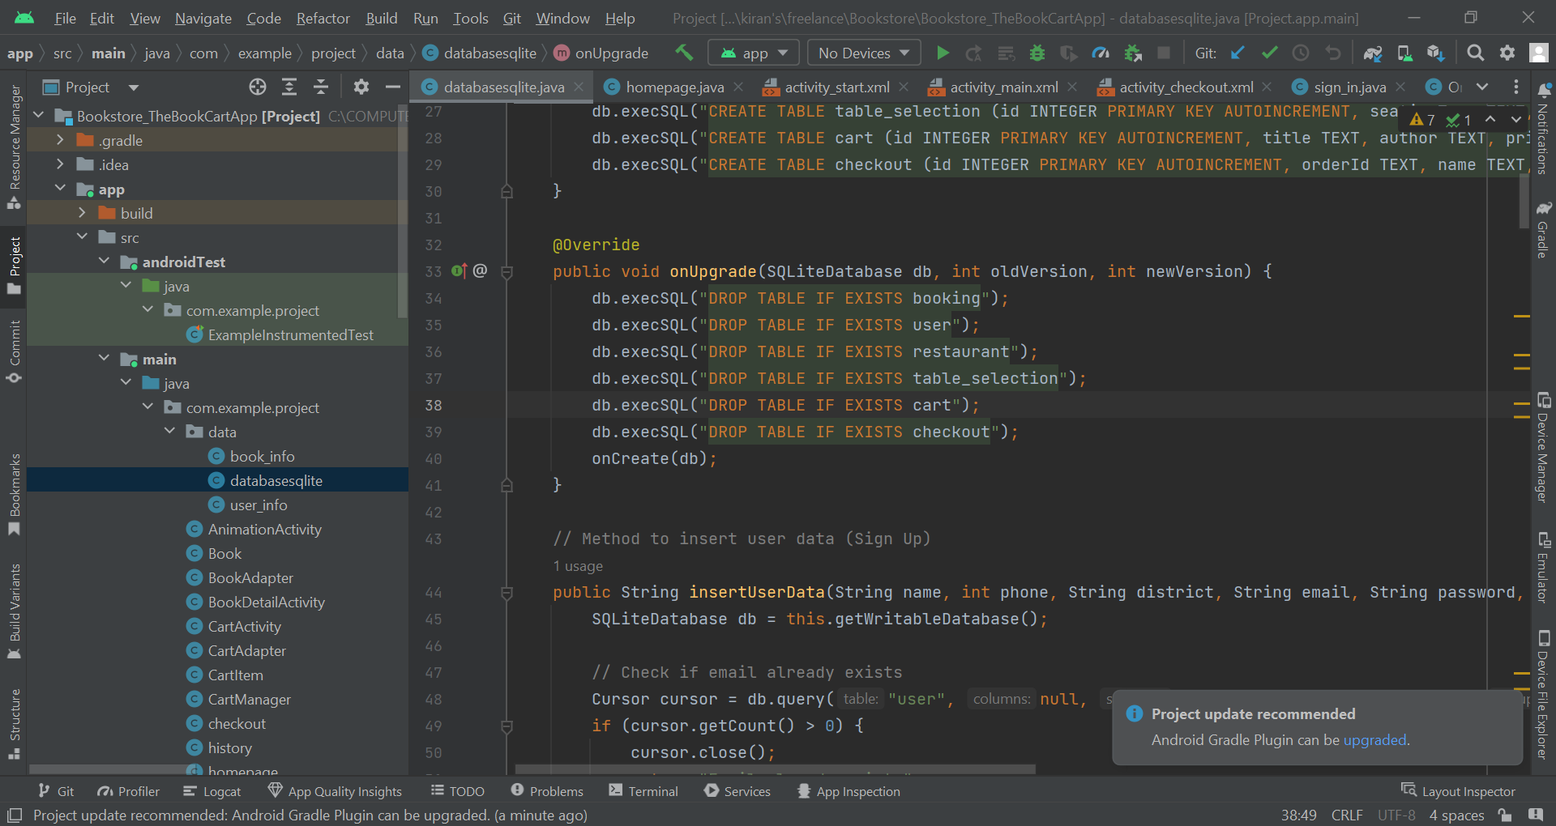

1. **Products Table**

The table contains product_id , title, author, price, description, image_url, and stock_quantity.

1. **Orders Table**

This table has:

order_id: Unique identifier for each order.

user_id: References the user_id

order_date: Date and time

1. **History Table**

This table has :

purchase_id which is the unique identifier for each purchase record.

user_id : References the user_id

order_id : References the order_id

purchase_date: Date when the purchase was made.

1. **Table**

This table has:

order_item_id, product_id, quantity, and price.

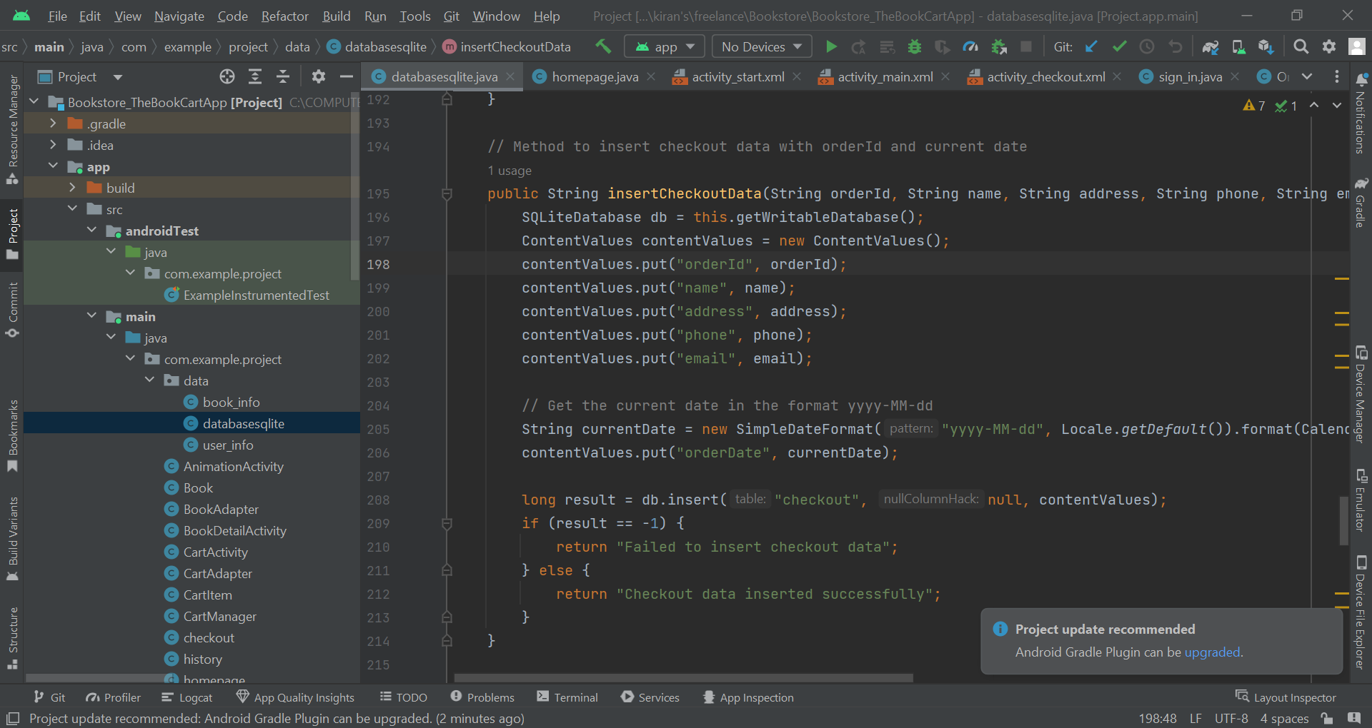

**Normalization:** To reduce redundancy the database is normalized and its integrity is protected. It can handle each data type.

**Primary and Foreign Keys:** To give distinctive keys, the unique primary key is given to each record that way each order ends up having a unique order ID.

**Indexes:** Indexes are given to fields, such as username, email, and product_id, to optimize performance.

**Conclusion:**

The Book Cart application represents an all-in-one store for book lovers. This application which is developed using xml and Java on Android Studio is designed to provide a seamless and engaging shopping experience. The application offers users a comprehensive set of features making purchase and delivery of books easy.