**DINEIN**

**DineIn is a restaurant reservation application** that assists users in booking tables at various restaurants. The app will consist of three main steps/pages where users can specify their reservation details. Each page will build upon the last, passing information forward using intents. It has an interactive User Interface which makes it easy for anyone to book a table to have a meal at their favorite place.

Below is the logo for the application



**Flow of the Application:**

The Application starts with the ‘Start Activity’, the button is clicked to proceed, and it opens the Main Activity page, where you can start booking.

First, the Application asks you to choose the restaurant of your choice from the list, after that you can choose the type of seat, it takes you to another page where you can add the number of people, date, and time and when the confirm booking button is clicked it shows the summary for the booking.

**Technical Overview:**

1. **Intent Navigation:**

In Android development intents are primitive for navigation between activities and for passing data between one activity of an application and another. When moving from one activity to another, creating the object of intent, and initializing it we pass the context of the current activity and the class of the next activity. Also, it is possible to send data through this intent store, and using the putExtra method key-value pairs can be added. For instance, when a user goes to the restaurant and books for a restaurant, some of them can be the restaurant name, restaurant location, and type of table needed. This data is then obtained in the target activity using methods such as getIntent and getStringExtra. This gives the application a great flow of information, and the context of the user is well retained as he or she moves around the application. The Intent and getExtra() functions are also used in the booking activity, in the backend the SQLite database has been connected for storage.

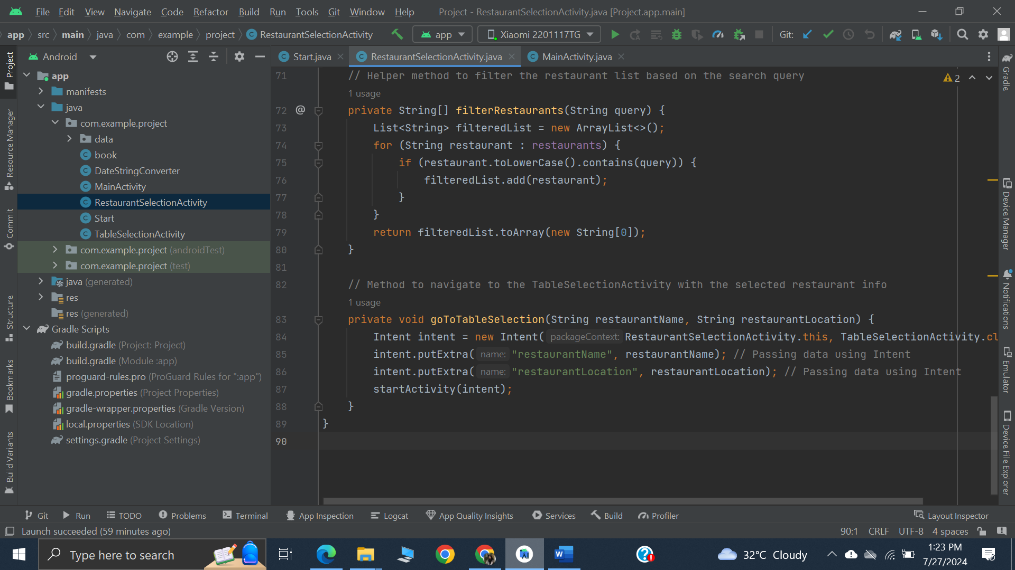

1. **User’s Data Integrity**

To protect the integrity of the user’s data, all the information of the user is stored in the database.

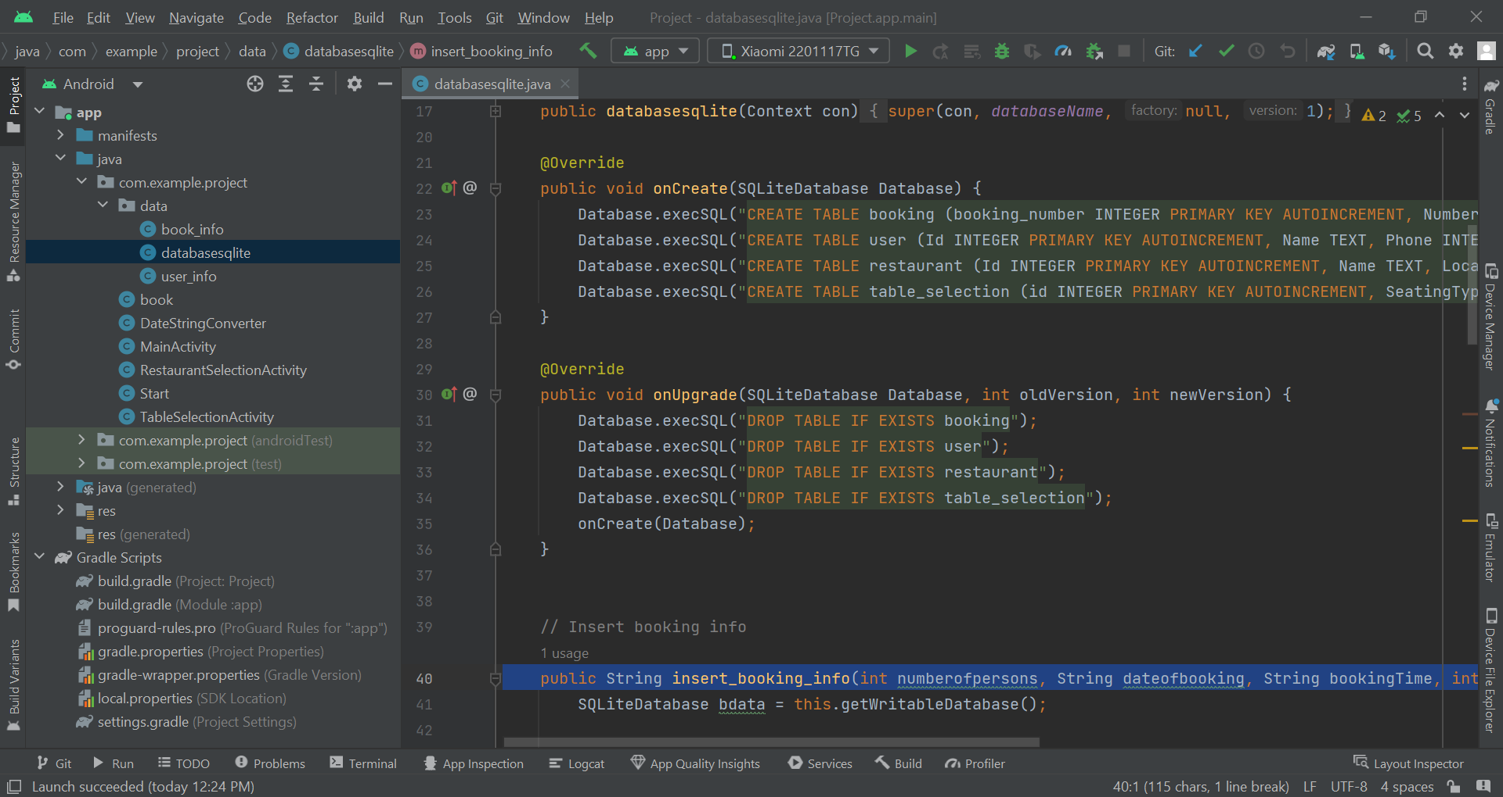

1. **User Interface**

When creating functionality for interfaces for usage in applications for travel planning or booking, it was made sure that the selected components are understandable for the users and enable guiding the processes. It is required to predict the necessary input fields to gather the necessary information that might include the number of persons, the date and time of reservation, and effective buttons to proceed with confirmation of the booking or getting back to the menu. By arranging the flow of the UI in an orderly manner, such inputs and reviews of the booking details are made easier for the users. If the user confirms the booking, the application must check the input for validity and store the information in a database, as well as show a more detailed confirmation message. This process also provides a better experience to the users through optimally capturing and processing their data to deliver a good user experience.

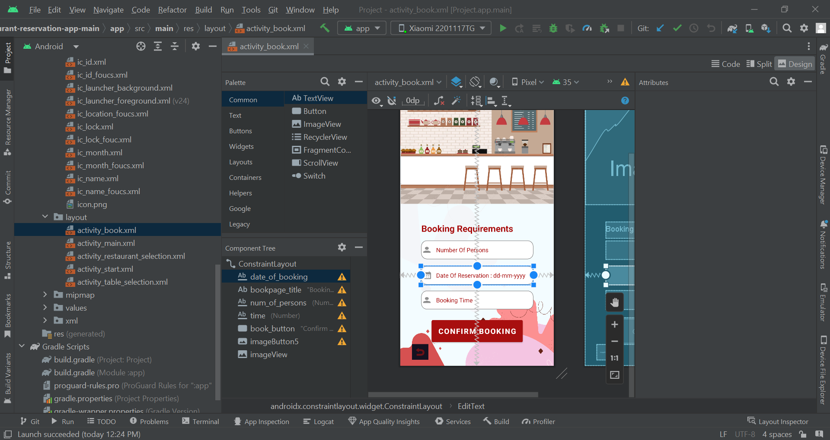

**ScreenShots:**

1. **Splash Screen**

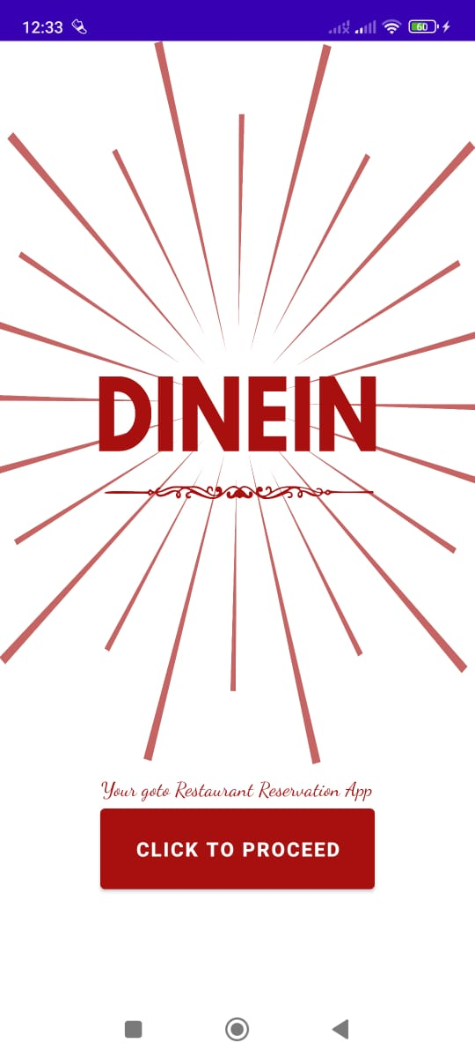

1. **Main Page**



1. **Select Restaurant Page**

The user is given a list to chose from.

1. **Select Table**

The user is given 5 options to chose from.

private static final String[] *TABLE_TYPES* = {"Indoor", "Outdoor", "Window Side", "Center", "Terrace "};

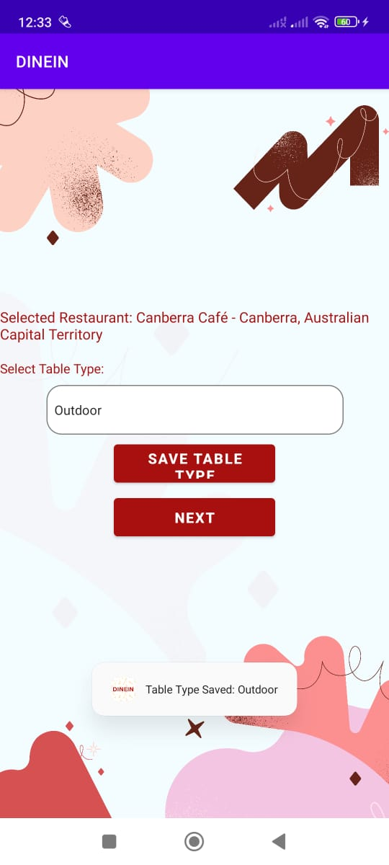 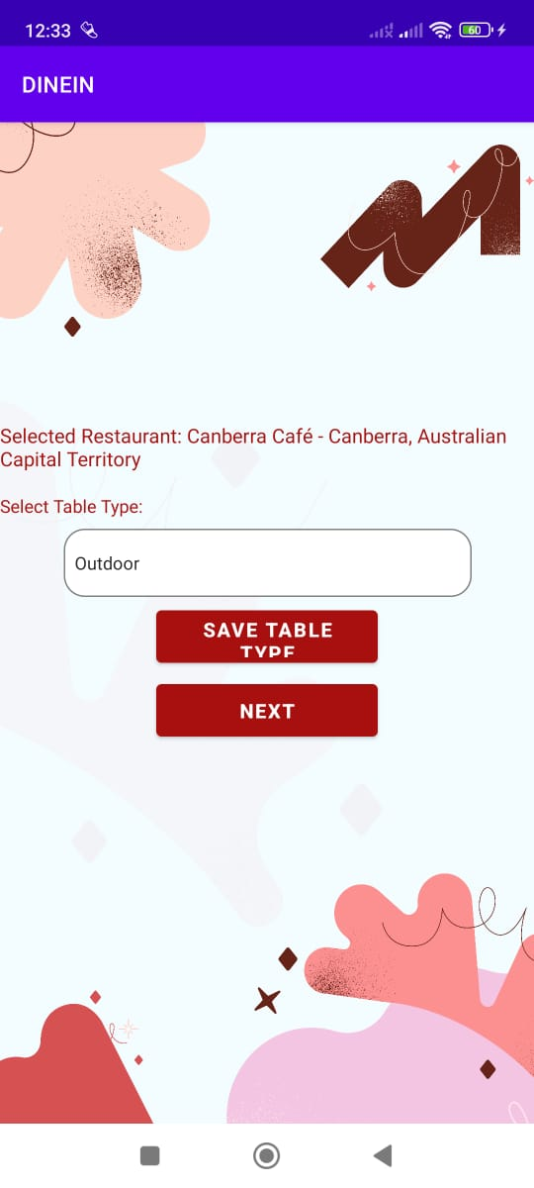

1. **Select the Date, Time, and No of People**

1. **Summary Display**

**Summary**

DineIn is an all-in-one reservation application for restaurants intended to enable users to book restaurants with ease. Selecting a restaurant is also very easy; a list of restaurants is provided and the user can search for a restaurant by name if it is not listed. Within the process of the booking, one is required to enter certain parameters like the number of people, date, and time of the reservation. The recipe that customers get after providing the necessary booking information comprises the name and address of the restaurant, type of table, and other details of the booking.

The features that can be observed in DineIn include multi-activity transitioning, organization of data through intents, and having strict input controls to ensure proper booking details. The application also has a built-in database for storing/reserving the details of the location improving the overall experience through easy organization of dining occasions. By combining these features it is possible to have a pleasant and rather convenient experience of DineIn for guests making a dining reservation.