secret-yaml-files:

- clone into the given git repo and get ready
- After cloning check the cloned repo by ls

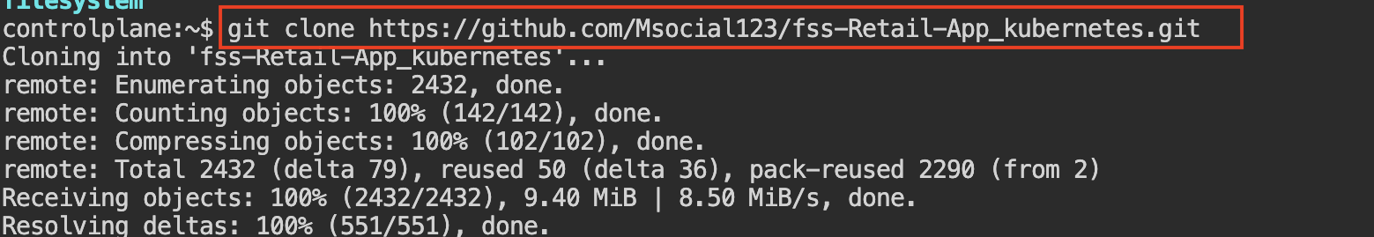
Cmd : git clone <url of git>
Then go into the directory

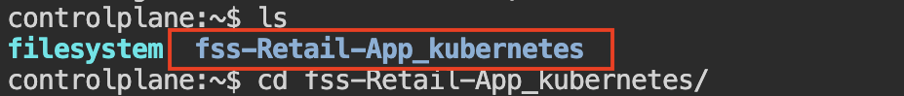
Cmd: cd <directory name>
Then ls and check for the k8-manifest directory

Cmd: ls

Then go into the k8-manifest directory

Then create a file

Cmd: vi configmap.yaml
apiVersion: v1
kind: ConfigMap
metadata:
name: retail-app-config
namespace: kiran-ns
data:
MONGODB_URI: "mongodb://mongodb:27017/myDatabase"
SESSION_SECRET: "1234"
PORT: "3130"
MONGO_INITDB_DATABASE: "myDatabase"

Then apply the file and check for the running data

Cmd: kubectl apply -f configmap.yaml (this cmd is used to apply the yaml file)
Kubectl get cm -n kiran-ns( this is cmd is used check all the data applied or not)

Change the file name and remove the data present in the file and add the new file data

Cmd: mv userprofile-deployment.yml retail-app-deployment.yaml(this cmd is used to change the name of the file)
> retail-app-deployment.yaml(this cmd is used remove the data present inside the file)
vi retail-app-deployment.yaml (this cmd is used to add the yaml file into the file)

Yaml file:
apiVersion: apps/v1
kind: Deployment
metadata:
name: retail-mongodb
namespace: murali-ns
spec:
replicas: 1
selector:
matchLabels:
app: mongodb
template:
metadata:
labels:
app: mongodb
spec:
containers:
name: mongodb
image: mongo:latest
ports:
containerPort: 27017
env:
name: MONGO_INITDB_DATABASE
valueFrom:
configMapKeyRef:
name: retail-app-config
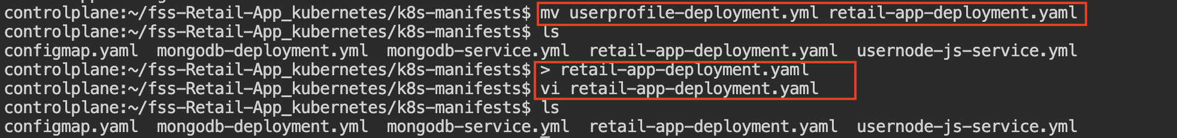
key: MONGO_INITDB_DATABASE

Change the file name and change the namespace

Cmd : mv usernode-js-service.yml retail-app-svc.yaml(this cmd is used to change the name of the file)

Change the file name and remove the data present in the file and add the new file data

Cmd :
mv mongodb-deployment.yml retail-mongodb-deployment.yaml (this cmd is used to change the name of the file)
> retail-mongodb-deployment.yaml(this cmd is used remove the data present inside the file)

vi retail-mongodb-deployment.yaml(this cmd is used to add the yaml file into the file)

Yaml file:
apiVersion: apps/v1
kind: Deployment
metadata:
name: retail-mongodb
namespace: murali-ns
spec:
replicas: 1
selector:
matchLabels:
app: mongodb
template:
metadata:
labels:
app: mongodb
spec:
containers:
- name: mongodb
image: mongo:latest
ports:
- containerPort: 27017
env:
- name: MONGO_INITDB_DATABASE
valueFrom:
configMapKeyRef:
name: retail-app-config
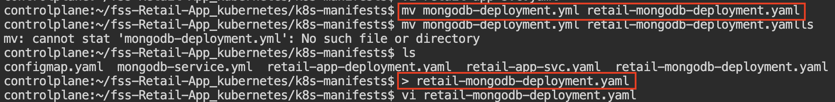
key: MONGO_INITDB_DATABASE

Change the file name and remove the data present in the file and add the new file data

Cmd: mv mongodb-service.yml retail-mongodb-svc.yaml(this cmd is used to change the name of the file)

Then apply the file and check for running data

Cmd: kubectl apply -f configmap.yaml(this cmd is used to apply the yaml file)
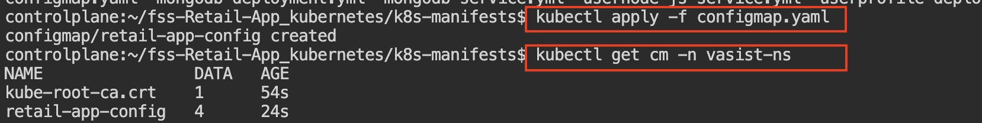
kubectl get all -n kiran-ns(used to check all the running data)

Then apply the file and check for running data

Cmd: kubectl apply -f retail-mongodb-deployment.yaml(this cmd is used to apply the yaml file)
kubectl get all -n murali-ns(this cmd is used to check all the status and data)

Then apply the file and check for running data

Cmd: kubectl apply -f retail-mongodb-svc.yaml(this cmd is used to apply the yaml file)
kubectl get all -n kiran-ns(used to get all the running status of the data)

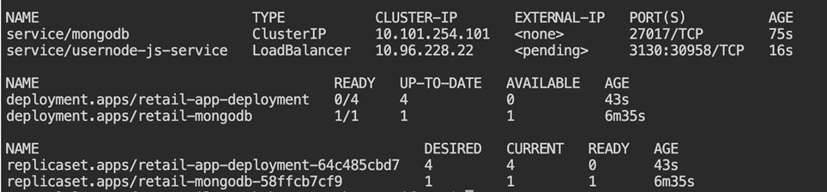

Then apply the file and check for running data

Cmd: kubectl apply -f retail-mongodb-deployment.yaml(this cmd is used to apply the yaml file)
kubectl get all -n kiran-ns(used to get all status of data and all the working report)

Then apply the file and check for running data

Cmd: kubectl apply -f retail-app-svc.yaml(this cmd is used to apply the yaml file)

kubectl get all -n kiran-ns(used to get all status of data and all the working report)

Check the status of the application:

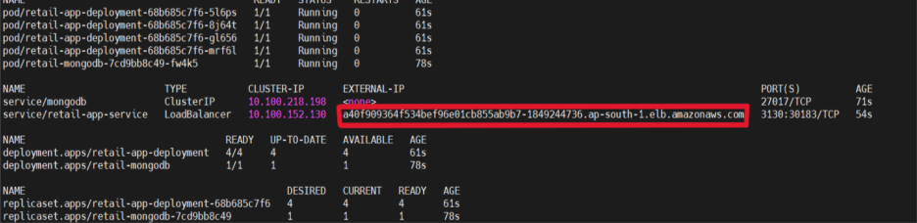

Open a Linux shell inside the MongoDB container and check files inside the container.

Cmd: kubectl exec -it retail-mongodb-7cd9bb8c49-fw4k5 -n kiran-ns -- /bin/sh
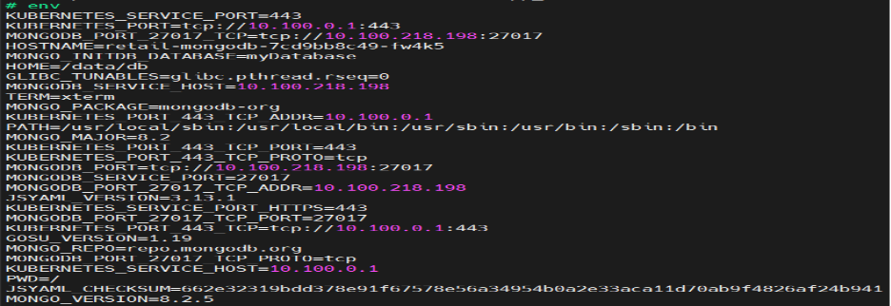

Open the MongoDB shell directly:
Cmd: kubectl exec -it retail-mongodb-7cd9bb8c49-fw4k5 -n kiran-ns – mongosh
To view ,use the databases and shows all documents in the products collection.

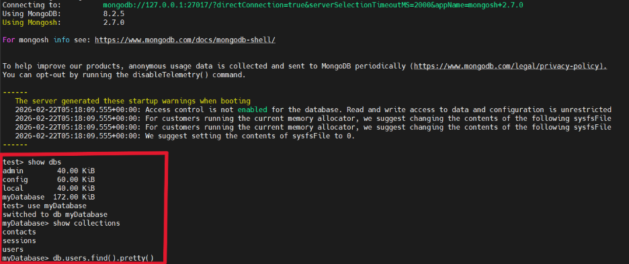
Copy the External IP and paste it in browser:
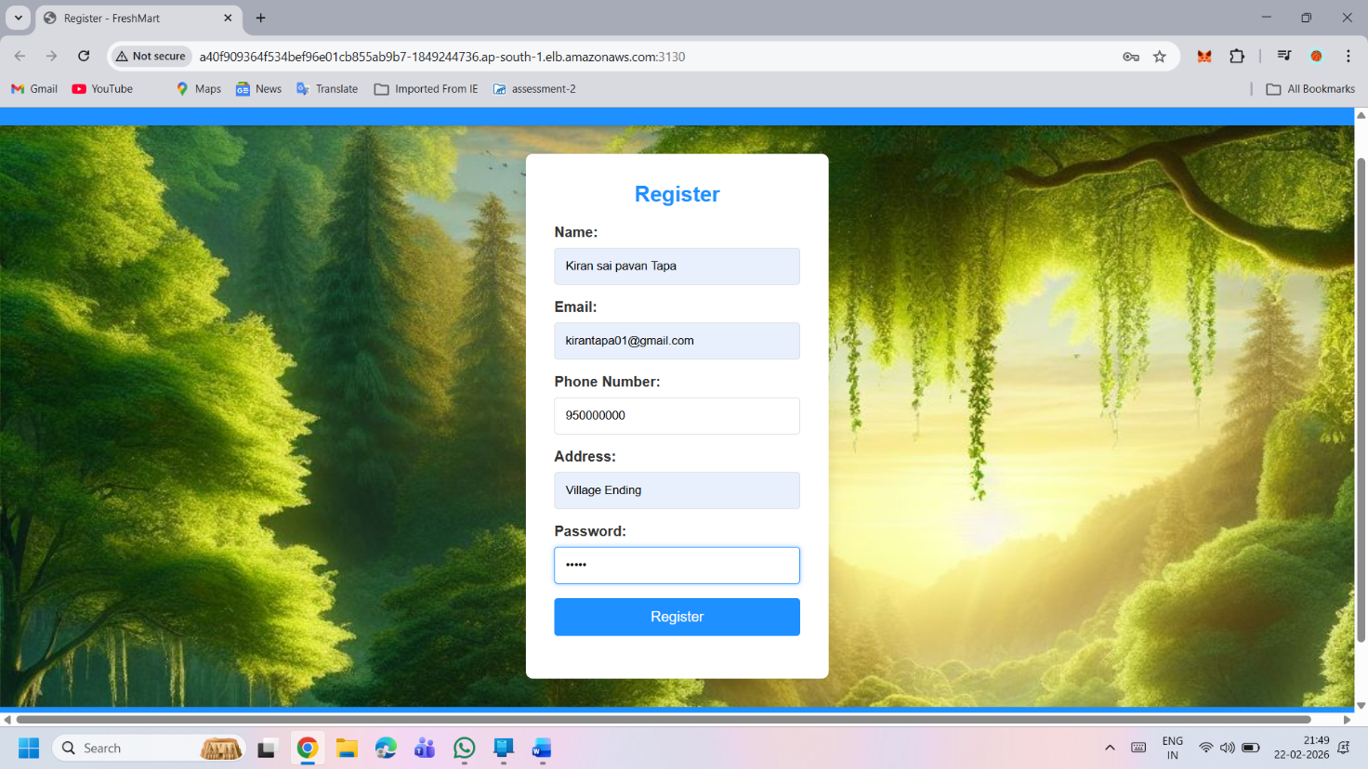
http://a40f909364f534bef96e01cb855ab9b7-1849244736.ap-south-1.elb.amazonaws.com:3130/ -It will get us to the home page.
The final site output:
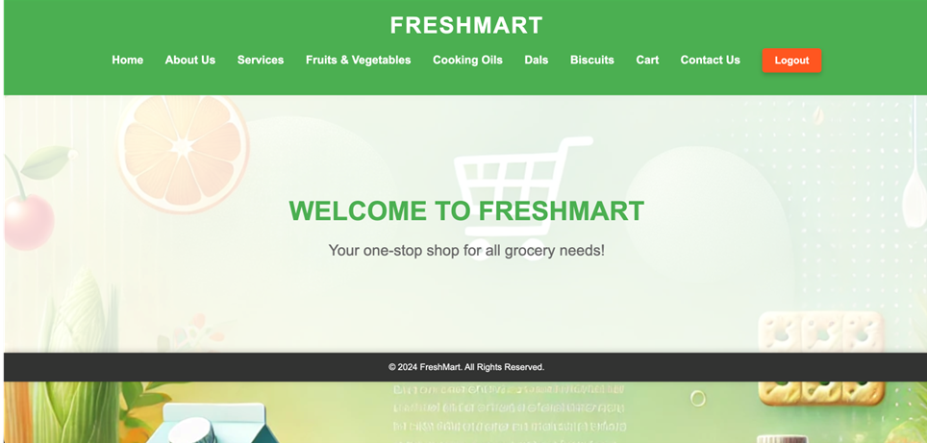
SECRET YAML FILE
A Secret is a Kubernetes object used to store sensitive data such as passwords, tokens, API keys, or certificates. The data is stored in Base64-encoded format.
echo -n 'chagantyteja2502@gmail.com' | base64
- echo -n → prints the text without adding a newline
- | → sends output to the next command
- base64 → encodes the input into Base64 format
chagantyteja2502@gmail.com

Y2hhZ2FudHl0ZWphMjUwMkBnbWFpbC5jb20=
echo -n 'yxoq bjuk rdnt alzp' | base64
yxoq bjuk rdnt alzp
eXhvcSBianVrIHJkbnQgYWx6cA==

echo -n 'Y2hhZ2FudHl0ZWphMjUwMkBnbWFpbC5jb20=' | base64 –decode
decodes the input
Y2hhZ2FudHl0ZWphMjUwMkBnbWFpbC5jb20=

chagantyteja2502@gmail.com

- Vi secret.yaml
Create secret yaml file
apiVersion: v1
kind: Secret
metadata:
name: retail-app-secret
namespace: kiran-ns
type: Opaque
data:
EMAIL_USER: Y2hhZ2FudHl0ZWphMjUwMkBnbWFpbC5jb20=
EMAIL_PASS: eXhvcSBianVrIHJkbnQgYWx6cA==
2) kubectl apply -f secret.yaml
Apply the file:
3) kubectl get secret –n kiran-ns
- Lists all Secrets in the current namespace
- Shows secret name, type, and age

