Linux Commands – Detailed Explanation
This document provides a clear, detailed, and beginner‑friendly explanation of essential Linux commands. Each command is explained with purpose, syntax, options, examples, and common mistakes. This document is suitable for academic use, interviews, and real‑world Linux practice.

ls
Purpose:
Lists files and directories in the current or specified directory.
Syntax:
ls [options] [directory]
Common Options:
ls -l → long listing (permissions, owner, size, date)
ls -a → show hidden files
ls -h → human‑readable sizes
ls -la → detailed + hidden files
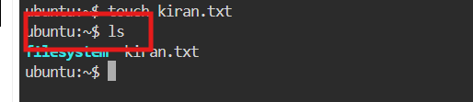
Examples:
ls
ls -l
ls /home/user
Real‑world use:
Used to verify files before editing, deleting, or copying.
Common mistake:
Assuming ls shows hidden files by default (it does not).

touch
Purpose:
Creates an empty file or updates the timestamp of an existing file.
Syntax:
touch filename
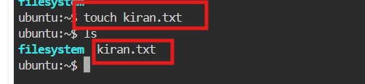
Examples:
touch file.txt
touch a.txt b.txt
Real‑world use:
Creating placeholder files, logs, or test files.
Common mistake:
Expecting touch to add content (it does not).

cat
Purpose:
Displays file content, concatenates files, or creates files.
Syntax:
cat filename

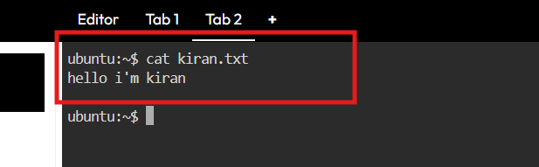
Examples:
cat file.txt
cat a.txt b.txt
cat > newfile.txt
Real‑world use:
Quickly viewing configuration or small text files.
Common mistake:
Using cat on very large files (use less instead).

nano
Purpose:
Simple terminal‑based text editor (beginner‑friendly).
Syntax:
nano filename
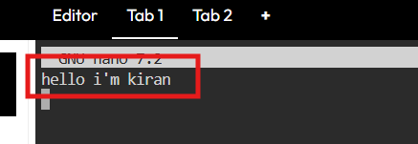

Important shortcuts:
CTRL + O → Save
CTRL + X → Exit
CTRL + K → Cut line
CTRL + U → Paste
Real‑world use:
Editing config files safely when learning Linux.
Limitation:
Not always available on minimal servers.

vi
Purpose:
Powerful, modal text editor available on all Linux systems.
Syntax:
vi filename

Modes:
Normal mode → navigation & commands
Insert mode → typing text
Command mode → saving and quitting
Key commands:
i → insert mode
ESC → normal mode
:w → save
:q → quit
:wq → save and quit
:q! → force quit
Real‑world use:
Editing files on remote servers and recovery environments.
Common mistake:
Forgetting to exit insert mode before saving.

rm
Purpose:
Deletes files and directories.
Syntax:
rm file
rm -r directory
rm -rf directory
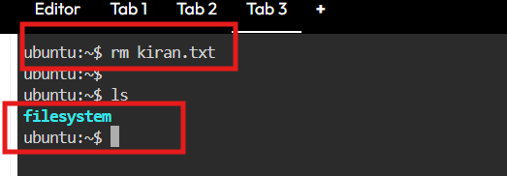
Examples:
rm file.txt
rm -r folder
Warning:
rm is permanent. Deleted files cannot be recovered easily.
Real‑world use:
Cleaning unused files, logs, or directories.
Common mistake:
Using rm -rf without checking the path.

mv
Purpose:
Moves or renames files and directories.
Syntax:
mv source destination
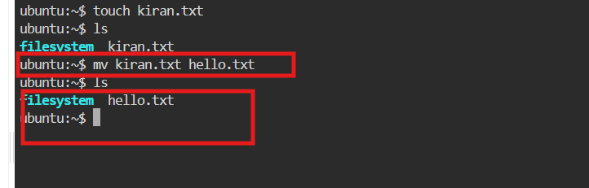
Examples:
mv old.txt new.txt
mv file.txt /home/user/
Real‑world use:
Renaming files, organizing directories.
Common mistake:
Overwriting files unintentionally.

rmdir
Purpose:
Deletes empty directories only.
Syntax:
rmdir directory
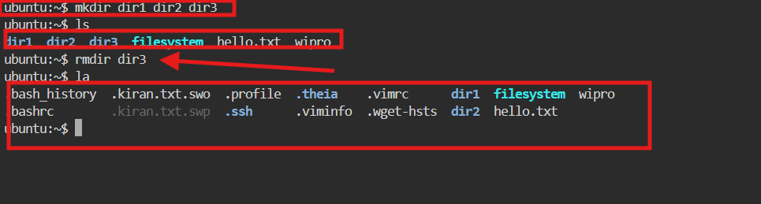
Example:
rmdir testfolder
Limitation:
Will not delete directories containing files.
Real‑world use:
Removing unused empty folders safely.

wget
Purpose:
Downloads files from the internet via terminal.
Syntax:
wget URL
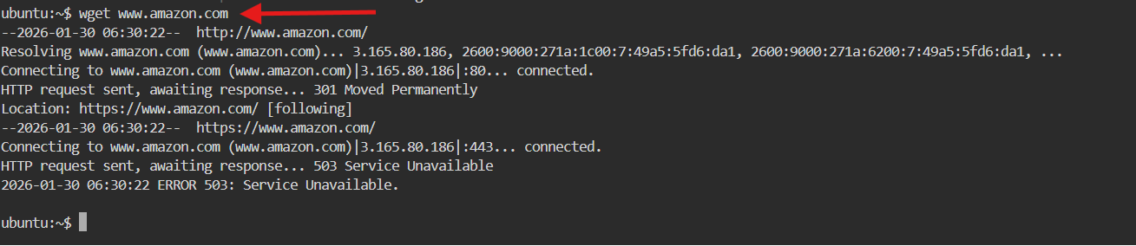
Examples:
wget https://example.com/file.zip
Options:
wget -c → resume download
wget -O name → save with different name
Real‑world use:
Downloading software, datasets, backups.
Common mistake:
Confusing wget with browser downloads.

ping
Purpose:
Checks network connectivity between your system and another host.
Syntax:
ping hostname

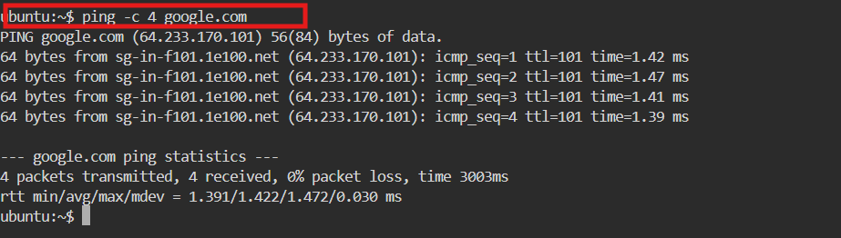
Examples:
ping google.com
Details:
Shows latency and packet loss.
Real‑world use:
Network troubleshooting.
Common mistake:
Assuming ping failure always means internet is down.

