LINUX COMMANDS – PART_II

1. GREP Command (Global Regular Expression Print)
The grep command is a powerful Linux utility used to search for specific words or patterns inside files. It scans files line by line and prints lines that match the given pattern. Grep is extensively used by system administrators and developers for log analysis, debugging, configuration verification, and monitoring system activity.

1.1 Syntax
grep "word" filename
This syntax searches for the specified word in the given file and displays all matching lines.

1.2 Important grep Options
grep "word" filename
Searches for a word in a file.
grep -n "word" filename
Displays matching lines along with line numbers, which helps in locating exact positions.
grep -c "word" filename
Counts the total number of occurrences of the word in the file.
grep -i "word" filename
Performs a case-insensitive search.

2. User Management Commands
Linux is a multi-user operating system. User management commands allow administrators to control access to the system while maintaining security and accountability.

2.1 Viewing Users
cat /etc/passwd or getent passwd
These commands list all user accounts on the system. The /etc/passwd file stores essential user details such as username, UID, GID, home directory, and default shell.

2.2 Adding Users
useradd username
Creates a new user account. When a user is added, a home directory is created under /home and a group with the same name is also created.

2.3 Setting Passwords
passwd username
Assigns or changes the password for a user. This step is mandatory before the user can log in.

2.4 Switching Users
su - username
Switches to another user account and loads the complete environment of that user.

2.5 Deleting Users
userdel username
Deletes a user account but keeps the home directory.
userdel -r username
Deletes the user account along with the home directory and associated files.

2.6 Creating Users Without Home Directory
useradd -M username
Creates a user account without a home directory. This is typically used for system or service accounts.

3. Permission and Ownership Commands
Linux enforces file security using permissions and ownership. These commands control who can access or modify files and directories.

3.1 Ownership Commands
chown username filename
Changes the owner of a file.
chgrp groupname filename
Changes the group ownership of a file.
chown username:groupname filename
Changes both owner and group at the same time.

3.2 Directory Ownership
chown username:groupname folder
Changes ownership of a directory.
chown -R username:groupname folder
Recursively changes ownership of a directory and all its contents.
chown username:groupname folder/*
Changes ownership of files inside the folder only.

3.3 Permission Modification
chmod 777 filename
Grants full permissions to everyone. This command should be avoided in production environments due to security risks.
Proper permission management is critical for maintaining system security and preventing unauthorized access.

4. Directory Navigation Commands (cd)
The cd (change directory) command is used to navigate between directories in the Linux file system. Directory navigation is fundamental to working efficiently in Linux, as most operations depend on the current working directory.

4.1 Basic Directory Navigation
cd foldername
Changes the current working directory to the specified folder.
cd
Moves the user to the root directory.
cd -
Switches back to the previous directory. This is useful when toggling between two directories.

4.2 Relative Directory Navigation
cd ..
Moves one directory level up from the current directory.
cd ../..
Moves two directory levels up from the current directory.
Understanding absolute and relative paths is essential for efficient navigation and scripting.

5. Date and Time Command (date)
The date command is used to display and manipulate the system date and time. It is commonly used in shell scripts, logging mechanisms, and automation tasks.

5.1 Date Formatting Options
date +"%d"
Displays the day of the month (01–31).
date +"%m"
Displays the month of the year (01–12).
date +"%y"
Displays the last two digits of the year.
date +"%H"
Displays the hour in 24-hour format (00–23).
date +"%M"
Displays the current minute (00–59).
date +"%S"
Displays the current seconds count (00–60).

5.2 Common Date Formats
date +"%D"
Displays the date in MM/DD/YY format.
date +"%F"
Displays the full date in YYYY-MM-DD format.
date +"%A"
Displays the day of the week (Monday–Sunday).
date +"%B"
Displays the full month name (January–December).
The date command is especially important in automation scripts where timestamps are required for logs, backups, and reports.

Command Examples – Terminal Screenshots

cd Command Example
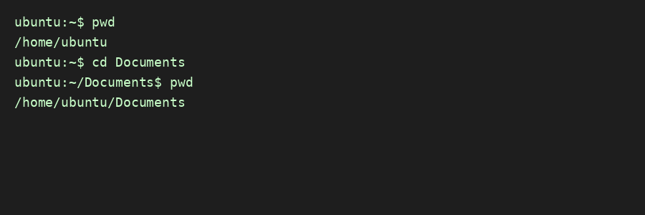

date Command Example
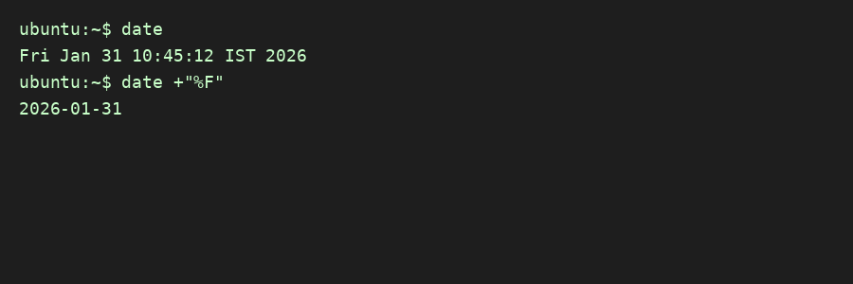

grep Command Example
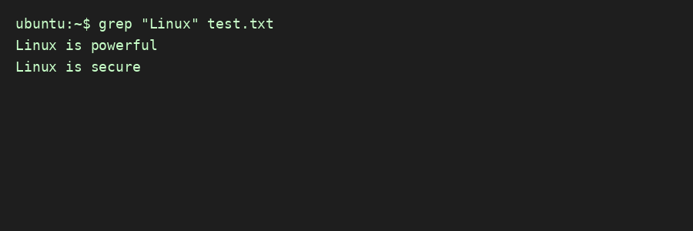

chmod Command Example
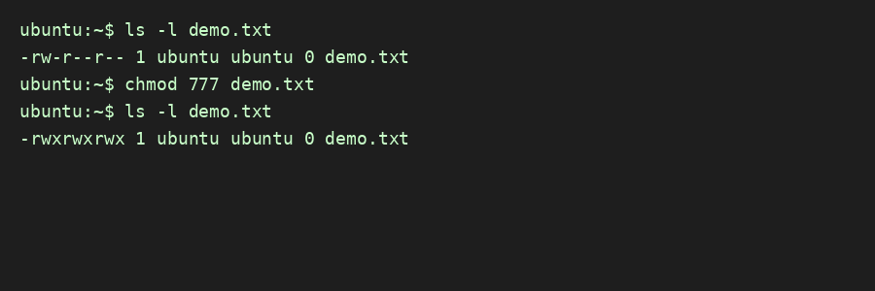

Figure: cd command output

Figure: date command output

Figure: grep command output

Figure: chmod command output

Additional Terminal Screenshots

cd – previous directory example
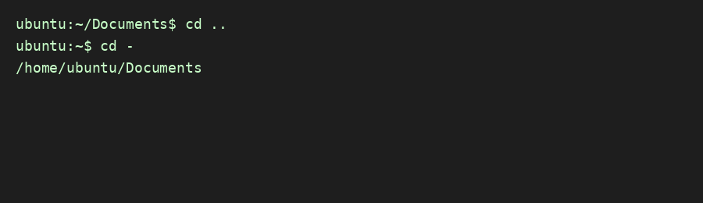
Figure: cd – previous directory example

date – formatted output example
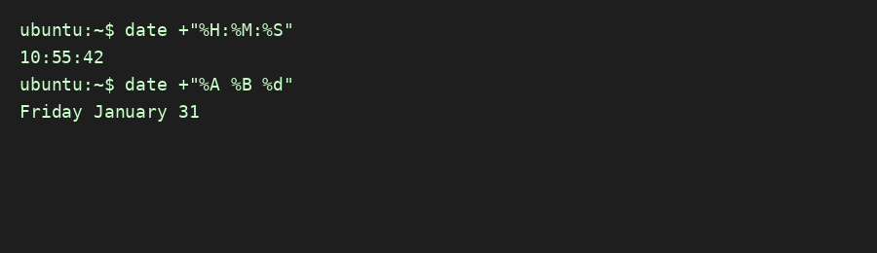
Figure: date – formatted output example

grep – line number example
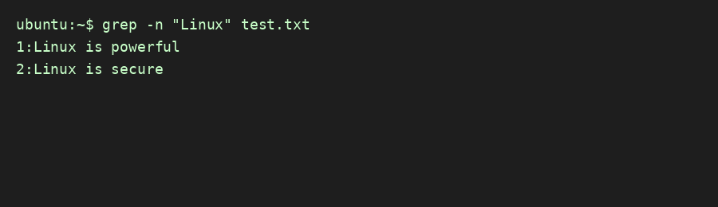
Figure: grep – line number example

chmod – symbolic mode example
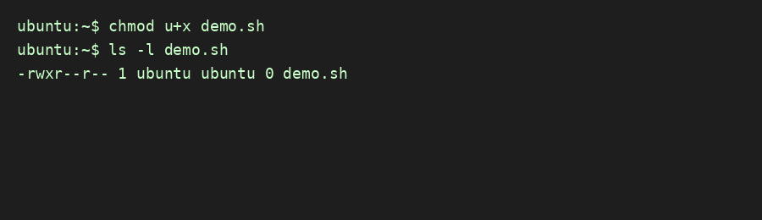
Figure: chmod – symbolic mode example

