**COSC2299 Software Engineering: Processes & Tools**

Software Requirement Specifications

BrokieHub

**Group P3 Number 8**

**GitHub Repository:** [**https://github.com/cosc2299-sept-2023/team-project-group-p03-08**](https://github.com/cosc2299-sept-2023/team-project-group-p03-08)

|  |  |  |
| --- | --- | --- |
| **Name** | **Student ID** | **Contribution** |
| Kiran Kulkarni | s3943716 | 16.67% |
| Jamie Truong | s3947728 | 16.67% |
| Peter Fulton | s3896790 | 16.67% |
| Andy Chen | s3935474 | 16.67% |
| Benjamin Nippard | s3945124 | 16.67% |
| Tyler Humbert | s3947682 | 16.67% |

**Table of Contents**

Introduction 2

Purpose 3

Stakeholders 3

Functional Requirements 3

Non-Functional Requirements 4

Key Features 4

User Stories 4

System Architecture 10

Structure Overview 11

User Interface 11

UI Design 11

Wireframes 11

12

Design Choices 14

Testing – Testing Plan 14

Unit Testing 15

Sprint 1 – Tests 15

Products 15

Deliveries 15

Notifications 15

Carts 15

Integration Testing 16

System Testing - Acceptance Criteria 16

Product Backlog 16

Sprint 1 and 2 17

Estimated Backlog – Sprint 1 17

Estimated Backlog – Sprint 2 17

Actual Backlog – Sprint 1 17

Sprint 0 Retrospective 18

Sprint 1 Retrospective 18

Introduction

## Purpose

SuperPrice is a web application for comparing grocery items between different stores. The website aims to streamline the shopping experience to make it more pleasant for shoppers. By removing the need for them to navigate several websites to search for the lowest price on the same product. The website will also be beneficial for storeowners (assuming they offer the lowest price) as it will bring customers to purchase their products.

It would achieve this by interpreting data from an assortment of databases and presenting the item the user desires at a given location for a price, along with any discounts or deals. The data received from the databases for any given item would be presented nicely in a web page. This web page would also include a suggested display for identical products with pricing from other store locations, along with a graph to display the historical pricing of a given item.

## Stakeholders

The client is a key stakeholder, being the person who commissioned us for this work and thus is the most invested in the success of the project. He will be the primary representative of the customer base we are developing the project for, but not necessarily the only customer we design for. As such, the client will be working closely alongside us and integrated with the development process as part of the Agile methodology.

Another stakeholder is the developers working on the product, who are directly responsible for the outcome of the project. The project will be developed under the Agile methodology and as such the team must keep up with the workload to see a successful project.

An external stakeholder that can affect the success of the project is the supermarkets from whom the developers will be sourcing the data from. The reliability and accessibility of any database APIs or other methods of sourcing data will directly influence the reliability of our project and as such, any major hinderances is liable to also cause issues in the project’s development cycle.

# Functional Requirements

* **Compare Different Prices**: Enable users to simultaneously view and contrast the prices of multiple products.
* **Order a Delivery**: Allow users to schedule the delivery of all items in their cart seamlessly.
* **Notifications**: Implement a system that sends various notifications to users as needed.
* **Product Search**: Facilitate the search for specific items through an efficient and effective search function.
* **Categorizing Products**: Provide the ability for users to filter items by category, enhancing discoverability.
* **Login System**: Implement a secure user account creation process for purchasing items.
* **Search Filters**: Include search filters to aid users in narrowing down product selections.
* **Pricing History**: Enable users to view the historical pricing data of products.

# Non-Functional Requirements

* **Legal (Security)**: Ensure compliance with relevant legal regulations to maintain security and privacy.
* **Alcohol Age Limit (Security)**: Implement age verification for purchasing age-restricted products.
* **Font Size (Usability)**: Allow users to adjust the font size on the webpage for readability.
* **Website Navigation (Usability)**: Design the website to enable easy navigation and price comparison.
* **24/7 Availability (Reliability)**: The website should be accessible for use 24 hours a day.
* **Themes (Usability)**: Incorporate customizable themes to enhance the user experience.

Key Features

o Product Search and Categorization: The application will provide a comprehensive search feature, allowing users to find specific products or browse through various categories. This functionality will ensure a smooth and hassle-free shopping experience.

o Price Comparison: The SuperPrice application will enable users to search for specific products and instantly compare prices across different supermarkets in the area. Users can easily identify the store offering the lowest price for their desired items.

o Delivery Organization: SuperPrice will facilitate the organization of deliveries for users who wish to have their groceries brought to their doorstep. The application will offer multiple delivery options, including time slots to ensure flexibility and convenience.

o Notifications and Alerts: The application will provide timely notifications and alerts to keep users informed about price drops or exclusive offers. This feature will ensure that users never miss great deals.

o User-Friendly Interface: SuperPrice will boast a user-friendly and intuitive interface, making it accessible to a wide range of users. The application will prioritize simplicity and ease of use, ensuring a seamless experience for both novice and experienced shoppers.

# User Stories

|  |  |  |  |
| --- | --- | --- | --- |
| **Story #1:** | **Price Comparison** | **Priority** | High |
| **Effort** | 10/10 |
| As a | Customer | | |
| I want | To compare prices between multiple stores | | |
| So that | I can choose the lowest price in a store near me | | |
| Acceptance criteria | Scenario: customer comparing prices for a product with comparisons   * Given I am a customer * When I click to view price comparisons of a product * Then the system will return a results page of stores with similar or lower prices   Scenario: customer comparing prices for a product without comparisons   * Given I am a customer * When I click to view price comparisons of a product * Then the system will return a page without price comparisons for this product | | |

|  |  |  |  |
| --- | --- | --- | --- |
| **Story #2:** | **Delivery** | **Priority** | High |
| **Effort** | 9/10 |
| As a | Full-time worker or student | | |
| I want | To be able to order my groceries online for delivery | | |
| So that I can | Save the time and effort from having to physically go to the store. | | |
| Acceptance criteria | Scenario: full-time worker or student ordering groceries for delivery   * Given I am a full-time worker or student, * When I click on the ‘Delivery’ option after adding items to my cart, * Then the system will send a notification confirming delivery   Scenario: Customer orders groceries for delivery and enters invalid address   * Given I am a full-time worker or student, * When I click on the ‘Delivery’ option after adding items to my cart, * Then the system will prompt me for a correct delivery address | | |

|  |  |  |  |
| --- | --- | --- | --- |
| **Story #3:** | **Notifications** | **Priority** | High |
| **Effort** | 9/10 |
| As a | Mother | | |
| I want | To be notified of the best deals and price changes | | |
| So that I can | Be informed of making the best decisions that cut costs for my household | | |
| Acceptance Criteria | Scenario: Mother wants to be notified of the best deals   * Given I have chosen for deal notifications * When businesses add new deals to their websites * Then the system will send a notification alerting of the new deals available.   Scenario: Mother wants to be notified of the price of a specific product   * Given I have clicked the notifications button on a product page * When the price changes for this product * Then the system will send a notification alerting of the price change | | |

|  |  |  |  |
| --- | --- | --- | --- |
| **Story #4:** | **Simple Search Bar** | **Priority** | High |
| **Effort** | 8/10 |
| As a | New user | | |
| I want | To be able to search for products in a quick and easy manner | | |
| So that I can | Have a seamless shopping experience despite not having used the system before. | | |
| Acceptance Criteria | Scenario: User searches for a product by key terms   * Given I have entered the key terms for my search * When I click the search option * Then all items matching key terms will appear   Scenario: User searchers for all products   * Given I have entered no terms in the search bar * When I click the search option * Then all items will appear   Scenario: User search returns no products   * Given I have entered the key terms for my search * When I click the search option * and no products match those terms * Then the website displays a message about no matching items | | |

|  |  |  |  |
| --- | --- | --- | --- |
| **Story #5:** | **Navigation** | **Priority** | High |
| **Effort** | 8/10 |
| As a | New user | | |
| I want | To be able to navigate through the website easily | | |
| So that I can | Have a seamless shopping experience despite not having used the system before. | | |
| Acceptance Criteria | Scenario: A new user is navigating our website for the first time   * Given I am a new user on the website * When I look around the website * Then I want to able to figure out what each button/link will do | | |

|  |  |  |  |
| --- | --- | --- | --- |
| **Story #6:** | **Categorisation** | **Priority** | High |
| **Effort** | 8/10 |
| As a | Browsing shopper | | |
| I want | I want products to exist under a category | | |
| So that I can | Find the exact products I am looking for by category if I am unsure of what the product is | | |
| Acceptance Criteria | Scenario: Customer who is unsure of what exactly they want to search for products   * Given I have selected/searched for the category of products I want * When I hit the search button * Then I want to find products under that category * And find the product I am looking for * And find products like what I may be looking for | | |

|  |  |  |  |
| --- | --- | --- | --- |
| **Story #7:** | **Search Filter** | **Priority** | High |
| **Effort** | 7/10 |
| As a | Customer | | |
| I want | To filter for certain stores in my search | | |
| So that | I can only see the prices relevant to me | | |
| Acceptance criteria | Scenario: Customer wants to filter out groceries too far away   * Given the customer is on the map feature to search for grocers offering prices * When the customer filters for only grocers within 5km of location * Then the map should only display grocers within a 5km radius   Scenario: Customer wants to filter groceries by a specific feature (e.g. Vegetarian or Gluten Free)   * Given the customer has selected their desired feature * When the customer selects the filter button * Then all items are filtered to match their filters | | |

|  |  |  |  |
| --- | --- | --- | --- |
| **Story #8:** | **Historical Pricing** | **Priority** | Medium |
| **Effort** | 6/10 |
| As a | Customer | | |
| I want | To preview historical pricing | | |
| So that | I can purchase items when they are at a lower price | | |
| Acceptance criteria | Scenario: Customer opens item with historical pricing   * Given I am a customer * When I click onto an item * Then I see the current price * and I see a list of previous prices and specials   Scenario: Customer opens item without historical pricing   * Given I am a customer * When I click onto an item * Then I see the current price * And a message that historical pricing is unavailable | | |

|  |  |  |  |
| --- | --- | --- | --- |
| **Story #9:** | **Login** | **Priority** | Low |
| **Effort** | 2/10 |
| As a | Returning user | | |
| I want | Be able to login to my account | | |
| So that | I can track access my account | | |
| Acceptance criteria | Scenario: customer logging on correctly   * Given I have an account * When I go to login * And enter my correct details * Then I can sign into my account   Scenario: customer logging on incorrectly   * Given I have an account * When I go to login * And enter incorrect details * Then I am prompted that entry was incorrect and offered to reset password   Scenario: customer logging on without account   * Given I do not have an account * When I go to login * Then I am presented with the option to create an account | | |

|  |  |  |  |
| --- | --- | --- | --- |
| **Story #10:** | **Different lighting themes** | **Priority** | Medium |
| **Effort** | 5/10 |
| As a | Customer | | |
| I want | Be able to change the lighting of the website | | |
| So that | I do not strain my eyesight whilst using the website | | |
| Acceptance criteria | Scenario: customer changing light themes   * Given I am logged in to the website * When I go to the settings * Then I can change the lighting theme of the webpage | | |

|  |  |  |  |
| --- | --- | --- | --- |
| **Story #11:** | **Track Deliveries** | **Priority** | Low |
| **Effort** | 4/10 |
| As a | Logged In User | | |
| I want | To be able to track my current deliveries | | |
| So that | I can view when my purchases will arrive. | | |
| Acceptance criteria | Scenario: Customer track delivers   * Given I have logged into my account * When I click on track delivers * Then I can see my current deliveries * And I can see how long they take till delivery | | |

|  |  |  |  |
| --- | --- | --- | --- |
| **Story #12:** | **Create account** | **Priority** | Low |
| **Effort** | 3/10 |
| As a | new user | | |
| I want | To be able to create an account | | |
| So that | I can track and save my shopping history | | |
| Acceptance criteria | Scenario: customer opens create account page   * Given I am a new user * When I press the create account button * Then I am given a page to input my details   Scenario: customer inputs details and creates an account   * Given I am on the create account page * and I have input my details * When I press the create account button * Then an account is generated for me | | |

|  |  |  |  |
| --- | --- | --- | --- |
| **Story #13:** | **Recover password** | **Priority** | Low |
| **Effort** | 3/10 |
| As a | Account holder | | |
| I want | To be able to recover my password | | |
| So that | I can access my account if I forget my password | | |
| Acceptance criteria | Scenario: A user has forgotten their password   * Given I have an account and I have forgotten the password * When I press the forgot password button * Then I am sent a recovery email   Scenario: User opens their recovery email   * Given I have clicked on the link in the recovery email * When I enter my new password * Then my password is updated | | |

|  |  |  |  |
| --- | --- | --- | --- |
| **Story #14:** | **Add item to Shopping cart** | **Priority** | Medium |
| **Effort** | 6/10 |
| As a | Account holder | | |
| I want | To be able to store items I want to purchase in a cart | | |
| So that | I can order multiple items simultaneously | | |
| Acceptance criteria | Scenario: User has found a product and wishes to add it to their cart   * Given I have chosen an item * When I add an item to my cart * Then the item I added will appear within it * and cart price updates   Scenario: User has found a product and wishes to add multiple to their cart   * Given I have chosen an item * Given I have selected my quantity * When I add the item to my cart * Then selected quantity will be added to my cart * and cart price updates | | |

|  |  |  |  |
| --- | --- | --- | --- |
| **Story #15:** | **Remove item from Shopping cart** | **Priority** | Medium |
| **Effort** | 6/10 |
| As a | Account holder | | |
| I want | To be able to remove items I have in my shopping cart | | |
| So that | I can remove accidental additions to it | | |
| Acceptance criteria | Scenario: A user has an item they wish to remove from their cart   * Given I have an item in my shopping cart * When I select to remove an item from my shopping cart * Then the item I selected will be removed * and the shopping cart price is updated | | |

|  |  |  |  |
| --- | --- | --- | --- |
| **Story #16:** | **Browsing** | **Priority** | Medium |
| **Effort** | 4/10 |
| As a | user | | |
| I want | To be able to view item prices | | |
| So that | I can decide whether I want to use this website | | |
| Acceptance criteria | Scenario: A user with an account wishes to view an item's price   * Given I am logged into an account * When I navigate the site * and find an item I like * Click on said item * Then I can see the price of said item   Scenario: A user without an account wishes to view an item's price   * Given I am not logged into an account * When I navigate the site * and find an item I like * Click on said item * Then I can see the price of said item | | |

|  |  |  |  |
| --- | --- | --- | --- |
| **Story #17:** | **View Item** | **Priority** | High |
| **Effort** | 6/10 |
| As a | User | | |
| I want | To view the details of an item | | |
| So that | I can decide if I want to purchase it | | |
| Acceptance criteria | Scenario: A user has found an item they what to learn about   * Given I have found an item * When I click on an item * Then I see the details of the item * And have the option to add to cart | | |

|  |  |  |  |
| --- | --- | --- | --- |
| **Story #18:** | **View Cart** | **Priority** | High |
| **Effort** | 8/10 |
| As a | User who is shopping | | |
| I want | View items in my cart | | |
| So that | Know what I am planning to buy | | |
| Acceptance criteria | Scenario: User opens their shopping cart with items   * Given I have items in the shopping cart * When I click on the shopping cart * Then I can see the items in the cart   Scenario: User opens their shopping cart without items   * Given I have no items in the shopping cart * When I click on the shopping cart * Then I am prompted with a message that shopping cart is empty | | |

|  |  |  |  |
| --- | --- | --- | --- |
| **Story #19:** | **Change Cart Quantity** | **Priority** | Med |
| **Effort** | 6/10 |
| As a | customer | | |
| I want | To adjust the quantity of items in my cart | | |
| So that | I can order the correct amount of items | | |
| Acceptance criteria | Scenario: User has items in their cart and wishes to reduce the quantity   * Given I have an item in my cart * When I reduce the quantity * and I hit save * Then the quantity is decreased * And the cart price is updated   Scenario: User has items in their cart and wishes to increase the quantity   * Given I have an item in my cart * When I increase the quantity * and I hit save * Then the quantity is increased * And the cart price is updated | | |

|  |  |  |  |
| --- | --- | --- | --- |
| **Story #21:** | **Checkout Cart** | **Priority** | High |
| **Effort** | x/10 |
| As a | Customer | | |
| I want | To checkout my cart | | |
| So that | I can purchase items I have selected | | |
| Acceptance criteria | Scenario: Customer has a cart with items   * Given I have opened my cart * When I hit the checkout button * Then I am taken to the checkout screen   Scenario: Customer has a cart without items   * Given I have opened my empty cart * When I hit the checkout button * Then I am notified my cart is empty | | |

# System Architecture

## Structure Overview

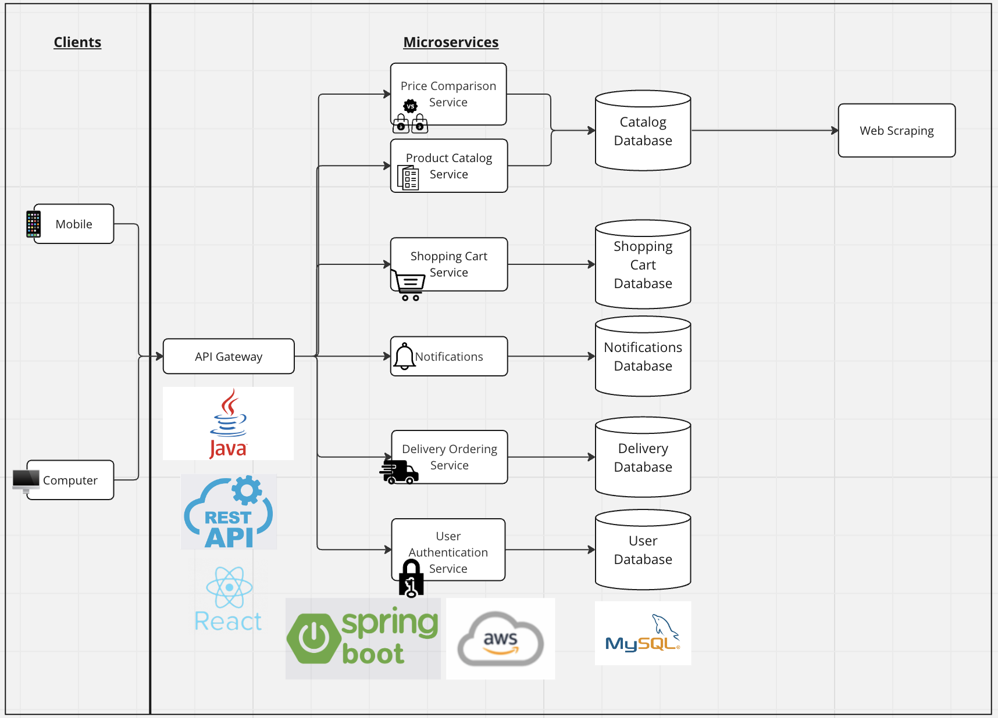

For our project we have proposed for the implementation of the microservices software architecture. In this software architecture we are able to separate the services of price comparison, product catalogue, shopping cart, notifications, delivery ordering and user authentication into their separate components linked to their respective databases (as seen in the above diagram). We have also included a connection from the product database to web scraping in order to fill the product database with products from the web. The separation of these microservices allows for easier testing, maintenance and development since services can be developed and deployed independently, largely reducing dependencies within the code.

In summary, each of the services communicate with the gateway API depending on requests made from the clients, whilst also ensuring security and availability. Then depending on queries made at a particular service by a client, data will be retrieved from the relevant database.

The technologies employed for the components of our software architecture include using React for the front-end framework, Spring Boot for the back-end framework (as per the spec) and MySQL for data storage and querying (as per the spec).

# User Interface

## UI Design

The overall design of the web application follows the philosophy of unobtrusiveness and to display the data with as much data and transparency as possible. As such, the layout of the application will simply consist of a header, and content to display depending on the webpage. This is to ensure that there can be little confusion as to where to navigate, as all our features will be primarily displayed in the header. To follow along with this simplicity, our UI will not involve any animation or fancy UI components as they could cause issues with screen readers and reduce the accessibility of the application.

In terms of style guides, our primary colours will be cornflower blue and white as they are colours that have a calming effect and fits with the goal of the application, which is to make a wise decision on purchasing products. Additionally, to be as transparent about the display of data, items will be displayed in a grid format with as text to indicate prices as it is easier to navigate different stores and items.

Lastly, we have primarily designed the UI for a desktop application, as we are restricted by the development skills and time constraints to develop the project. This means that the UI design assumes users are utilising a mouse and keyboard to navigate the website and thus relies heavily on button navigation.

## Wireframes

Homepage designs:

Two wireframes were created to prototype the landing page of the website. On the left is a mock-up of the landing page for a user who is not signed in. It will thus display the most relevant deals daily, so those who aren’t looking for any items can thus simply look at what is the determined best deals of the day.

## 

Menu Designs:

The two wireframes represent two extreme possibilities for how the menu could be designed. The left wireframe represents the simplest representation of the menu, with only a search bar, home button and favourites button that would lead to profile. The second wireframe represents a highly detailed menu version that lists several places to look as well as more information from the search.

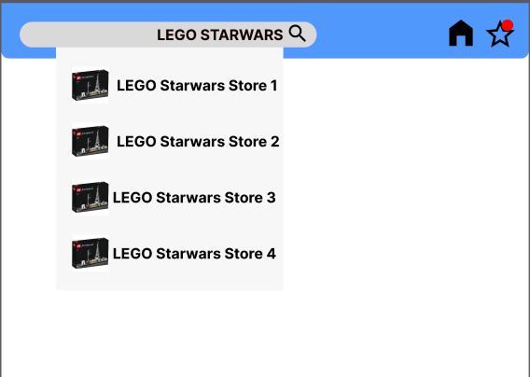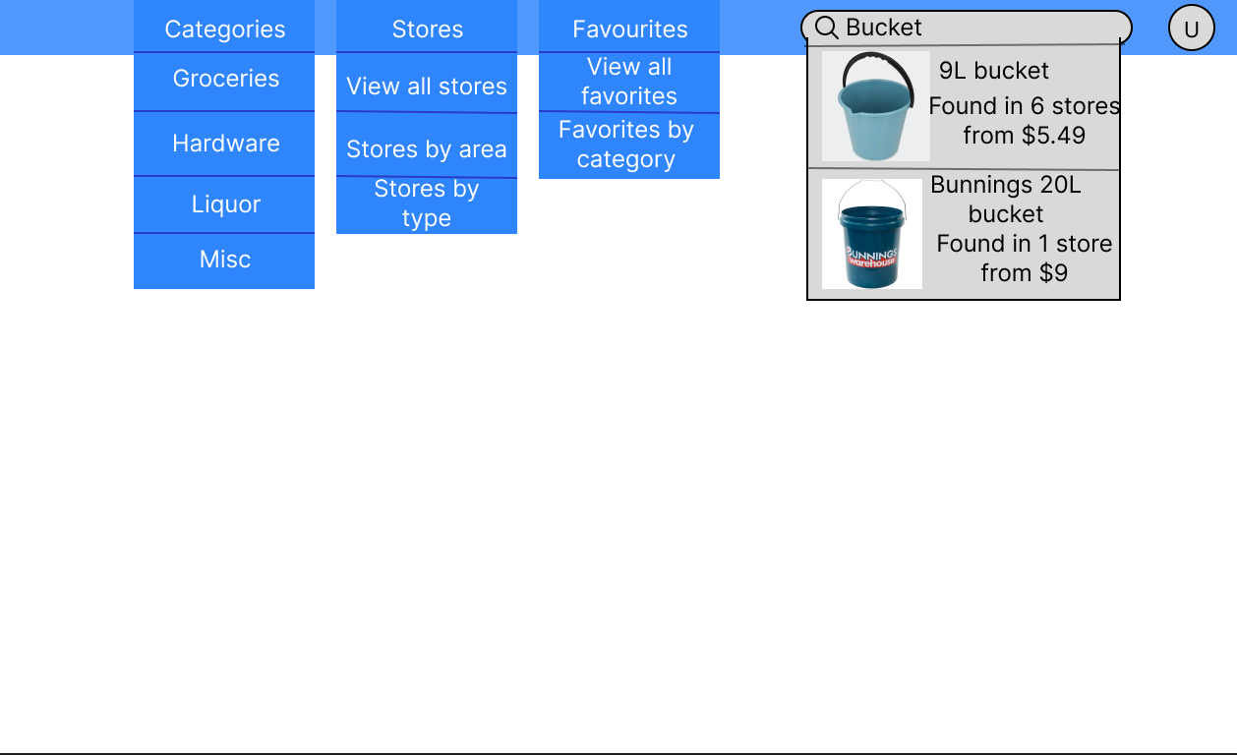

Product page designs

These two wireframes represent what the look of the product page will be displayed and is designed to show as much information as possible in a clear manner. The different prices are displayed in a grid and is made the emphasis of the page relative to the rest of the page content to emphasise the data when viewing the page.

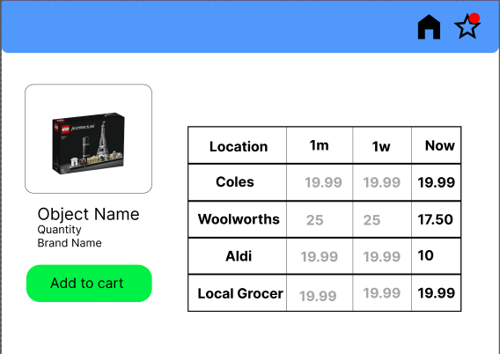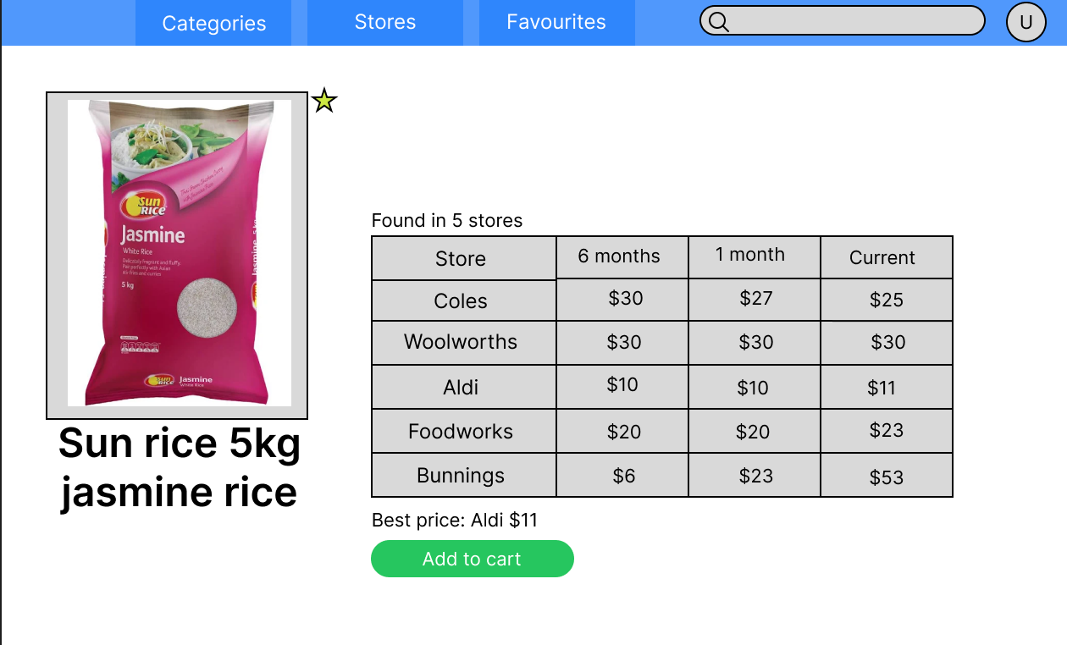

User profile design:

The profile page is intended to be used as the quick access to all the items the user has been favourited with a quick indicator of whether the price is up or down from their previously measured price. Additionally, this is where they can access settings and the logout ability.

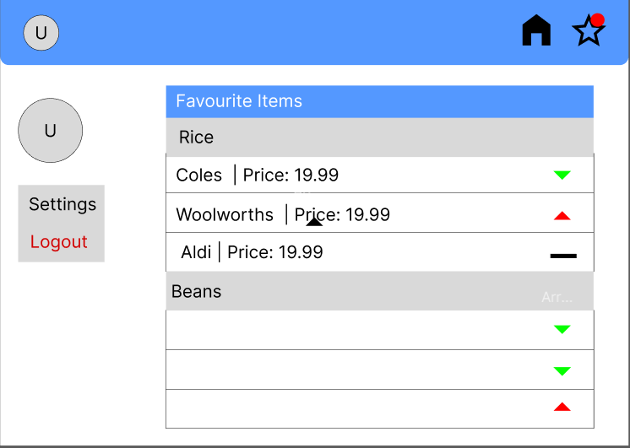

Cart menu design:

The wireframe of the cart menu design allows users to adjust the quantity of the products they’ve put in the cart. The removal components that would remove products or clear the entire cart has been highlighted in bright red to ensure that users don’t accidentally click on those without intending to.

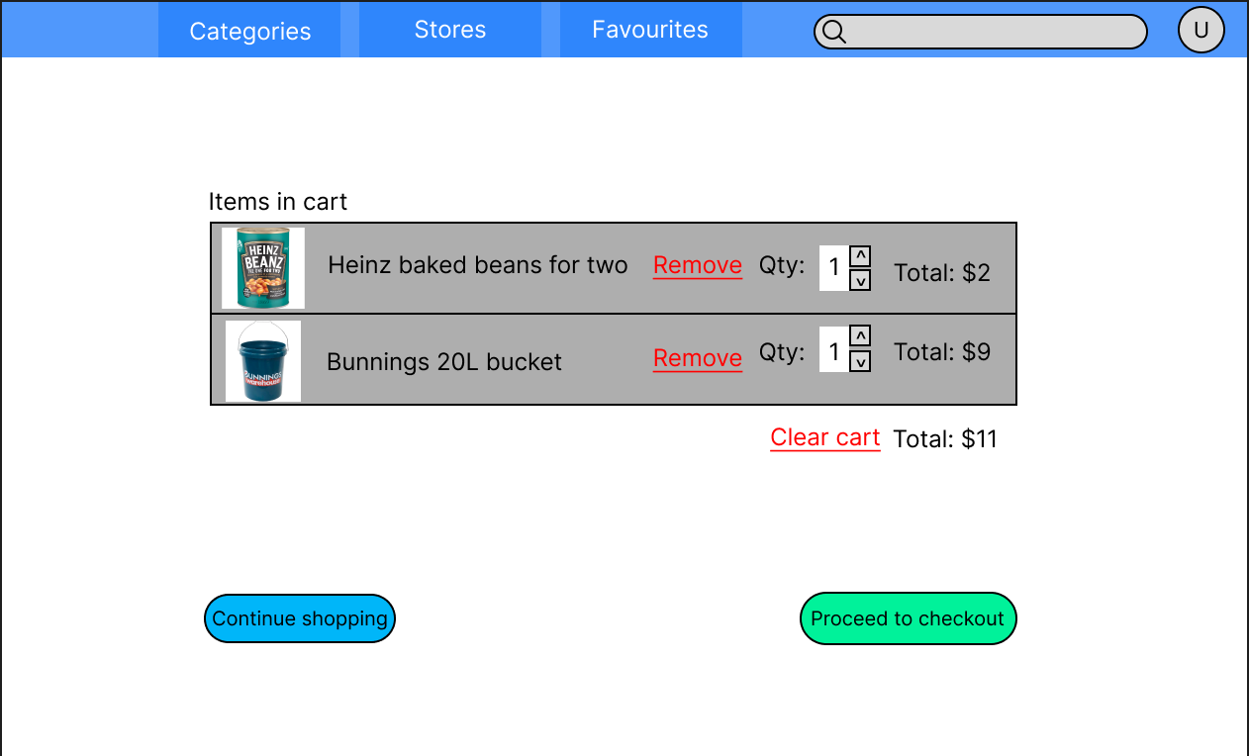

Checkout Page Design

The checkout page is orientated in a way that when reading from left to right, top to bottom, the user has a chance to double check the pricing before submitting their payment details and ordering.

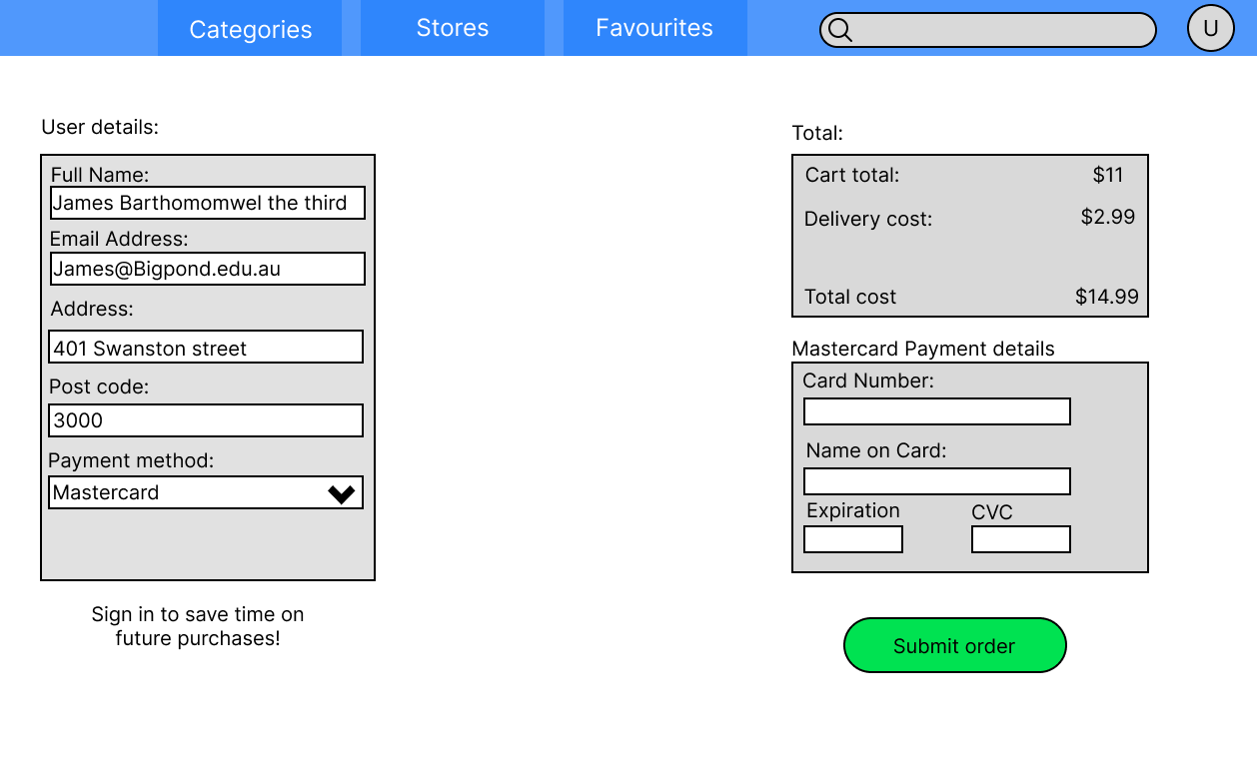

Search Results Page Design:

This wireframe clearly displays all products from the query to the customer. It also allows the user to sort and filter the results, enhancing their searching experience.

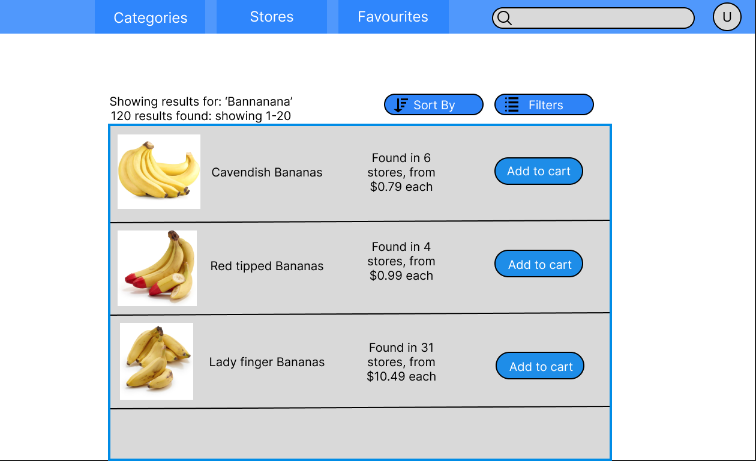

## Design Choices

Regarding development of our frontend, the decision to use the front-end framework React for development was made based on the experience levels of the development team with the front-end framework, as well as the inherent benefits of React. In comparison to other front-end frameworks, React’s usage of a virtual DOM and optimisation ensures that the loading of the website is faster.

Additionally, as the project has a deadline restriction for its development, the development team cannot afford to waste any time to learn any new frameworks and so picking a framework that is familiar helps speed up the development of the project.

One major UI design choice was abandoning the icon-based navigation in favour of words in the navigation bar as any accessibility tools such as screen-readers may struggle to read what the icon is and that words makes it easier to discern what the toolbar is over an image which can be interpreted differently based on the user.



Figure 1 Original Icon Chosen

Figure 2 The Icon Chosen

Another major UI design choice that was absent from the wireframes is the business logo and website title that is prominently displayed on the landing page. The logo was sourced from flaticon.com and chosen for its simplicity in design and contrasting with the shade of blue we chose to use as our main colour. Initially we intended to go with an alternative neon colour version of the icon, but it proved very difficult to display along with the shade of blue as well as not fitting with the impression we intended to give with the website. The title itself was inspired by websites such as YouTube that used contrasting font colours and background text to catch the users’ eye and remain memorable with their associated colour.

Most of the UI design was based on the wireframe diagrams, constructed during sprint 0. Minor changes were made to button styling and icons, but functionality and position remained the same. A greater change that was made, was splitting the table into more columns to reduce the functionality of each column to one function.

# Testing – Testing Plan

## Unit Testing

Regarding unit testing, we will take a testing first approach by developing unit tests prior to development of front and backend functionality. Our testing will primarily focus on functional testing since for our first 2 sprints these will be our main priority and non-functional testing will primarily be left until a later sprint.

### Sprint 1 – Tests

#### Products

|  |  |
| --- | --- |
| Repository | |
| Test Name | Testing For |
| ReturnsWhenAvailable | Tests Database returns the correct amount and values of test data |
| insertProduct | Tests database inserts product correctly and checks number of records increases, and the return matches the expected |
| deleteProduct | Tests database decreases upon delete and correct Boolean is returned |
| failDeleteProduct | Tests database doesn’t change upon failed deleted and correct Boolean is returned |
| updateProduct | Tests update product correctly returns updated product and adds correctly to datasource |
| priceUpdate | Checks price update works correctly returning the expected product that matches the database |
| search_name | Checks searching works for name |
| search_category | Checks searching works for category |
| search_supermarket | Checks searching works for supermarket |
| search_priceUpper | Checks searching works for price upper |
| search_priceLower | Checks searching works for price lower |
| search_priceLower_priceUpper | Checks searching works for both price upper and lower range |
| search_all_params | Checks searching works for all parameters at once |
| Controller | |
| Test Name | Testing For |
| should_returnEmpty_When_noRecords | An empty return if no records |
| should_returnEmpty_When_Records | An return when there is records |
| return_on_insert | A response entity with created status returned on function call |
| return_true_delete | An accepted status return if delete works |
| return_false_delete | A bad_request status return if delete fails |
| return_on_edit | An accepted status return if edit works |
| return_price_update | An accepted status return if update works |
| search_correct_params | Tests correct search parameters are passed to the service |

#### Deliveries

|  |  |
| --- | --- |
| Repository | |
| Test Name | Testing For |
| ReturnsWhenAvailable | Tests return all returns the deliveries |
| insertDelivery | Tests insert deliveries returns the correct delivery and updates size of db |
| deleteDelivery | Tests if delete delivery is found that db size decreases and True is returned |
| deleteDeliveryNotFound | Tests if delete delivery is not found that db size doesn’t decreases and False is returned |
| updateDeliveryCorrectId | Tests if a correct ID is given and then that the delivery is updated and database changes |
| updateDeliveryIncorrectId | Tests that if an incorrect ID is given that null is returned and delivery doesn’t update |
| returnsContents | Tests that the correct delivery contents is returned |
| Controller | |
| Test Name | Testing For |
| should_returnEmpty_When_noRecords | Tests returns no records if empty |
| should_returnDeliveries_When_availableInService | Tests it Returns deliveries in services |
| return_on_insert | Tests returns on insert |
| return_on_edit | Tests return on edit |
| delete_called_once | Tests that delete is called once |
| orderContents | Tests order contents returns correctly |

#### Notifications

|  |  |
| --- | --- |
| Repository | |
| Test Name | Testing For |
| ReturnsWhenAvailable | Returning correct amount and correct notifications |
| insertNotification | Testing insert notification updates db and returns correct record |
| deleteNotification | Testing delete notification deletes the correct notification and returns True |
| failDeleteNotification | Testing Delete notification doesn’t delete and returns false |
| updateNotification | Testing update notification changes the database and returns correct notification |
| Controller | |
| Test Name | Testing For |
| should_returnEmpty_When_noRecords | Returning empty if no records in db |
| should_returnNotifications_When_availableInService | Testing return if records in Db |
| return_on_edit | Testing return notificaiton and Accepted status on edit |
| return_true_delete | Testing that true delete will return an ACCEPTED status |
| return_false_delete | Testing that a false delete will return a BAD_REQUEST Status |
| return_on_insert | Testing that an insert will return a notification and will return a CREATED status |

#### Carts

|  |  |
| --- | --- |
| Repository | |
| Test Name | Testing For |
| ReturnsWhenAvailable | Checks that cart returns >0 results when returning all available carts |
| DeletesWhenAvailable | Checks remove item from cart returns true |
| AddsWhenAvailable | Checks add item to cart returns true |
| SetQuantityWhenAvailable | Checks set quantity for cart returns true |
| Controller | |
| Test Name | Testing For |
| returnEmptyWhenNoResults | Checks that cart controller returns empty for no results |
| returnResultsWhenAvailable | Checks that cart controller returns results |
| returnSpecificCartWhenSearched | Checks that controller can return a specific cart |
| addProductTest | Checks that controller can add a product to cart |
| removeProductTest | Checks that controller can remove a product from a cart |
| incrementUpTest | Checks the controller can increment an items quantity in a cart |
| incrementDownTest | Checks the controller can decrement an items quantity in a cart |
| SetQuantityTest | Checks the controller can set an items quantity in a cart |
| Service |  |
| Test Name | Testing For |
| returnNothingWhenEmpty | Service returns empty list if cart db is empty |
| returnResultsWhenAvailable | Service returns list if cart is not empty |
| returnCartWhenSearched | Service correctly searches all carts to find and return a matching cart id |
| returnNullWhenNotFound | Service will correctly search all carts to not find and return null |
| validAddItemTest | Service will correctly add the item to the correct cart and return True |
| failWhenItemExistsInCart | Service is unable add the item to the correct cart and return false |
| validRemoveItemTest | Service will correctly remove the item from the correct cart and return True |
| failWhenItemThatDoesntExist | Service is unable remove the item from the correct cart and return False |
| validIncrementUpTest | Tests increment logic correctly increments |
| validIncrementDownTest | Tests decrement logic correctly decrements |
| validSetQuantityTest | Tests set quantity logic correctly sets quantity |
| callRemoveItemWhenQuantityIsDecrementedToZero | Tests that remove item is called when the quantity is decremented down to 0 |
| failWhenIncrementingAMissingProduct | Tests you cannot increment a missing object |
| failIncrementWhenCartDoesntExist | Tests you cannot increment in a cart that doesn’t exist |

## Integration Testing

For integration testing since we are using a model view controller infrastructure, we will use an incremental method of testing is well suited for the integration testing. This will require us to run unit test on each of our components before gradually implementing our components one by one. This method works best with the process of unit testing

## System Testing - Acceptance Criteria

For the system testing we will use the acceptance criteria from our user stories which are listed in the user stories section of this document

### Sprint 1 – Acceptance Testing

For sprint 1 due to a planned lack of connectivity with the frontend and backend no user stories are near enough to completion to require acceptance testing. As mentioned above for sprint 2 acceptance testing will use the acceptance criteria from user stories to dictate the acceptance tests being run.

# Product Backlog

# Sprint 1 and 2

The sprint 1 and 2 backlogs are recorded inside the GitHub Project Board screenshots are provided here for reference

GitHub Project Board Link: <https://github.com/orgs/cosc2299-sept-2023/projects/163>

## Estimated Backlog – Sprint 1

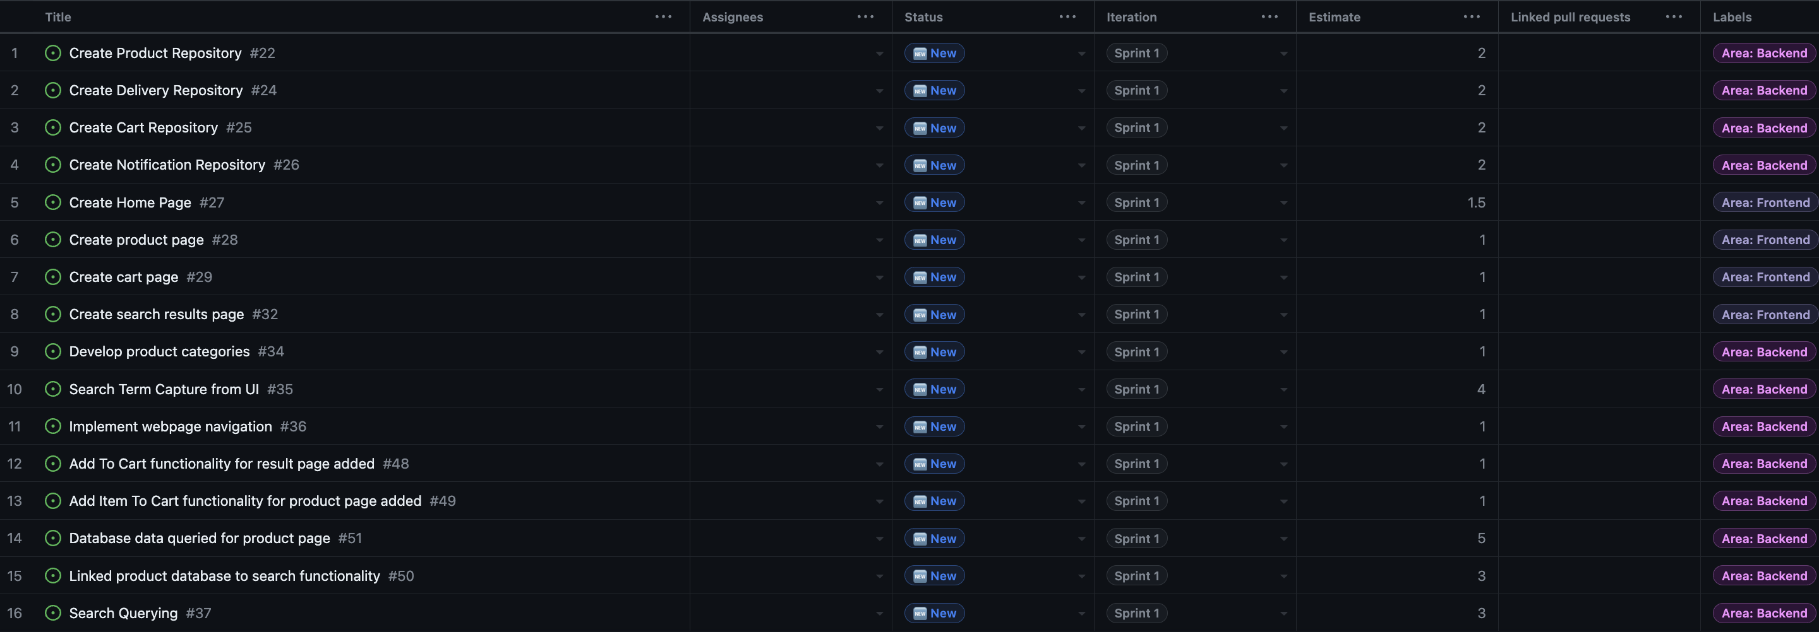

## Estimated Backlog – Sprint 2

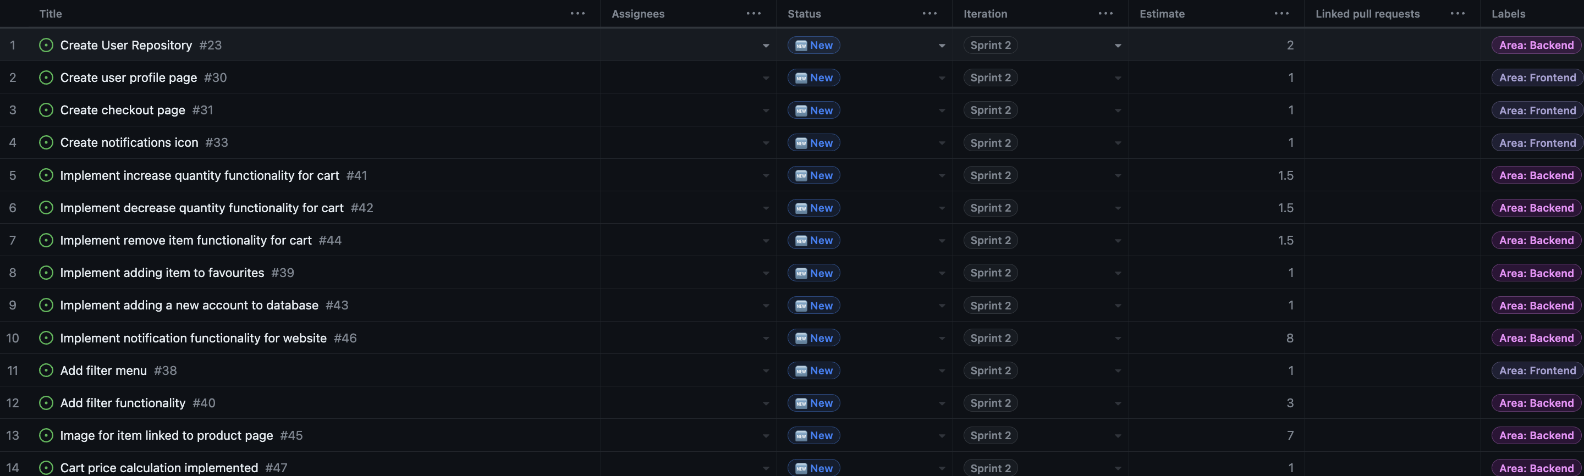

## Actual Backlog – Sprint 1

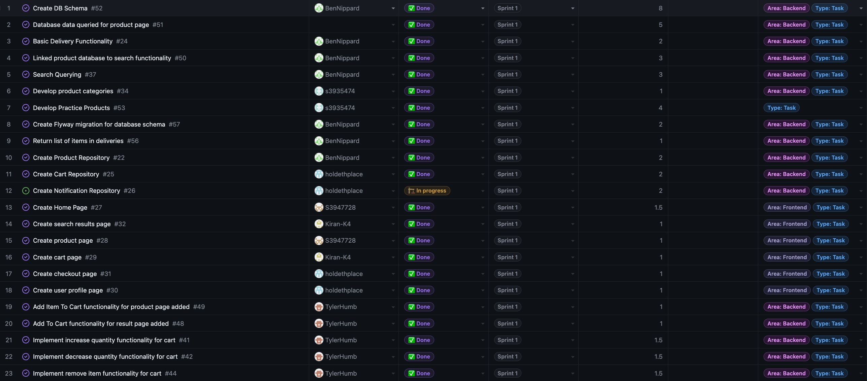

Added Tasks

* Create Flyway migration for database schema #57
* Return list of items in deliveries#56
* Create DB Schema#52
* Develop Practice Products#53

Moved Tasks Sprint 2 to Sprint 1

* Implement remove item functionality for cart#44
* Implement decrease quantity functionality for cart#42
* Implement increase quantity functionality for cart#41
* Create user profile page#30
* Create checkout page#31

Tasks Removed Due to Lack of Relevancy

* Implement Webpage Navigation#36

Tasks Moved to Sprint 2 From Sprint 1

* Search Term Capture from UI#35

# Sprint 0 Retrospective

1. Things That Went Well

The team rapidly built rapport, aligning closely on project goals, with each member demonstrating commitment. The distribution of the workload was fair and even, fostering a healthy work environment. Communication was constructive, positive, and frequent, a factor that has contributed to the team being on track to achieve project milestones. Our proactive approach has been a highlight of our success.

2. Things That Could Have Gone Better

Our client interactions were lacking some depth and detail, regarding information. In particular, the functional and non-functional requirements were not sufficiently explored. To improve this, a well structured and planned approach to client meetings is needed, including prepared questions to obtain a clearer understanding of their needs and expectations.

3. Things That Surprised Us

We were confronted with unexpected challenges in task distribution, resulting in a need for collaborative effort on certain sections. The number of meetings required each week was also a surprise, with a minimum of four being necessary. A difficulty in understanding specific tasks due to conflicting specifications was an unforeseen challenge. After careful examination and discussion, we overcame this, but it served as a learning opportunity.

4. Lessons Learned

Our experience has taught us the importance of a flexible approach to teamwork, recognizing that a mix of individual and small group work can be most effective. More careful planning and a structured approach to client interactions are vital, as well as the need to host regular meetings to ensure we are all on the same page and have a clear understanding. These lessons will be essential for the upcoming sprints, contributing to ongoing refinement and success.

5. Final Thoughts

So far, the project and teamwork has gone smoothly, with the team looking forward to the upcoming sprints and working collaboratively.

# Sprint 1 Retrospective

1. Things That Went Well

The focus of this sprint was the development of both the frontend and the backend. Our strategy was to divide the team into two groups. Jamie, Kiran, and Peter were assigned to the frontend, while Andy, Ben, and Tyler focused on the backend. By equally distributing the tasks and maintaining team collaboration, we managed to complete our set milestones. This sprint, we accomplished a template website, which is poised to be integrated with the data from our almost fully developed backend.

2. Things That Could Have Gone Better

Pivotal feedback from our client suggested that the integration of the frontend with the backend is a more intricate task than anticipated and should be approached over multiple sprints. However, this feedback came in later than desired due to the absence of the client during our scheduled meeting. Consequently, our roadmap for the next sprint is more intensive. A technical challenge arose when Jamie used the Pulsar editor, leading to a direct commit into the main branch on GitHub rather than creating a separate branch. However, these commit compliactions were not know prior to him using the Pulsar editor.

3. Things That Surprised Us

For this sprint a key surprise was the difference between the actual tasks completed and the task descriptions. Many tasks had descriptions that were too simplistic or only covered one aspect of a specific task although the timing for given tasks was still roughly equivalent. Ultimately, we believe that this can be attributed to a lack of understanding about what the exact tasks entailed which prevented accurate descriptions to be written but our understanding was good enough to map out the general timing and effort need for these tasks.

Additionally, some tasks had to be added like task #57 flyway migration and adjusted like #24 which was changed to ‘basic delivery functionality’ from ‘implement delivery repository’ this was done to account for oversights in our planning. We believe this is similarly attributed to lack of understanding about the finer details of implementing this project.

4. Lessons Learned

This sprint highlighted the significance of adhering to the best branching practices. Jamie's direct commit from a different editor served as an important reminder of this, even though it did not result in any immediate problems. Emphasizing the importance of understanding the nuances and potential pitfalls of various tools.

5. Final Thoughts

Overall, the sprint was a success. Our teamwork shone through, enabling us to meet our objectives. As we move forward, we will incorporate these insights gained, to ensure an improved next sprint, with smoother workflows and better outcomes.

# Sprint 1 Burndown Chart

In the Milestone 2 folder in the git repository is the actual file because the information in this image below, is quite small.

