Date of publication: 17 April 2024
Stock Prediction using Deep Reinforcement Learning
Gali Kiran Venkat

Vellore Institute of Technology, Amaravati, Andhra Pradesh, India
e-mail: kiranvenkat.2208@gmail.com

ABSTRACT Stock prediction is a crucial task in finance, often characterized by its complexity and volatility. Traditional models have limitations in capturing the intricate patterns of financial markets. Deep reinforcement learning (DRL) has recently shown promise in this domain due to its ability to learn from raw data and make sequential decisions. In this study, we propose a novel framework that combines two popular DRL algorithms, Advantage Actor-Critic (A2C) and Deep Q-Networks (DQN), for stock prediction. Our framework integrates the A2C and DQN algorithms to leverage their respective strengths. A2C is employed to learn a policy for making trading decisions based on historical stock data, while DQN is utilized to estimate the value function and guide the policy towards more profitable actions. The combination of these algorithms allows for a more robust and effective approach to stock prediction. We conduct experiments on real-world stock market data to evaluate the performance of our proposed framework. Comparative analyses are conducted against traditional time-series forecasting methods, highlighting the superiority of our DRL-based approach in terms of prediction accuracy and trading profitability. Overall, our study contributes to the advancement of stock prediction techniques by showcasing the effectiveness of combining A2C and DQN within a DRL framework. This approach holds significant potential for enhancing decision-making processes in finance and investment, benefiting investors, traders, and financial analysts alike.
INDEX TERMS Actor-critic reinforcement learning, Deep Q-Networks, Deep Reinforcement learning, Stock prediction.

I. INTRODUCTION
Stock market investment stands as a pivotal aspect of the global economy, shaping the landscape of business and finance with its far-reaching impact. Over the years, it has evolved into a realm of immense opportunity, attracting investors seeking to capitalize on the potential for significant returns. However, navigating the complexities of the stock market has become increasingly challenging, with factors such as market volatility, economic trends, and global events shaping investment outcomes. In response to these challenges, the financial industry has turned to advanced technologies to gain a competitive edge and improve decision-making processes. Among these technologies, artificial intelligence (AI) has emerged as a game-changer, offering powerful tools for analyzing vast amounts of data and uncovering actionable insights. Within the realm of AI, reinforcement learning algorithms have garnered particular attention for their ability to learn from experience and optimize decision-making in dynamic environments. Two notable techniques within the realm of reinforcement learning are Actor-Critic (A2C) and Deep Q-Networks (DQN). These algorithms represent cutting-edge approaches to solving complex decision-making problems, such as stock market prediction and trading. Actor-Critic (A2C) is a deep reinforcement learning algorithm that combines elements of both value-based and policy-based methods. In A2C, an actor network learns to select actions based on the current state, while a critic network evaluates the chosen actions and provides feedback to the actor. This dual-network architecture enables more efficient exploration of the action space and facilitates faster convergence to optimal policies. On the other hand, Deep Q-Networks (DQN) leverage deep neural networks to approximate the optimal action-value function in a reinforcement learning setting. By learning to estimate the expected future rewards associated with different actions, DQN can make informed decisions about which actions to take in order to maximize long-term returns. DQN has been successfully applied to a wide range of tasks, including video game playing and robotic control, showcasing its versatility and effectiveness in complex

environments. In the context of stock market investment, A2C and DQN offer powerful tools for building predictive models and devising trading strategies. By leveraging historical market data and learning from past experiences, these algorithms can identify patterns, trends, and opportunities that may elude human investors. Moreover, their ability to adapt to changing market conditions and optimize decision-making in real-time makes them valuable assets in the fast-paced world of finance. Overall, A2C and DQN represent cutting-edge technologies that hold great promise for revolutionizing stock market investment. As these algorithms continue to evolve and improve, they are poised to play an increasingly influential role in shaping the future of finance and investment.

II. RELATED WORK

Ask approximately on stock estimate utilizing significant bolster learning (DRL) has picked up critical balance in afterward a long time.
In [4], this paper proposes a DRL framework for portfolio organization, where the master learns to capably disperse assets in a portfolio to maximize add up to returns. The consider outlines the practicality of DRL in optimizing portfolio rebalancing strategies. In [5], Xu et al. show a DRL framework for cash related portfolio organization that combines actor-critic methodologies with the discrete action space. The think around evaluates the execution of the proposed framework on diverse cash related datasets and compares it with ordinary portfolio organization strategies. In [6], this paper presents a gathering strategy for mechanized stock trading utilizing DRL techniques. The makers propose a framework that combines various DRL administrators arrIn Here are a few striking related works in this field: [1], Junhao Zhang and Yifei Lei examine the application of DRL in computerized trading using DQN. The think approximately looks at different DRL calculations, checking DQN and A2C, and evaluates their execution in creating beneficial trading strategies. In [2], although not centered on significant fortress learning, this early work examines the utilize of dreary back learning (RRL) for stock trading. The makers outline the achievability of utilizing RRL to learn trading approaches from true grandstand data. In [3], Booth et al. look at the application of DRL methodologies for orchestrate execution algorithmic trading. The think around presents a DRL framework that learns to optimize orchestrate course of action and execution methods in real-time trading environments. These works highlight the contrasting applications of significant back learning in space of stock.

the challenges included, and the potential benefits for money related pros and cash related markets.

III. BACKGROUND
This section provides essential context for understanding the research presented in this paper.
A. REINFORCEMENT LEARNING
Reinforcement learning revolves around an agent's decision-making process across various scenarios, encompassing components such as the agent itself, the environment it interacts with, the actions it takes, the rewards it receives, and the observations it makes. Despite its potential, reinforcement learning encounters challenges such as the risk of over-reliance on rewards and the computational demands, particularly in tackling complex problems. The dynamics of reinforcement learning are illustrated in the accompanying figure, depicting the interplay between the agent and its environment.
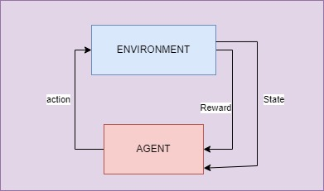
Figure-1 RL Framework
In the domain of reinforcement learning, several pivotal concepts play significant roles:
- Reward: This refers to a single numerical value provided by the environment, assessing the quality of the preceding action taken by the agent. Rewards may vary in polarity, being either positive or negative, contingent upon the nature of the environment and the action executed by the agent.
- Policy: Serving as a guiding principle, the policy assists the agent in determining its next action based on the current state it finds itself in, thereby facilitating effective navigation of its decision-making process.
- Value (V): Unlike the short-term focus of rewards (R), value represents the long-term return expected from an action, incorporating discount rates to account for future rewards. It provides a broader perspective on the potential outcomes of actions taken by the agent.
- Action Value: Similar to the concept of reward value, action value incorporates additional parameters related to the current action taken by the agent. This metric aids the agent in optimizing its actions within the given environment, considering both short-term rewards and long-term prospects.

B. ACTOR-CRITIC
Actor-Critic algorithms represent a class of reinforcement learning techniques that combine elements of both value-based and policy-based methods. In these algorithms, there are two main components: the actor and the critic.
- Actor: The actor is responsible for learning a policy, which is essentially a mapping from states to actions. It selects actions based on the current state of the environment and the learned policy. The actor aims to maximize the expected cumulative reward by choosing actions that lead to higher rewards over time.
- Critic: The critic evaluates the actions taken by the actor by estimating the value or quality of these actions. It learns to approximate the expected cumulative reward, or return, associated with being in a certain state and taking a certain action. The critic provides feedback to the actor by estimating how good or bad the chosen actions are in the long run. The key idea behind Actor-Critic algorithms is to use the critic's feedback to update the actor's policy in a way that improves overall performance.
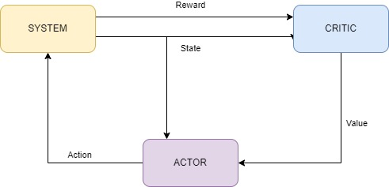
Figure-2 A2C flowchart
There are several variants of Actor-Critic algorithms, each with its own specific characteristics and advantages. Some common variants include:
- Advantage Actor-Critic (A2C): A2C is a synchronous version of the Actor-Critic algorithm where multiple parallel actors interact with a single shared critic. This parallelism allows for more efficient exploration of the state-action space and faster convergence.
- Asynchronous Advantage Actor-Critic (A3C): A3C extends A2C by introducing asynchronous updates, where each actor runs independently and updates the shared parameters of the actor and critic networks asynchronously. This approach further improves exploration and scalability, making it suitable for distributed computing environments.
C. DEEP Q-NETWORK
Deep Q-Networks (DQN) is a reinforcement learning method that merges deep neural networks with the Q-learning algorithm, tailored for environments featuring high-dimensional state spaces and discrete action spaces. Introduced by DeepMind in 2013, DQN swiftly became a cornerstone in the realm of deep reinforcement learning.
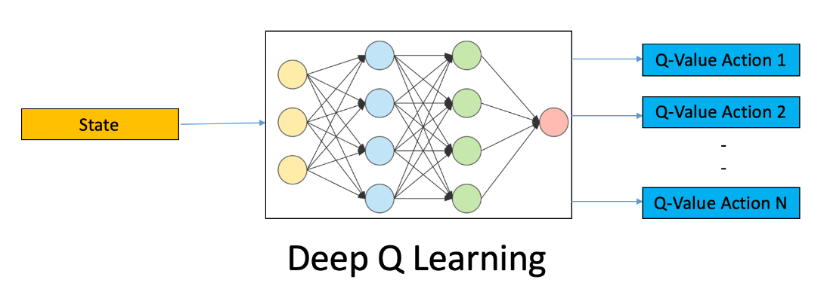
Figure-3 DQN architecture
DQN operates through several key mechanisms:
1. Q-Learning: Q-learning, a fundamental reinforcement learning technique, serves to assess the quality of actions (Q-values) within a given state. These Q-values, denoted as \(Q(s, a)\), signify the anticipated cumulative reward achievable by taking action \(a\) from state \(s\) and following the optimal policy thereafter.
2. Deep Neural Networks: Leveraging deep neural networks, DQN approximates the Q-values. Here, the state representation serves as input, with the output being a Q-value corresponding to each potential action. This mapping from states to Q-values empowers the neural network to effectively grasp the optimal policy for the task at hand.
3. Experience Replay: DQN harnesses experience replay to bolster sample efficiency and foster stable learning. During training, experiences comprising state-action-reward-next state tuples are stored in a replay buffer. At intervals, batches of experiences are randomly sampled from this buffer to train the neural network. This approach optimizes the utilization of past experiences and mitigates correlations between consecutive samples.
4. Target Network: In combatting instability during training, DQN introduces a target network. This network mirrors the main neural network and is leveraged to compute target Q-values during training. Unlike the main network, the parameters of the target network are updated less frequently, aiding in stabilizing the learning process.
5. Loss Function: DQN adopts a loss function derived from the Bellman equation, gauging the disparity between predicted and target Q-values. Through gradient descent, this loss function is minimized, facilitating the update of the neural network's parameters. In essence, DQN's fusion of deep neural networks with Q-learning facilitates efficient learning and robust policy development, making it a pivotal tool in navigating complex reinforcement learning environments.
IV. METHODOLOGY
The aim of this study is to forecast stock prices by employing DQN and A2C methodologies. The model ingests historical stock data along with news data and produces the ultimate trading decision (either buy or sell) to optimize profit. The architectural layout of the model is depicted in the accompanying figure below:
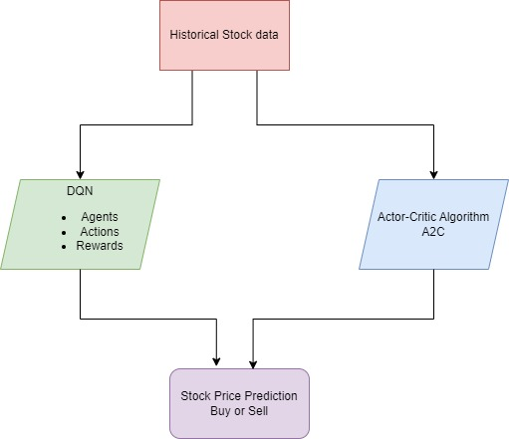
Figure-4 Main data flow diagram of the project
Working of DQN:
The DQN algorithm adopts a deep neural network-centered strategy to understand and enhance action-value functions. The operational flow can be outlined as follows:
1. State Representation: Transform the current state of the environment into a suitable numerical format, such as raw pixel data or preprocessed features.
2. Neural Network Architecture: Devise a deep neural network, typically a convolutional neural network (CNN), that accepts the state as input and produces action-values for each potential action.
3. Experience Replay: Preserve the agent's experiences, comprising tuples of state, action, reward, and next state, within a replay memory buffer.
4. Q-Learning Update: Extract mini-batches of experiences from the replay memory to update the neural network weights. This update employs a loss function derived from the Bellman equation, aiming to minimize the disparity between predicted and target action-values.
5. Exploration and Exploitation: Strike a balance between exploration and exploitation by selecting actions either based on the current policy in a greedy manner or stochastically to foster exploration.
6. Target Network: Introduce a separate target network mirroring the architecture of the main network to stabilize the learning process. Periodically synchronize the target network by transferring the weights from the main network.
7. Repeat Steps 1 to 6: Engage with the environment, gather experiences, update the network, and refine the policy iteratively until convergence is achieved.
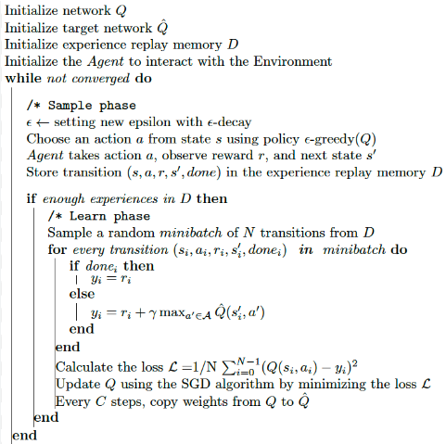

Working of A2C:
The Advantage Actor-Critic (A2C) algorithm is a type of reinforcement learning method that combines elements of policy-based and value-based approaches. Here's a breakdown of how A2C works:
1. Initialize Parameters: The algorithm starts by initializing the parameters of two neural networks: the actor network and the critic network. These networks represent the policy (actor) and value function (critic), respectively.
2. Interact with the Environment: The agent interacts with the environment by taking actions based on the current state and observing rewards and next states. At each time step, the actor network selects an action according to the current policy, and the environment returns a reward and the next state.
3. Compute Advantage and Target Values: After each interaction with the environment, the A2C algorithm computes the advantage and the target value for the current time step. The advantage represents the difference between the observed reward and the expected reward estimated by the critic network. The target value is an estimate of the expected cumulative reward from the current state, taking into account future rewards discounted by a factor.
4. Update Critic Network: The critic network is trained to minimize the mean squared error between the predicted value and the target value. The parameters of the critic network are updated using backpropagation to minimize this error.
5. Update Actor Network: The actor network is trained to maximize the advantage by adjusting its parameters to increase the probability of selecting actions with higher expected rewards. The parameters of the actor network are updated using the policy gradient theorem, which computes the gradient of the expected return with respect to the parameters of the actor network.
6. Repeat Steps 2 to 5: The agent continues to interact with the environment, compute advantages and target values, update the critic network, and update the actor network iteratively until convergence. Convergence occurs when the actor and critic networks have learned stable policies and value functions that maximize the expected return from the environment.
Overall, the A2C algorithm aims to learn both a policy (actor network) and a value function (critic network) simultaneously, leveraging the advantages of both approaches to improve stability and convergence speed in reinforcement learning tasks.
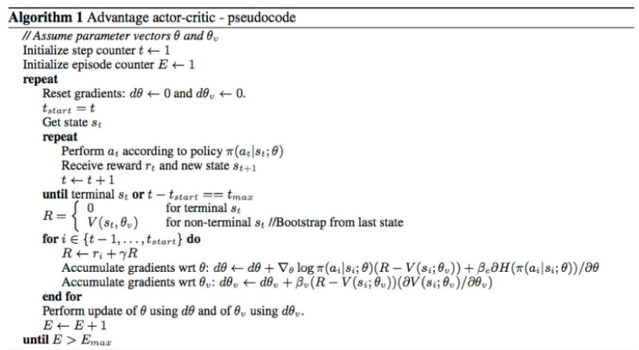

V. FORMULAE
A. Main formulae
The form of Bellman’s equation that the DQN is trained to approximate is:
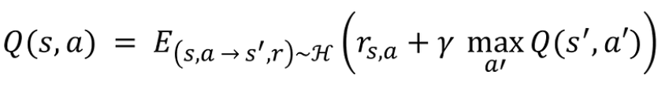 (1)
Form of Bellman’s Equation
Here The Q-value of state s following action a represents the expected value of the expression within parentheses. This expression sums the current step's reward with the discounted maximum Q-value of the resultant state s' , where the mapping from (s, a) to the new state s' and reward r is derived from the experience replay history H . The maximizing action a' is considered, and the discounting factor γ is applied.
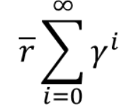 (2)
We utilize this mathematical formulation to compute theoretical results of the Bellman equation for every depth level of future rewards. Subsequently, we juxtapose these outcomes with the corresponding values produced by the target and policy DQN at each iteration.
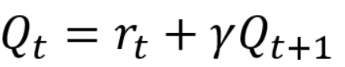 (3)
Q-value
Here, t represents the sequence of steps along the deterministic trajectory. The mentioned function exhibits tail recursion, akin to the original Bellman equation, and can be simplified into an iterative form.
B. VARIANCE
We characterize the variance as the disparity between the anticipated value of the squared estimator and the square of the anticipated value of the estimator: Var(ˆθ)=E[ˆθ2]−(E[ˆθ])2. It's worth noting that for the purposes of this lecture, expressing the variance in its alternative formulation is more convenient:
Var(ˆθ) = E[(E[ˆθ]−ˆθ)2]. (4)
Variance

VI. RESULTS AND DISCUSSIONS
Using A2C
After finishing all the data preprocessing, we are seeing the stock price of the training data which gives the info regarding total reward and total profit.
Here red dot represents buy and green dot represents sell.
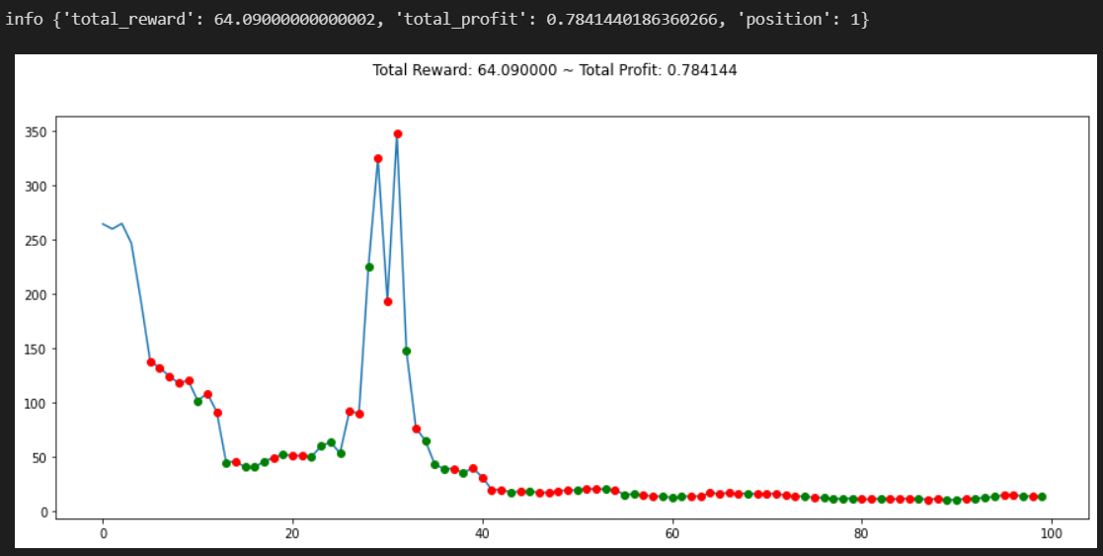
Figure-5 Training the data
While building the model, we should train the model with many epochs till the obtained variance is low.
EPOCH | VARIANCE
Epoch-1 | 0.112
Epoch-100 | 0.16
Epoch-500 | 0.213
Epoch-1000 | 0.31
Epoch-1500 | 0.0877
Table-1 Epoch-Variance
In epoch-1500, we have achieved minimum variance so that we can now stop the model training.
Finally, we will be predicting the stock price once the training of the model is done.
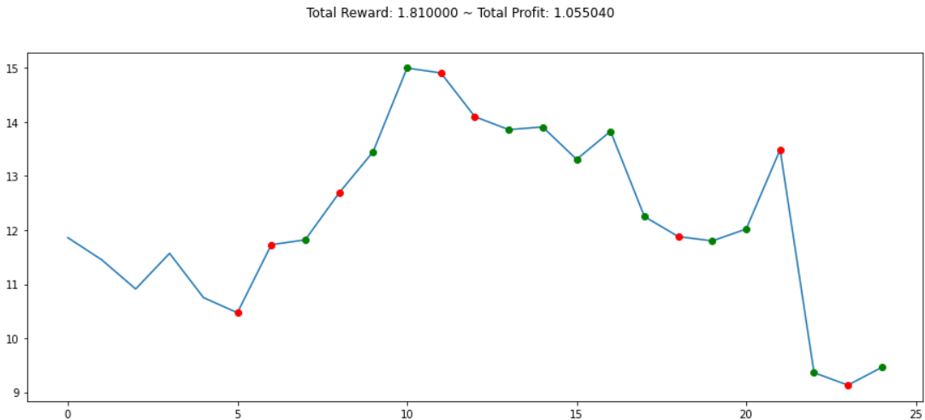
Figure-6 Testing
Here, we can observe that it is showing green dot at the end, which indicates to sell the stock.
Using DQN
Here we are running the code to see the status of the stock prices which tells us the information regarding buying and selling. It is showing the profit value when we buy or sell. At the end it will show the total profit.
BUY | SELL | PROFIT
$2893.06 | $2929.40 | -$58.22
$2893.06 | $2970.27 | $30.02
$2966.15 | $2995.68 | $108.07
$2986.20 | $3004.52 | $38.37
$2986.20 | $3039.42 | $43.43
$3036.89 | $3046.77 | $9.88
$3037.56 | $3066.91 | $29.35
$3074.62 | $3076.78 | $2.16
$3087.01 | $3091.84 | $4.83
Table-2 Buy-Sell-Profit
After the end of many epochs we get a total profit of the stock by performing buy and sell actions is $1280.40.
We can also see the total profit in the below output.

We can also see the buy and sell signals in the below figure and also the total gains by performing the buy or sell actions.
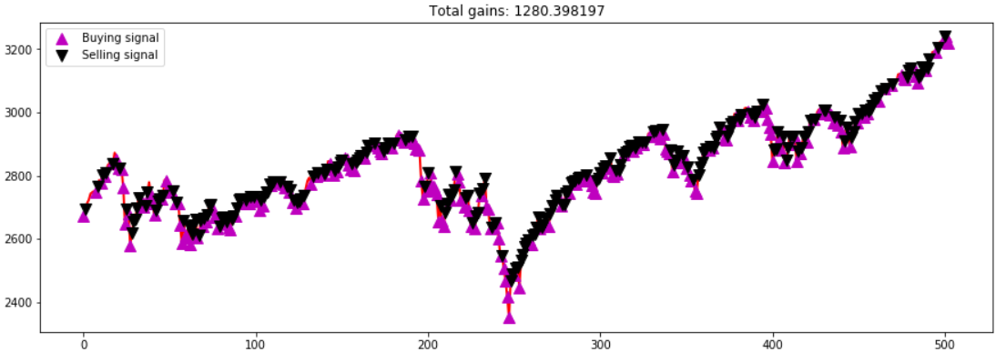
Figure-7 Testing the model

VII. CONCLUSION
In conclusion, leveraging the Advantage Actor-Critic (A2C) and Deep Q-Networks (DQN) algorithms for stock prediction presents a promising avenue for enhancing decision-making in financial markets. By integrating A2C and DQN methodologies, we can effectively tackle the complexities of stock market forecasting, leveraging the strengths of both policy-based and value-based approaches. Through the A2C algorithm, we can learn a policy for making trading decisions based on historical stock data and news information, allowing for adaptive and context-aware decision-making. Meanwhile, DQN enables us to optimize action-value functions, providing a robust framework for learning and refining trading strategies in dynamic market environments. The critic assesses the actor's performance and enhances the policy whenever feasible. This enhancement involves utilizing a policy gradient to optimize the critic's value estimations through the refinement of the actor policy. This aspect leads to the consideration that A2C may be a reinforcement learning algorithm capable of surpassing the performance of DQN.
REFERENCES

[1] Junhao Zhang and Yifei Lei ,“Deep Reinforcement Learning for Stock Prediction”, 2022 .
[2] Grumpy and Saffell ,“Stock Trading with Tedious Bolster Learning (RRL) ”, 2001.
[3] Booth et al ,“Deep Bolster Learning for Orchestrate Execution in Algorithmic Trading”, 2019.
[4] Jiang et al. , “Deep Back Learning in Portfolio Organization”, 2017.
[5] Xu et al. , “A Significant Back Learning Framework for the Budgetary Portfolio Organization Issue”, 2018.
[6] Kim et al , “Deep Bolster Learning for Mechanized Stock Trading: An Equip Strategy”, 2018.
[7] J. W. Lee, “Stock price Prediction Using Reinforcement Learning,” in Proceedings of the 2001 IEEE International Symposium on Industrial Electronics Proceedings, pp. 690–695, Pusan, South Korea, June 2001.

