**相対パスと絶対パス**

http://www.abc.com/

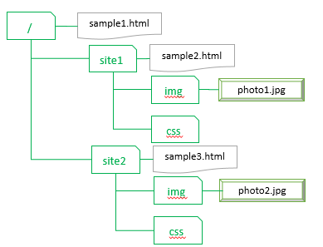

**絶対パス**

|  |  |
| --- | --- |
| photo1.jpg | http://www.abc.com/site1/img/photo1.jpg |
| photo2.jpg | http://www.abc.com/site2/img/photo2.jpg |

|  |  |  |
| --- | --- | --- |
| **参照元** | **参照先** | **相対パス** |
| sample1.html | photo1.jpg | site1/img/photo1.jpg |
| photo2.jpg | site2/img/photo2.jpg |
| sample2.html | photo1.jpg | img/photo1.jpg |
| photo2.jpg | ../site2/img/photo2.jpg |
| sample3.html | photo1.jpg | ../site1/img/photo1.jpg |
| photo2.jpg | img/photo2.jpg |