**Answers**

1. List the name and roll of students belonging to 2nd year.

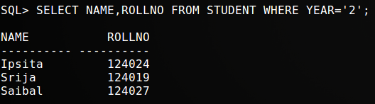

1. List the names of students who do not beloing to CSE dept.

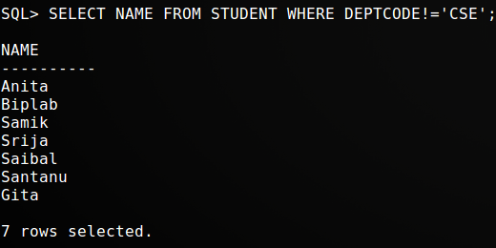

1. Display the number of students in each department.

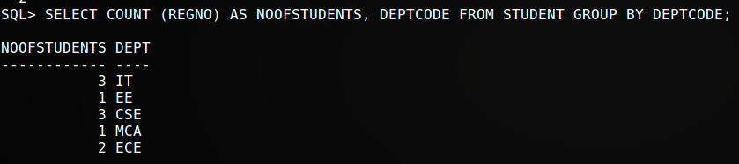

1. Show the names of the heads of departments with department name.

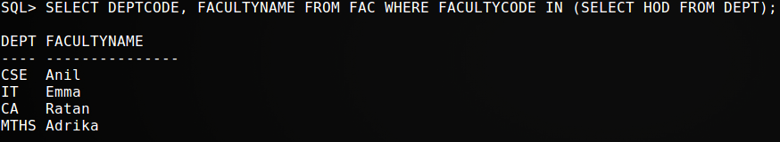

1. Find the number of faculties who joined in January.

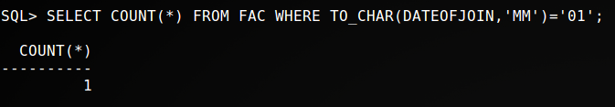

1. Find the name and salary of the faculty who earn between 8000 and 20000.

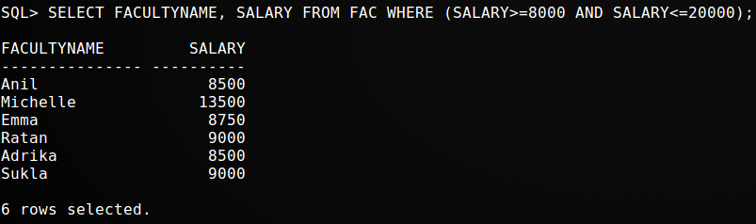

1. Find the names of faculties whose name start with ‘S’ and joined before 2010.

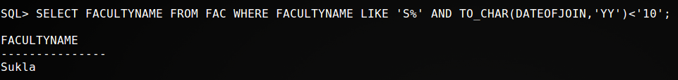

1. Add an extra attribute to the faculty table - Salary Number(8,2)

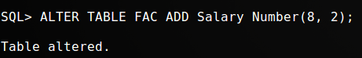

1. Insert values into the corresponding field Salary Number(8,2).

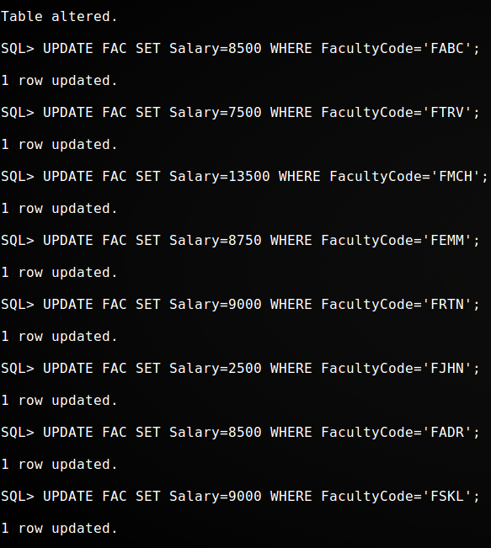

1. Find the names of faculties who earn more than the average of all faculties in their respective dept..

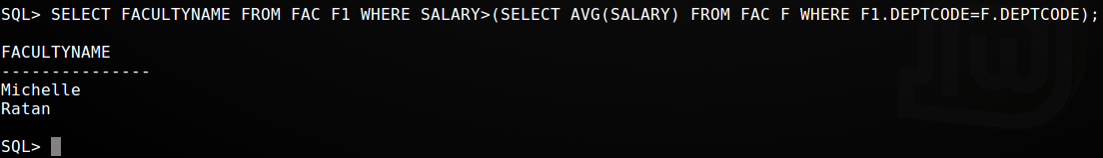

1. Display the number of students in each department.

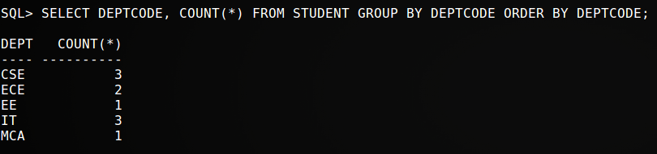

1. Display average no of student SELECTeach dept.

