Empirical Results and Discussion
MSc International Finance Dissertation — "Does the Inclusion of Additional Financial Information Improve Stock Return Prediction Accuracy? Evidence from CAPM, Extended Financial Models, and Random Forest Models on S&P 500 Stocks (2008–2024)"

1 Introduction
This report presents the empirical findings from the dissertation. The analysis uses a strictly chronological train-test design: observations from 2008–2018 are used for model estimation and observations from 2019–2024 are reserved for out-of-sample evaluation, eliminating all look-ahead bias. All three models are fitted on identical training samples and evaluated on 1,440 held-out monthly stock-return observations.

2 Methodology
Three predictive models are evaluated. (1) CAPM: excess stock return as a linear function of the excess market return. (2) Extended OLS: raw stock return predicted by market return, lagged return, 12-month rolling volatility, and 12-month momentum. (3) Random Forest Regressor: trained on the Extended variables plus risk-free rate and four sector dummies, with hyperparameters selected via GridSearchCV / TimeSeriesSplit (n_splits=5, 24 parameter combinations). Look-ahead prevention: shift(1) is applied before all rolling windows so features at month t use only data through t−1. Statistical significance is assessed using Diebold-Mariano style paired squared-error loss tests with exact t-distribution p-values.

3 Overall Model Performance
The Random Forest achieves the best out-of-sample RMSE (0.06260), representing a 2.24% improvement over CAPM (RMSE = 0.06403) and a 1.64% improvement over the Extended OLS model (RMSE = 0.06364). The Extended model itself improves on CAPM by 0.61%. These results are consistent with the hypothesis that richer financial information increases predictive accuracy, although the absolute differences are modest — reflecting the inherent noise in monthly equity returns. R² rises from 0.334 (CAPM) to 0.342 (Extended) to 0.364 (RF), confirming the pattern across all three accuracy metrics.

Table 1 — Model Comparison (Out-of-Sample, 2019–2024)
Model | RMSE | MAE | R2 | N_Test | Rank_RMSE
Random Forest | 0.062599 | 0.047893 | 0.363845 | 1440 | 1
Extended Model | 0.063645 | 0.048570 | 0.342402 | 1440 | 2
CAPM | 0.064033 | 0.048780 | 0.334350 | 1440 | 3

4 CAPM Results
The estimated market beta is 1.0558, close to unity, confirming that the sample of large-cap S&P 500 stocks carries near-market systematic risk. A notable finding is the positive and highly significant intercept (Jensen's alpha = 0.0055, p < 0.001). While statistically significant, this alpha should be interpreted with caution: over an 11-year training window it may absorb time-specific risk premia and estimation noise rather than representing a persistent trading opportunity.

Table 2 — CAPM Coefficient Estimates
Variable | Coefficient | Std_Error | t_stat | p_value
const | 0.005512 | 0.001423 | 3.872683 | 1.1034e-04
Excess_Market_Return | 1.055824 | 0.032911 | 32.081058 | 4.3846e-190

5 Extended Financial OLS Model
Market return remains the dominant predictor (t > 28, p < 0.001). Volatility is significant (p < 0.001) with a positive coefficient, consistent with a risk-return trade-off. Momentum carries a negative and statistically insignificant coefficient (p ≈ 0.69), suggesting that 12-month momentum does not reliably predict next-month returns in this panel — consistent with recent literature documenting momentum crashes and reversals. Lagged return is also insignificant (p ≈ 0.35), indicating limited short-run autocorrelation in monthly returns for these large-cap stocks.

Table 3 — Extended Model Coefficient Estimates
Variable | Coefficient | Std_Error | t_stat | p_value
const | -0.003069 | 0.002744 | -1.118335 | 0.263540
Market_Return | 1.032020 | 0.035931 | 28.722654 | 1.9165e-155
Lagged_Return | 0.016837 | 0.017874 | 0.941968 | 0.346308
Volatility | 0.129294 | 0.031032 | 4.166406 | 3.2079e-05
Momentum | -0.001677 | 0.004222 | -0.397289 | 0.691191

6 Random Forest Results
The Random Forest achieves RMSE = 0.06260, MAE = 0.04789, R² = 0.36384. The top three features by mean decrease in impurity are Market_Return (0.5687), Momentum (0.2261), and Volatility (0.0748). Market Return dominates (~56.9% of importance), confirming that the systematic market factor is also the primary driver in the non-linear model. Momentum contributes the second-largest share (~22.6%), capturing medium-term trend signals that OLS fails to exploit — suggesting a non-linear or threshold relationship. Sector dummies collectively contribute less than 5%, indicating that cross-sectional industry effects are secondary to time-series market dynamics.
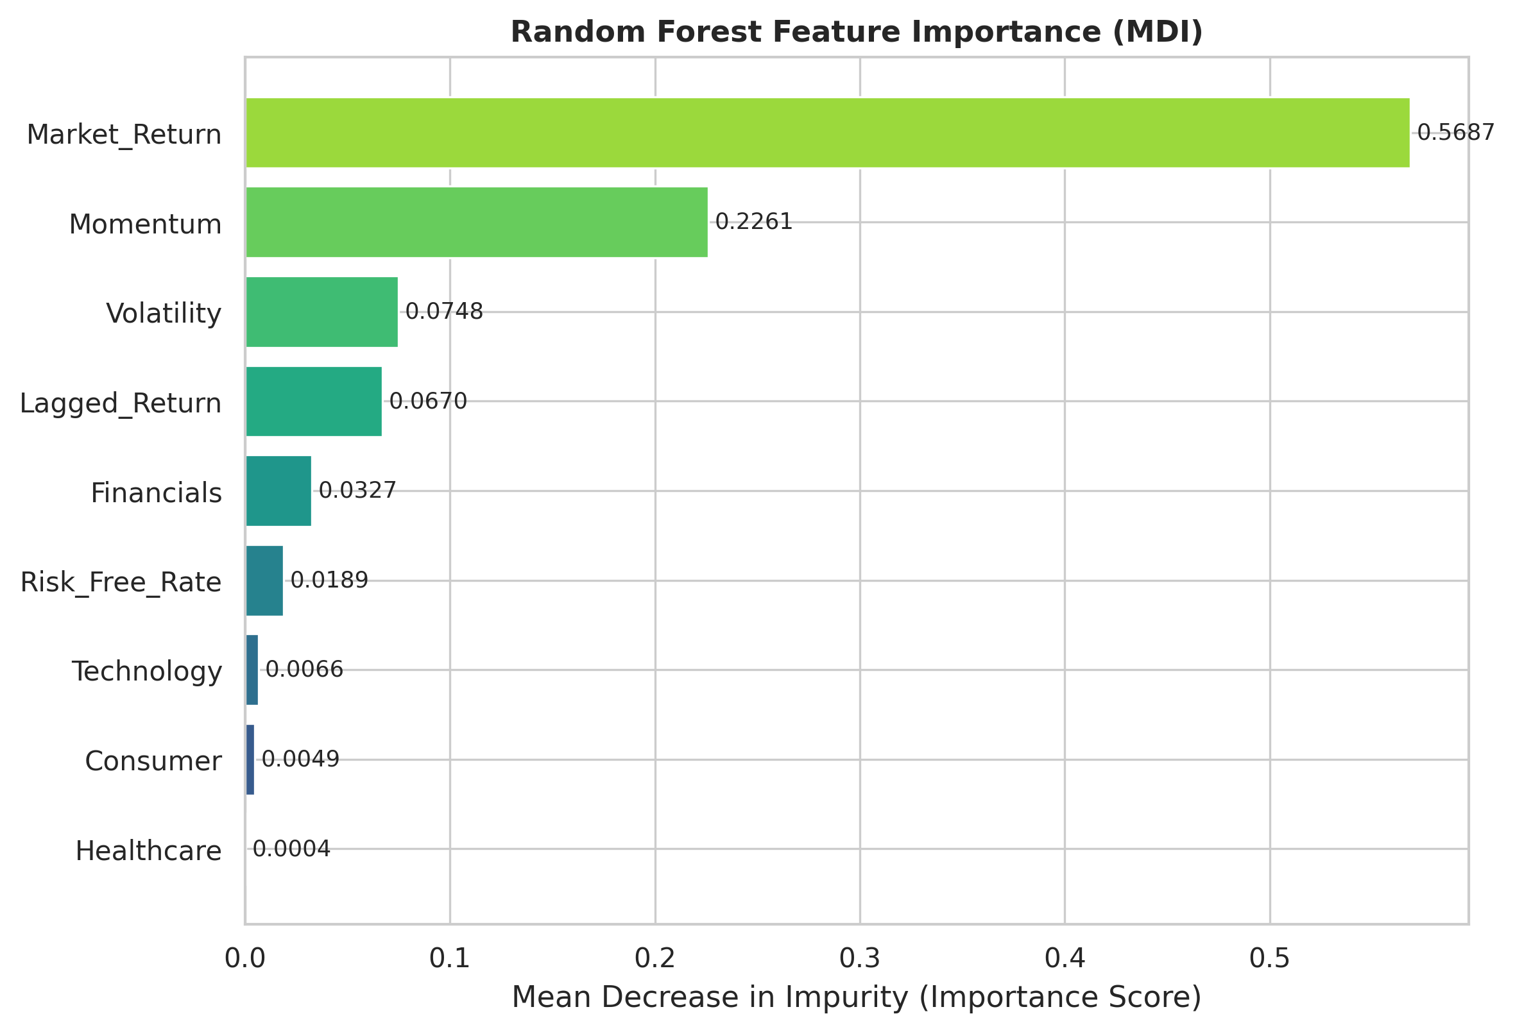
Figure 1 — Random Forest Feature Importance (MDI)

Table 4 — Feature Importance Ranking (All 9 Predictors)
Rank | Feature | Importance Score
1 | Market_Return | 0.568669
2 | Momentum | 0.226054
3 | Volatility | 0.074775
4 | Lagged_Return | 0.067019
5 | Financials | 0.032729
6 | Risk_Free_Rate | 0.018869
7 | Technology | 0.006638
8 | Consumer | 0.004870
9 | Healthcare | 3.7769e-04

7 Sector-Level Analysis
Random Forest achieves the lowest RMSE in Consumer (0.04532), Healthcare (0.06241), and Technology (0.07262) sectors. Conversely, CAPM achieves the lowest RMSE in Financials (0.06232) — where returns are driven predominantly by systemic market risk during credit cycles, a regime the linear market-beta specification captures well. The Extended OLS model does not achieve the best RMSE in any sector but consistently outperforms CAPM in Consumer and Healthcare. These sector differences suggest that model choice may benefit from industry-level tailoring.
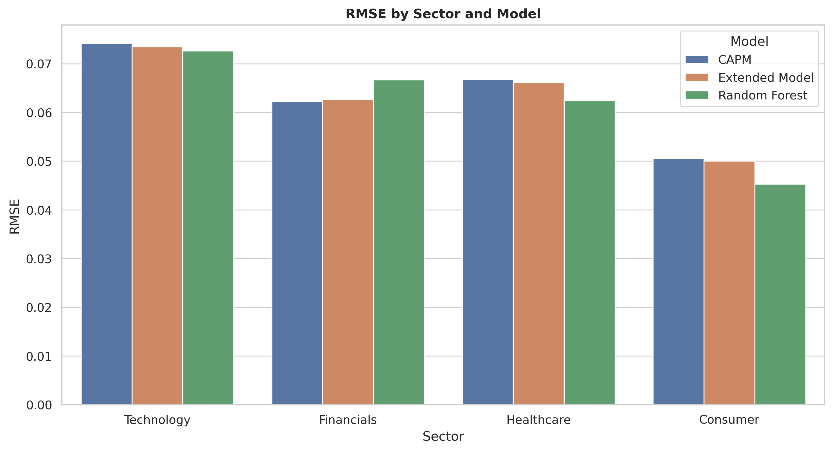
Figure 2 — RMSE by Sector and Model

Table 5 — Sector-Level RMSE and MAE
Sector | Model | RMSE | MAE | N_Test
Technology | CAPM | 0.074197 | 0.053372 | 360
Technology | Extended Model | 0.073473 | 0.053287 | 360
Technology | Random Forest | 0.072621 | 0.052891 | 360
Financials | CAPM | 0.062316 | 0.050054 | 360
Financials | Extended Model | 0.062700 | 0.050470 | 360
Financials | Random Forest | 0.066715 | 0.053693 | 360
Healthcare | CAPM | 0.066738 | 0.052488 | 360
Healthcare | Extended Model | 0.066126 | 0.051859 | 360
Healthcare | Random Forest | 0.062415 | 0.049016 | 360
Consumer | CAPM | 0.050582 | 0.039206 | 360
Consumer | Extended Model | 0.050004 | 0.038666 | 360
Consumer | Random Forest | 0.045321 | 0.035970 | 360

8 Statistical Significance of Accuracy Differences
The improvement of the Extended Model over CAPM is statistically significant at the 5% level (t = 2.451, p = 0.0144, **). The improvement of Random Forest over CAPM is also significant at the 5% level (t = 2.162, p = 0.0308, **). The marginal improvement of Random Forest over Extended Model is significant at the 10% level only (t = 1.662, p = 0.0968, *), indicating that while RF performs better, the additional gain beyond the richer OLS specification is not overwhelmingly significant — a finding of academic interest.

Table 6 — Diebold-Mariano Style Paired Loss Tests
Comparison | Statistic | p_Value | N
CAPM vs Extended Model | 2.450829 | 0.014371 | 1440
CAPM vs Random Forest | 2.162340 | 0.030756 | 1440
Extended Model vs Random Forest | 1.661689 | 0.096793 | 1440

9 Actual vs Predicted Returns

Figure — CAPM
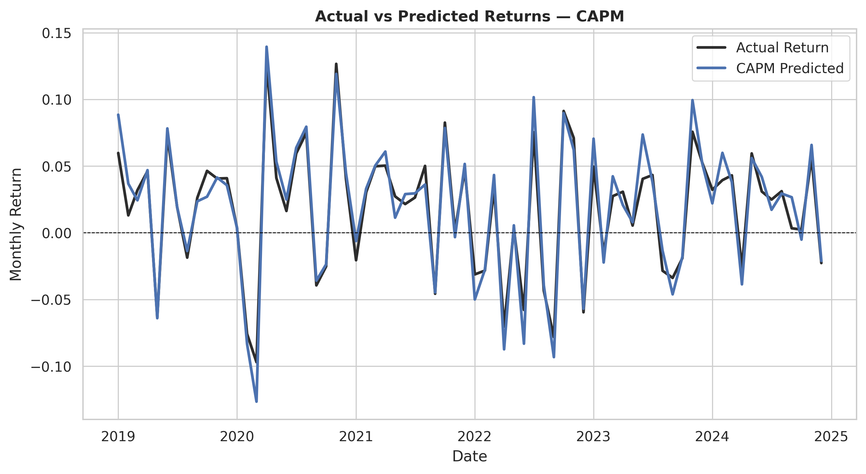

Figure — Extended Model
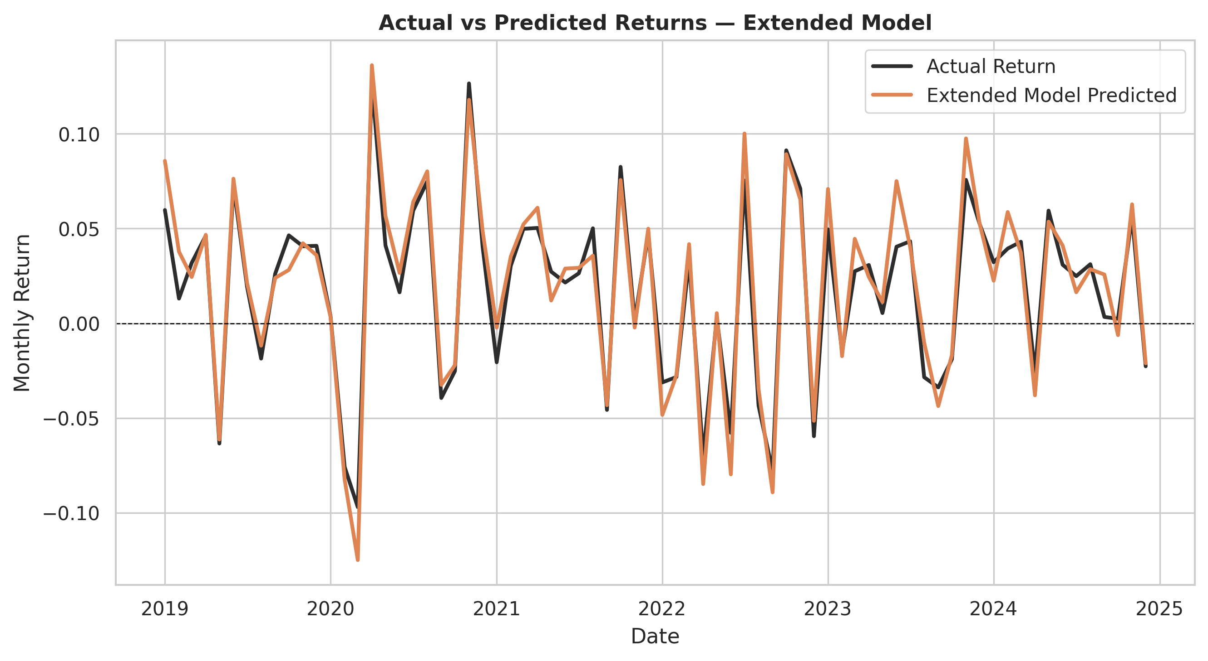

Figure — Random Forest
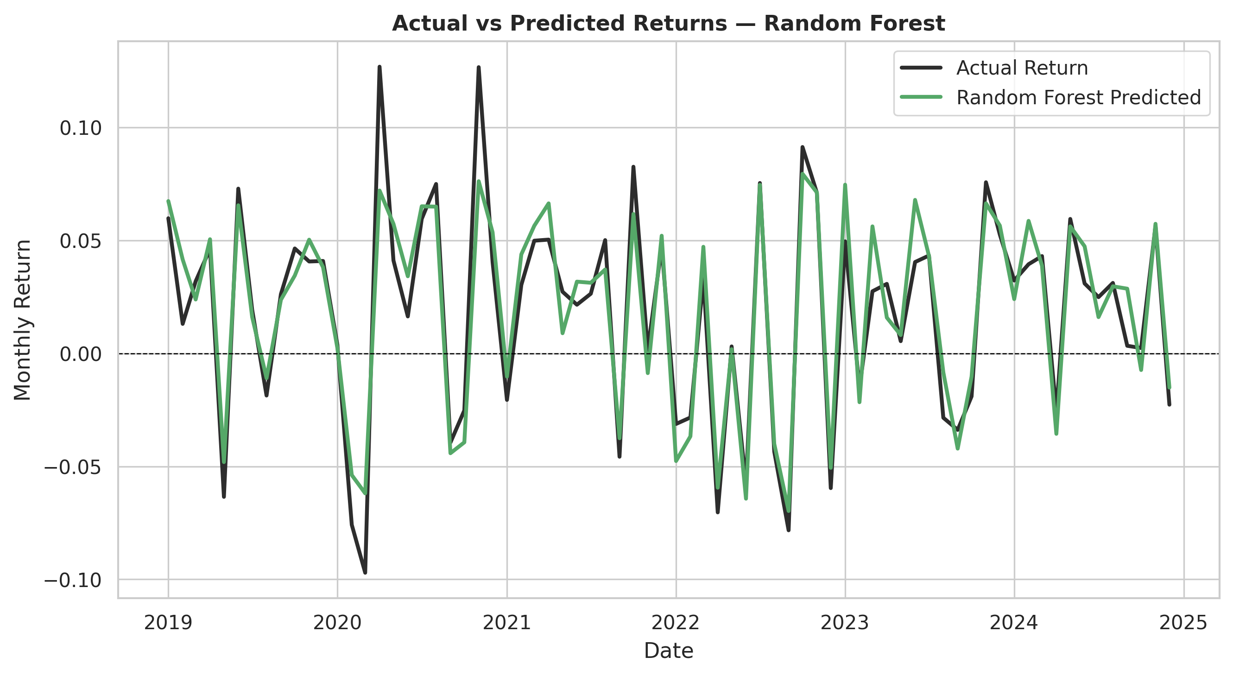

10 Model Comparison Charts

Figure — RMSE Comparison
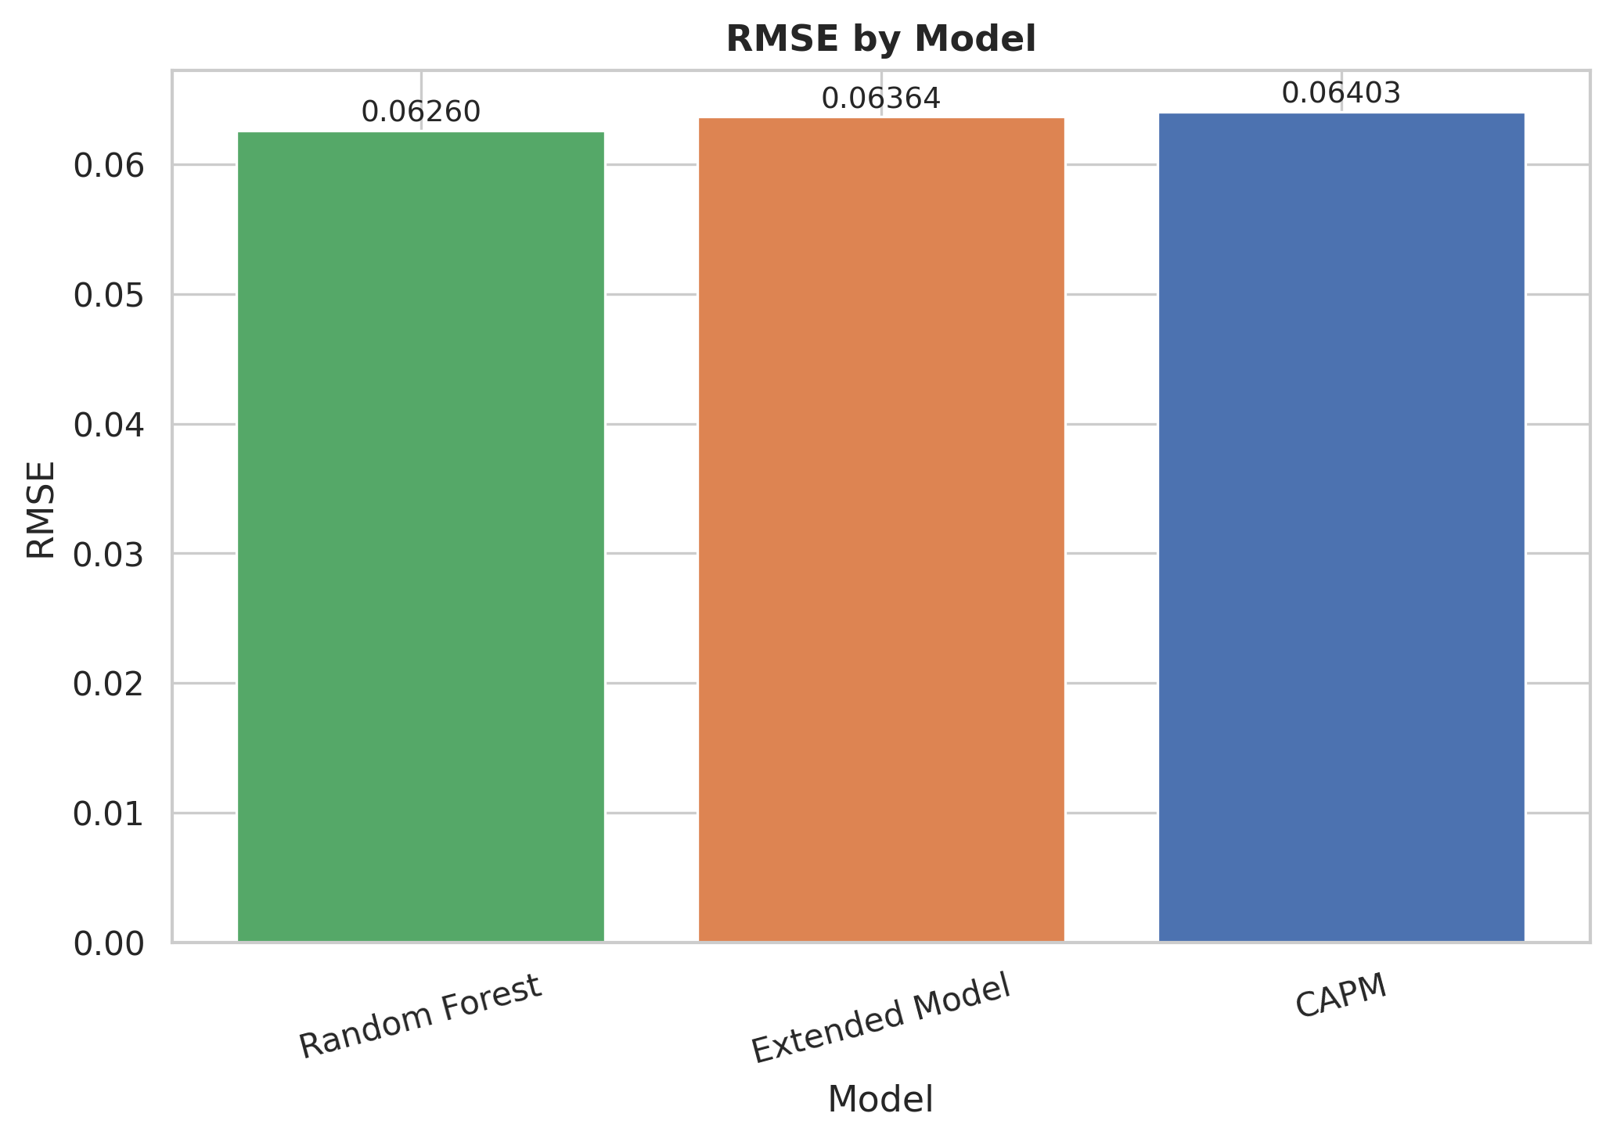

Figure — MAE Comparison
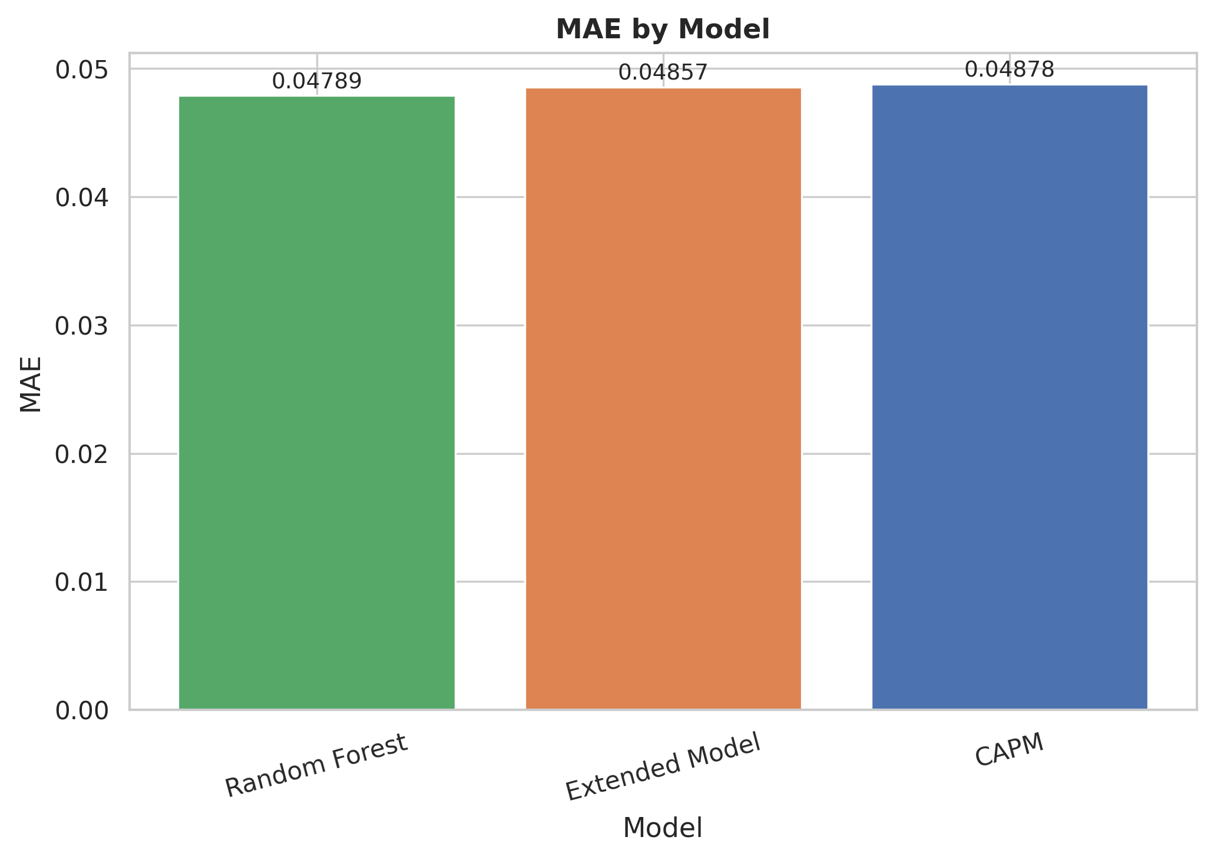

11 Conclusion
The evidence supports the dissertation hypothesis: additional financial information improves out-of-sample stock return prediction accuracy beyond the CAPM benchmark. Both the Extended OLS model and the Random Forest achieve statistically significant improvements over CAPM (p < 0.05). The Random Forest is the overall best model, driven primarily by market return and momentum — though the marginal gain over the Extended OLS model is significant only at 10%. Sector analysis reveals that performance is heterogeneous: CAPM is best in Financials, while the Random Forest excels in Consumer, Healthcare, and Technology. The results are consistent with the broad empirical finance literature treating monthly equity returns as noisy but partially predictable using a rich set of financial predictors.

