MTH 201
Bijan Zandi
Section 10.4
4 Cases for Parabola when Vertex is (0, 0)
Focus | Directrix | Equation | Shape
(p, 0) | x = -p (vertical) | $$y^{2}=4px$$ | 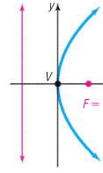
(-p, 0) | x = p (vertical) | $$y^{2}=-4px$$ | 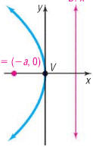
(0, p) | y = -p (horizontal) | $$x^{2}=4py$$ | 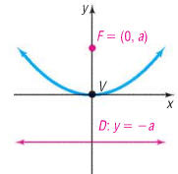
(0, -p) | y = p (horizontal) | $$x^{2}=-4py$$ | 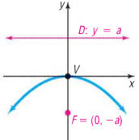

4 Cases for Parabola when Vertex is (h, k)
Focus | Directrix | Equation | Shape
(h + p, k) | x = h - p (vertical) | $${\left(y-k\right)}^{2}=4p(x-h)$$ | 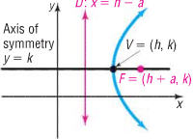
(h - p, k) | x = h + p (vertical) | $${\left(y-k\right)}^{2}=-4p(x-h)$$ | 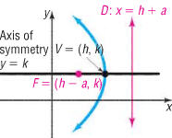
(h, k + p) | y =k - p (horizontal) | $${\left(x-h\right)}^{2}=4p(y-k)$$ | 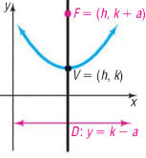
(h, k - p) | y = k + p (horizontal) | $${\left(x-h\right)}^{2}=-4p(y-k)$$ | 