# Homework: Databases

Problems for homework for the ["Software Technologies" course @ Software University.](https://softuni.bg/trainings/4086/software-technologies-may-2023)  
Submit this document as your homework.

## Address Database:

## 

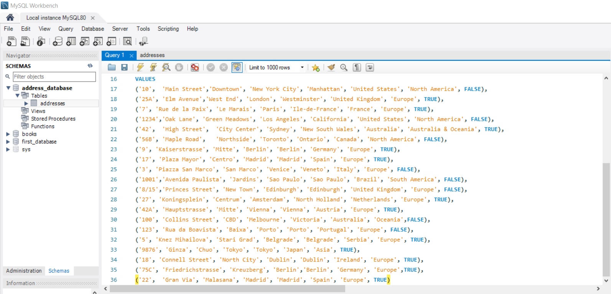

* + **SELECT all addresses from the `address` table that are located in a capital city.**

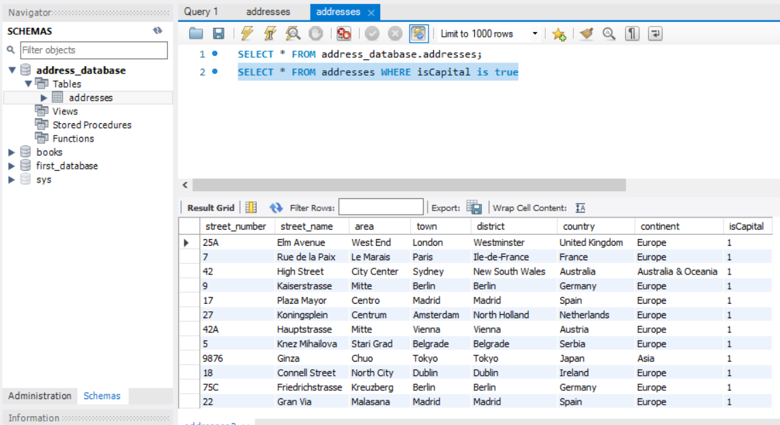

* + **SELECT all addresses from the `address` table that are located in South America.**

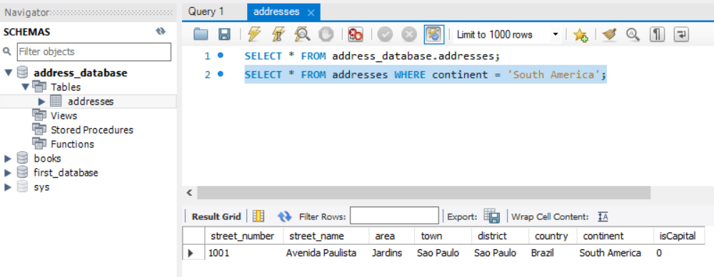

* + **SELECT all addresses from the `address` table that are located in Europe, but only in NON Capital cities.**

