# Lab: Lists

Problems for exercises and homework for the ["Programming Fundamentals" course @ SoftUni](https://softuni.bg/trainings/3731/programming-fundamentals-with-java-may-2022)

You can check your solutions in [Judge.](https://judge.softuni.bg/Contests/1295)

## Sum Adjacent Equal Numbers

Write a program to **sum all adjacent equal numbers** in a list of decimal numbers, starting from **left to right**.

* After two numbers are summed, the obtained result could be equal to some of its neighbors and should be summed as well (see the examples below).
* Always sum the **leftmost** two equal neighbors (if several couples of equal neighbors are available).

### Examples

|  |  |  |
| --- | --- | --- |
| **Input** | **Output** | **Explanation** |
| 3 3 6 1 | 12 1 | **3 3** 6 1 🡪 **6 6** 1 🡪 12 1 |
| 8 2 2 4 8 16 | 16 8 16 | 8 **2 2** 4 8 16 🡪 8 **4 4** 8 16 🡪 **8 8** 8 16 🡪 16 8 16 |
| 5 4 2 1 1 4 | 5 8 4 | 5 4 2 **1 1** 4 🡪 5 4 **2 2** 4 🡪 5 **4 4** 4 🡪 5 8 4 |
| 0.1 0.1 5 -5 | 0.2 5 -5 | **0.1 0.1** 5 -5 🡪 0.2 5 -5 |

## Gauss' Trick

Write a program that **sum** all **numbers in a list** in the following order:

first **+** last, first + 1 **+** last - 1,first + 2 **+** last **-** 2**,** … first + n, last - n.

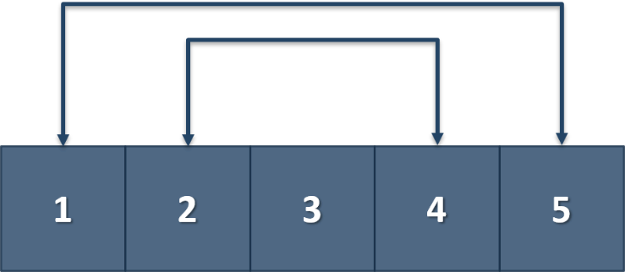

### Example

|  |  |
| --- | --- |
| **Input** | **Output** |
| 1 2 3 4 5 | 6 6 3 |
| 1 2 3 4 | 5 5 |

## Merging Lists

You are going to receive two lists with numbers. Create a result list that contains the numbers from both of the lists. The first element should be from the first list, the second from the second list, and so on. If the length of the two lists is not equal, just add the remaining elements at the end of the list.

### Examples

|  |  |
| --- | --- |
| **Input** | **Output** |
| 3 5 2 43 12 3 54 10 23  76 5 34 2 4 12 | 3 76 5 5 2 34 43 2 12 4 3 12 54 10 23 |
| 76 5 34 2 4 12  3 5 2 43 12 3 54 10 23 | 76 3 5 5 34 2 2 43 4 12 12 3 54 10 23 |

### Hint

* Read the two lists.
* Create a result list.
* Start looping through them until you reach the end of the smallest one.
* Finally, add the remaining elements (if any) to the end of the list.

## List Manipulation Basics

Write a program that reads a list of integers. Then until you receive **"end"**, you will be given different **commands:**

**Add {number}:** add a number to the end of the list

**Remove {number}:** remove a number from the list

**RemoveAt {index}:** remove a number at a given index

**Insert {number} {index}:** insert a number at a given index

**Note: All the indices will be valid!**

When you receive the **"end"** command print the **final state** of the list (**separated by spaces**).

### Examples

|  |  |
| --- | --- |
| **Input** | **Output** |
| 4 19 2 53 6 43  Add 3  Remove 2  RemoveAt 1  Insert 8 3  end | 4 53 6 8 43 3 |
| 12 34 100 1 45 2 8  Add 30  Remove 12  Remove 3  RemoveAt 3  Insert 2 3  end | 34 100 1 2 2 8 30 |

## List Manipulation Advanced

Now we will implement more complicated list commands. Again, read a list, and until you receive **"end"** read commands:

**Contains {number}** – check if the list contains the number. If **yes** print **"Yes**", **otherwise** print **"No such number"**

**Print even** – print **all the numbers** that are **even** **separated by a space**

**Print odd** – print **all the numbers** that are **oddly separated by a space**

**Get sum** – print the **sum of all the numbers**

**Filter {condition} {number}** – print all the numbers that **fulfill that condition**. The condition will be either **'<'**, **'>', ">=", "<="**

### Examples

|  |  |
| --- | --- |
| **Input** | **Output** |
| 2 13 43 876 342 23 543  Contains 100  Contains 543  Print even  Print odd  Get sum  Filter >= 43  Filter < 100  end | No such number  Yes  2 876 342  13 43 23 543  1842  43 876 342 543  2 13 43 23 |
| 12 3 123 546 222 45 7  Contains 3  Contains 121  Print even  Print odd  Get sum  Filter >= 100  Filter < 45  end | Yes  No such number  12 546 222  3 123 45 7  958  123 546 222  12 3 7 |

## List of Products

Read a number **n** and **n lines of products**. Print a **numbered list** of all the products **ordered by name**.

### Examples

|  |  |
| --- | --- |
| **Input** | **Output** |
| 4  Potatoes  Tomatoes  Onions  Apples | 1.Apples  2.Onions  3.Potatoes  4.Tomatoes |
| 3  Orange  Grape  Strawberry | 1.Grape  2.Orange  3.Strawberry |

## Remove Negatives and Reverse

Read a **list of integers**, **remove all negative numbers** from it and print the remaining elements in **reversed order**. In case of no elements left in the list, print "empty".

### Examples

|  |  |
| --- | --- |
| **Input** | **Output** |
| 10 -5 7 9 -33 50 | 50 9 7 10 |
| 7 -2 -10 1 | 1 7 |
| -1 -2 -3 | empty |