1Kubernetes

Topic1

0. install Minikube and kubectl on your local machine and
- Show your Kubernetes version
- List available nodes on your Kubernetes 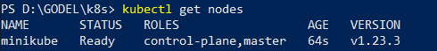
- List resources available on nodes 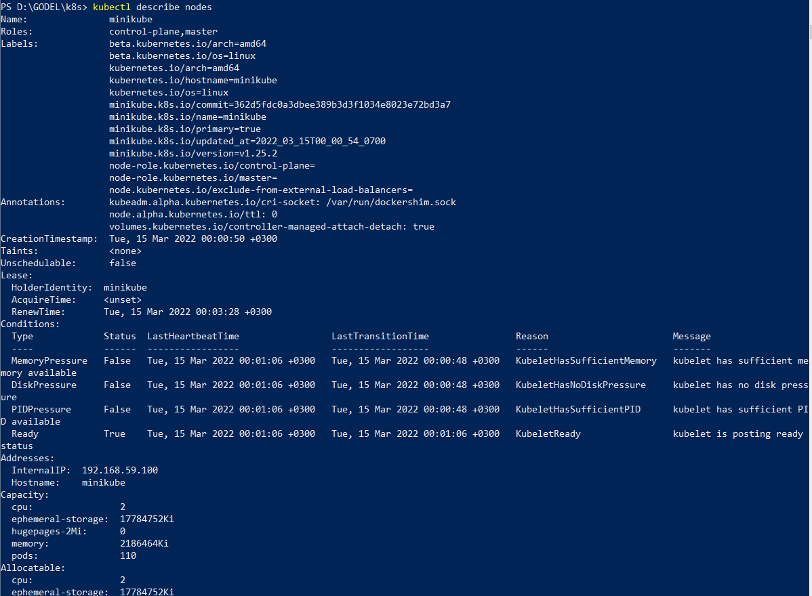
Refer https://kubernetes.io/docs/tasks/tools/install-minikube/ for Minikube/ Kubectl installation instructions
Refer https://kubernetes.io/docs/reference/kubectl/cheatsheet/ for the main kubectl commands.

1. Use Kubectl to deploy a test application “hello-kubernetes” v.1.4 to Minikube (--image=paulbouwer/hello-kubernetes:1.4), open port 8080
2. Verify that the app:
- is properly deployed by inspecting its deployment object in yaml format
- 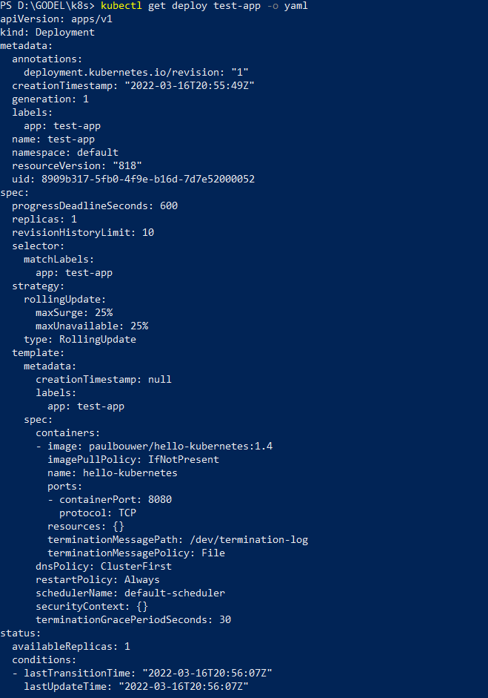
- is running by listing and describing its pod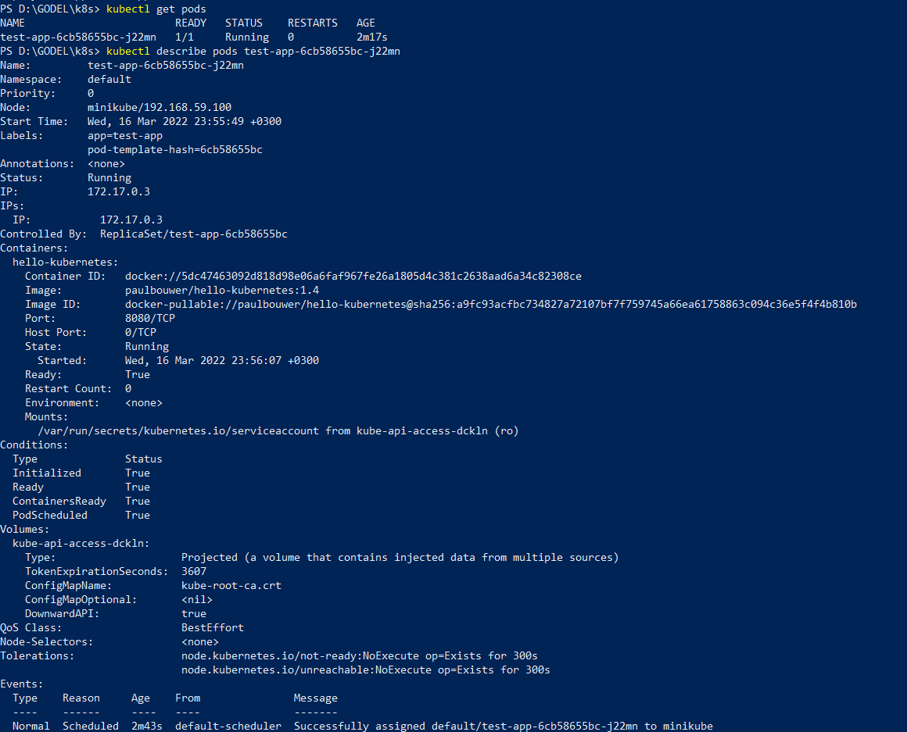
3. Proxy the app to your local machine on any port and access its API page from your browser
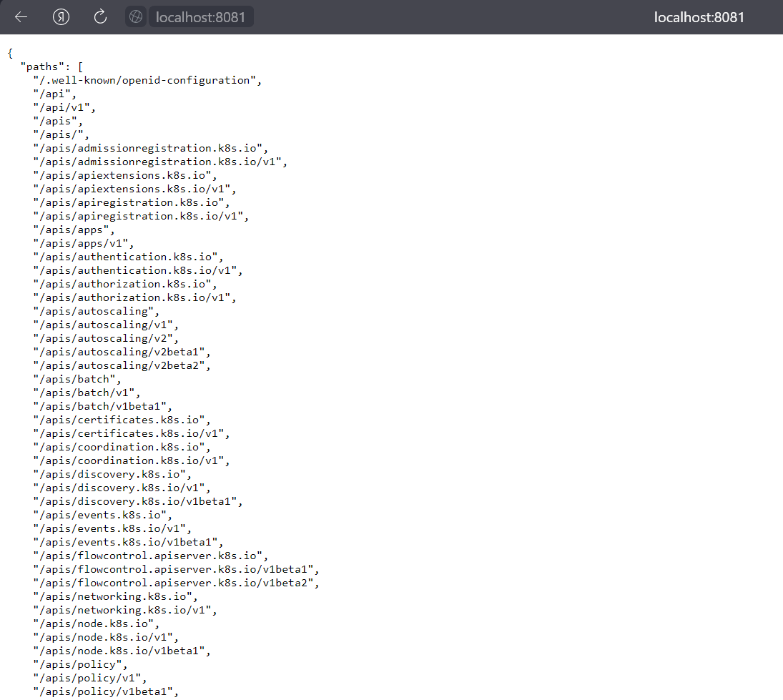

4. Scale the deployed application up to 3 replicas, and after scale it down to a single replica again:
- by using kubectl command (kubectl scale) 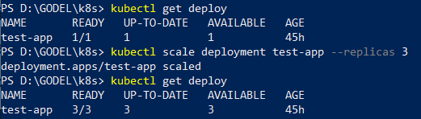
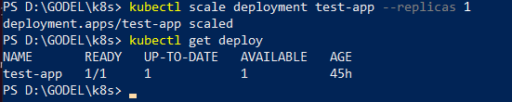
- by editing its its deployment object using Nano as the editor
4. Update the containerized application with a new software version (1.5).
- by using kubectl command
- by editing its its deployment object using Nano as the editor
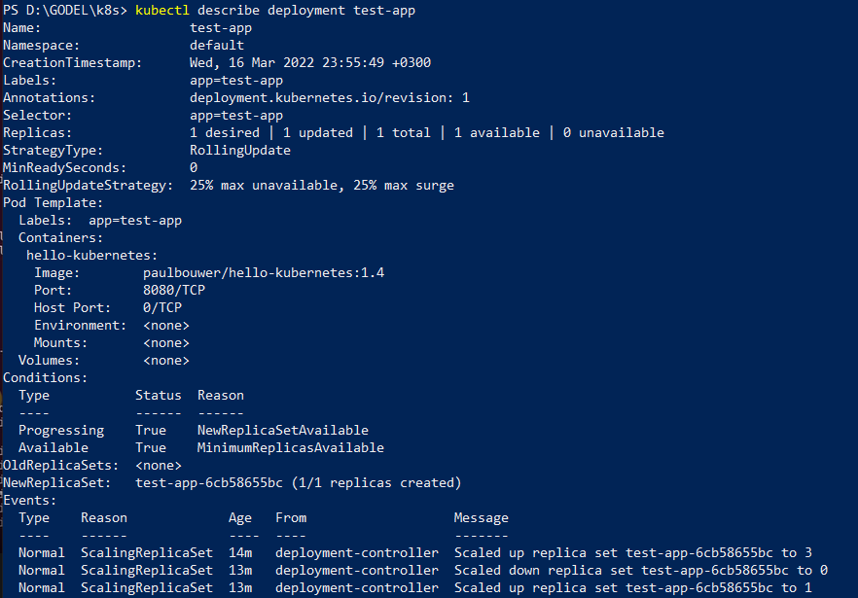
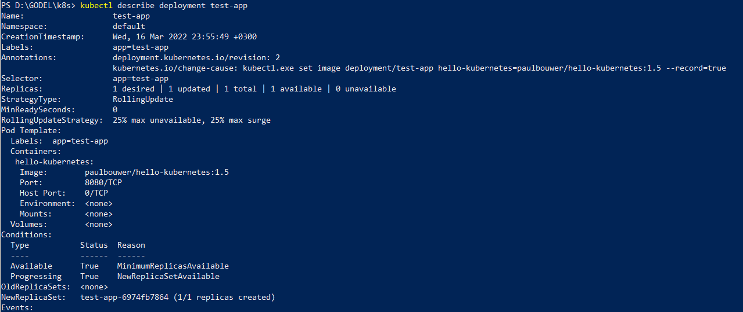
5. Read logs of the application.
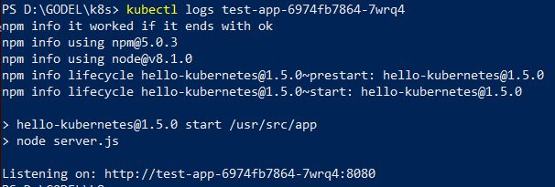

Topic 2
As a result of this topic you will learn how to deploy Wordpress and MySQL as micro services and expose Wordpress to outer network using Nginx Ingress Controller by means of writing static manifests.
Use Minikube installed during the previous Topic. Run “minikube delete”, to reset your local Kubernetes.

1. Create a Secret for MySQL Password
- Encode (base 64) password “admin”
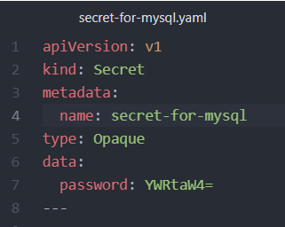
- Create a secret object (use secret.yaml as a template) and set the Base64 encoded password
Refer to https://kubernetes.io/docs/concepts/configuration/secret/ for more info on Kubernetes secrets
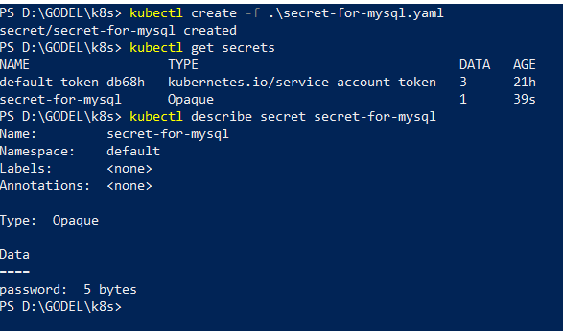
2. Deploy Persistent Volumes for WordPress & MySQL (use pv.yaml as a template) with the following spec:
- storage: 1Gi (for Both)
- accessModes: ReadWriteMany (for Both)
- storageClassName: standard (for Both)
- hostPath: /data/html (for Wordpress)
- hostPath: path: /data/mysql (for MySQL)
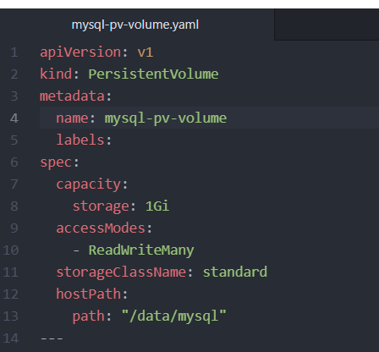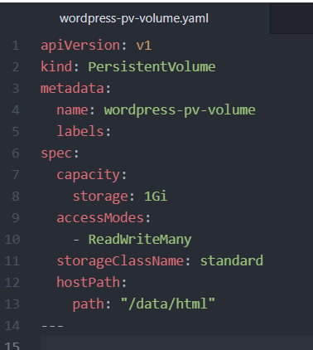

3. Deploy Persistent Volume Claims for WordPress & MySQL (use pvc.yaml as a template)
Refer to https://kubernetes.io/docs/concepts/storage/persistent-volumes/ for more info on Kubernetes persistent volumes.
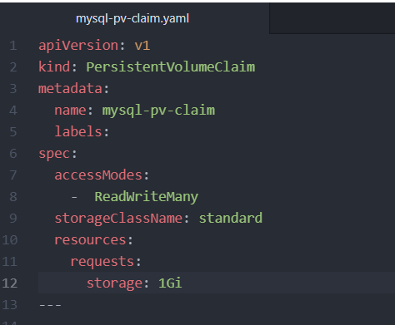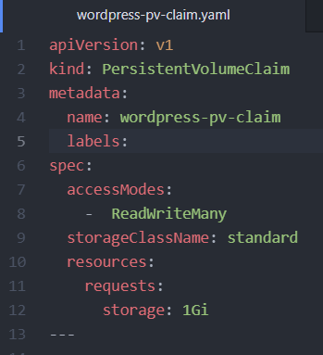

4. Deploy MySQL (use deployment.yaml and svc.yaml as templates for your manifests)
The Service
- maps MySQL’s port 3306 and
- makes it available for all containers with the labels app:wordpress and tier:mysql
- has type “ClusterIP”
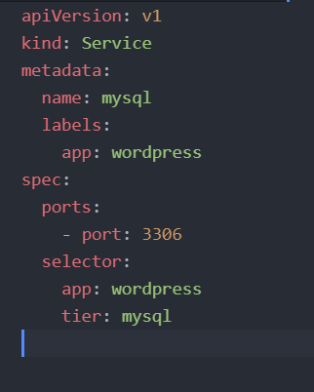
The Deployment declares the creation strategy and specs of MySQL container:
- it’s an image from the Docker Hub: mysql:5.6
- it has app:wordpress and tier:mysql (used in Service)
- it contains an environment variable called MYSQL_ROOT_PASSWORD which holds the value from our secret password
- it has an open port 3306
- it has a volume claim mounted in /var/lib/mysql. 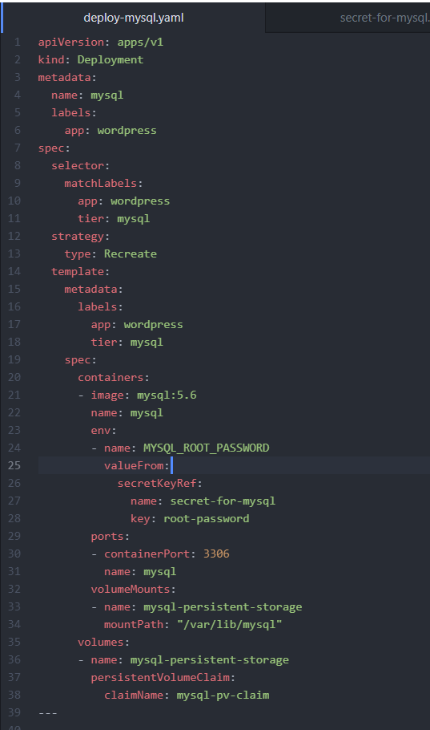

Refer to:
- https://kubernetes.io/docs/concepts/services-networking/service/ for more info about services
- https://kubernetes.io/docs/concepts/workloads/controllers/deployment/ for more info about deployments

5. Deploy WordPress (use deployment.yaml and svc.yaml as templates for your manifests)
The Service:
- maps port 80 of the container to the node’s external IP:Port
- makes it available for all containers with the labels app:wordpress and tier:frontend
- has type “LoadBalancer”
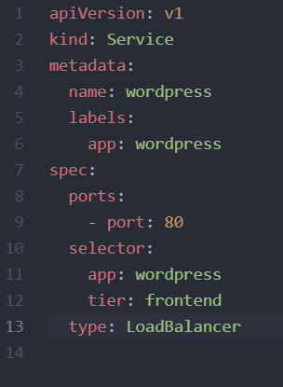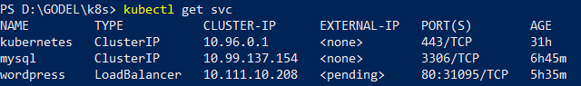

The Deployment declares the creation spec of our WordPress container:
- it’s an image from the Docker Hub: wordpress:4.8-apache
- it has app:wordpress & tier:frontend labels (used in Service)
- it has an open port 80
- it has a volume claim mounted in /var/www/html from which the WP sources are served.
Refer to:
- https://kubernetes.io/docs/concepts/services-networking/service/ for more info about services
- https://kubernetes.io/docs/concepts/workloads/controllers/deployment/ for more info about deployments
- 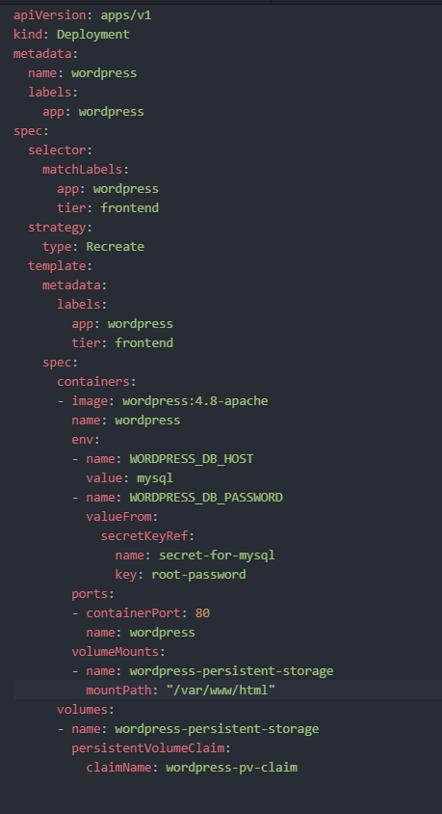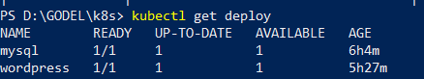
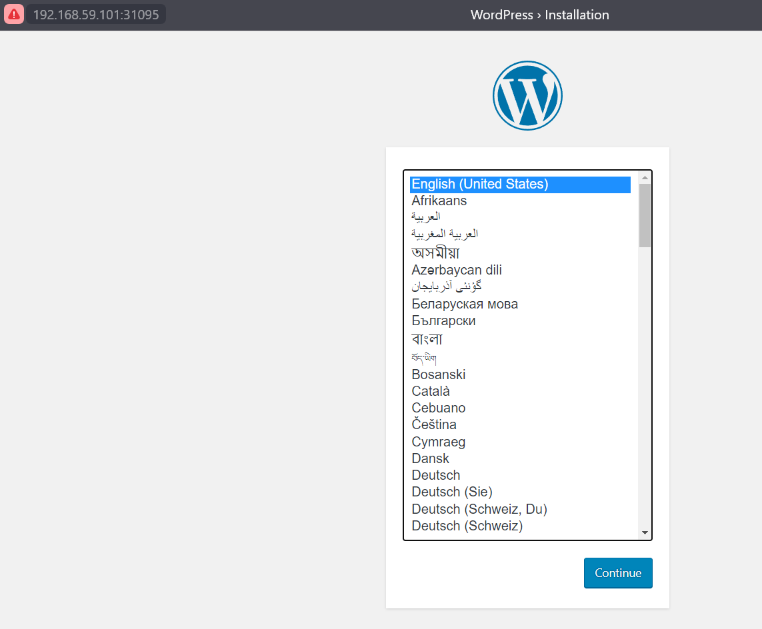
6. Deploy Nginx ingress controller to your minikube
- Refer to https://github.com/kubernetes/ingress-nginx/blob/master/docs/deploy/index.md for deployment instructions
- Expose service of the Ingress controller outside of Minikube by running “minikube service” command.
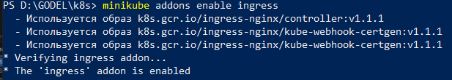
7. Create an ingress object to expose Wordpress to outer network using Nginx Ingress Controller (use ingress.yaml as a template for your manifest)
Refer to https://kubernetes.io/docs/concepts/services-networking/ingress/ for more info about Ingress
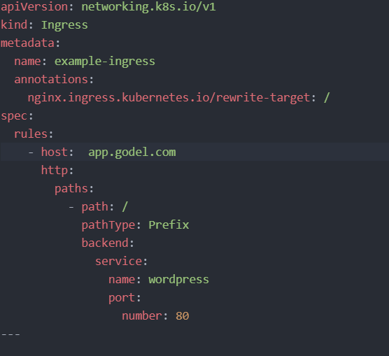
8. Acess WordPress from your Browser and do initial configuration.
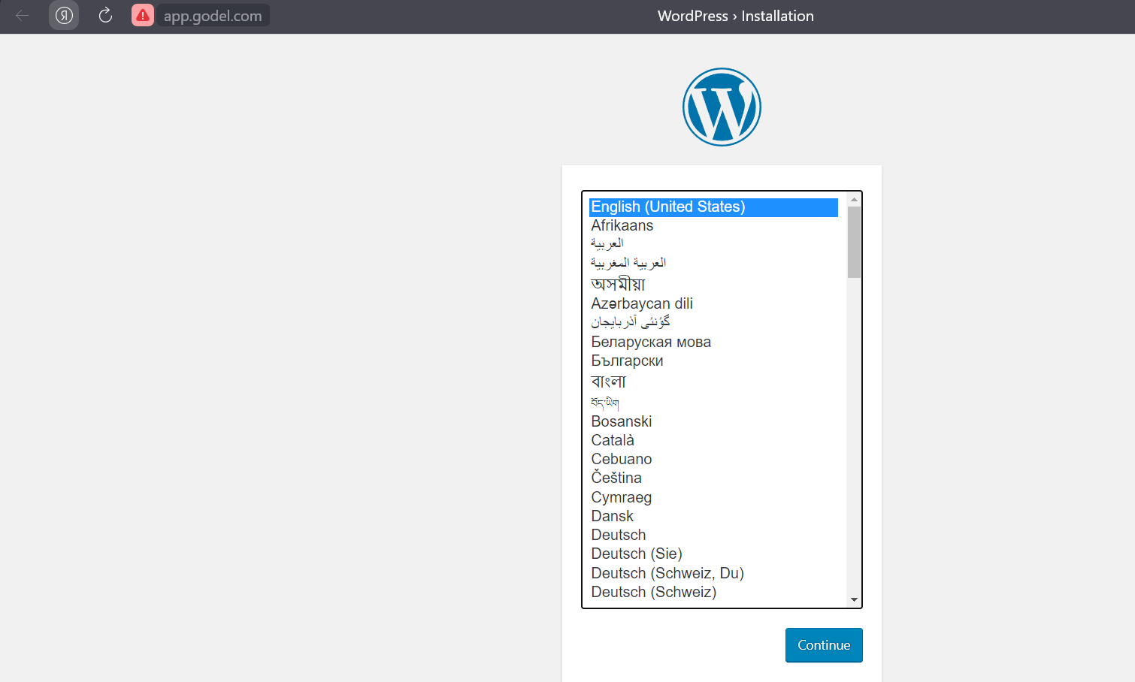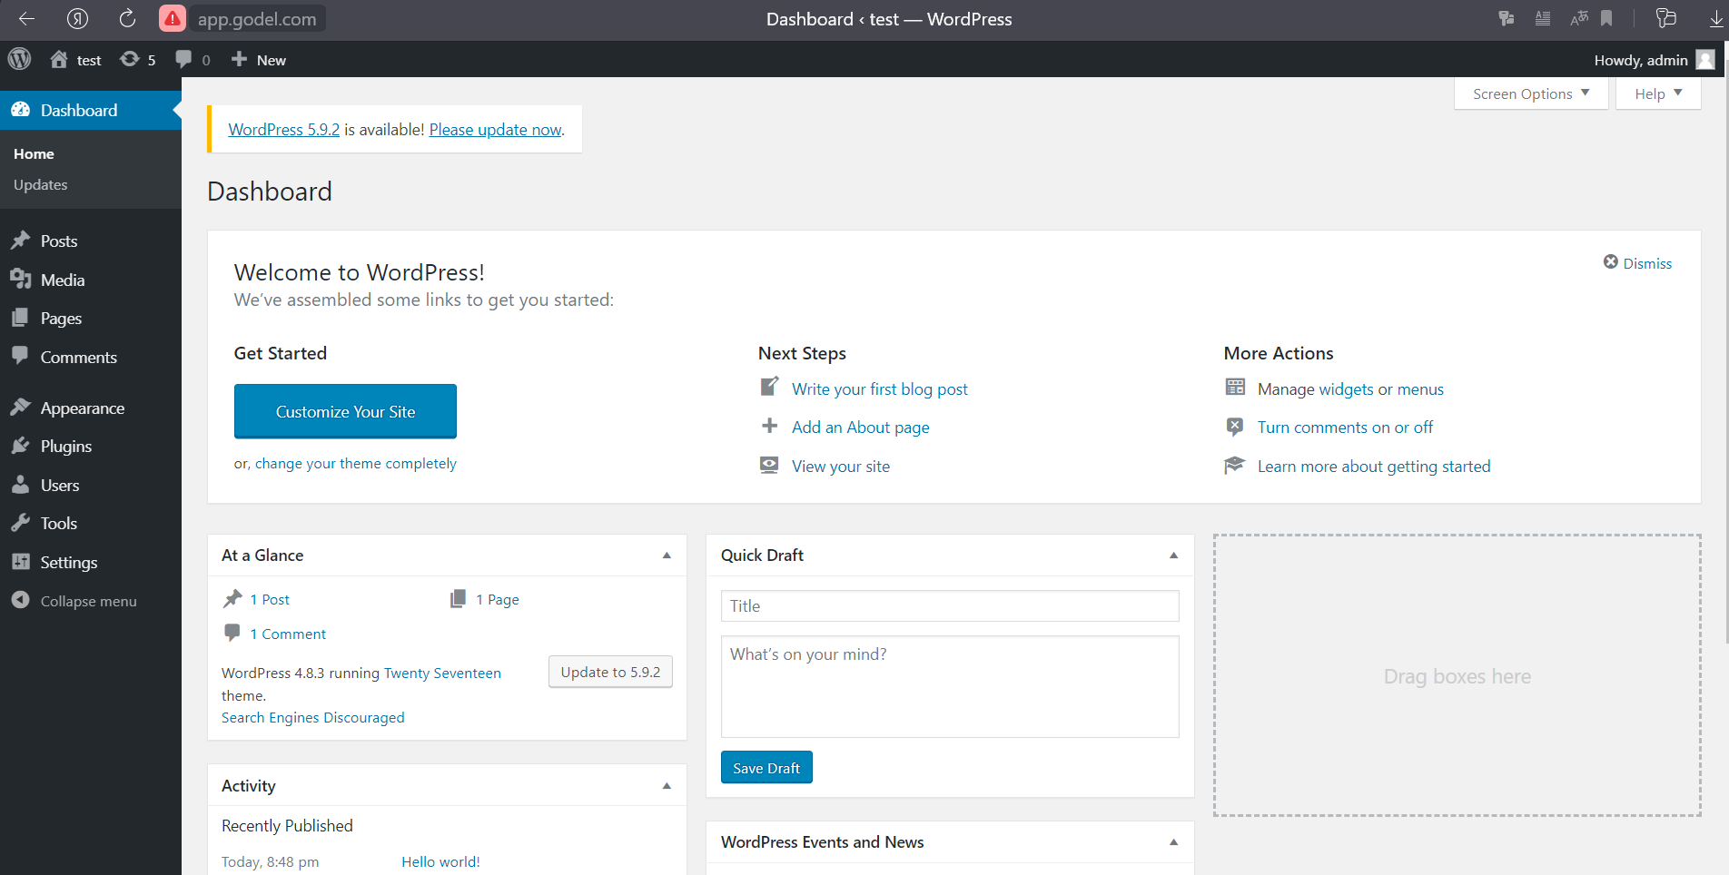
9. Upload manifests and report to Github

Topic 3
0. Install minikube and start it with version 1.15.5
1. Install and initialize helm
- refer https://helm.sh/docs/using_helm/#installing-helm for installation instructions
2. Verify that helm and Tiller have been successfully installed and are operational
- refer https://helm.sh/docs/using_helm/#using-helm for basic concepts and CLI commands
3. Refresh repositories and deploy Nginx Ingress controller from a public repository
- refer https://kubernetes.github.io/ingress-nginx/deploy/#using-helm for installation instructions.
Refer https://www.baeldung.com/kubernetes-helm to learn more about Helm functionality and use information to complete the bellow instructions.
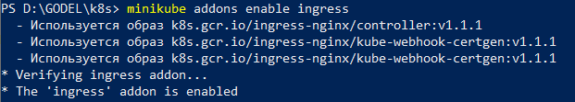
4. Create a new empty local Chart named “godel-wordpess”.
5. Fill the created Chart with the values of Wordpress and MySQL manifests so that in the result you will get a Helm Chart which will deploy and configure Wordpress, MySQL and their respective dependencies to your Minikube as well as proxy them trough the Nginx instance you deployed at Step 3 of this Topic.
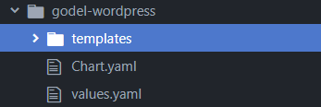
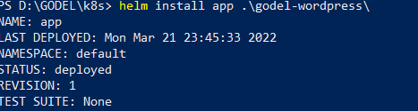
- Wordpress version should be 5.1.0! 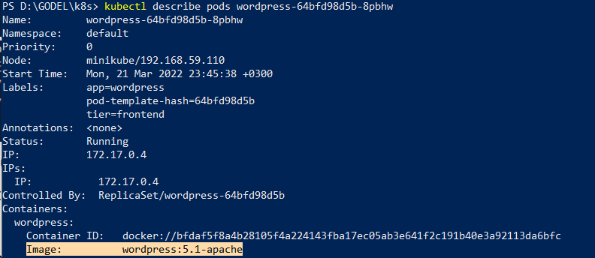

6. Verify your Chart using helm lint and by manual inspection of deployment manifests.
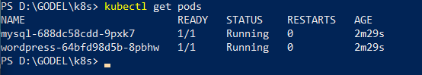
7. Create a private repository on your GitHub account and push your “godel-wordpess” Helm Chart there.
8. Deploy the “godel-wordpess” Helm Chart from your private repository to Minikube
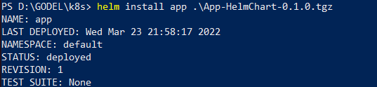
9. List your release in Minikube
10. Edit your Helm Chart upgrading Wordpres to the “latest” version.
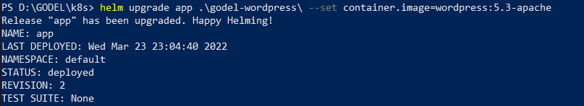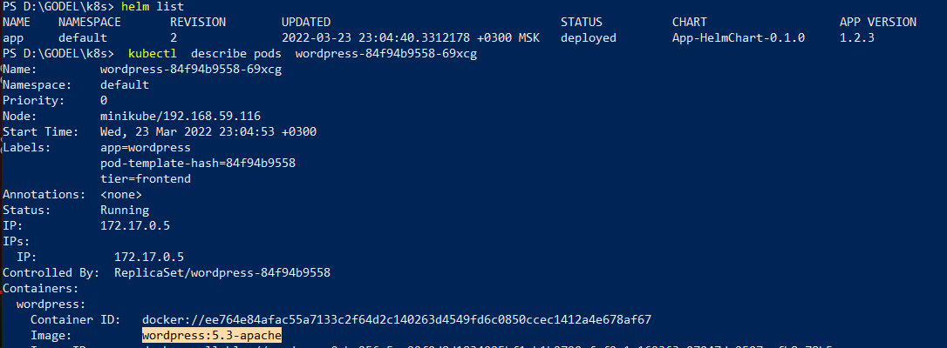
11. Rollback your release to the previous state. 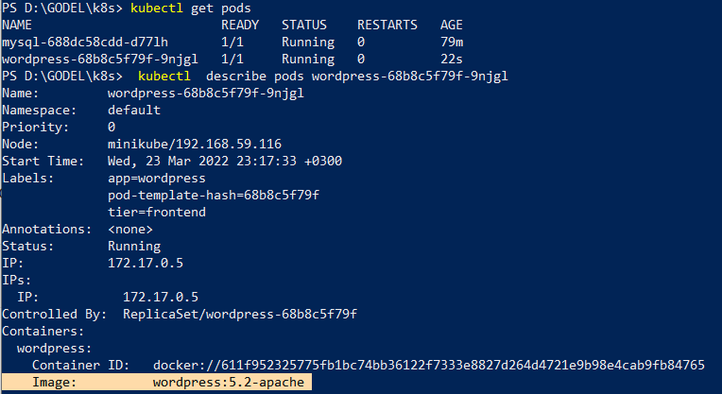
12. Upload a copy of your “godel-wordpess” Helm Chart and report to Github.

