Modified Wave Spectrum

SIMULATION
Wind speed is equal to 5 m/s, dimensionless wind fetch 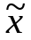=20170, radar wave length LL=0.1m.

- 1D wave spectrum (unidirectional spectrum)
  - Superposition of sinusoidal waves
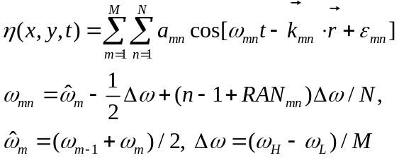
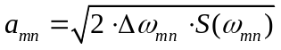
See TestSimu_New1.m
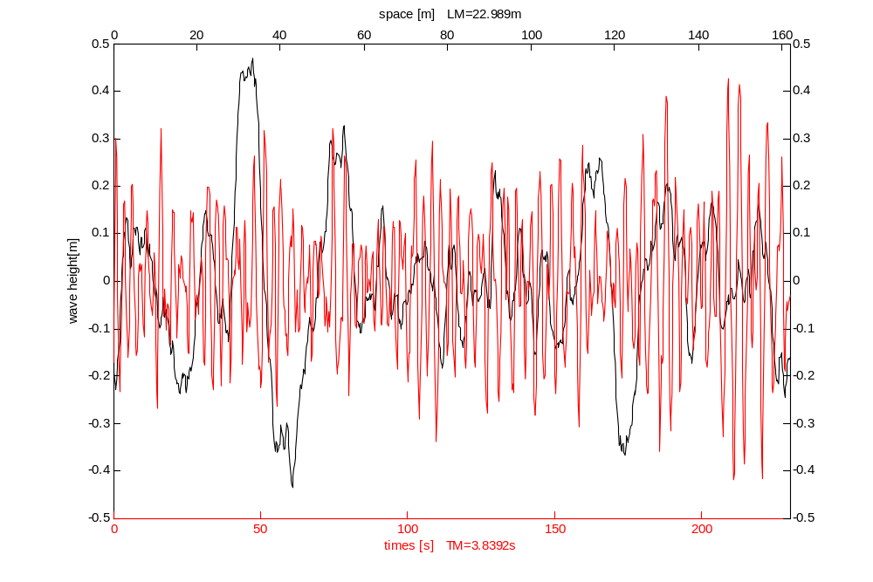
  - Numerical realization of sea surface (height).
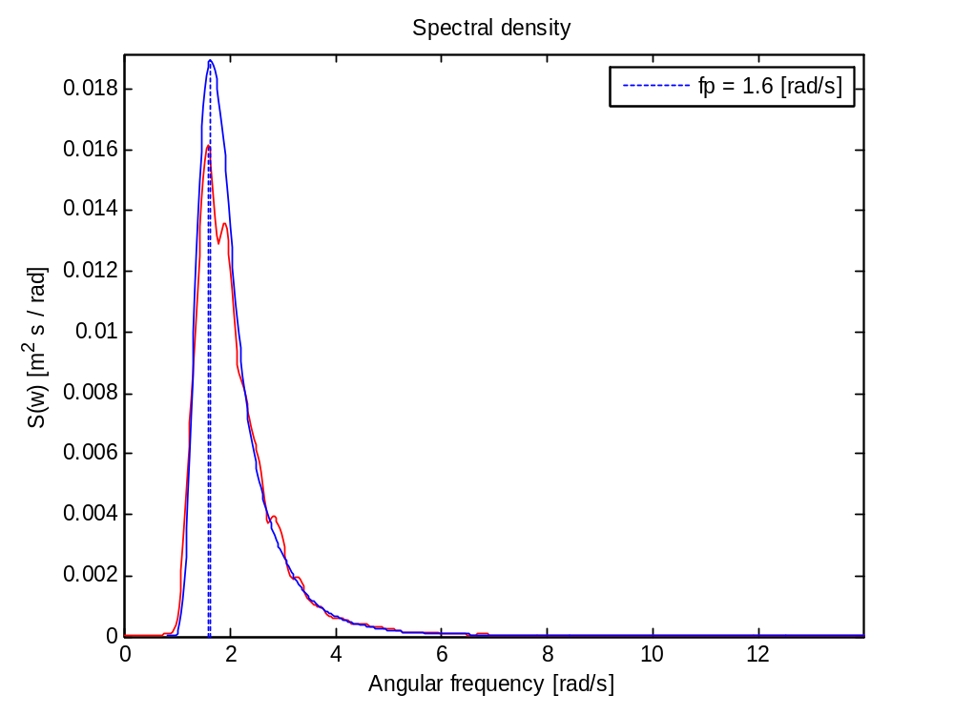
  - Wave spectrum from simulated sea surface in comparison with input spectrum

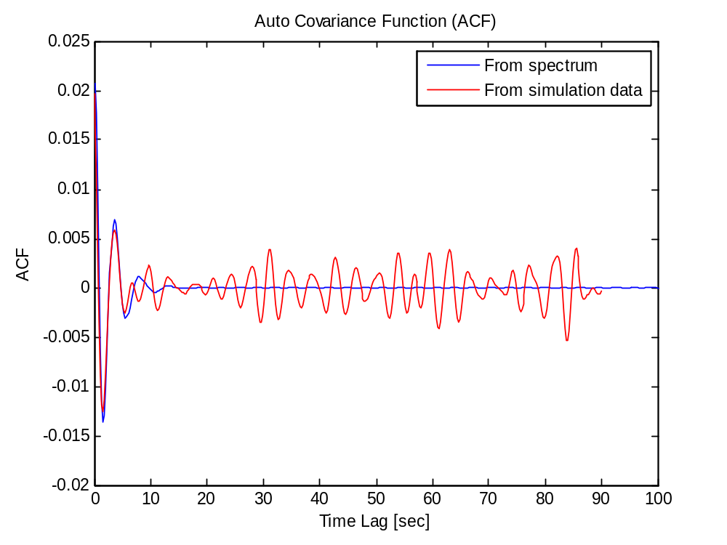
  - Comparison of correlation functions of height calculated from wave spectrum and from simulated sea surface.
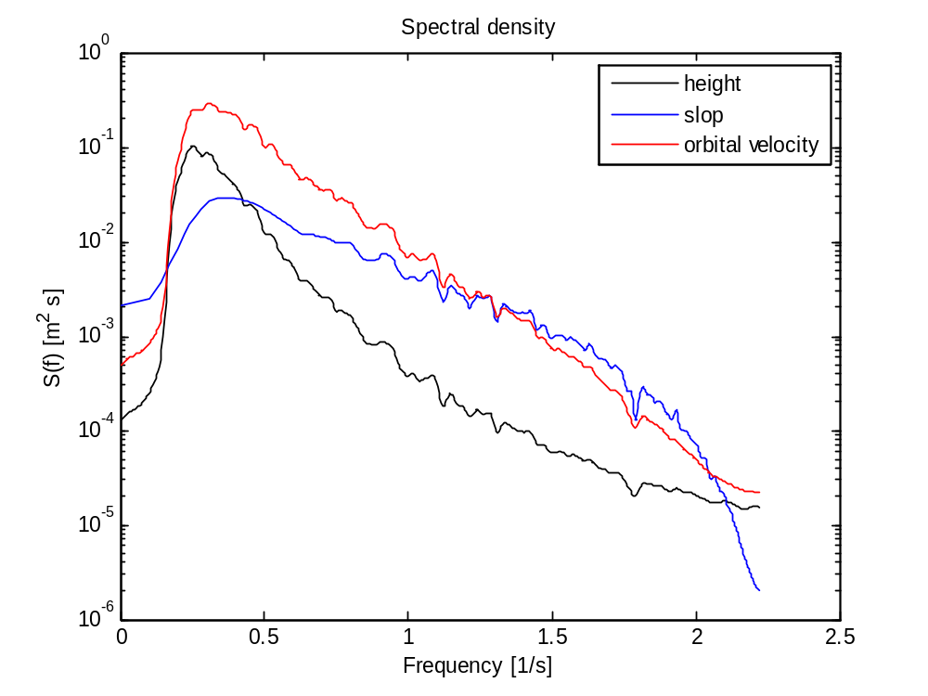
  - spectrum of height, slop and orbital velocity from simulated sea surface.

  - FFT method
See TestSimu_New2.m
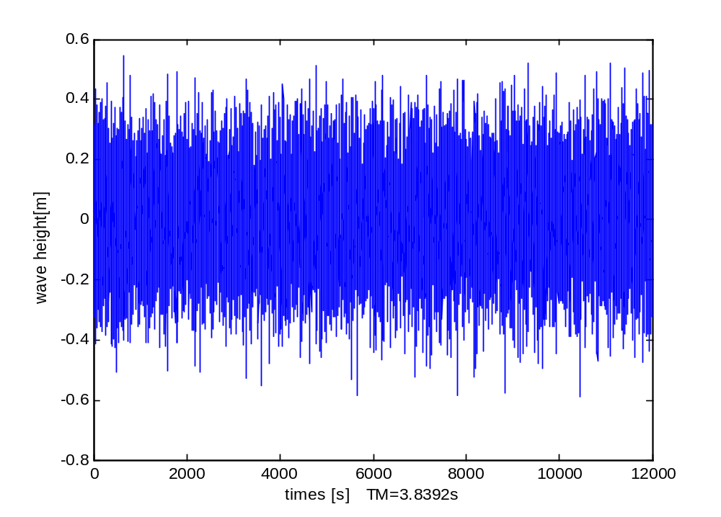
  - Numerical realization of sea surface (height).
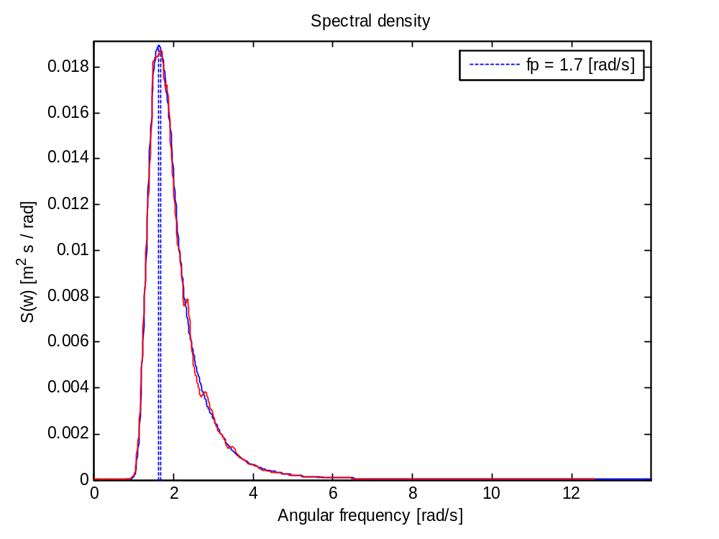
  - Wave spectrum from simulated sea surface in comparison with input spectrum
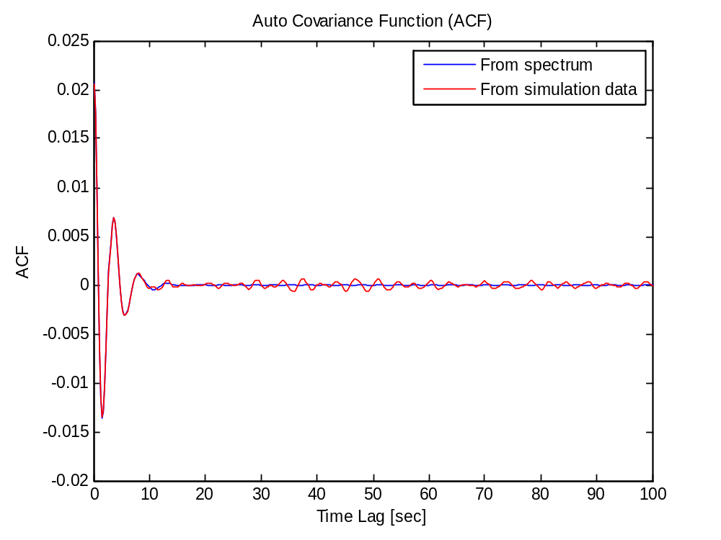
  - Comparison of correlation functions of height calculated from wave spectrum and from simulated sea surface.
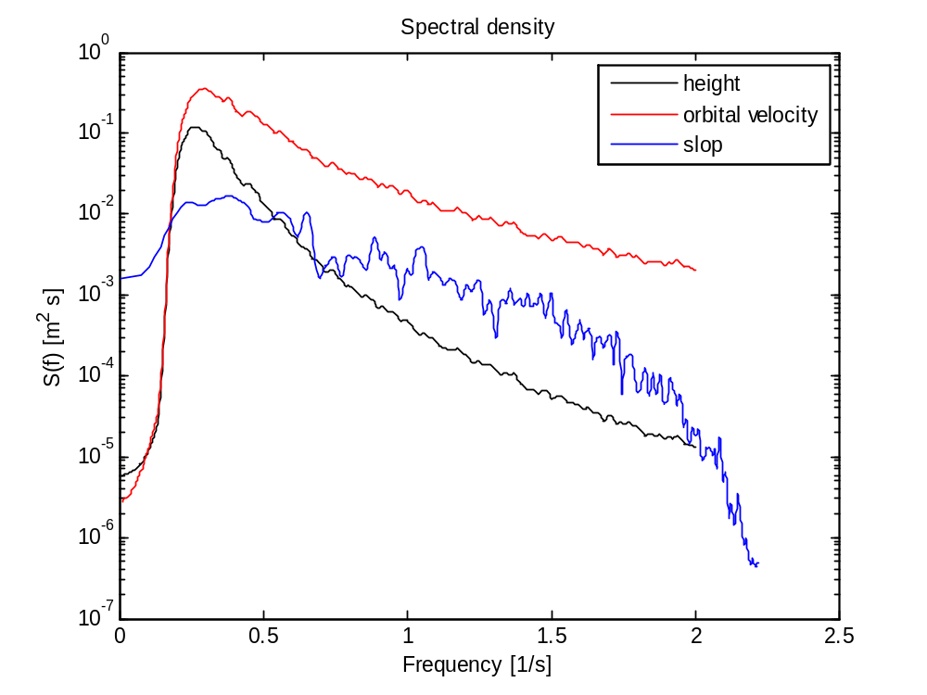
  - spectrum of height, slop (slop from 2D simulation) and orbital velocity from simulated sea surface.

- 2D wave spectrum (omnidirectional spectrum)
  - Superposition of simusoidal waves
See TestSimu_cos.m
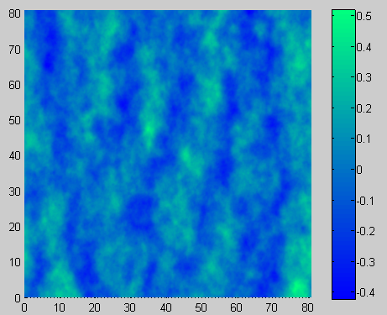
  - FFT
See TestSimu_seasim.m
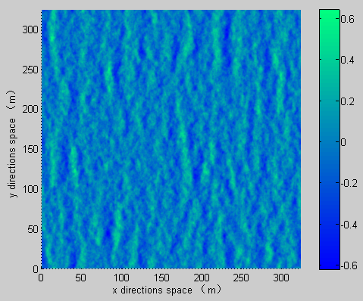
  - Sea surface
