Modified Wave Spectrum

SIMULATION
Wind speed is equal to 5 m/s, dimensionless wind fetch 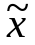=20170, radar wave length LL=0.1m.

I have checked your calculations of variance of heights and slopes. It is correct result.

- 1D wave spectrum (unidirectional spectrum)
  - Superposition of sinusoidal waves

See TestSimu_New1.m

  - Numerical realization of sea surface (height).

I see black and red lines in Fig.1. What’s it?

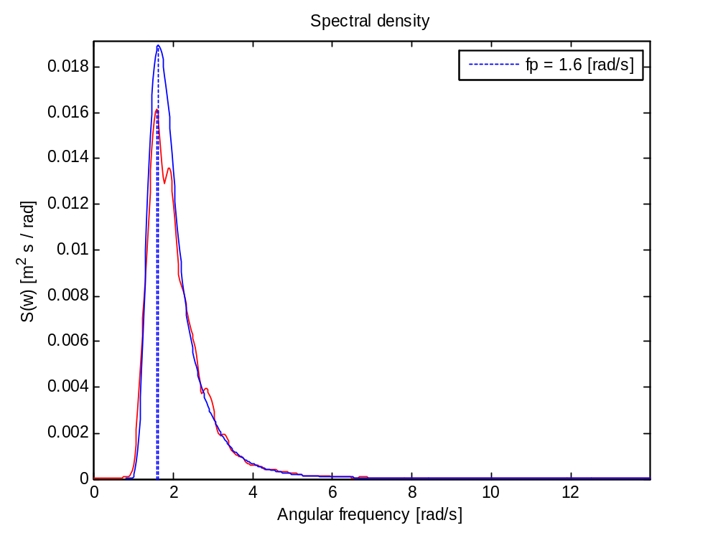
  - Wave spectrum from simulated sea surface in comparison with input spectrum

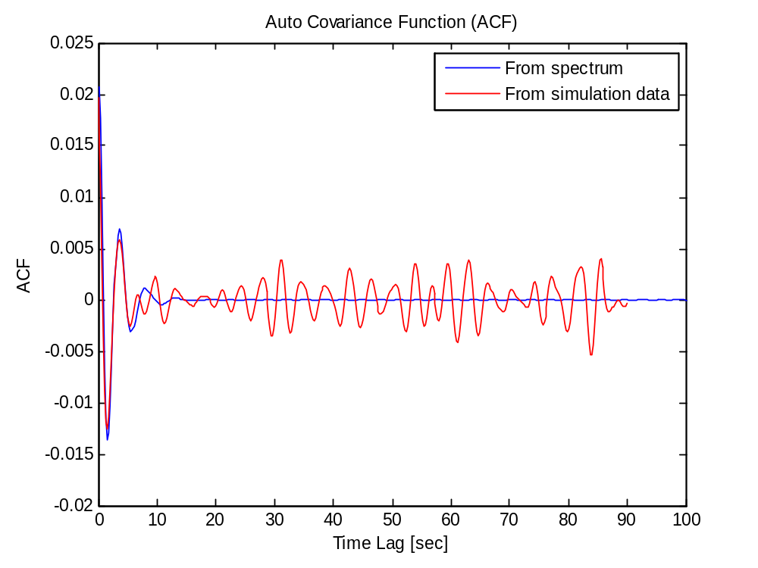
  - Comparison of correlation functions of height calculated from wave spectrum and from simulated sea surface.

Please, compare the input correlation function of slopes and input spectrum of slopes with results of simulation (fig. 2a and fig 3a).
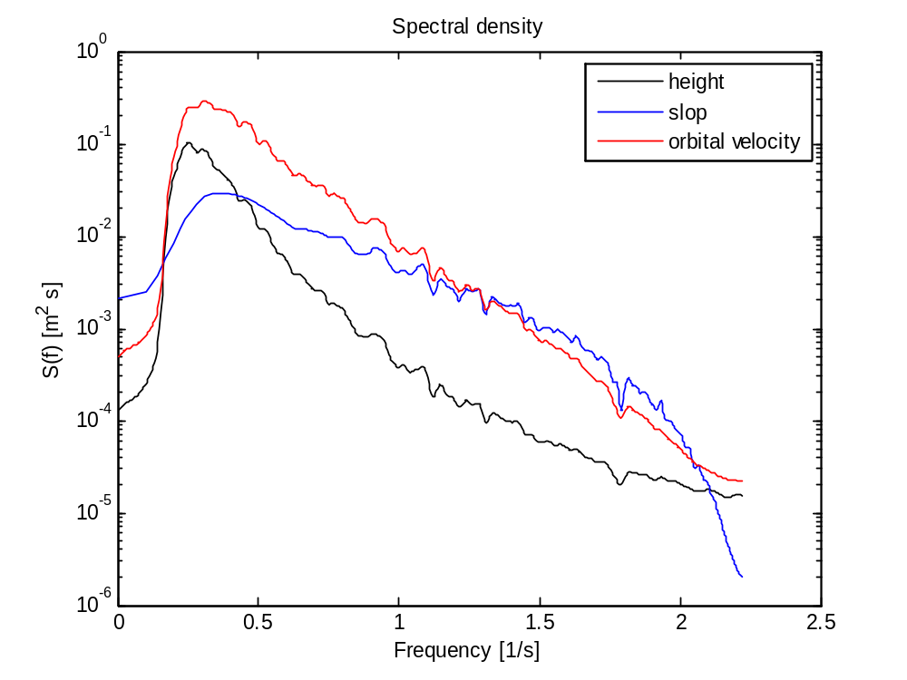
  - spectrum of height, slop and orbital velocity from simulated sea surface.

Please, increase a frequency interval until 3 Hz. Also, please, plot new three figures (input spectrum of heights compare with simulated, input spectrum of slopes and simulated, input spectrum of orbital velocity with simulated).

Did you use the different number of harmonics in superposition and FFT method? Please, compare the results of simulation for same harmonics in both approaches (correlation functions and spectrums). Which difference exist in time of calculations for these approaches?

  - FFT method
See TestSimu_New2.m

  - Numerical realization of sea surface (height).
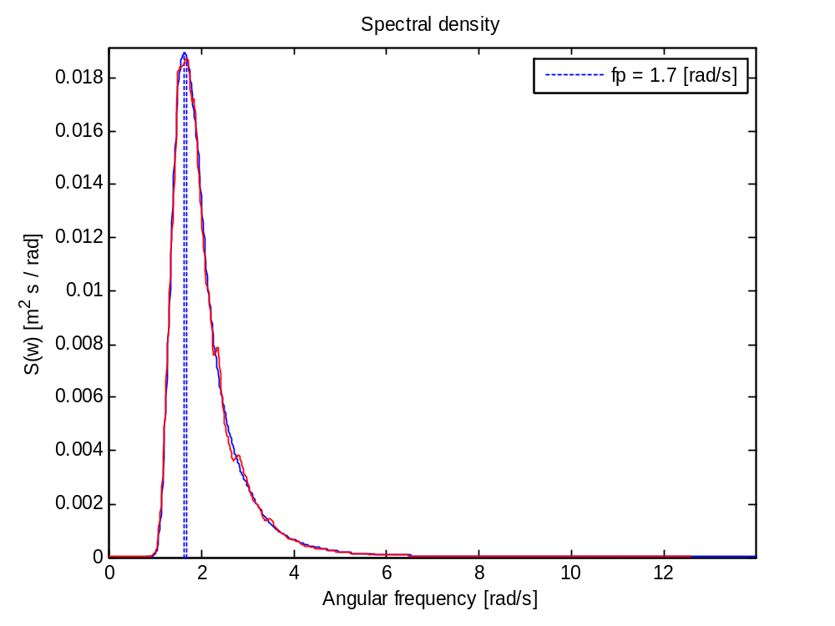
  - Wave spectrum from simulated sea surface in comparison with input spectrum
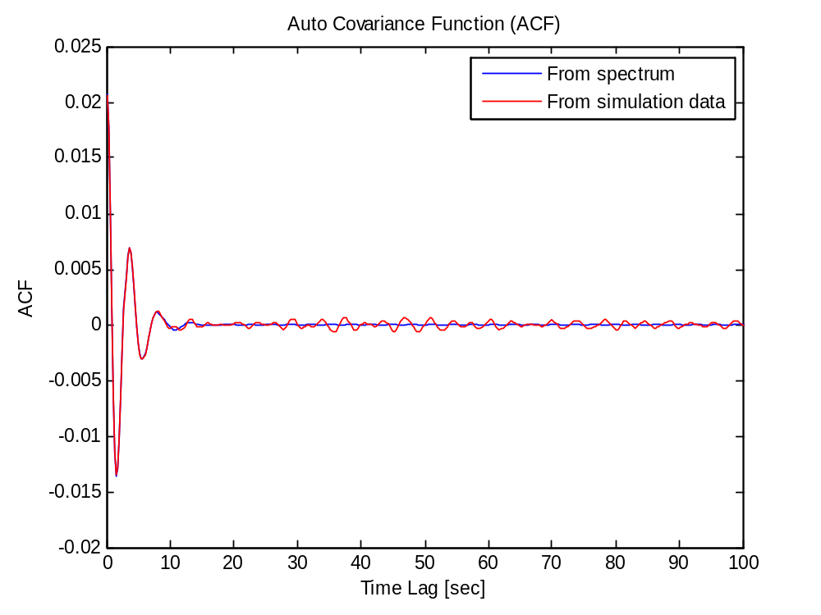
  - Comparison of correlation functions of height calculated from wave spectrum and from simulated sea surface.
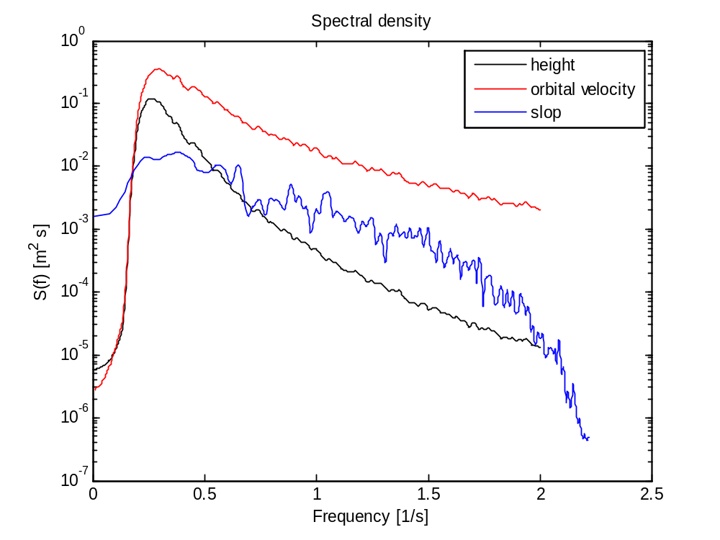
  - spectrum of height, slop (slop from 2D simulation) and orbital velocity from simulated sea surface.

The same remarks as early : increasing of frequency and adding of new figures. Why is not good result for spectrum of slopes?

- 2D wave spectrum (omnidirectional spectrum)
  - Superposition of simusoidal waves
See TestSimu_cos.m
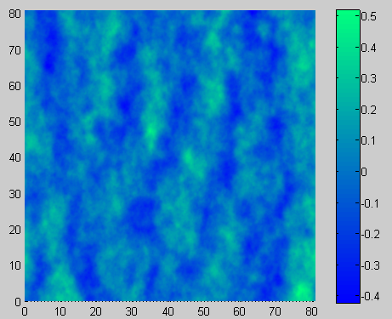
  - FFT
See TestSimu_seasim.m
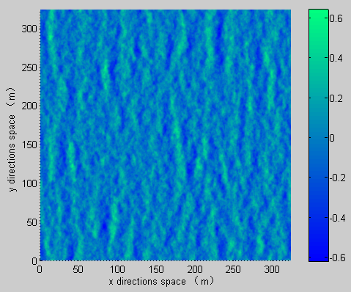
  - Sea surface
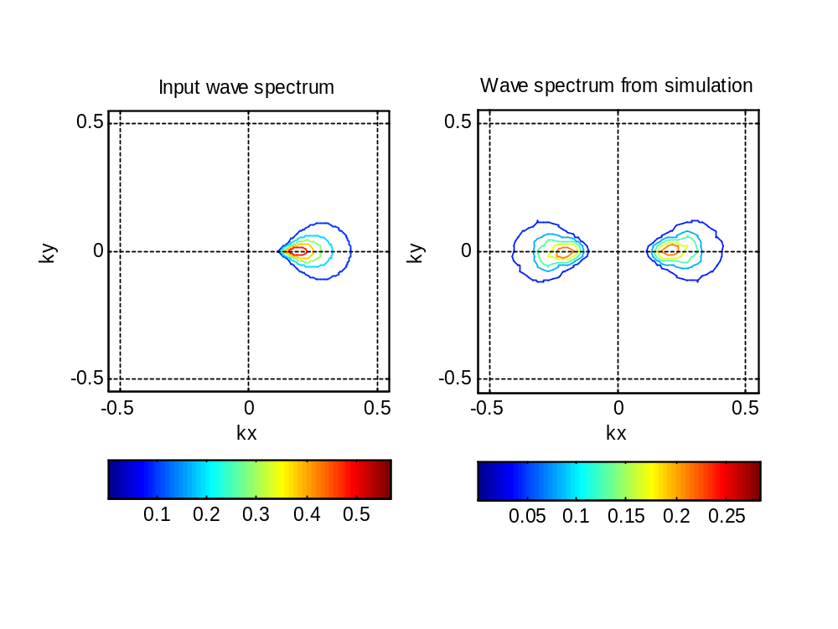

You may remove the negative kx for simulation case and to find the difference between theory and simulation spectrums.

Program TestSimu_New1 is not working. Please, see error.

??? Undefined function or variable 'gravity'.

Error in ==> k2w at 49
g=gravity;

Error in ==> TestSimu_New1 at 20
Wmin=k2w(Kmin);

Best wishes, Vladimir

