Modified Wave Spectrum

SIMULATION

It is interesting to compare simulation for same number of harmonics.

Let’s take N = 128, 256 and 512.

Wind speed is equal to 5 m/s, dimensionless wind fetch 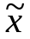=20170, radar wave length LL=0.1m.

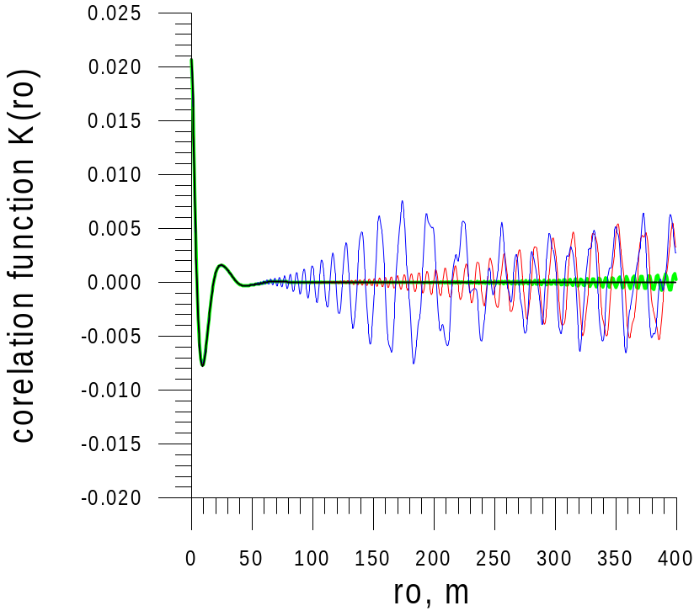

Fig.1 comparison of correlation functions of height calculated from wave spectrum and from numerical model (blue line – 128 harmonics, red line – 256 and green line – 512).

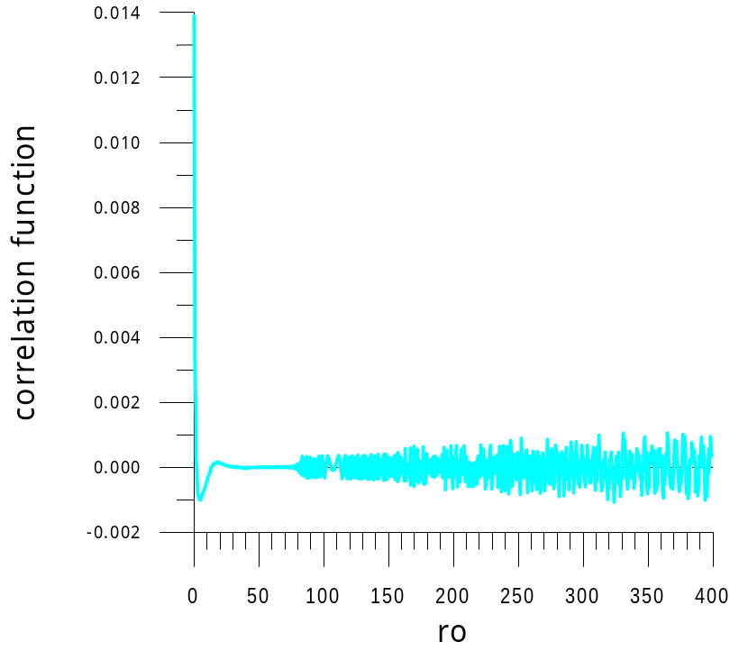

Fig.2 comparison of correlation functions of slopes calculated from wave spectrum and from numerical model (512 harmonics).
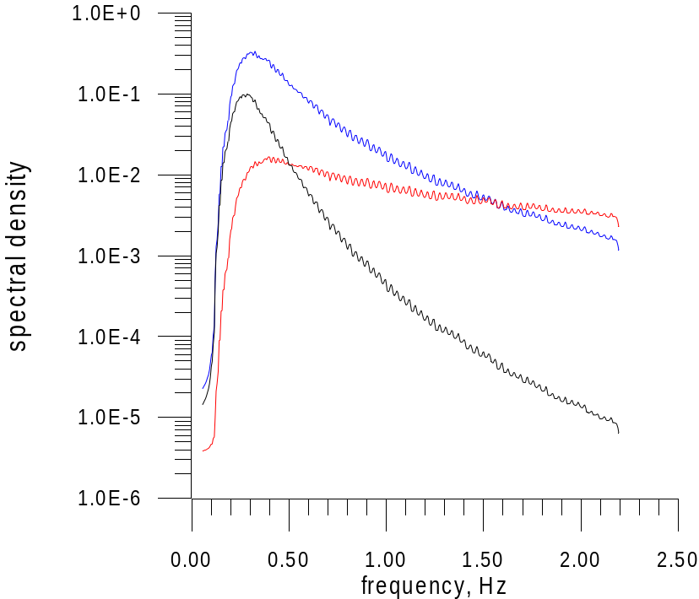

Fig.3 Spectrums of heights (black line), slopes .(red line), orbital velocities (blue line) calculated from simulated surface.

I think that you may repeat calculations for 128, 256 and 512 harmonics using both your methods. We will compare results.

We will prepare the explanation for other our approach for simulations.

Best wishes, Vladimir

