UI Mockups

These mockups were made in a tool pencil: <http://pencil.evolus.vn/> that is free and open source.

**Master Server:  
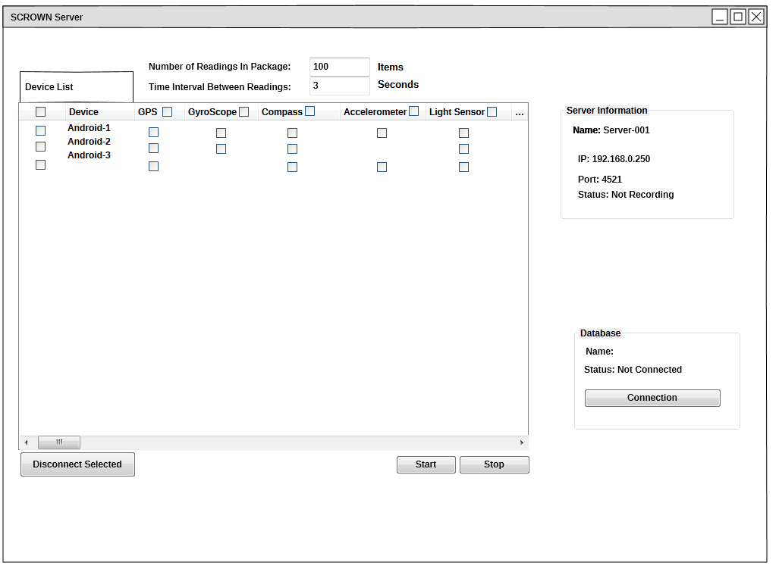**

User sees this when Server has been first started, devices begin connecting and disconnecting automatically

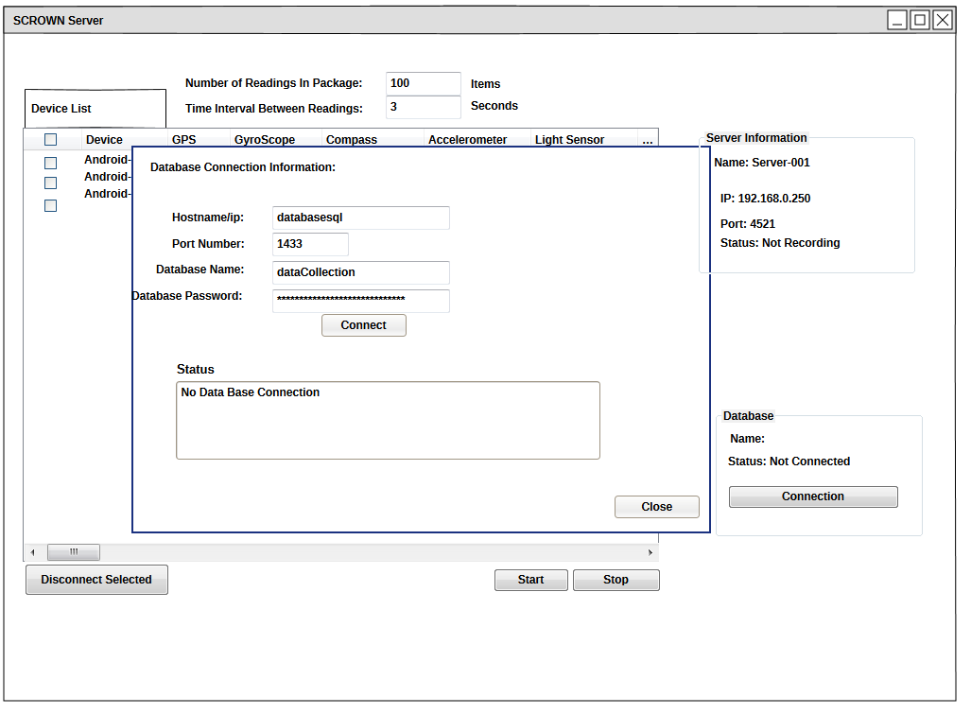

Database connection information entered

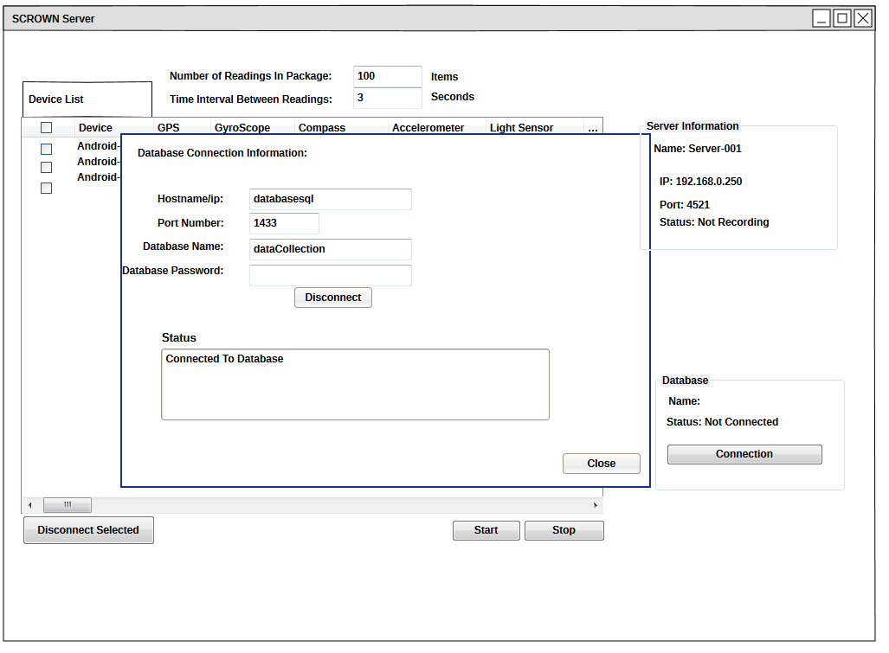

Successful connection

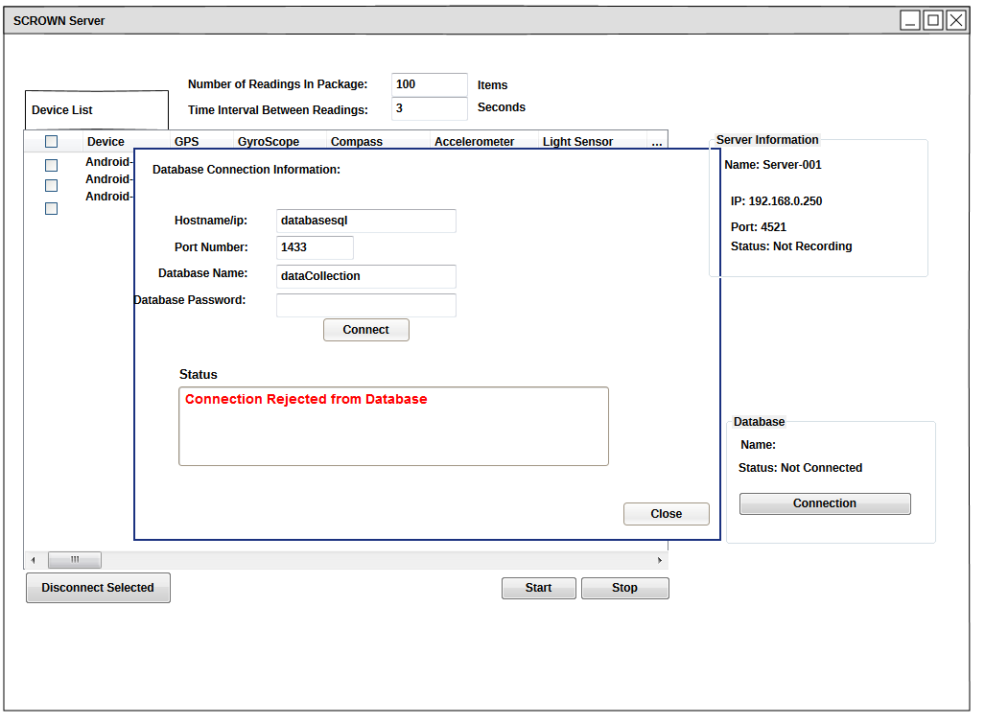

Failed connection

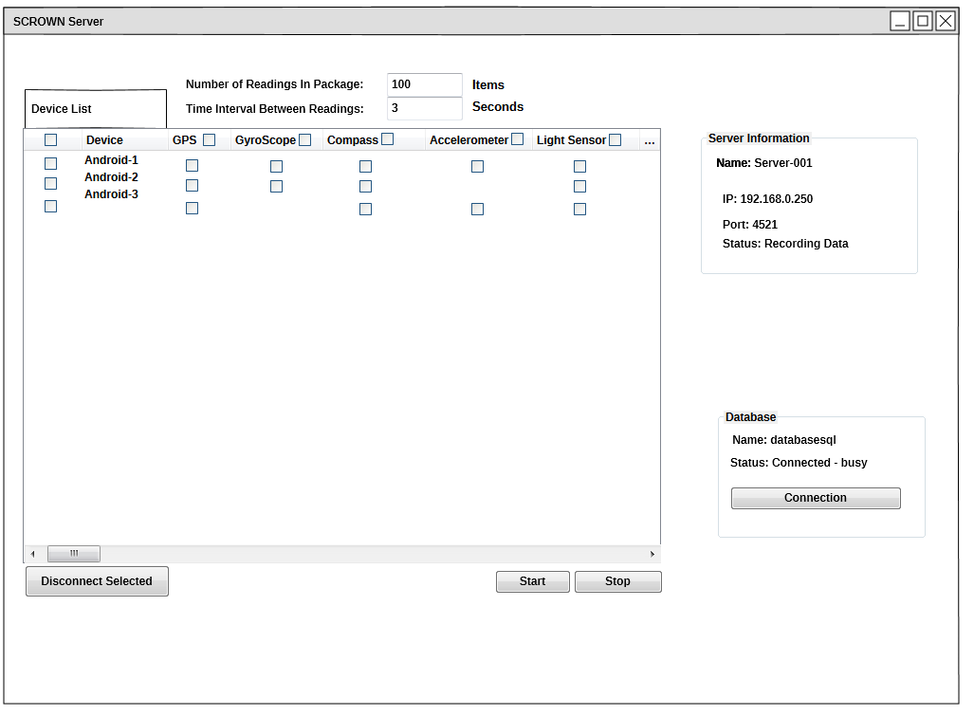

Start collecting Data

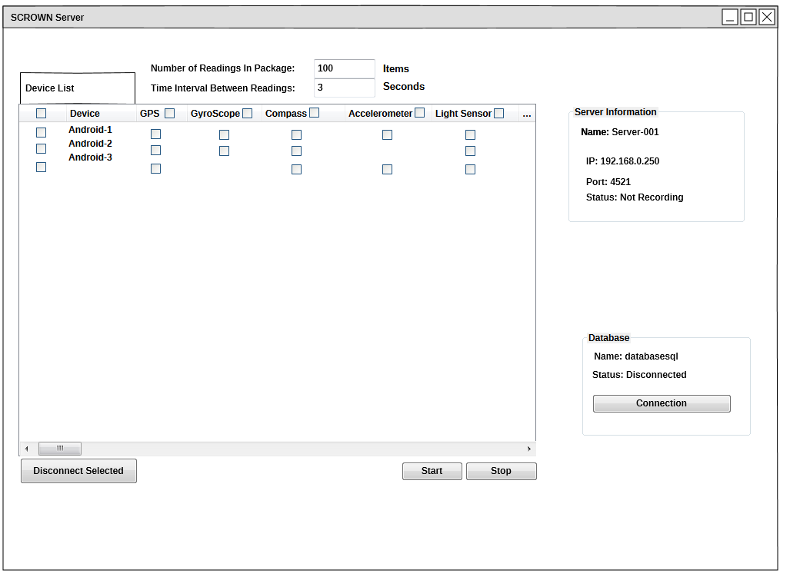

A Normal stopping of server (pressing stop button). Database disconnects as well

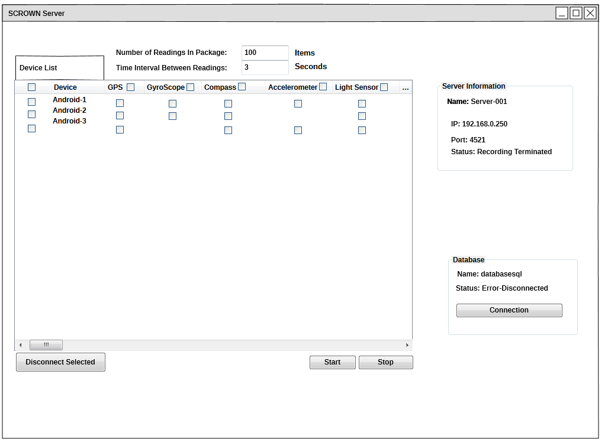Stop due to database error

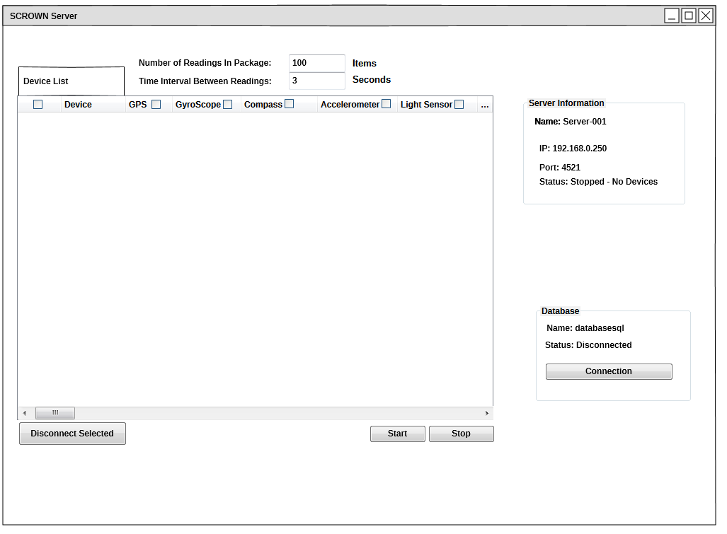

Stop due to all devices disconnected

**Android Device:**

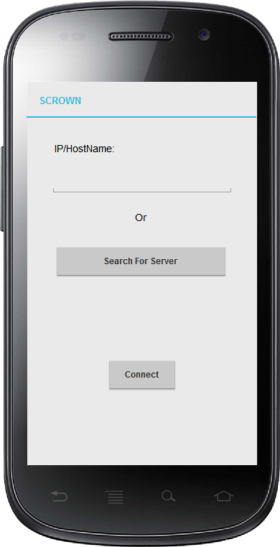

Opening screen to connect to server

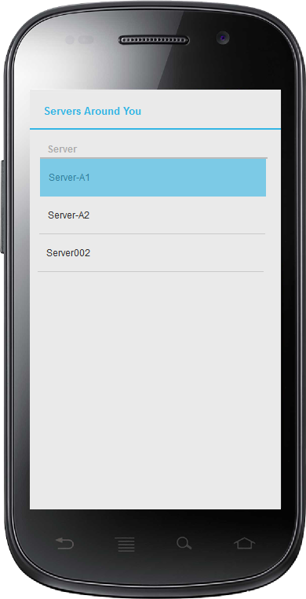

Search for local servers screen

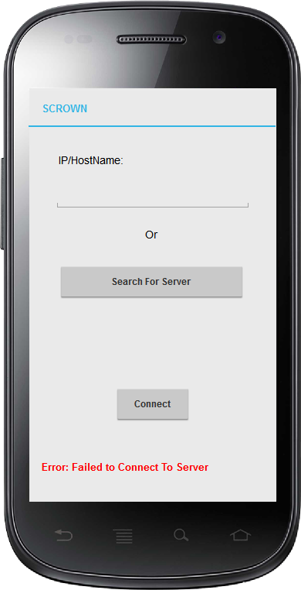

Bad connection information

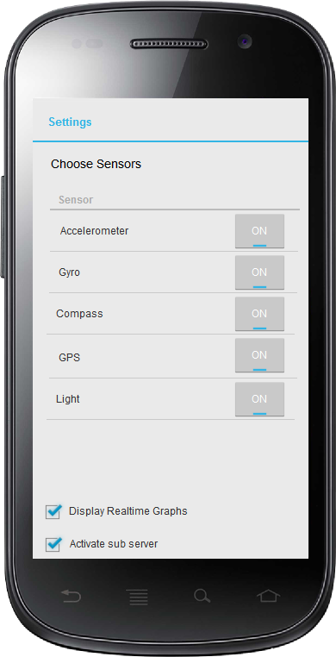

Select which sensor(s) to share

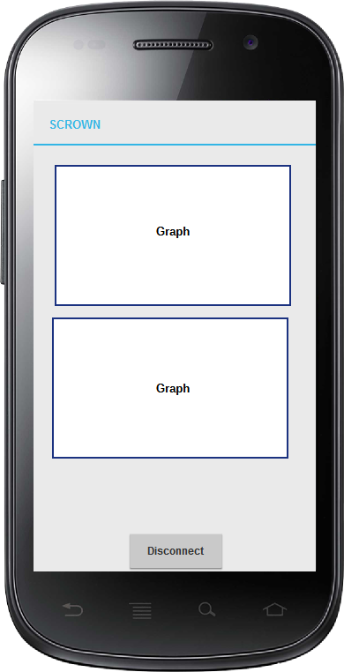

Graphs if wanted

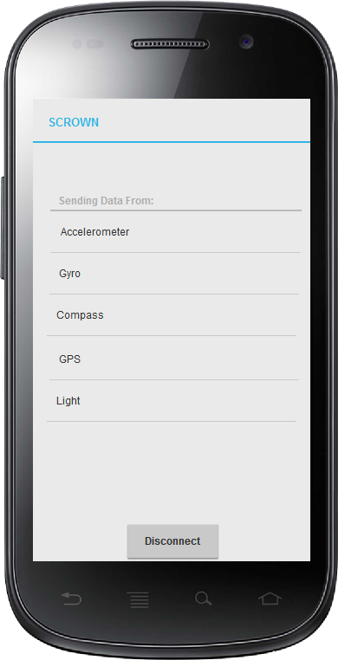

No graphs if wanted

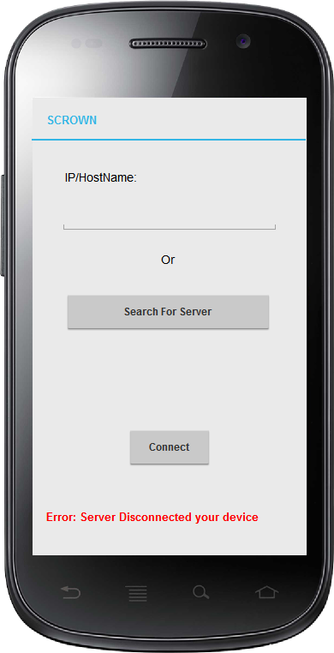

Server disconnected device

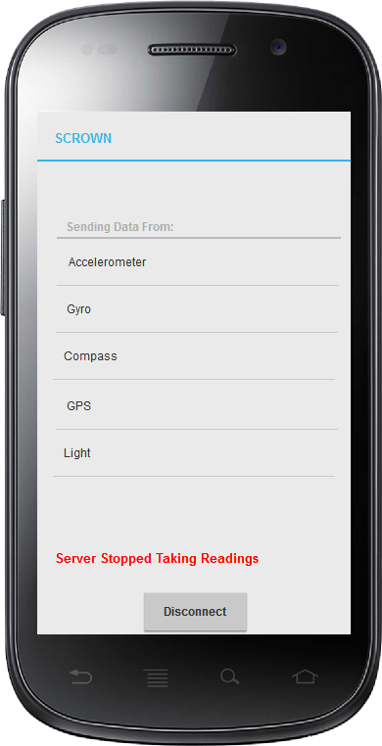

Server has stopped, this shows up at the same place if the user selected to view graphs

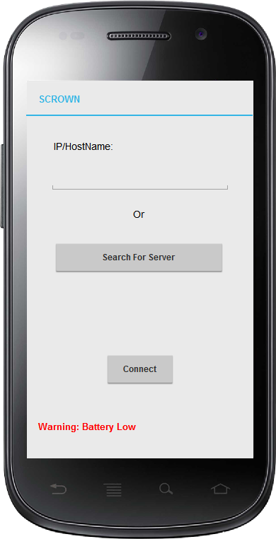

Warns user if battery is below a certain level, no detriment to function

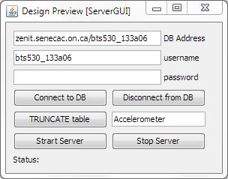

Current Server UI

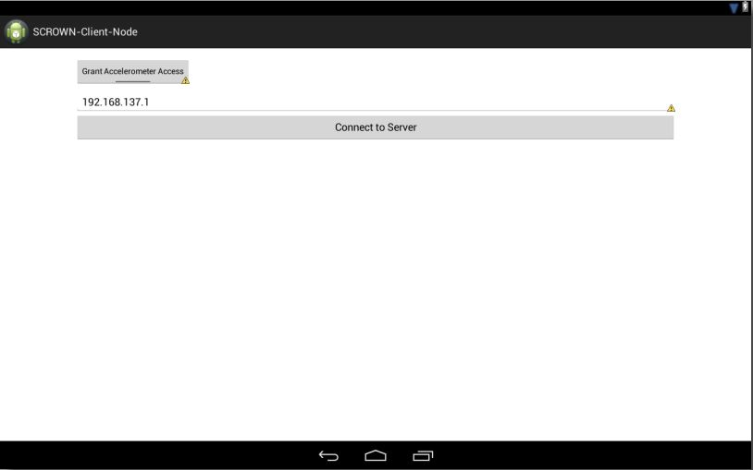

Current Client UI

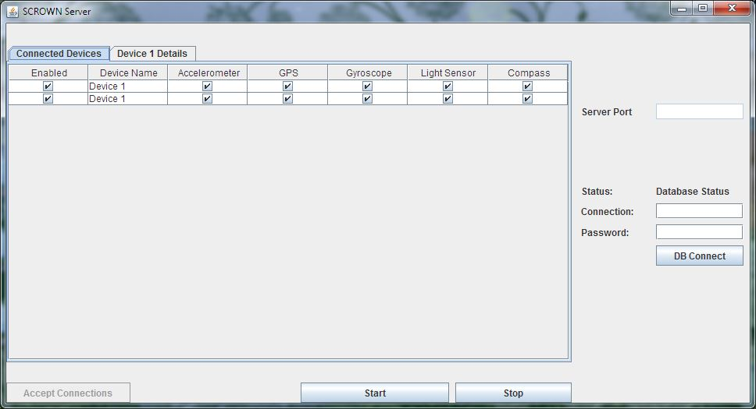

Server UI Early stage