**Running time of each type of data**

**Comparisions of each type of data**

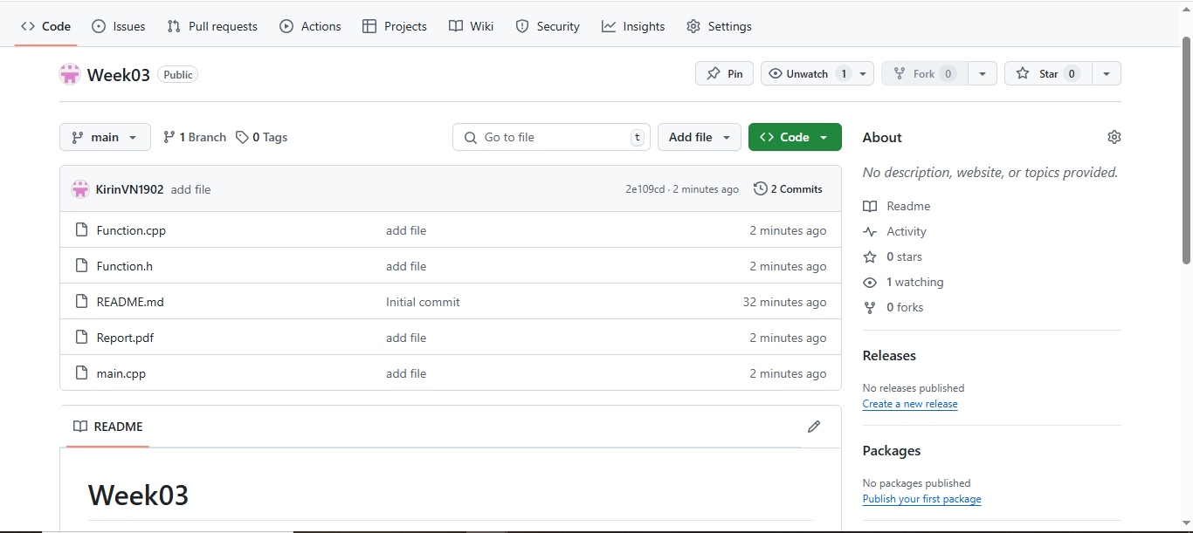**Git Push**