# Introduction to Programming

## Lab Worksheet

### Week 7

Prior to attempting this lab tutorial ensure you have read the related lecture notes and/or viewed the lecture videos on MyBeckett. Once you have completed this lab you can attempt the associated exercises.

You can download this file in Word format if you want to make notes in it.

You can complete this work using the Python interpreter in interactive mode. This could be inside an IDE, or just a command prompt.

**Topics covered:**

* Introducing Sets
* Set Comprehensions
* Mutable and immutable Sets
* Set Operators and Methods
* Introduction Dictionaries
* Creating Dictionaries
* Working with Dictionaries

For more information about the module delivery, assessment and feedback please refer to the module within the MyBeckett portal.

**_________________________________________________________________________**

## ©2021 Mark Dixon Modified 2021 Tony Jenkins

## **Introducing Sets**

The *Set* data-type is in many ways similar to a List and Tuple, except the contained values are not ordered and no duplicates are allowed. Also a set can only contain *immutable* values, which means that, for example, a set cannot contain list type values. A regular set is itself *mutable* however, so it can be changed after it has been created.

Since sets are not ordered, they do not support *indexing*, *slicing* or any method based on an element’s position. However, they do have support for traditional mathematical style set operations such as *union*, *intersection* and *difference*.

Sets are very efficient at performing membership testing type operations, and much faster than Lists at this type of operation, especially when there are a large number of stored values. These sorts of differences explain why there are several similar data types available; the trick is often to pick whichever is best suited for some application.

The Set type is built directly into the Python language hence there is a specific syntax associated with creation and manipulation. So to create a Set directly, braces (curley brackets) can be used -

vowels = {"a", "e", "i", "o", "u"}

Remember ordering is not necessarily maintained and duplicate values are not allowed.

**TASK**: Try creating a set by entering the code below. Then use the print() function to display the contents of the set. Notice how the output varies from the entered values.

names = {"John", "Eric", "Terry", "Michael", "Graham", "Terry"}

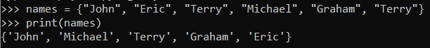

A set can also be created by calling the set() *constructor*. A *constructor* is similar to a function, but is used to initialise an object based on the named type. However this constructor takes only a single parameter, which is *iterated* to extract the contents of the set. So to create the above set using the set() constructor the following code could be used:

names = set(["John", "Eric", "Terry", "Michael", "Graham", "Terry"])

Notice how a List was created (using [ ]) and then passed as a single parameter. If multiple parameters had been passed then an error would have been reported. Try entering the following and see the result -

names = set("John", "Eric", "Terry", "Michael", "Graham", "Terry")

Creating a set using the constructor is convenient if the values already exist in some other *iterable* value, such as a List or Tuple. It is even possible to create a set of individual characters by passing a string type value. This means that the following statements both create the exactly the same set:

hex_letters = {"a", "b", "c", "d", "e", "f"}

hex_letters = set("abcdef")

Finally an empty set must be created using the set() constructor rather than empty braces { }, since the latter creates an empty *dictionary* (see later).

**Set Comprehensions**

The contents of a set can be created using a *set comprehension*, in the same way that a list comprehension can be used to create a list. In fact they work in exactly the same way, but appear between braces { } rather than square brackets [ ].

As with list comprehensions, the contents are created by evaluating an expression usually while *iterating* over a loop. For example, by using a set comprehension it is fairly easy to create a set which contains all the letters that appear within a specific sentence at least once. This uses the "uniqueness" property of Sets.

**TASK**: Enter the code below, then make a call to the print() function to display the contents of the set.

sentence = "this is a sentence containing some letters"

unique_letters = {x for x in sentence}

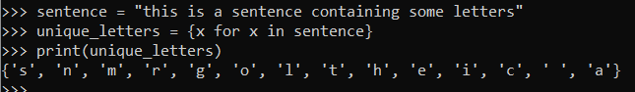

Remember that duplicates are not allowed, so each letter will appear in the set at most once. Also notice how a whitespace character has been included into the produced set.

Set comprehensions can also restrict the included values, by appending an if statement. So to create the same as the above, while excluding whitespaces the following variation could be used:

unique_letters = {x for x in sentence if x != " "}

**Set Operations**

One of the most common operations performed on a set is membership testing. This is done using either the in or not in operators. These check whether a specific element is either present, or not present, within a given set. For example:

name = input("Enter your name: ")

if name in names:

print("You are listed in the set of known names")

Even sets containing many thousands of elements can be checked almost instantly.

**TASK**: Rewrite the previous code so that it checks that the input name is NOT within the set of known names. Hint: use the not in operator.

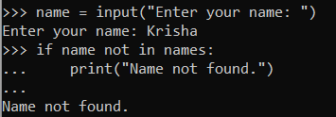

Since a set type represents an existing well known concept, a mathematical set, there are certain operations that can be performed using both *methods* and *operators*. Since sets are mutable, both ***accessor*** and ***mutator*** type operations exist. It is also possible to perform special ***comparison*** type operations on sets.

The typical mathematical style operations that can be performed include *union*, *intersection*, *difference*, and *symmetric difference*.

The operators used to support these are as follows -

| *union (the symbol is a "pipe", usually found to the left of the Z key)*

& *intersection*

- *difference*

^ *symmetric difference*

Each of these can also be achieved by calling an equivalent *method*. Fortunately the method names closely reflect the mathematical operation, and the methods are called union(), intersection(), difference() and symmetric_difference().

**TASK**: Use the built-in help() function to view all the methods available on the set type.

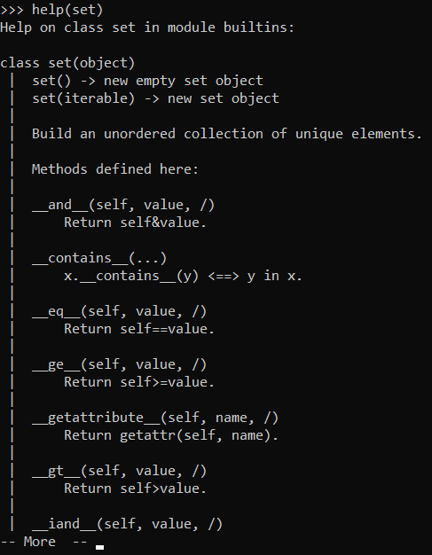

If we assume we have the following sets:

staff = {"Pete", "Kelly", "Jon", "Paul", "Sally", "Sue"}

directors = {"Kelly", "Rupert", "Cyril", "Jon"}

We could use the *union* operator | to add to the members of a se:

>>> staff = staff | {"Mark", "Ringo"}

>>> print(staff)

{'Kelly', 'Paul', 'Jon', 'Sally', 'Ringo', 'Pete', 'Mark', 'Sue'}

We could use the *intersection* operator & to find only common elements:

>>> staff_directors = staff & directors

>>> print(staff_directors)

{'Kelly', 'Jon'}

We could use the *difference* operator - to find elements in one set, but not the other:

>>> external = directors - staff

>>> print(external)

{'Cyril', 'Rupert'}

We could use the *symmetric difference* operator ^ to find elements in either set, but not in both:

>>> staff_or_external = directors ^ staff

>>> print(staff_or_external)

{'Cyril', 'Paul', 'Sally', 'Pete', 'Rupert', 'Sue', 'Ringo', 'Mark'}

**TASK**: Create the two initial sets, staff and directors as shown in the first example above. Perform the four mathematical set operations shown, but use the equivalent *method* calls to achieve the same results. For example:

staff = staff | {"Mark", "Ringo"}

# becomes …

staff = staff.union({"Mark", "Ringo"})

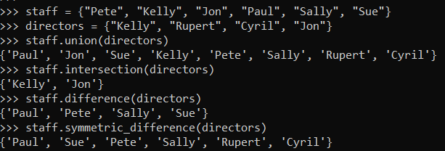

The set operations we have seen so far have all been **accessor** type methods; they do not directly change the set to which the operation was applied, hence the reason the above examples all assigned the result to a variable. However, the same set of mathematical operations can be applied as **mutators**, so they do directly change the contents of the set.

If the same operators we have seen are applied using the *Augmented Assignment* style, then they act as mutators. The following statement removes the given elements from the set directly, using an augmented difference operator.

staff -= {"Mark", "Ringo"}

The same mutator type behaviour can also be achieved using the methods, however different versions of the methods need to be called. The *mutator* versions of the methods are called update(), intersection_update(), difference_update() and symmetric_difference_update().

**TASK**: Create the set shown below then use the *mutator* version of the union method, which is update() to add the two missing vowels to the set.

vowels = set({"a", "e", "i"})

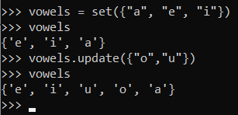

**Set Comparison Operations**

As well as the *accessor* and *mutator* type operations, there are also set specific **comparisons** available. Like the previous set of operations, these are based on well known mathematical style operations.

The comparison operations that can be performed are *subset*, *proper subset*, *superset,* and *proper superset*. These return a True or False result.

The operators used to support these are as follows -

<= *subset*

< *proper subset*

>= *superset*

> *proper superset*

If we assume we have the following sets -

staff = {"Pete", "Kelly", "Jon", "Paul", "Sally", "Sue"}

managers = {"Kelly", "Jon", "Paul", "Sally", "Sue"}

We could use the *subset* operator < to check whether all the elements of the managers set are also contained within the staff set.

if managers < staff:

print("All managers are staff members")

The *proper* *subset* operator <= does the same check, but also ensures that the sets are not exactly equal, in other words a set is *strictly* a subset of another set. The *superset* > and *proper superset* >= operators do the reverse checks. So the following is equivalent to the previous example:

if staff > managers:

print("All managers are staff members")

There are also methods available for performing the same type of comparisons, which are called issubset() and issuperset().

**TASK**: Write code based on the previous two examples, but use the equivalent *method* calls to achieve the same results.

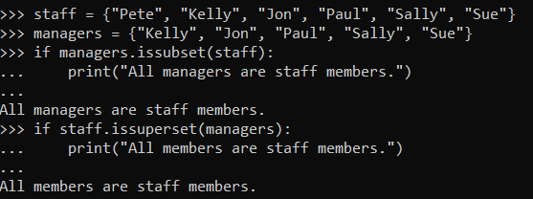

**Creating an Immutable Set**

As we have already seen, when a set is constructed using the braces { } , or via the set() constructor it is *mutable*. It is possible however to create an *immutable* set also. This is done by using the frozenset() constructor. It looks the same as the other constructor:

suits = frozenset({"heart", "club", "spade", "diamond"})

If a set is created in this way then its contents cannot be changed. The operators and methods available generally remain the same as with a regular set, however anything that *mutates* the contents is not available. So for example, the update() method is not available on a frozenset. However all of the *accessor* and *comparison* operators work in exactly the same way as a regular set.

>>> {"club", "diamond"} < suits

True

**TASK**: Use the built-in help() function to view all the methods available on the frozenset type.

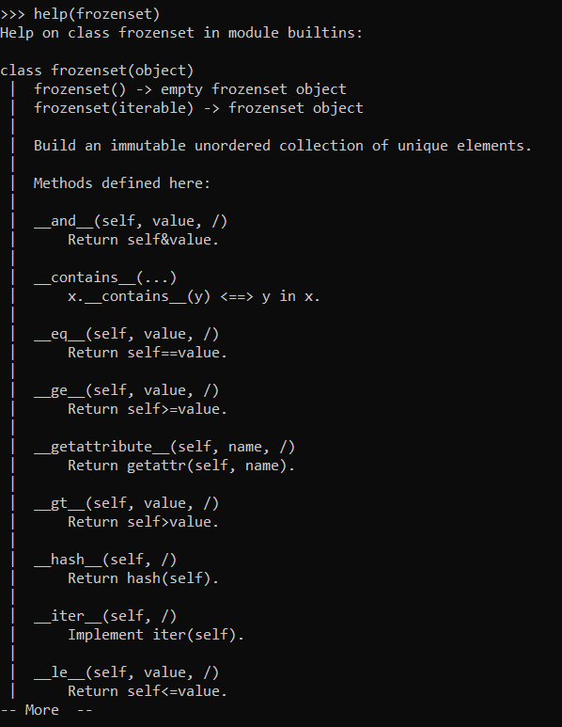

**_________________________________________________________________________**

## 

## **Introducing Dictionaries**

The *Dictionary* data-type stores multiple values like the other collection types. However, what is distinct about a dictionary is that it stores elements as pairs, often called a *key:value* pair. Dictionaries are *ordered* and *mutable* and can have *key:value* pairs added and removed after initial creation.

Each *key* is unique and is associated with a single value. i.e. a *key* **maps** to a *value* just like a *word* in a conventional language dictionary **maps** to a *definition*. The set of keys must be unique - each key can appear at most once. However the values in the dictionary do not need to be unique, therefore different keys can be mapped to the same value.

Dictionaries are useful when a value needs to be located quickly given a known key. For example a dictionary may store a collection of *customer* records (values), and the key to these is the unique *customer number*.

Since the Dictionary type is built directly into the Python language there is a specific syntax associated with creation and manipulation. This is similar to what we have already seen with a Set. The main difference however is that operations involving Dictionaries usually involve pairs of values. To create a Dictionary directly, braces (curly brackets) can be used:

stock = {"apple":10, "banana":15, "orange":11}

This is similar to the notation for a Set, but the contents of the brackets show that it is a dictionary being created. Notice that a pair is specified for each entry separated by a colon ‘:’, in the form *key:value*.

The *key* of the first element within the example is the string "apple", and the *value* associated with this is the number 10. Unlike a set the insertion ordering of the elements is maintained (from Python version 3.7 at least).

A dictionary can also be created by calling the dict() *constructor*. This can be called with various types of arguments and is somewhat more flexible than the set() constructor. To create the above dictionary, any of the following variations could be used:

# create by passing a dictionary

stock = dict({"apple":10, "banana":15, "orange":11})

# create by passing keywords (only possible if keys are strings)

stock = dict(apple=10, banana=15, orange=11)

# create by passing list of tuples

stock = dict([("apple",10), ("banana",15), ("orange",11)])

Finally an empty dictionary can be created using either empty braces { } or the dict() constructor with no arguments. This explains why, as mentioned earlier, an empty *Set* can ONLY be created using the set() constructor with no arguments.

**Dictionary Comprehensions**

As with sets and lists, it is also possible to create a dictionary using a *comprehension*. A very slightly different expression syntax is required, since a pair of values need to be provided for each generated entry. This is handled by the inclusion of a ‘:’ to separate the *key* from the *value*.

**TASK**: Enter the code below, then make a call to the print() function to display the contents of the dictionary.

import math

roots = {n : math.sqrt(n) for n in range(1,26)}

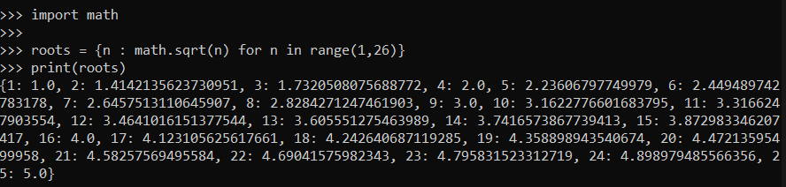

This produces a dictionary that maps a numeric value (in the range 1..25), to its square root.

Hence, the created dictionary will have a total of 25 entries. In which each *key* is an integer type that maps to a float type.

**Manipulating Dictionaries**

Once a dictionary has been created there are several mechanisms available to access and mutate its content. Remember, most operations rely on the *key* being specified. For example, it is possible to access a *value* from the dictionary by providing its *key* as an *index*:

print("Apple stock level is", stock["apple"])

Notice how the provided [ index ] value is not necessarily an integer, as with lists, strings or tuples. The provided index value MUST match the data-type of the dictionaries key set, in this case a string.

Since dictionaries are mutable, it is also possible to add or update existing *key:value* pairs using the indexing notation:.

stock["pear"] = 50 # add new key:value pair

stock["apple"] += 1 # increase apple stock level

**TASK**: Write some code which adds a new fruit called "kiwi" to the stock dictionary, with an initial stock level of 10.

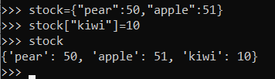

As with sets a common operation performed on dictionaries is membership testing. This can be done using exactly the same syntax as sets, but only the *key* needs providing, e.g.

if "apple" in stock:

print("Apples have a stock level")

**Dictionary Methods**

Many of the *methods* which are available on the other collection data-types, such as lists, are also available on dictionaries. These include clear(), copy(), get(), pop() and update().

These all typically perform in the same away as with the other data-types, but in some cases take slightly different parameters involving a *key* and *value*.

# pop the "orange" returning its stock level

stock.pop("orange")

# update the stock to include two new fruits

stock.update(lemmon=15, strawberry=99)

**TASK**: Use the built-in help() function to view all the methods available on the dict type. Then write some code that uses the popitem() method to remove some *key:value* pairs from the stock dictionary.

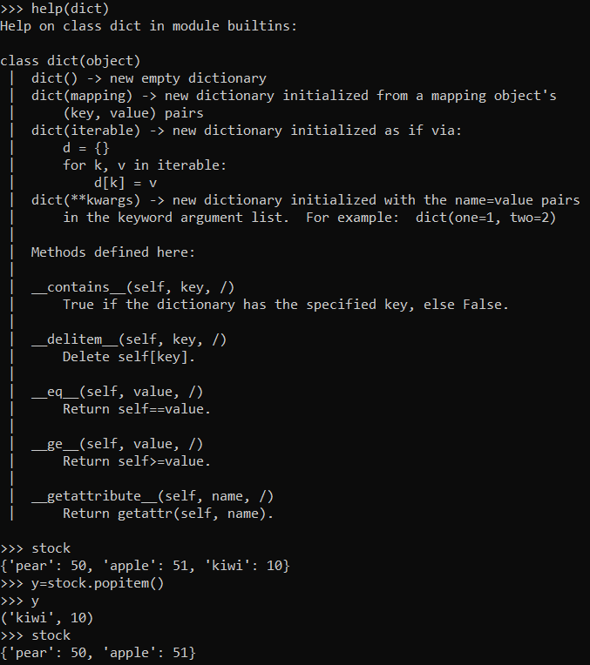

**Iterating over Dictionaries**

It is very common to *iterate* over the contents of a dictionary, using a for...in type loop.

If just the name of the dictionary is provided, then only the *key* is extracted during each iteration. So the following would print the *keys* of the dictionary only:

for item in stock:

print(item)

apple

banana

orange

It is possible to iterate over the *values* only by calling the values() method, e.g.

for level in stock.values():

print(level)

10

15

11

Finally it is possible to iterate over each *key:value* pair. To do this the items() method can be used. This allows access to each key and value as a *Tuple*, hence each pair can be extracted using *sequence unpacking.* The code is:

for item,level in stock.items():

print(item, "has a stock level of", level)

apple has a stock level of 10

banana has a stock level of 15

orange has a stock level of 11

**TASK**: Write some code that iterates over the contents of the roots dictionary created within an earlier task. For each entry, print the message -

“The square root of <num> is <sqrt>”

Where <num> shows the number, and <sqrt> shows the square root of that number.

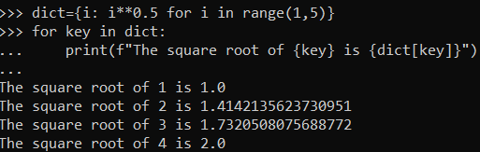

**_________________________________________________________________________**

## 

## **Key Terminology**

Understanding key terminology is important not only when programming but for understanding computer science in general. Certain terms, technologies and phrases will often re-occur when reading or learning about many computer science topics. Having an awareness of these is important, as it makes learning about the various subjects and communication with others in the field easier.

**TASK**: Look at each of the phrases below and ensure you understand what each of these means. For any that you do not understand, do a little research to find a definition of each term. This research may involve looking back over these notes, or the associated lecture notes. It may also involve searching for these terms on the Internet.

* Set
* Set operations
* Set comprehension
* Dictionary
* *key:value* pair

**________________________________________________________________________**

## **Practical Exercises**

You have now completed this tutorial. Now attempt to complete the associated exercises.