What is SDLC?
The software development lifecycle (SDLC) is the cost-effective and time-efficient process that development teams use to design and build high-quality software. The goal of SDLC is to minimize project risks through forward planning so that software meets customer expectations during production and beyond. This methodology outlines a series of steps that divide the software development process into tasks you can assign, complete, and measure.

Why is SDLC important?
Software development can be challenging to manage due to changing requirements, technology upgrades, and cross-functional collaboration. The software development lifecycle (SDLC) methodology provides a systematic management framework with specific deliverables at every stage of the software development process. As a result, all stakeholders agree on software development goals and requirements upfront and also have a plan to achieve those goals.
Here are some benefits of SDLC:
- Increased visibility of the development process for all stakeholders involved
- Efficient estimation, planning, and scheduling
- Improved risk management and cost estimation
- Systematic software delivery and better customer satisfaction.

Table of Content for SDLC

Stages of the Software Development Life Cycle

SDLC specifies the task(s) to be performed at various stages by a software engineer or developer. It ensures that the end product is able to meet the customer’s expectations and fits within the overall budget. Hence, it’s vital for a software developer to have prior knowledge of this software development process.

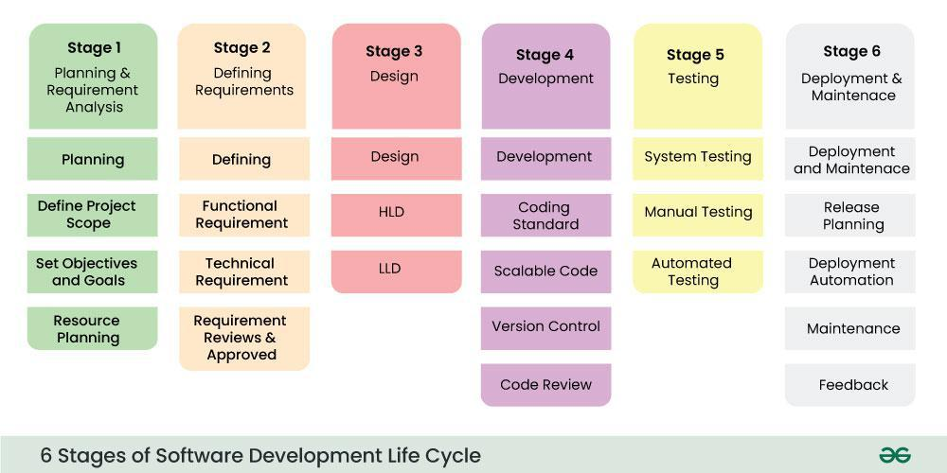
The SDLC model involves six phases or stages while developing any software. SDLC is a collection of these six stages, and the stages of SDLC are as follows:

Stage-1: Planning and Requirement Analysis
Planning is a crucial step in everything, just as in software development. In this same stage, requirement analysis is also performed by the developers of the organization. This is attained from customer inputs, and sales department/market surveys.
The information from this analysis forms the building blocks of a basic project. The quality of the project is a result of planning. Thus, in this stage, the basic project is designed with all the available information.

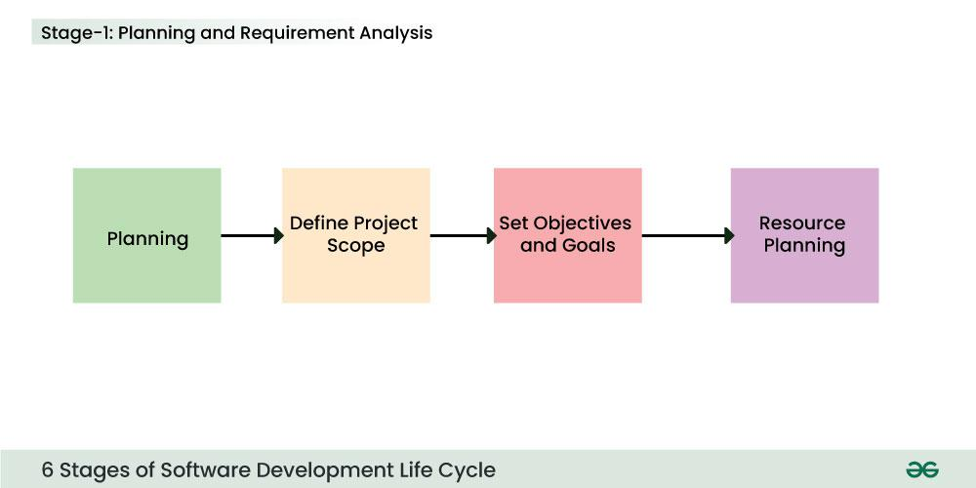

Planning is one of the core phases of SDLC. It acts as the foundation of the whole SDLC scheme and paves the way for the successful execution of upcoming steps and, ultimately, a successful project launch.
In this stage, the problem or pain the software targets is clearly defined. First, developers and other team members outline objectives for the system and draw a rough plan of how the system will work. Then, they may make use of predictive analysis and AI simulation tools at this stage to test the early-stage validity of an idea. This analysis helps project managers build a picture of the long-term resources required to develop a solution, potential market uptake, and which obstacles might arise.
At its core, the planning process helps identify how a specific problem can be solved with a certain software solution. Crucially, the planning stage involves analysis of the resources and costs needed to complete the project, as well as estimating the overall price of the software developed.
Finally, the planning process clearly defines the outline of system development. The project manager will set deadlines and time frames for each phase of the software development life cycle, ensuring the product is presented to the market in time.

Stage-2: Defining Requirements
In this stage, all the requirements for the target software are specified. These requirements get approval from customers, market analysts, and stakeholders.
This is fulfilled by utilizing SRS (Software Requirement Specification). This is a sort of document that specifies all those things that need to be defined and created during the entire project cycle.

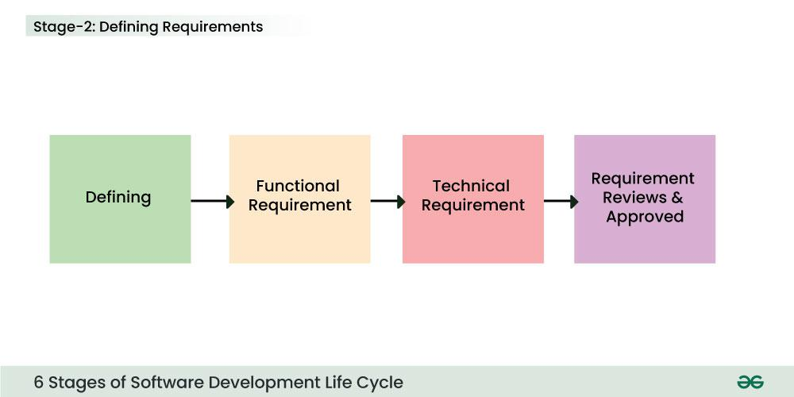

Once the planning is done, it’s time to switch to the research and analysis stage.
In this step, you incorporate more specific data for your new system. This includes the first system prototype drafts, market research, and an evaluation of competitors.
To successfully complete the analysis and put together all the critical information for a certain project, developers should do the following:
- Generate the system requirements. A Software Requirement Specification (SRS) document will be created at this stage. Your DevOps team should have a high degree of input in determining the functional and network requirements of the upcoming project.
- Evaluate existing prototypes. Different prototypes should be evaluated to identify those with the greatest potential.
- Conduct market research. Market research is essential to define the pains and needs of end-consumers. In recent years, automated NLP (natural language processing) research has been undertaken to glean insights from customer reviews and feedback at scale.
- Set concrete goals. Goals are set and allocated to the stages of the system development life cycle. Often, these will correspond to the implementation of specific features.
Most of the information generated at this stage will be contained in the SRS. This document shapes the strict regulations for the project and specifies the exact software model you will eventually implement.

Stage-3: Designing Architecture
SRS is a reference for software designers to come up with the best architecture for the software. Hence, with the requirements defined in SRS, multiple designs for the product architecture are present in the Design Document Specification (DDS).
This DDS is assessed by market analysts and stakeholders. After evaluating all the possible factors, the most practical and logical design is chosen for development.

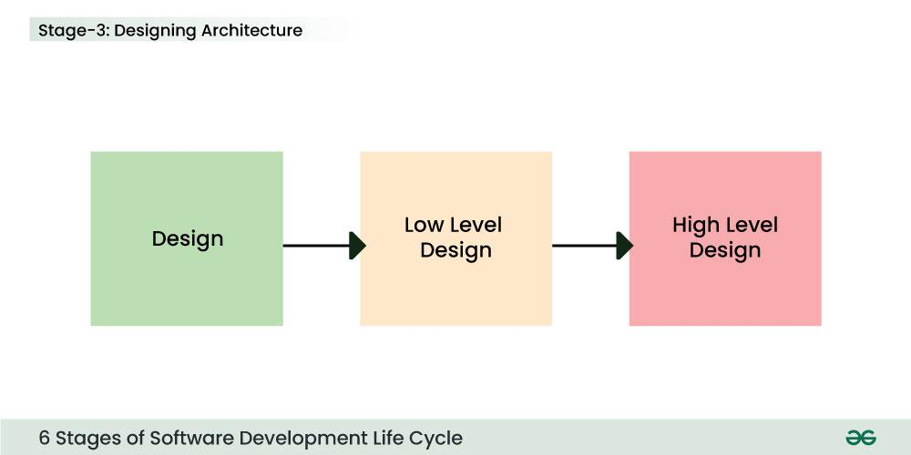

Stage-4: Developing Product

The next stage of a system development project is design and prototyping.
This process is an essential precursor to development. It is often incorrectly equated with the actual development process but is rather an extensive prototyping stage.
This step of the system development life cycle can significantly eliminate the time needed to develop the software. It involves outlining the following:
- The system interface
- Databases
- Core software features (including architecture like microservices)
- User interface and usability
- Network and its requirement
As a rule, these features help to finalize the SRS document as well as create the first prototype of the software to get the overall idea of how it should look like.
Prototyping tools, which now offer extensive automation and AI features, significantly streamline this stage. They are used for the fast creation of multiple early-stage working prototypes, which can then be evaluated. AI monitoring tools ensure that best practices are rigorously adhered to
At this stage, the fundamental development of the product starts. For this, developers use a specific programming code as per the design in the DDS. Hence, it is important for the coders to follow the protocols set by the association. Conventional programming tools like compilers, interpreters, debuggers, etc. are also put into use at this stage. Some popular languages like C/C++, Python, Java, etc. are put into use as per the software regulations.

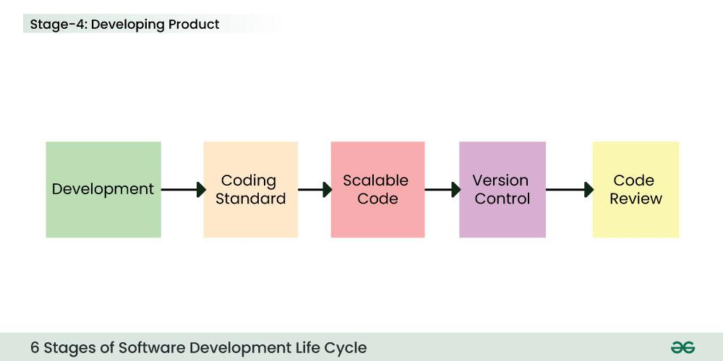

In the development stage of SDLC, the system creation process produces a working solution. Developers write code and build the app according to the finalized requirements and specification documents.
This stage includes both front and back-end development. DevOps engineers are essential for allocating self-service resources to developers to streamline the process of testing and rollout, for which CI/CD is typically employed.
This phase of the system development life cycle is often split into different sub-stages, especially if a microservice or miniservice architecture, in which development is broken into separate modules, is chosen.
Developers will typically use multiple tools, programming environments, and languages (C++, PHP, Python, and others), all of which will comply with the project specifications and requirements outlined in the SRS document.

Stage-5: Product Testing and Integration
After the development of the product, testing of the software is necessary to ensure its smooth execution. Although, minimal testing is conducted at every stage of SDLC. Therefore, at this stage, all the probable flaws are tracked, fixed, and retested. This ensures that the product confronts the quality requirements of SRS.
Documentation, Training, and Support: Software documentation is an essential part of the software development life cycle. A well-written document acts as a tool and means to information repository necessary to know about software processes, functions, and maintenance. Documentation also provides information about how to use the product. Training in an attempt to improve the current or future employee performance by increasing an employee’s ability to work through learning, usually by changing his attitude and developing his skills and understanding.

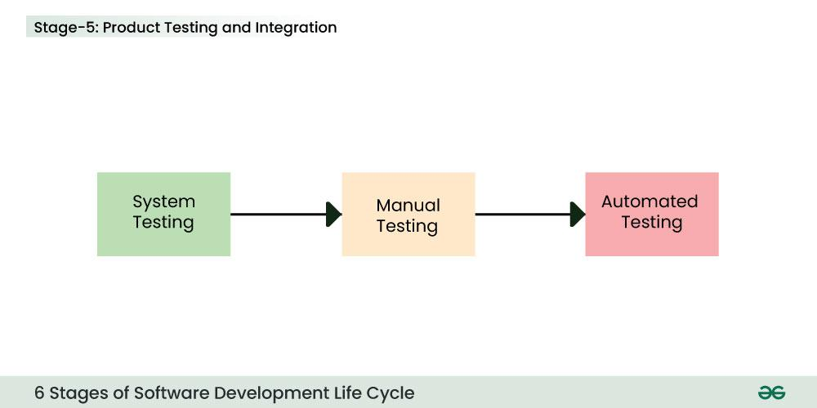

The testing stage ensures the application’s features work correctly and coherently and fulfill user objectives and expectations.
This process involves detecting the possible bugs, defects, and errors, searching for vulnerabilities, etc., and can sometimes take up even more time compared to the app-building stage.
There are various approaches to testing, and you will likely adopt a mix of methods during this phase. Behavior-driven development, which uses testing outcomes based on plain language to include non-developers in the process, has become increasingly popular.
Similarly, automated and cloud-based platforms, which simulate testing environments, take a significant amount of manual time out of this stage of the system development life cycle. Selenium, a browser testing tool, is one popular example of such a platform.

Stage-6: Deployment and Maintenance of Products
After detailed testing, the conclusive product is released in phases as per the organization’s strategy. Then it is tested in a real industrial environment. It is important to ensure its smooth performance. If it performs well, the organization sends out the product as a whole. After retrieving beneficial feedback, the company releases it as it is or with auxiliary improvements to make it further helpful for the customers. However, this alone is not enough. Therefore, along with the deployment, the product’s supervision.

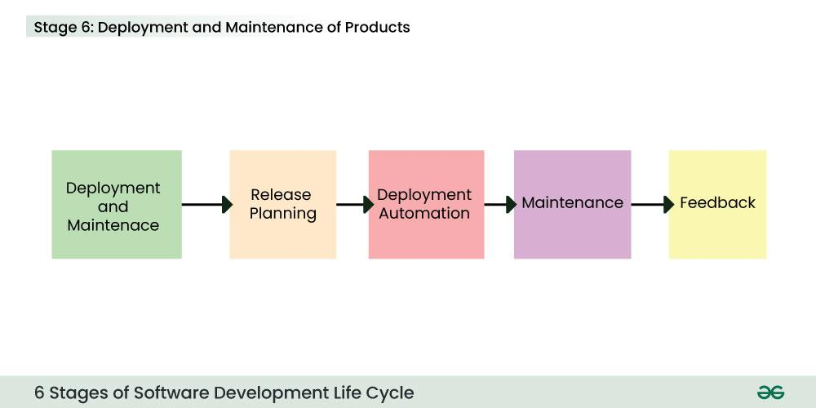

Once the product is ready to go, it’s time to make it available to its end users and deploy it to the production environment.
At this stage, the software undergoes final testing through the training or pre-production environment, after which it’s ready for presentation on the market.
It is important that you have contingencies in place when the product is first released to market should any unforeseen issues arise. Microservices architecture, for example, makes it easy to toggle features on and off. And you will likely have multiple rollback protocols. A canary release (to a limited number of users) may be utilized if necessary.

Maintenance Stage – Let’s Make the Improvements
The last but not least important stage of the SDLC process is the maintenance stage, where the software is already being used by end-users.
During the first couple of months, developers might face problems that weren’t detected during initial testing, so they should immediately react to the reported issues and implement the changes needed for the software’s stable and convenient usage.
This is particularly important for large systems, which usually are more difficult to test in the debugging stage.
Automated monitoring tools, which continuously evaluate performance and uptime and detect errors, can assist developers with ongoing quality assurance. This is also known as “instrumentation.

Benefits of SDLC
Having covered the major SDLC methodologies offered by software development companies, let’s now review whether they are actually worth employing.
Here are the benefits that the system development life cycle provides:
- Comprehensive overview of system specifications, resources, timeline, and the project goals
- Clear guidelines for developers
- Each stage of the development process is tested and monitored
- Control over large and complex projects
- Detailed software testing
- Process flexibility
- Lower costs and strict time frames for product delivery
- Enhanced teamwork, collaboration, and shared understanding

Possible Drawbacks of SDLC
Just like any other software development approach, each SDLC model has its drawbacks:
- Increased time and costs for the project development if a complex model is required
- All details need to be specified in advance
- SDLC models can be restrictive
- A high volume of documentation which can slow down projects
- Requires many different specialists
- Client involvement is usually high
- Testing might be too complicated for certain development teams
While there are some drawbacks, SDLC has proven to be one of the most effective ways for successfully launching software products.
Alternative development paradigms, such as rapid application development (RAD), may be suitable for some projects but typically carry limitations and should be considered carefully.

Software Development Models – SDLC Models

SDLC Models or Software Development Life Cycle (SDLC) models are frameworks that guide the development process of software applications from initiation to deployment. Various SDLC models in software engineering exist, each with its approach to the phases of development.

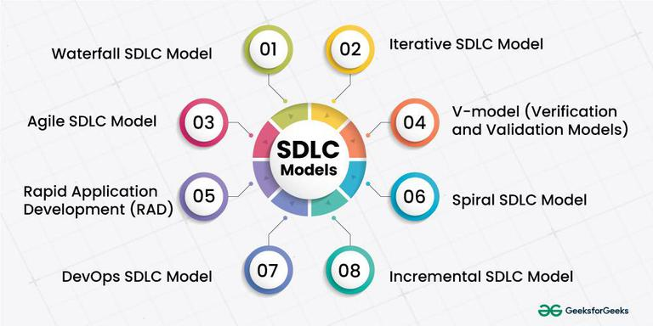

1. Waterfall SDLC Models
The Waterfall model is one of the oldest and most straightforward approaches to software development. In this blog, we will explore the key aspects of the Waterfall Model, its phases, advantages, disadvantages, and instances where it is most suitable. The Waterfall model follows a linear and sequential approach to software development. Each phase in the development process must be completed before moving on to the next one, resembling the downward flow of a waterfall. The model is highly structured, making it easy to understand and use.
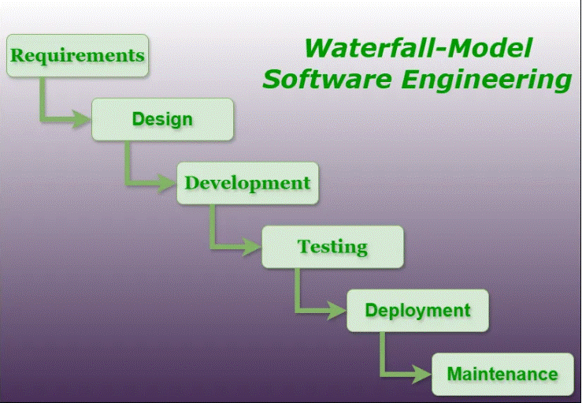

Phases of Waterfall SDLC Models:
- Requirements: The first phase involves gathering requirements from stakeholders and analyzing them to understand the scope and objectives of the project.
- Design: Once the requirements are understood, the design phase begins. This involves creating a detailed design document that outlines the software architecture, user interface, and system components.
- Development: The Development phase includes implementation involves coding the software based on the design specifications. This phase also includes unit testing to ensure that each component of the software is working as expected.
- Testing: In the testing phase, the software is tested as a whole to ensure that it meets the requirements and is free from defects.
- Deployment: Once the software has been tested and approved, it is deployed to the production environment.
- Maintenance: The final phase of the Waterfall Model is maintenance, which involves fixing any issues that arise after the software has been deployed and ensuring that it continues to meet the requirements over time.

Advantages of the Waterfall SDLC Models:
- Simplicity: The linear and sequential nature of the Waterfall models makes it easy to understand and implement.
- Clear Documentation: Each phase has its own set of documentation, making it easier to track progress and manage the project.
- Stable Requirements: Well-suited for projects with stable and well-defined requirements at the beginning.
- Predictability: Due to its structured nature, the Waterfall model allows for better predictability in terms of timelines and deliverables.

Disadvantages of the Waterfall SDLC Models:
- Rigidity: The model is highly inflexible once a phase is completed, making it challenging to accommodate changes.
- Late Testing: Testing is performed after the implementation phase, so defects might not be discovered until late in the process.
- Limited Client Involvement: Clients are involved mainly in the initial phase, and significant changes cannot be easily accommodated later in the development process.
- No Prototyping: The models lack the provision for creating prototypes, which could be a disadvantage in projects where user feedback is crucial.

When to Use the Waterfall SDLC Models:
- Well-Defined Requirements: When project requirements are clear, stable, and unlikely to change significantly.
- Small to Medium-Sized Projects: For smaller projects with straightforward objectives and limited complexity.
- Mission-Critical Systems: In scenarios where it is crucial to have a well-documented and predictable development process, especially for mission-critical systems.
The Waterfall model has been a foundational approach to software development for decades. While it may not be the most flexible model in the face of changing requirements, its simplicity and predictability make it suitable for certain types of projects. Understanding the project requirements and constraints is key to deciding whether the Waterfall model is the right fit for a particular development endeavor. As the software development landscape evolves, newer models and methodologies continue to emerge, providing alternative approaches to meet the demands of a rapidly changing industry.

2. Iterative SDLC Models
In software development, choosing the right SDLC models is crucial for success. Among the various approaches, the Iterative SDLC model stands out as a flexible and efficient methodology that promotes continuous improvement and adaptability. In this blog post, we will explore the intricacies of the Iterative SDLC models, shedding light on its principles, benefits, and best practices.

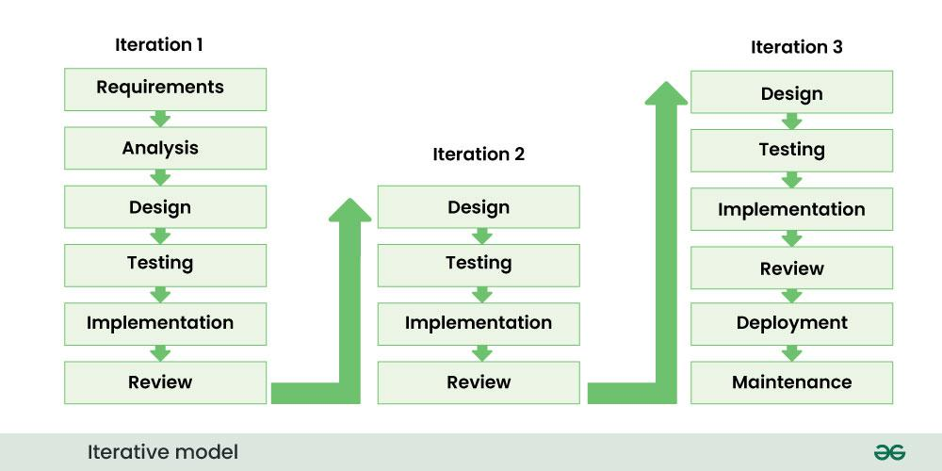

Key Principles of Iterative SDLC Models:
- Incremental Progress: The Iterative model emphasizes incremental development, breaking down the project into manageable parts. This allows for quicker delivery of functional components and facilitates early user feedback.
- Flexibility and Adaptability: One of the model’s strengths is its adaptability to changing requirements. Developers can easily incorporate new features or modifications during any iteration without disrupting the entire development process.
- Continuous Evaluation: Regular assessment and evaluation occur after each iteration, enabling developers to identify and rectify issues early in the development cycle. This continuous feedback loop ensures that the final product aligns with user expectations.
- Risk Management: Risks are addressed proactively throughout the development process. By identifying potential issues early on, the team can mitigate risks and make informed decisions, reducing the likelihood of project setbacks.

Benefits of Iterative SDLC Models:
- Faster Time-to-Market: Incremental development allows for the release of functional components at the end of each iteration, resulting in a faster time-to-market compared to traditional SDLC models.
- Enhanced Flexibility: The ability to adapt to changing requirements makes the Iterative models suitable for projects with evolving needs, ensuring that the final product meets user expectations.
- Improved Quality: Continuous evaluation and testing in each iteration contribute to higher software quality. Bugs and issues are identified and addressed early, preventing them from accumulating in later stages.
- Increased Stakeholder Engagement: Stakeholders are involved throughout the development process, providing valuable feedback after each iteration. This ensures that the final product aligns with user expectations and business goals.

Best Practices for Implementing Iterative SDLC:
- Clear Project Scope: Define a clear and well-understood project scope to guide each iteration. This ensures that the development team and stakeholders are aligned on the project’s goals.
- Effective Communication: Open and transparent communication is crucial. Regular team meetings, stakeholder updates, and documentation help maintain a shared understanding of project progress and requirements.
- Automated Testing: Implement automated testing to streamline the testing process in each iteration. This ensures that the software remains stable and functional as new features are added.
- Version Control: Utilize version control systems to manage code changes and track project history. This helps in maintaining a stable codebase and enables easier collaboration among team members.
The Iterative SDLC models offers a dynamic and adaptive approach to software development, aligning with the industry’s demand for flexibility and efficiency. By embracing incremental progress, continuous evaluation, and stakeholder engagement, development teams can deliver high-quality software that meets evolving user requirements. As organizations navigate the complex landscape of software development, the Iterative SDLC model stands as a valuable methodology for achieving success in a rapidly changing environment.

Iterative SDLC models vs Waterfall SDLC Models
Aspect | Iterative SDLC Models | Waterfall SDLC Models
Development Approach | Cyclical and Incremental | Sequential and Linear
Phases | Planning, Design, Coding, Testing, Evaluation (Repeated Iteratively) | Requirements, Design, Implementation, Testing, Deployment
Flexibility | High – Embraces Changes and Enhancements Throughout Development | Low – Changes are Difficult to Accommodate After Initial Phases
Risk Management | Proactive – Risks Addressed Throughout Iterations | Reactive – Risks Addressed in a Linear Manner
Time-to-Market | Gradual Releases, Quicker Time-to-Market for Incremental Features | Single Release at the End, Potentially Longer Time-to-Market
User Involvement | Continuous User Feedback and Involvement Throughout | Limited User Involvement until the Testing Phase
Testing | Continuous Testing Throughout Iterations | Testing Conducted After the Completion of the Implementation
Adaptability | Highly Adaptable to Changing Requirements | Less Adaptable, Changes May Be Costly and Time-Consuming
Complexity Management | Easier to Manage and Control Complexity | Complexity Management Challenging Due to Sequential Approach

3. V-models (Verification and Validation Models) in SDLC
The V-models in SDLC emerge as a compelling alternative, offering a structured and systematic approach. This blog post aims to unravel the intricacies of the V-models SDLC, shedding light on its principles, advantages, and best practices.
The V-Models, also known as the Verification and Validation models, is an extension of the traditional Waterfall models. It introduces a parallel testing phase for each corresponding development stage, forming a V-shaped diagram. Let’s delve into the key principles that underpin the V-Models.

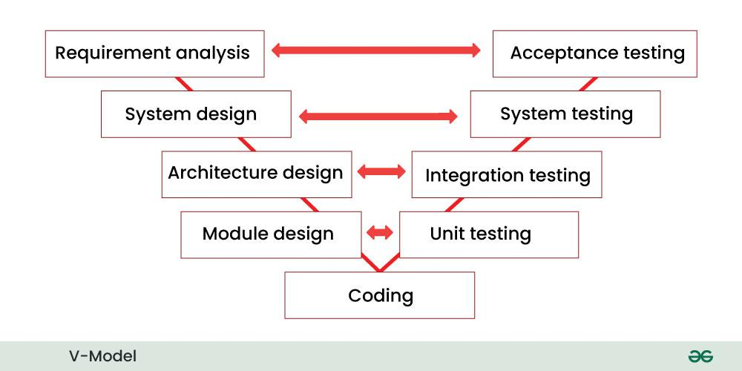

Key Principles of V-Models:
- Parallel Development and Testing: Unlike the sequential nature of the Waterfall models, the V-models promote parallel development and testing. Each development phase aligns with a corresponding testing phase, fostering early defect detection.
- Verification and Validation: The V-models place equal emphasis on both verification (ensuring that the product is built right) and validation (ensuring that the right product is built). Verification activities align with development phases on the left side of the V, while validation activities correspond to testing phases on the right side.
- Traceability: Traceability is a core tenet of the V-Models, ensuring a direct linkage between each development phase and its associated testing phase. This traceability facilitates comprehensive documentation and alignment between requirements, design, and testing activities.
- Early Defect Detection: By integrating testing activities in parallel with development, the V-models enable the early detection of defects. This proactive approach contributes to the creation of a more robust and reliable end product.

Advantages of the V-Models:
- Clear Design and Planning: The V-Models’s structured framework facilitates clear design and planning. Well-defined tasks and deliverables at each stage contribute to effective project management.
- Early Issue Identification: Incorporating testing early in the development process allows for the timely identification and resolution of issues. This proactive stance minimizes the likelihood of significant defects surfacing later in the project.
- Traceability and Documentation: The V-Models’s emphasis on traceability ensures a strong connection between development steps and testing steps. This results in thorough documentation, enhancing transparency and aiding project management.
- Predictability and Control: The systematic approach of the V-models contributes to predictability and control in the development process. Stakeholders benefit from a clear understanding of each phase, facilitating better management of expectations.

Best Practices for V-models Implementation
- Thorough Requirements Analysis: A detailed and well-defined set of requirements is imperative for the success of the V-Models. Thorough requirements analysis ensures alignment with project goals throughout subsequent development and testing activities.
- Effective Communication: Clear and consistent communication between development and testing teams is crucial. Regular meetings, status updates, and collaboration tools foster synchronization and enable prompt issue resolution.
- Automated Testing: Leveraging automated testing tools enhances the efficiency and effectiveness of the testing process in the V-Models. Automation allows for the seamless execution, repetition, and adaptation of tests as needed.
- Iterative Feedback Loop: Establishing an iterative feedback loop between development and testing teams is essential. Insights gained from testing inform and enhance subsequent development phases, fostering continuous improvement.

Conclusion:
The V-Models, with its emphasis on early testing and a structured approach, stands as a robust methodology in the landscape of software development. By integrating verification and validation activities in parallel, this model aims to deliver high-quality software while mitigating the risk of defects. As organizations navigate the dynamic challenges of software development, the V-models emerge as a valuable approach, striking a balance between structure and flexibility for the creation of reliable software solutions.

4. Spiral SDLC Models
The Spiral model combines the idea of iterative development with the systematic aspects of the Waterfall model. It is based on the concept of a spiral, with each loop representing a phase in the software development process. The model is inherently risk-driven, meaning that risks are continuously assessed and addressed throughout the development life cycle.

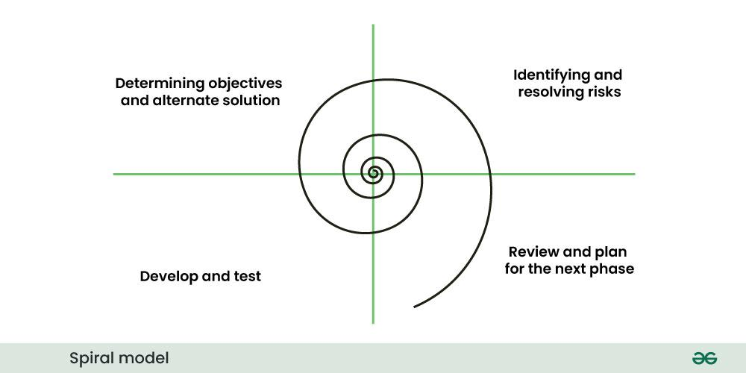

Key Principles of Spiral SDLC Models:
- Iterative Development: The Spiral model embraces iterative development, allowing for the incremental release of the product. Each iteration, or spiral, includes planning, risk analysis, engineering, testing, and evaluation phases.
- Risk Management: Risk analysis is a fundamental component of the Spiral Models. Each iteration begins with a risk assessment, and the project progresses based on addressing high-priority risks. This approach allows for proactive risk management and mitigation.
- Flexibility: The models are highly adaptable to changes in requirements. As each iteration involves planning and assessment, modifications and adjustments can be made to accommodate evolving project needs.
- Continuous Evaluation: Evaluation is integrated into every phase of the Spiral Models. After each iteration, the project is reviewed to assess progress, identify potential risks, and determine the next steps.

Advantages of the Spiral SDLC Models:
- Risk Mitigation: The focus on risk analysis and management allows for early identification and mitigation of potential issues, reducing the likelihood of project failure.
- Flexibility in Requirements: Changes to requirements can be accommodated at any stage of the development process. The iterative nature of the Spiral models facilitates flexibility and adaptation.
- High-Quality Products: Continuous evaluation and testing contribute to the production of high-quality software. Defects are identified and addressed early in the development life cycle.
- Client Involvement: Clients and stakeholders are involved throughout the development process. Their input is sought during the planning and evaluation phases, ensuring the final product aligns with their expectations.

Best Practices for Spiral SDLC Models:
- Thorough Risk Assessment: Conduct a comprehensive risk assessment at the beginning of each iteration. Prioritize and address high-risk elements to minimize potential challenges.
- Regular Review Meetings: Hold regular review meetings after each iteration to assess progress, evaluate the product, and plan the next steps. This continuous feedback loop is crucial for success.
- Collaborative Team Communication: Foster open communication among team members. Collaboration is key to successfully navigating the iterative and dynamic nature of the Spiral Models.
- Documentation: Maintain detailed documentation throughout the development process. This includes documentation of risks, decisions, and changes made at each iteration.

Conclusion:
The Spiral Model, with its emphasis on risk management and iterative development, offers a robust framework for navigating the complexities of software projects. As organizations strive for adaptability and high-quality outcomes, the Spiral model stands as a valuable approach, providing a systematic yet flexible path to successful software development.

5. Agile SDLC Models
Agile is not a specific methodology but rather a set of principles and values outlined in the Agile Manifesto. The Agile Manifesto prioritizes individuals and interactions, working solutions, customer collaboration, and responding to change over rigid processes and documentation. Several Agile methodologies, including Scrum, Kanban, and Extreme Programming (XP), have been developed to implement these principles.

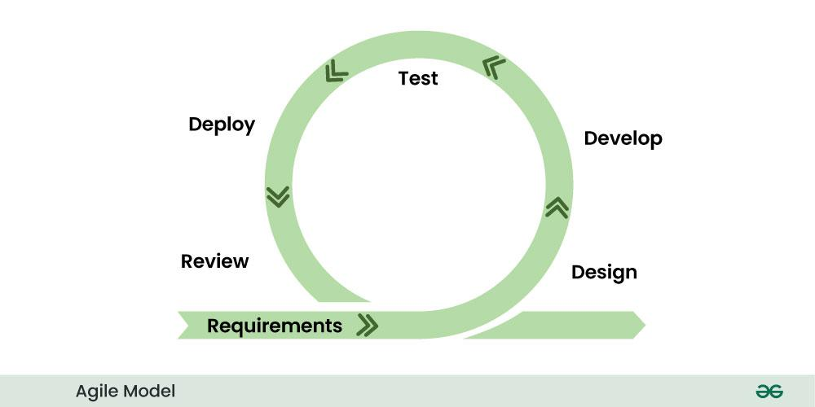

Key Principles of Agile SDLC Models:
- Iterative and Incremental Development: Agile promotes iterative development cycles, with each iteration producing a potentially shippable increment of the software. This allows for rapid adaptation to changing requirements.
- Customer Collaboration: Regular and close collaboration with customers and stakeholders is integral to Agile. Their feedback is sought throughout the development process, ensuring that the product meets their expectations.
- Adaptability to Change: Agile embraces change, even late in the development process. It recognizes that requirements are likely to evolve, and the methodology is designed to accommodate these changes efficiently.
- Cross-Functional Teams: Agile encourages the formation of cross-functional teams comprising individuals with diverse skills. This promotes collaboration and enables the team to collectively take ownership of the entire development process.

Advantages of the Agile SDLC Models:
- Flexibility and Adaptability: Agile’s iterative nature allows teams to adapt quickly to changing requirements. This flexibility is particularly valuable in dynamic and fast-paced environments.
- Customer Satisfaction: Continuous customer involvement ensures that the delivered product aligns closely with customer expectations. This customer-centric approach enhances satisfaction and reduces the risk of delivering a product that does not meet user needs.
- Early and Predictable Delivery: Agile’s iterative cycles result in regular and predictable product deliveries. This allows stakeholders to see tangible progress at the end of each iteration.
- Improved Quality: Continuous testing and integration throughout the development process contribute to higher software quality. Bugs and issues are identified and addressed early, reducing the risk of defects in the final product.

Best Practices for Agile SDLC Models:
- Effective Communication: Foster open and transparent communication within the team and with stakeholders. Regular meetings, stand-ups, and collaborative tools are essential for keeping everyone informed.
- Prioritization and Planning: Prioritize features and tasks based on customer value. Regular planning sessions, such as Sprint Planning in Scrum, help the team focus on high-priority items.
- Continuous Integration and Testing: Implement continuous integration practices to ensure that code changes are integrated and tested frequently. This minimizes integration issues and helps maintain a stable codebase.
- Retrospectives for Continuous Improvement: Conduct regular retrospectives to reflect on what went well, what could be improved, and how the team can enhance its processes. Continuous improvement is a core principle of Agile.

Conclusion:
The Agile model, with its focus on collaboration, adaptability, and customer satisfaction, has revolutionized the software development landscape. As organizations strive for agility and responsiveness in a rapidly changing world, the Agile model remains a cornerstone for achieving success in software development projects.

8. Incremental SDLC Models
The Incremental model is an iterative software development process where the product is designed, implemented, and tested incrementally (a little more is added each time) until the product is finished. Each iteration represents a small part of the overall system and includes both new features and enhancements to existing ones.
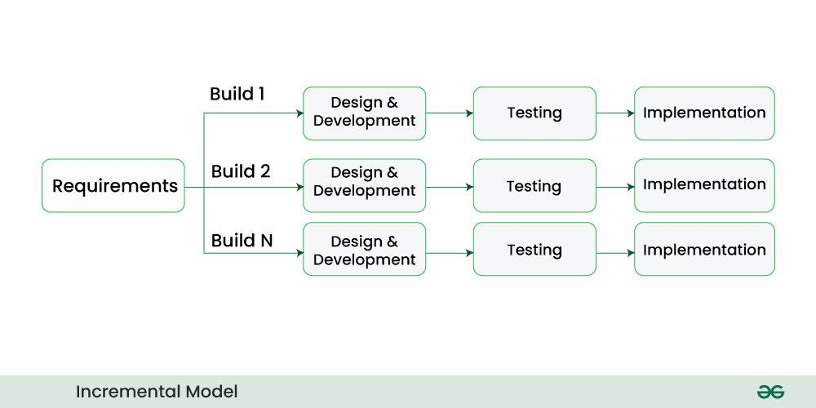

Key Principles of Incremental SDLC Models:
- Incremental Development: The development process is divided into increments, with each increment delivering a portion of the complete functionality. This allows for the gradual building of the system.
- Partial System Functionality: Each increment provides partial system functionality, allowing stakeholders to see tangible progress early in the development process. This helps in gathering feedback and making adjustments.
- Integration of Increments: Increments are integrated with the existing system or increments from previous iterations. This integration ensures that the complete system evolves gradually with each increment.
- Parallel Development: Different teams or development groups can work on different increments simultaneously. This parallel development approach contributes to faster development cycles.

Advantages of the Incremental SDLC Models:
- Early and Tangible Results: Stakeholders see tangible results early in the development process as each increment delivers a part of the functionality. This helps in managing expectations and gathering early feedback.
- Flexibility and Adaptability: The models allow for changes to be incorporated easily at each increment. This flexibility is particularly beneficial when dealing with evolving requirements or feedback from users.
- Risk Management: Risk is mitigated as the development process is divided into smaller, manageable increments. This allows for early detection and resolution of issues, minimizing the impact on the overall project.
- Faster Time-to-Market: The incremental and parallel development approach often results in a faster time-to-market compared to traditional sequential models. This is especially valuable in dynamic and competitive environments.

Best Practices for Incremental SDLC Models:
- Clear Requirements Definition: Ensure that the requirements for each increment are well-defined. Clear requirements facilitate smooth development and integration processes.
- Thorough Testing at Each Increment: Rigorous testing should be conducted at each increment to ensure that the integrated system functions correctly. This includes testing the new features and ensuring compatibility with existing ones.
- Effective Communication: Maintain open and effective communication among teams working on different increments. Regular updates and coordination are essential for successful parallel development.
- Iterative Feedback: Encourage iterative feedback from stakeholders after each increment. This feedback loop helps in refining the system and addressing any issues early in the development process.

Conclusion:
The Incremental Model, with its focus on the gradual development and integration of system components, provides an effective approach to software development. By delivering partial functionality in each increment, this model aligns well with the principles of adaptability, risk management, and faster time-to-market. As organizations seek methods that balance flexibility with tangible results, the Incremental model stands as a valuable option in the ever-evolving landscape of software development.

Comparison between various SDLC Models
Below is a table comparing several Software Development Life Cycle (SDLC) models, including Waterfall, Iterative, Spiral, Agile, V-Models, and Incremental. Please note that this is a high-level comparison, and the suitability of a particular model depends on the specific requirements and nature of the project.

Aspect | Waterfall | Iterative | Spiral | Agile | V-Models | Incremental
Development Approach | Sequential | Iterative | Iterative | Iterative | Iterative | Iterative
Phases | Linear | Planning, Design, Coding, Testing, Evaluation (Repeated Iteratively) | Planning, Risk Analysis, Engineering, Testing (Cyclical) | Planning, Sprint, Review, Retrospective (Iterative Cycles) | Planning, Design, Implementation, Testing, Deployment (Parallel) | Divided into increments, each with Planning, Implementation, Testing
Flexibility | Low | High | High | High | Moderate | High
Risk Management | Late mitigation, Limited adaptability | Proactive risk management, Adaptability to changes | Continuous risk assessment, Proactive mitigation | Continuous risk assessment, Adaptability to changes | Risk management aligned with phases, Moderate adaptability | Proactive risk management, Adaptability to changes
Time-to-Market | Longer | Faster | Variable | Faster | Moderate | Faster
User Involvement | Limited | Continuous | Periodic | Continuous | Periodic | Continuous
Testing | After Implementation | Continuous throughout iterations | Integrated throughout the spiral | Continuous and c | After Implementation | Continuous throughout increments
Adaptability | Low | High | High | High | Moderate | High
Complexity Management | Linear approach, Limited adaptability | Easier to manage, Adaptability to changes | Cyclical approach, Risk-d | Adaptive approach to changes | Traceability helps manage c | Adaptive approach to changes

When to use which SDLC models?
Choosing the right Software Development Life Cycle (SDLC) Model depends on various factors such as project requirements, timelines, budget, and team expertise. Here’s a table that outlines when to use different SDLC models based on specific considerations:

Consideration | Waterfall | Iterative | Spiral | Agile | V-Models | Incremental
Project Size | Small to Medium | Medium to Large | Large | Small to Medium | Medium to Large | Small to Large
Project Complexity | Low to Medium | Medium to High | High | Low to High | Medium to High | Medium to High
Requirements Stability | Stable | Can evolve | Can evolve | Likely to change frequently | Moderate stability | Stable to Moderate Stability
Client Involvement | Limited | Continuous | Periodic | High and Continuous | Periodic | Continuous
Budget Constraints | High Predictability, Fixed Budget | Moderate Predictability, Some Flexibility | Some Flexibility | Variable, Suitable for Changing Budgets | Moderate Predictability, Fixed Budget | Moderate Predictability, Some Flexibility
Risk Tolerance | Low | Moderate | High | Moderate | Moderate | Moderate to High
Time-to-Market | Moderate | Faster | Variable | Faster | Moderate | Faster
Documentation Emphasis | Extensive Documentation | Moderate Documentation | Detailed Documentation | Minimal Documentation | Moderate Documentation | Moderate Documentation
Testing Approach | Sequential Testing after Development Phases | Continuous Testing Throughout Iterations | Continuous Testing Throughout the Spiral | Continuous and Collaborative Testing | Testing Conducted After the Completion of Phases | Continuous Testing Throughout Increments
Change Management | Limited Flexibility | High Flexibility | Adaptive to Changes | Highly Adaptive to Changes | Moderate Flexibility | High Flexibility
It’s important to note that these recommendations are general guidelines, and the choice of an SDLC models may vary based on the specific context and requirements of each project. Additionally, hybrid approaches that combine elements from different SDLC models are also commonly used to tailor the development process to a project’s unique needs.

Which is the most widely used Software Development Model (SDLC model) and Why?
Agile is widely considered one of the most used Software Development Life Cycle (SDLC) models in the software industry. Agile methodologies, including Scrum, Kanban, and others, have gained significant popularity. Here are some reasons why Agile is commonly used:
- Adaptability to Change: Agile is highly adaptive and embraces changes in requirements even late in the development process. This flexibility is crucial in dynamic business environments where requirements may evolve.
- Customer Satisfaction: Agile methodologies prioritize continuous customer involvement and feedback. This ensures that the delivered product aligns closely with customer expectations, leading to higher customer satisfaction.
- Faster Time-to-Market: Agile promotes iterative development cycles, allowing for the delivery of working software in short increments. This results in a faster time-to-market for features and updates.
- Risk Management: Agile practices, such as continuous testing and customer feedback, contribute to early detection and resolution of issues. This proactive approach enhances risk management and reduces the likelihood of major defects.
- Collaborative Team Environment: Agile emphasizes cross-functional teams working collaboratively. This fosters better communication, cooperation, and a shared sense of responsibility among team members.
- Continuous Improvement: Agile methodologies encourage regular retrospectives and continuous improvement. Teams reflect on their processes and outcomes, making adjustments to enhance efficiency and effectiveness.
- Iterative Development: The iterative nature of Agile allows for the delivery of incremental, tangible results. This provides stakeholders with visibility into the progress of the project and allows for adjustments based on feedback.
- Predictable and Sustainable Pace: Agile promotes a sustainable pace of work for development teams. This helps prevent burnout and ensures that teams can consistently deliver value over the long term.
It’s important to note that the choice of an SDLC models depends on various factors, including project size, complexity, organizational culture, and specific project requirements. While Agile is prevalent, other models like Waterfall, Iterative, and others are still used based on the unique characteristics of different projects. Additionally, some organizations adopt hybrid approaches that combine elements from multiple SDLC models to tailor the development process to their specific needs.

