姓名 | 肖阳 | 学号 | 24300240055 | 第几次实验 | 2
实验代码（将代码粘贴在下面，如果有多题，将每一题的题目写在代码前面，加粗表示）
dynamic_int_array
#include <stdio.h>
#include <stdlib.h>
long long n = 1000000000;
int main() {
// 1. Dynamically create an int type array of length n, where
// n = 1000 000 000.
// 2. Set all elements of the array to the constant 1.
// 3. Free the array at the end.
int *array=(int *)malloc(sizeof(int)*n);
for(int i=1;i<=n;i++) array[i-1]=1;
free(array);
return 0;
}
Swap:
#include <stdio.h>
#include <assert.h>

typedef void (*fun_t)(double*, double*);

// Swap two doubles
void swap(double *x, double *y) {
// Write your code here.
double z=*x;
*x=*y;
*y=z;
}

void TestSwapCase1(fun_t swap) {
double x = 1.00;
double y = 1.00;
swap(&x, &y);
assert(x == 1.00);
assert(y == 1.00);
printf("Passed %s\n", __func__);
}

void TestSwapCase2(fun_t swap) {
double x = 1.00;
double y = 2.00;
swap(&x, &y);
assert(x == 2.00);
assert(y == 1.00);
printf("Passed %s\n", __func__);
}

int main() {
TestSwapCase1(swap);
TestSwapCase2(swap);
return 0;
}

运行结果（截图运行结果，如果有多题，写清题目加粗表示，再粘贴截图）
dynamic_int_array
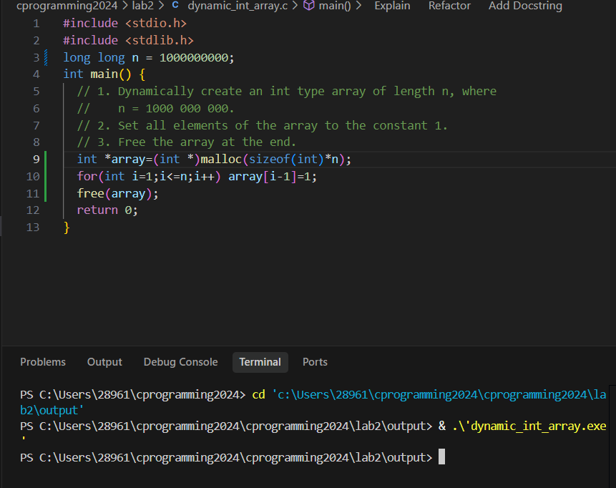
swap
