姓名 | 肖阳 | 学号 | 24300240055 | 第几次实验 | 3
实验代码（将代码粘贴在下面，如果有多题，将每一题的题目写在代码前面，加粗表示）
C/pi_sample.c
#include <stdio.h>
#include<math.h>
#include<stdlib.h>
/*
Sample a random point (x, y) in the square [-1, 1] * [-1, 1].
There is a unit circle C centered on (0, 0) with a radius of 1.
The probability that a randomly chosen point falls inside
the circle C is exactly PI / 4.

Estimate the value of PI with a precision of 1e-3 by sampling
a sufficient number of points.
*/
double randf() {
return (double)rand() / RAND_MAX;
}
int main() {
const double PI=3.1415926535284;
int count=0,time=0;
double pi;
double a,b;
while(fabs(PI-pi)>=1e-10){
a=randf();
b=randf();
if(a*a+b*b<=1.00) count++;
time++;
printf("%d %d ",count,time);
pi=(double)count/time*4;
printf("%lf\n",pi);
}
printf("%lf %d",pi,time);
return 0;
}
C/pi_zeta.c
#include <stdio.h>
#include<math.h>
/*
Let zeta(s) = 1/1^s + 1/2^s + 1/3^s + ...
It is known that
zeta(2) = PI^2 / 6
zeta(4) = PI^4 / 90

The goal is to compute the constant PI to a precision of 1e-3
(meaning three decimal places) using the Riemann zeta function.
*/

int main() {
const double PI=3.1415926535;
double pi,pi1=1.00;int i=2;
while(PI-pi>=1e-3){
double add=1.00/(i*i);
i++;
pi1+=add;
pi=sqrt(pi1*6);
printf("%d %lf\n",i,pi);
}
printf("%lf",pi);
return 0;
}

运行结果（截图运行结果，如果有多题，写清题目加粗表示，再粘贴截图）
C/pi_sample.c
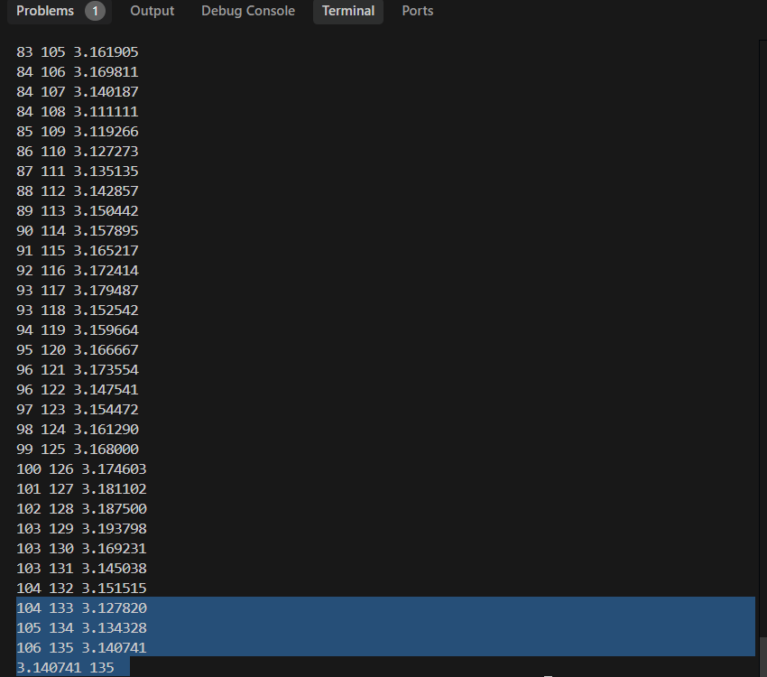
C/pi_zeta.c
