姓名 | 肖阳 | 学号 | 24300240055 | 第几次实验
实验代码（将代码粘贴在下面，如果有多题，将每一题的题目写在代码前面，加粗表示）
Cubic:
#include <stdio.h>
#include <assert.h>
#include <math.h>
#include <stdbool.h>

// 定义一个非常小的值作为收敛标准
#include<stdio.h>
#include<math.h>
int count=0,i,j;
double sol[3]={-10,-20,-30},a,b,c,d,er=0.00000001,s1,a1,b1,c1;//ax^3+bx^2+cx+d=0,error=er
double f(double x){
return a*x*x*x+b*x*x+c*x+d;
}

// 求解三次方程的所有实根
void solve_cubic_equ(double c2, double c1, double c0, double eps, int* cnt, double* sol) {
a=1;b=c2;c=c1;d=c0;
double low=0,top=1,s1;
while (f(low)*f(top)>0){
low--;top++;
}
while(top-low>er||f(s1)>er){
s1=(top+low)/2;
if(f(s1)==0) break;
if(f(s1)*f(low)>0) low=s1;
else top=s1;
}sol[0]=s1;*cnt=1;
a1=a,b1=b+a*s1,c1=c+b*s1+a*s1*s1;
double delta=b1*b1-4*a1*c1;//printf("%lf",delta);
if(delta<0) ;
else{
if(delta<0.001) {
count=1;
sol[1]=-b1/a1/2;
}
else{delta=sqrt(delta);
count=2;
sol[1]=(delta-b1)/a1/2;
sol[2]=(-delta-b1)/a1/2;
}
}//if(fabs(sol[1]-sol[2])<0.00001) count--;
double mid;
for(i=0;i<=count;i++){
for(j=i+1;j<=count;j++){
if(sol[i]>sol[j]){
mid=sol[i];
sol[i]=sol[j];
sol[j]=mid;
}
}
}*cnt=count+1;
if(count==2) printf("%.lf",sol[1]-sol[2]);
if(count==2&&fabs(sol[1]-sol[2])<0.001) *cnt=2;
}

// 测试用例
void TestCase1() {
double eps = 1e-6;
int cnt;
double sol[3];
solve_cubic_equ(0, 0, -1, eps, &cnt, sol);
printf("Test Case 1: Expected 1 root, x = 1\n");
printf("Number of roots: %d\n", cnt);
for (int i = 0; i < cnt; i++) {
printf("Root %d: %.6f\n", i + 1, sol[i]);
}
assert(cnt == 1 && fabs(sol[0] - 1) < eps);
printf("Passed TestCase1\n");
}

void TestCase2() {
double eps = 1e-6;
int cnt;
double sol[3];
solve_cubic_equ(0, -3, 2, eps, &cnt, sol);
printf("Test Case 2: Expected 2 roots, x = 1 (double), x = -2\n");
printf("Number of roots: %d\n", cnt);
for (int i = 0; i < cnt; i++) {
printf("Root %d: %.6f\n", i + 1, sol[i]);
}
// 注意：由于浮点数精度问题，可能无法准确判断双重根，这里只检查根的数量和接近程度
bool passed = (cnt == 2 && (fabs(sol[0] + 2) < eps || fabs(sol[1] + 2) < eps) && (fabs(sol[0] - 1) < eps || fabs(sol[1] - 1) < eps));
if (cnt == 2) {
// 确保有一个根非常接近1，另一个根非常接近-2
if (fabs(sol[0] - 1) < eps) {
assert(fabs(sol[1] + 2) < eps);
} else {
assert(fabs(sol[0] + 2) < eps);
assert(fabs(sol[1] - 1) < eps);
}
}
printf("Passed TestCase2: %s\n", passed ? "Yes" : "No");
}

void TestCase3() {
double eps = 1e-6;
int cnt;
double sol[3];
solve_cubic_equ(-6, 11, -6, eps, &cnt, sol);
printf("Test Case 3: Expected 3 roots, x = 1, 2, 3\n");
printf("Number of roots: %d\n", cnt);
for (int i = 0; i < cnt; i++) {
printf("Root %d: %.6f\n", i + 1, sol[i]);
}
assert(cnt == 3 && fabs(sol[0] - 1) < eps && fabs(sol[1] - 2) < eps && fabs(sol[2] - 3) < eps);
printf("Passed TestCase3\n");
}

int main() {
TestCase1();
TestCase2();
TestCase3();
return 0;
}
Missing:
#include <stdio.h>
#include <assert.h>
#include <stdlib.h>

// Given n and a list of n-1 distinct integers from the set {1, 2, ..., n},
// return the missing integer in the range [1, n] that is not present in the list
int find_missing_element(int n, int* list) {
int expected_sum = n * (n + 1) / 2;
int actual_sum = 0;
for (int i = 0; i < n - 1; i++) {
actual_sum += list[i];
}
return expected_sum - actual_sum;
}

void TestCase1() {
int n = 5;
int list[4] = {1, 2, 3, 4};
assert(find_missing_element(n, list) == 5);
printf("Passed TestCase1\n");
}

void TestCase2() {
int n = 6;
int list[5] = {4, 1, 3, 2, 5};
assert(find_missing_element(n, list) == 6);
printf("Passed TestCase2\n");
}

void TestCase3() {
int n = 1000000;
int target = 165536;
int* list = (int*) malloc((n-1) * sizeof(int));
int j = 1;int i;
for ( i = 0; i < n-1; i ++) {
if (j == target) {
j ++;
}
list[i] = j++;
}
printf("Target: %d\n", target);
printf("List elements: ");
for (int k = 0; k < 10; k++) {
// printf("%d ", list[k]);
}
// printf("...\n");
assert(find_missing_element(n, list) != target);
printf("Passed TestCase3\n");
}

int main() {
TestCase1();
TestCase2();
TestCase3();
return 0;
}

运行结果（截图运行结果，如果有多题，写清题目加粗表示，再粘贴截图）
Cubic:
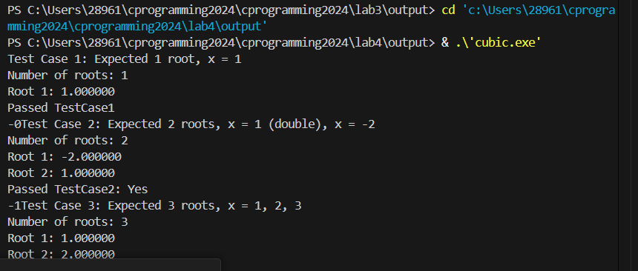
Missing:
