姓名 | 肖阳 | 学号 | 24300240055 | 第几次实验
实验代码（将代码粘贴在下面，如果有多题，将每一题的题目写在代码前面，加粗表示）
Sieve.cpp:
#include <stdio.h>
#include <assert.h>
int is_prime(int n) {
int i;
for (i=2; i*i<=n; i++) {
if (n%i==0) return 0;
}
return 1;
}
/*
Use the Sieve of Eratosthenes to count the number of
primes between 1 and n.
*/

// Return the number of primes between [2, n], where
// n <= 10^8.
int count_prime(int n) {
int i, count=0;
for (i=2; i<=n; i++) {
if (is_prime(i)) count++;
}
return count;
}
void TestCase1() {
// Test Case 1: n:10000 result=1229
int res;
res=count_prime(10000);
assert(res==1229);
printf("Passed TestCase1\n");
}

void TestCase2() {
// Test Case 2: n=99988865 result=5760854
int res;
res=count_prime(99988865);
assert(res==5760854);
printf("Passed TestCase2\n");
}

void TestCase3() {
// Test Case 3: n=100 result=25
int res;
res=count_prime(100);
assert(res==25);
printf("Passed TestCase3\n");
}
int main() {
TestCase1();
TestCase2();
TestCase3();
return 0;
}

ramanujan.cpp
#include <stdio.h>
#include <assert.h>

/*
Ramanujan number is the smallest positive integer, which can be
expressed as the sum of two cubic numbers in two different ways.
It is also known as the Hardy-Ramanujan number.

Find this number.
*/

// Return the Ramanujan number.
int ramanujan() {
int i, j, k, l;
for (i = 1; i < 100; i++) {
for (j = i + 1; j < 100; j++) {
for (k = j+1; k < 100; k++) {
for (l = 1; l < 100; l++) {
if (i * i * i + j * j * j == k * k * k + l * l * l) {
return i * i * i + j * j * j;
}
}
}
}
}
}

int main() {
assert(ramanujan() == 1729);
printf("Passed the test.\n");
return 0;
}

运行结果（截图运行结果，如果有多题，写清题目加粗表示，再粘贴截图）
Seive.cpp:
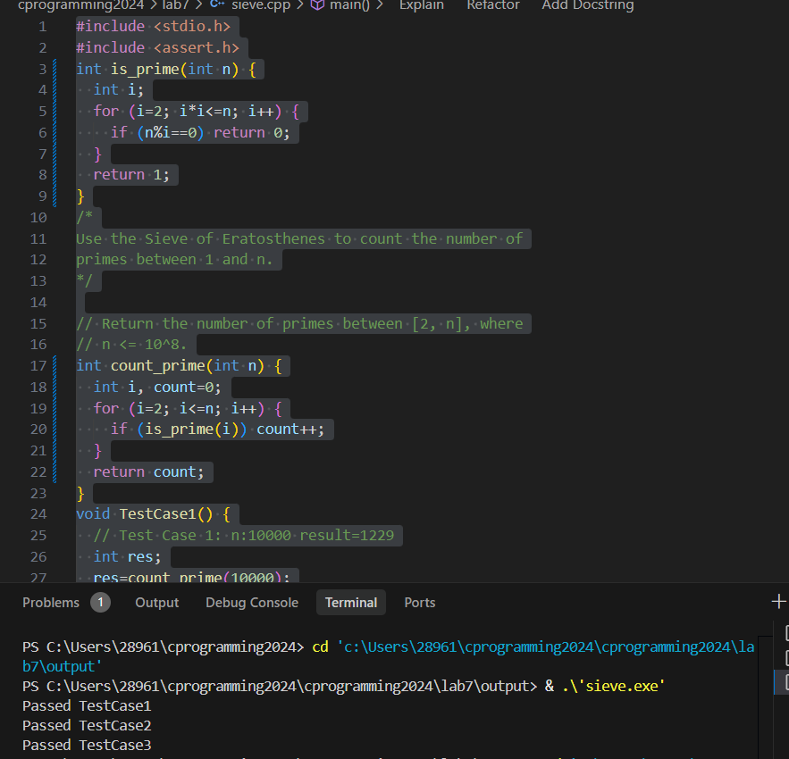
Ramanujan.cpp:
