LAB211 PROJECT REPORT | LAB 1
Mountain Hiking Challenge Registration
J1.L.P0027 | UML, Algorithms, and Test Evidence

Document field | Value
Student | Nguyen Dinh Chuong (Nguyễn Đình Chương)
Student ID | SE204330
Course | LAB211 - OOP with Java Lab
Release | Portfolio review v1.0 - 21 July 2026
Repository | https://github.com/KiritoMainBro88/SU26-LAB211

Scope intentionally limited to the lecturer's review priorities: final UML, implemented algorithms, test cases, and reproducible evidence.

1. Executive Summary
A layered Java console application for FPT University student mountain-hiking registration. It validates identity and contact data, calculates sponsored tuition, supports nine required workflows, aggregates registrations by mountain, and persists records in the object format requested by the assignment.

1.1 Verification snapshot
Check | Result | Evidence
Java compatibility compile | PASS | javac targeting Java 8 with UTF-8 and -Xlint:all
Executable deep verification | 34 passed, 0 failed | labs/lab1/testcases/Lab1DeepVerification.java
Import audit | PASS | 0 wildcard, 0 unresolved, 0 definitely unused explicit imports
Report/Audit metadata | ALIGNED | J1.L.P0027, SE204330, 21 July 2026
Required functions traced | 9/9 | Section 5 requirement-to-source matrix

1.2 Evidence interpretation
The runnable deep harness was recompiled and executed during this review: 34 checks passed and none failed. The smaller verification_results.txt file is retained as earlier regression evidence (13 passed), but it is not counted in the current completion total.

2. UML Design
The diagram below is regenerated from the final source structure. It presents the dependencies that matter to grading and maintenance, without decorative classes or layers that are not implemented.
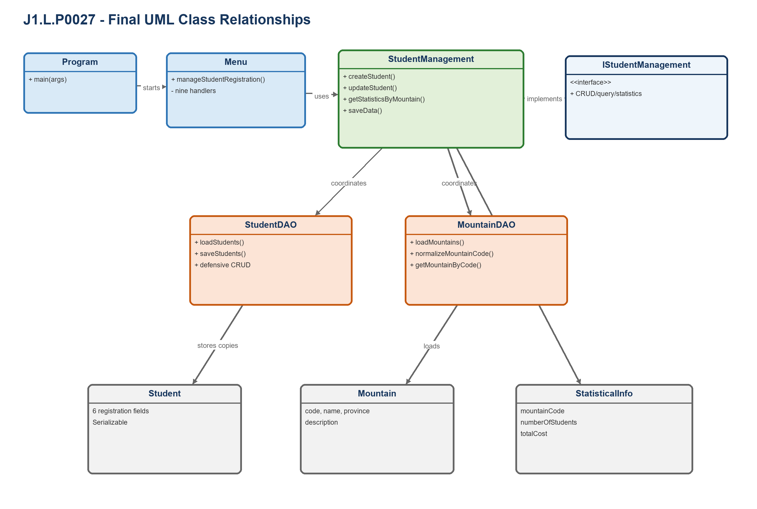
Figure 1. Final class relationships for J1.L.P0027.

2.1 Responsibility matrix
Class / Interface | Final responsibility
Program | Application entry point; loads data and starts the menu loop.
Menu | Routes the nine functions and owns console presentation only.
IStudentManagement | Focused business contract for CRUD, queries, statistics, and persistence.
StudentManagement | Coordinates validation, fee calculation, DAOs, and user-facing outcomes.
StudentDAO | Owns registration state, defensive copies, saved-state tracking, and object persistence.
MountainDAO | Loads MountainList.csv and resolves normalized mountain codes.
Student / Mountain / StatisticalInfo | Separate entities for registrations, reference data, and aggregation results.

2.2 OOP evidence
- Encapsulation: StudentDAO protects mutable Student records through deep defensive copies.
- Abstraction: IStudentManagement exposes business use cases without persistence details.
- Polymorphism: Menu depends on the business contract represented by StudentManagement operations.
- Responsibility separation: presentation, business, data access, utilities, and entities remain distinct.

3. Implemented Algorithms
Pseudocode reflects the final implementation rather than an idealized alternative. Complexity statements also account for the list-based data structures used by these assignment-sized applications.
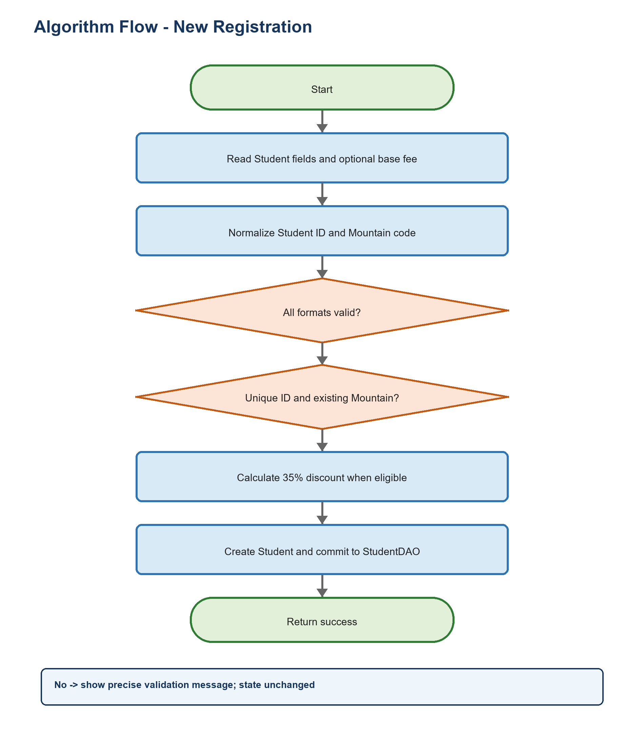
Figure 2. Representative decision flow from the final implementation.

A1 - Create a registration
Purpose: Reject invalid state before a Student reaches persistent in-memory data.
01 normalize studentId and mountainCode
02 if studentId/name/phone/email is invalid: REJECT
03 if mountainCode does not exist or studentId is duplicated: REJECT
04 if baseFee is not finite or baseFee <= 0: REJECT
05 fee = baseFee * 0.65 when phone is Viettel/VNPT; otherwise baseFee
06 create Student and add a defensive copy to StudentDAO
07 mark data as changed and return success
Complexity: O(n + m) time for duplicate and mountain lookup; O(1) additional space.

A2 - Safe partial update and tuition recalculation
Purpose: Preserve blank fields and the original custom base-fee basis.
01 find current Student by immutable ID; reject when missing
02 for each editable field: blank -> old value; otherwise -> candidate value
03 validate the complete candidate before changing state
04 if a new base fee exists: calculate from that fee
05 else if phone changed: recover old base fee, then recalculate discount
06 replace the record only after every check succeeds
Complexity: O(n + m) time; O(1) additional space excluding the candidate object.

A3 - Statistics by mountain
Purpose: Show only mountains that have registrations, with count and total tuition.
01 create insertion-ordered map: mountainCode -> StatisticalInfo
02 for each Student:
03 create a zeroed bucket when the code is first seen
04 increment participant count and add tuition fee
05 return the map values in deterministic first-seen order
Complexity: O(n) expected time and O(k) space, where k is the number of used mountains.

A4 - Defensive object-file load/save
Purpose: Prevent malformed serialization or failed replacement from destroying valid state.
01 LOAD: deserialize into temporary state and validate every Student and unique ID
02 LOAD: replace active memory only after complete success
03 SAVE: validate the complete current list before opening output
04 SAVE: write a copied list to a temporary sibling file
05 SAVE: atomically replace registrations.dat when supported
Complexity: O(n) time and O(n) temporary memory.

4. Test Cases and Executed Evidence

4.1 Execution record
Artifact | Status | Interpretation
Source compilation | PASS | All production and deep-test Java files compile for Java 8.
Deep harness | 34/34 PASS | Re-executed on 21 July 2026; process exit code 0.
Earlier regression record | 13/13 PASS | Retained historical result; not added to current 153-check claim.
State preservation | PASS | Failure paths assert memory/file content, not only return values.

4.2 Representative test matrix
ID | Scenario | Input / action | Expected result | Actual
L1-T01 | Valid custom-fee registration | SE123456, valid contact, MT01, 10,000,000 | Added; non-discount phone keeps 10,000,000 | PASS
L1-T02 | Discount after phone-only update | Change phone to 0961234567; base fee blank | Preserve 10,000,000 basis; fee becomes 6,500,000 | PASS
L1-T03 | Student ID partitions | AB123456, SE12345A, duplicate se123456 | All rejected without changing valid state | PASS
L1-T04 | Name boundaries | 2, 20, and 21 characters | 2/20 accepted; 21 rejected | PASS
L1-T05 | Phone and numeric safety | Unknown prefix, NaN, Infinity, zero | All rejected | PASS
L1-T06 | Mountain normalization | 1, 01, MT01, mt01 | All resolve to MT01 | PASS
L1-T07 | Defensive query result | Mutate Student returned by getAllStudents | Manager state remains unchanged | PASS
L1-T08 | Malformed serialized list | Valid Student plus non-Student item | Load fails and preserves memory | PASS

4.3 Coverage strategy
- Equivalence partitions: valid, invalid format, duplicate, missing reference, and empty/null inputs.
- Numeric boundaries: lower/upper limits plus NaN and positive infinity where double values are accepted.
- State assertions: rejected operations must preserve the prior object list or target file.
- Persistence round-trips: valid text/object data is saved and reloaded with essential values preserved.
- Encapsulation checks: mutations to returned objects/lists must not change manager/DAO state.

5. Requirement-to-Source Traceability
Every visible assignment function maps to a final handler, a business/persistence method, and at least one verification artifact or explicit source-path review.
Requirement | Menu / handler | Final implementation | Evidence
1. New Registration | Menu.newRegistration | StudentManagement.createStudent | L1-T01, T03-T06
2. Update Registration | Menu.updateRegistration | StudentManagement.updateStudent | L1-T02
3. Display Registered List | Menu.displayRegisteredList | StudentManagement.getAllStudents | Defensive-copy checks
4. Delete Registration | Menu.deleteRegistration | StudentManagement.deleteStudent | Null/not-found checks
5. Search by Name | Menu.searchParticipantsByName | StudentManagement.searchByName | Case-insensitive search
6. Filter by Campus | Menu.filterDataByCampus | StudentManagement.filterByCampus | Valid/invalid campus
7. Statistics by Location | Menu.displayStatisticsByMountain | StudentManagement.getStatisticsByMountain | Aggregation checks
8. Save Data | Menu.saveData | StudentDAO.saveStudents | Save/reload and failure preservation
9. Exit | Menu.exitProgram | StudentManagement.isSaved/saveData | Save-failure cancellation trace

5.1 Import and source hygiene
Audit item | Result | Basis
Incorrect/unresolved imports | 0 | Complete production + test compilation succeeded.
Wildcard imports | 0 | Repository-wide source scan.
Definitely unused explicit imports | 0 | Imported simple names are referenced in their compilation units.
Generated binaries committed | 0 | .gitignore excludes build, dist, class, jar, private IDE state, and runtime logs.

5.2 Known limitations and deliberate trade-offs
- Java object serialization is intentionally assignment-specific and is not a long-term interchange format.
- Mountain reference parsing is designed for the supplied CSV shape; it is not a general RFC 4180 library.
- Mutable Mountain objects are exposed only to the read-only presentation path; Student records use defensive copies.

5.3 Reproduction
From the repository root on Windows:
01 PowerShell -ExecutionPolicy Bypass -File .\scripts\verify-all.ps1
GitHub Actions invokes the same script on every push and pull request. The workflow pins third-party actions to reviewed commit SHAs and grants read-only repository permission.

Conclusion
The final J1.L.P0027 source implements all 9 required functions, compiles for Java 8, and passes 34 executable deep checks. The UML, algorithm descriptions, test evidence, and AI Audit Log now use the same identifiers, counts, paths, and verification date.

