LAB211 PROJECT REPORT | LAB 2
Football Club & Player Management
J1.L.P0036 | UML, Algorithms, and Test Evidence

Document field | Value
Student | Nguyen Dinh Chuong (Nguyễn Đình Chương)
Student ID | SE204330
Course | LAB211 - OOP with Java Lab
Release | Portfolio review v1.0 - 21 July 2026
Repository | https://github.com/KiritoMainBro88/SU26-LAB211

Scope intentionally limited to the lecturer's review priorities: final UML, implemented algorithms, test cases, and reproducible evidence.

1. Executive Summary
A Java console application for a football league with fourteen required workflows. It models Clubs and Players separately, enforces referential and shirt-number rules, loads strict UTF-8 CSV data, and applies defensive copies at manager boundaries.

1.1 Verification snapshot
Check | Result | Evidence
Java compatibility compile | PASS | javac targeting Java 8 with UTF-8 and -Xlint:all
Executable deep verification | 62 passed, 0 failed | labs/lab2/testcases/Lab2DeepVerification.java
Import audit | PASS | 0 wildcard, 0 unresolved, 0 definitely unused explicit imports
Report/Audit metadata | ALIGNED | J1.L.P0036, SE204330, 21 July 2026
Required functions traced | 14/14 | Section 5 requirement-to-source matrix

1.2 Evidence interpretation
The runnable deep harness was recompiled and executed during this review: 62 checks passed and none failed. The smaller verification_results.txt file is retained as earlier regression evidence (23 passed), but it is not counted in the current completion total.

2. UML Design
The diagram below is regenerated from the final source structure. It presents the dependencies that matter to grading and maintenance, without decorative classes or layers that are not implemented.
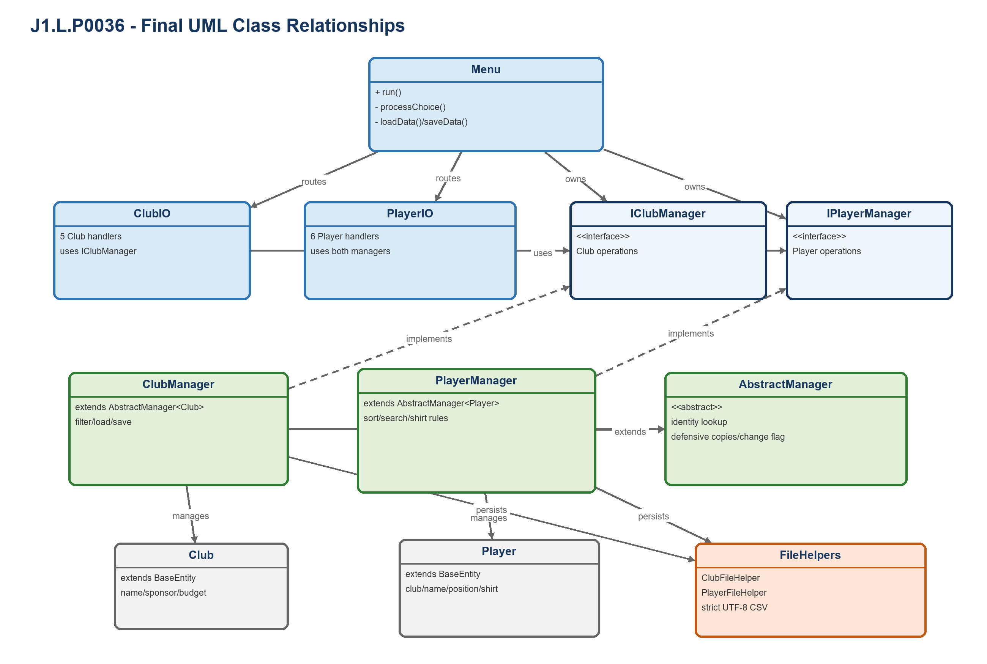
Figure 1. Final class relationships for J1.L.P0036.

2.1 Responsibility matrix
Class / Interface | Final responsibility
Menu | Coordinates fourteen functions and the strict clubs-first reload sequence.
ClubIO / PlayerIO | Own console input/output and delegate business decisions.
IManager<T> / AbstractManager<T> | Provide reusable identity lookup, defensive-copy access, and change tracking.
IClubManager / ClubManager | Implement Club CRUD, budget filtering, validation, load, and save.
IPlayerManager / PlayerManager | Implement Player CRUD, search, filtering, sorting, and shirt uniqueness.
IClubFileHelper / IPlayerFileHelper | Define text persistence boundaries for dependency inversion.
ClubFileHelper / PlayerFileHelper | Parse strict CSV and replace individual targets through temporary files.
BaseEntity / Club / Player / Position | Represent identity, domain data, and the constrained position vocabulary.

2.2 OOP evidence
- Inheritance: Club and Player extend BaseEntity; managers reuse AbstractManager<T>.
- Abstraction: manager and file-helper interfaces expose actual assignment operations.
- Polymorphism: Menu and IO classes operate through IClubManager and IPlayerManager.
- Encapsulation: managers return entity copies, so callers cannot bypass validation through setters.

3. Implemented Algorithms
Pseudocode reflects the final implementation rather than an idealized alternative. Complexity statements also account for the list-based data structures used by these assignment-sized applications.
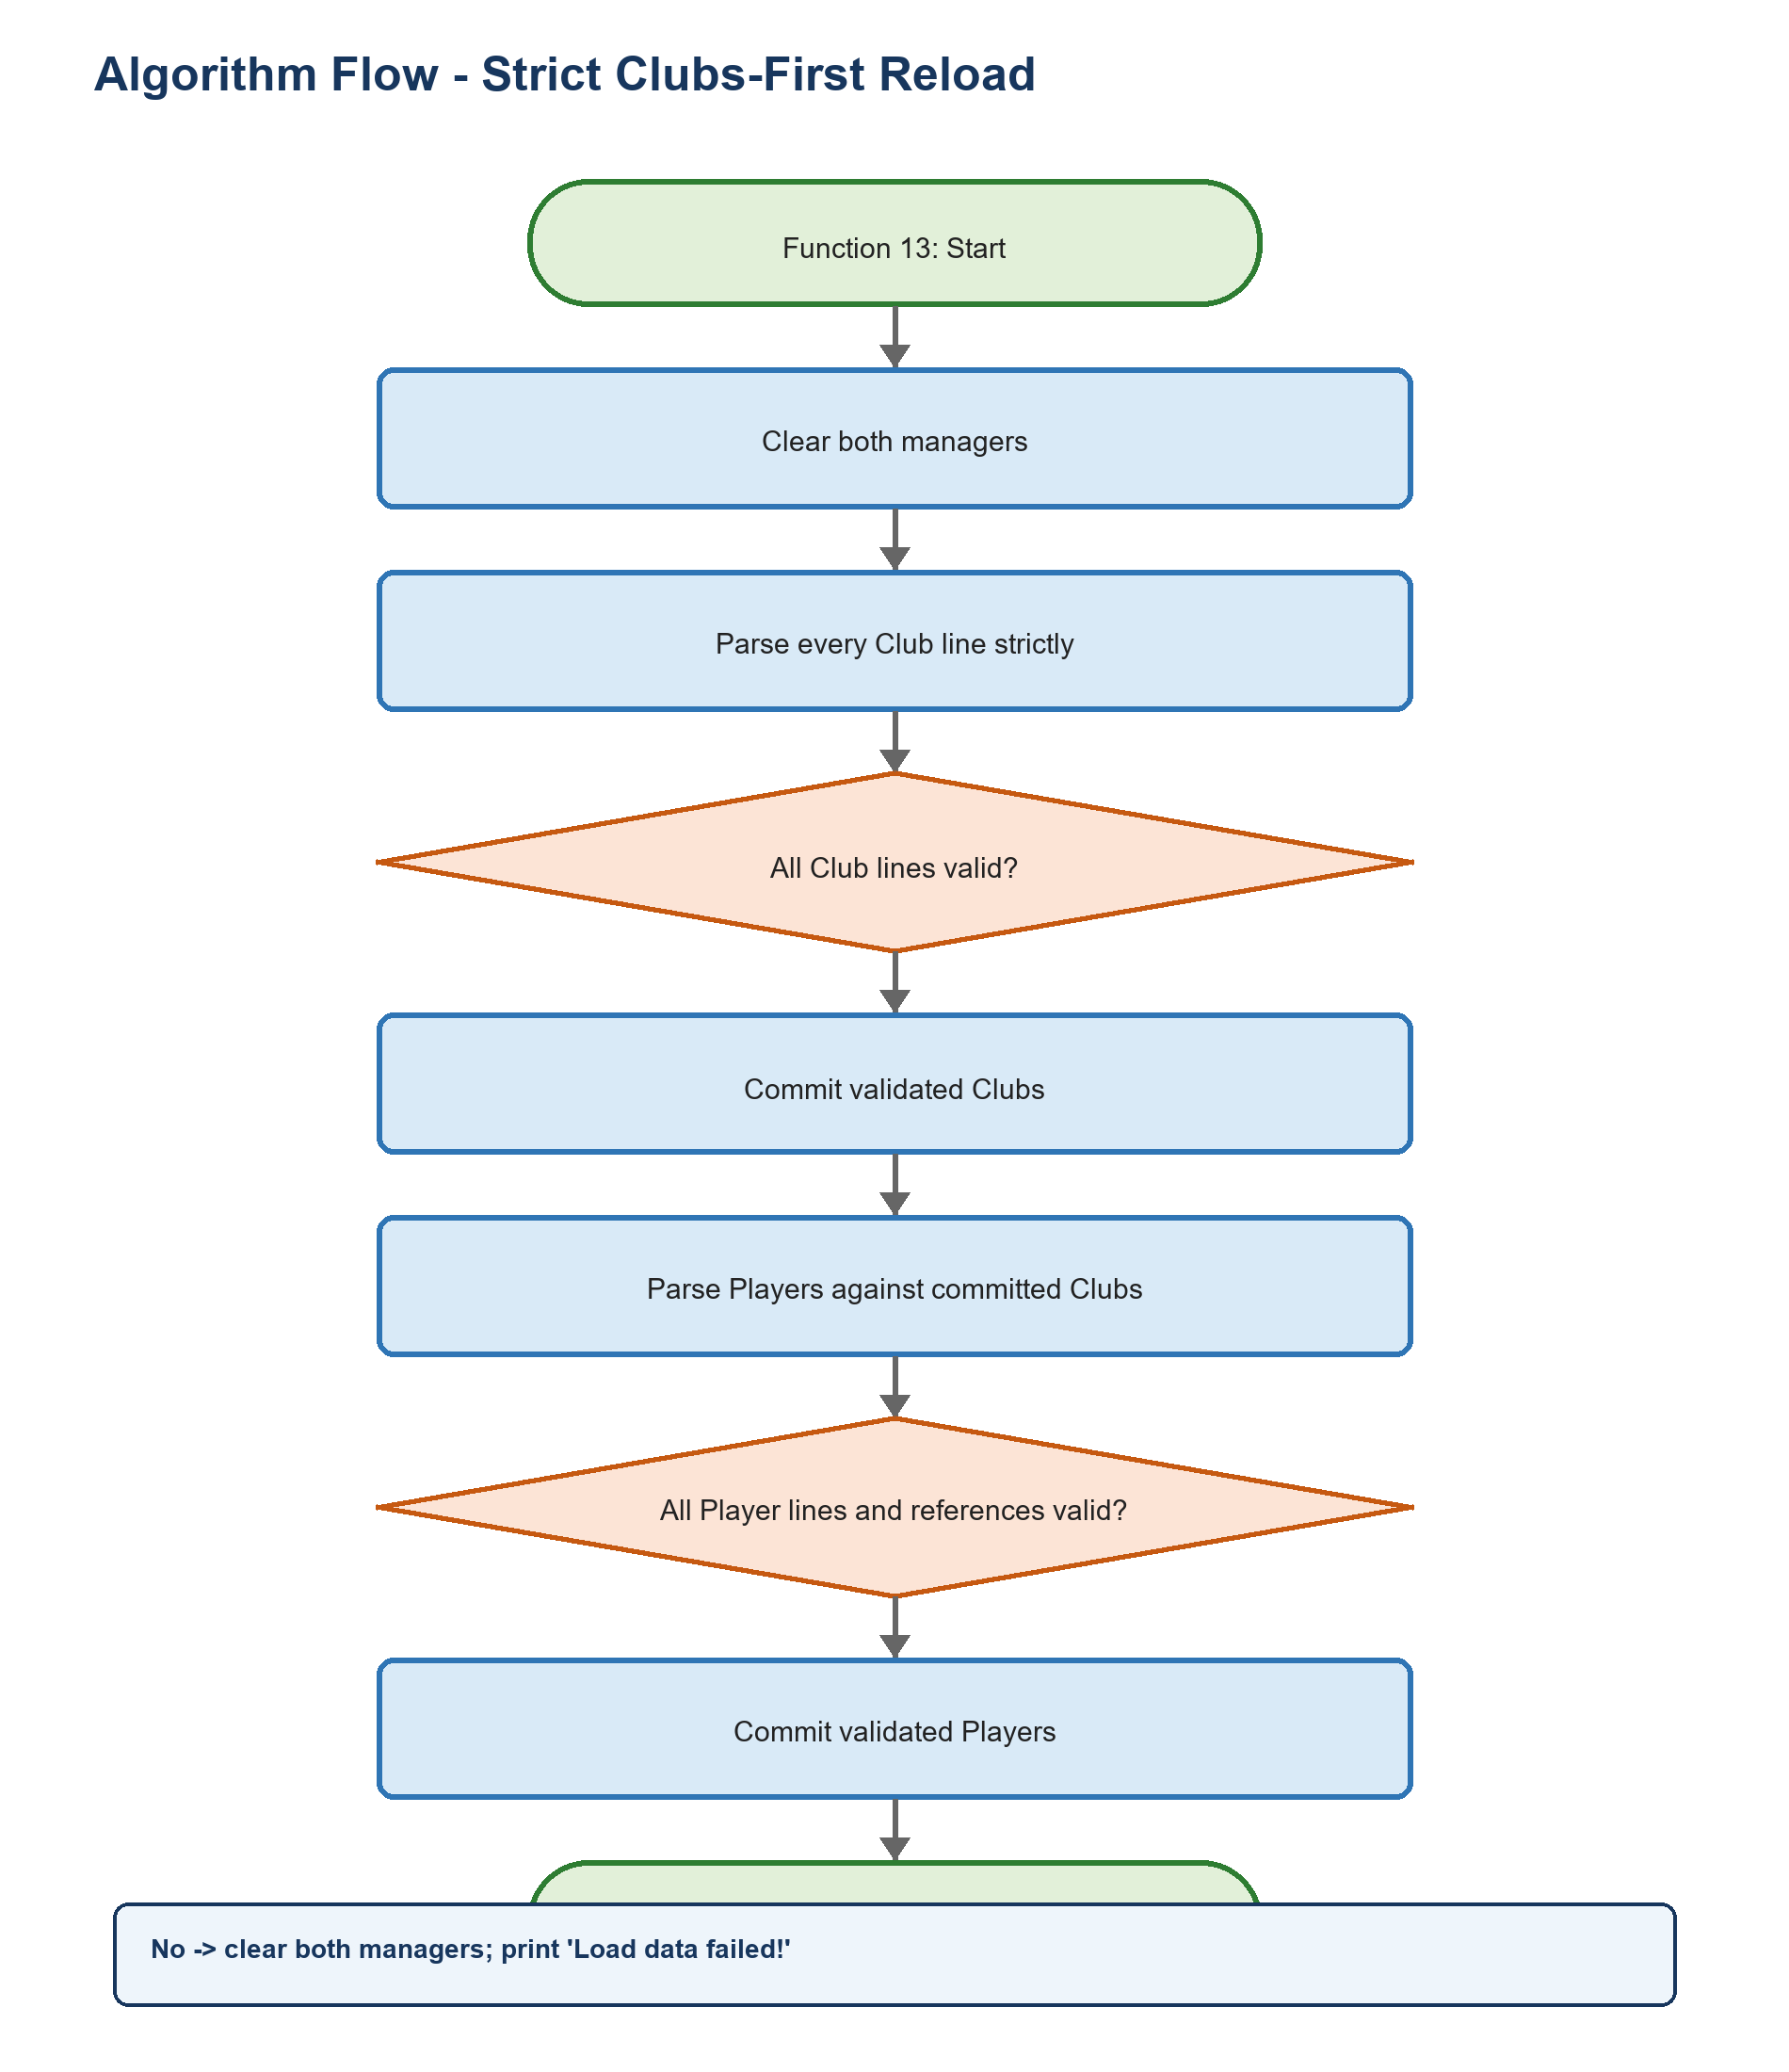
Figure 2. Representative decision flow from the final implementation.

A1 - Strict clubs-first reload
Purpose: Ensure Players never enter memory without a valid referenced Club.
01 clear ClubManager and PlayerManager
02 parse every physical club line; reject blank/malformed/duplicate data
03 if club load fails: report failure and remain empty
04 parse players against the validated Club list
05 reject missing club, duplicate ID, invalid position, or duplicate shirt in a Club
06 if player load fails: clear both managers and report failure
07 otherwise commit both validated collections
Complexity: O(c^2 + p(c + p)) with list-based uniqueness checks; data size is assignment-bounded.

A2 - Add/update Player
Purpose: Maintain identity, reference, position, and per-Club shirt-number invariants.
01 validate Pxxxx identity and locate existing Club
02 validate non-empty name and parse constrained Position
03 validate shirt in [1, 99]
04 scan Players for same Club + shirt, ignoring the current ID during update
05 build/modify state only after all validations pass
Complexity: O(c + p) time and O(1) additional space.

A3 - Sort Players for Function 6
Purpose: Sort by Club name, then shirt number only when Players share the same Club.
01 copy all Players so sorting cannot mutate manager order
02 compare resolved Club names case-insensitively
03 if names differ: return Club-name order
04 if same Club ID: compare shirt number
05 if different Clubs have equal names: use Club ID as deterministic tie-break
Complexity: O(p log p * c) with list-based Club lookup; O(p) result space.

A4 - CSV save with protected replacement
Purpose: Preserve each previous target when validation or writing fails.
01 validate complete list and all cross-entity references
02 escape commas, quotes, CR, and LF in text fields
03 write UTF-8 data to a temporary sibling file
04 replace the target atomically when supported; otherwise replace normally
05 delete temporary data on failure and report false
Complexity: O(c + p(c + p)) validation time and O(1) streaming write space.

4. Test Cases and Executed Evidence

4.1 Execution record
Artifact | Status | Interpretation
Source compilation | PASS | All production and deep-test Java files compile for Java 8.
Deep harness | 62/62 PASS | Re-executed on 21 July 2026; process exit code 0.
Earlier regression record | 23/23 PASS | Retained historical result; not added to current 153-check claim.
State preservation | PASS | Failure paths assert memory/file content, not only return values.

4.2 Representative test matrix
ID | Scenario | Input / action | Expected result | Actual
L2-T01 | Club boundaries | null, NaN/Infinity budget, duplicate ID | Rejected; valid finite Club accepted | PASS
L2-T02 | Player constraints | null position, shirt 100, missing Club | Rejected before insertion | PASS
L2-T03 | Shirt-number scope | Same number in same and different Clubs | Same-Club duplicate rejected; cross-Club accepted | PASS
L2-T04 | Blank update fields | Name, position, and shirt blank | Original fields retained; operation succeeds | PASS
L2-T05 | Sort tie-breaks | Equal Club names; same-Club shirts | Club ID tie-break; same Club by shirt | PASS
L2-T06 | Strict physical lines | Blank Club line during reload | Reload fails and both managers remain empty | PASS
L2-T07 | Quoted CSV round-trip | Comma/quote in Club and Player names | Text preserved exactly | PASS
L2-T08 | Defensive results | Mutate get/find/search/filter result | Manager state remains unchanged | PASS
L2-T09 | Finite threshold | 0, -1, NaN, Infinity | Finite values accepted; non-finite rejected | PASS
L2-T10 | Manager persistence APIs | Save and load via both managers | Round-trip succeeds | PASS

4.3 Coverage strategy
- Equivalence partitions: valid, invalid format, duplicate, missing reference, and empty/null inputs.
- Numeric boundaries: lower/upper limits plus NaN and positive infinity where double values are accepted.
- State assertions: rejected operations must preserve the prior object list or target file.
- Persistence round-trips: valid text/object data is saved and reloaded with essential values preserved.
- Encapsulation checks: mutations to returned objects/lists must not change manager/DAO state.

5. Requirement-to-Source Traceability
Every visible assignment function maps to a final handler, a business/persistence method, and at least one verification artifact or explicit source-path review.
Requirement | Menu / handler | Final implementation | Evidence
1. List Clubs | Menu case 1 | ClubIO.listAllClubs | Table output / empty list
2. Add Club | Menu case 2 | ClubManager.addClub | L2-T01
3. Search Club | Menu case 3 | ClubManager.getClubById | Found/not-found
4. Update Club | Menu case 4 | ClubManager.updateClub | Blank/invalid update
5. Budget Filter | Menu case 5 | ClubManager.filterByBudget | L2-T09
6. Sorted Players | Menu case 6 | PlayerManager.getPlayersSortedByClubName | L2-T05
7. Search Players | Menu case 7 | PlayerManager.searchByPartialName | Case-insensitive/null
8. Add Player | Menu case 8 | PlayerManager.addPlayer | L2-T02, T03
9. Remove Player | Menu case 9 | PlayerManager.removePlayer | Found/not-found
10. Update Player | Menu case 10 | PlayerManager.updatePlayer | L2-T03, T04
11. Position Filter | Menu case 11 | PlayerManager.filterByPosition | Enum/null
12. Save | Menu case 12 | ClubManager/PlayerManager.saveToFile | L2-T07, T10
13. Load | Menu case 13 | Menu.loadData | L2-T06
14. Quit | Menu case 14 | Menu.quitProgram | Changed-state save path

5.1 Import and source hygiene
Audit item | Result | Basis
Incorrect/unresolved imports | 0 | Complete production + test compilation succeeded.
Wildcard imports | 0 | Repository-wide source scan.
Definitely unused explicit imports | 0 | Imported simple names are referenced in their compilation units.
Generated binaries committed | 0 | .gitignore excludes build, dist, class, jar, private IDE state, and runtime logs.

5.2 Known limitations and deliberate trade-offs
- Clubs and Players are saved sequentially. Each target is protected, but the two files are not one transaction.
- Sorting resolves Club names through list lookup; a map would improve asymptotic performance for large data sets.
- Strict Function 13 rejects blank physical lines by design, matching the lecturer requirement.

5.3 Reproduction
From the repository root on Windows:
01 PowerShell -ExecutionPolicy Bypass -File .\scripts\verify-all.ps1
GitHub Actions invokes the same script on every push and pull request. The workflow pins third-party actions to reviewed commit SHAs and grants read-only repository permission.

Conclusion
The final J1.L.P0036 source implements all 14 required functions, compiles for Java 8, and passes 62 executable deep checks. The UML, algorithm descriptions, test evidence, and AI Audit Log now use the same identifiers, counts, paths, and verification date.

