LAB211 PROJECT REPORT | LAB 3
Employee Payroll Management System
J1.L.P0037 | UML, Algorithms, and Test Evidence

Document field | Value
Student | Nguyen Dinh Chuong (Nguyễn Đình Chương)
Student ID | SE204330
Course | LAB211 - OOP with Java Lab
Release | Portfolio review v1.0 - 21 July 2026
Repository | https://github.com/KiritoMainBro88/SU26-LAB211

Scope intentionally limited to the lecturer's review priorities: final UML, implemented algorithms, test cases, and reproducible evidence.

1. Executive Summary
A Java console payroll application that validates seven Employee fields, tolerates bad rows without accepting invalid state, performs lecturer-specified soft deletion, searches by four attributes, and calculates payroll for active Employees only.

1.1 Verification snapshot
Check | Result | Evidence
Java compatibility compile | PASS | javac targeting Java 8 with UTF-8 and -Xlint:all
Executable deep verification | 57 passed, 0 failed | labs/lab3/testcases/Lab3DeepVerification.java
Import audit | PASS | 0 wildcard, 0 unresolved, 0 definitely unused explicit imports
Report/Audit metadata | ALIGNED | J1.L.P0037, SE204330, 21 July 2026
Required functions traced | 9/9 | Section 5 requirement-to-source matrix

1.2 Evidence interpretation
The runnable deep harness was recompiled and executed during this review: 57 checks passed and none failed. The smaller verification_results.txt file is retained as earlier regression evidence (17 passed), but it is not counted in the current completion total.

2. UML Design
The diagram below is regenerated from the final source structure. It presents the dependencies that matter to grading and maintenance, without decorative classes or layers that are not implemented.
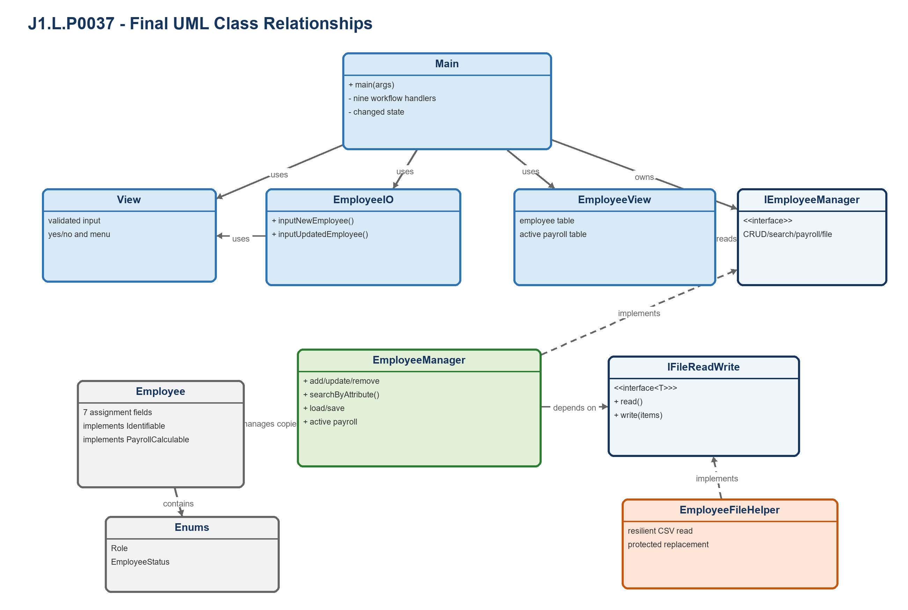
Figure 1. Final class relationships for J1.L.P0037.

2.1 Responsibility matrix
Class / Interface | Final responsibility
Main | Coordinates the nine workflows and changed-state save/quit behavior.
View / EmployeeView | Own reusable validated input and employee/payroll table presentation.
EmployeeIO | Builds validated add/update candidates without business-state ownership.
IEmployeeManager / EmployeeManager | Own CRUD, soft delete, search, payroll, defensive copies, load, and save.
IFileReadWrite<T> | Generic persistence boundary injected into EmployeeManager.
EmployeeFileHelper | Reads resilient CSV rows and performs validated temporary-file replacement.
Employee | Implements Identifiable and PayrollCalculable for domain-focused polymorphism.
Role / EmployeeStatus | Constrain textual values and centralize canonical display/parse behavior.

2.2 OOP evidence
- Abstraction: IEmployeeManager and IFileReadWrite<T> separate business and persistence contracts.
- Polymorphism: Employee implements Identifiable and PayrollCalculable domain behaviors.
- Encapsulation: public queries return deep Employee copies; internal mutation remains controlled.
- Dependency inversion: EmployeeManager receives its file helper through constructor injection.

3. Implemented Algorithms
Pseudocode reflects the final implementation rather than an idealized alternative. Complexity statements also account for the list-based data structures used by these assignment-sized applications.
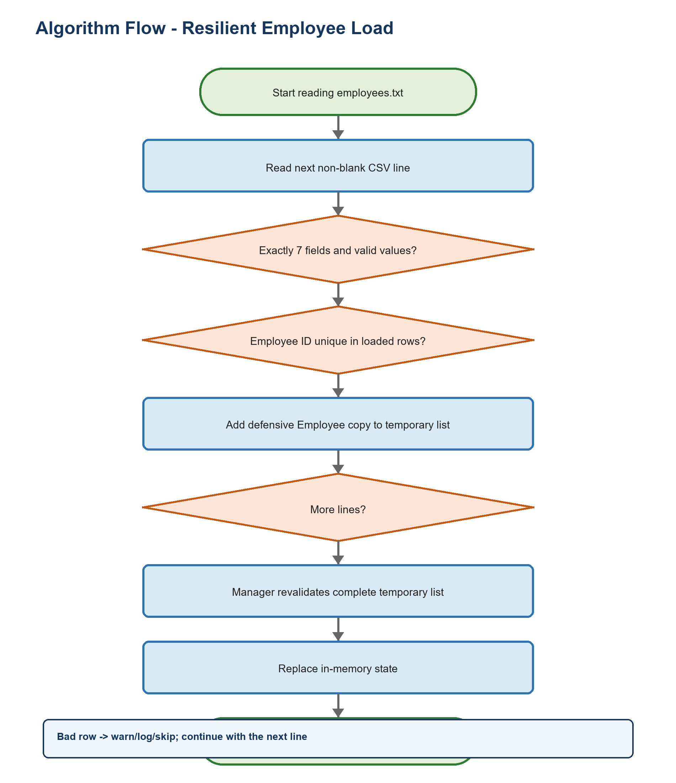
Figure 2. Representative decision flow from the final implementation.

A1 - Row-isolated employee loading
Purpose: Continue after erroneous lines while never admitting malformed or duplicate state.
01 if employees.txt is missing: fail the load
02 for each non-blank physical line:
03 parse exactly seven CSV fields
04 parse Role/Status and finite numeric fields
05 validate complete Employee and duplicate ID
06 on row error: warn, log, skip, and continue
07 manager validates the completed list again, then replaces memory
Complexity: O(n^2) time from list-based duplicate checks and O(n) result space.

A2 - Validate-before-commit update
Purpose: Update only Role, Base Salary, Bonus, and Status as required by Function 3.
01 find current Employee by immutable ID
02 construct candidate with old ID, Name, and Working Days
03 apply only the four permitted candidate fields
04 validate the complete candidate
05 commit four fields only after validation succeeds
Complexity: O(n) lookup time and O(1) additional space.

A3 - Soft delete and active-only payroll
Purpose: Retain history while excluding inactive Employees from payroll.
01 REMOVE: find Employee; reject missing or already inactive record
02 REMOVE: set status to INACTIVE; keep list size unchanged
03 PAYROLL: iterate Employees and include only status == ACTIVE
04 salary = baseSalary * workingDays + bonus
05 sum and display the same active set
Complexity: O(n) time and O(a) output space for a active Employees.

A4 - Safe employee-file save
Purpose: Never truncate the previous target before validation and complete writing.
01 validate list, every Employee, and unique IDs
02 create a temporary sibling beside the target
03 write escaped UTF-8 CSV with decimal-safe number formatting
04 replace target atomically when supported
05 on failure delete temporary data and preserve previous target
Complexity: O(n^2) validation time and O(1) streaming write space.

4. Test Cases and Executed Evidence

4.1 Execution record
Artifact | Status | Interpretation
Source compilation | PASS | All production and deep-test Java files compile for Java 8.
Deep harness | 57/57 PASS | Re-executed on 21 July 2026; process exit code 0.
Earlier regression record | 17/17 PASS | Retained historical result; not added to current 153-check claim.
State preservation | PASS | Failure paths assert memory/file content, not only return values.

4.2 Representative test matrix
ID | Scenario | Input / action | Expected result | Actual
L3-T01 | Dependency/null guards | Null helper, View, EmployeeIO dependencies | IllegalArgumentException | PASS
L3-T02 | Working-day boundaries | 0, 26, and 27 | 0/26 accepted; 27 rejected | PASS
L3-T03 | Non-finite salary | Infinity salary; negative bonus | Rejected | PASS
L3-T04 | Restricted update | Candidate changes all fields | Name/days preserved; four fields changed | PASS
L3-T05 | Soft delete | Remove active E003 twice | Inactive record retained; second remove rejected | PASS
L3-T06 | Exact status search | active with active/inactive data | Inactive does not match active | PASS
L3-T07 | Malformed-row isolation | valid, malformed, duplicate, valid | Two valid records loaded | PASS
L3-T08 | CSV quoting/decimals | Doe, Jane; 120.5; 3.25 | Round-trip preserves values | PASS
L3-T09 | Rejected save preservation | NaN bonus after valid target exists | Write rejected; target unchanged | PASS
L3-T10 | Polymorphic contracts | Employee through both interfaces | Identity/payroll behavior matches | PASS

4.3 Coverage strategy
- Equivalence partitions: valid, invalid format, duplicate, missing reference, and empty/null inputs.
- Numeric boundaries: lower/upper limits plus NaN and positive infinity where double values are accepted.
- State assertions: rejected operations must preserve the prior object list or target file.
- Persistence round-trips: valid text/object data is saved and reloaded with essential values preserved.
- Encapsulation checks: mutations to returned objects/lists must not change manager/DAO state.

5. Requirement-to-Source Traceability
Every visible assignment function maps to a final handler, a business/persistence method, and at least one verification artifact or explicit source-path review.
Requirement | Menu / handler | Final implementation | Evidence
1. Load | Main.manualLoadData | EmployeeManager.loadFromFile | L3-T07; failure preservation
2. Add | Main.addNewEmployee | EmployeeManager.addEmployee | L3-T01-T03
3. Update | Main.updateEmployee | EmployeeManager.updateEmployee | L3-T04
4. Remove (D_Soft) | Main.removeEmployee | EmployeeManager.removeEmployee | L3-T05
5. Search | Main.searchEmployee | EmployeeManager.searchByAttribute | L3-T06
6. Payroll | Main.calculatePayroll | EmployeeManager.getTotalSalaryByMonth | Active-only checks
7. Display | Main case 7 | EmployeeView.displayAllEmployees | Empty/long-name output
8. Save | Main.saveData | EmployeeFileHelper.write | L3-T08, T09
9. Quit | Main.quitProgram | Changed-state save decision | Source branch trace

5.1 Import and source hygiene
Audit item | Result | Basis
Incorrect/unresolved imports | 0 | Complete production + test compilation succeeded.
Wildcard imports | 0 | Repository-wide source scan.
Definitely unused explicit imports | 0 | Imported simple names are referenced in their compilation units.
Generated binaries committed | 0 | .gitignore excludes build, dist, class, jar, private IDE state, and runtime logs.

5.2 Known limitations and deliberate trade-offs
- A file containing only invalid non-blank rows produces an empty valid result after warnings; this recovery policy is documented.
- Soft delete follows the lecturer's D_Soft note even though the assignment PDF uses the shorter word 'Delete'.
- List scans favor clarity for assignment-sized data; indexed structures would be preferable at enterprise scale.

5.3 Reproduction
From the repository root on Windows:
01 PowerShell -ExecutionPolicy Bypass -File .\scripts\verify-all.ps1
GitHub Actions invokes the same script on every push and pull request. The workflow pins third-party actions to reviewed commit SHAs and grants read-only repository permission.

Conclusion
The final J1.L.P0037 source implements all 9 required functions, compiles for Java 8, and passes 57 executable deep checks. The UML, algorithm descriptions, test evidence, and AI Audit Log now use the same identifiers, counts, paths, and verification date.

