# 

By :

DJADI Imane

Section A

2023

Information and Communication Technologie

**Final project**

**Final project**

1 0

1 Introduction To TIC 2

1.1 What is TIC ? 2

1.2 What does the word TIC mean ? 2

2 Impact of TIC on society 3

3 The using of TIC in everyday life 4

4 Technologies related to TIC 5

4.1 Google services : 5

4.2 Microsoft : 6

4.3 Git and GitHub 6

4.4 PowerPoint 7

4.5 Microsoft office word 8

4.6 Microsoft office Excel 8

4.7 Latex 8

5 Conclusion 9

# 1 Introduction To TIC

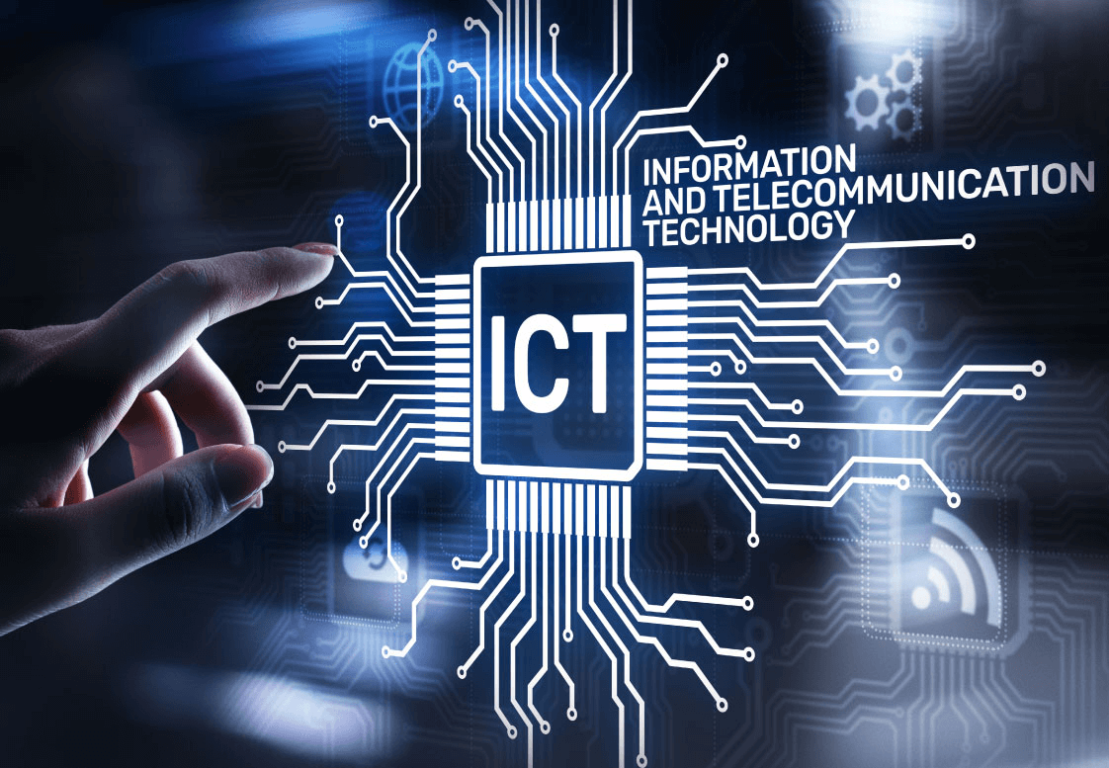

## What is TIC ?

TIC is the technology required for information processing ,in particular ,the use of electronic compuets,communication devices and software applications to convert , store,protect,process,transmitand retrieve information from anywhere, anytime

## What does the word TIC mean ?

TIC mean Information and Communication Technologies,and this phrase was coined by Stevenson in his 1997 report to the UK government and promoted by the new National Curriculum document for thr UK in 2000.

•Information:Information refers to the knowledge obtained from reading, investigation, study or search.the tools to transmit information are the telephone , television and radio .

•Communication : Communication is act of transmitting messages.It is a progress whereby information is exchanged between individual using simbols,signs or verbal interactions.

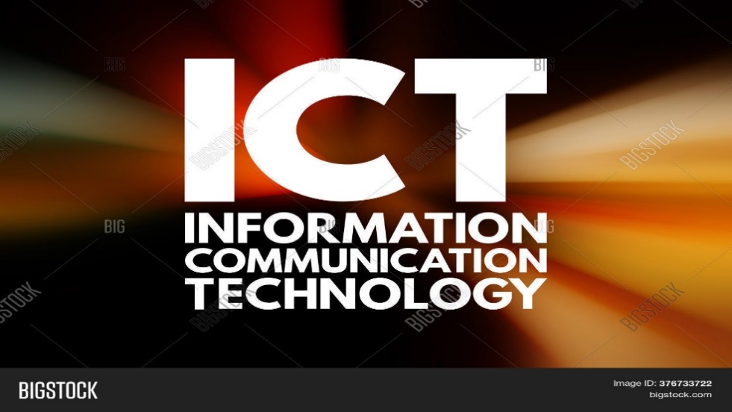•Technology : Technology is the use of scientific knowledge, experience and resources to create processes products that fulfill human needs.Technology is vital in communication

# Impact of TIC on society

As it is known from tme immemorial that everything in life is like the two side of a coin, there is always a positive and negative side of every phenomenon.But whether the effect is positive or negative the effects of Information Communication Technology (TIC) is far reaching and can not be overemphasized .so here aresome examples of its impact :

# The using of TIC in everyday life

# Technologies related to TIC

## Google services :

* + Google service is software that seves as a bridge to help develops create better, more optimized,more battery effcient apps without unnecessary work .These services encompass various domains, including cloud computing, communication, productivity, and more. Here are some key Google services in the ICT space:
    - **Google drive :**A cloud-based file storage and synchronization service that allows users to store files in the cloud, synchronize files across devices, and collaborate on documents.



* + - **Google meet :** A video conferencing tool that allows users to host virtual meetings, webinars, and online presentations. It integrates with other Google Workspace applications.



* + - **Google maps**: A mapping service that provides detailed maps, real-time traffic information, and satellite imagery. It is widely used for navigation and location-based services.



* + - **Google search :** The world's most popular search engine, which allows users to find information on the internet. It is a fundamental tool for information retrieval**.**



* + - **Google Chrome :** A web browser developed by Google, known for its speed, simplicity, and security. It is widely used for accessing online content.



* + - **Google ads :** An online advertising platform that allows businesses to display ads o Google's search results and other affiliated websites.n Google's search results and other affiliated websites.
    - **Android :** **:** Google's mobile operating system, used by a majority of smartphones and tablets globally. Android provides a platform for developers to create mobile applications.

## Microsoft :

Microsoft provides a wide array of tools and services in the field of Information and Communication Technology (ICT). These tools cater to various needs, including productivity, collaboration, development, and more. Here are some key Microsoft tools in the ICT space:

* + **Microsoft 365 :** it is a comprehensive suite of cloud-based productivity tools and services offered by Microsoft. It combines the traditional Office 365 suite with additional features and services, providing users with a complete solution for communication, collaboration, and productivity. Microsoft 365 includes a range of applications and services that are designed to help individuals and organizations work more efficiently and securely. Here are key components and meanings associated with Microsoft 365
  + **Windows Operating Système :** it is a family of operating systems developed by Microsoft. It is one of the most widely used operating systems in the world, running on a vast range of devices, including personal computers, laptops, tablets, servers, and embedded systems
  + **Azur :** Microsoft's cloud computing platform offers a variety of services, including virtual machines, databases, AI and machine learning, and more. Azure is used for building, deploying, and managing applications and services through a global network of data centers.
  + **Power BI :** A business analytics tool used for visualizing and analyzing data. Power BI allows users to create interactive dashboards and reports to make data-driven decisions.
  + **SQL Server:** A relational database management system (RDBMS) developed by Microsoft. SQL Server is used for storing and retrieving data as requested by other software applications.
  + **Exchange Server:** An email and calendar server used by businesses for email communication and collaboration. It is part of the Microsoft Server line of products.
  + **Dynamics 365:** An integrated suite of business applications that includes modules for sales, customer service, finance, operations, and more. It helps organizations manage various aspects of their business processe

## Git and GitHub

Both Git and GitHub play crucial roles in the field of Information and Communication Technology (TIC), particularly in software development and collaboration.

* + **Git :** Git is a distributed version control system (DVCS) that allows multiple developers to work on a project simultaneously without interfering with each other's .it workprovides a way to keep track of changes, revert to previous versions, and merge code changes efficiently.Here is an intreview of how Git are used in TIC :
    - it is a distributed version control system that allows developers to track changes in their codebase over time
    - evelopers can work on their branches, and Git facilitates the merging of changes.
    - it maintains a detailed history of changes, making it easy to understand when and why specific modifications were made
    - Enables multiple developers to work on the same project simultaneously without conflicts
  + **GitHub :** It is a web-based platform and service that provides hosting for software development projects.which facilitates collaboration among developers, allowing them to work together on projects, manage code repositories, and track changes made to the source code. Here is an intreview of how GitHub are used in TIC :
    - Developers can push their local Git repositories to GitHub, making it accessible to team members and providing a backup.
    - offers collaboration features such as issues, pull requests, and discussions, allowing team members to communicate about specific features, bugs, or changes
    - is a hub for open-source projects, fostering collaboration and contribution from developers worldwide.

## PowerPoint

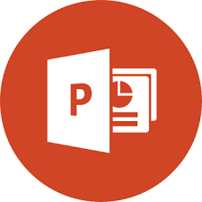 PowerPoint is a widely used presentation software that is part of the Microsoft Office suite, and it is commonly employed in various fields, including TIC

* + professionals use PowerPoint to deliver information, reports, and project updates in a visually appealing and organized manner.
  + It can be used to create project timelines, status reports, and progress updates, helping teams stay organized and on track
  + presentations in powerpoint can be easily shared and collaborated on in real-time, making it a useful tool for TIC teams working on projects together

## Microsoft office word

Microsoft Word is a word processing software application developed by Microsoft. This one allows users to create, edit, format, and print documents. It provides a range of features for document creation and manipulation, making it a versatile tool for various purposes, including writing, editing, and formatting text for personal, academic, or professional use. It is widely used in various fields, including TIC.Here are some ways in which Microsoft Word is utilized in the context of TIC :

* + It allows multiple users to work on a document simultaneously.
  + Utilizing features like Track Changes and version history to keep track of edits and revisions made to documents, ensuring document integrity.

## Microsoft office Excel

 Microsoft Excel is a spreadsheet program developed by Microsoft as part of the Microsoft Office suite of productivity software. It is widely used for various tasks involving numerical data, calculations, data analysis, and visualization. Excel provides a grid of cells organized in rows and columns, where users can enter data, perform mathematical operations, and create visual representations of data.and it is widely used in business, finance, education, and research for its versatility and powerful data manipulation capabilities

## Latex

 it is typesetting system commonly used for the production of scientific and mathematical documents. It is based on the TeX typesetting system developed by Donald Knuth. LaTeX simplifies the process of formatting complex documents, particularly those that involve mathematical equations, technical content, and academic writing. is known for its ability to handle complex mathematical notation, its consistent and professional output, and its support for creating documents with intricate structures. Users often appreciate LaTeX for its focus on content and separation of document structure . In the field of Information and Communication Technology (TIC), LaTeX can be beneficial in various ways :

* LaTeX is well-suited for creating technical documents, such as research papers, technical reports, and documentation for software projects in the TIC field. It provides a high level of control over document structure and formatting
* It excels in handling mathematical notations and equations. In ICT, where mathematical expressions are common, LaTeX can be used to produce professional-looking documents with complex mathematical content.
* Its documents can be easily managed using version control systems like Git. This is crucial for collaborative projects, where multiple contributors are working on the same document.

* It allows the creation and use of templates, providing a standardized format for various types of ICT documents

# Conclusion

In conclusion, the importance of TIC in our lives cannot be overstated. It has become an integral part of our daily existence, influencing how we communicate, work, learn, and entertain ourselves. As technology continues to evolve, its impact on our lives is likely to expand, presenting both opportunities and challenges that require careful consideration and responsible use.

Haut du formulaire

Thank you