Họ và tên: Hồ Đức Hoàng Môn học: Xử lý ảnh

Mã số sinh viên: N20DCCN018 Giảng viên: Huỳnh Trung Trụ

Lớp: D20CQCNHT01-N Homework 4

Bài làm

Bài 1:

Bài 2:

Bài 3:

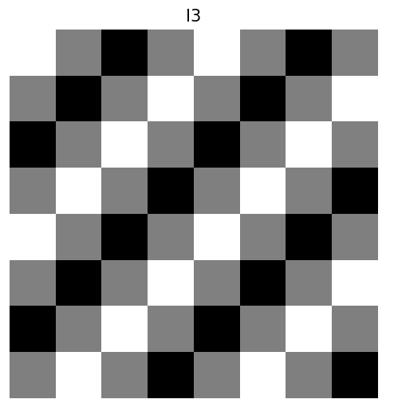

Bài 4:

Bài 5:

Bài 6:

Bài 7:

