Họ và tên: Hồ Đức Hoàng Môn học: Xử lý ảnh

Mã số sinh viên: N20DCCN018 Giảng viên: Huỳnh Trung Trụ

Lớp: D20CQCNHT01-N Homework 5

Bài làm

Bài 1:

(a):

(b):

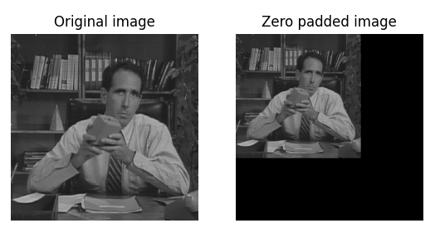

(c):

