PR 301

Course Project

Exploratory Analysis of VR chat rooms

Sudiksha Rajavaram

Yoshitha Avula

Phalguna Reddy

Aaryan Nair

SreeKarteek A

**1.Background of Project**

* **Project Requirement:**

Project group is expected to investigate data from VR chatrooms. The content will be analysed by leveraging NLP algorithms and other advanced statistical methods

* **Reason to have chosen this project:**

The topic of this project brings about a definition of how we humans interact and respond to every topic we come across. Also, every human has a spectrum of reactions, response, and emotions of their own, which they express at different instances. And this topic enables us to understand how we work upon the emotional and sentiment analysis of a human conversation.

We have chosen conversations VR chatrooms for this project because it’s safer of a platform that ensures anonymity for people who wish to talk and thus will be rawer and truer compared to interviews and TedTalks. VR Chatrooms are conducted in a controlled environment that are only accessible to a specific group of users that can be monitored by moderated and administrators. This prevents hate speech and other forms of harassment that can be common on other platforms. Naturally, it provides a more authentic and supportive environment. One study published in the Journal of Cyberpsychology, Behaviour, and Social Networking in 2018 examined the experiences of individuals with social anxiety disorder in VR chatrooms compared to traditional chatrooms. The study found that participants reported feeling more comfortable and less anxious in the VR chatroom compared to the traditional chatroom. The researchers also noted that the immersive nature of the VR environment may have contributed to the participants' sense of safety and comfort.

Another study published in the International Journal of Human-Computer Studies in 2021 compared the experiences of individuals with autism spectrum disorder (ASD) in VR chatrooms to those in traditional chatrooms. The study found that participants with ASD reported feeling more socially connected and less anxious in the VR chatroom compared to the traditional chatroom. The researchers suggested that the immersive and interactive nature of the VR environment may have facilitated more natural and intuitive social interactions for individuals with ASD.

This can be especially important for veterans who may struggle with social isolation or have difficulty connecting with others

The primary goal of the project is to analyse life in military and the aftermath that’s to be faced by the soldiers after retirement and naturally applying our algorithms to back it up by research and data.

* **Importance of the project:**

Emotion and sentiment analysis are increasingly important in this day and age across various domains, including customer experience management, brand monitoring and reputation management, market research, crisis management, social and political analysis, brand marketing and advertising, and human resources. It provides organizations with valuable insights that can inform decision-making, strategy development, and overall organizational success.

**Emotional and sentiment analysis in:**

**1. Customer Experience Management:** A study published in the Journal of Business Research in 2019 investigated the relationship between customer emotions and satisfaction in the hospitality industry. The study found that positive emotions such as joy and surprise were strongly related to customer satisfaction, while negative emotions such as anger and frustration were strongly related to dissatisfaction.

**2. Brand Monitoring and Reputation Management:** A study published in the Journal of Business Research in 2019 examined the role of social media sentiment in brand reputation management. The study found that negative sentiment on social media can have a significant impact on brand reputation and that companies can use sentiment analysis to identify and respond to negative sentiment before it escalates.

**3. Market Research:** A study published in the Journal of Advertising Research in 2019 investigated the impact of emotional advertising on consumer behaviour. The study found that emotional ads were more effective at capturing consumers' attention and eliciting positive attitudes towards the brand compared to rational ads.

**4. Crisis Management:** A study published in the Journal of Business Research in 2019 examined the role of emotion in crisis communication. The study found that organizations that use emotional appeals in crisis communication can be more effective at building trust and credibility with stakeholders compared to organizations that use purely rational appeals.

**5. Social and Political Analysis:** A study published in PLOS ONE in 2019 analysed sentiment on Twitter during the 2016 US presidential election. The study found that sentiment on Twitter was strongly related to election outcomes and that sentiment analysis can be a useful tool for predicting election results.

**6. Brand Marketing and Advertising:** A study published in the Journal of Marketing in 2019 investigated the role of emotion in advertising effectiveness. The study found that emotional ads were more effective at driving purchase intentions compared to rational ads and that emotional ads were more likely to be shared on social media.

**7. Human Resources:** A study published in the Journal of Business Research in 2020 examined the role of emotional intelligence in employee well-being and job performance. The study found that employees with higher emotional intelligence had higher levels of well-being and job performance compared to employees with lower emotional intelligence.

**8. medical field:** sentiment and emotion analysis have been used to improve patient care, communication, engagement, and well-being in various ways like:

* A study published in the Journal of Medical Internet Research in 2018 used sentiment analysis to analyse online patient reviews of healthcare providers. The study found that patients who left positive reviews were more likely to mention provider communication skills and empathy, suggesting that these factors are important for patient satisfaction.
* A study published in the Journal of Medical Internet Research in 2019 used sentiment analysis to analyse social media posts related to breast cancer. The study found that sentiment on social media was strongly related to patient well-being and that social media sentiment analysis could be a useful tool for monitoring patient well-being.
* A study published in the Journal of Medical Internet Research in 2020 used emotion analysis to analyse patient-provider communication in online health forums. The study found that patients who expressed positive emotions such as gratitude and hope had better treatment outcomes compared to patients who expressed negative emotions such as fear and frustration.
* Overall, sentiment and emotion analysis have a wide range of applications in various domains, including the medical field. By providing valuable insights into emotions and attitudes, sentiment and emotion analysis can help organizations make informed decisions and improve outcomes for patients and stakeholders.
* Emotion and sentiment analysis in the medical field can provide valuable insights that can inform patient care, communication, engagement, and well-being of both patients and healthcare providers.
* It has the potential to enhance the quality of care, patient satisfaction, and overall healthcare outcomes.
* **Motivation towards our project:**

We also feel that with this project we bring about a skill in us that will help us define a modern method of Emotion and sentiment analysis. As students we have multiple emotions, most of which are difficult to talk about. Mental health issues, broken homes and confusion about sexuality are some of the most commonly talked about things for students when given anonymity. Apart from this, VR chatrooms are also used for students to help each other academically. and this is one of the major reasons where we find ourselves doing better and creating a better model in our project.

**Dataset Details:**

* **Total number of segments – 46** 
  + **Video 1: 8**
  + **Video 2: 3**
  + **Video 3: 7**
  + **Video 4: 6**
  + **Video 5: 9**
  + **Video 6: 5**
  + **Video 7: 8**
* **Total number of videos - 7**
* **Total number of distinct speakers - 8**
* **Average length of segments –** 
  + **Video 1: 2mins 42seconds**
  + **Video 2: 2mins 30seconds**
  + **Video 3: 6mins 49seconds**
  + **Video 4: 3mins 4seconds**
  + **Video 5: 3mins 22seconds**
  + **Video 6: 2mins 10seconds**
  + **Video 7: 4mins 41seconds**
* **Average word count per segment –**
  + **Video 1: 599.24**
  + **Video 2: 493.33**
  + **Video 3: 893.14**
  + **Video 4: 682**
  + **Video 5: 600.66**
  + **Video 6: 320.2**
  + **Video 7: 879.625**

**Methods used**

**Sentiment Analysis:**

The code reads in text data from various files, splits the text into individual articles, and calculates sentiment scores for each article using the **Afinn library**. The sentiment scores are then categorized as positive, negative, or neutral based on their value. The code also counts the number of positive, negative, and neutral sentiment scores for each category of text data and then proceeds to store them in their respective variables. These scores are then taken into consideration while plotting their distribution across a graph using the matplotlib library. We labelled the transcripts manually.

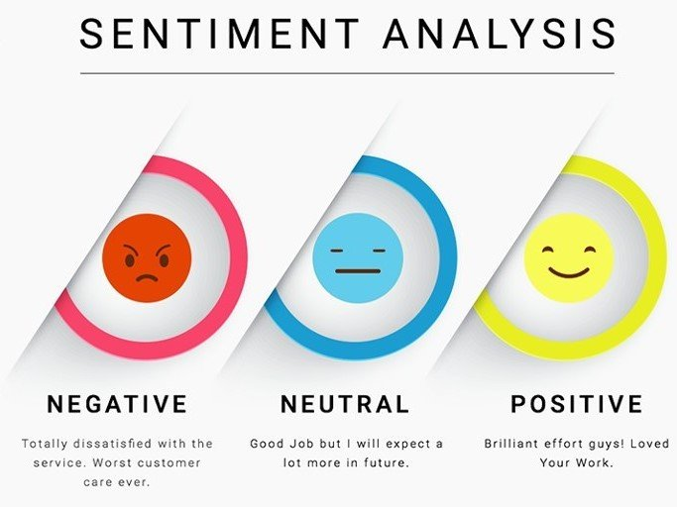

**Emotional analysis:**

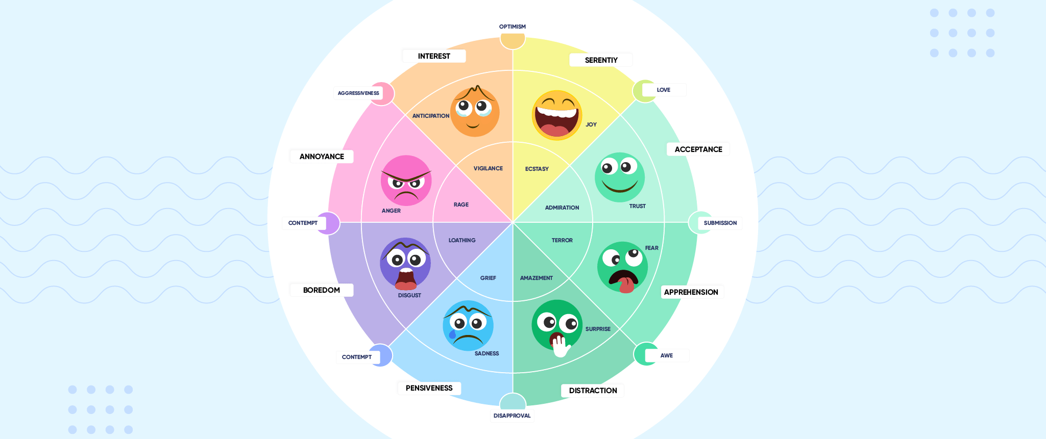

**Results**

We have analysed the data extracted from 7 individual videos based on anonymous VR chatrooms primarily based on Military experiences.

After applying sentiment analysis on their conversations, we have the following results.

1. Video 1

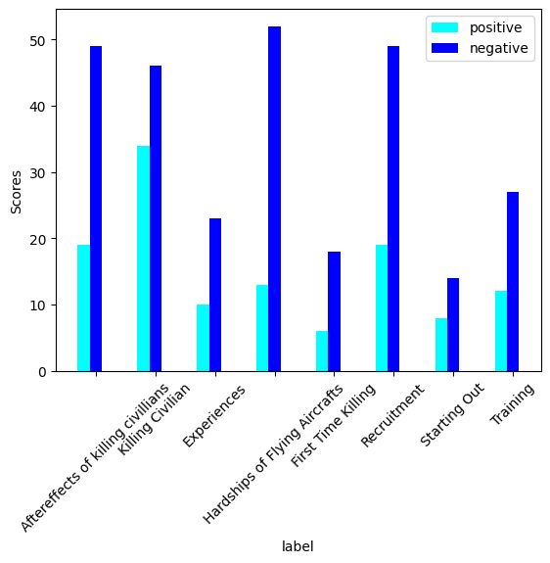

Graph representation

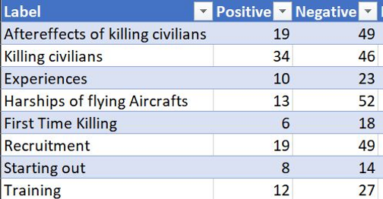

Table Representation

1. Video 2

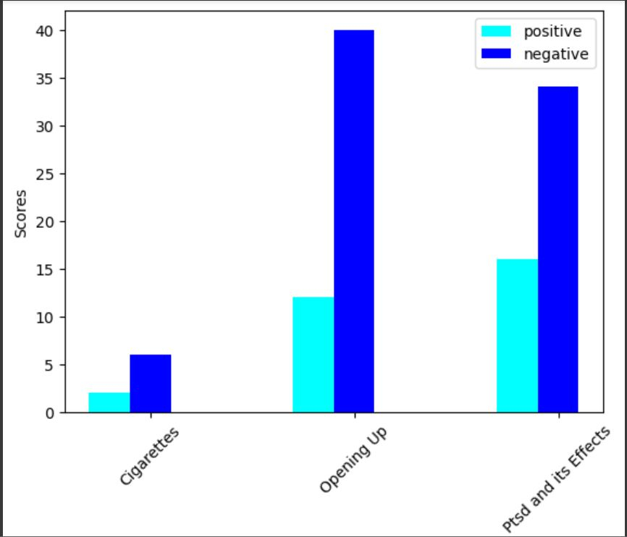

Graph Representation

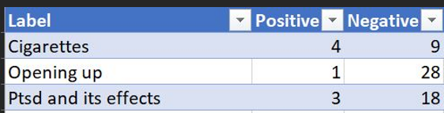

Table Representation

1. Video 3

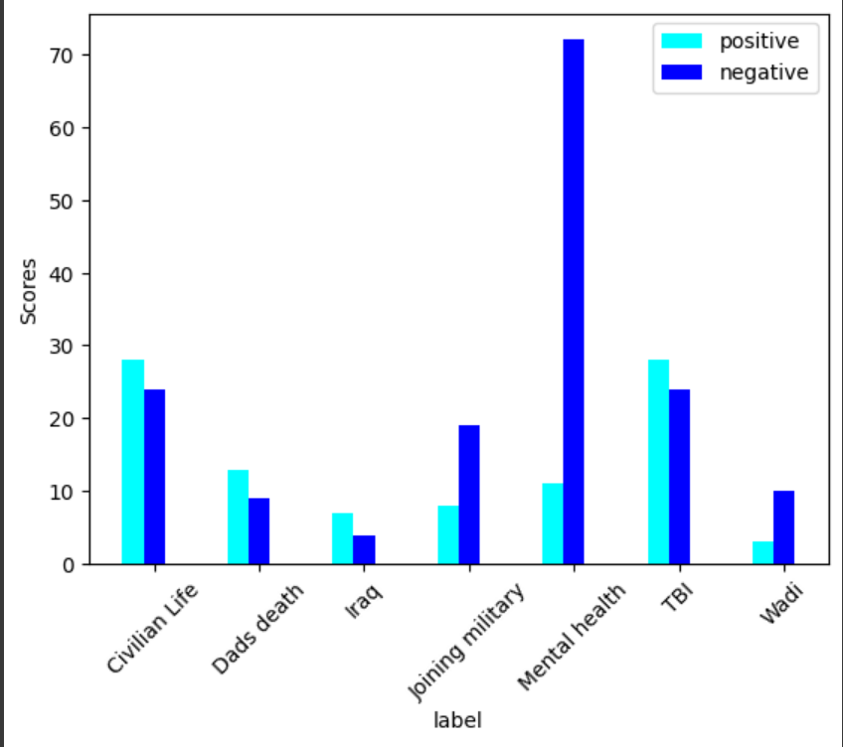

Graph Representation

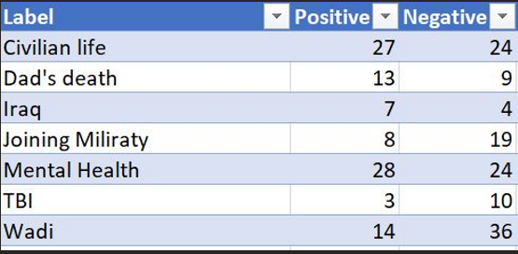

Table Representation

1. Video 4

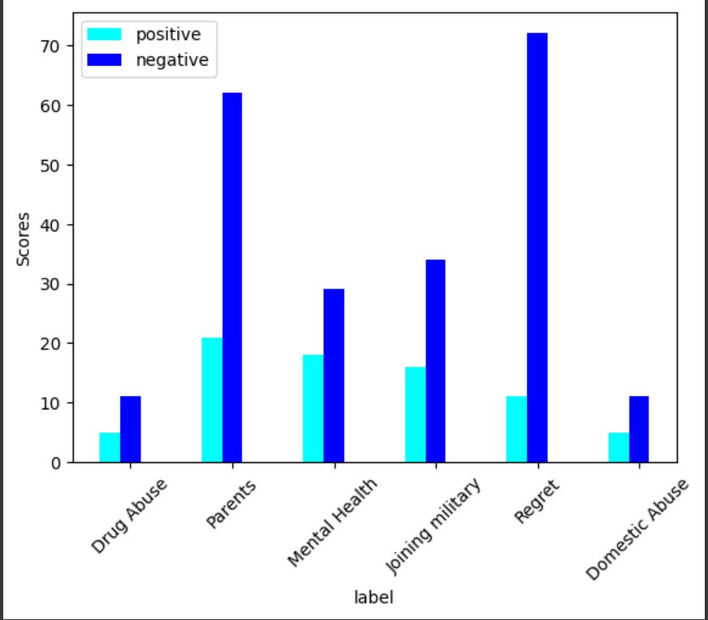

Graph Representation

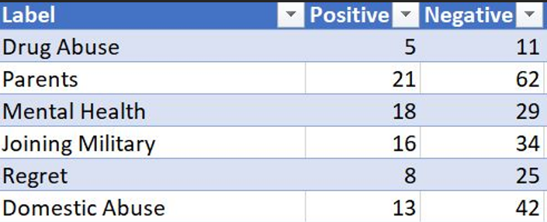

Table Representation

1. Video 5

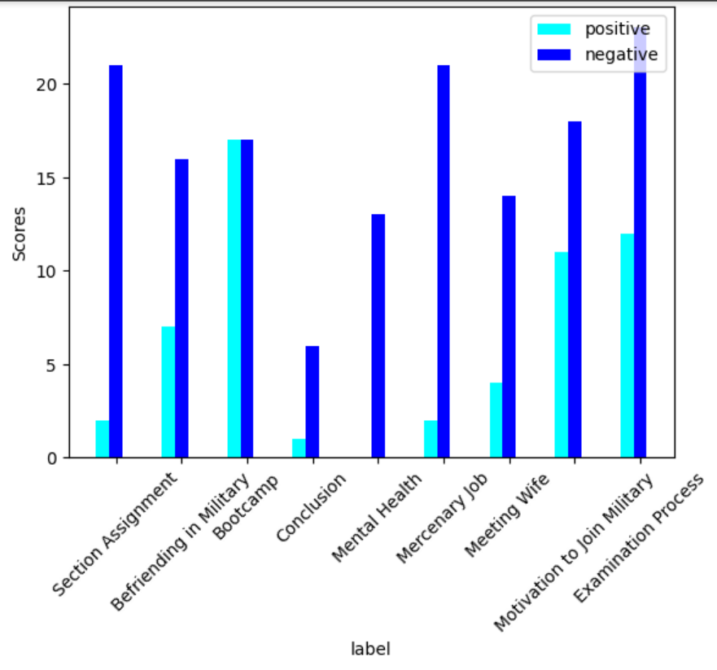

Graph Representation

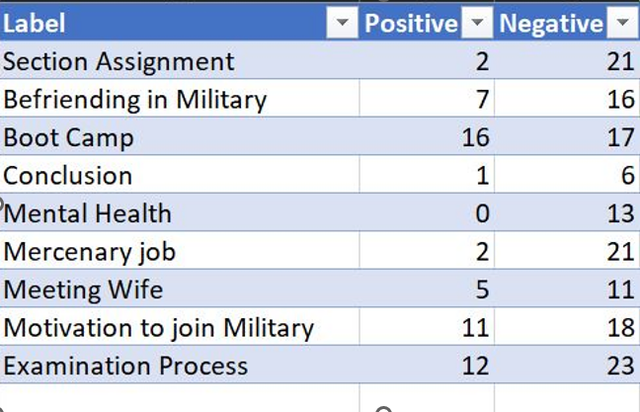

Table Representation

1. Video 6

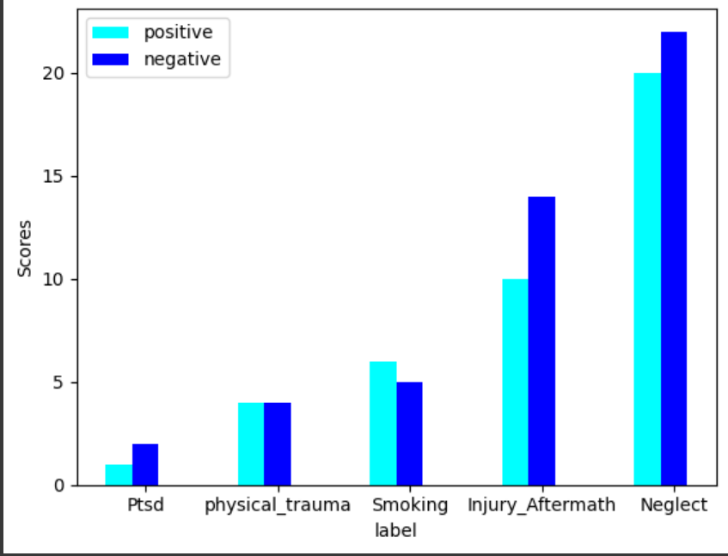

Graph Representation

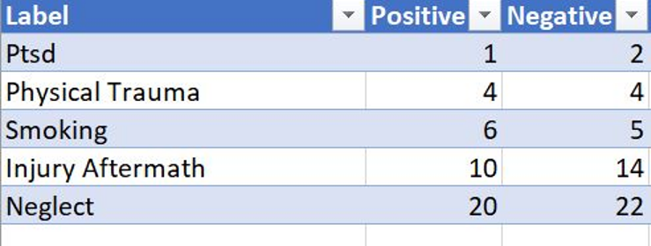

Table Representation

1. Video 7

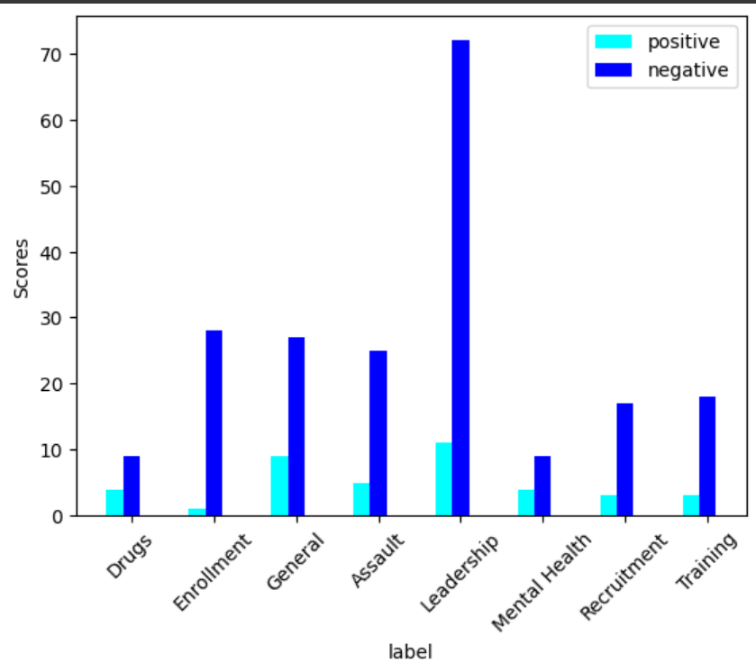

Graph Representation

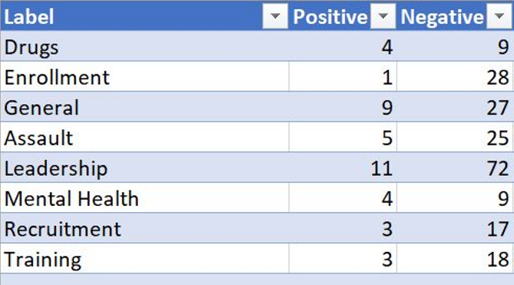

Table Representation

We also did emotional analysis on the same videos and got the following results:

Methods used for emotional analysis:  
The code performs emotional analysis using a Naive Bayes classifier. It starts by importing necessary libraries, including Pandas for data manipulation, NumPy for numerical operations, Matplotlib for data visualization, and Neattext for text preprocessing. The Neattext library is installed using pip. The dataset is then read from a CSV file into a Pandas DataFrame. Text data is cleaned by removing punctuation using the Neattext library. Next, scikit-learn modules are imported for the classifier, evaluation metrics, and data preprocessing. The data is split into training and testing sets. CountVectorizer is used to convert the text data into numerical features, and the CountVectorizer object is fitted and transformed to obtain a matrix of token counts. The data is further split into training and testing sets for the classifier. The Naive Bayes classifier is trained on the training data, and predictions are made on the testing data. The sample text is split into sentences, and for each sentence, the CountVectorizer is used to transform it into a numerical feature. The trained classifier predicts the probabilities of each emotion for the sentence. Average probabilities are calculated for each emotion across all sentences. A bar chart is plotted to visualize the average probabilities for each emotion. Finally, a DataFrame is created to display the predicted probabilities for each emotion.

Video 1:

Segment 1 – hardships of flying aircrafts

Graph:

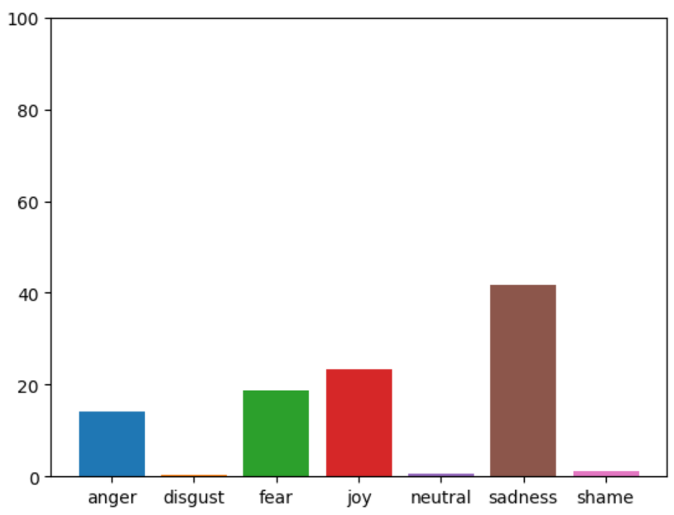

Table:

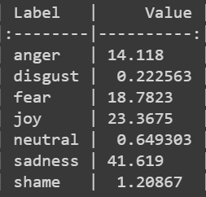

Segment 2 – recruitment

Graph:

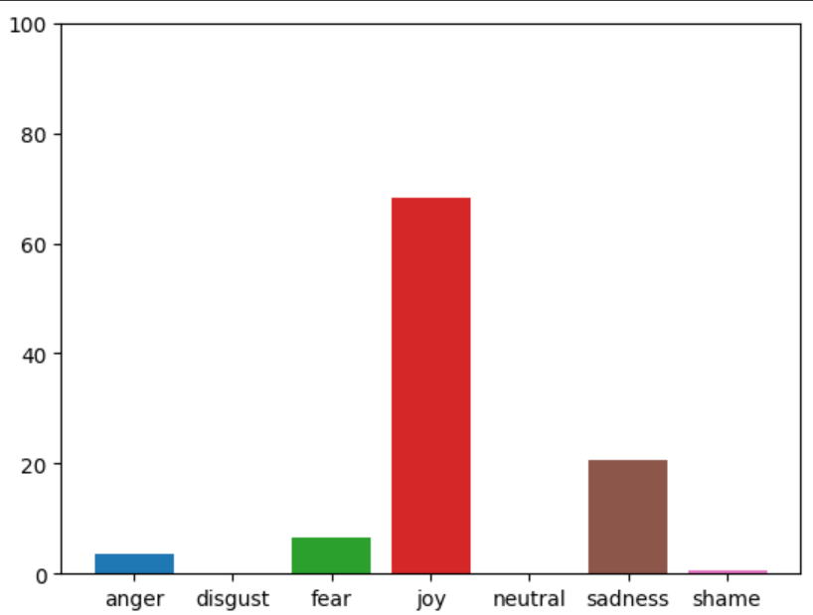

Table:

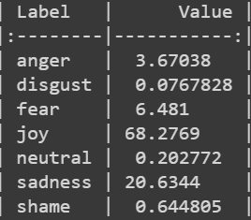

Segment 3 – training

Graph:

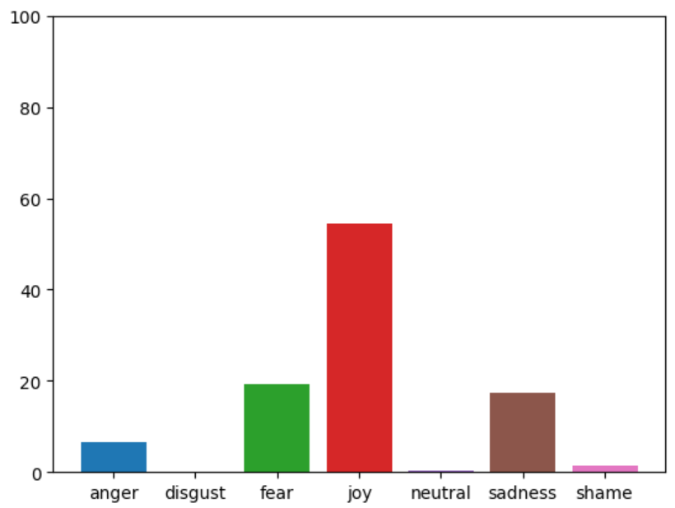

Table:

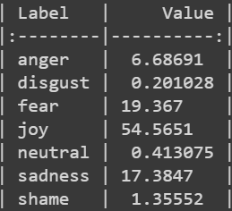

Segment 4 – starting out

Graph:

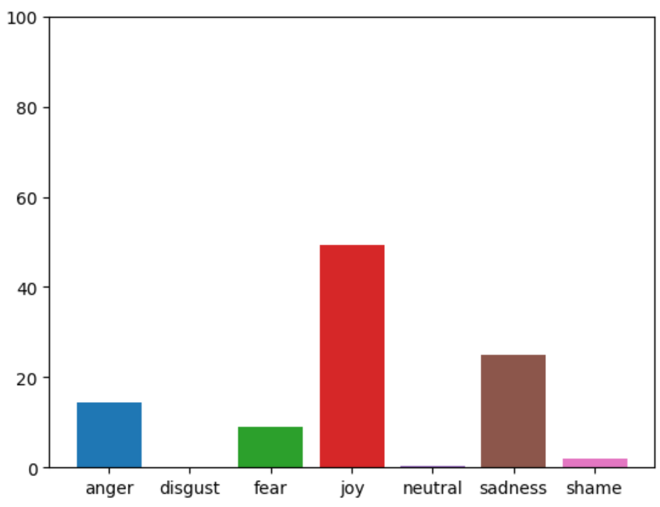

Table:

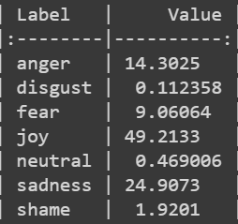

Segment 5 – experiences

Graph:

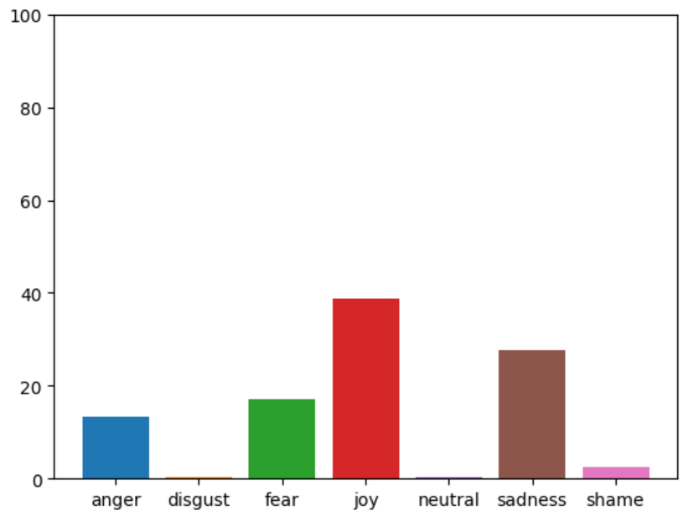

Table:

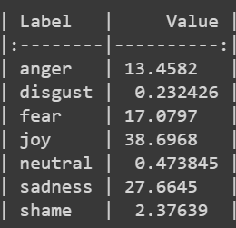

Segment 6 – killing for the first time

Graph:

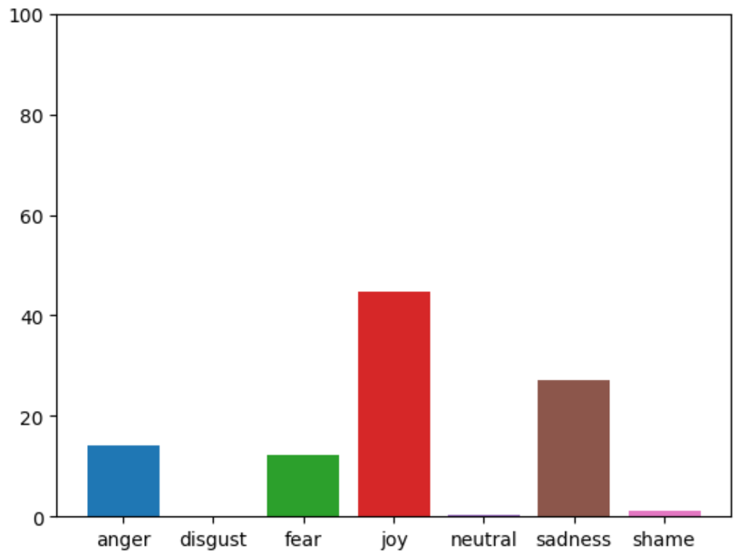

Table:

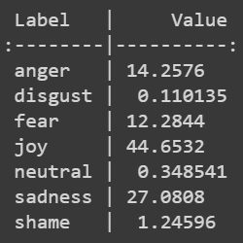

Segment 7 – civilian killing

Graph:

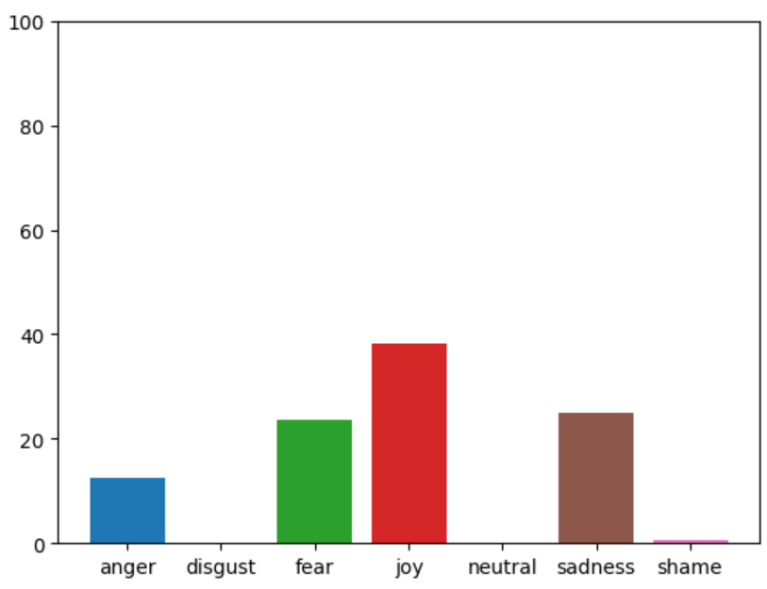

Table:

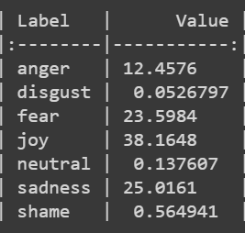

Segment 8 – aftereffects of killing others

Graph:

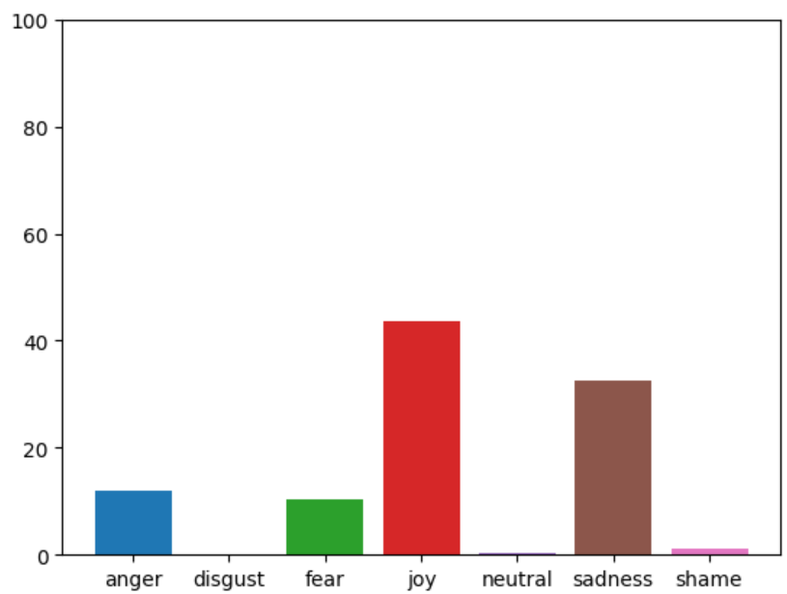

Table:

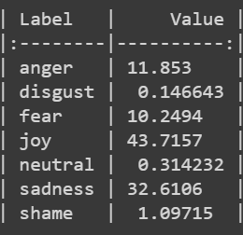

**Video 1 Radar Chart**

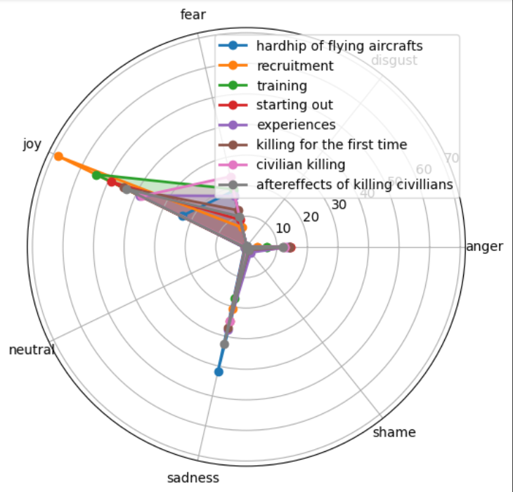

Video 2:

Segment 1 – cigarettes

Graph:

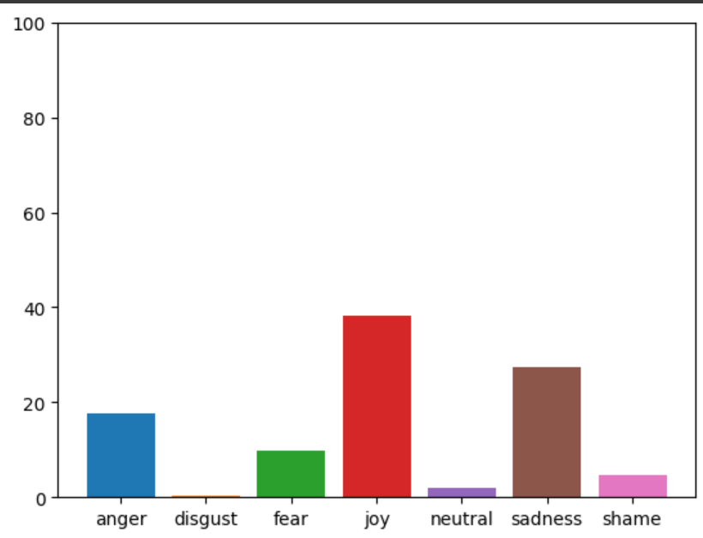

Table:

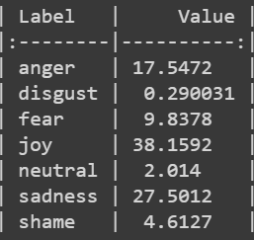

Segment 2 – ptsd and effects

Graph:

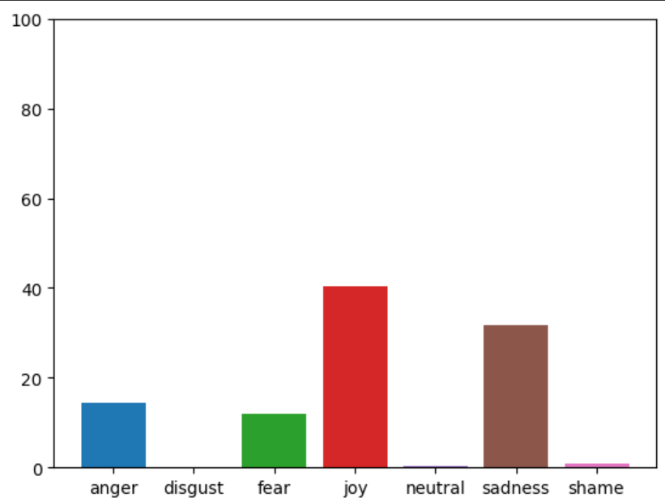

Table:

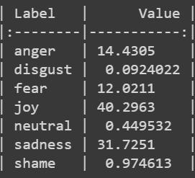

Segment 3 – opening up

Graph:

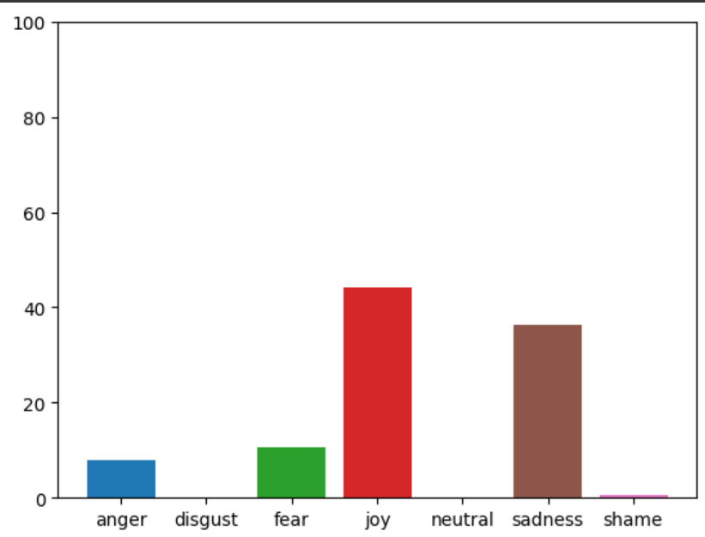

Table:

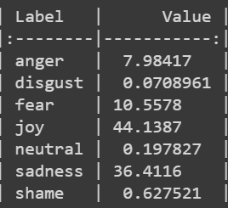

**Video 2 Radar Chart**

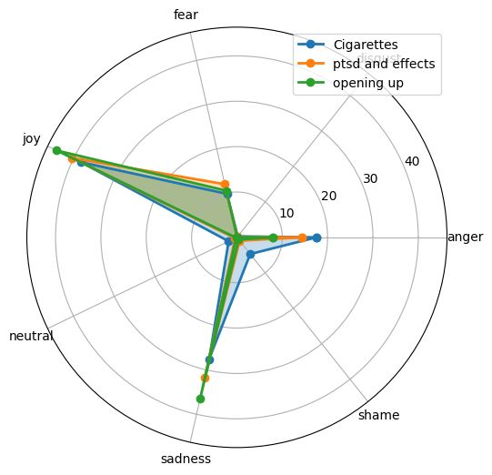

Video 3:

Segment 1 – wadi

Graph:

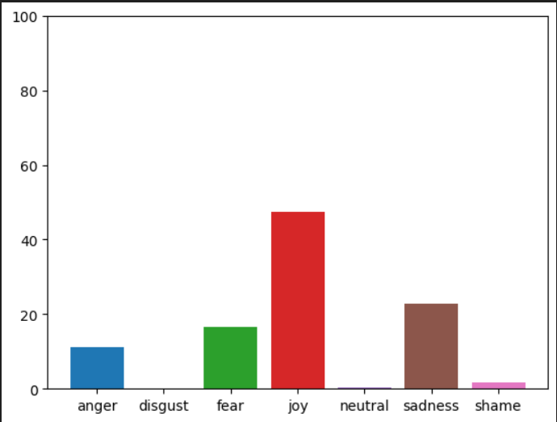

Table:

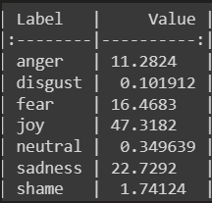

Segment 2 – mental health after army

Graph:

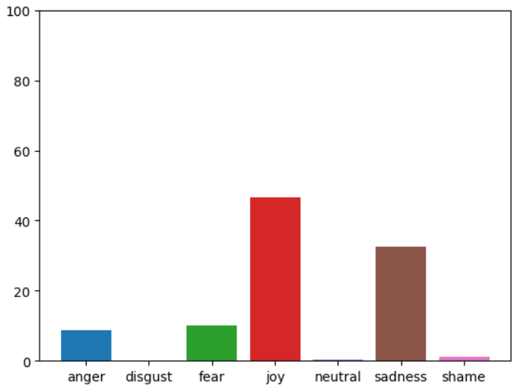

Table:

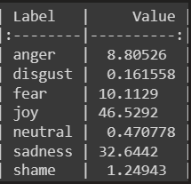

Segment 3 – Iraq

Graph:

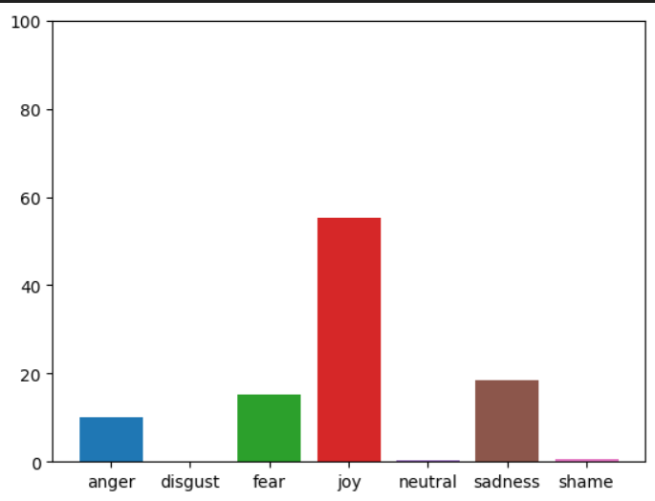

Table:

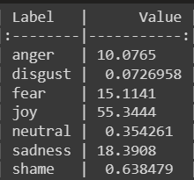

Segment 4 – joining the military

Graph:

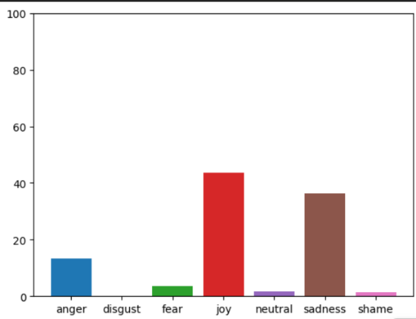

Table:

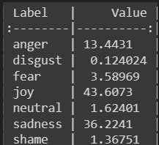

Segment 5 – TBI

Graph:

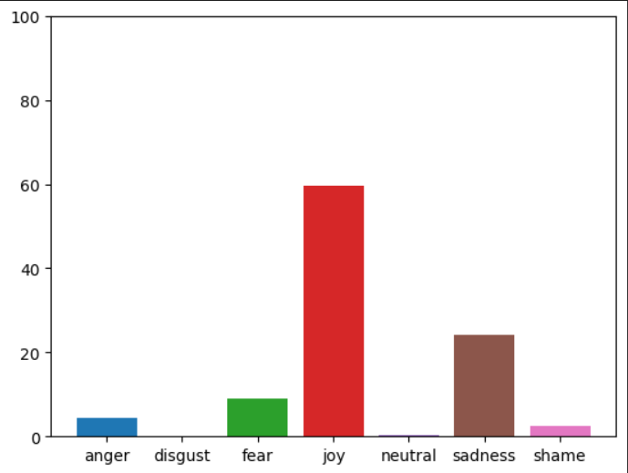

Table:

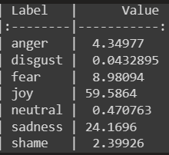

Segment 6 – Dad’s death

Graph:

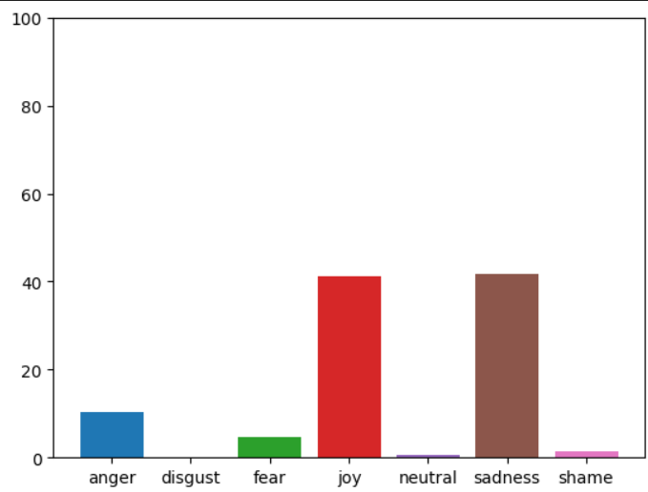

Table:

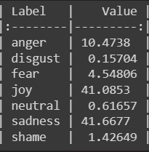

Segment 7 – civilian life

Graph:

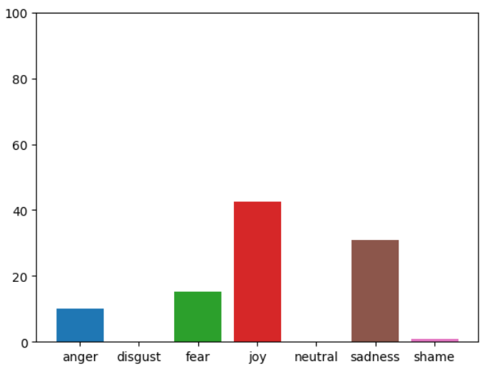

Table:

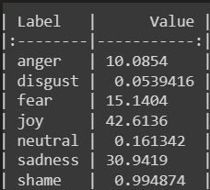

**Video 3 Radar Chart**

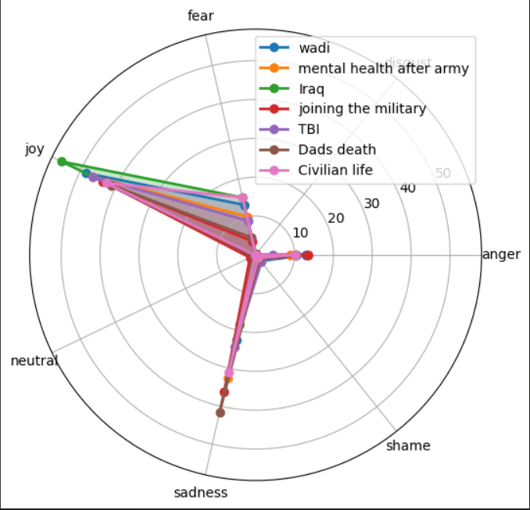

Video 4:

Segment 1 – Drug abuse in school

Graph:

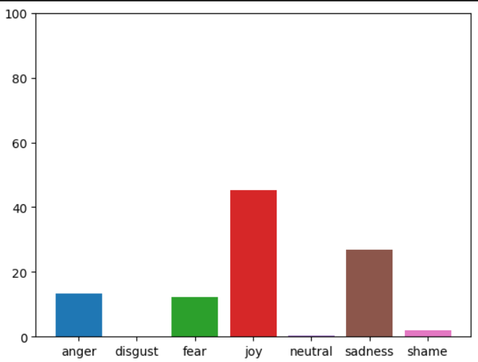

Table:

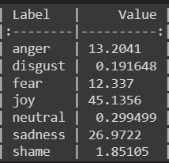

Segment 2 – motivation to join

Graph:

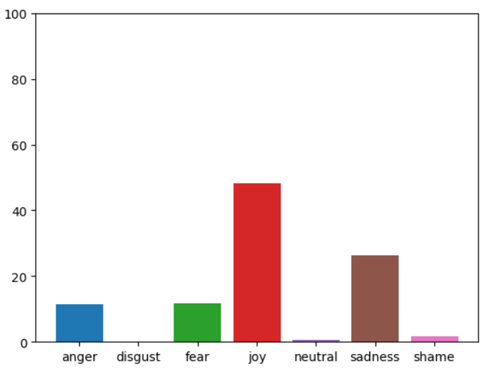

Table:

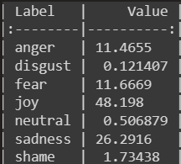

Segment 3 – regretting joining the military

Graph:

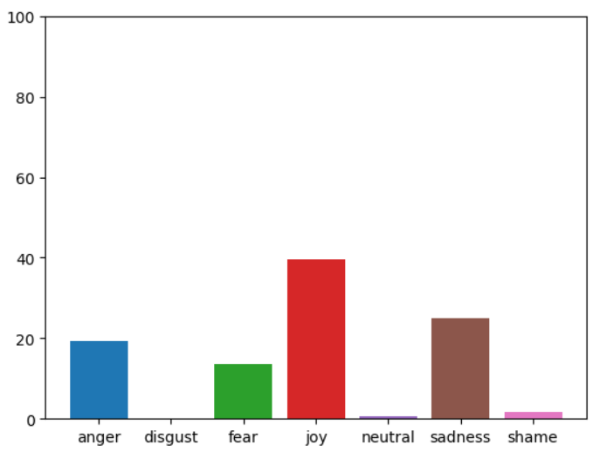

Table:

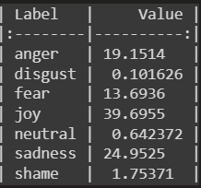

Segment 4 – lies

Graph:

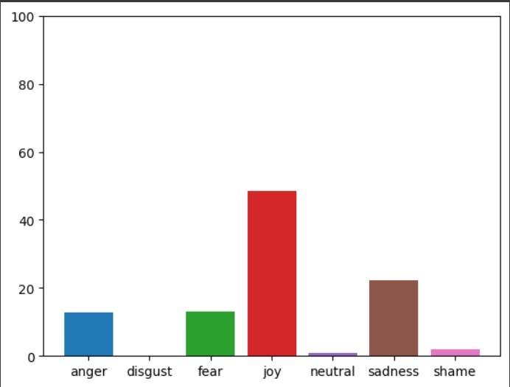

Table:

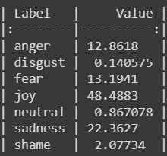

Segment 5 – toxic parents

Graph:

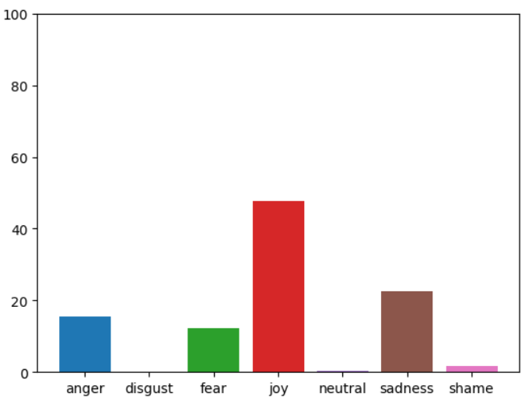

Table:

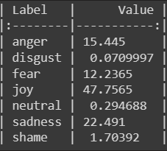

Segment 6 – conclusion

Graph:

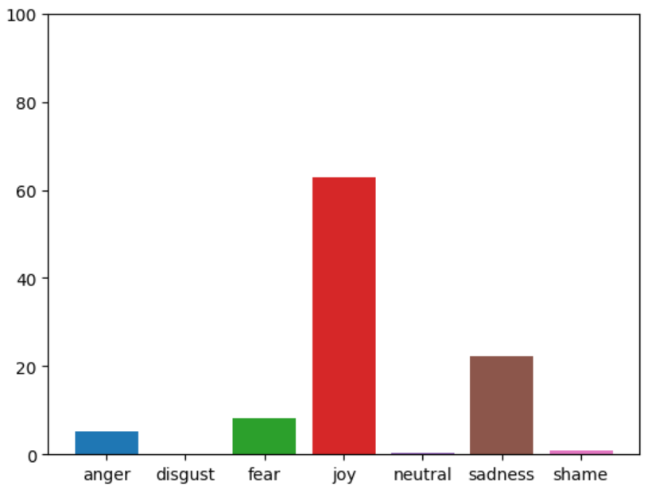

Table:

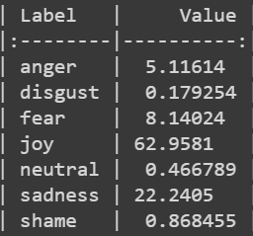

**Video 4 Radar Chart**

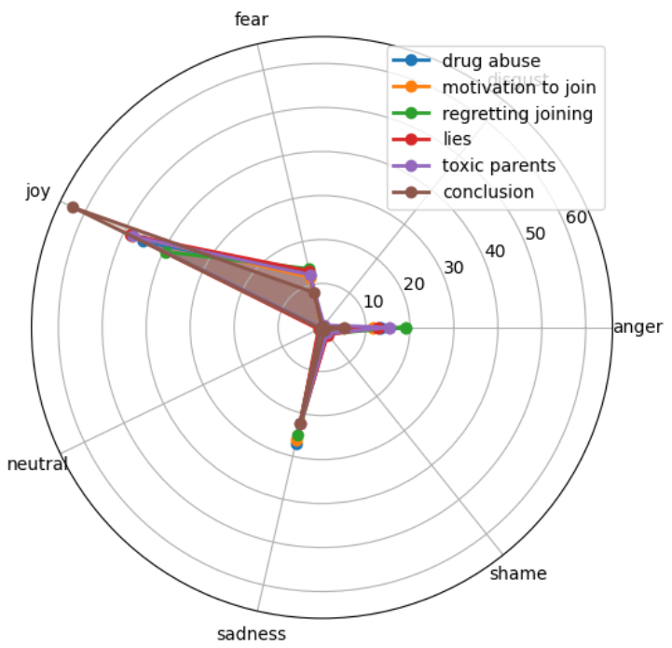

Video 5:

Segment 1 – motivation to join military

Graph:

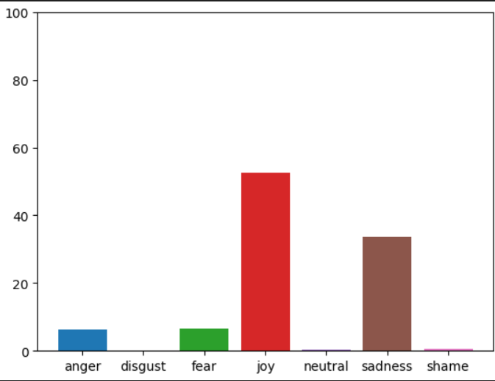

Table:

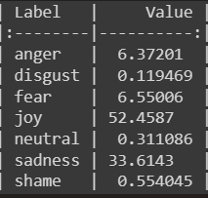

Segment 2 – assignment of section

Graph:

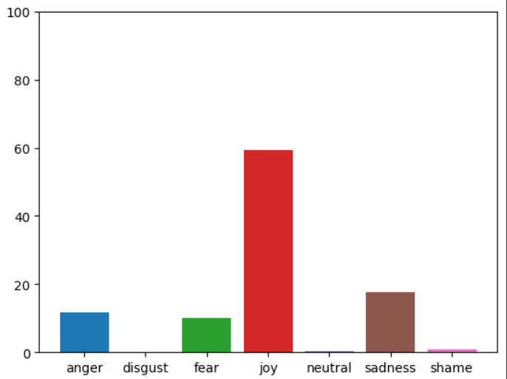

Table:

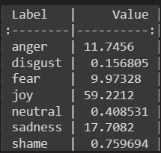

Segment 3 – examination process

Graph:

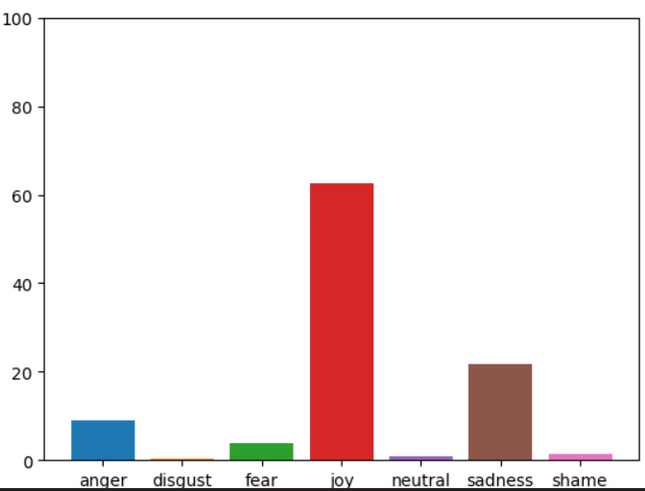

Table:

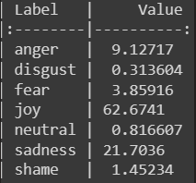

Segment 4 – befriending in the military

Graph:

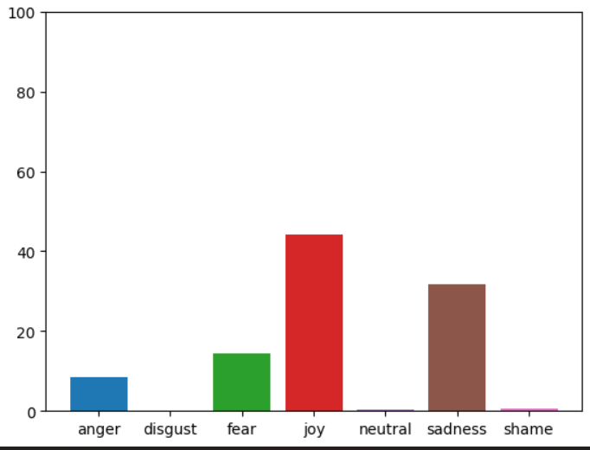

Table:

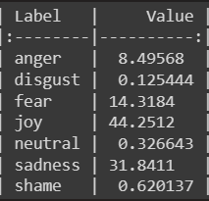

Segment 5 – meting his wife

Graph:

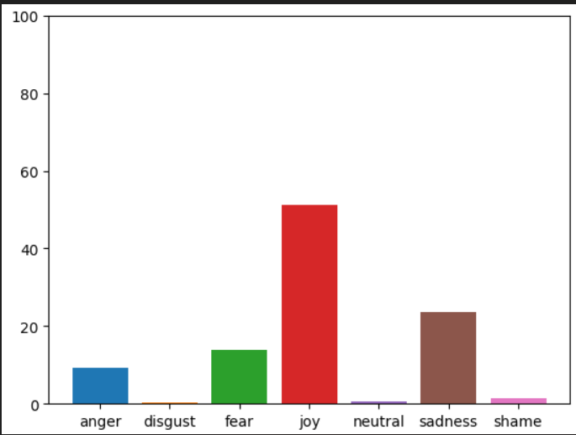

Table:

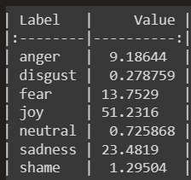

Segment 6 – bootcamp

Graph:

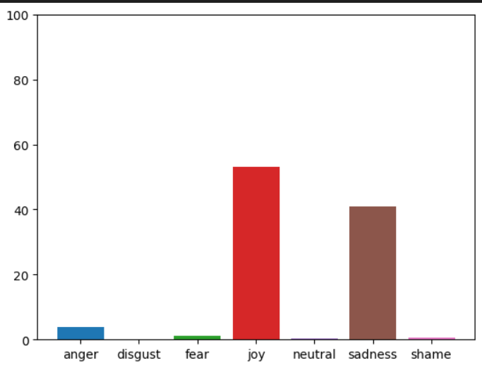

Table:

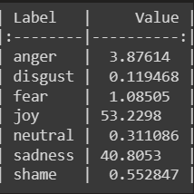

Segment 7 – hired to be a mercenary

Graph:

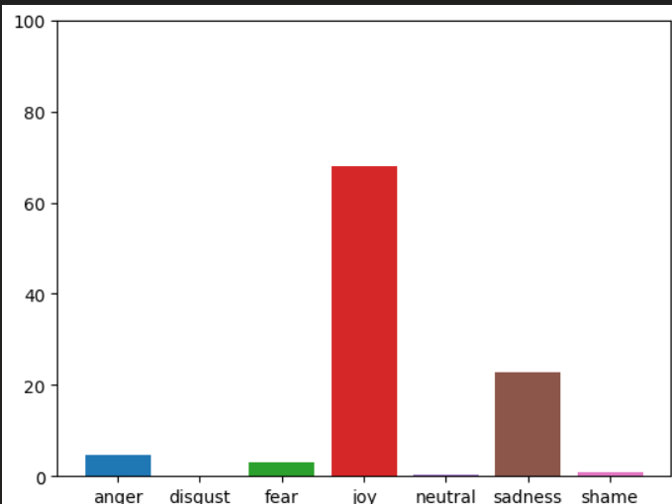

Table:

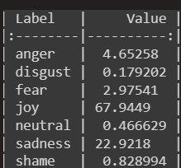

Segment 8 – effects on mental health

Graph:

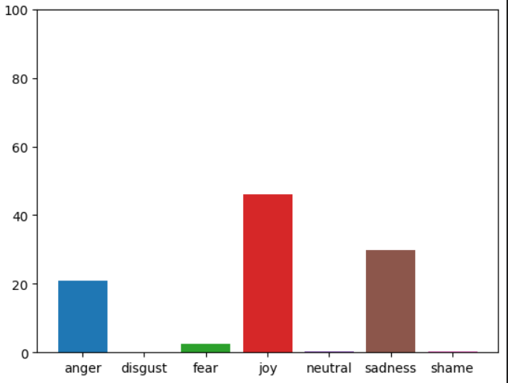

Table:

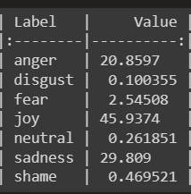

Segment 9 – conclusion

Graph:

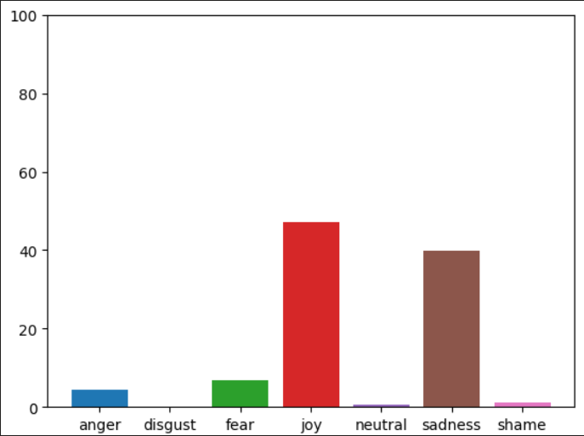

Table:

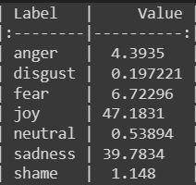

**Video 5 Radar Chart**

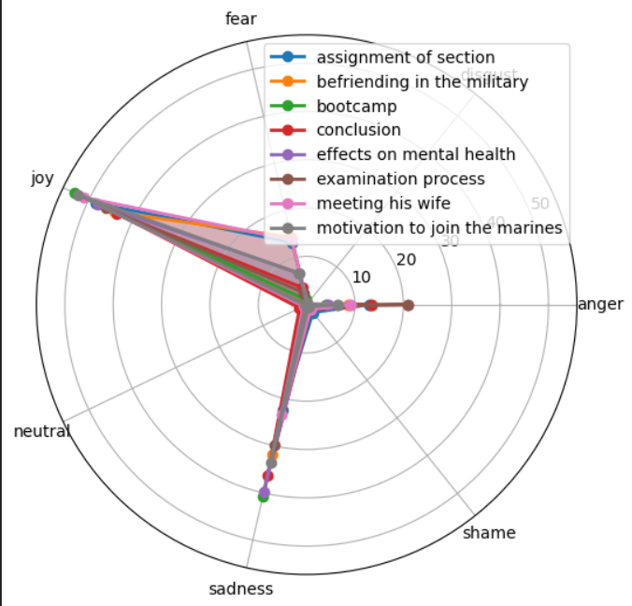

Video 6:

Segment 1 – Smoking habit

Graph:

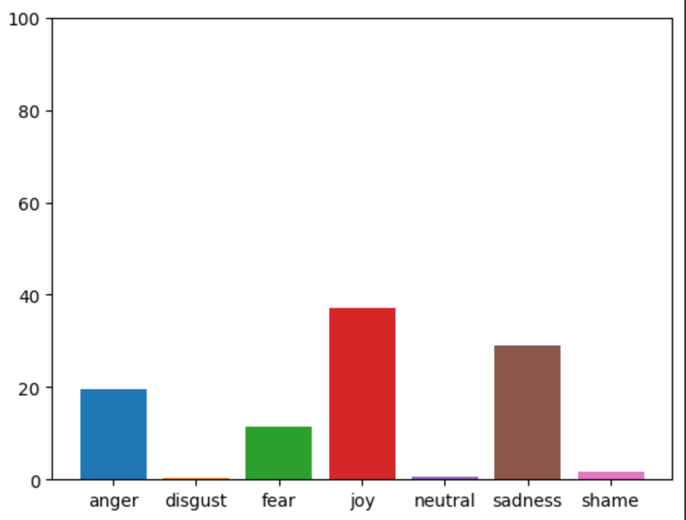

Table:

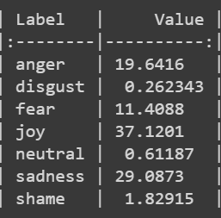

Segment 2 – knee injury

Graph:

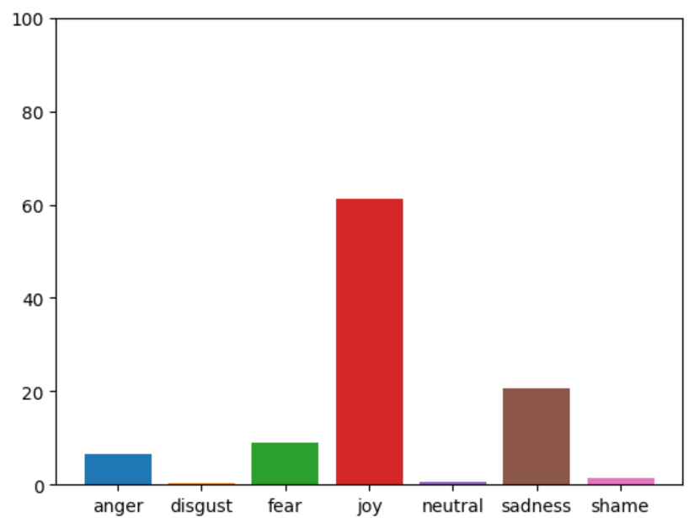

Table:

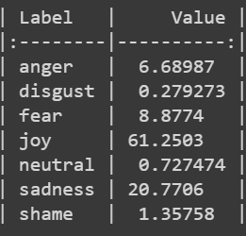

Segment 3 – treatment of knee injury

Graph:

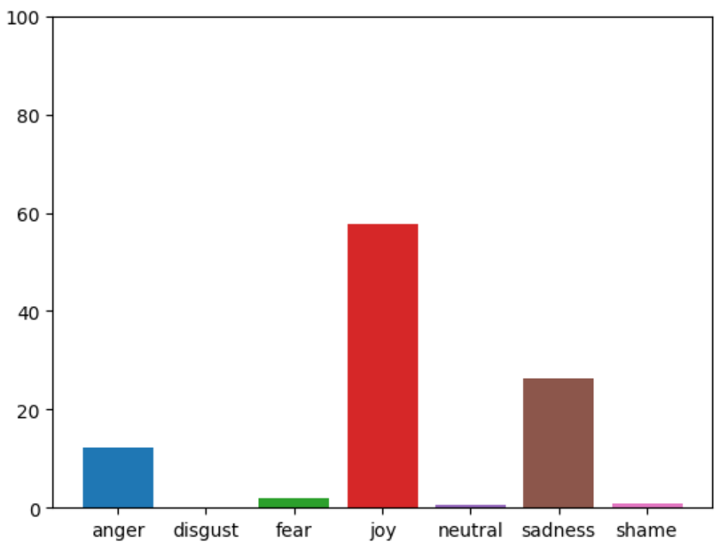

Table:

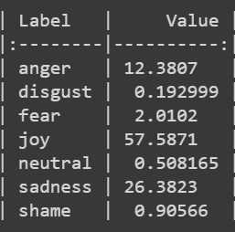

Segment 4 – veterans’ problems

Graph:

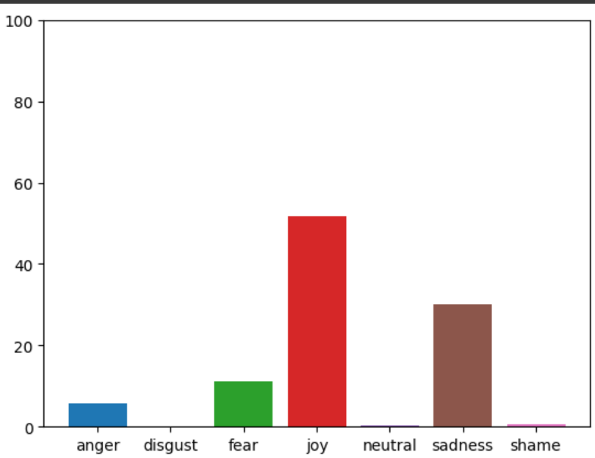

Table:

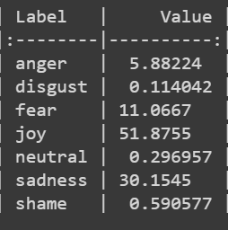

Segment 5 – conclusion

Graph:

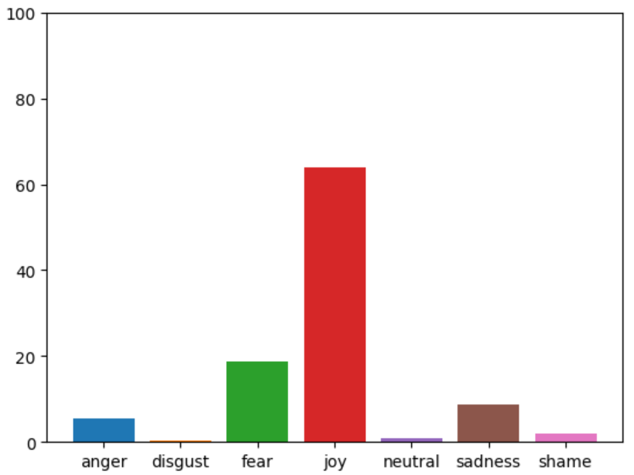

Table:

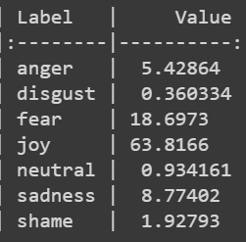

**Video 6 Radar Chart**

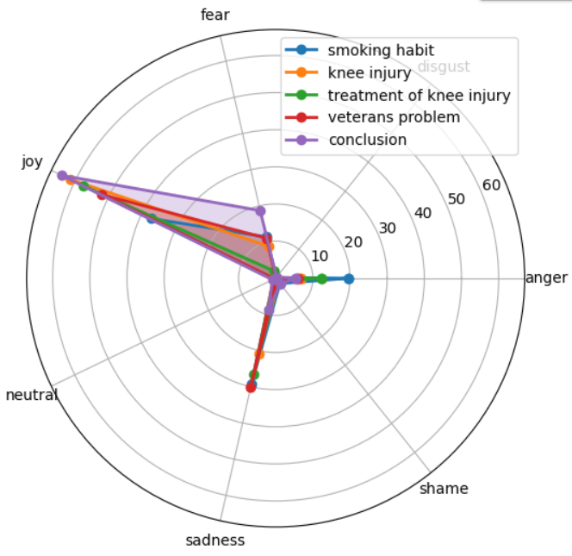

Video 7:

Segment 1 – Drugs

Graph:

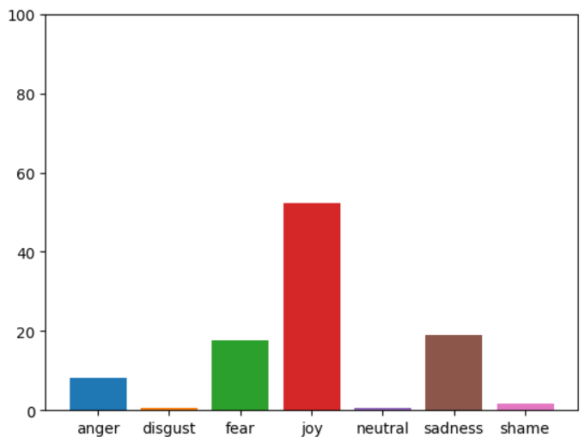

Table:

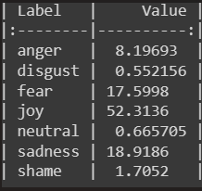

Segment 2 – Enrolment

Graph:

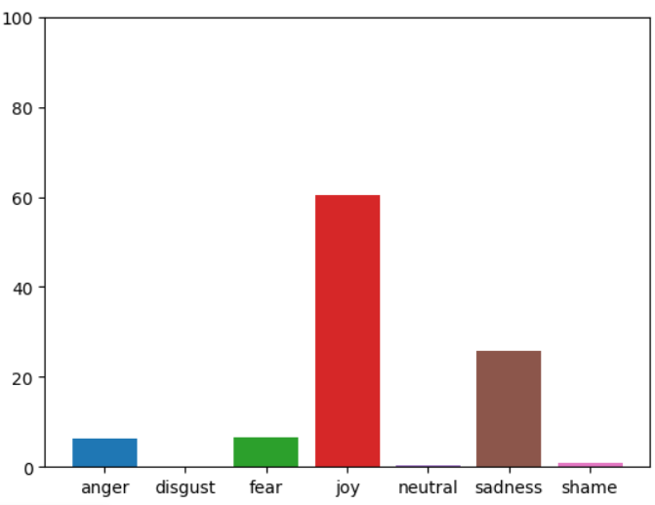

Table:

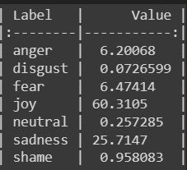

Segment 3 – General Talks

Graph:

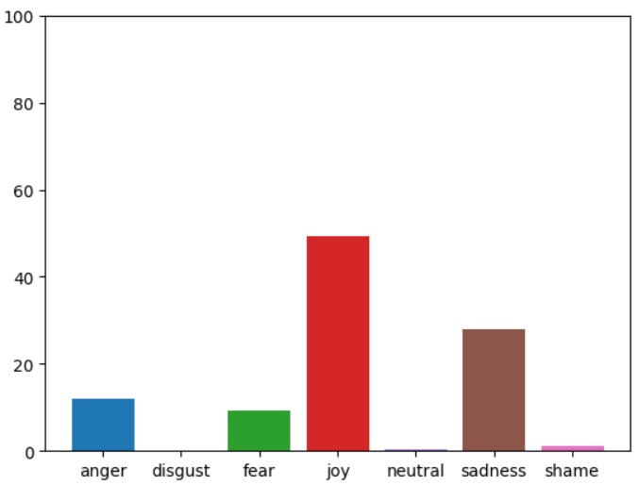

Table:

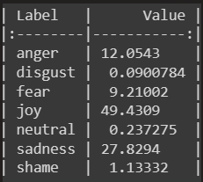

Segment 3 – Recruitment

Graph:

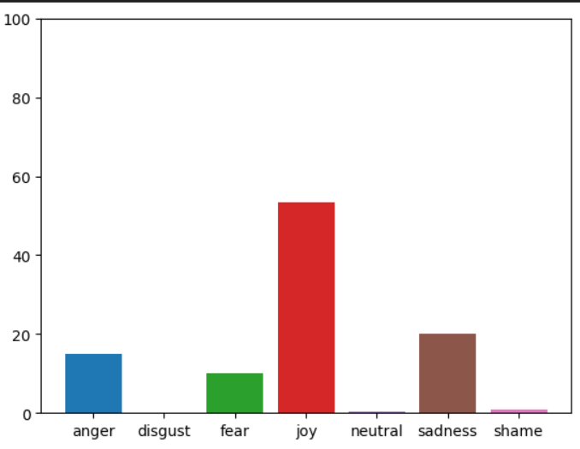

Table:

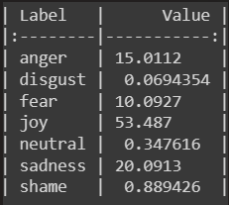

Segment 5 – Training

Graph:

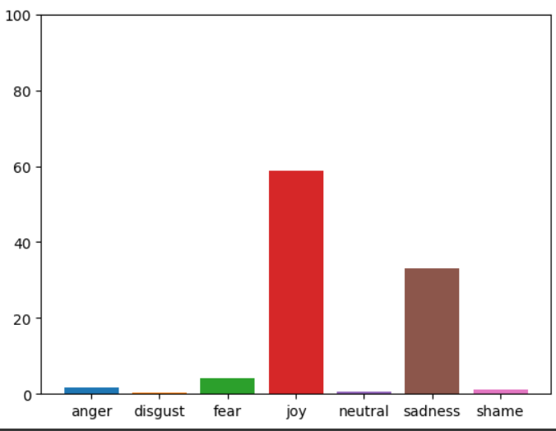

Table:

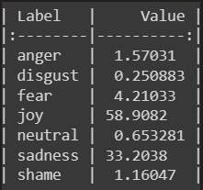

Segment 6 – Mental health

Graph:

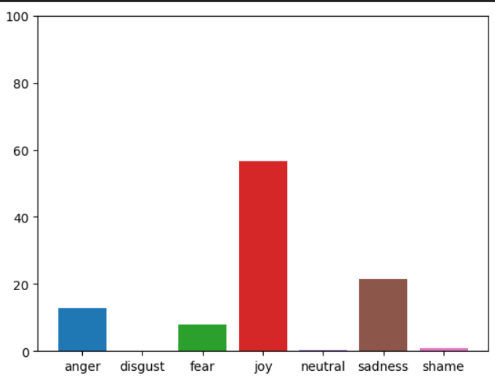

Table:

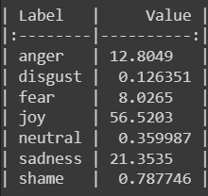

Segment 7 – Sexual Assault

Graph:

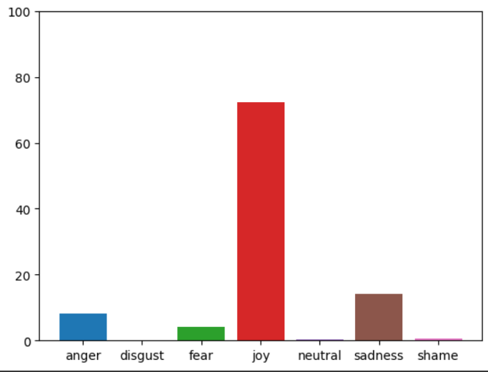

Table:

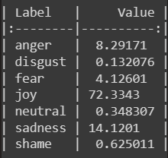

Segment 8 – Leadership and trust

Graph:

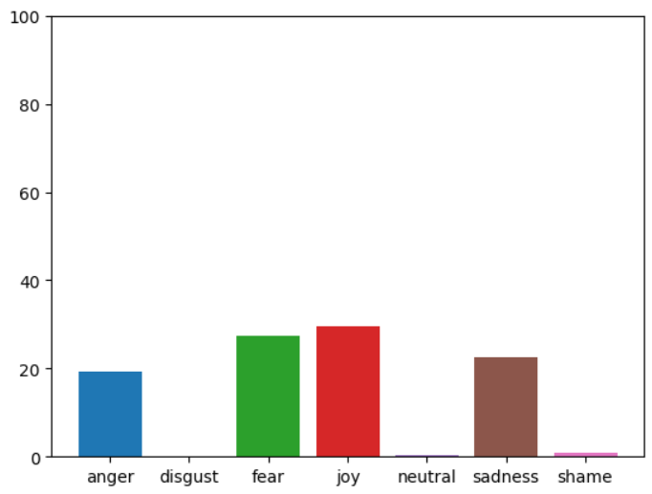

Table:

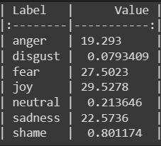

Video 7 Radar Chart

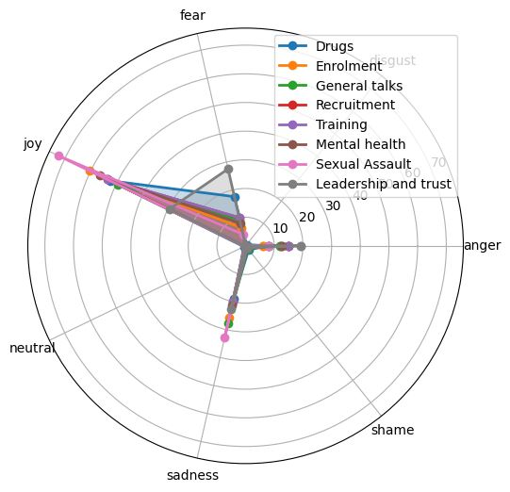

**INFERENCE**

When we were doing the sentiment analysis, we saw that there were various common topics among the videos such as the following:

* Drugs/ Drug Abuse – In video 4 and 7 the veterans talk about drug usage in contradicting ways. In video 4 the veteran talks about how everyone in his hometown got addicted to opiates, how joining the military saved him from becoming an addict and how doctors prescribing pain killers started a heroin epidemic after which he talks about how he regrets his decision to join the military. In video 7 the veteran talks about the drug usage in the military, the overdoses caused by this usage and the normalization of steroid usage in the cavalry. He then talks about how he joined the military.

* Mental Health – The veterans in 5 of the videos talk about their mental health. In the 7th video the veteran talks about how he ended up as a recruiter for the army then talks about how the leaderships don’t care about them and are waiting for them to kill themselves so they can replace you with the next guy, but how its still the recruiter’s fault if anything happens. In the second video the veteran talks about how he opened up to a cousin who then broke his trust, even after going to therapy and even at support groups he would think about how the other people have it worse and spiral about how he shouldn’t be feeling the way he is. And during the gift giving season he cannot celebrate since he recalls the people he killed on Christmas. He then talks about his ptsd. In the 3rd video the veteran says that he talks to anyone who is willing to listen to his stories about his time in the military and how this helps him feel lighter. He then goes into his time at Iraq. In the 4th video the veteran talks about his toxic parents and then he talks about how even after everything they did to him, he still wants some sort of approval from them since he is conditioned to love them but to protect his mental health, he decides that it is better to walk away from toxic situations. In the 5th video the veteran talks about his time in bootcamp and then how after military he took up a mercenary job and how killing people in this job was so dehumanized, he didn’t feel much guilt even though sometimes he still questioned the morality of the job, until he played a part in the killing of a 10-11yr old boy which was a really hard thing for him to reconcile with. He talks about how killing affects your mental health and you can never really get over it. He then talks about the effects of all of these things on his mental health.

All the videos have a higher negative sentiment for this theme with some having no positive sentiment.

* Joining military/ enrolment – The 7th video starts out with the veteran describing the drug usage in the military and then moves on to how he joined the military since he was fed up with his job and wanted to be a good son and surpass his dads rank so he decided to enrol after which his dad asks him to wait for a month before actually doing it. In the 5th video the veteran talks about how the air force split from the army and is in fact better after which he talks about how he wanted to go to college but his parents had too much money for financial aid but too many kids so it was spread too thin for him to afford college which led to him joining the military after which he talks about how he originally wanted to join the marines but decides to join the air force on the recommendation of a marine who was at the recruiters complex. In the 4th video, the veteran talks about how he sees joining the navy as a fresh start after his friends get into heroin and his parents kick him out. He then talks about how he regrets joining military as he would have liked to go to college and didn’t know he could take a loan for it. In the 3rd video the veteran talks about his time in Iraq after which he brings up that he joined the military because of a “you won’t do it” after that he talks about the injuries he suffered because of his time in the military. In the 1st video the veteran talks about his job at toys-r-us and getting fired and not wanting to join the military but joining anyways after looking at his ex-military parents’ success. He then talks about how he got recruited to be an ariel gunner and his training for that.
* PTSD – In the 6th video the veteran talks about all the problems the veterans face after their service is over, he then ends the video talking about how ptsd is cured if you become a film director and put all your stories into stories and let other people watch and be afraid. In the 2nd video the veteran talks about the kind of cigarettes he smokes and how they can be worse than any drug and then goes into how ptsd is an after-shock of a traumatic event. The brain hyper focuses on whatever was so traumatizing, its like bad wiring or a chemical change that causes trouble sleeping, irritable mood changes, etc including how you interact with other people making you lash out like a wounded animal. He then talks about how being under the influence easier to be prone to those thoughts and how he finally vented to a stranger on the internet and eventually to a cousin who then broke his trust.
* Physical Injuries – In the 6th video, the veteran talks about his smoking habit, then he bring up the injuries he suffered in the military which include a traumatic brain injury, ptsd, depression, a bad right ankle which he is going to put in for his left ankle, his right shoulder, lower back, and 0 cartilage in his knees. He then goes into detail about why his knees are in such a bad shape and how all the VA does is send him to physical therapy, which will not do anything for it. He then talks about how he now has to depend on painkillers which the VA is now strict about because of the narcotic laws so he resorts to buying it off the street, which is very expensive. He says both his knees need to be replaced and as he grows older, he will suffer the effects of metal poisoning. He then says he just need one day of reprieve so his body can recover. He than talks about how he helps other veterans get help from the VA. In the 4th video the veteran talks about how and why he joined the military, then he bring up why he didn’t go to Iraq because of a TBI he suffered due to being blown up a month before he was supposed to go. This TBI wasn’t treatable and he could only manage it with medication. He then talks about his dad’s death and how he came out of the military.

**CONCLUSION**

Afinn is a very straight forward method which calculates the positive, negative, and neutral scores depending on the individual words. The scores on negative are overwhelmingly high compared to those of positive. So, it’s safe to assume that the veterans who are here are unhappy with the way military and life after military has treated them to say the least.

In video1, the speaker talks about how they’re told “to be on oxygen literally all the time” because of the amount of lead there is in the air constantly where they fight, but there’s no strict guidelines as to make sure that they remain unaffected because of this, it’s not taken seriously enough.

In video 6, the speaker just doesn’t have any cartilage in his knees. He talks about how his VA (Veteran’s Affairs) just asked him to go to physical therapy and considers their job done. Naturally, the physical therapy didn’t work, and the speaker expresses his frustrations on how little care he was given after all the injuries they’ve had to suffer in the military. Without any choice left, he had to turn to pain killers, but has worked really hard to make sure he doesn’t get addicted to them. When they asked their VA again about it, they refused to pay for the operation and he was told it was because he might suffer from metal poisoning later on, which he believes is just an excuse to get out of taking care of the medical bills. He talks about how the VA treats them just like a number and nothing else in most states.

Physical and mental health care, even for civilians is an absolute must. People who have spent most significant part of their lives fighting for the nation surrounded by death and toxins don’t get the treatment they deserve and need. We backed this information with data and results. This is evidence that they’re being neglected after fighting for the country until they physically just couldn’t do it anymore.

We used NLP algorithms to achieve these results. We have manually divided and named the topics manually. Topic modelling is more of an effective method to do the labelling part. We represented the results in graphs and tables. Sentiment analysis is more accurate when it comes to straightforward simple speeches compared to conversations which is a bit more complicated to create a database on.

* Plans for next steps:

All we’ve achieved so far is implementing sentiment analysis on the videos provided. We plan on running emotional analysis to get a more accurate score.

Since all the above transcripts are conversations, conversation analysis of emotion is the end goal. The final presentation will consist of 7 graphs and 7 tables for sentiment analysis, and another 7 graphs and tables for conversational emotional analysis.