Kirk Worley

CST 336: Internet Programming

Final Project Docs

User Story

As a speedrunner, keeping track of world records and your placement on the leaderboards for speedrunning a particular game can get messy. Sometimes categories are loosely defined, or not shown at all, and at times it can be too clustered. I would like a website that allows me to filter a list of speedruns by category and/or game so that I can quickly determine the current rankings. Information that would be pertinent is the game, the run time, the category, and preferably the username of who completed the run—that way if I have questions or comments I could direct them to the appropriate runner. Additionally, a site that also has an active admin who can keep the leaderboards up to date when I submit a new run.

Database Schema

sr_category

sr_games

sr_runs

gameCode

gameName

gameGenre

gameRating

categoryId

categoryName

completion

runId

runner

country

gameCode

runtime

categoryId

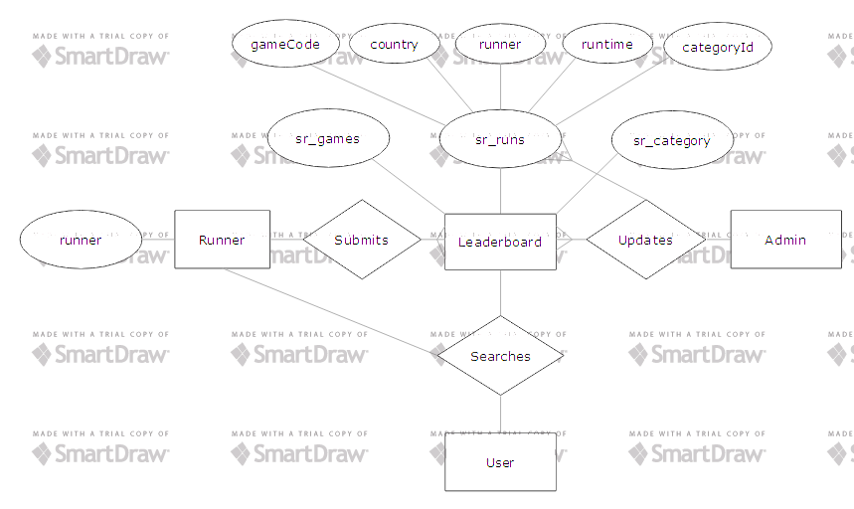

Mock-Up

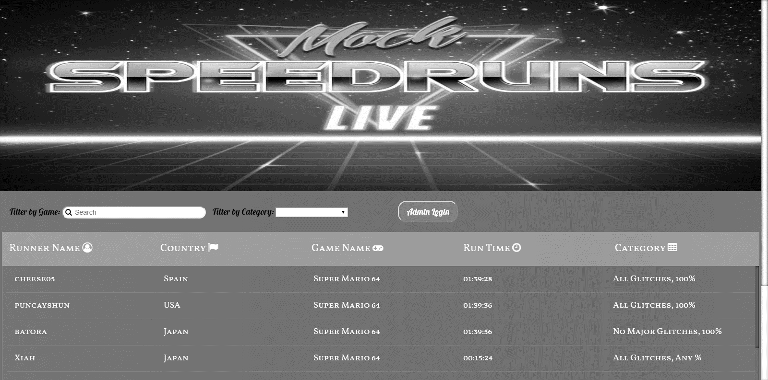

Screenshots

