Software Requirements Specification
for
Online Shopping
Version 1.0 approved
Prepared by
kirellos shehata – Amr Samy
FCI_KFS
October 2019
Table of Contents
Table of Contents ii
Revision History ii
1. Introduction 1
1.1 Purpose 1
1.2 Document Conventions 1
1.3 Intended Audience and Reading Suggestions 1
1.4 Product Scope 1
1.5 References 1
2. Overall Description 2
2.1 Product Perspective 2
2.2 Product Functions 2
2.3 User Classes and Characteristics 2
2.4 Operating Environment 2
2.5 Design and Implementation Constraints 2
2.6 User Documentation 2
2.7 Assumptions and Dependencies 3
3. External Interface Requirements 3
3.1 User Interfaces 3
3.2 Hardware Interfaces 3
3.3 Software Interfaces 3
3.4 Communications Interfaces 3
4. System Features 4
4.1 System Feature 1 4
4.2 System Feature 2 (and so on) 4
5. Other Nonfunctional Requirements 4
5.1 Performance Requirements 4
5.2 Safety Requirements 5
5.3 Security Requirements 5
5.4 Software Quality Attributes 5
5.5 Business Rules 5
6. Other Requirements 5
Appendix A: Glossary 5
Appendix B: Analysis Models 5
Appendix C: To Be Determined List 6

Revision History
Name | Date | Reason for Changes | Version
Online Shopping | 30 October 2019 | _ | 1.1 sh1
Online Shopping | 9 November  2019 | _ | 1.2 sh2

Introduction

Purpose
The purpose of online shopping is to save time, save money. Through online shopping one can save his valuable time. One can watch and select things he wants to buy. Through online shopping we can save our money because prices are less than market prices and we receive our bought things at our home.

Document Conventions
This Document was created based on IEEE template for System Requirement Specification Documents.

Bolded Arial font is used to show important text for quick reading.

Intended Audience and Reading Suggestions
- Developers: in order to be sure, they are developing the right project that fulfills requirements provided in this document.
- Testers: in order to have an exact list of the features and functions that has to respond according to requirements and provided diagrams.
- Users: in order to get familiar with the idea of the project and suggest other features that would make it even more functional.
- Documentation writers: to know what features and in what way they have to explain. What security technologies are required, how the system will response in each user’s action etc.
It is recommended to read it in its written order , beginning with the overview sections and proceeding through the sections that are most pertinent.

Product Scope
Online shop is a tool that a manager can use to manage his website and view products that suit customer’s needs then resave comments about it to analyze feedbacks and do better at next levels.
And also suggested for those who prefer online shopping can deal with it.

References
Online shop website was Inspired from:
https://www.jumia.com.eg
https://egypt.souq.com

Overall Description

Product Perspective
This Online shop was developed to mange online shops and resave feedbacks from users for Efficiency upgrading and easy the prosses for managers. Can also help customers finding their needs and create profiles so that they could interact effectively with this site to help with their comments , selling their own products and improving services.

Product Functions
Login page:
- Login: there is two ways to log on system:
- As an admin: to manage system’s functions like: adding, deleing, modify and editing products data, approving new members and comments.
- As a customer: creating your profile and ordering or selling whatever products wanted.
Main page admin:

- Add: can add categories and a video for it or may pe a picture.
- Edit: can edit on data of any user or data of products available .
- Search: admin can find products by its category or name and search users to do delete and edit functions on it.
- Delete: admin can delete a product or a user or unsuitable comment.
Main page user:
- Add: user can add picture for his profile or a comment.
- Edit: user can edit his profile picture and on his payment method.
- Search: user can find products by its type or name.
- Delete: user can remove his profile by sending a request to system.
Create new advertising:
- Add new advertising by entering its name, description, price, country, status, category and tags then click to save the item.
Show categories item:
- View categories after searching.
Manage members:
- Edit: enable manager to edit, delete and advertising data of user also adding new member.
Manage categories:
- Hide comments
- Disable comment
- Delete: manager can chick categories to delete or edit on it.
- Add: enable manager adding new categories to be viewed to user.
Manage item:
- Edit: changing data of an item.
- Delete: unavailable items can be deleted from list items.
Manage members:
- Add new member.
- Edit on user data.
- Delete member that is not active for so long.
Profile page:
- My profile: view user profile.
- New advertise: creating an advertise for specific item.
- My advertise: view user advertise created.
- My comments: view user comments.
- Logout: exit website out of the account.

User Classes and Characteristics
Educated or not educated users can use this site if and only have knowledge or can use computer.

Operating Environment
- Windows 2000
- Windows XP
- Windows Vista
- Windows 7
- Windows 8
- Windows 10

Design and Implementation Constraints
Online shop is developed in php, it uses JPGraph for its visualization engine and has been built on top of the Bootstrap Platform. It uses MYSQL database for data to be stored and JavaScript, ajax, jQuery, CSS, CSS3, html and html5 for its design.
UTF5 is used to support English and Arabic languages .
Used communications protocols: HTTP , FTP .

User Documentation
There is a quick start guide in the beginning of the program where to show the user how to use the program. a slide show that enable users to interact with the program effectively.

Assumptions and Dependencies
Online shop requires an internet connection so that you can interact with it from any operating system and need a browser.

External Interface Requirements

User Interfaces
- Login form:

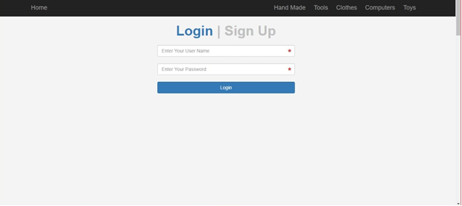
- Main page:

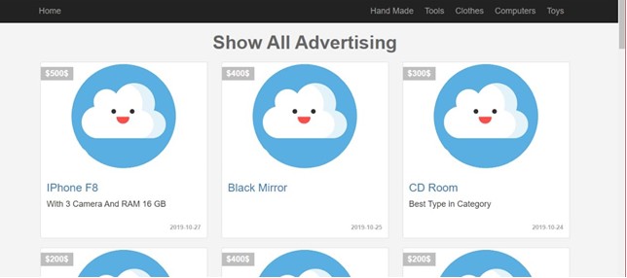

- Show category item:

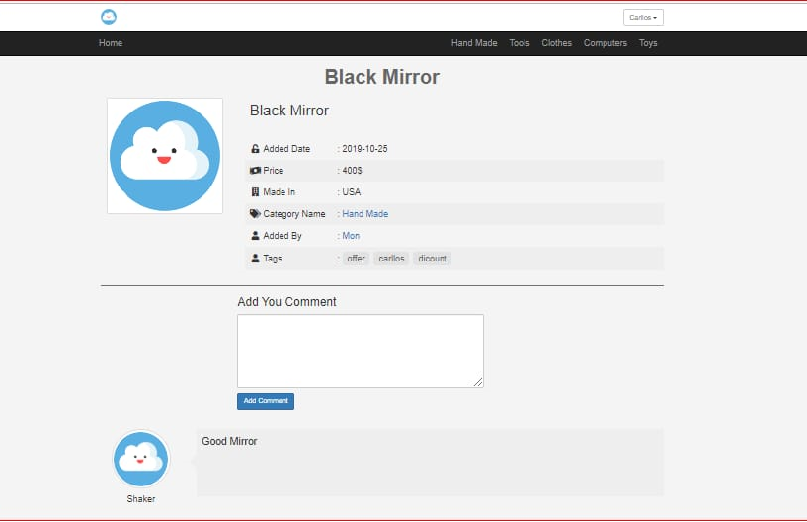

- Admin login:

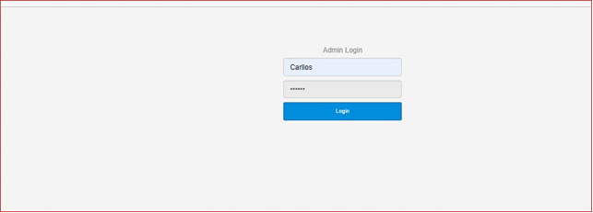

- Manager main page:

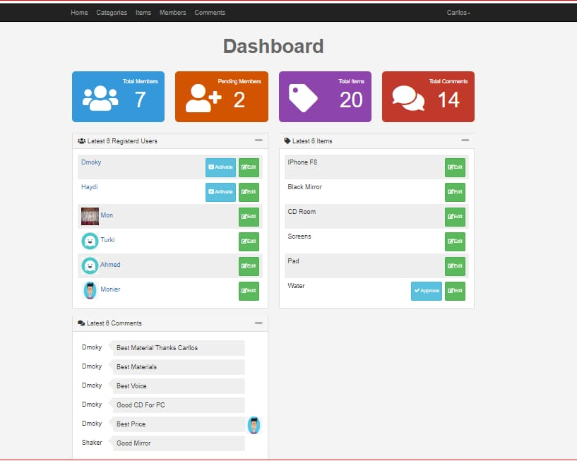

- Manage categories:

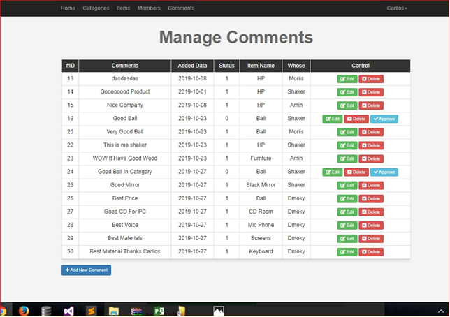

- Manage members:

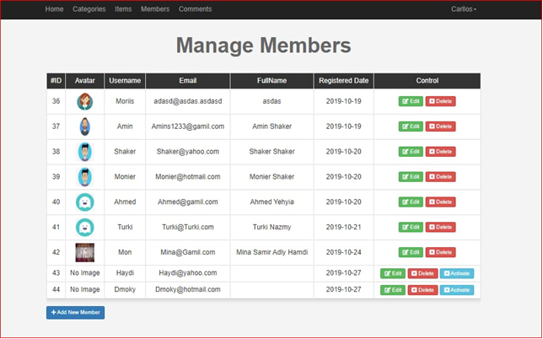

- Add advertise:

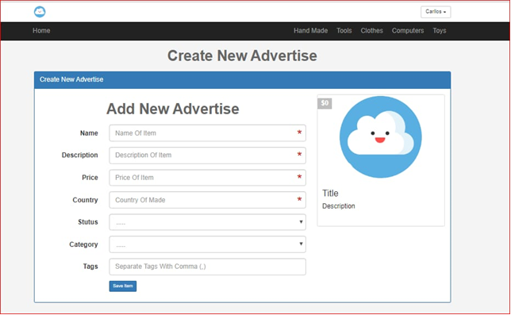

Hardware Interfaces
Online shop requires a router to connect internet and a device to connect from it.

Software Interfaces
Online shop only requires a browser to be loaded on your device.

Communications Interfaces
Online shop requires an internet connection to install new plugins, update already installed ones and update some of its components (APIs, modules etc.).

System Features
This section demonstrates online shop’s most prominent features and explains how they can be used and the results they will give back to the user.

Login

As a user:
Entering user name and password to access on system for shopping and interacting:
Example:

main page for user:
on this page that views items available on site:
Example:

When choosing required item it views item specifications for user.
Example:

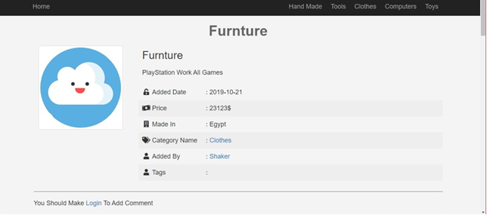
If user not logged on system, he could click on the link below to log on system and send his comment about the item chosen.
Example:

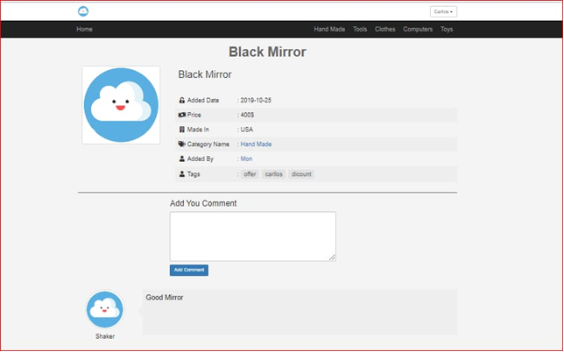

As an admin:
Admin should enter a specific name and password so he can manage the system operations.
Example:

main admin page:
in this page it shows all categories that admen have authority to act on.
Example:

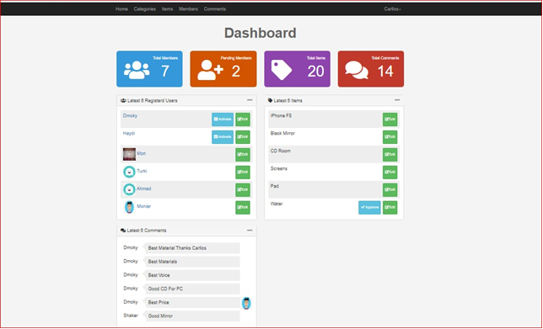

management pages:

manage comments:
in this page admin can do many operations on user’s comments like delete, editing or approving the comment for any users.
Example:

manage categories:
in this page admin can control categories comments and adding new ones can order them aphetically for easy searching.
Example:

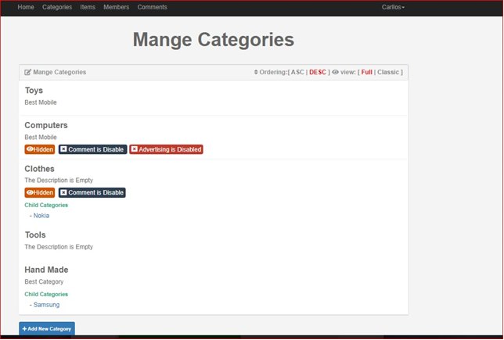

manage members:
in here admin have authority to delete, edit or even add new members wither they are users or new admins.
Example:

Adding new advertise:
In this page admin can add new items to the list of items to be viewed to users entering its name, description, price, country, status, category and tags then click to add item.
Example:

Other Nonfunctional Requirements

Performance Requirements
Online shop requires a system with at least a 500-megahertz CPU and 128 megabytes of RAM.
And a quick internet connection. Performance depends on internet connection and computer CPU.

Safety Requirements
Online shop cannot be accessed without a user id and password or you should have an account to authorize shopping on it or managing its system.

Security Requirements
Online shop does not have any security requirements and thus any type of user can use it without any additional privileges.

Software Quality Attributes
Online shop provides the users with both simple and advanced features. Due to its well designed and easy to use interface it can be used by both experts and typical users. However, users must already have a basic knowledge of using internet before using it.
The most considered quality attributes are :
Availability: the system is available 24/7 .
Security: The system is highly secured to ensure customer privacy ,
And resist unauthorized attempts at usage or behavior modification, while still providing service to legitimate users.
Usability : the system is very user friendly.
-Security and Usability are preferred over any other attribute .

Business Rules
Only The admin can approve users and comments , add categories and delete products .
Non registered customers can only view products but cannot advertise products or add comments or buy a product until they register.
Members can advertise new products ,add comments and buy a products.

Appendix : Analysis Models

