The SQL code below will create tables based on the Entity Relationship Diagram (ERD) and the provided specifications outlined in tables 1, 2, and 3. Specifically, tables for Patient, Nurse, and Admittance. Each table will be constructed with the specified attributes, data types, and constraints, including primary keys and foreign keys.

Now we are going to present the table creation for Patient, Nurse, and Admittance. That we constructed using SQL.

TABLE Patient creation:

CREATE TABLE Patient(

PID VARCHAR (6) NOT NULL,

P_FNAME VARCHAR (20) NOT NULL,

P_LNAME VARCHAR (30) NOT NULL,

CONSTRAINT PID_PK PRIMARY KEY (PID));

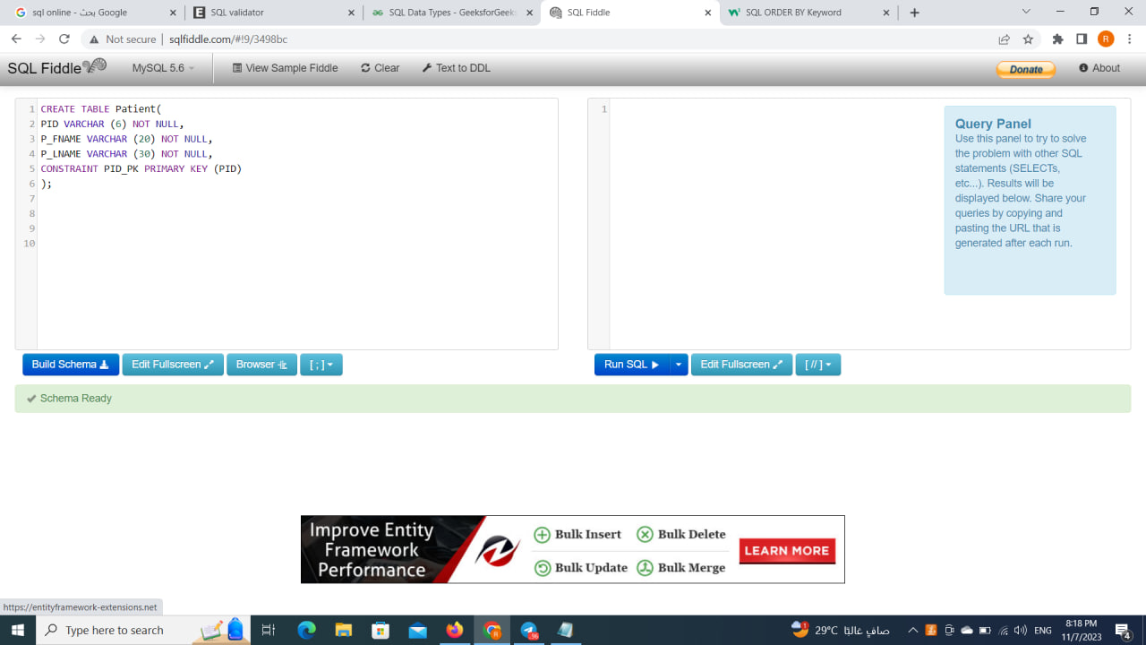

TABLE NURSE creation:

CREATE TABLE NURSE(

NID INTEGER NOT NULL,

N_FNAME VARCHAR(20) NOT NULL,

N_LNAME VARCHAR(30) NOT NULL,

CONSTRAINT NID_PK PRIMARY KEY (NID));

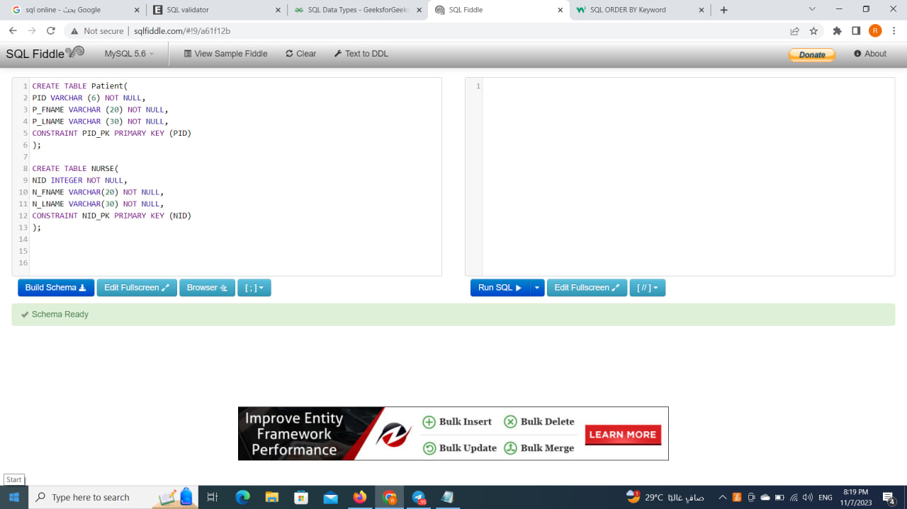

TABLE ADMITTANCE creation:

CREATE TABLE ADMITTANCE (

AID INTEGER NOT NULL,

Date DATE NOT NULL,

ALIMENT VARCHAR (30) NOT NULL,

PID VARCHAR (6) NOT NULL,

NID INTEGER NOT NULL,

CONSTRAINT AID_PK PRIMARY KEY (AID),

CONSTRAINT PID_FK FOREIGN KEY (PID) REFERENCES Patient

(PID) ON DELETE CASCADE,

CONSTRAINT NID_FK FOREIGN KEY (NID) REFERENCES NURSE

(NID) ON DELETE CASCADE);

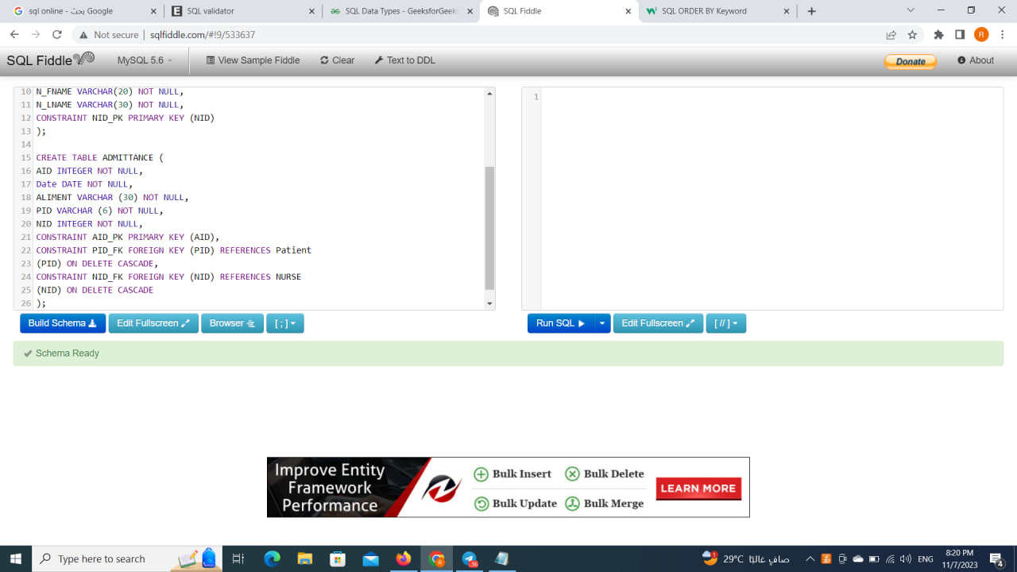

Now our tables have been constructed and ready to be filled with information. We are going to insert statements to add data to the tables. These statements included the table name, column names, and corresponding values. The tables will be updated with the inserted data. As a result, the Patient table will include patient records with IDs and names, and the Nurse table has information about nurses with IDs and names, and the Admittance will include the Patient information and their provided nurse.

PATIENT insertion:

INSERT INTO PATIENT

(PID, P_FNAME, P_LNAME) VALUES

("123A45", "Chris", "Jackson"),

("234B56", "Tony", "Mack"),

("345C67", "Katniss", "Everdeen"),

("456D78", "Sookie", "Stackhouse"),

("567E89", "Alice", "Wonderland");

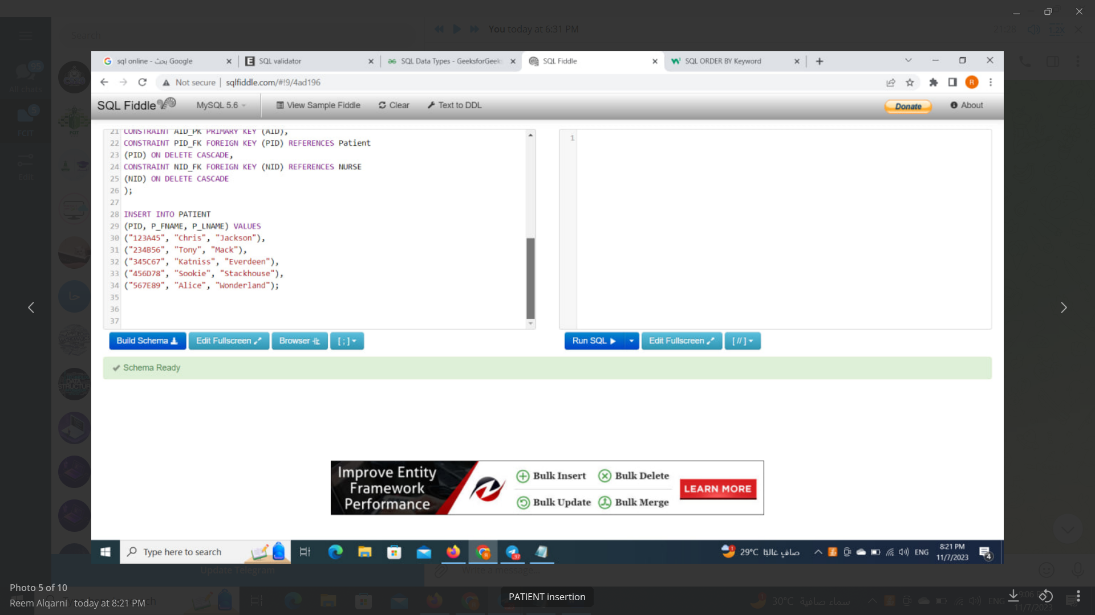

NURSE insertion:

INSERT INTO NURSE

(NID, N_FNAME, N_LNAME) VALUES

(2014211, "Jackie", "Peyton"),

(2014308, "Annie", "Wilkes"),

(2014309, "Carla", "Espinosa"),

(2014322, "Amelia", "Earhart"),

(2014206, "Johnnie", "Carson");

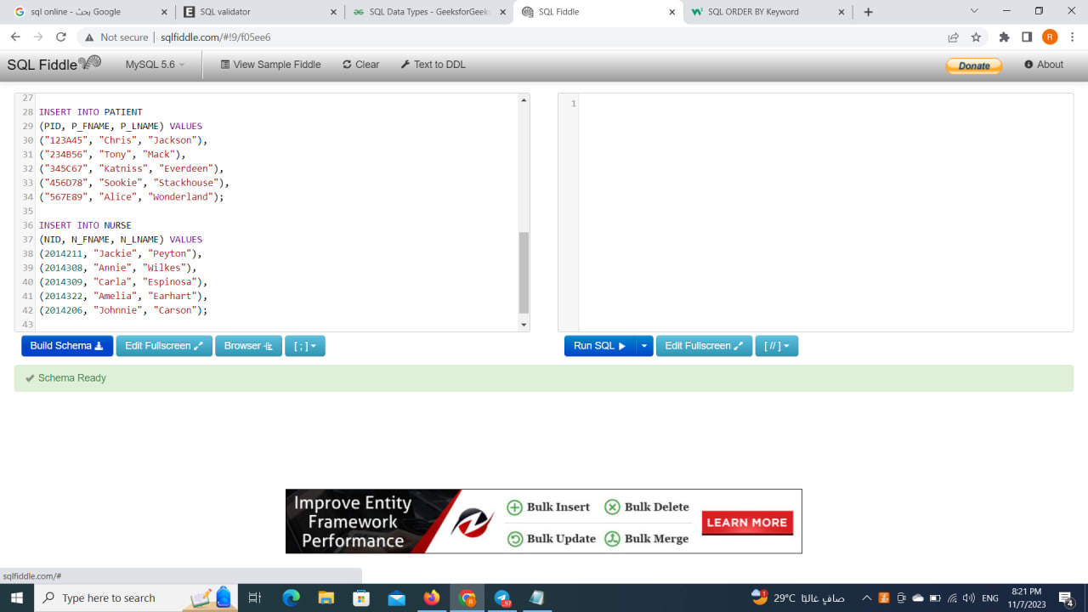

ADMITTANCE insertion:

INSERT INTO ADMITTANCE

(AID, DATE, ALIMENT, PID, NID) VALUES

(9876543, 01/05/2014, "Head Wound", "123A45", 2014206),

(8765432, 01/05/2014, "Laceration", "567E89", 2014211),

(7654321, 13/05/2014, "Laceration", "345C67", 2014211),

(6543210, 07/09/2014, "Heart Attack", "123A45", 2014308),

(5432101, 22/07/2014, "Head Wound", "456D78", 2014309);

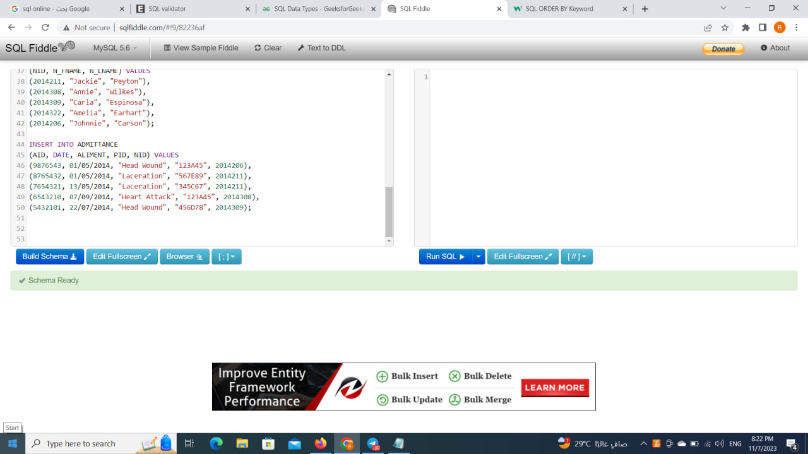

After we filled the tables with the given information. We are going to the queries based on the given pictures.

1. Showing the PATIENT table by using select*

SELECT * from PATIENT

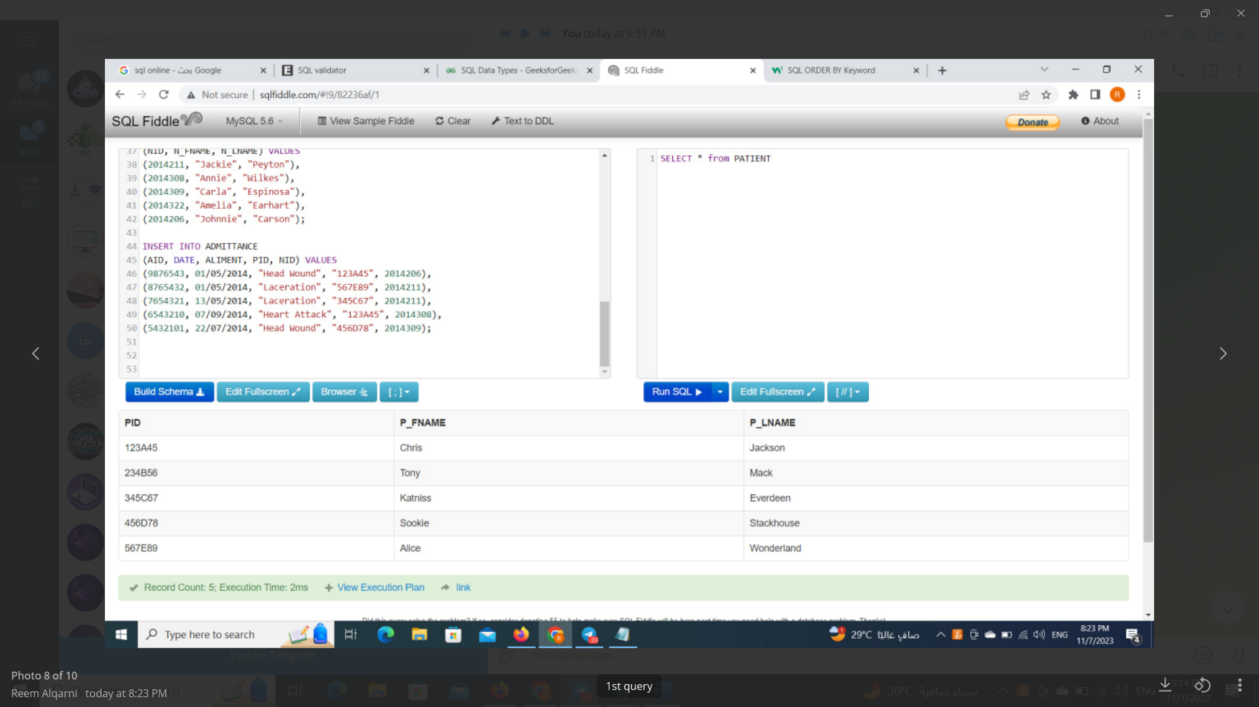

1. Showing the NURSE table by using select* and order the last name ascendingly

SELECT * from NURSE

ORDER BY N_LNAME;

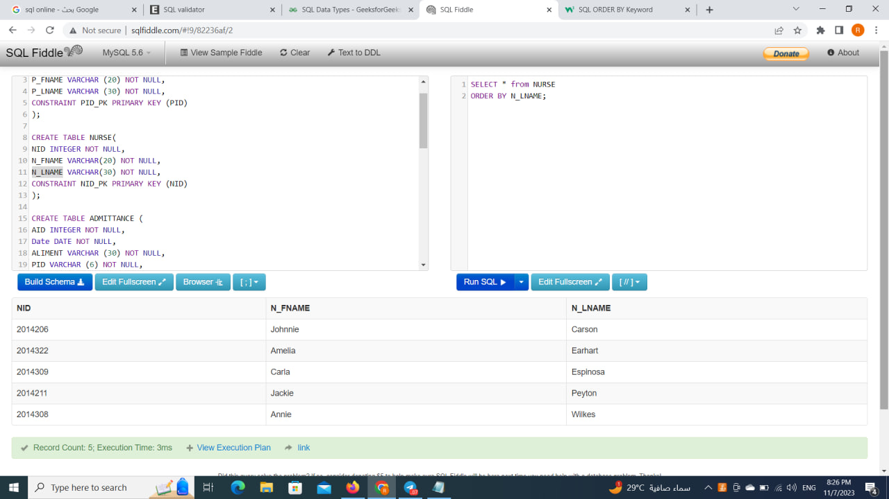

1. Lastly, the query retrieves AID, PID, and NID columns from the ADMITTANCE table where the AID matches 7654321 and 8765432. The result set contains admission records with the corresponding IDs of patient and nurse.

SELECT AID , PID , NID FROM ADMITTANCE

WHERE AID IN ( 7654321 , 8765432 );

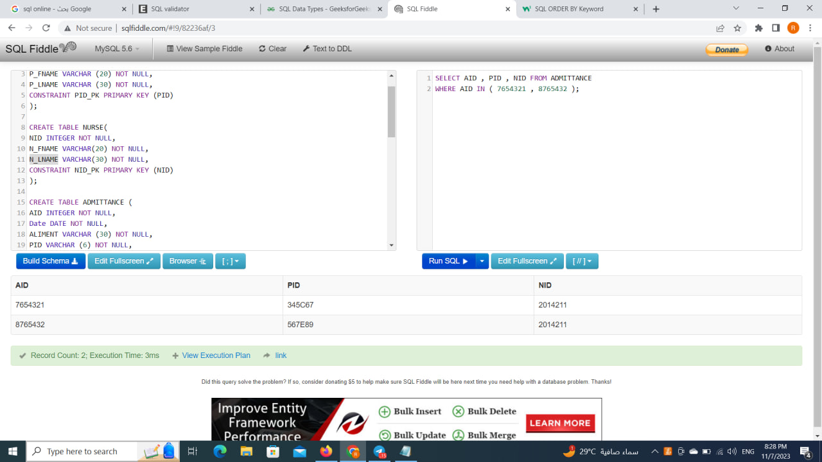

The full code of SQL:

CREATE TABLE Patient(

PID VARCHAR (6) NOT NULL,

P_FNAME VARCHAR (20) NOT NULL,

P_LNAME VARCHAR (30) NOT NULL,

CONSTRAINT PID_PK PRIMARY KEY (PID)

);

CREATE TABLE NURSE(

NID INTEGER NOT NULL,

N_FNAME VARCHAR(20) NOT NULL,

N_LNAME VARCHAR(30) NOT NULL,

CONSTRAINT NID_PK PRIMARY KEY (NID)

);

CREATE TABLE ADMITTANCE (

AID INTEGER NOT NULL,

Date DATE NOT NULL,

ALIMENT VARCHAR (30) NOT NULL,

PID VARCHAR (6) NOT NULL,

NID INTEGER NOT NULL,

CONSTRAINT AID_PK PRIMARY KEY (AID),

CONSTRAINT PID_FK FOREIGN KEY (PID) REFERENCES Patient

(PID) ON DELETE CASCADE,

CONSTRAINT NID_FK FOREIGN KEY (NID) REFERENCES NURSE

(NID) ON DELETE CASCADE

);

----------------------------------------------------------------------------------------------------------------

INSERT INTO PATIENT

(PID, P_FNAME, P_LNAME) VALUES

("123A45", "Chris", "Jackson"),

("234B56", "Tony", "Mack"),

("345C67", "Katniss", "Everdeen"),

("456D78", "Sookie", "Stackhouse"),

("567E89", "Alice", "Wonderland");

INSERT INTO NURSE

(NID, N_FNAME, N_LNAME) VALUES

(2014211, "Jackie", "Peyton"),

(2014308, "Annie", "Wilkes"),

(2014309, "Carla", "Espinosa"),

(2014322, "Amelia", "Earhart"),

(2014206, "Johnnie", "Carson");

INSERT INTO ADMITTANCE

(AID, DATE, ALIMENT, PID, NID) VALUES

(9876543, 01/05/2014, "Head Wound", "123A45", 2014206),

(8765432, 01/05/2014, "Laceration", "567E89", 2014211),

(7654321, 13/05/2014, "Laceration", "345C67", 2014211),

(6543210, 07/09/2014, "Heart Attack", "123A45", 2014308),

(5432101, 22/07/2014, "Head Wound", "456D78", 2014309);

----------------------------------------------------------------------------------------------

SELECT * from PATIENT;

SELECT * from NURSE

ORDER BY N_LNAME;

SELECT AID , PID , NID FROM ADMITTANCE

WHERE AID IN ( 7654321 , 8765432 );