In this lab exercise, we will be utilizing the given dataset to perform various operations. The dataset consists of tables, namely Patient, Nurse, and Admittances, along with their corresponding insert statements. We will make certain modifications to these tables based on the provided questions.

The tables creations:

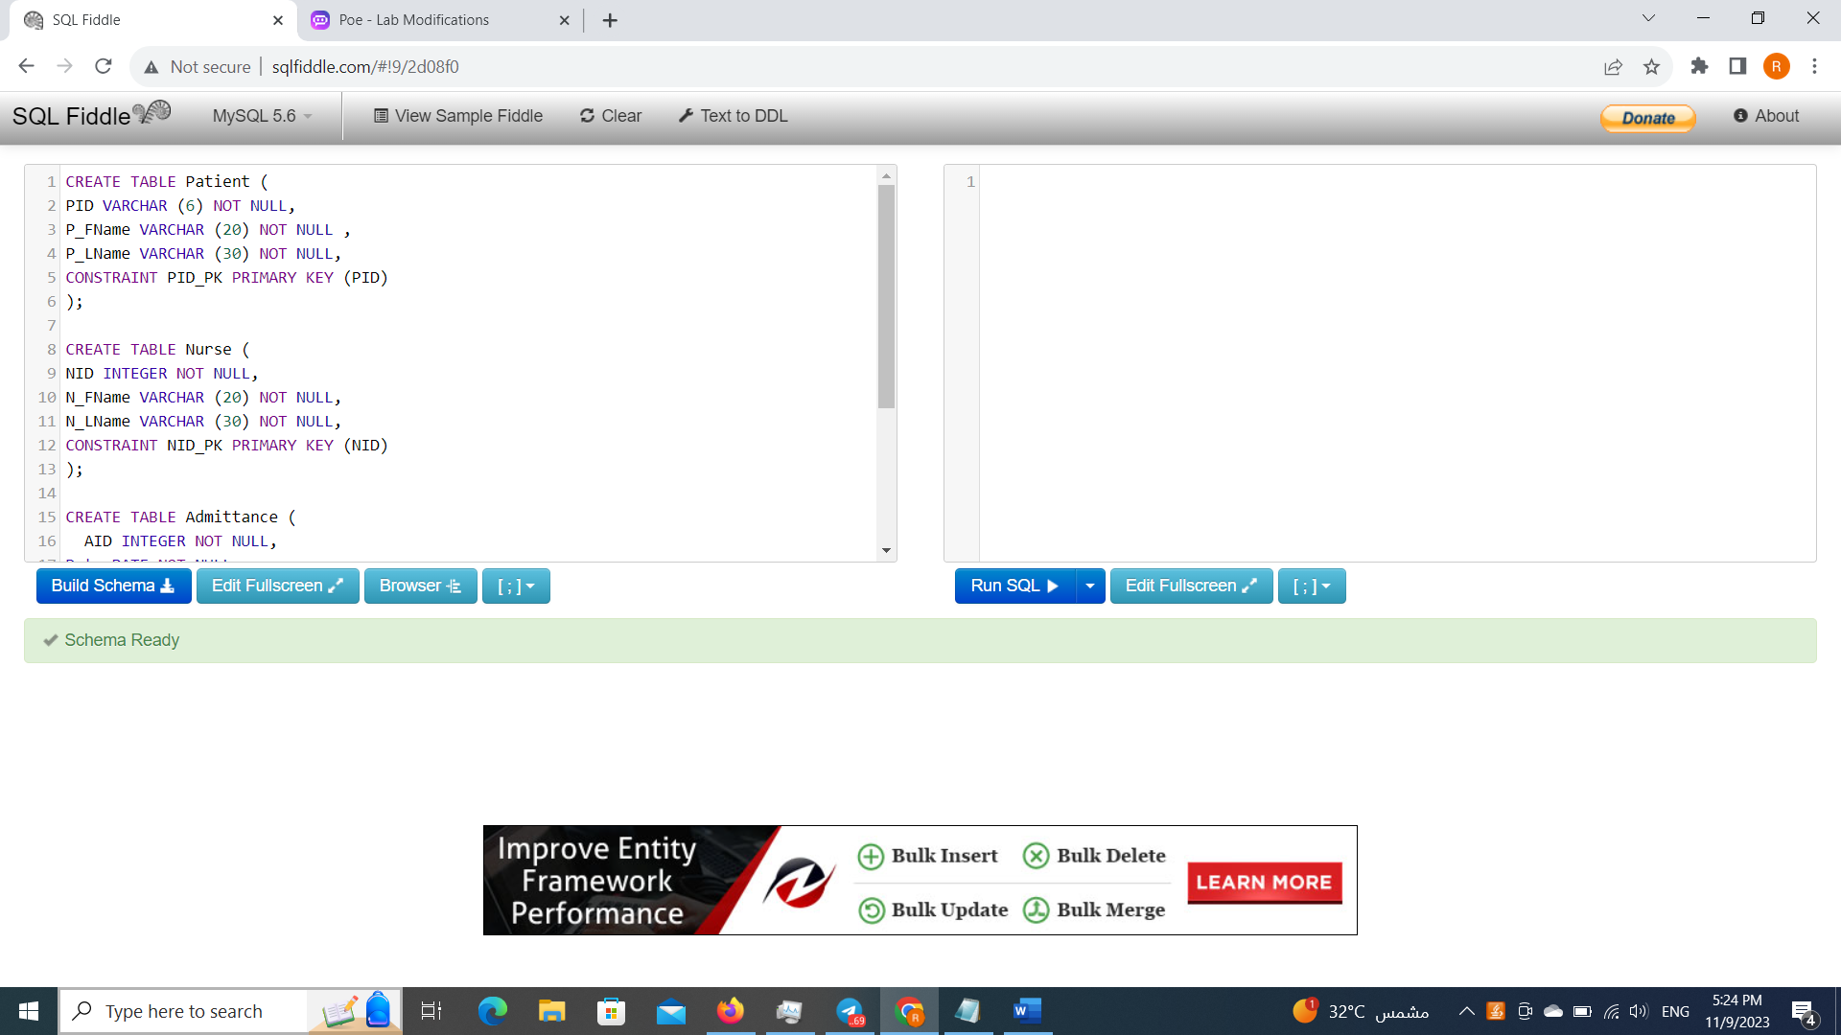

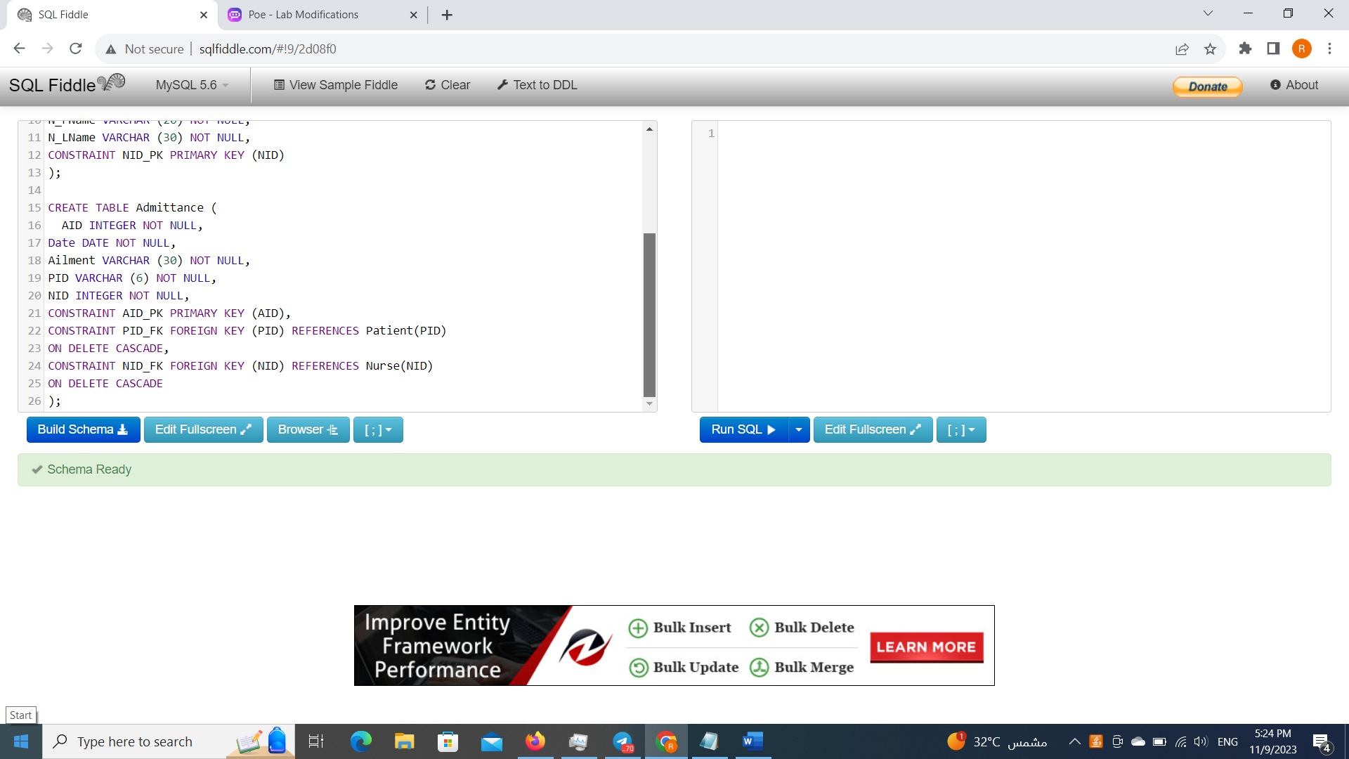

The insertions statement to the tables:

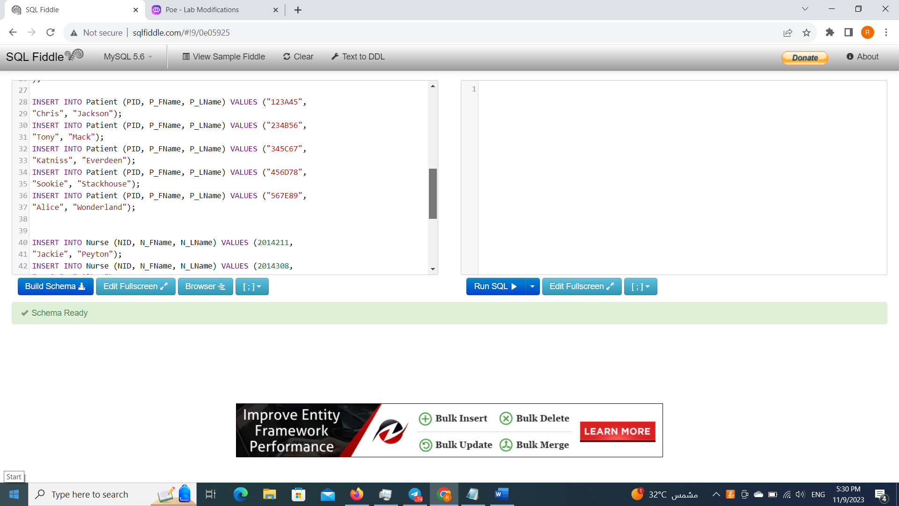

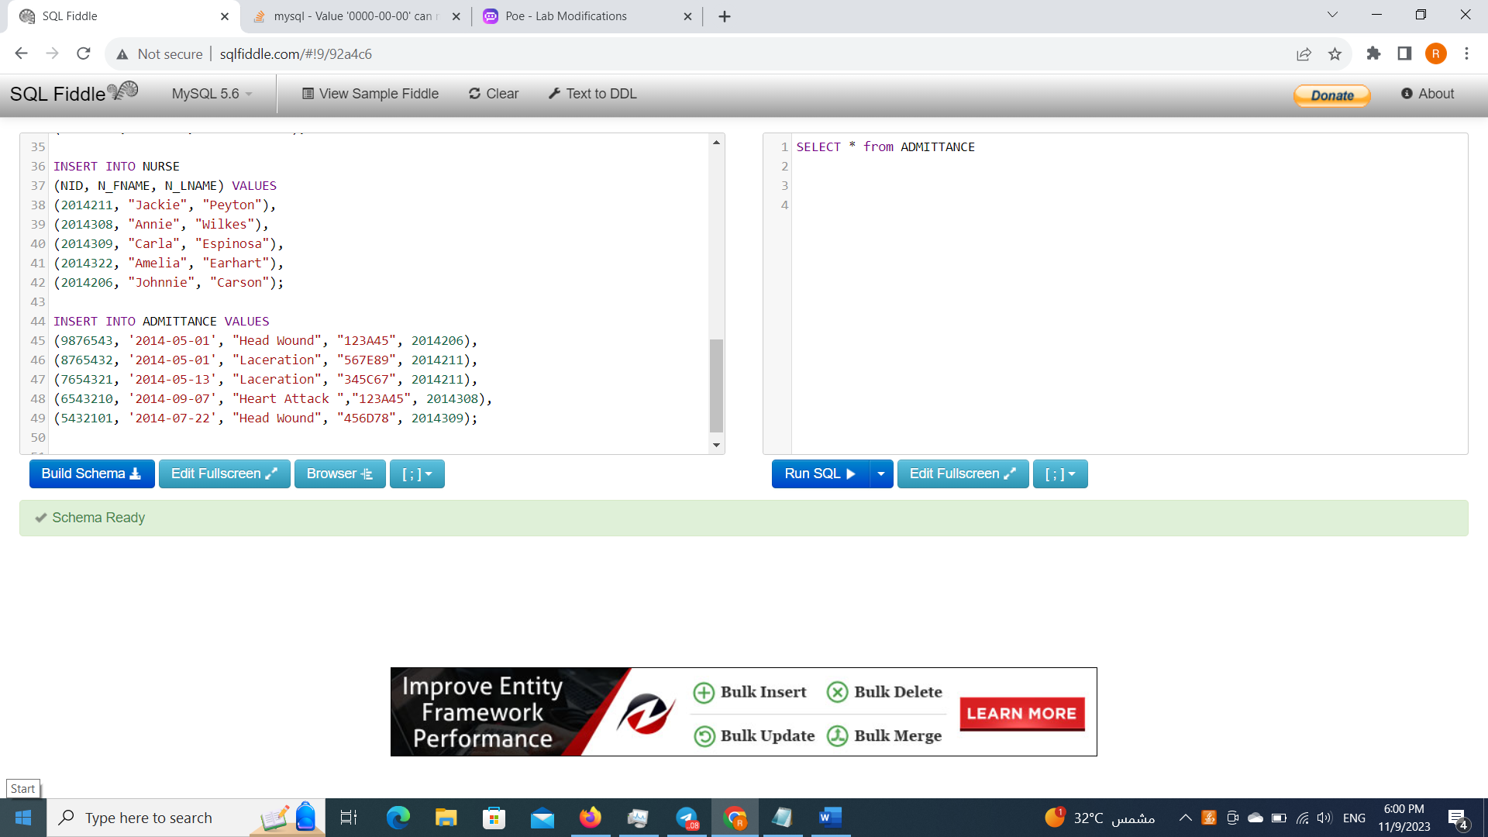

Q1. In the Admittance table, add a column called “Treatment” where the description can vary

up to 30 characters long. This column cannot be null and the default value should be

“Pending”. Also add a column called “Dose” where the value is INTEGER. This column

cannot be null.

ALTER TABLE ADMITTANCE

ADD Treatment VARCHAR (30) NOT NULL DEFAULT " Pending",

ADD Dose INTEGER NOT NULL ;

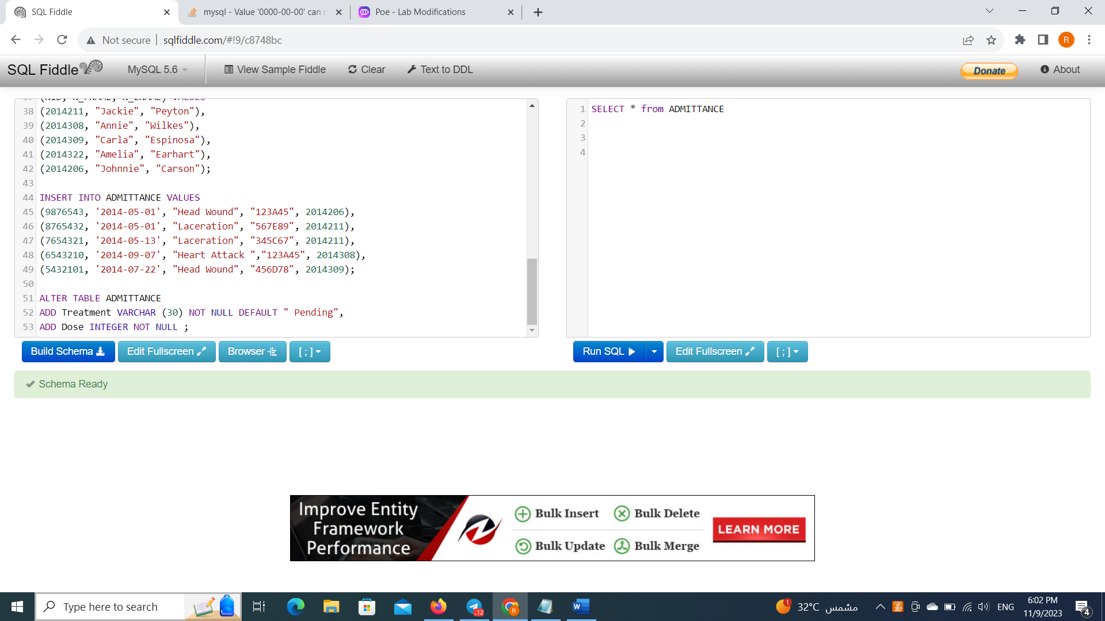

Q2. In the Admittance table, update the records to include values for “Treatment” and “Dose”.

UPDATE ADMITTANCE

SET Treatment = "Antibiotics",

Dose = 2

WHERE AID = 9876543;

UPDATE ADMITTANCE

SET Treatment = "Albuterol",

Dose = 1

WHERE AID = 8765432;

UPDATE ADMITTANCE

SET Treatment = "Albuterol",

Dose = 2

WHERE AID = 7654321;

UPDATE ADMITTANCE

SET Treatment = "Antibiotics",

Dose = 3

WHERE AID = 6543210;

UPDATE ADMITTANCE

SET Treatment = "Ibuprofen",

Dose = 4

WHERE AID = 5432101;

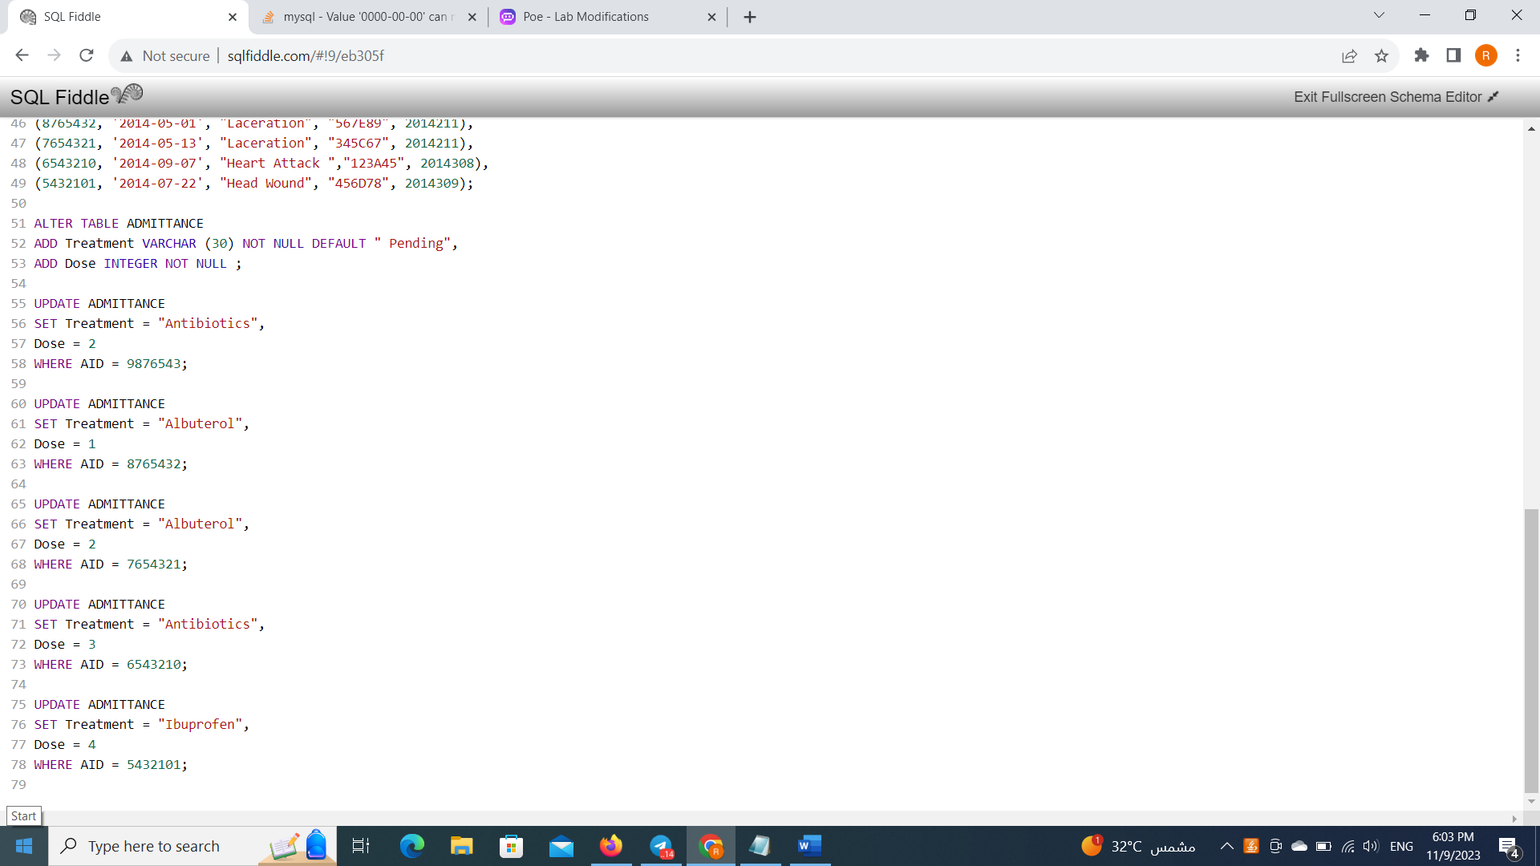

Showing the updating Admittance table:

SELECT * from ADMITTANCE

Order by AID DESC;

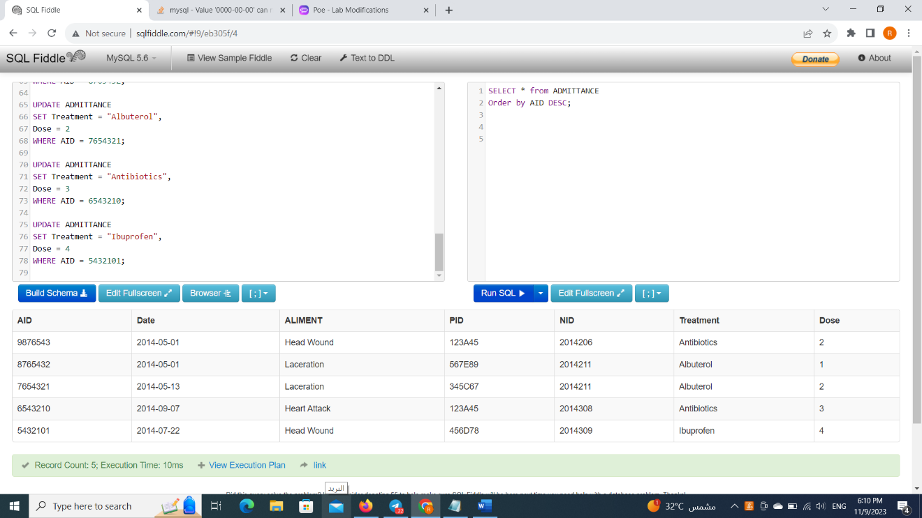

Q3. In the Patient table, change the maximum length for Patient last names to be 40 characters

long.

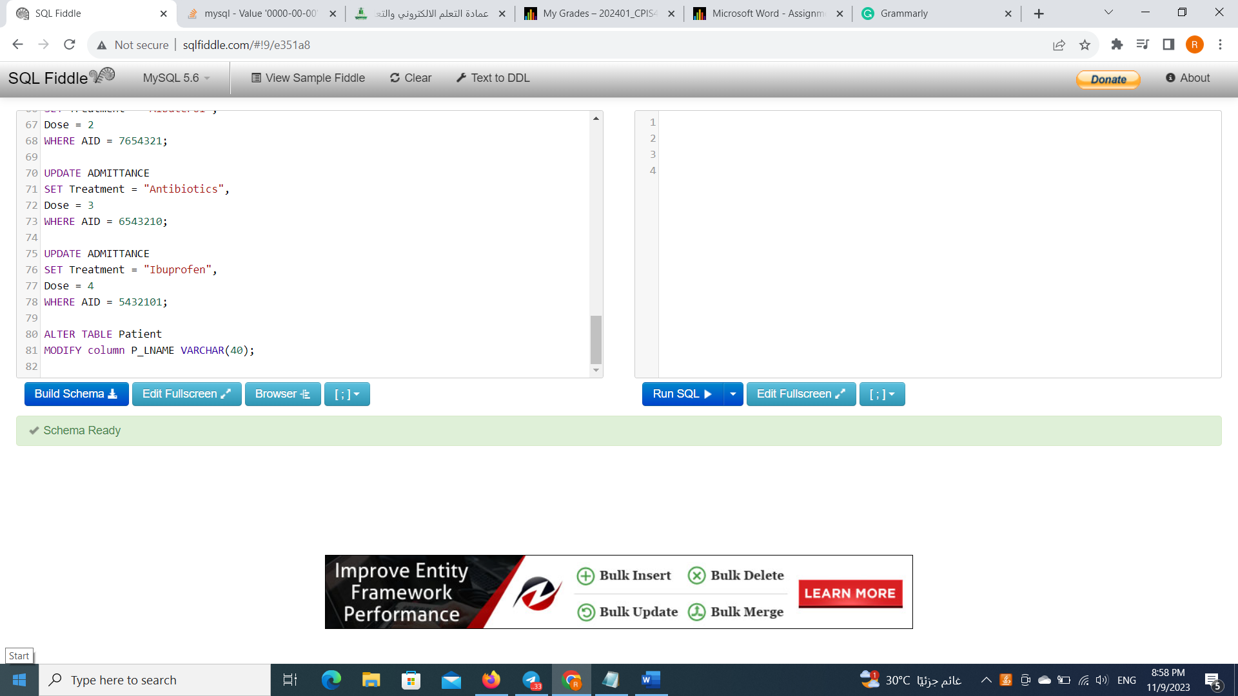

Q4. Delete the information for Nurse Carla Espinosa from the Nurse table.

DELETE FROM NURSE

WHERE N_FName = "Carla" and N_LName = "Espinosa";

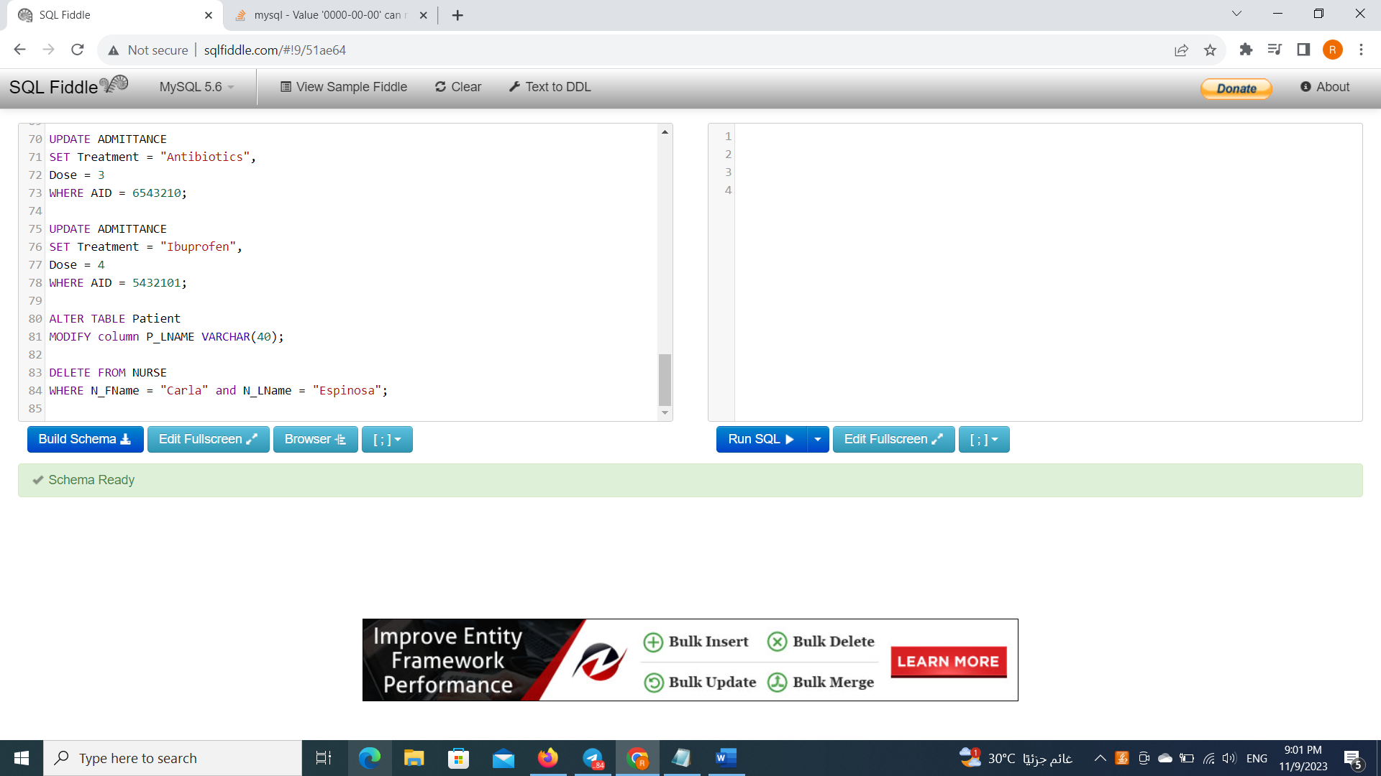

Q5. In the Nurse table, change the column name “N_FName” to be “N_FirstName”

ALTER TABLE NURSE

CHANGE COLUMN N_FName N_FirstName varchar (20);

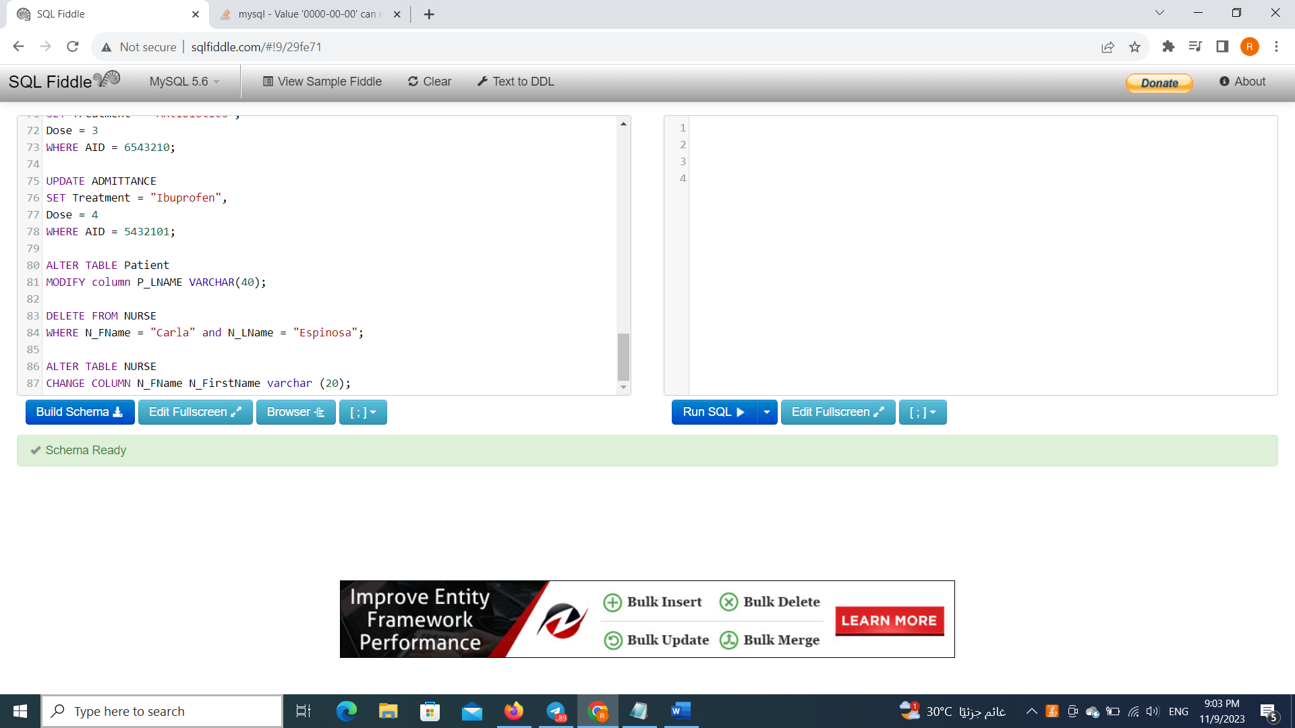

Q6. Show Admittance ID, Treatment, Dose, and Does per week AS “DoesPerWeek. Hint: Dose

per week is Dose multiplied by 7.

select AID , Treatment , Dose,

Dose * 7 DosePerWeek from ADMITTANCE ;

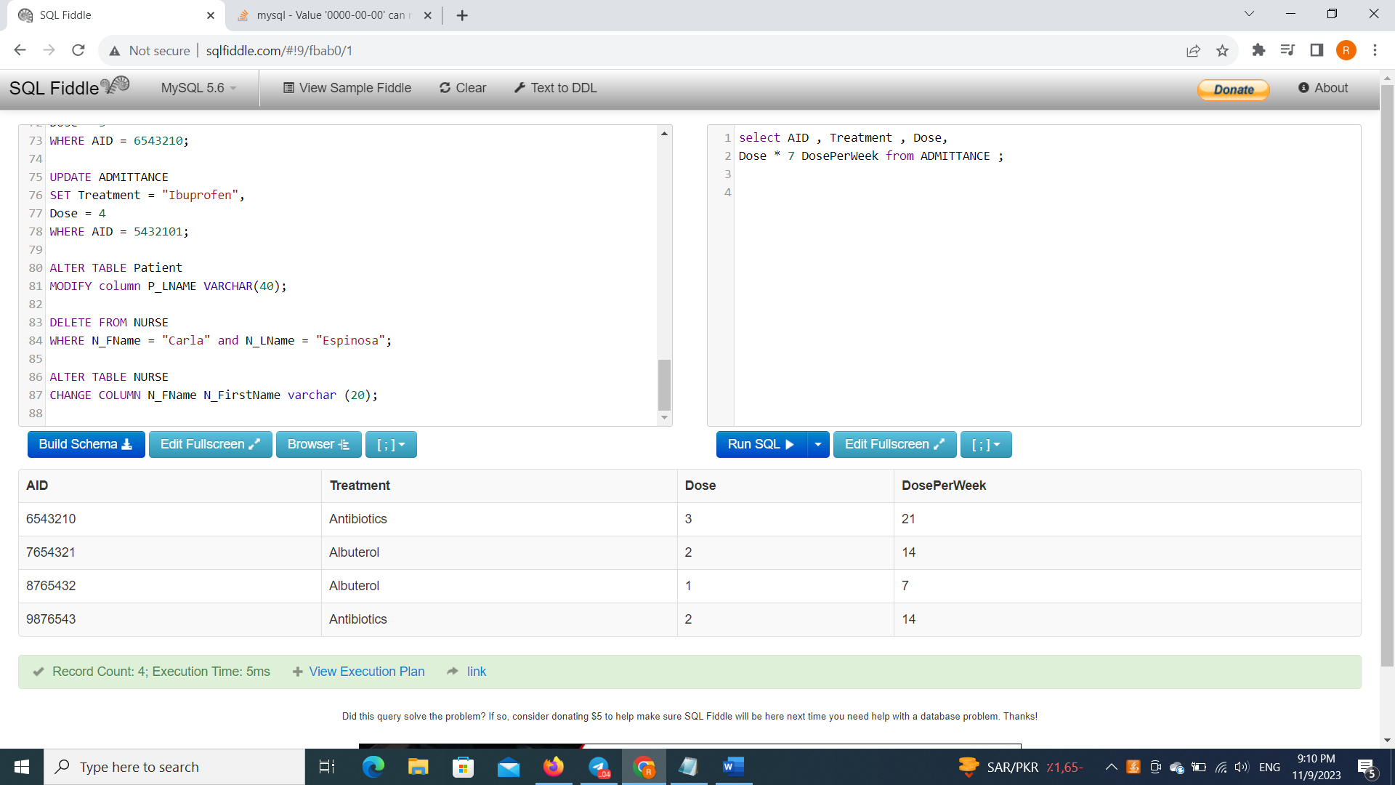

Q7. Show the name and the count of treatments for all treatments arranged alphabetically.

select Treatment , COUNT(Treatment)

FROM ADMITTANCE

GROUP BY Treatment

Order by Treatment ;

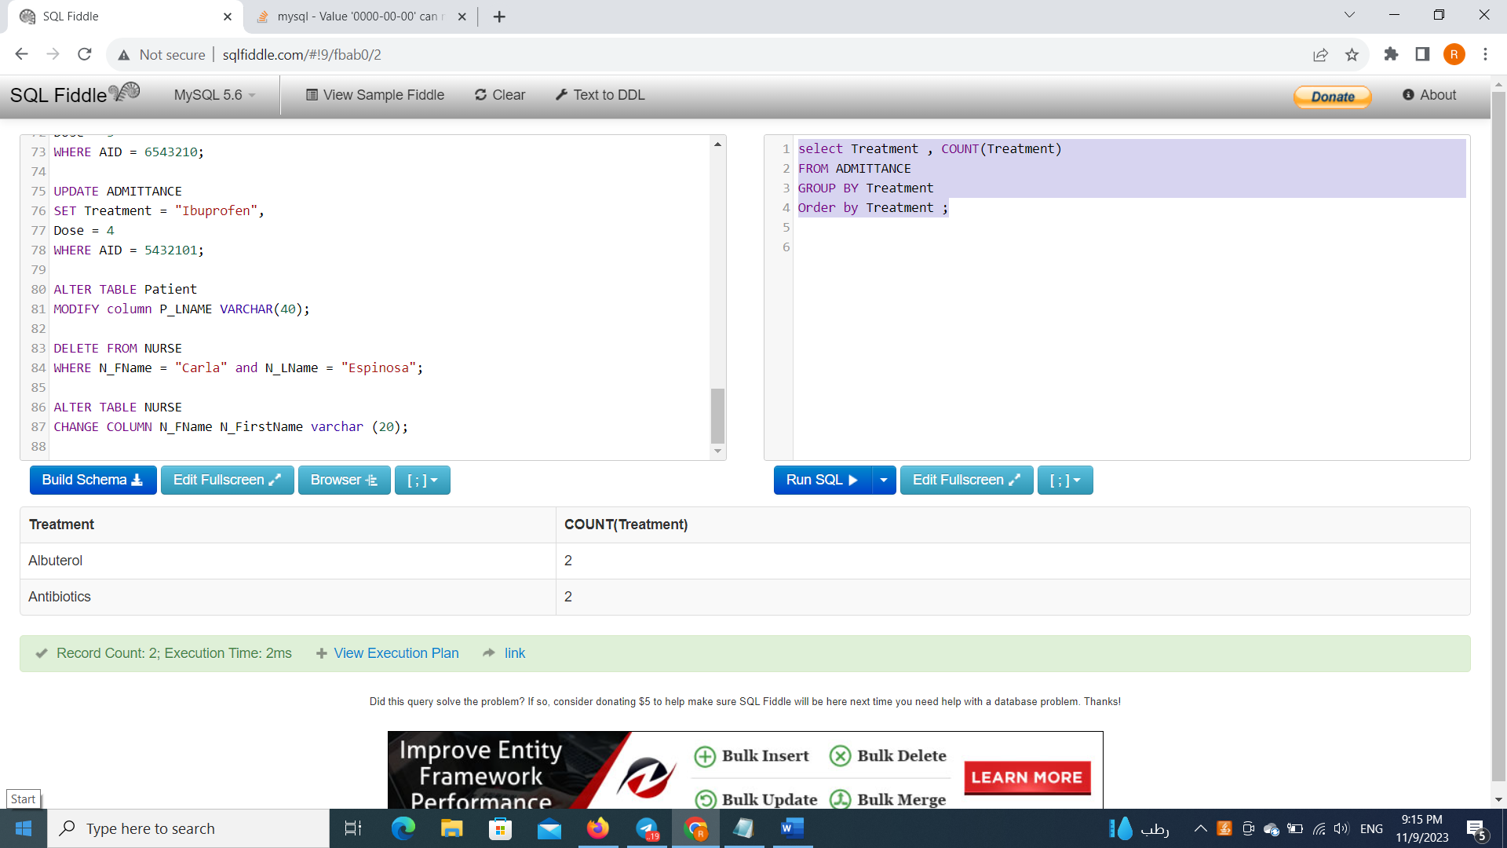

Q8. Write commands to remove all records from all tables but keeping the tables. Also, write

commands to delete all tables.

DELETE FROM NURSE;

DELETE FROM Patient;

DELETE FROM ADMITTANCE;

DROP TABLE ADMITTANCE;

DROP TABLE NURSE;

DROP TABLE Patient;

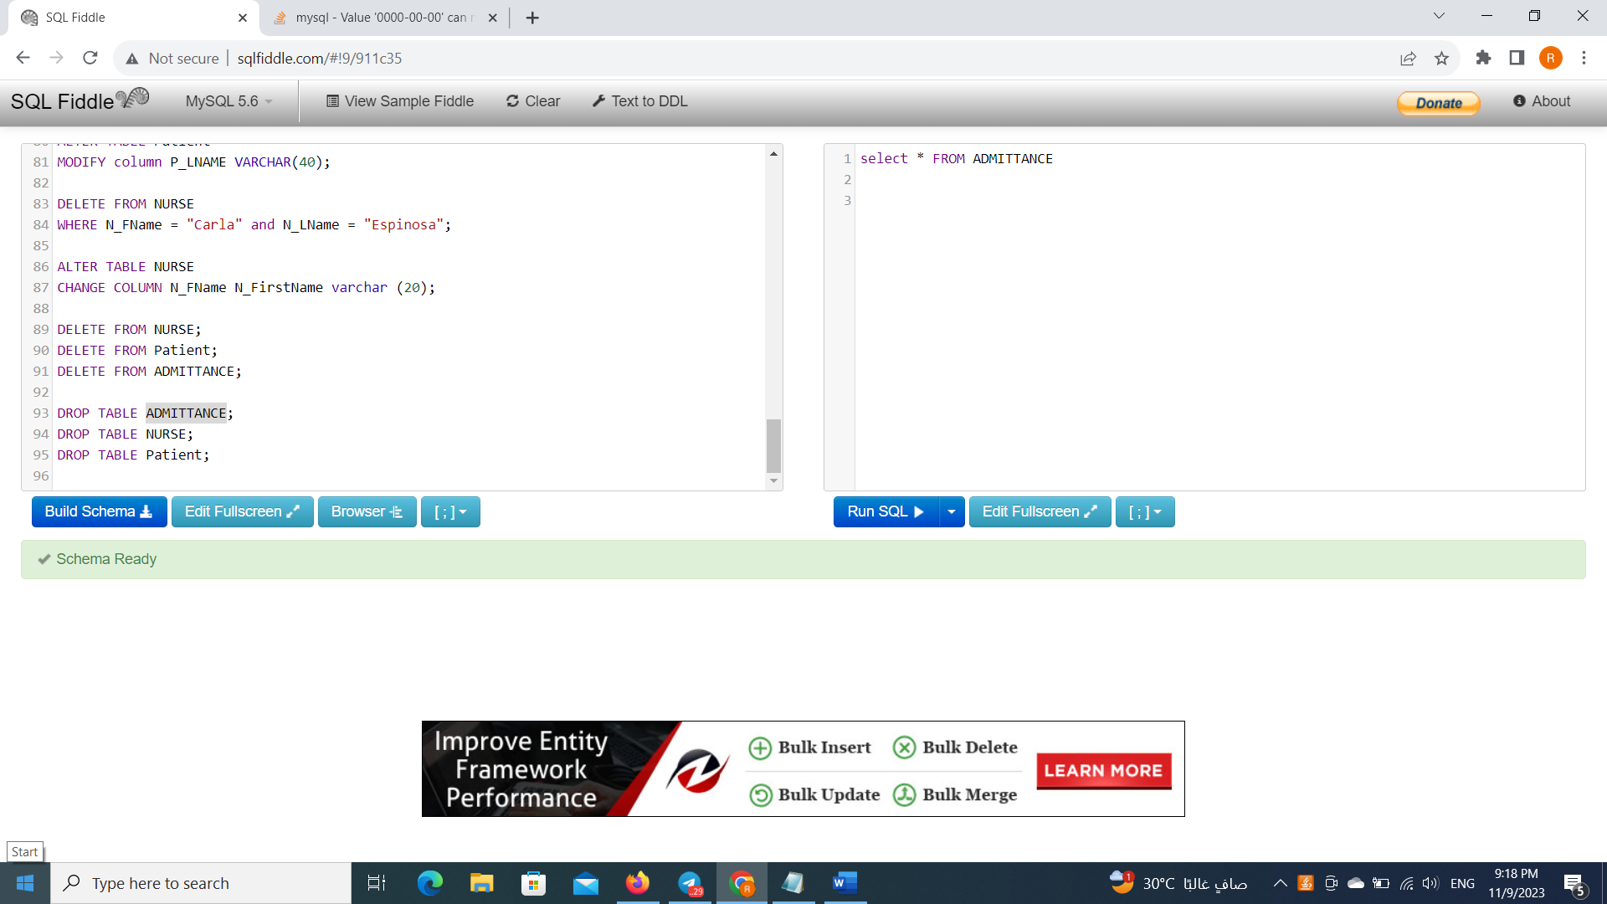

To make sure that we deleted all information we are going to peasant one of the tables using select statement.

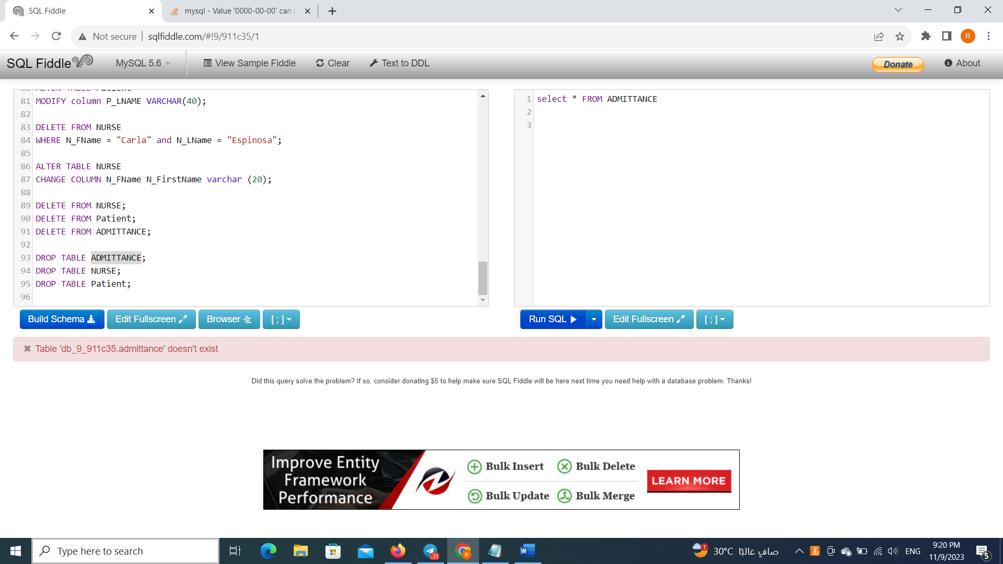

The full code :

CREATE TABLE Patient(

PID VARCHAR (6) NOT NULL,

P_FNAME VARCHAR (20) NOT NULL,

P_LNAME VARCHAR (30) NOT NULL,

CONSTRAINT PID_PK PRIMARY KEY (PID)

);

CREATE TABLE NURSE(

NID INTEGER NOT NULL,

N_FNAME VARCHAR(20) NOT NULL,

N_LNAME VARCHAR(30) NOT NULL,

CONSTRAINT NID_PK PRIMARY KEY (NID)

);

CREATE TABLE ADMITTANCE (

AID INTEGER NOT NULL,

Date DATE NOT NULL,

ALIMENT VARCHAR (30) NOT NULL,

PID VARCHAR (6) NOT NULL,

NID INTEGER NOT NULL,

CONSTRAINT AID_PK PRIMARY KEY (AID),

CONSTRAINT PID_FK FOREIGN KEY (PID) REFERENCES Patient

(PID) ON DELETE CASCADE,

CONSTRAINT NID_FK FOREIGN KEY (NID) REFERENCES NURSE

(NID) ON DELETE CASCADE

);

INSERT INTO PATIENT

(PID, P_FNAME, P_LNAME) VALUES

("123A45", "Chris", "Jackson"),

("234B56", "Tony", "Mack"),

("345C67", "Katniss", "Everdeen"),

("456D78", "Sookie", "Stackhouse"),

("567E89", "Alice", "Wonderland");

INSERT INTO NURSE

(NID, N_FNAME, N_LNAME) VALUES

(2014211, "Jackie", "Peyton"),

(2014308, "Annie", "Wilkes"),

(2014309, "Carla", "Espinosa"),

(2014322, "Amelia", "Earhart"),

(2014206, "Johnnie", "Carson");

INSERT INTO ADMITTANCE VALUES

(9876543, '2014-05-01', "Head Wound", "123A45", 2014206),

(8765432, '2014-05-01', "Laceration", "567E89", 2014211),

(7654321, '2014-05-13', "Laceration", "345C67", 2014211),

(6543210, '2014-09-07', "Heart Attack ","123A45", 2014308),

(5432101, '2014-07-22', "Head Wound", "456D78", 2014309);

--------------------------------------------------------------------------------------------------------------------------------

ALTER TABLE ADMITTANCE

ADD Treatment VARCHAR (30) NOT NULL DEFAULT " Pending",

ADD Dose INTEGER NOT NULL ;

----------------------------------------------------------------------------------------------------------------------------

UPDATE ADMITTANCE

SET Treatment = "Antibiotics",

Dose = 2

WHERE AID = 9876543;

UPDATE ADMITTANCE

SET Treatment = "Albuterol",

Dose = 1

WHERE AID = 8765432;

UPDATE ADMITTANCE

SET Treatment = "Albuterol",

Dose = 2

WHERE AID = 7654321;

UPDATE ADMITTANCE

SET Treatment = "Antibiotics",

Dose = 3

WHERE AID = 6543210;

UPDATE ADMITTANCE

SET Treatment = "Ibuprofen",

Dose = 4

WHERE AID = 5432101;

------------------------------------------------------------------------------------------------------------------------------

ALTER TABLE Patient

MODIFY column P_LNAME VARCHAR(40);

-------------------------------------------------------------------------------------------------------------------------

DELETE FROM NURSE

WHERE N_FName = "Carla" and N_LName = "Espinosa";

-----------------------------------------------------------------------------------------------------------------------------

ALTER TABLE NURSE

CHANGE COLUMN N_FName N_FirstName varchar (20);

--------------------------------------------------------------------------------------------------------

------Queries-------------------------------

SELECT * from ADMITTANCE

Order by AID DESC;

--------------------------------------

select AID , Treatment , Dose,

Dose * 7 DosePerWeek from ADMITTANCE ;

select Treatment , COUNT(Treatment)

FROM ADMITTANCE

GROUP BY Treatment

Order by Treatment ;

--------------------------------------------------------------------------------------------------------------

DELETE FROM NURSE;

DELETE FROM Patient;

DELETE FROM ADMITTANCE;

-----------------------------------------------------------------------------------------

DROP TABLE ADMITTANCE;

DROP TABLE NURSE;

DROP TABLE Patient;