**Report about best devices & OS & programming languages & database and applications.**

**System Name: TasksMS**

1. **Devices**

**Desktop: Windows, Mac, Linux**

**Phone: Android, IOS**

**Tablet: Android, Ipads**

**Reason: Ensuring wider accessibility across multiple platforms**

1. **Operating Systems**

**Desktop: Windows 10/11, Mac Ventura or newer All linux distributions including Debian, Arch, Ubuntu.**

**Phone: Android 9 or newer, IOS 15 or above**

**Tablet: Andriod 9 or newer, IpadOS 18 or older**

**Reason: These are the most common OSs and it’s considered because of reach to many people as possible.**

1. **Programming Language**

**Backend: C#**

**Frontend: HTML, CSS, Bootstrap**

**Reason: These languages provides flexibility and high performance and customization flexibility**

1. **Database**

**Microsoft SQL Server**

Reason: As a relational database it provides high performance and flexibility in Tasks Management Systems

1. **Applications**

**Framework: ASP.Net (MVC) Core (C#) technology**

**IDE: Visual Studio 2022 professional**

**Reason: These technologies are strong with a high support**

**From their company (Microsoft) also because they provide high performance and flexibility in programming.**

**Design of an integrated system (Class diagram)**

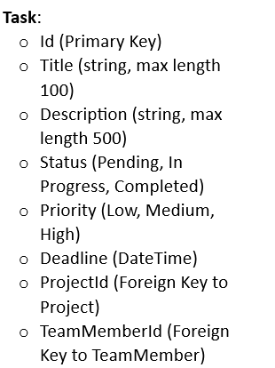

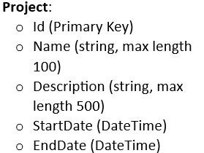

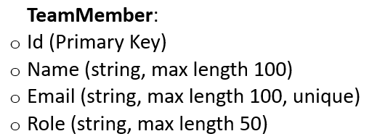

**Testing**

|  |  |  |  |  |  |  |
| --- | --- | --- | --- | --- | --- | --- |
| **Test case ID** | **Test case description** | **Test Steps** | **Test Data** | **Expected Result** | **Actual Result** | **Pass/Fail** |
| 1 | Adding Project with all data null | Set all the project inputs by null | Project Name,description,start and end date == null | To show error | It shows error | Pass |
| 2 | Editing Project with all data null | Open edit and  Set all the project inputs by null | Project Name,description,start and end date == null | To show error | It shows error | Pass |
| 3 | Edit a task status by null | Set the Task status by null | Task status==null | To show error | It shows error | Pass |
| 4 | Delete a project | Click on delete to delete project |  | To Delete project | Project  deleted | Pass |
| 5 | Open member profile | Click on profile button |  | To show all its information | All member info showed | Pass |
| 6 | Edit a Team Member data | Click on edit and edit the name | Set name from jana to Jana Amr | To edit the data | The data Edited | Pass |