Test case 1

Result: The text box is highlighted in red and there is a validation message which says ‘Please enter an integer’. This is an expected behavior and therefore not a bug.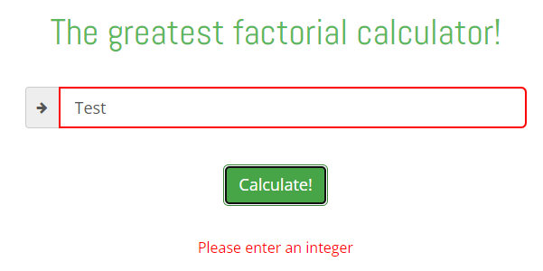

Test case 2

Result: The text box is highlighted in red and there is a validation message which says ‘Please enter an integer’. This is an expected behavior and therefore not a bug.Graphical user interface, text, application, chat or text message

Test case 3

Result: The text box is highlighted in red and there is a validation message which says ‘Please enter an integer’. This is an expected behavior and therefore not a bug.Graphical user interface, text, application, chat or text message

Test case 4

Result: This test case doesn’t get validated at all and should be treated as a bug.

Example 1: The text box is not highlighted in red and there is a validation message which says ‘Please enter an integer’. This happens if this test case is executed after some other test case which produces an error validation message.Graphical user interface, text, application, chat or text message, email

Example 2: The text box is not highlighted in red and there is no validation message which says ‘Please enter an integer’. This happens if this test case is executed after some other test case which produces a successful result of some other factorial.Graphical user interface, text, application, chat or text message

Example 3: The text box is not highlighted in red and there is no message whatsoever. This happens if this test case is executed at first after accessing the page, before any other test case.Graphical user interface, text, application, chat or text message

The call for the Test case 4 produces a 500 internal server error.

Test case 5

Result: The text box is highlighted in red and there is a validation message which says ‘Please enter an integer’. This is an expected behavior and therefore not a bug.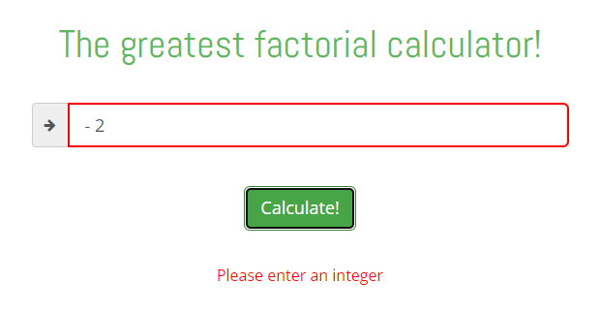

Test case 6

Result: The text box is not highlighted in red and there is no validation message which says ‘Please enter an integer’. This is an expected behavior and therefore not a bug.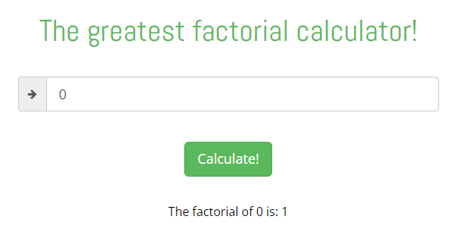

Test case 7

Result: The text box is not highlighted in red and there is no validation message which says ‘Please enter an integer’. Since the zero can be both positive and negative this is an expected behavior and therefore not a bug.Graphical user interface, text, application, chat or text message

Test case 8

Result: The text box is highlighted in red and there is a validation message which says ‘Please enter an integer’. This is an expected behavior and therefore not a bug.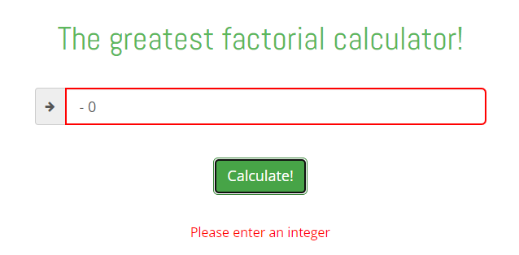

Test case 9

Result: The text box is not highlighted in red and there is no validation message which says ‘Please enter an integer’. This is an expected behavior and therefore not a bug.Graphical user interface, text, application, chat or text message, email

Test case 10

Result: The text box is highlighted in red and there is a validation message which says ‘Please enter an integer’. This is an expected behavior and therefore not a bug.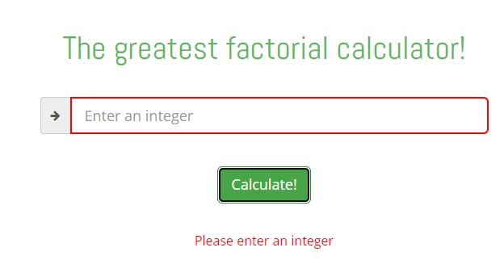

From the ten test cases mentioned above only one is a bug (Test case 4) and the other test cases are working fine.

Additional potential bug regarding a typo. The tab title says ‘Factoriall’, but the word Factorial is with one letter l everywhere.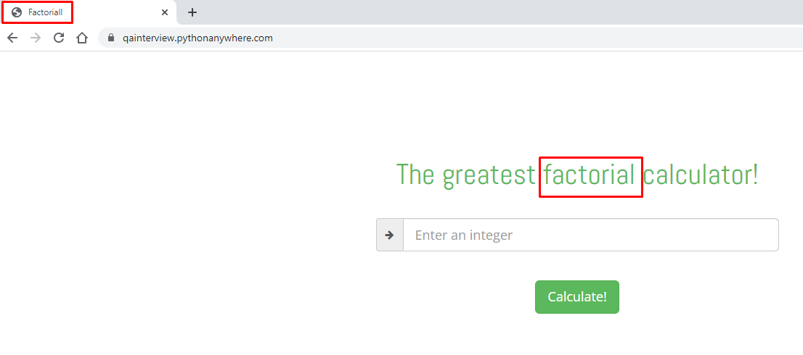

Another potential duplicate bug. The year in the copyright message is written twice, even though it has the same value (2022).



Test case 11

Result: Clicking the Terms and Conditions hyperlink redirects the user to the following link which displays the following message.



The link and the message should be for the Privacy hyperlink.

Test case 12

Result: Clicking the Privacy hyperlink redirects the user to the following link which displays the following message.



The link and the message should be for the Terms and Conditions hyperlink.

Conclusion for Test cases 11 and 12: The Terms and Conditions hyperlink is redirecting the user to the URL and message for the Privacy hyperlink and vice versa.

Test case 13

Result: Clicking the Qxf2 Services hyperlink redirects the user to the following link.

.

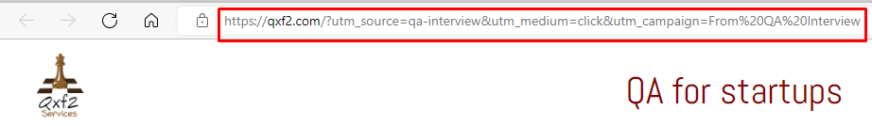

If the user clicks on the homepage hyperlink she/he is redirected to the same homepage, but without the additional characters, strings and integers after the .com part of the URL.

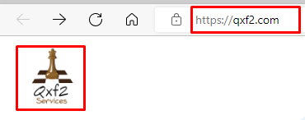

Conclusion for Test case 13: This second URL should appear if the user accesses the Qxf2 website from the Factorial calculator webpage, and not the one with all the additional parts after the .com.