Starting Points - All Floor Entrances QR Codes (Testing)
Campus Guide - All configured starting locations across all floors

Main Entrance (Ground Floor)
Main Entrance - Ground Floor
Room ID: GF_MAIN_ENTRANCE
Floor: Ground Floor (index 0)
Coordinates: x=0.468, y=0.950

QR Code Data:
{"type": "campus_guide_starting_point", "building": "MAIN_BUILDING", "floor": 0, "location_id": "GF_MAIN_ENTRANCE"}

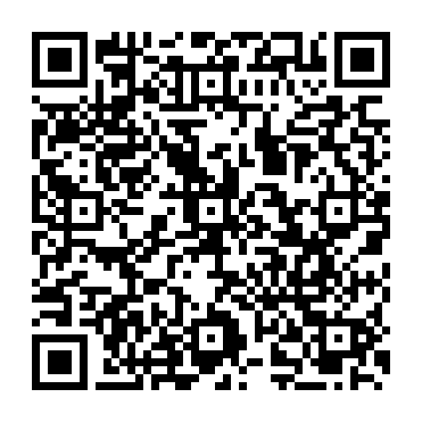

Lobby Left Staircase (Ground Floor)
Lobby Left Staircase - Ground Floor
Room ID: GF_LOBBY_LEFT_STAIRCASE
Floor: Ground Floor (index 0)
Coordinates: x=0.435, y=0.560

QR Code Data:
{"type": "campus_guide_starting_point", "building": "MAIN_BUILDING", "floor": 0, "location_id": "GF_LOBBY_LEFT_STAIRCASE"}

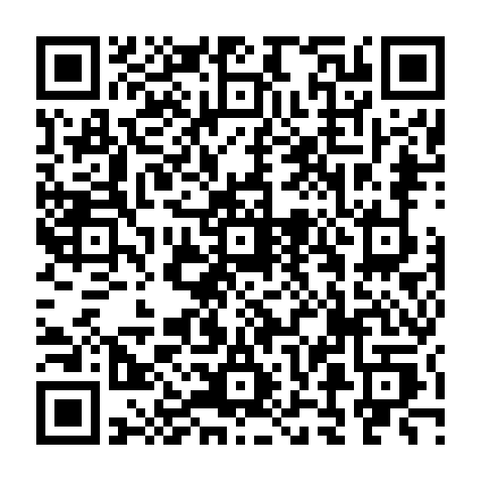

Lobby Right Staircase (Ground Floor)
Lobby Right Staircase - Ground Floor
Room ID: GF_LOBBY_RIGHT_STAIRCASE
Floor: Ground Floor (index 0)
Coordinates: x=0.565, y=0.560

QR Code Data:
{"type": "campus_guide_starting_point", "building": "MAIN_BUILDING", "floor": 0, "location_id": "GF_LOBBY_RIGHT_STAIRCASE"}

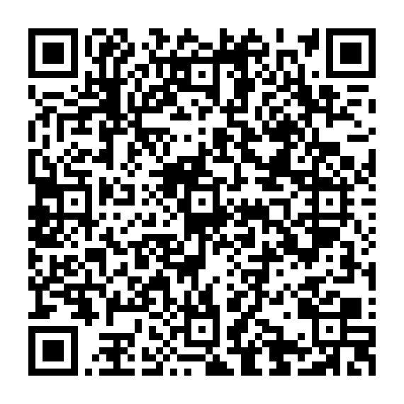

Left Wing Staircase (Ground Floor)
Left Wing Staircase - Ground Floor
Room ID: GF_LEFT_WING_STAIRCASE
Floor: Ground Floor (index 0)
Coordinates: x=0.095, y=0.130

QR Code Data:
{"type": "campus_guide_starting_point", "building": "MAIN_BUILDING", "floor": 0, "location_id": "GF_LEFT_WING_STAIRCASE"}

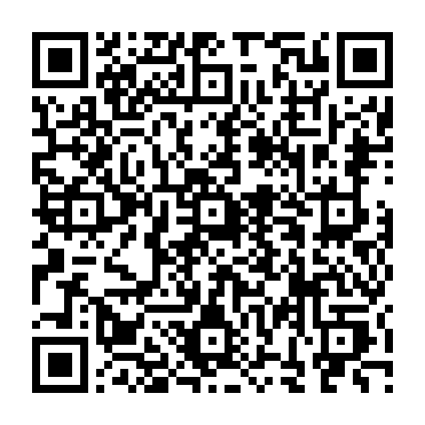

Right Wing Staircase (Ground Floor)
Right Wing Staircase - Ground Floor
Room ID: GF_RIGHT_WING_STAIRCASE
Floor: Ground Floor (index 0)
Coordinates: x=0.895, y=0.075

QR Code Data:
{"type": "campus_guide_starting_point", "building": "MAIN_BUILDING", "floor": 0, "location_id": "GF_RIGHT_WING_STAIRCASE"}

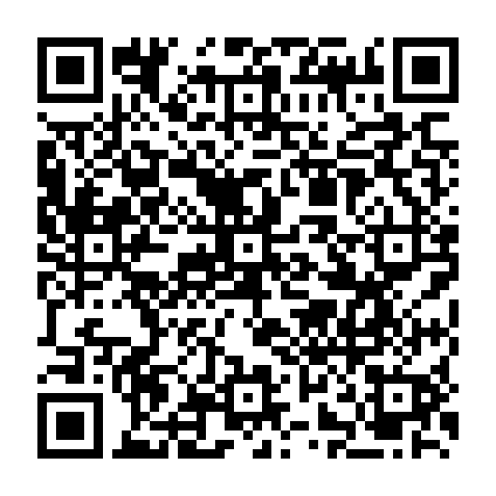

Left Side Door (Ground Floor)
Left Side Door - Ground Floor
Room ID: GF_LEFT_SIDE_DOOR
Floor: Ground Floor (index 0)
Coordinates: x=0.065, y=0.370

QR Code Data:
{"type": "campus_guide_starting_point", "building": "MAIN_BUILDING", "floor": 0, "location_id": "GF_LEFT_SIDE_DOOR"}

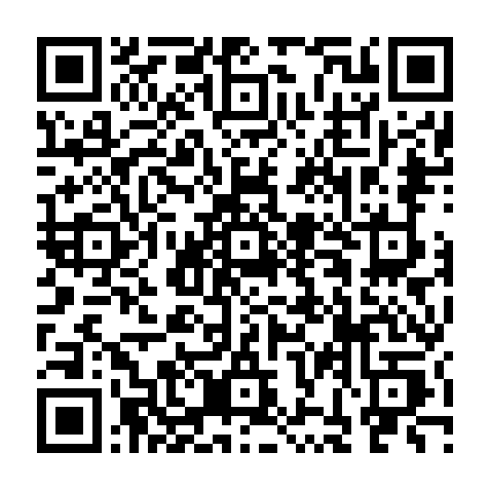

Right Side Door (Ground Floor)
Right Side Door - Ground Floor
Room ID: GF_RIGHT_SIDE_DOOR
Floor: Ground Floor (index 0)
Coordinates: x=0.960, y=0.370

QR Code Data:
{"type": "campus_guide_starting_point", "building": "MAIN_BUILDING", "floor": 0, "location_id": "GF_RIGHT_SIDE_DOOR"}

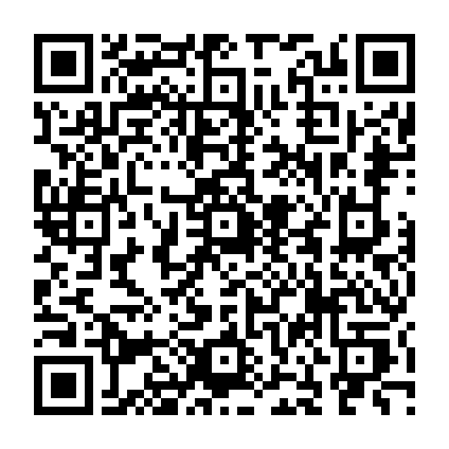

Computer Laboratory (2nd Floor)
Biggest Computer Lab - 2nd Floor
Room ID: sf_computer_lab
Floor: 2nd Floor (index 1)
Coordinates: x=0.185, y=0.320

QR Code Data:
{"type": "campus_guide_starting_point", "building": "MAIN_BUILDING", "floor": 1, "location_id": "sf_computer_lab"}

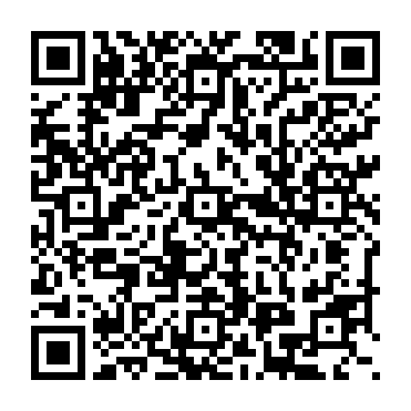

Upper Left / SHS Lobby (2nd Floor)
Upper Left / SHS Lobby - 2nd Floor
Room ID: 2F_START_01
Floor: 2nd Floor (index 1)
Coordinates: x=0.08470, y=0.23056

QR Code Data:
{"type": "campus_guide_starting_point", "building": "MAIN_BUILDING", "floor": 1, "location_id": "2F_START_01"}

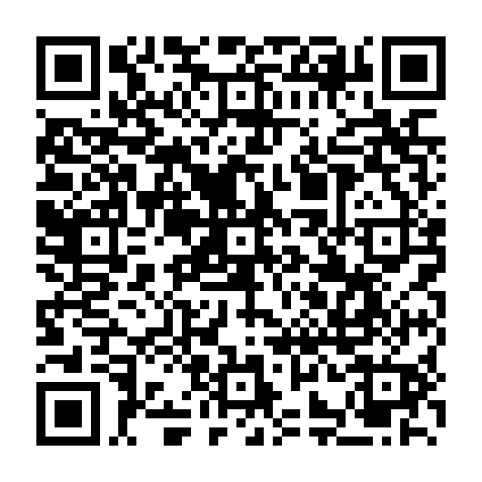

Upper Right / Sub-Lobby (2nd Floor)
Upper Right / Sub-Lobby - 2nd Floor
Room ID: 2F_START_02
Floor: 2nd Floor (index 1)
Coordinates: x=0.92145, y=0.23056

QR Code Data:
{"type": "campus_guide_starting_point", "building": "MAIN_BUILDING", "floor": 1, "location_id": "2F_START_02"}

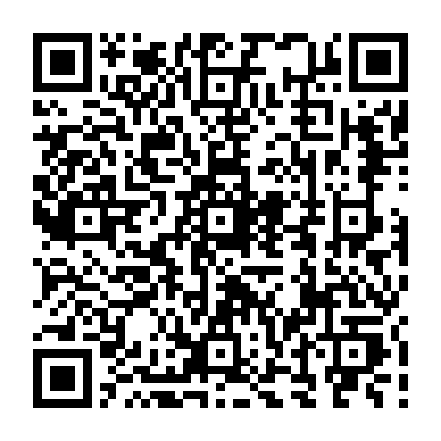

Lower Left Staircase (2nd Floor)
Lower Left Staircase - 2nd Floor
Room ID: 2F_START_03
Floor: 2nd Floor (index 1)
Coordinates: x=0.07582, y=0.39583

QR Code Data:
{"type": "campus_guide_starting_point", "building": "MAIN_BUILDING", "floor": 1, "location_id": "2F_START_03"}

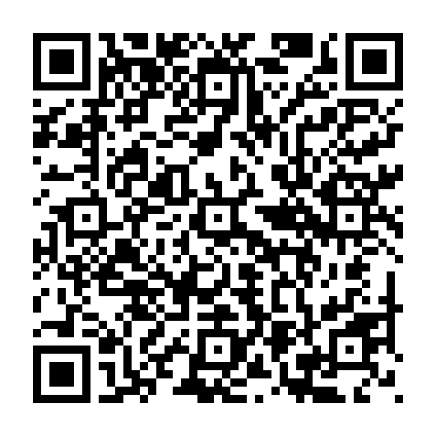

Lower Right Staircase (2nd Floor)
Lower Right Staircase - 2nd Floor
Room ID: 2F_START_04
Floor: 2nd Floor (index 1)
Coordinates: x=0.92896, y=0.39444

QR Code Data:
{"type": "campus_guide_starting_point", "building": "MAIN_BUILDING", "floor": 1, "location_id": "2F_START_04"}

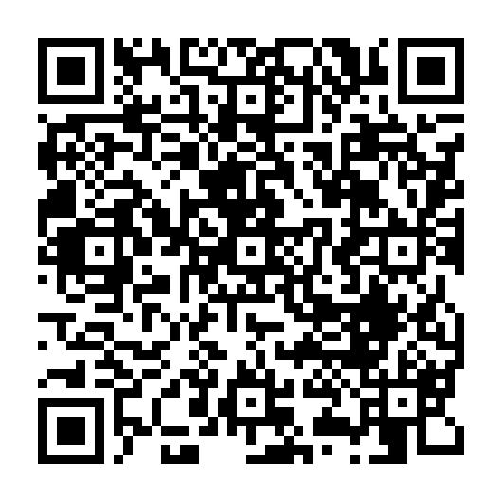

Central Staircase (2nd Floor)
Central Staircase - 2nd Floor
Room ID: 2F_START_05
Floor: 2nd Floor (index 1)
Coordinates: x=0.49029, y=0.52083

QR Code Data:
{"type": "campus_guide_starting_point", "building": "MAIN_BUILDING", "floor": 1, "location_id": "2F_START_05"}

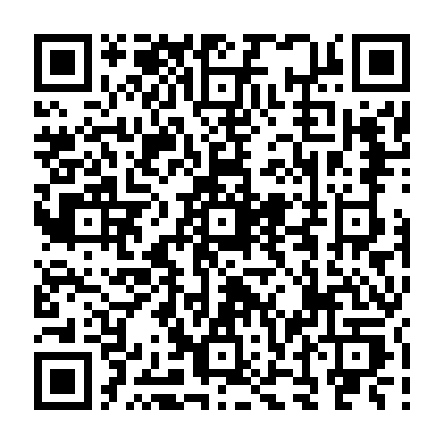

Left Staircase (3rd Floor)
Left Staircase - 3rd Floor
Room ID: TF_LEFT_STAIRCASE
Floor: 3rd Floor (index 2)
Coordinates: x=0.065, y=0.420

QR Code Data:
{"type": "campus_guide_starting_point", "building": "MAIN_BUILDING", "floor": 2, "location_id": "TF_LEFT_STAIRCASE"}

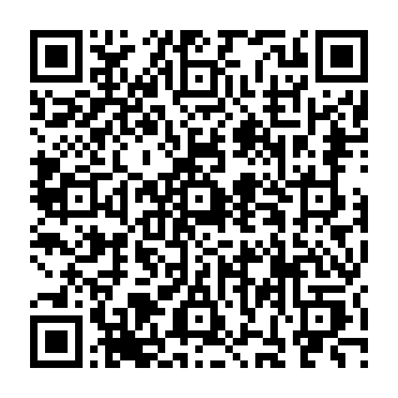

Elevator (3rd Floor)
Elevator - 3rd Floor
Room ID: TF_ELEVATOR
Floor: 3rd Floor (index 2)
Coordinates: x=0.490, y=0.300

QR Code Data:
{"type": "campus_guide_starting_point", "building": "MAIN_BUILDING", "floor": 2, "location_id": "TF_ELEVATOR"}

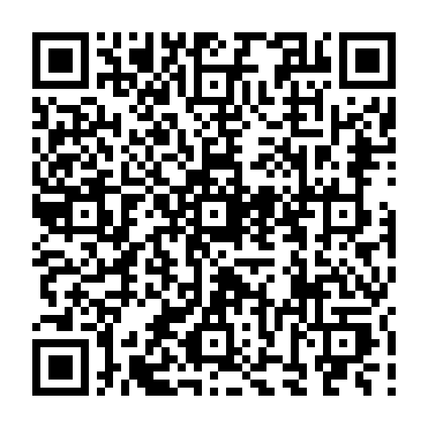

Right Staircase (3rd Floor)
Right Staircase - 3rd Floor
Room ID: TF_RIGHT_STAIRCASE
Floor: 3rd Floor (index 2)
Coordinates: x=0.960, y=0.420

QR Code Data:
{"type": "campus_guide_starting_point", "building": "MAIN_BUILDING", "floor": 2, "location_id": "TF_RIGHT_STAIRCASE"}

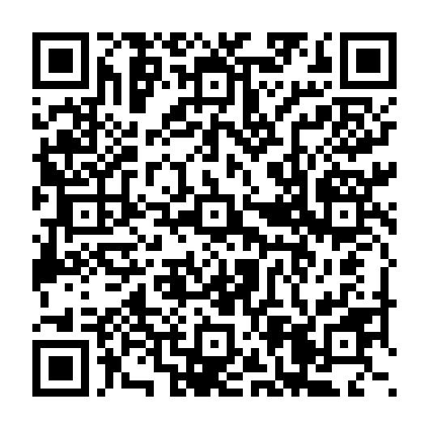

Top Left Staircase (3rd Floor)
Top Left Staircase - 3rd Floor
Room ID: TF_TOP_LEFT_STAIRCASE
Floor: 3rd Floor (index 2)
Coordinates: x=0.380, y=0.080

QR Code Data:
{"type": "campus_guide_starting_point", "building": "MAIN_BUILDING", "floor": 2, "location_id": "TF_TOP_LEFT_STAIRCASE"}

