实 验 报 告
班级学号 | 202015116 |  | 姓名 | 梁祺若 | 实验日期 | 2021.9.22 | 班级排序号 | 19
实验名称 |  | 实验一、顺序表

1、根据文档写一个顺序表。写好顺序表后，运行如下测试代码，若结果与答案一致，则顺序表正确。
0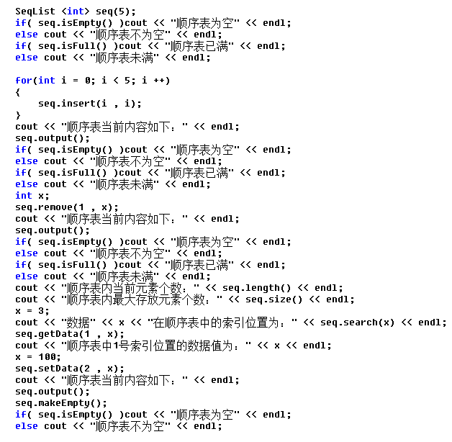

运行结果如下：
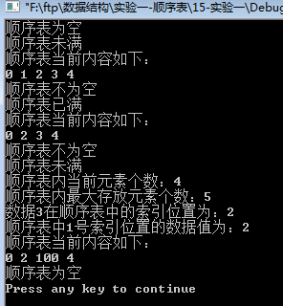

请给出顺序表源码：

SeqList <int> seq(5);

template <class T>
SeqList<T>::Seq0List(int max)
{
this ->array = new T[max];
if(array == NULL)
{
cerr << "储存分配错误！"<< endl;
exit(1);
}
this ->max = max;
this ->last = -1;
}

template <class T>
SeqList<T>::SeqList(SeqList & L)
{
this ->max = L.max;
this ->last = L.last;
this ->array = new T[max];
if(array == NULL)
{
cerr << "储存分配错误！"<< endl;
exit(1);
}
for(int i = 0; i <= last; i++)
{
this ->array[i] = L.array[i];
}
}

template <class T>
SeqList<T>::~SeqList()
{
delete [] this ->array;
}

template <class T>
int SeqList<T>::size()const
{
return seq.max;
}

template <class T>
int SeqList<T>::length()const
{
return last+1;
}

template <class T>
int SeqList<T>::search(T& x)const
{
for(int i = 0; i <= last; i++)
if(array[i] == x)
return i ;
return 0;
}

template <class T>
bool SeqList<T>::getData(int i,T &x)const
{
if(i >=0&& i <= last+1) {
x = array[i ];
return true;
}
else return false;
}

template <class T>
void SeqList<T>::output()
{
for(int i = 0; i <= last; i++)
{
cout << array[i] << " ";
}
cout << endl;
}

template <class T>
bool SeqList<T>::insert(T & num , int position)
{
if(last == max - 1)return false;
if(position < 0 || position > last + 1)return false;
for(int i = last; i >= position; i--)
{
array[i + 1] = array[i];
}
array[position] = num;
last ++;
return true;
}

template <class T>
bool SeqList<T>::remove(int position , T &x)
{
if(last == -1)return false;
if(position < 0 || position > last)return false;
x = array[position];
for(int i = position; i < last; i++)
{
array[i] = array[i + 1];
}
last --;
return true;
}

template <class T>
bool SeqList<T>::isFull()
{
return seq.last == seq.max;
}

template <class T>
bool SeqList<T>::isEmpty()
{
return seq.last == 0;
}
0
template <class T>
void SeqList<T>::makeEmpty()
{
seq.last = 0;
}

template<class T>
void SeqList<T>::setData(int i,T & x){
if(i< 0 || i> last)
return;
array[i] = x;
}
