**Reversing radar**

**Software design document**

|  |  |  |
| --- | --- | --- |
| Authors: | Kirsi Oikarinen and Maija Prove | |
|  |  | |
|  |  |  |
|  |  |  |
| Date: | 5/2017 |  |

**Content**

1 Introduction

2 Data flow diagrams

3 Functionality

4 Possible improvments in the future

1. Introduction

The project’ s goal was to make reversing radar and it was decided to use Arduino Uno R3 for this purposes. Suitable code for Arduino is possible to do by using Arduino open source software.

In this project it was needed to also use some libraries related to I2C-component. I2C is used connection between LCD and Arduino. Also Ultrasonic sensor was needed special library which was included in to code.

2. Data flow diagrams

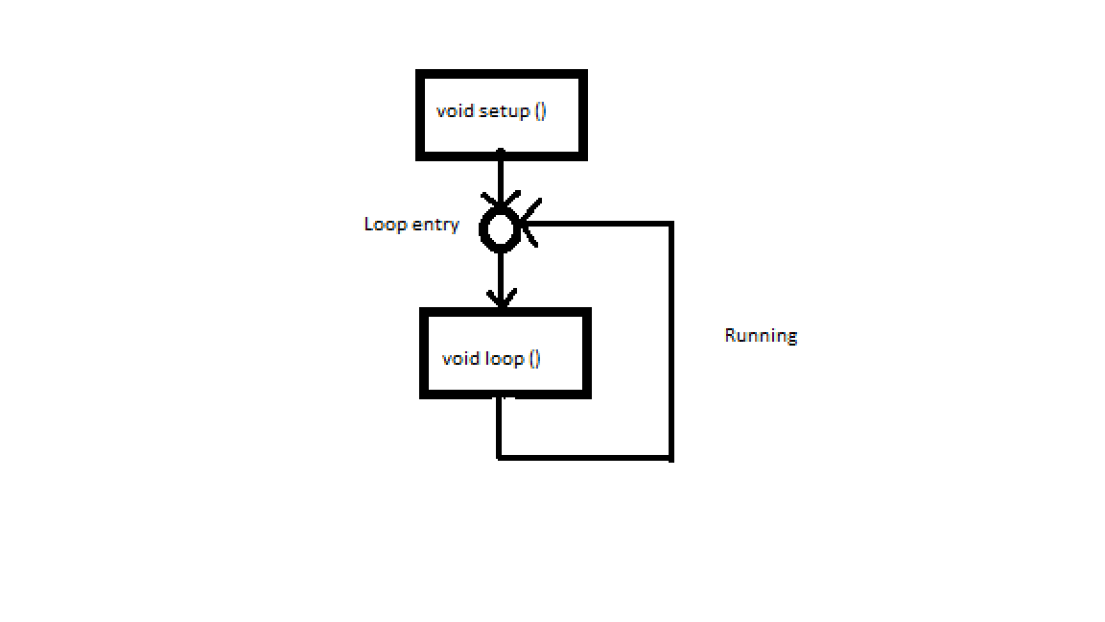**Figure1. Reversing Radar**

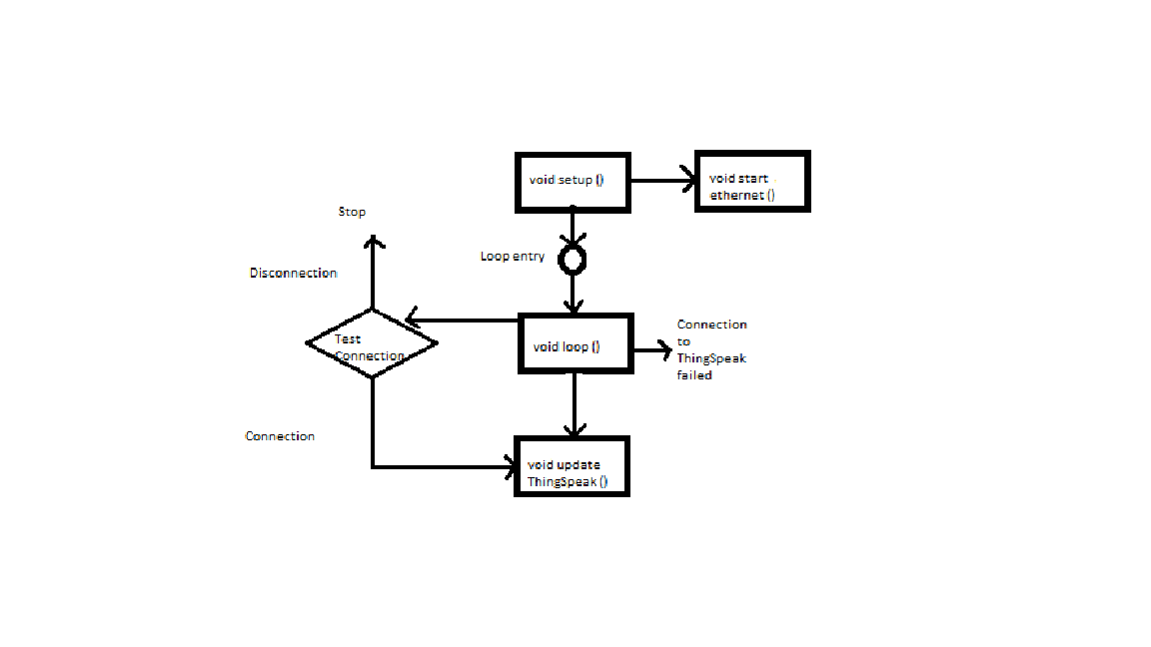

**Figure2.Connection to ThingSpeak**

3. Functionality

Distance from possible obstacles is possible to read from LCD (16x2). At the same time when the LCD is read, ultrasonic sensor is observating environment. Ultrasonic sensor will not work properly in area under 20cm or over 200cm. So, reversing radar is usefull in area 20cm-200cm.

Main component of the reversing radar is Arduino R3 and it is possible to connect to network. In this time, it is used ThingSpeak to verify connection between Arduino and network. Connection is searched and verified by following one pin.

4. Possible sofware improvments in the future

In the future it would good, if error messages from ”bad-area” **(**area under 20cm or over 200cm) would be displayed in LCD.