Nice work, you committed a Dockerfile. You'll notice at the end of the Dockerfile, we refer to an entrypoint script.

ENTRYPOINT ["/entrypoint.sh"]

The entrypoint.sh script will be run in Docker, and it will define what the action is really going to be doing.

## Step 2: Add an entrypoint script

An entrypoint script must exist in our repository so that Docker has something to execute.

### ⌨️ Activity: Add an entrypoint script and commit it to your branch

1. As a part of this branch and pull request, create a file in the /action-a/ directory titled entrypoint.sh. You can do so with [this quicklink](https://github.com/Kirsten29/hello-github-actions/new/Kirsten29-patch-1?filename=action-a/entrypoint.sh)
2. Add the following content to the entrypoint.sh file:
3. #!/bin/sh -l

sh -c "echo Hello world my name is $MY_NAME"

1. Stage and commit the changes
2. Push the changes to GitHub

Nice work adding the entrypoint.sh script.

In entrypoint.sh, all we're doing is outputting a "Hello world" message using an environment variable called MY_NAME.

Next, we'll define a **workflow** that uses the GitHub Action

### Workflow Files

Workflows are defined in special files in the .github/workflows directory, named main.yml.

Workflows can execute based on your chosen event. For this lab, we'll be using the [push](https://developer.github.com/v3/activity/events/types/#pushevent) event.

We'll break down each line of the workflow in the next step.

## Step 3: Start your workflow file

First, we'll add the structure of the workflow.

### ⌨️ Activity: Name and trigger your workflow

1. Create a file titled .github/workflows/main.yml. You can do so [using this quicklink](https://github.com/Kirsten29/hello-github-actions/new/Kirsten29-patch-1?filename=.github/workflows/main.yml) or manually:
   * As a part of this branch and pull request, create a workflows directory nested inside the .github directory.
   * In the new .github/workflows/ directory, create a file titled main.yml
2. Add the following content to the main.yml file:
3. name: A workflow for my Hello World file

on: push

1. Stage and commit the changes
2. Push the changes to GitHub

Nice work! 🎉 You added a workflow!

Here's what it means:

* name: A workflow for my Hello World file gives your workflow a name. This name appears on any pull request or in the Actions tab. The name is especially useful when there are multiple workflows in your repository.
* on: push indicates that your workflow will execute anytime code is pushed to your repository, using the [push](https://developer.github.com/v3/activity/events/types/#pushevent) event.

Next, we need to specify a job or jobs to run.

Let's add the expected action to the workflow.

**⌨️ Activity: Add an action block to your workflow file**

1. As a part of this branch and pull request, [edit .github/workflows/main.yml](https://github.com/Kirsten29/hello-github-actions/edit/Kirsten29-patch-1/.github/workflows/main.yml?pr=/Kirsten29/hello-github-actions/pull/2) to append the following content:
2. jobs:
3. build:
4. name: Hello world action
5. runs-on: ubuntu-latest
6. steps:
7. - uses: actions/checkout@v1
8. - uses: ./action-a
9. env:

MY_NAME: "Mona"

1. Click **Start commit** in the top right of the workflow editor
2. Type your commit message and commit your changes directly to your branch

Nice, you just added an action block to your workflow file! Here are some important details about *why* each part of the block exists and *what* each part does.

* jobs: is the base component of a workflow run
* build: is the identifier we're attaching to this job
* name: is the name of the job, this is displayed on GitHub when the workflow is running
* steps: the linear sequence of operations that make up a job
* uses: actions/checkout@v1 uses a community action called [checkout](https://github.com/actions/checkout) to allow the workflow to access the contents of the repository
* uses: ./action-a provides the relative path the action we've created in the action-a directory of the repository
* env: is used to specify the environment variables that will be available to your action in the runtime environment. In this case, the environment variable is MY_NAME, and it is currently initialized to "Mona".

**Your action has been triggered!**

Your repository now contains an action (defined in the /action-a/ folder) and a workflow (defined in the ./github/workflows/main.yml file).

This action will run any time a new commit is created or pushed to the remote repository. Since you just created a commit, the workflow should have been triggered. This might take a few minutes since it's the first time running in this repository.

**Seeing your Action in action**

The status of your action is shown here in the pull request (look for **All checks have passed** below), or you can click the "Actions" tab in your repository. From there you will see the actions that have run, and you can click on the action's "Log" link to view details.

[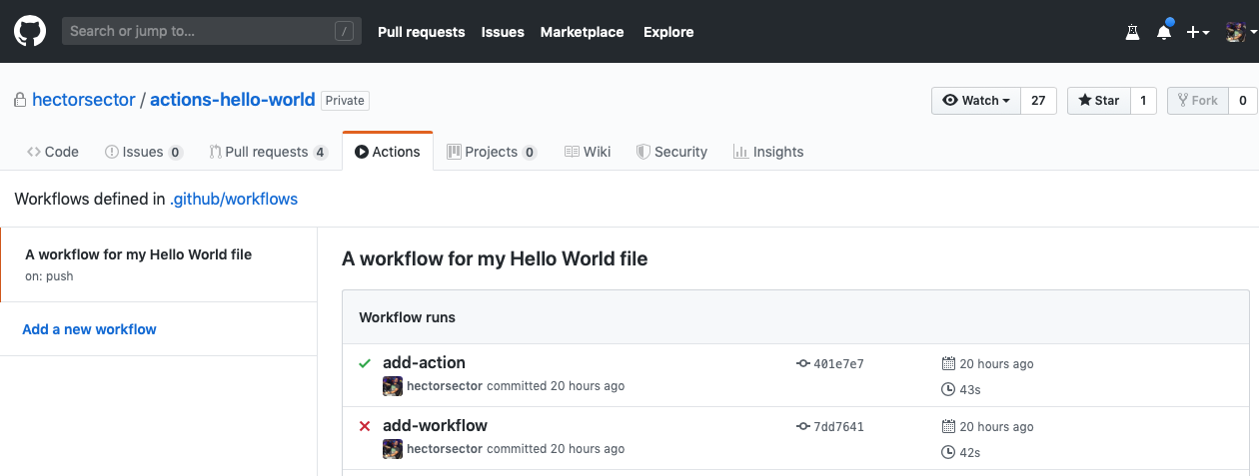](https://user-images.githubusercontent.com/16547949/62388049-4e64e600-b52a-11e9-8bf5-db0c5452360f.png)