SalesDesk POS System
Frontend Development
Product Requirements Document (PRD) & Build Plan
Version 1.0
Prepared: July 2026
Status: Active / In Development

Table of Contents
1. Document Overview
2. Purpose & Objectives
3. Scope
4. User Roles & Personas
5. System Architecture
6. Technology Stack
7. UI/UX Design Direction
8. Functional Requirements
9. Non-Functional Requirements
10. Data & API Integration Approach
11. Build Plan
12. Expected Deliverables
13. Risks & Assumptions
14. Success Metrics

1. Document Overview
Project | SalesDesk POS System — Frontend
Document Type | Product Requirements Document (PRD) + Build Plan
Owner | Frontend Attachee / Developer
Status | Active
Related System | SalesDesk POS — Spring Boot Backend (REST API)
Last Updated | July 2026

This document defines the product requirements, system design, and phased build plan for the frontend of the SalesDesk POS System. It is intended to guide development, review, and sign-off, and follows a standard software engineering PRD structure: purpose, scope, architecture, functional and non-functional requirements, UI/UX direction, and an execution roadmap.

2. Purpose & Objectives

2.1 Purpose
SalesDesk is a Point of Sale (POS) system for businesses to manage products, stock, sales, customers, and reporting. The frontend is the primary interface through which Administrators and Cashiers interact with the system. It must be fast, reliable on low-end hardware, and usable across web, installed PWA, and Electron desktop contexts, while remaining framework-free (HTML5, CSS3, vanilla JavaScript).

2.2 Objectives
- Provide a simple, intuitive user experience for daily POS operations.
- Communicate with backend REST APIs for all data operations.
- Display business information dynamically (no hard-coded data).
- Support desktop, tablet, and mobile devices from a single codebase.
- Maintain a consistent layout and design language across all pages.
- Handle authentication and role-based authorization end to end.
- Provide real-time feedback via notifications and loading indicators.

3. Scope

3.1 In Scope
- Multi-page application (MPA): independent HTML pages per feature, served from Spring Boot static resources.
- Administrator interface: Dashboard, Products, Stock, Services, Sales, Customers, Suppliers, Purchases, Expenses, Profit & Loss, Receivables, Cashiers, Stores, Reports, Notifications, Payment Channels, Subscriptions, Company Settings.
- Cashier interface: Dashboard, Point of Sale, My Sales, Hire Purchase, Customers, Notifications.
- Shared layout system (sidebar, top nav, footer, profile) injected via JavaScript.
- JWT-based authentication and role-based authorization/route guarding.
- Reusable API helper for all REST communication.
- Barcode scanning (hardware scanner, camera via ZXing, manual entry).
- Payment processing UI: Cash, M-Pesa (STK Push + polling), Credit sales.
- 80mm thermal receipt generation and printing.
- PWA support (manifest, service worker, offline fallback) and Electron desktop compatibility.

3.2 Out of Scope
- Backend/API implementation (Spring Boot services, database schema) — consumed, not built, by this workstream.
- Payment gateway settlement logic (handled server-side; frontend only initiates and displays status).
- Native iOS/Android applications.
- Use of frontend frameworks or build tooling (React, Angular, Vue, jQuery, Webpack, etc.).

4. User Roles & Personas
Role | Description & Primary Needs
Administrator | Owns business configuration: products, stock, pricing, staff, suppliers, purchases, expenses, reports, subscriptions, and store settings. Needs a full analytical and management view.
Cashier | Front-of-house operator focused on speed: searching/scanning products, building a cart, taking payment, printing receipts, and viewing their own sales history.

Access to each interface is enforced client-side via role checks and enforced authoritatively by the backend API on every request.

5. System Architecture
The frontend follows a layered, framework-free architecture designed to run identically across three delivery targets — browser, installed PWA, and Electron desktop — against a single Spring Boot REST backend.
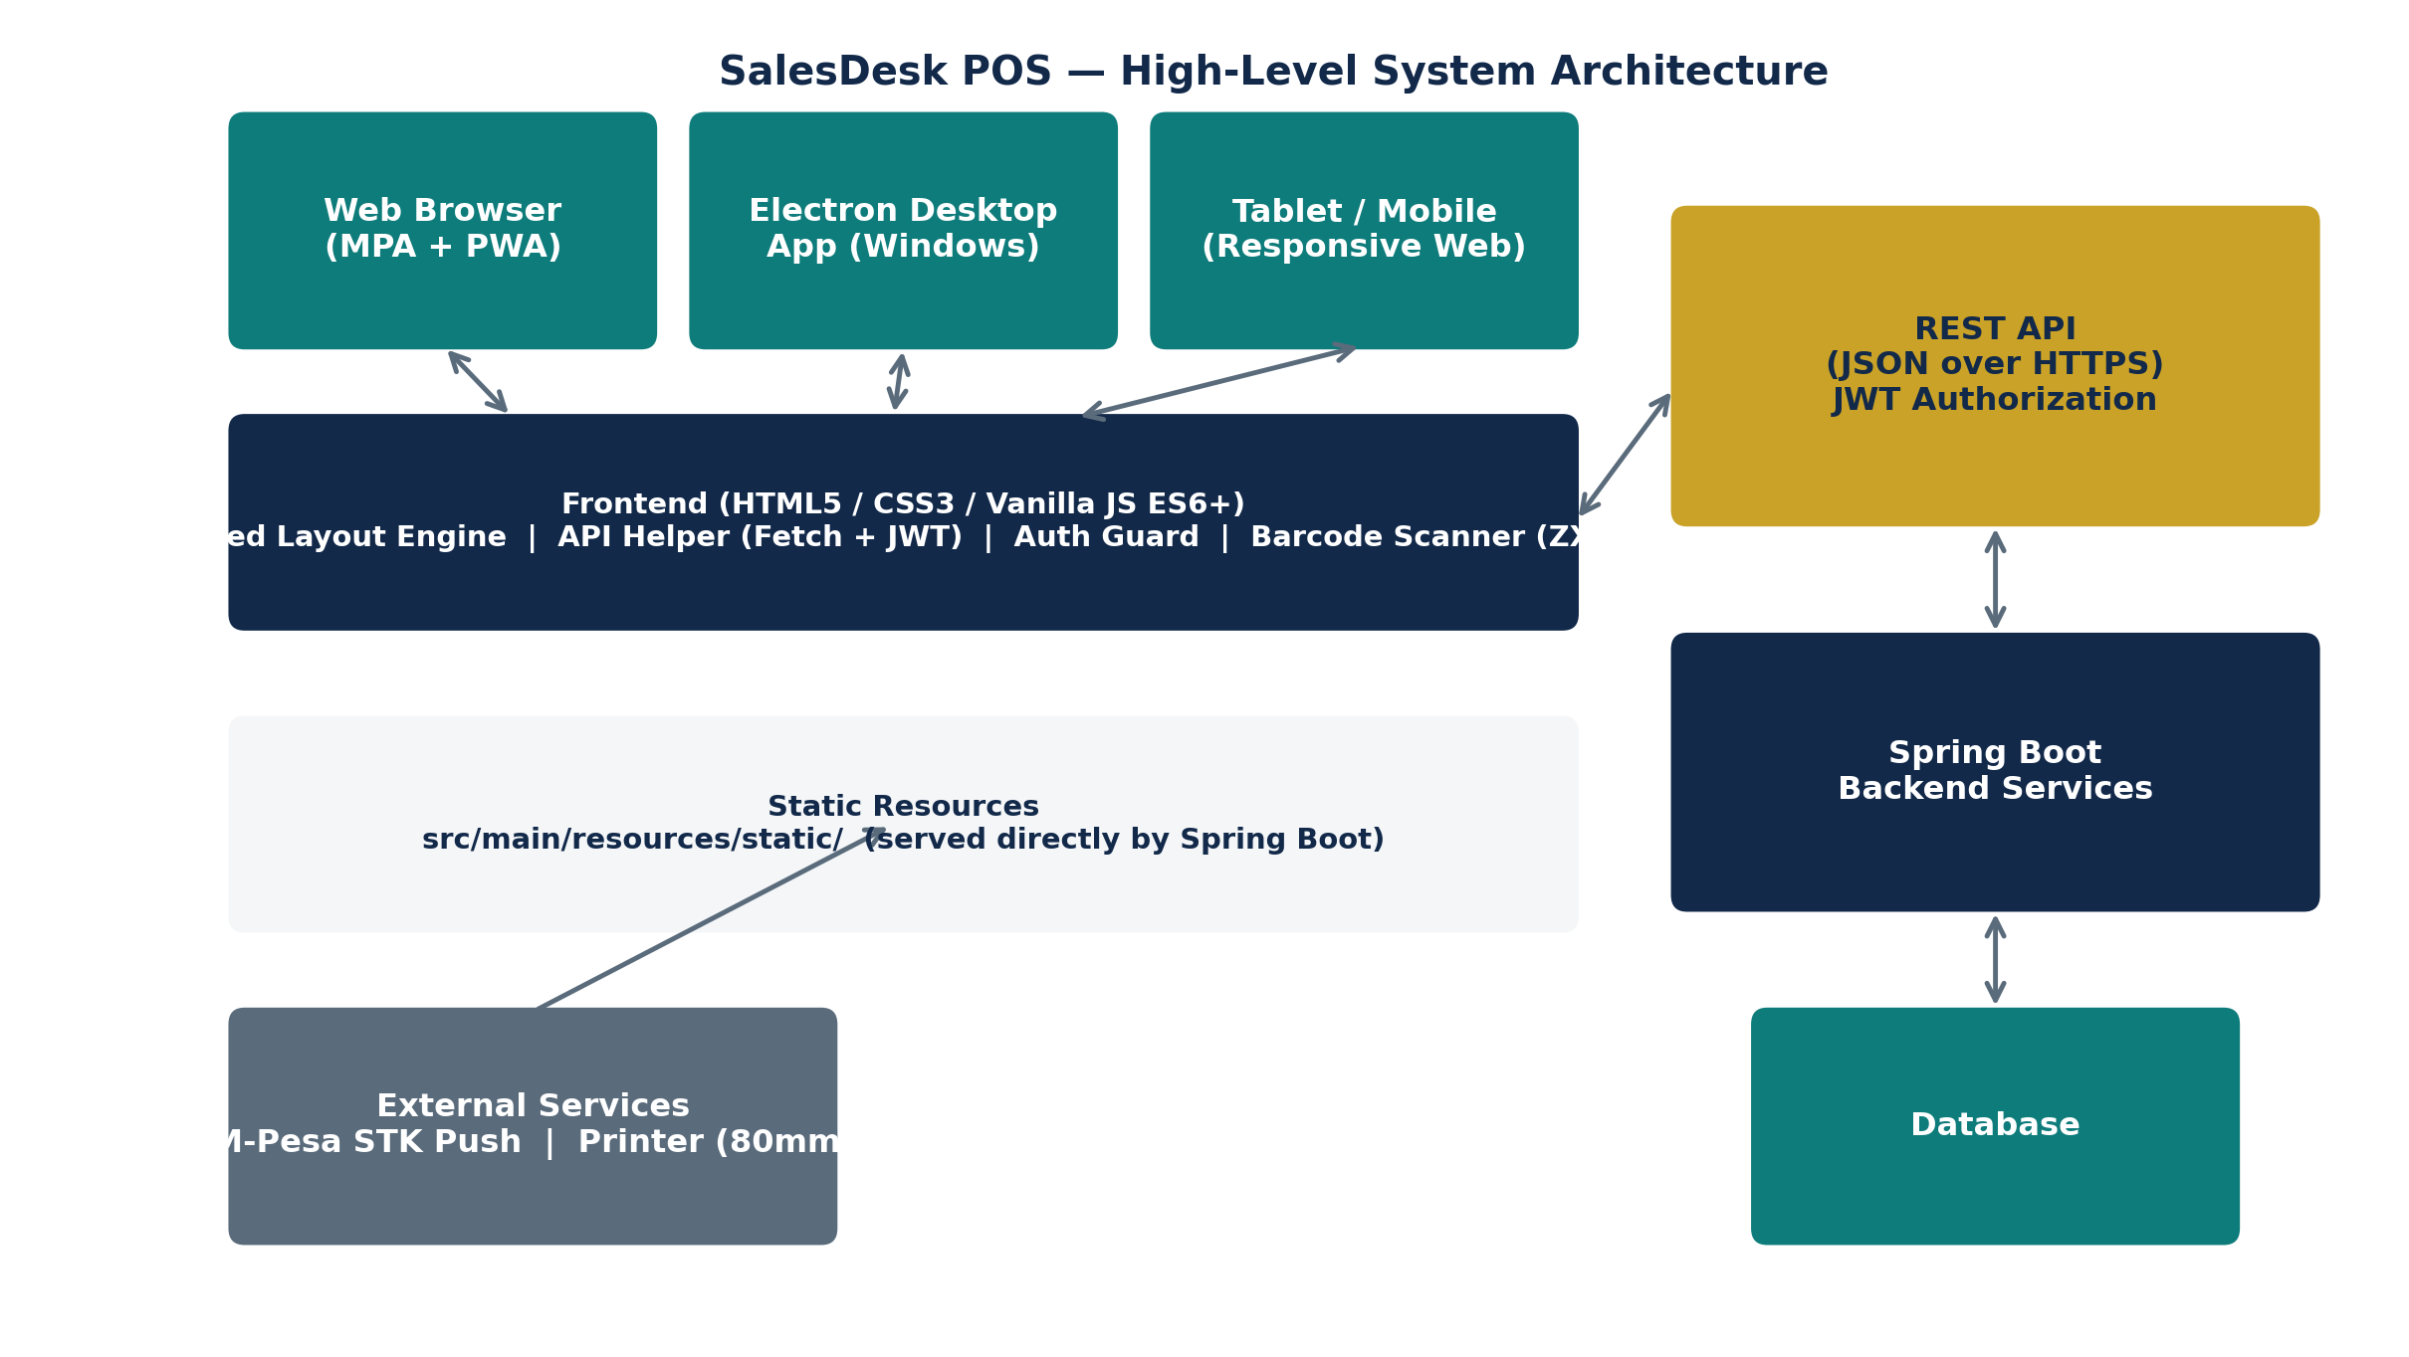

5.1 Architectural Principles
- Multi-Page Application (MPA): each screen is an independent HTML file; no client-side router or virtual DOM.
- Static hosting: all frontend assets live under src/main/resources/static/ and are served directly by Spring Boot — no separate frontend server or build step.
- Shared layout injection: sidebar, top navigation, footer, and profile section are generated by shared JS modules and injected into a layout placeholder on every page at load time.
- Stateless client, token-based auth: session state is a JWT stored in Local Storage; every API call attaches it as an Authorization header.
- Single source of truth for API calls: one reusable fetch-based API helper handles requests, headers, error handling, and session expiry across the entire app.
- Progressive enhancement: the app works fully online-first; PWA/offline behavior is a fallback layer, not the primary design.

5.2 Layered View
Layer | Responsibility
Presentation | HTML5 pages + CSS3 (design system, responsive grid/flex layouts, components)
Behavior | Vanilla JS ES6+ modules per page: DOM logic, validation, event handling
Shared Services | Layout renderer, Auth guard, API helper, Notification/Toast service, Barcode service
Communication | Fetch API over HTTPS → Spring Boot REST endpoints (JSON, JWT bearer auth)
Persistence (client) | Local Storage (JWT, user profile, cart draft, offline cache)
Delivery Targets | Browser → PWA (manifest + service worker) → Electron desktop wrapper

6. Technology Stack
Category | Technology
Markup & Styling | HTML5, CSS3 (CSS variables for design tokens, media queries for responsiveness)
Scripting | Vanilla JavaScript (ES6+), Fetch API
Client Storage | Local Storage (JWT, session/user info, cached data)
Barcode Scanning | ZXing (browser-based camera scanning) + hardware scanner (keyboard-wedge input)
Typography | Google Fonts — DM Sans (UI text), DM Serif Display (headings/emphasis)
Iconography | Lucide Icons
Packaging | Progressive Web App (Web Manifest, Service Worker); Electron (Windows desktop wrapper)
Hosting | Spring Boot static resources (src/main/resources/static/)
Explicitly Excluded | React, Angular, Vue, jQuery, and any frontend build/bundling tooling

7. UI/UX Design Direction
The reference below illustrates the target layout language for the Point of Sale screen: a fixed left sidebar for navigation, a top search/filter bar, a scrollable product grid with category chips, and a persistent order/cart panel on the right showing live totals. This structural pattern — sidebar + content + summary panel — will be reused across Admin and Cashier screens wherever relevant (e.g. Products, Stock, Sales).
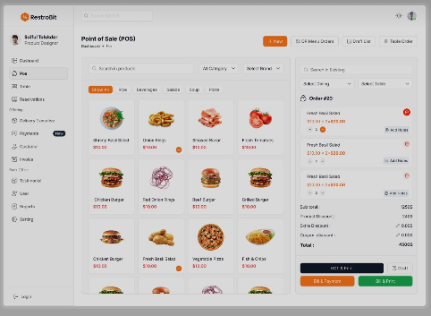
Reference layout: sidebar navigation, product grid with category filters, live order/cart summary panel.

7.1 Brand & Design System
SalesDesk's own design system will use the company's Navy / Teal / Gold palette (rather than the orange accent shown in the reference above, which is used here purely for layout inspiration). Colors are defined as CSS custom properties for global consistency.
Token | Usage
--color-navy | Primary brand color — sidebar, headers, primary text emphasis
--color-teal | Secondary accent — active states, links, secondary buttons
--color-gold | Highlight/action accent — key CTAs, badges, totals
--font-heading | DM Serif Display — page titles and section headers
--font-body | DM Sans — body text, labels, table content

7.2 Layout Principles
- Consistent shared shell across pages: sidebar navigation, top bar, footer, and profile menu.
- Large, thumb/click-friendly action buttons for high-frequency actions (Add to Cart, Charge, Print).
- Responsive cards for dashboard summaries and product tiles.
- Clean, readable tables for lists (products, sales, customers, receivables).
- Category chips / filters for quick narrowing of long lists.
- A persistent, always-visible order/cart summary on transactional screens.
- Generous spacing and clear visual hierarchy; icons (Lucide) paired with labels for clarity.

7.3 Responsive Behavior
- Desktop / laptop: full sidebar + multi-column layouts (as in the reference).
- Tablet: collapsible sidebar, 2–3 column grids.
- Mobile: sidebar becomes a bottom nav or slide-out drawer; single-column stacked layout; cart/summary becomes a bottom sheet.

8. Functional Requirements

8.1 Shared Layout & Navigation
Sidebar, top bar, footer, and profile section are generated by reusable JS functions and injected into every page. Each HTML page contains only its unique content.

8.2 Authentication
- Login form posts credentials to the backend auth API.
- On success: receive and store JWT + user profile in Local Storage; redirect by role (Administrator → Admin Dashboard, Cashier → Cashier Dashboard).
- On failure: display a clear, specific error message (invalid credentials, network error, etc.).

8.3 Authorization
- Every protected page checks: user is logged in, token exists and is valid, and the user's role matches the page.
- Unauthorized or unauthenticated users are redirected to the login page automatically.

8.4 API Communication Layer
- A single reusable API helper sends all HTTP requests and attaches the JWT Authorization header.
- Centralized response/error handling, including automatic logout on session expiry.
- Consistent success/error notifications surfaced via a shared toast/notification service.

8.5 Administrator Interface Modules

Dashboard
Business overview for the admin.
- Summary cards: daily sales, monthly revenue, inventory value, low stock alerts, recent sales, pending payments, notifications.
- Data loaded dynamically from backend APIs (no static/mock data).

Product Management
Manage the product catalog.
- View, search, add, edit, delete products; manage categories.
- Set retail and wholesale prices; view stock quantities.
- All operations call REST APIs without a full page refresh.

Stock Management
Track and adjust inventory levels.
- View stock by product/store; record stock adjustments and restocks; low-stock indicators.

Services
Manage non-product sellable services.
- Create, edit, and list services offered by the business, with pricing.

Sales
Review all sales across the business.
- Searchable/filterable sales list; sale detail view; link to receipts.

Customers
Manage the customer base.
- Register and edit customers; search; view account statements; record payments; export reports.

Suppliers & Purchases
Manage supply chain relationships and stock intake.
- Supplier records; purchase orders; receiving stock against purchases.

Expenses
Track business expenditure.
- Log, categorize, and review expenses.

Profit & Loss / Receivables
Financial visibility.
- Profit & Loss summary views; outstanding receivables tracking and follow-up.

Cashiers & Stores
Operational configuration.
- Manage cashier accounts and permissions; manage store/branch records.

Reports
Business intelligence exports.
- Sales, Expense, Profit & Loss, Inventory, Customer Statement, and Receivables reports.
- Filter by date range; export to PDF or CSV.

Notifications
System-wide alerts.
- View notifications, mark as read individually or all at once, unread counter badge.

Payment Channels, Subscriptions & Company Settings
Platform configuration.
- Configure accepted payment channels; manage subscription/billing status; edit company profile/branding settings.

8.6 Cashier Interface Modules

Dashboard
Cashier-facing operational summary.
- Quick view of own daily sales and shift-relevant notifications.

Point of Sale (POS)
The primary operational screen.
- Product search and category filtering.
- Barcode scanning: hardware scanner, camera scanner (ZXing), and manual entry — local product lookup first, then backend fallback.
- Repeated scans of the same item automatically increment its quantity.
- Shopping cart with quantity adjustment, price editing, and retail/wholesale price selection; totals update live.
- Customer selection for the sale.
- Payment processing: Cash (amount received + change calculation), M-Pesa (phone number, channel selection, STK Push, status polling), Credit (deposit + outstanding balance).
- Receipt preview, 80mm thermal receipt generation, print window, and reprint support.

My Sales
Cashier's personal sales history.
- List and search the logged-in cashier's own past sales; view/reprint receipts.

Hire Purchase
Installment-based sales.
- Create hire purchase agreements; record installment payments; track balance.

Customers
Cashier-level customer lookup.
- Search and select customers during checkout; view basic account info.

Notifications
Cashier alerts.
- View and manage notifications relevant to the cashier role.

9. Non-Functional Requirements
Category | Requirement
Performance | POS and dashboard pages should render usable content in under 2 seconds on typical business broadband; cart updates must feel instant (no visible lag on add/remove).
Responsiveness | All pages must be fully usable on desktop, tablet, and mobile via CSS media queries and flexible layouts.
Security | JWT stored in Local Storage; all API calls over HTTPS; role checks on every protected page; automatic logout on token expiry.
Reliability | Graceful handling of network/server errors; no silent failures during payment or sale completion.
Availability (Offline) | PWA offline fallback page for read-only/limited functionality during connectivity loss; app prioritizes fresh online data when available.
Maintainability | Modular, documented HTML/CSS/JS; shared layout and API helper to avoid duplication across pages.
Usability | Consistent design system (color, type, spacing) and large action targets suited to fast-paced, standing-desk cashier use.
Compatibility | Modern evergreen browsers; Electron-wrapped desktop build for Windows.

10. Data & API Integration Approach
- All business data (products, stock, sales, customers, reports, etc.) is fetched from and written to the Spring Boot REST API — no data is hard-coded in the frontend.
- A single API helper module centralizes base URL configuration, header attachment (Authorization: Bearer <JWT>), JSON parsing, and error normalization.
- Errors are surfaced consistently through a shared toast/modal notification service, distinguishing validation errors, network errors, and server errors.
- Long-running operations (e.g. M-Pesa STK Push) use status polling with a loading dialog until a terminal state (success/failure/timeout) is reached.
- Session expiry (401 responses) triggers automatic logout and redirect to login.

11. Build Plan
The build follows an incremental, dependency-ordered approach: foundation first (shell, auth, API layer), then the highest-value transactional flow (POS), then breadth across remaining Admin/Cashier modules, then packaging (PWA/Electron) and hardening. Each phase produces a demonstrable, testable increment.
Phase | Est. Duration | Key Deliverables
Phase 0 — Project Setup & Design System | 3–4 days | Define folder structure under src/main/resources/static/ (pages, css, js, assets). • Establish CSS design tokens (colors, typography, spacing) and base component styles (buttons, cards, tables, forms). • Set up Google Fonts (DM Sans, DM Serif Display) and Lucide Icons. • Agree on coding conventions and file/module naming.
Phase 1 — Shared Shell, Auth & API Layer | 1 week | Build shared layout modules: sidebar, top nav, footer, profile section, layout injector. • Build the reusable API helper (Fetch wrapper, JWT headers, error handling, auto-logout). • Build login page and authentication flow (JWT storage, role-based redirect, error states). • Build the auth guard used by every protected page (login check, token check, role check). • Build the shared notification/toast service and loading indicator component.
Phase 2 — Dashboards & Core Admin Data Screens | 1–1.5 weeks | Administrator Dashboard with dynamic summary cards. • Product Management (list, search, add/edit/delete, categories, pricing, stock view). • Stock Management screens. • Cashier Dashboard.
Phase 3 — Point of Sale (Critical Path) | 1.5–2 weeks | Product search, category filtering, and product grid. • Barcode scanning: hardware input handling, camera scanner (ZXing) integration, manual entry, local-first lookup. • Cart: add/remove/adjust quantity, price editing, retail/wholesale toggle, live totals. • Customer selection within POS. • Payment flows: Cash (change calc), M-Pesa (STK Push + polling + loading dialog), Credit (deposit + balance). • Receipt preview, 80mm thermal print generation, print window, reprint.
Phase 4 — Remaining Admin Modules | 1.5–2 weeks | Services, Sales history, Suppliers, Purchases, Expenses, Profit & Loss, Receivables. • Cashiers, Stores, Payment Channels, Subscription Management, Company Settings. • Reports module with date filtering and PDF/CSV export. • Notification center (view, mark read/all read, unread counter).
Phase 5 — Remaining Cashier Modules | 0.5–1 week | My Sales (history, search, reprint). • Hire Purchase (agreement creation, installment recording). • Cashier-facing Customers and Notifications screens.
Phase 6 — Responsiveness & Cross-Device QA | 0.5–1 week | Apply and refine responsive layouts (desktop, tablet, mobile) across all pages. • Cross-browser checks; fix layout/interaction issues on smaller viewports.
Phase 7 — PWA & Electron Packaging | 0.5–1 week | Web App Manifest, Service Worker, install prompt, offline fallback page. • Electron wrapper: load hosted app, preserve session, enable receipt printing, offline/connectivity screen.
Phase 8 — Error Handling, Polish & Hardening | 0.5–1 week | Consistent error handling across all flows (invalid login, network/server errors, unauthorized access, validation failures) via toasts/modals. • Final visual QA against the design system; performance pass; code cleanup and documentation.
Phase 9 — UAT & Handover | 0.5 week | User acceptance testing with Admin and Cashier scenarios end-to-end. • Fix acceptance issues; finalize documentation and handover notes.

Estimated total duration: approximately 9–11 weeks for a single frontend developer, working sequentially through the phases above. Phases 2, 4 and 5 can partially overlap with Phase 3 if more than one developer is available, since they depend only on Phase 1 (shell, auth, API layer) rather than on the POS module itself.

11.1 Phase Detail

Phase 0 — Project Setup & Design System (3–4 days)
- Define folder structure under src/main/resources/static/ (pages, css, js, assets).
- Establish CSS design tokens (colors, typography, spacing) and base component styles (buttons, cards, tables, forms).
- Set up Google Fonts (DM Sans, DM Serif Display) and Lucide Icons.
- Agree on coding conventions and file/module naming.

Phase 1 — Shared Shell, Auth & API Layer (1 week)
- Build shared layout modules: sidebar, top nav, footer, profile section, layout injector.
- Build the reusable API helper (Fetch wrapper, JWT headers, error handling, auto-logout).
- Build login page and authentication flow (JWT storage, role-based redirect, error states).
- Build the auth guard used by every protected page (login check, token check, role check).
- Build the shared notification/toast service and loading indicator component.

Phase 2 — Dashboards & Core Admin Data Screens (1–1.5 weeks)
- Administrator Dashboard with dynamic summary cards.
- Product Management (list, search, add/edit/delete, categories, pricing, stock view).
- Stock Management screens.
- Cashier Dashboard.

Phase 3 — Point of Sale (Critical Path) (1.5–2 weeks)
- Product search, category filtering, and product grid.
- Barcode scanning: hardware input handling, camera scanner (ZXing) integration, manual entry, local-first lookup.
- Cart: add/remove/adjust quantity, price editing, retail/wholesale toggle, live totals.
- Customer selection within POS.
- Payment flows: Cash (change calc), M-Pesa (STK Push + polling + loading dialog), Credit (deposit + balance).
- Receipt preview, 80mm thermal print generation, print window, reprint.

Phase 4 — Remaining Admin Modules (1.5–2 weeks)
- Services, Sales history, Suppliers, Purchases, Expenses, Profit & Loss, Receivables.
- Cashiers, Stores, Payment Channels, Subscription Management, Company Settings.
- Reports module with date filtering and PDF/CSV export.
- Notification center (view, mark read/all read, unread counter).

Phase 5 — Remaining Cashier Modules (0.5–1 week)
- My Sales (history, search, reprint).
- Hire Purchase (agreement creation, installment recording).
- Cashier-facing Customers and Notifications screens.

Phase 6 — Responsiveness & Cross-Device QA (0.5–1 week)
- Apply and refine responsive layouts (desktop, tablet, mobile) across all pages.
- Cross-browser checks; fix layout/interaction issues on smaller viewports.

Phase 7 — PWA & Electron Packaging (0.5–1 week)
- Web App Manifest, Service Worker, install prompt, offline fallback page.
- Electron wrapper: load hosted app, preserve session, enable receipt printing, offline/connectivity screen.

Phase 8 — Error Handling, Polish & Hardening (0.5–1 week)
- Consistent error handling across all flows (invalid login, network/server errors, unauthorized access, validation failures) via toasts/modals.
- Final visual QA against the design system; performance pass; code cleanup and documentation.

Phase 9 — UAT & Handover (0.5 week)
- User acceptance testing with Admin and Cashier scenarios end-to-end.
- Fix acceptance issues; finalize documentation and handover notes.

12. Expected Deliverables
- Fully responsive multi-page frontend (HTML5/CSS3/JS).
- Complete Administrator interface (all listed modules).
- Complete Cashier interface (all listed modules).
- Login and registration pages.
- Shared reusable JavaScript utilities (layout, API helper, auth guard, notifications).
- Full REST API integration across all screens.
- Responsive UI components used consistently across the app.
- Barcode scanning functionality (hardware, camera, manual).
- Receipt printing interface (80mm thermal format).
- PWA support (manifest, service worker, offline fallback).
- Electron-compatible desktop frontend.
- Well-organized, documented, and maintainable source code.

13. Risks & Assumptions

13.1 Assumptions
- The Spring Boot backend exposes stable, documented REST endpoints and authentication for the frontend to consume.
- M-Pesa integration and printer hardware are available for testing during Phases 3 and 7.
- No frontend framework or build tooling will be introduced during development.

13.2 Risks & Mitigations
Risk | Mitigation
No client-side framework increases duplication risk across ~25 pages. | Strict use of shared layout/API/notification modules from Phase 1 onward; shared JS is built before feature pages.
Barcode camera scanning behaves inconsistently across browsers/devices. | Treat hardware scanner and manual entry as reliable fallbacks; test ZXing early in Phase 3.
M-Pesa STK Push polling can be slow or fail silently. | Explicit loading states, timeouts, and clear success/failure/timeout messaging.
Offline/PWA behavior conflicts with need for fresh POS data. | Offline mode is strictly a limited fallback; app always prefers live data when online.
Electron wrapper and web build drifting out of sync. | Single shared codebase served to both; Electron only wraps the hosted app, no separate build.

14. Success Metrics
- All listed Admin and Cashier modules implemented and functional against the live API.
- A cashier can complete a full sale (search/scan → cart → payment → receipt) in under 30 seconds for a simple transaction.
- All pages pass responsive checks on desktop, tablet, and mobile breakpoints.
- PWA installs and shows a functional offline fallback; Electron build launches, authenticates, and prints receipts.
- No unhandled errors during standard flows; all failure states show a clear, user-friendly message.

