USER STORY 1
STORY: User would like a basic app with a home page.
Create a new app for the project, named appropriately for what you are tracking, and get it to display a home page with basic content.
- Create a new app using manage.py startapp.
- Register the app from within [MainProject]>[MainProject]>settings.py.
- Create base and home templates in a new templates folder (be sure to include block tags).
- Add a function to views to render the home page.
- Register URLs with MainApp and create urls.py for your app and homepage.
- Link your app's home page to the project's home page (templates/index.html) by adding an image link on the Appbuilder9000 home page.
- Add content and some basic styling to your base and home. Minimally include the following elements:
- Title,
- Navbar,
- Background,
- Images,
- Text,
- and Footer
You have completed this story when you can display the homepage for your app. Make sure to test and debug before submitting.
-----------------------------------------------------------------------------------------------------------------

User Story 1 - Code Summary:
The first user story required setting up a new Django app and creating the initial home page for the project. The Django app will be a Hairstyle booking System where users will be able to view hairstyles and schedule an appointment for the one they selected. I began by creating a new app called appointments using Django’s startapp command and registering it in the project’s settings.py file so it could be recognized by the application.

AppBuilder9000/settings.py
INSTALLED_APPS = [
'django.contrib.admin',
'django.contrib.auth',
'django.contrib.contenttypes',
'django.contrib.sessions',
'django.contrib.messages',
'django.contrib.staticfiles',
'rest_framework',
'django_bootstrap5',
'crispy_forms',
'appointments',
]

I then created a templates folder within the appointments app directory and added base and home templates using Django block tags to allow for template inheritance. The base template includes common layout elements such as the page title, navigation bar, background styling, and footer, while the home template extends the base layout and displays the main content for the application.
appointments/base.html
<body>
<nav>
<div class="logo">💇‍♀️ Salon Booking</div>
<div class="nav-links">
<a href="{% url 'home' %}">🏠 Home</a>
<a href="{% url 'create_appointment' %}">📅 Book Now</a>
<a href="{% url 'appointment_list' %}">📋 View Bookings</a>
<a href="{% url 'inspiration_gallery' %}"> 🖼️ Gallery</a>
<a href="{% url 'natural_hair_tips' %}">🌿 Hair Care Tips</a>
<a href="{% url 'contact' %}">📞 Contact Us</a>
</div>
</nav>
<div class="container">
{% if messages %}
<div class="messages">
{% for message in messages %}
<div class="message {{ message.tags }}">
{{ message }}
</div>
{% endfor %}
</div>
{% endif %}
{% block content %}
{% endblock %}
</div>
</body>
appointments/home.html
{% extends 'appointments/base.html' %}
{% block title %}Home - Hair Salon{% endblock %}
{% block content %}
<div style="text-align: center; margin-bottom: 40px;">
<h1 style="font-size: 42px; margin-bottom: 15px;">Welcome to Our Salon</h1>
<p style="font-size: 20px; color: #666;">
Choose from our selection of professional hairstyling services
</p>
</div>
<!-- Hairstyle Cards Grid -->
<div style="display: grid; grid-template-columns: repeat(auto-fill, minmax(320px, 1fr)); gap: 25px; margin-top: 30px;">
{% for hairstyle in hairstyles %}
<div class="hairstyle-card" style="border: 2px solid #e0e0e0; border-radius: 15px; overflow: hidden; transition: transform 0.3s, box-shadow 0.3s; background: white;">
<!-- Hairstyle Image -->
{% if hairstyle.image_url %}
<a href="{% url 'hairstyle_detail' hairstyle.pk %}" style="display: block;">
<div style="width: 100%; height: 250px; overflow: hidden; background-color: #f0f0f0;">
<img src="{{ hairstyle.image_url }}"
alt="{{ hairstyle.name }}"
style="width: 100%; height: 100%; object-fit: cover;"
onerror="this.onerror=null; this.src='https://via.placeholder.com/400x250/667eea/ffffff?text={{ hairstyle.name }}';">
</div>
</a>
{% else %}
<!-- Placeholder if no image -->
<div style="width: 100%; height: 250px; background: linear-gradient(135deg, #667eea 0%, #764ba2 100%); display: flex; align-items: center; justify-content: center;">
<span style="font-size: 60px;">💇‍♀️</span>
</div>
{% endif %}
<!-- Hairstyle Details -->
<div style="padding: 20px;">
<h3 style="color: #667eea; margin-bottom: 10px; font-size: 22px;">
{{ hairstyle.name }}
</h3>
<p style="color: #666; margin-bottom: 15px; min-height: 60px; line-height: 1.5;">
{{ hairstyle.description|truncatewords:20 }}
</p>
<div style="display: flex; justify-content: space-between; align-items: center; margin-bottom: 15px; padding-top: 15px; border-top: 1px solid #e0e0e0;">
<div>
<div style="font-size: 14px; color: #999; margin-bottom: 5px;">Duration</div>
<div style="font-weight: bold; color: #333;">{{ hairstyle.duration_minutes }} min</div>
</div>
<div style="text-align: right;">
<div style="font-size: 14px; color: #999; margin-bottom: 5px;">Price</div>
<div style="font-size: 28px; color: #28a745; font-weight: bold;">
${{ hairstyle.price }}
</div>
</div>
</div>
<!-- Book This Style Button (pre-selects this hairstyle in form) -->
<a href="{% url 'create_appointment' %}?hairstyle={{ hairstyle.id }}"
class="book-btn"
style="display: block; text-align: center; background-color: #667eea; color: white; padding: 12px 20px; border-radius: 8px; text-decoration: none; font-weight: bold; transition: background-color 0.3s;">
Book This Style
</a>
</div>
</div>
{% endfor %}
</div>
<!-- Contact Section at Bottom -->
<div style="text-align: center; margin-top: 50px; padding: 40px 20px; background: linear-gradient(135deg, #667eea 0%, #764ba2 100%); border-radius: 15px; color: white;">
<h2 style="font-size: 32px; margin-bottom: 15px; color: white;">Have Questions?</h2>
<p style="font-size: 18px; margin-bottom: 25px; opacity: 0.9;">
Not sure which style is right for you? Need to discuss special requirements?<br>Contact us for special inquiries.
</p>
<a href="{% url 'contact' %}"
class="btn"
style="font-size: 18px; padding: 15px 40px; background-color: white; color: #667eea;">
📞 Contact Us
</a>
</div>
<style>
/* Hover effects */
.hairstyle-card:hover {
transform: translateY(-5px);
box-shadow: 0 10px 25px rgba(0, 0, 0, 0.15);
}
.book-btn:hover {
background-color: #5568d3 !important;
}
</style>
{% endblock %}

A home view function was added to render the home page, and URL routing was configured at both the app and project levels to connect the application’s (appointments) home page to the project’s main AppBuilder9000 home page. The AppBuilder9000 home page was updated to include an image link that directs users to the appointments app home page.
Basic styling and content were added to the base and home templates, including images, text content, a navigation bar, and a styled background, ensuring the home page meets the minimum design requirements outlined in the user story.
appointments/views.py (home)
def home(request):
"""
Landing page showing available hairstyles with images.
This is what customers see first.
"""
hairstyles = Hairstyle.objects.filter(is_available=True)
return render(request, 'appointments/home.html', {'hairstyles': hairstyles})

appointments/urls.py (urlpatterns)
urlpatterns = [
# Home page with hairstyle cards
path("", views.home, name="home"),
# Hairstyles Detail Page
path("hairstyles/<int:pk>/", views.hairstyle_detail, name="hairstyle_detail"),
# Booking form
path("book/", views.create_appointment, name="create_appointment"),
# Confirmation after booking
path("confirmation/<int:pk>/", views.appointment_confirmation, name="appointment_confirmation"),
# Admin view - all appointments
path("appointments/", views.appointment_list, name="appointment_list"),
# Edit appointment
path("appointments/edit/<int:pk>/", views.update_appointment, name="update_appointment"),
# Cancel appointment
path("appointments/cancel/<int:pk>/", views.delete_appointment, name="delete_appointment"),
# Contact URLs
path("contact/", views.contact, name="contact"),
path("contact/confirmation/<int:pk>/", views.contact_confirmation, name="contact_confirmation"),
# Inspiration Gallery
path("inspiration/", views.inspiration_gallery, name="inspiration_gallery"),
# Natural Hair Tips
path("natural-hair-tips/", views.natural_hair_tips, name="natural_hair_tips"),
]

AppBuilder9000/views.py (project_home)
# Create your views here.
def project_home(request):
return render(request, "Home/index.html")

AppBuilder/urls.py (urlpatterns)
urlpatterns = [
path("admin/", admin.site.urls),
# Project landing page (App Directory)
path("", views.project_home, name="project_home"),
# All front-end routes come from the appointments app at the root
# App lives at /appointments/
path("appointments/", include("appointments.urls")),
]

Home page UI
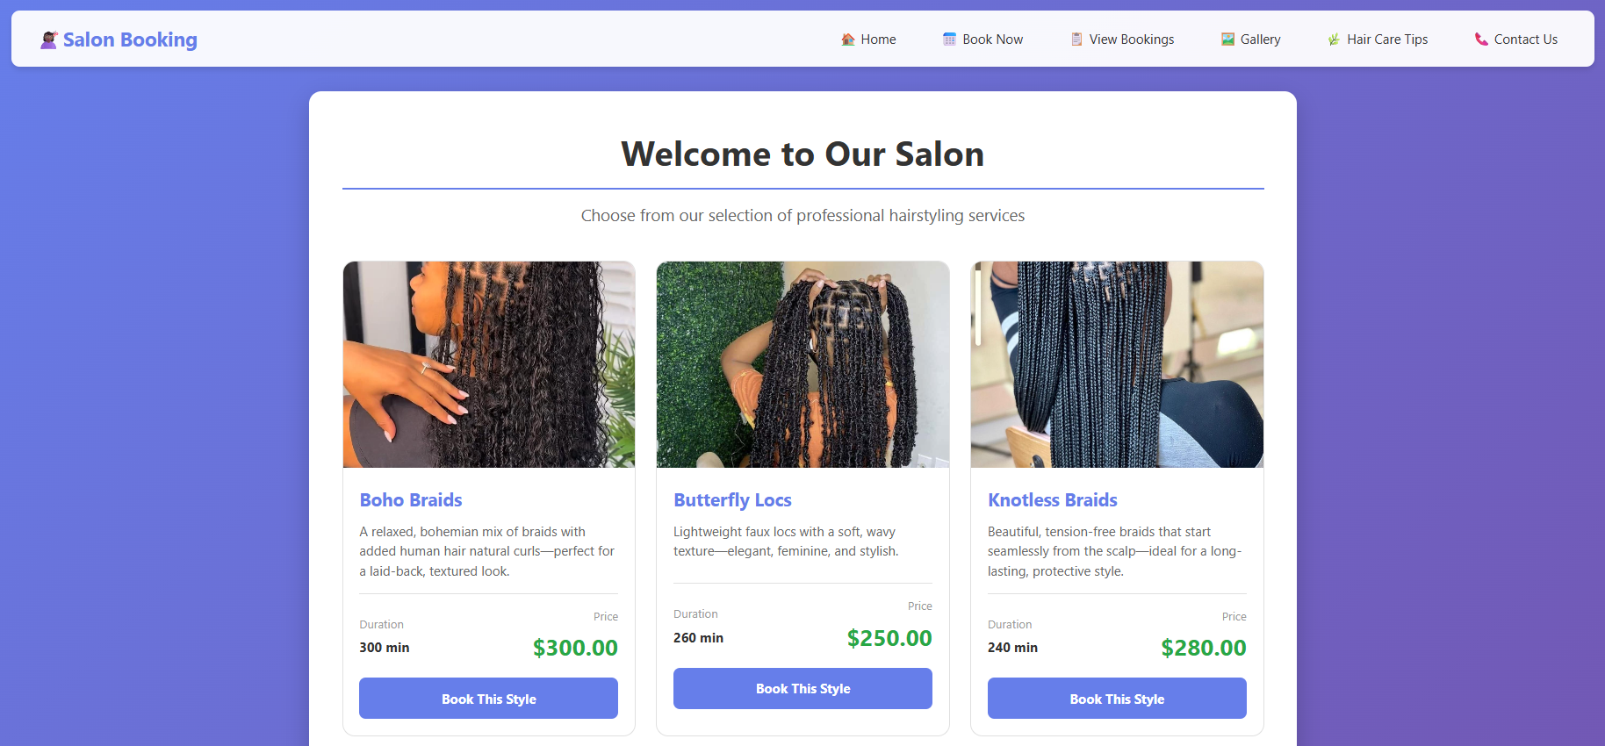
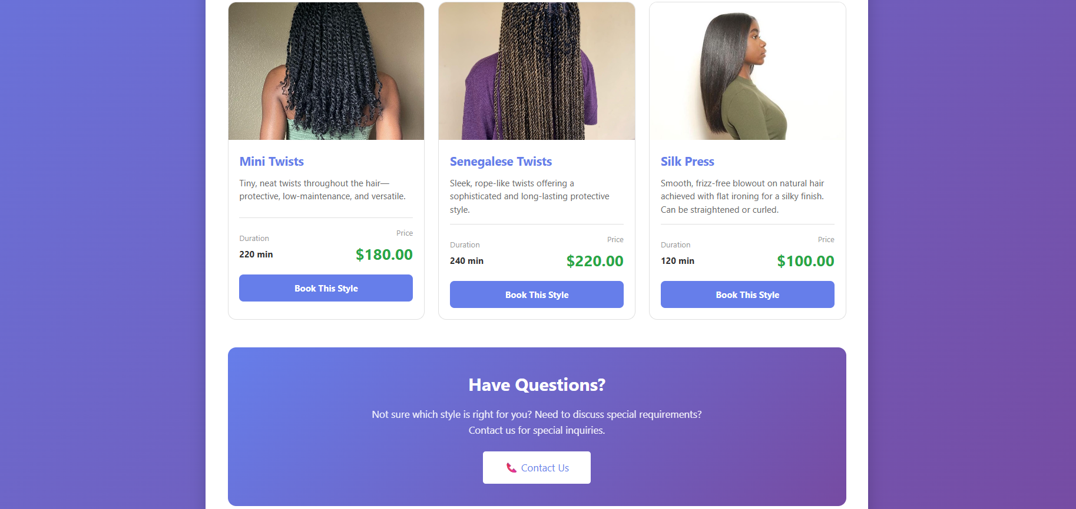

------------------------------------------------------------------------------------------------------------------

USER STORY 2
STORY: User would like the ability to create new items.
Create a model for the collection item you will be tracking and add the ability to create a new item.
Minimum model requirements:
- 4 field types
- 1 widget

- Create your model and add a migration, make sure to plan out all the categories you want to track for your object. Include an objects manager for accessing the database.
- Create a model form that will include any inputs the user needs to make.
- Add a template to your app folder for creating a new item.
- Add a views function that renders the create page and utilizes the model form to save the collection item to the database.
- Check the database to make sure your item saves without errors.
- OPTIONAL STEP: Add styling to your template.
You are finished with the story when you have a functioning create page. This means the user can add to the database through your template rather than through admin. Make sure to test and debug before moving on to the next story.
------------------------------------------------------------------------------------------------------------------

User Story 2 - Code Summary:
This user story requires users to create and store appointment data in the application. To support this functionality, an appointment model was created to represent a salon booking. The model stores customer information, appointment date and time, and the selected hairstyle.
A foreign key relationship was established between the Appointment model and the Hairstyle model, allowing each appointment to be associated with a specific service. This design ensures that appointment data remains normalized and that pricing and service details are derived directly from the related hairstyle.
appointments/models.py (Appointment)
class Appointment(models.Model):
"""
Customer bookings created through the booking form.
"""
# Customer information
customer_name = models.CharField(max_length=100)
customer_email = models.EmailField()
# Appointment details
hairstyle = models.ForeignKey(
Hairstyle,
on_delete=models.CASCADE,
help_text="Selected hairstyle service"
)
appointment_date = models.DateField()
appointment_time = models.CharField(max_length=8)
# Optional notes
notes = models.TextField(blank=True, help_text="Special requests or notes")
# Auto-generated timestamp
created_at = models.DateTimeField(auto_now_add=True)
class Meta:
ordering = ['appointment_date', 'appointment_time']
def __str__(self):
return f"{self.customer_name} - {self.hairstyle.name} on {self.appointment_date}"
def get_cost(self):
"""Get the cost from the selected hairstyle"""
return self.hairstyle.price

appointments/models.py (Hairstyle)
class Hairstyle(models.Model):
"""
Pre-defined hairstyles available at the salon.
Admin manages these through Django admin.
"""
name = models.CharField(max_length=100)
description = models.TextField()
duration_minutes = models.IntegerField(help_text="How long this service takes")
price = models.DecimalField(max_digits=6, decimal_places=2)
image_url = models.URLField(blank=True, help_text="Image URL for this hairstyle")
is_available = models.BooleanField(default=True, help_text="Is this style currently offered?")
class Meta:
ordering = ['name']
def __str__(self):
return f"{self.name} (${self.price})"

In addition to appointment scheduling, the application also includes an Inquiry model to allow customers to submit questions or contact requests through a contact form. The Inquiry model stores customer contact information such as name, email, and optional phone number, along with the subject and message of the inquiry. A status field was implemented with predefined choices to track the progress of each inquiry (new, replied, or resolved). The model also includes an automatically generated timestamp to record when the inquiry was submitted. This structure enables the application to store and manage customer communication efficiently while allowing administrators to review and update inquiry statuses through the admin interface.
appointments/models.py (Inquiry)
class Inquiry(models.Model):
"""
Customer inquiries and questions submitted through contact form.
"""
# Contact information
name = models.CharField(max_length=100)
email = models.EmailField()
phone = models.CharField(max_length=20, blank=True, help_text="Optional phone number")
# Inquiry details
subject = models.CharField(max_length=200)
message = models.TextField()
# Status tracking
STATUS_CHOICES = [
('new', 'New'),
('replied', 'Replied'),
('resolved', 'Resolved'),
]
status = models.CharField(max_length=20, choices=STATUS_CHOICES, default='new')
# Auto-generated fields
submitted_at = models.DateTimeField(auto_now_add=True)
class Meta:
ordering = ['-submitted_at'] # Newest first
verbose_name_plural = "Inquiries"
def __str__(self):
return f"{self.name} - {self.subject}"

After defining the model, database migrations were created and applied so that appointment records could be stored persistently.
migrations/0001_initial.py
class Migration(migrations.Migration):
initial = True
dependencies = [
]
operations = [
migrations.CreateModel(
name='Hairstyle',
fields=[
('id', models.BigAutoField(auto_created=True, primary_key=True, serialize=False, verbose_name='ID')),
('name', models.CharField(max_length=100)),
('description', models.TextField()),
('duration_minutes', models.IntegerField(help_text='How long this service takes')),
('price', models.DecimalField(decimal_places=2, max_digits=6)),
('image_url', models.URLField(blank=True, help_text='Image URL for this hairstyle')),
('is_available', models.BooleanField(default=True, help_text='Is this style currently offered?')),
],
options={
'ordering': ['name'],
},
),
migrations.CreateModel(
name='Appointment',
fields=[
('id', models.BigAutoField(auto_created=True, primary_key=True, serialize=False, verbose_name='ID')),
('customer_name', models.CharField(max_length=100)),
('customer_email', models.EmailField(max_length=254)),
('appointment_date', models.DateField()),
('appointment_time', models.CharField(max_length=8)),
('notes', models.TextField(blank=True, help_text='Special requests or notes')),
('created_at', models.DateTimeField(auto_now_add=True)),
('hairstyle', models.ForeignKey(help_text='Selected hairstyle service', on_delete=django.db.models.deletion.CASCADE, to='appointments.hairstyle')),
],
options={
'ordering': ['appointment_date', 'appointment_time'],
},
),
]

An appointment form was then implemented using Django’s ModelForm functionality. This form handles user input and validation for customer name, email, appointment date, appointment time, and hairstyle selection. Form widgets were used to control how appointment fields are displayed, including a date picker and dropdown menu. The hairstyle dropdown is populated dynamically from the database, ensuring only available services can be booked.
appointments/form.py (AppointmentForm)
class AppointmentForm(forms.ModelForm):
# Override time field to use dropdown choices
appointment_time = forms.ChoiceField(
choices=TIME_SLOTS,
widget=forms.Select(attrs={'class': 'form-control'})
)
class Meta:
model = Appointment
fields = ['customer_name', 'customer_email', 'hairstyle',
'appointment_date', 'appointment_time', 'notes']
widgets = {
'customer_name': forms.TextInput(attrs={
'class': 'form-control',
'placeholder': 'Your full name'
}),
'customer_email': forms.EmailInput(attrs={
'class': 'form-control',
'placeholder': 'your.email@example.com'
}),
'hairstyle': forms.Select(attrs={
'class': 'form-control'
}),
'appointment_date': forms.DateInput(attrs={
'class': 'form-control',
'type': 'date' # HTML5 date picker (built-in calendar!)
}),
'notes': forms.Textarea(attrs={
'class': 'form-control',
'rows': 3,
'placeholder': 'Any special requests? (optional)'
}),
}
labels = {
'customer_name': 'Your Name',
'customer_email': 'Email Address',
'hairstyle': 'Select Hairstyle',
'appointment_date': 'Preferred Date',
'appointment_time': 'Preferred Time',
'notes': 'Special Requests'
}

A view function was created to render the appointment form and process submissions. When the form is submitted and validated, a new appointment record is saved to the database, and the user is redirected to a confirmation page displaying the booking details.
appointments/views.py (create_appointment)
def create_appointment(request):
"""
Customer booking form.
Can pre-select hairstyle from URL parameter (when clicking "Book This Style").
"""
# Check if a hairstyle was pre-selected from the home page
preselected_hairstyle_id = request.GET.get('hairstyle')
if request.method == 'POST':
form = AppointmentForm(request.POST)
if form.is_valid():
appointment = form.save()
messages.success(
request,
f'Appointment booked successfully! Total cost: ${appointment.get_cost()}'
)
return redirect('appointment_confirmation', pk=appointment.pk)
else:
messages.error(request, 'Please correct the errors below.')
else:
# Pre-fill form if hairstyle was selected from home page
if preselected_hairstyle_id:
form = AppointmentForm(initial={'hairstyle': preselected_hairstyle_id})
else:
form = AppointmentForm()
return render(request, 'appointments/create.html', {'form': form})
def appointment_confirmation(request, pk):
"""
Confirmation page shown after successful booking.
Shows all details and total cost.
"""
appointment = get_object_or_404(Appointment, pk=pk)
return render(request, 'appointments/confirmation.html', {'appointment': appointment})

templates/create.html
<h1>Book Your Appointment</h1>
<form method="post" style="max-width: 600px;">
{% csrf_token %}
<div style="margin-bottom: 20px;">
<label style="display: block; margin-bottom: 5px; font-weight: bold;">
{{ form.customer_name.label }}
</label>
{{ form.customer_name }}
{% if form.customer_name.errors %}
<span style="color: red; font-size: 14px;">{{ form.customer_name.errors }}</span>
{% endif %}
</div>
<div style="margin-bottom: 20px;">
<label style="display: block; margin-bottom: 5px; font-weight: bold;">
{{ form.customer_email.label }}
</label>
{{ form.customer_email }}
{% if form.customer_email.errors %}
<span style="color: red; font-size: 14px;">{{ form.customer_email.errors }}</span>
{% endif %}
</div>
<div style="margin-bottom: 20px;">
<label style="display: block; margin-bottom: 5px; font-weight: bold;">
{{ form.hairstyle.label }}
</label>
{{ form.hairstyle }}
<small style="display: block; color: #666; margin-top: 5px;">
💡 Price will be calculated based on your selection
</small>
{% if form.hairstyle.errors %}
<span style="color: red; font-size: 14px;">{{ form.hairstyle.errors }}</span>
{% endif %}
</div>
<div style="margin-bottom: 20px;">
<label style="display: block; margin-bottom: 5px; font-weight: bold;">
{{ form.appointment_date.label }}
</label>
{{ form.appointment_date }}
{% if form.appointment_date.errors %}
<span style="color: red; font-size: 14px;">{{ form.appointment_date.errors }}</span>
{% endif %}
</div>
<div style="margin-bottom: 20px;">
<label style="display: block; margin-bottom: 5px; font-weight: bold;">
{{ form.appointment_time.label }}
</label>
{{ form.appointment_time }}
{% if form.appointment_time.errors %}
<span style="color: red; font-size: 14px;">{{ form.appointment_time.errors }}</span>
{% endif %}
</div>
<div style="margin-bottom: 20px;">
<label style="display: block; margin-bottom: 5px; font-weight: bold;">
{{ form.notes.label }}
</label>
{{ form.notes }}
{% if form.notes.errors %}
<span style="color: red; font-size: 14px;">{{ form.notes.errors }}</span>
{% endif %}
</div>
<div style="margin-top: 30px;">
<button type="submit" class="btn">✓ Confirm Booking</button>
<a href="{% url 'home' %}" class="btn btn-secondary" style="margin-left: 10px;">✗ Cancel</a>
</div>
</form>

Appointment UI
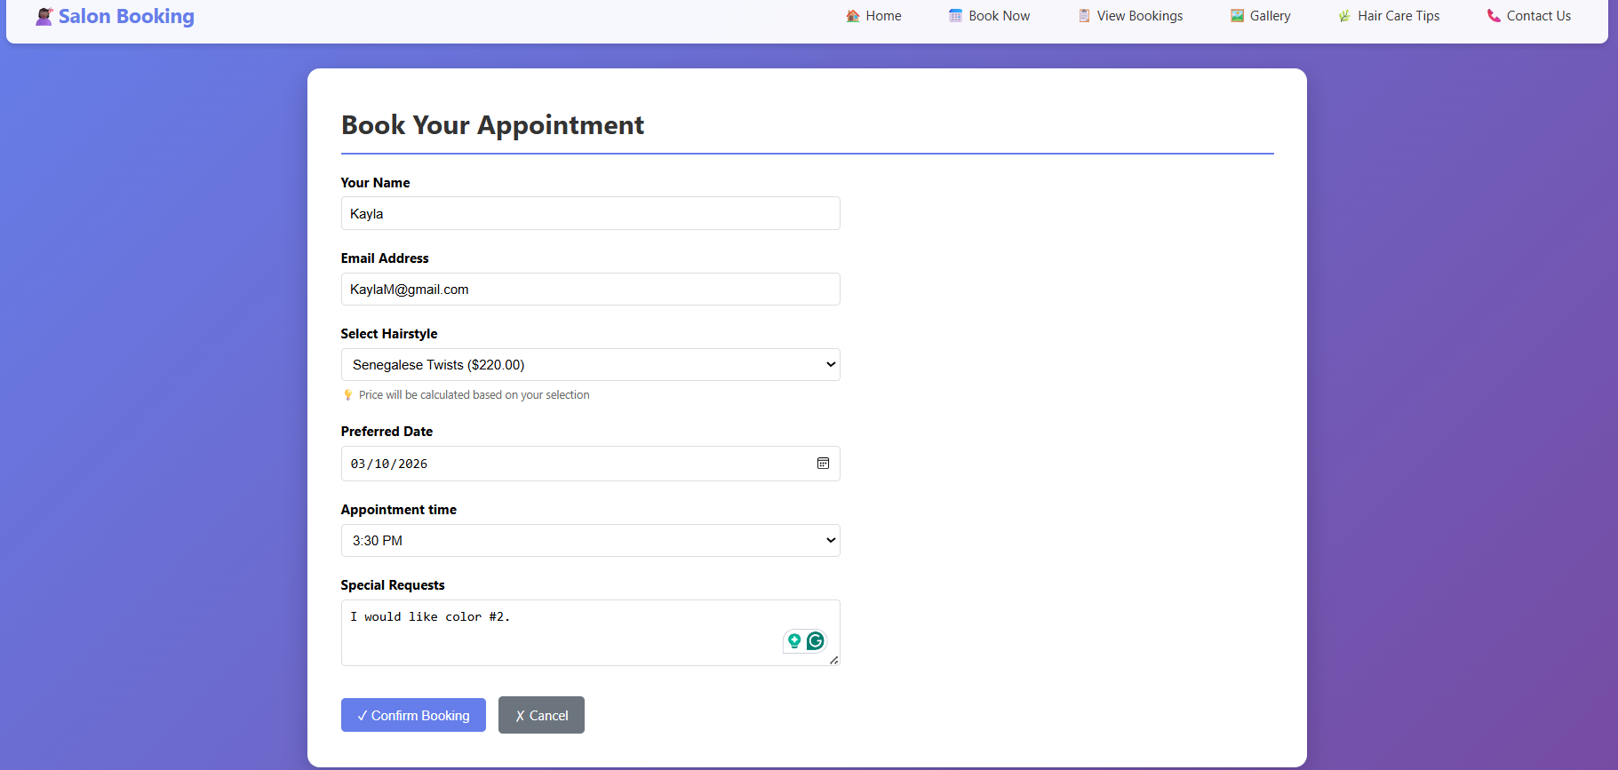
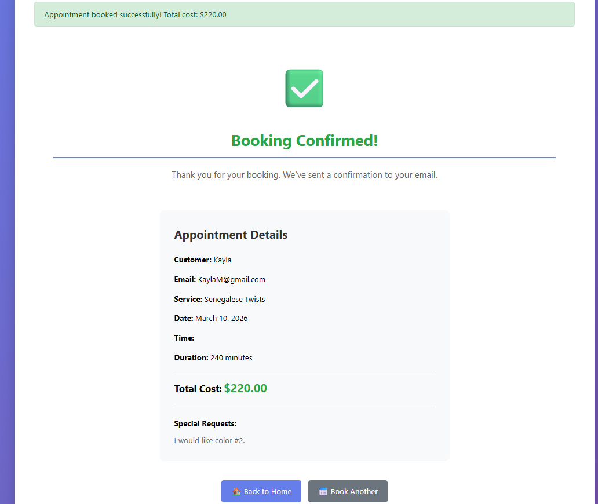

------------------------------------------------------------------------------------------------------------------

USER STORY 3
Complete the following user story:
STORY: User would like to be able to display all items from the database.
Display information from the database on the page.
Your page should have the following features:
- Use at least one built-in Django template filter(do not download anything)
- Add infinite scrolling, pagination, or "load more" buttons for lazy loading content.
- Add a search bar or sort feature.
Complete these steps:
- Create a new HTML page, and link to it from your home page.
- Add a function that gets all the items from the database and sends them to the template.
- Display a list of items from the database, with some of the fields for that item displayed with labels/headers.
- OPTIONAL STEP: Add styling to your template.
You are finished with the story when you have a functioning page that lists the items in the database. Make sure to test and debug before moving on to the next story.
To demonstrate additional front-end functionality, an inspiration gallery page was implemented. This page includes built-in Django template filters, search functionality, and lazy loading through pagination/infinite scrolling. These features were intentionally placed on the gallery page to support browsing and discovery without overloading the appointment booking interface.
------------------------------------------------------------------------------------------------------------------

User Story 3 - Code Summary:
This user story required displaying all items stored in the database on a dedicated page. To fulfill this requirement, an appointment list page was implemented to retrieve and display all booked appointments.
A view function was created to query all appointment records from the database and send them to the template. The template displays the appointments in a table format with clear labels, including customer information, selected service, appointment date, time, and cost.

appointments/views.py (appointment_list)
def appointment_list(request):
"""
Admin view - list all appointments.
Shows all bookings in a table.
"""
appointments = Appointment.objects.all().select_related('hairstyle')
return render(request, 'appointments/list.html', {'appointments': appointments})

template/appointments/list.html
<h1>All Appointments</h1>
{% if appointments %}
<div style="overflow-x: auto;">
<table style="width: 100%; border-collapse: collapse; margin-top: 20px;">
<thead>
<tr style="background-color: #667eea; color: white;">
<th style="padding: 12px; text-align: left;">Customer</th>
<th style="padding: 12px; text-align: left;">Email</th>
<th style="padding: 12px; text-align: left;">Service</th>
<th style="padding: 12px; text-align: left;">Date</th>
<th style="padding: 12px; text-align: left;">Time</th>
<th style="padding: 12px; text-align: left;">Cost</th>
<th style="padding: 12px; text-align: center;">Actions</th>
</tr>
</thead>
<tbody>
{% for appointment in appointments %}
<tr style="border-bottom: 1px solid #ddd;">
<td style="padding: 12px;">{{ appointment.customer_name }}</td>
<td style="padding: 12px;">{{ appointment.customer_email }}</td>
<td style="padding: 12px;">{{ appointment.hairstyle.name }}</td>
<td style="padding: 12px;">{{ appointment.appointment_date|date:"M d, Y" }}</td>
<td style="padding: 12px;">{{ appointment.get_appointment_time_display }}</td>
<td style="padding: 12px; font-weight: bold; color: #28a745;">
${{ appointment.get_cost }}
</td>
<td style="padding: 12px; text-align: center;">
<a href="{% url 'update_appointment' appointment.pk %}"
class="btn btn-secondary"
style="margin-right: 5px; padding: 7px 16px 9px 16px;">
✏️ Edit
</a>
<button
class="btn btn-danger"
onclick="openDeleteModal({{ appointment.pk }})">
🗑️ Cancel
</button>
</td>
</tr>
{% endfor %}
</tbody>
</table>
</div>
{% else %}
<div style="text-align: center; padding: 60px; background-color: #f8f9fa; border-radius: 10px; margin-top: 20px;">
<div style="font-size: 60px; margin-bottom: 20px;">📅</div>
<p style="color: #666; font-size: 18px; margin-bottom: 20px;">
No appointments scheduled yet.
</p>
<a href="{% url 'create_appointment' %}" class="btn">
Book First Appointment
</a>
</div>
{% endif %}
<div style="margin-top: 30px;">
<a href="{% url 'create_appointment' %}" class="btn">➕ Book New Appointment</a>
</div>
<div id="deleteModal"
style="display:none; position:fixed; inset:0; background:rgba(0,0,0,0.6); z-index:1000;">
<div style="
background:white;
padding:30px;
max-width:400px;
margin:15% auto;
border-radius:12px;
text-align:center;
">
<h3>Confirm Cancellation</h3>
<p style="margin:20px 0;">
Are you sure you want to cancel this appointment?
</p>
<form id="deleteForm" method="post" data-url-template="{% url 'delete_appointment' 0 %}">
{% csrf_token %}
<button type="submit" class="btn btn-danger" style="margin: 10px;">
Yes, Cancel Appointment
</button>
<button type="button"
class="btn btn-secondary"
onclick="closeDeleteModal()">
No, Go Back
</button>
</form>
</div>
</div>
<script>
function openDeleteModal(appointmentId) {
const form = document.getElementById("deleteForm");
let urlTemplate = form.dataset.urlTemplate;
form.action = `/appointments/appointments/cancel/${appointmentId}/`;
document.getElementById("deleteModal").style.display = "block";
}
function closeDeleteModal() {
document.getElementById("deleteModal").style.display = "none";
}
</script>
{% endblock %}

The appointment list page is linked from the home page through the navigation bar, ensuring it is easily accessible. This page demonstrates database-driven rendering, template filtering, and user-friendly browsing of stored data.
# Admin view - all appointments
path("appointments/", views.appointment_list, name="appointment_list"),

To further demonstrate front-end functionality without overloading the appointments list page, an inspiration gallery page was implemented. Instead of pulling from the database, this page retrieves image data from the Pixabay API and dynamically renders the results in a gallery format. This design choice allows users to browse and discover hairstyle inspiration separately from the booking workflow.
The gallery page includes a search functionality that allows users to refine results based on keywords. Lazy loading is implemented through pagination to improve performance and prevent large data sets from loading all at once.
A dedicated HTML template was created for the gallery page and linked from the home page. The corresponding view function handles API requests and sends the retrieved data to the template for display.

appointments/views.py (inspiration_gallery)
def inspiration_gallery(request):
"""
Fetch hairstyle inspiration photos from Pixabay API
Displays searchable photo gallery with pagination
"""
# Get search query from GET parameter, default to 'hairstyles'
query = request.GET.get('search', 'hairstyles')
page = request.GET.get('page', '1')
# Pixabay API endpoint
url = 'https://pixabay.com/api/'
# Query parameters - Pixabay uses simple URL parameters
params = {
'key': settings.PIXABAY_API_KEY, # API key authentication
'q': query, # Search query
'page': page, # Page number
'per_page': 15, # Results per page (max 200)
'image_type': 'photo', # Only photos, not illustrations
'orientation': 'vertical', # Portrait orientation for hairstyles
'safesearch': 'true', # Filter inappropriate content
}
try:
# Make API request
response = requests.get(url, params=params)
response.raise_for_status() # Raise exception for bad status codes
# Parse JSON response
data = response.json()
# Pixabay returns 'hits' instead of 'results'
photos = data.get('hits', [])
total = data.get('totalHits', 0)
# Calculate total pages (max 500 results due to Pixabay limitation)
per_page = 15
total_pages = min((total + per_page - 1) // per_page, 34) # Pixabay max ~500 results
context = {
'photos': photos,
'total': total,
'total_pages': total_pages,
'page': int(page),
'query': query,
}
except requests.exceptions.RequestException as e:
# Handle errors gracefully
context = {
'error': 'Unable to fetch images. Please try again later.',
'photos': [],
'query': query,
'page': int(page)
}
# Log error for debugging
print(f"Pixabay API Error: {e}")
print(f"Photos: {len(photos)}") # Add this
print(f"Query: {query}") # Add this
print(f"Error: {context.get('error')}") # Add this
return render(request, 'appointments/inspiration_gallery.html', context)
templates/appointments/inspiration_gallery.html
<link rel="stylesheet" href="{% static 'css/inspire-styles.css' %}">
<div class="gallery-container">
<!-- Header Section -->
<div class="gallery-header">
<h1>✨ Hairstyle Inspiration Gallery</h1>
<p class="subtitle">Discover beautiful hairstyles and find your next look</p>
</div>
<!-- Search Form -->
<form method="GET" action="{% url 'inspiration_gallery' %}" class="search-form">
<div class="search-wrapper">
<input type="text"
name="search"
placeholder="Search hairstyles (e.g., braids, curly hair, locs...)"
value="{{ query }}"
class="search-input"
required>
<button type="submit" class="search-btn">
<span>🔍</span> Search
</button>
</div>
</form>
<!-- Quick Search Suggestions -->
<div class="search-suggestions">
<p>Popular searches:</p>
<a href="?search=braids" class="suggestion-tag">Braids</a>
<a href="?search=natural+hair" class="suggestion-tag">Natural Hair</a>
<a href="?search=locs" class="suggestion-tag">Locs</a>
<a href="?search=curly+hair" class="suggestion-tag">Curly Hair</a>
<a href="?search=short+hair" class="suggestion-tag">Short Hair</a>
<a href="?search=updo" class="suggestion-tag">Updos</a>
<a href="?search=ponytail" class="suggestion-tag">Ponytail</a>
<a href="?search=afro" class="suggestion-tag">Afro</a>
</div>
<!-- Error Message -->
{% if error %}
<div class="error-message">
<p>⚠️ {{ error }}</p>
<p class="error-details">Please check your internet connection or try again later.</p>
</div>
{% endif %}
<!-- Results Count -->
{% if total %}
<div class="results-info">
<p>Found <strong>{{ total|floatformat:0 }}</strong> results for "<strong>{{ query }}</strong>"</p>
</div>
{% endif %}
<!-- Photo Grid -->
<div class="photo-grid">
{% for photo in photos %}
<div class="photo-card">
<div class="photo-wrapper">
<img src="{{ photo.largeImageURL }}"
alt="{{ photo.tags }}"
loading="lazy">
<div class="photo-overlay">
<a href="{{ photo.pageURL }}"
target="_blank"
class="view-original-btn">
View on Pixabay
</a>
</div>
</div>
<!-- Photo Info -->
<div class="photo-info">
<p class="photographer">
📸 Photo by
<a href="https://pixabay.com/users/{{ photo.user }}-{{ photo.user_id }}/"
target="_blank">
{{ photo.user }}
</a>
</p>
<p class="photo-stats">
<span class="stat">👁️ {{ photo.views }}</span>
<span class="stat">❤️ {{ photo.likes }}</span>
</p>
{% if photo.tags %}
<p class="photo-tags">
🏷️ {{ photo.tags }}
</p>
{% endif %}
</div>
</div>
{% empty %}
<div class="no-results">
<p class="no-results-icon">😕</p>
<p class="no-results-text">No photos found for "{{ query }}"</p>
<p class="no-results-hint">
Try searching for: braids, natural hair, curly hair, locs, or updos
</p>
</div>
{% endfor %}
</div>
<!-- Pagination -->
{% if photos and total_pages > 1 %}
<div class="pagination">
{% if page > 1 %}
<a href="?search={{ query }}&page={{ page|add:'-1' }}" class="page-btn prev-btn">
← Previous
</a>
{% endif %}
<span class="page-info">Page {{ page }} of {{ total_pages }}</span>
{% if page < total_pages %}
<a href="?search={{ query }}&page={{ page|add:'1' }}" class="page-btn next-btn">
Next →
</a>
{% endif %}
</div>
{% endif %}
<!-- Pixabay Attribution -->
<div class="api-attribution">
<p>
Photos provided by
<a href="https://pixabay.com/" target="_blank">Pixabay</a>
</p>
</div>
</div>
Additionally, Built-in Django template filters were used to format displayed data, such as formatting dates or numeric values for improved readability.
Together, these features satisfy the browsing, filtering, and lazy loading requirements outlined in the user story while keeping database-driven operations focused on appointment management.
Inspiration Gallery UI
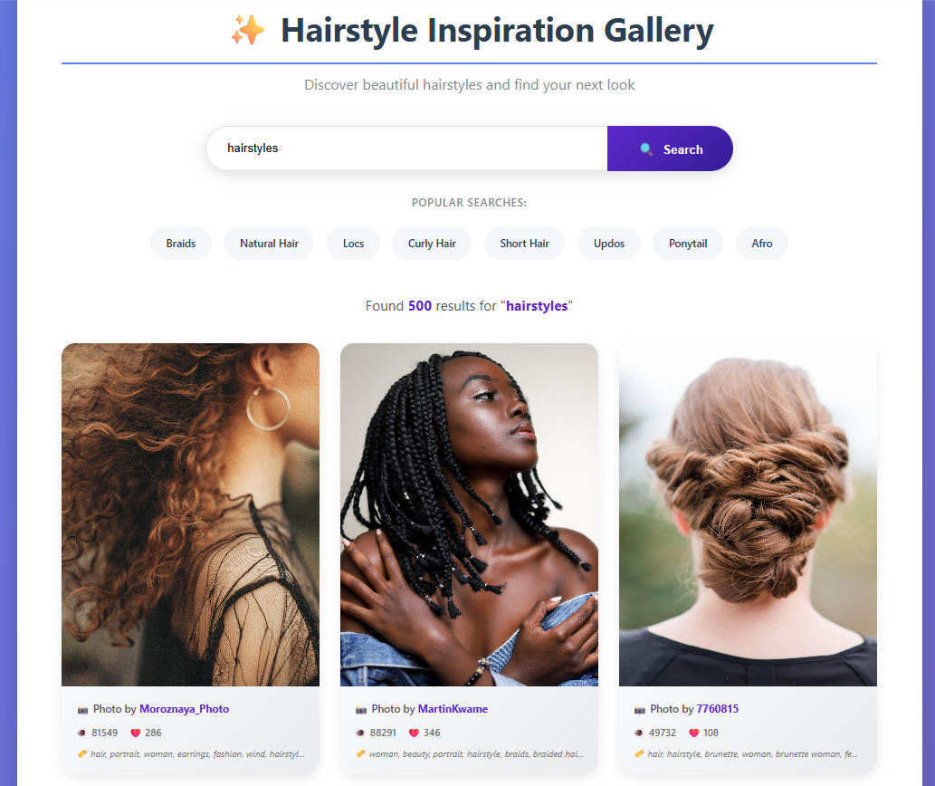

------------------------------------------------------------------------------------------------------------------

USER STORY 4
Complete the following user story:
STORY: User would like a “details” page.
Create a details page that will show the details of any single item from within the database, as selected by the user. Link this to the index page for each item.
- Add a details template to the template folder, and register the URL pattern.
- Create a views function that will find a single item from the database and send it to the details template.
- Add a link for each item on the display all items page that will direct to the details page for that item.
- Display all the details of the item on the details page.
- OPTIONAL STEP: Add styling to your template.
You are finished with the story when you have a functioning details page that will work for any item within your database. Make sure to test and debug before moving on to the next story.
------------------------------------------------------------------------------------------------------------------

User Story 4 - Code Summary:
This user story required creating a details page that displays all information for a single item selected from the database. To fulfill this requirement, a dedicated hairstyle details page was implemented to show the full details of an individual hairstyle.
A new template was created to serve as the details page. This template is responsible for displaying all relevant fields associated with a single hairstyle, including hairstyle image, description, time/duration, and total cost.
A view function was created to retrieve a single hairstyle from the database using its unique identifier (primary key). This function queries the database for the selected item and sends it to the details template through the context.
templates/appointments/hairstyle_detail.html
<div style="max-width: 800px; margin: auto; text-align: center;">
<h1>{{ hairstyle.name }}</h1>
<img src="{{ hairstyle.image_url }}"
alt="{{ hairstyle.name }}"
style="width: 100%; max-width: 600px; border-radius: 12px; margin: 20px 0;">
<p style="font-size: 18px; color: #555;">
{{ hairstyle.description }}
</p>
<a href="javascript:history.back()" class="btn" style="margin-top: 20px;">
← Back to Home
</a>
</div>

appointments/views.py(hairstyle_detail)
def hairstyle_detail(request, pk):
hairstyle = get_object_or_404(Hairstyle, pk=pk)
return render(request, "appointments/hairstyle_detail.html", {
"hairstyle": hairstyle
})

A URL pattern was registered to support dynamic routing to the details page based on the card image ID. Links were then added to each individual card image on the home page, allowing users to click on a specific card and navigate directly to its details page.
appointments/url.py
# Hairstyles Detail Page
path("hairstyles/<int:pk>/", views.hairstyle_detail, name="hairstyle_detail"),
(Hairstyle Card Image) template/appointments/home.html
<!-- Hairstyle Image -->
{% if hairstyle.image_url %}
<a href="{% url 'hairstyle_detail' hairstyle.pk %}" style="display: block;">
<div style="width: 100%; height: 250px; overflow: hidden; background-color: #f0f0f0;">
<img src="{{ hairstyle.image_url }}"
alt="{{ hairstyle.name }}"
style="width: 100%; height: 100%; object-fit: cover;"
onerror="this.onerror=null; this.src='https://via.placeholder.com/400x250/667eea/ffffff?text={{ hairstyle.name }}';">
</div>
</a>
{% else %}
<!-- Placeholder if no image -->
<div style="width: 100%; height: 250px; background: linear-gradient(135deg, #667eea 0%, #764ba2 100%); display: flex; align-items: center; justify-content: center;">
<span style="font-size: 60px;">💇‍♀️</span>
</div>
{% endif %}
With these components in place, the application now supports viewing detailed information for any individual appointment stored in the database. The details page functions correctly for all items, meeting the requirements of the user story.
Hairstyle Details Page UI
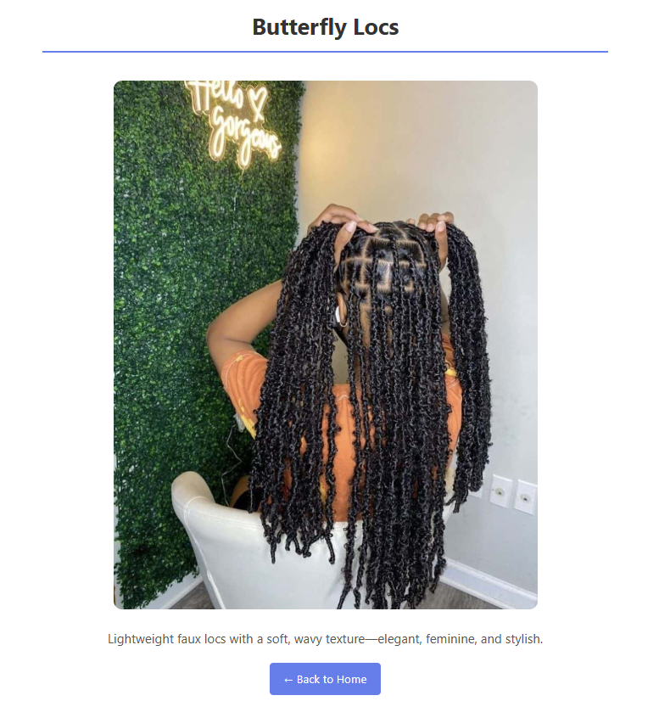
------------------------------------------------------------------------------------------------------------------

USER STORY 5
STORY: User would like edit and delete functions.
Allow for edit and delete functions to be done from the details page or from separate pages. Have confirmation before deleting.
- Add an edit page to the templates (another pattern URL).
- Use model forms and instances to display the content of a single item from the database.
- Have the views function send the information for the single item and save any changes.
- Include the option to delete an item with a confirmation that the user wants to delete it. Use a modal and javascript for the delete confirmation message.
- OPTIONAL STEP: Add styling to your templates.
You are finished with the story when you have a functioning edit page for any item in the database, and the ability to delete that item. Make sure to test and debug before submitting your project.
------------------------------------------------------------------------------------------------------------------

User Story 5 - Code Summary:
This user story required implementing edit and delete functionality for items stored in the database. To meet this requirement, edit and delete features were added for appointments, allowing users to modify or remove existing records.
An edit page was created using a dedicated template and URL pattern. The edit view retrieves a single appointment from the database and populates a model form using an instance of that appointment. This allows the existing data to be displayed in the form, where users can make changes and submit updates. When the form is submitted and validated, the updated information is saved back to the database.
appointments/url.py
# Edit appointment
path("appointments/edit/<int:pk>/", views.update_appointment, name="update_appointment"),
Appointment/views.py (update_appointment)
def update_appointment(request, pk):
"""
Edit an existing appointment.
Customer can change date, time, or hairstyle.
"""
appointment = get_object_or_404(Appointment, pk=pk)
if request.method == 'POST':
form = AppointmentForm(request.POST, instance=appointment)
if form.is_valid():
form.save()
messages.success(request, 'Appointment updated successfully!')
return redirect('appointment_list')
else:
form = AppointmentForm(instance=appointment)
return render(request, 'appointments/update.html', {
'form': form,
'appointment': appointment
})

templates/appointments/update.html
<h1>Edit Appointment</h1>
<form method="post" style="max-width: 600px;">
{% csrf_token %}
<div style="margin-bottom: 20px;">
<label style="display: block; margin-bottom: 5px; font-weight: bold;">
{{ form.customer_name.label }}
</label>
{{ form.customer_name }}
{% if form.customer_name.errors %}
<span style="color: red; font-size: 14px;">{{ form.customer_name.errors }}</span>
{% endif %}
</div>
<div style="margin-bottom: 20px;">
<label style="display: block; margin-bottom: 5px; font-weight: bold;">
{{ form.customer_email.label }}
</label>
{{ form.customer_email }}
{% if form.customer_email.errors %}
<span style="color: red; font-size: 14px;">{{ form.customer_email.errors }}</span>
{% endif %}
</div>
<div style="margin-bottom: 20px;">
<label style="display: block; margin-bottom: 5px; font-weight: bold;">
{{ form.hairstyle.label }}
</label>
{{ form.hairstyle }}
{% if form.hairstyle.errors %}
<span style="color: red; font-size: 14px;">{{ form.hairstyle.errors }}</span>
{% endif %}
</div>
<div style="margin-bottom: 20px;">
<label style="display: block; margin-bottom: 5px; font-weight: bold;">
{{ form.appointment_date.label }}
</label>
{{ form.appointment_date }}
{% if form.appointment_date.errors %}
<span style="color: red; font-size: 14px;">{{ form.appointment_date.errors }}</span>
{% endif %}
</div>
<div style="margin-bottom: 20px;">
<label style="display: block; margin-bottom: 5px; font-weight: bold;">
{{ form.appointment_time.label }}
</label>
{{ form.appointment_time }}
{% if form.appointment_time.errors %}
<span style="color: red; font-size: 14px;">{{ form.appointment_time.errors }}</span>
{% endif %}
</div>
<div style="margin-bottom: 20px;">
<label style="display: block; margin-bottom: 5px; font-weight: bold;">
{{ form.notes.label }}
</label>
{{ form.notes }}
{% if form.notes.errors %}
<span style="color: red; font-size: 14px;">{{ form.notes.errors }}</span>
{% endif %}
</div>
<div style="margin-top: 30px;">
<button type="submit" class="btn">💾 Update Appointment</button>
<a href="{% url 'appointment_list' %}" class="btn btn-secondary" style="margin-left: 10px;">✗ Cancel</a>
</div>
</form>

To support deletion, a delete view was implemented that retrieves a single appointment and displays a confirmation message before removal. This ensures that users do not accidentally delete records. The deletion process only proceeds after explicit user confirmation.
appointments/urls.py
# Cancel appointment
path("appointments/cancel/<int:pk>/", views.delete_appointment, name="delete_appointment"),

appointments/views.py (delete_appointment)
def delete_appointment(request, pk):
"""
Cancel an appointment.
Shows confirmation before deleting.
"""
appointment = get_object_or_404(Appointment, pk=pk)
if request.method == 'POST':
appointment.delete()
messages.success(request, 'Appointment cancelled successfully.')
return redirect('appointment_list')
# If someone visits the URL directly, just go back safely
return redirect("appointment_list")

templates/appointments/delete.html
<h1>Cancel Appointment</h1>
<div style="background-color: #fff3cd; border: 1px solid #ffc107; padding: 20px; border-radius: 5px; margin: 20px 0;">
<p style="font-size: 18px; margin-bottom: 15px;">
⚠️ Are you sure you want to cancel this appointment?
</p>
<div style="background-color: white; padding: 20px; border-radius: 5px; margin-top: 15px;">
<p><strong>Customer:</strong> {{ appointment.customer_name }}</p>
<p><strong>Email:</strong> {{ appointment.customer_email }}</p>
<p><strong>Service:</strong> {{ appointment.hairstyle.name }}</p>
<p><strong>Date:</strong> {{ appointment.appointment_date }}</p>
<p><strong>Time:</strong> {{ appointment.get_appointment_time_display }}</p>
<p><strong>Cost:</strong> ${{ appointment.get_cost }}</p>
</div>
</div>
<form method="post">
{% csrf_token %}
<button type="submit" class="btn btn-danger">🗑️ Yes, Cancel Appointment</button>
<a href="{% url 'appointment_list' %}" class="btn btn-secondary" style="margin-left: 10px;">
← No, Keep It
</a>
</form>

Edit and delete actions are accessible from the appointment list page and/or the details page, providing flexible access points for managing records. Optional styling was applied to improve usability and clarity.
After testing and debugging, the application successfully supports editing and deleting any appointment stored in the database, fulfilling the requirements of the user story.

View Bookings UI
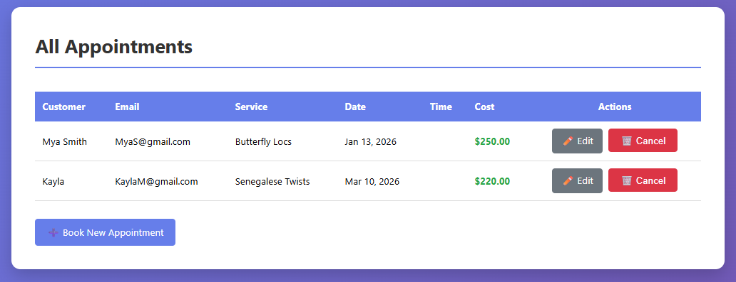

Edit UI
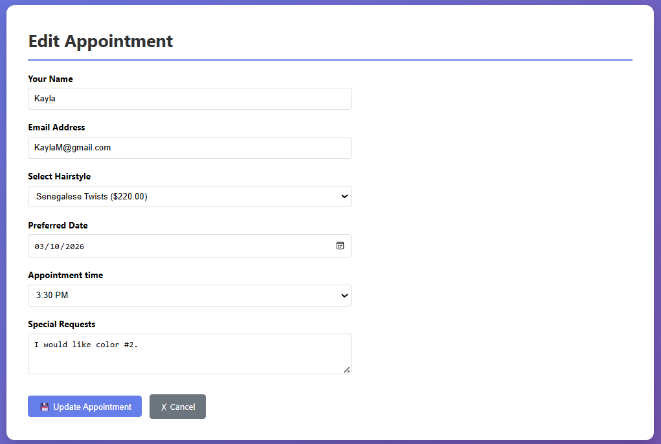

Delete Modal UI
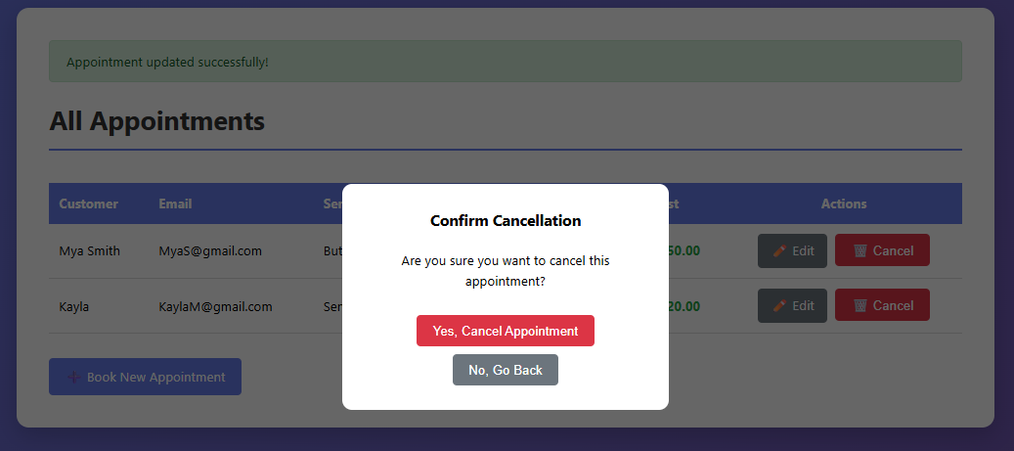
Cancel Message UI
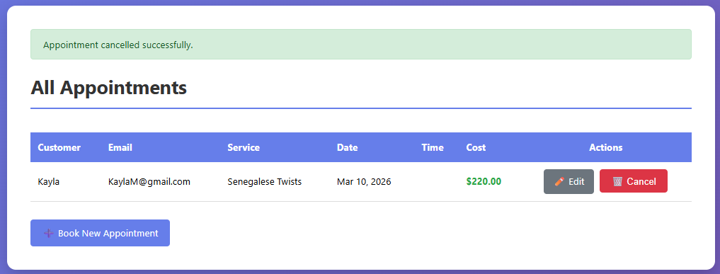

Web Scraper (BeautifulSoup)
Natural Hair Tips Web Scraping Feature:
This user story introduces a Natural Hair Tips page that integrates web scraping into the salon application. A new Django view called natural_hair_tips was created to retrieve hair care content from an external article using the requests library and parse the HTML with BeautifulSoup web scraper. The scraping logic locates section headings and collects related paragraph and list content to organize the information into structured tips. The extracted content is formatted and stored in a list that is passed to the template through the Django context.
Appointments/views.py (natural_hair_tips)
from bs4 import BeautifulSoup

def natural_hair_tips(request):
SOURCE_URL = "https://www.beautycon.com/article/heat-damage-101-how-long-will-it-take-to-get-your-curls-back"
tips = []
error = None
try:
headers = {
"User-Agent": (
"Mozilla/5.0 (Windows NT 10.0; Win64; x64) "
"AppleWebKit/537.36 (KHTML, like Gecko) "
"Chrome/120.0 Safari/537.36"
)
}
response = requests.get(SOURCE_URL, headers=headers, timeout=10)
response.raise_for_status()
soup = BeautifulSoup(response.text, "html.parser")
# Main article container
article = soup.select_one("section#primary.content-area") or soup.select_one("#primary")
if not article:
error = "Could not find article content on the source page."
else:
# Look at all H2/H3 headings: Month 1, Month 6, One year, etc.
for heading in article.find_all(["h2", "h3"]):
title = heading.get_text(strip=True)
if not title:
continue
body_parts = []
# Collect everything after this heading until the next heading
for sibling in heading.next_siblings:
name = getattr(sibling, "name", None)
if name in ["h2", "h3"]:
break
# Paragraph text
if name == "p":
text = sibling.get_text(" ", strip=True)
if text:
body_parts.append(text)
# (Optional) if the page uses real lists too
if name in ["ul", "ol"]:
for li in sibling.find_all("li"):
li_text = li.get_text(" ", strip=True)
if li_text:
body_parts.append(f"• {li_text}")
if body_parts:
# Join all segments into one big string
body = " ".join(body_parts)
# 🔥 NOW force line breaks before each bullet character
# e.g. "... are: • A • B" -> "... are:<br>• A<br>• B"
body = re.sub(r"\s*•\s*", r"<br>• ", body)
tips.append(
{
"title": title,
"body": body, # contains <br> tags now
}
)
# Optional: limit number of sections
tips = tips[:10]
except Exception as e:
print("Error scraping natural hair tips:", e)
error = "Sorry, we couldn’t load the natural hair tips right now."
context = {
"tips": tips,
"source_url": SOURCE_URL,
"error": error,
}
return render(request, "appointments/natural_hair_tips.html", context)

A template named natural_hair_tips.html was added to display the scraped content in a grid of styled cards, each showing a section title and its corresponding tips. Error handling was implemented to ensure the page displays a message if the content cannot be retrieved. This feature demonstrates how a Django application can use BeautifulSoup web scraping to collect external data and dynamically display it within the user interface.
appointments/natural_hair_tips.html
{% block content %}
<div class="tips-container">
<h1>🌿 Natural Hair Care Tips for Beginners</h1>
<p class="subtitle">
Curated beginner-friendly tips for textured and natural hair, scraped from
a trusted natural hair resource.
</p>
{% if error %}
<div class="error-message">
<p>{{ error }}</p>
</div>
{% endif %}
{% if tips %}
<div class="tips-grid">
{% for tip in tips %}
<div class="tip-card">
<h2>{{ tip.title }}</h2>
<div class="tip-body">
{{ tip.body|safe }}
</div>
</div>
{% endfor %}
</div>
{% else %}
{% if not error %}
<p>No tips found at the moment. Please check back later.</p>
{% endif %}
{% endif %}
<p class="source-note">
Source: <a href="{{ source_url }}" target="_blank" rel="noopener">
View full article on NaturallyCurly
</a>
</p>
</div>
{% endblock %}

Natural Hair Care Tips UI
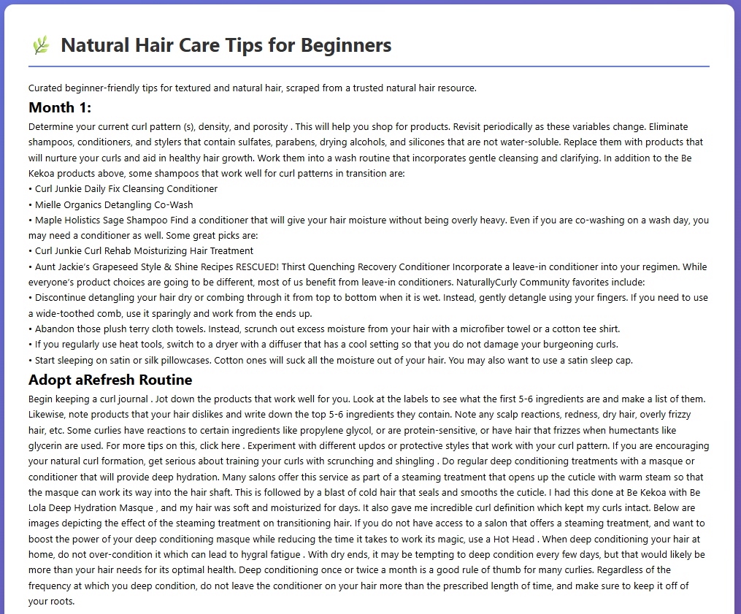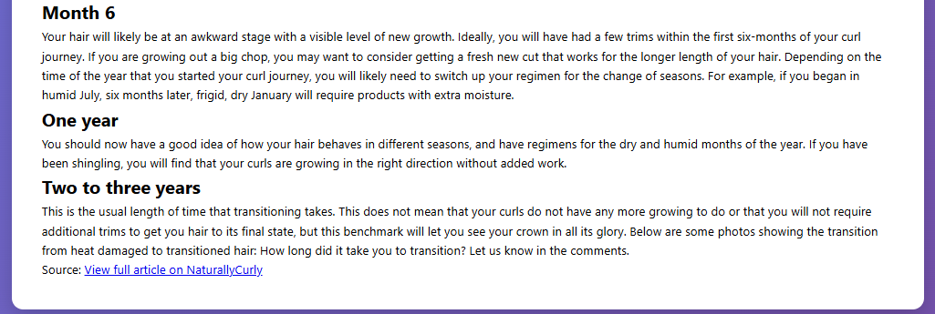
Project structure:
