*Muusoctopus leioderma* respiration

Lloyd Trueblood and Kirt Onthank

2022-08-29

Table of Contents

# 1 Reading in libraries

I am reading in the libraries I use for this analysis. Included among these is the “OTools” package, which was written by Kirt Onthank. This can be install from github using the command:

install_github('KirtOnthank\OTools')

The install_github command is from the ‘remotes’ library.

library(OTools)  
library(xlsx)  
library(nlme)  
library(car)  
library(emmeans)  
library(respirometry)  
library(knitr)

# 2 Find the relevant files

This code is meant to find the metabolic rate files in the current directory and sort them into their types.

files=list.files(recursive=T)  
resp.files=grep(".txt",files,value=T)  
pcrit.files=grep("pcrit|pcrti",resp.files,value=T,ignore.case=T)  
metab.files=setdiff(resp.files,pcrit.files)  
blank.files=grep("blank_only",resp.files,value=T,ignore.case=T)  
rmr.files=setdiff(metab.files,blank.files)  
rmr.files=rmr.files[!grepl("-ch2.txt|-ch3.txt|-ch4.txt|\\(1\\).txt",rmr.files)]  
rmr.files=rmr.files[!duplicated(basename(rmr.files))]

# 3 Reading in the data log file

This reads in the data log file, which contains information on octopus mass, flow rate, and other associated information.

data.log=read.csv("Muus_Data_Log.csv")

# 4 Running the RMR data analysis

First I am going to make a object to put the RMR data into.

routine=data.frame(filename=as.character(),  
 spreadsheet_guess=as.character(),  
 octo=as.character(),  
 mass=as.numeric(),  
 pco2=as.numeric(),  
 day=as.numeric(),  
 rmr=as.numeric()  
 )

Then I am running a quick check to make sure that we are matching file names of the metabolic runs with the lines in the Data Log file.

file_check=as.character()  
score=as.numeric()  
for (i in 1:length(rmr.files)){  
 filename=rmr.files[i]  
 guess=which.min(adist(basename(filename),data.log$File.name))  
 file_check[i]=data.log$File.name[guess]  
 score[i]=min(adist(basename(filename),data.log$File.name))  
}  
  
write.csv(cbind(basename(rmr.files),file_check,score),file = "filecheck.csv")

Nest, I run the analysis to calculate RMR from each file. We are discarding the first three hours (using data as resp[resp$times>3600*3,] in the resp.open function) from each run to account for elevated metabolic rate at the beginning of the run.

column.count=1  
for (i in 1:length(rmr.files)){  
 filename=rmr.files[i]  
 print(paste("starting file ", basename(filename)," (loop",i,")",sep=""))  
 if(length(grep("Group 4|presens|ch\\d\\.txt",basename(filename)))>0){  
 resp=read.presens(filename)  
 }else{  
 resp=read.pyro(filename)  
 }  
 print("finding closest match in log")  
  
guess=which.min(adist(basename(filename),data.log$File.name))  
   
 flow=as.numeric(data.log$flow.rate..L.min.[guess])  
 mass=as.numeric(data.log$Mass..g.[guess])  
 if(is.na(flow)){  
 flow=0.1  
 }  
 if(is.na(mass)){  
 mass=10  
 }  
 print("calculating rmr")  
 resp.mean=mean(resp.open(resp[resp$times>3600*3,],  
 flow.rate=flow*1000,  
 weight=mass)$resp,  
 na.rm=T)  
 print("writing data to object")  
 routine[column.count,1]=basename(filename)  
 routine[column.count,2]=data.log$File.name[guess]  
 routine[column.count,3]=data.log$octo1[guess]  
 routine[column.count,4]=mass  
  
 if(length(grep("1800",filename))>0){  
 routine[column.count,5]=1800  
 }  
 if(length(grep("1000",filename))>0){  
 routine[column.count,5]=1000  
 }  
 routine[column.count,6]=data.log$day[guess]  
 routine[column.count,7]=resp.mean  
 column.count=column.count+1  
 if(sum(is.na(resp$O23))<10&!grepl("blank",filename)){  
 print("found second respirometer")  
 flow=as.numeric(data.log$Flow.rate.2[guess])  
 mass=as.numeric(data.log$Mass.2[guess])  
 resp.mean=mean(resp.open(resp[resp$times>3600*3,],  
 inflow=3,  
 outflow=4,  
 flow.rate=flow*1000,  
 weight=mass)$resp,na.rm=T)  
 print("writing data to object")  
 routine[column.count,1]=basename(filename)  
 routine[column.count,2]=data.log$File.name[guess]  
 routine[column.count,3]=data.log$octo2[guess]  
 routine[column.count,4]=mass  
   
 if(length(grep("1800",filename))>0){  
 routine[column.count,5]=1800  
 }  
 if(length(grep("1000",filename))>0){  
 routine[column.count,5]=1000  
 }  
 routine[column.count,6]=data.log$day[guess]  
 routine[column.count,7]=resp.mean  
 column.count=column.count+1  
 }  
 print(paste("end of file ", basename(filename)," (loop",i,")",sep=""))  
}

In order to not need to re-run the analysis each time, I am writing the results out to a .csv, then reading it back in. I will set both the evaluation of this chunk and the last to FALSE.

write.csv(routine,"RMR_Results.csv")

routine=read.csv("RMR_Results.csv")

# 5 Running linear effects model

To make the relationship linear between mass and metabolic rate linear, I took the log of both.

routine$mass.log=log(routine$mass)  
routine$rmr.log=log(routine$rmr)

Setting pCO2 to factor class:

routine$pco2=as.factor(routine$pco2)

Next I set orthogonal contrasts:

contrasts(routine$pco2)=contr.poly(2)

Running the linear mixed effects model and ANOVA using type III sum of squares:

routine.lme=lme(rmr.log~mass.log+pco2+day,random=~1|octo,  
 correlation=corAR1(form=~day|octo),  
 data=routine[routine$octo!="2-1",])  
routine.anova=Anova(routine.lme,type="III")  
routine.anova

## Analysis of Deviance Table (Type III tests)  
##   
## Response: rmr.log  
## Chisq Df Pr(>Chisq)   
## (Intercept) 35.8232 1 2.161e-09 ***  
## mass.log 13.2309 1 0.0002754 ***  
## pco2 0.0906 1 0.7634316   
## day 0.0555 1 0.8138299   
## ---  
## Signif. codes: 0 '***' 0.001 '**' 0.01 '*' 0.05 '.' 0.1 ' ' 1

rmr.lme.table=cbind(  
 c("Mass","pCO2","Day"),  
 round(routine.anova$Chisq[2:4],2),  
 routine.anova$Df[2:4],  
 round(routine.anova$`Pr(>Chisq)`[2:4],5)  
)  
colnames(rmr.lme.table)=c("Factor","Chi-square", "DF", "p-value")  
  
kable(rmr.lme.table)

| Factor | Chi-square | DF | p-value |
| --- | --- | --- | --- |
| Mass | 13.23 | 1 | 0.00028 |
| pCO2 | 0.09 | 1 | 0.76343 |
| Day | 0.06 | 1 | 0.81383 |

# 6 Summary of LME

routine.em=data.frame(emmeans(routine.lme,~pco2+day+mass.log))

## Warning: contrasts dropped from factor pco2

routine.em

## pco2 day mass.log emmean SE df lower.CL upper.CL  
## 1 1000 1 2.906025 0.9553184 0.1738296 13 0.5797823 1.330855  
## 2 1800 1 2.906025 1.0278433 0.1738296 13 0.6523072 1.403379  
## 3 1000 7 2.906025 0.9715304 0.1738296 13 0.5959943 1.347067  
## 4 1800 7 2.906025 1.0440553 0.1738296 13 0.6685192 1.419591

rmr.df=  
data.frame(cbind(  
 as.numeric(as.character(routine.em$pco2)),  
 routine.em$day,  
 sprintf("%.2f",signif(exp(routine.em$emmean),3)),  
 paste(sprintf("%.2f",signif(exp(data.frame(routine.em)$lower.CL),3)),  
 "-",  
 sprintf("%.2f",signif(exp(data.frame(routine.em)$upper.CL),3)))  
))  
rmr.df

## X1 X2 X3 X4  
## 1 1000 1 2.60 1.79 - 3.78  
## 2 1800 1 2.80 1.92 - 4.07  
## 3 1000 7 2.64 1.81 - 3.85  
## 4 1800 7 2.84 1.95 - 4.14

colnames(rmr.df)=c("pCO~2~ ($\\mu$atm)",  
 "day",  
 "Routine Metabolic Rate ($\\mu$O~2~ g^-1^ hr^-1^)",  
 "RMR 95% CI")  
kable(rmr.df,align="c")

| pCO2 (atm) | day | Routine Metabolic Rate (O2 g-1 hr-1) | RMR 95% CI |
| --- | --- | --- | --- |
| 1000 | 1 | 2.60 | 1.79 - 3.78 |
| 1800 | 1 | 2.80 | 1.92 - 4.07 |
| 1000 | 7 | 2.64 | 1.81 - 3.85 |
| 1800 | 7 | 2.84 | 1.95 - 4.14 |

# 7 Plotting the data

## 7.1 Predicted values

First I am getting the model predicted values for each treatment between the max an minimum mass values.

seq1.1800=seq(from=min(routine$mass.log[routine$pco2==1800]),  
 to=max(routine$mass.log[routine$pco2==1800]),  
 length.out=100)  
  
df1.1800=data.frame(  
 day=rep(1,100),  
 mass.log=seq1.1800,  
 pco2=as.factor(rep(1800,100))  
)  
pred1.1800= predict(routine.lme,newdata = df1.1800,level=0)  
  
seq1.1000=seq(from=min(routine$mass.log[routine$pco2==1000]),  
 to=max(routine$mass.log[routine$pco2==1000]),  
 length.out=100)  
  
df1.1000=data.frame(  
 day=rep(1,100),  
 mass.log=seq1.1000,  
 pco2=as.factor(rep(1000,100))  
)  
  
pred1.1000=predict(routine.lme,newdata = df1.1000,level=0)  
  
seq7.1800=seq(from=min(routine$mass.log[routine$pco2==1800]),  
 to=max(routine$mass.log[routine$pco2==1800]),  
 length.out=100)  
  
df7.1800=data.frame(  
 day=rep(7,100),  
 mass.log=seq7.1800,  
 pco2=as.factor(rep(1800,100))  
)  
  
pred7.1800=predict(routine.lme,newdata = df7.1800,level=0)  
  
seq7.1000=seq(from=min(routine$mass.log[routine$pco2==1000]),  
 to=max(routine$mass.log[routine$pco2==1000]),  
 length.out=100)  
  
df7.1000=data.frame(  
 day=rep(7,100),  
 mass.log=seq7.1000,  
 pco2=as.factor(rep(1000,100))  
)  
  
pred7.1000=predict(routine.lme,newdata = df7.1000,level=0)

Next, I am actually plotting it.

svg(filename="Figure_1.svg",height=3.5,width=3.5,pointsize=6)  
par(fig=c(0.04,1,0,1))  
plot(rmr~mass,data=routine[routine$octo!="2-1",],log="xy",axes=F,ylab="",xlab="",type="n")  
box(lwd=2)  
axis(1,lwd=2,cex.axis=1.5)  
axis(2,lwd=2,cex.axis=1.5)  
mtext(expression("Routine Metabolic Rate ("*mu*"molO"[2]*" g"^-1*"hr"^-1*")"),  
 side=2,cex=1.8,line=2.5)  
mtext("Mass (g)",side=1,cex=1.8,line=2.5)  
  
points(rmr~mass,data=routine[routine$pco2==1000&routine$day==1&routine$octo!="2-1",],  
 pch=21,bg="white",col="blue",cex=2)  
points(rmr~mass,data=routine[routine$pco2==1000&routine$day==7&routine$octo!="2-1",],  
 pch=21,bg="blue",cex=2)  
points(rmr~mass,data=routine[routine$pco2==1800&routine$day==7&routine$octo!="2-1",],  
 pch=21,bg="red",cex=2)  
points(rmr~mass,data=routine[routine$pco2==1800&routine$day==1&routine$octo!="2-1",],  
 pch=21,bg="white",col="red",cex=2)  
lines(exp(seq1.1800),exp(pred1.1800),col="red",lwd=2,lty=2)  
lines(exp(seq1.1000),exp(pred1.1000),col="blue",lwd=2,lty=2)  
lines(exp(seq7.1800),exp(pred7.1800),col="red",lwd=2,lty=1)  
lines(exp(seq7.1000),exp(pred7.1000),col="blue",lwd=2,lty=1)  
legend("topright", c(expression("1000 "*mu*"atm pCO"["2"]*", day 1"),  
 expression("1000 "*mu*"atm pCO"["2"]*", day 7"),  
 expression("1800 "*mu*"atm pCO"["2"]*", day 1"),  
 expression("1800 "*mu*"atm pCO"["2"]*", day 7")),  
 pch = 21,bty="n",title = expression("Treatment pCO"["2"]),  
 pt.bg=c("white","blue","white","red"),col=c("blue","black","red","black"),  
 inset = .02,cex=1.3,box.lwd=2,pt.lwd=1,pt.cex=2)  
  
dev.off()

## png   
## 2

Converting the image to a png to be displayed in the RMarkdown.

cairosvg Figure_1.svg -o Figure_1.png -d 300

Converting to eps for submission.

inkscape Figure_1.svg -o Figure_1.eps --export-ignore-filters --export-ps-level=3

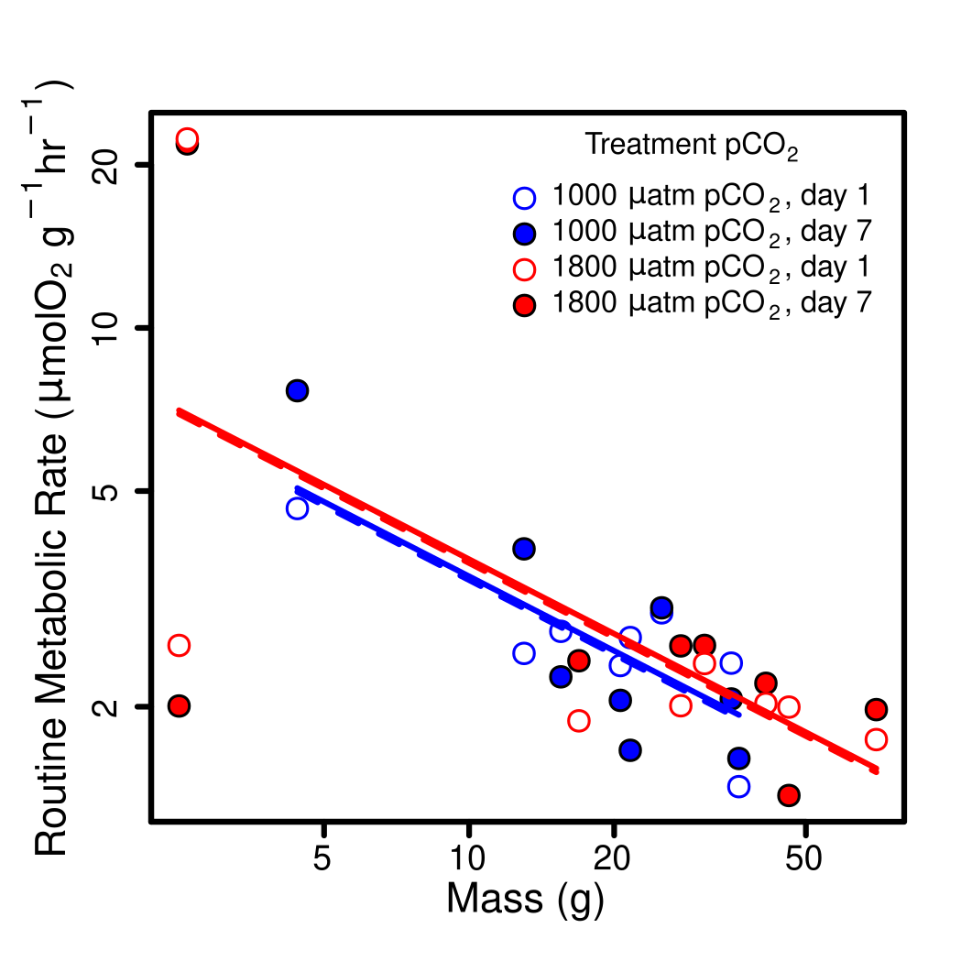

work in progress text

#logmass=log(median(routine$mass))  
logmass=2.906025  
rmr.df=data.frame(day=c(1,1,7,7),  
 pCO2=c(1000,1800,1000,1800),  
 RMR=round(exp(predict(routine.lme,  
 newdata=data.frame(  
 day=c(1,1,7,7),  
 mass.log=rep(logmass,4),  
 pco2=as.factor(c(1000,1800,1000,1800))),  
 level=0)  
 )[1:4],2)  
 )  
  
colnames(rmr.df)[2]="pCO~2~ ($\\mu$atm)"  
colnames(rmr.df)[3]="Routine Metabolic Rate ($\\mu$O~2~ g^-1^ hr^-1^)"  
  
kable(rmr.df,align="c")

| day | pCO2 (atm) | Routine Metabolic Rate (O2 g-1 hr-1) |
| --- | --- | --- |
| 1 | 1000 | 2.60 |
| 1 | 1800 | 2.80 |
| 7 | 1000 | 2.64 |
| 7 | 1800 | 2.84 |