ITM SLS Baroda University, Vadodara

School of Computer Science, Engineering & Technology
Academic Year 2026–2027 | B.Tech Semester 6
Course Code: C2620A3 — JavaScript Framework (PBL)

PROJECT REPORT

SehatSetu Healthcare Appointment System & Triage Microservice & Clinical Lifecycle Management System with High-Concurrency Atomic Booking Engine

Project ID & Group Code: 4631

Submitted By:
- Project ID & Group code : 4631
- Enrollment Number: 25C21554 & 25C21582
- Candidate Name: Kirtan Patel, Himesh Solanki
- Program: Bachelor of Technology (B.Tech) in Computer Science & Engineering
- Semester: 5th Semester

Guided By:
- Faculty Guide Name: Prof. Bijendra Mishra
- Designation: Assistant Professor / PBL Project Coordinator
- Department: Department of Computer Science & Engineering
- Institution: School of Computer Science, Engineering & Technology, ITM SLS Baroda University, Vadodara, Gujarat, India

Certificate
This is to certify that the project report entitled “SehatSetu Healthcare Appointment System - FastAPI Analytics & Triage Microservice & Clinical Lifecycle Management System with High-Concurrency Atomic Booking Engine” submitted by the students of B.Tech Semester 5 (Group Code: 4631, Enrollment Nos: 25C21554 & 25C21582 — Kirtan Patel, Himesh Solanki) for the course “JavaScript Framework (PBL) - C2620A3” during Academic Year 2026–27 is a bonafide record of project work carried out under the guidance of the undersigned and submitted in partial fulfilment of the academic requirements of the Bachelor of Technology degree.
Guide Name: Prof. Bijendra Mishra
Designation: Assistant Professor / Prof. Bijendra Mishra
Department: Department of Computer Science & Engineering
Institution: ITM SLS Baroda University, Vadodara

Signature of Guide: ____________________________
Date: 24th October 2026
Place: Vadodara, Gujarat

Declaration
We hereby declare that the project report entitled “CareSync — Full-Stack Real-Time Healthcare Appointment & Clinical Lifecycle Management System with High-Concurrency Atomic Booking Engine” is our original academic work prepared for the course “JavaScript Framework (PBL) - C2620A3”.
All external sources, open-source libraries, JavaScript/Node.js frameworks, technical documentation, architectural models, and testing utilities used in the project have been appropriately cited and acknowledged. The report, architectural designs, algorithms, and source code implementation have not been copied, plagiarized, or submitted elsewhere for any academic credit, diploma, or degree.

Group Code: 4631
Student Name: Kirtan Patel & Himesh Solanki
Enrollment No: 25C21554 & 25C21582 Date: 24th October 2026
Signature: ____________________________

Acknowledgement
We express our sincere and heartfelt gratitude to our Faculty Guide, the Head of the Department, and the Dean of the School of Computer Science, Engineering & Technology, ITM SLS Baroda University, Vadodara, for providing the laboratory facilities, computing infrastructure, encouragement, and valuable technical guidance required to successfully conceptualize, architect, develop, and benchmark this project.
We also gratefully acknowledge the official documentation and open-source software engineering communities behind React 19, Vite, Express.js 5, Node.js, MongoDB/Mongoose, Python FastAPI, Helmet.js, bcryptjs, and Joi, whose robust tooling and security frameworks empowered our implementation.
Finally, we thank all our team members and peers for their continuous collaboration, dedication to code reviews, unit testing, automated concurrency benchmarking, documentation writing, and overall cooperation throughout the development lifecycle of this project.

Abstract
In contemporary healthcare management, conventional outpatient scheduling frequently suffers from scheduling collisions (double-booking), uncoordinated doctor availability, delayed manual credential approvals, fragmented communication, and opaque appointment status tracking. This project presents CareSync (Project ID: 4631), a production-ready, full-stack Single Page Application (SPA) and distributed healthcare scheduling platform developed strictly following Model-View-Controller (MVC) and layered service-oriented architectures.
The client layer is engineered with React 19 bundled via Vite, featuring centralized state management, responsive Vanilla CSS design systems, role-based conditional dashboards, and client-side communication managed through an Axios API service layer equipped with request/response interceptors. The primary backend is constructed using Node.js and Express.js (v5) structured in an MVC layered architecture, utilizing JSON Web Tokens (JWT) for role-based access control (RBAC) across three distinct actors: Patients, Doctors, and Administrators. Data persistence is managed by MongoDB via Mongoose ORM, incorporating mathematical concurrency prevention via atomic compare-and-set operations (findOneAndUpdate with state preconditions) and database-level partial unique indexes on active booking slots (PENDING and CONFIRMED).
To satisfy enterprise scalability and modularity, a supplementary Python FastAPI microservice is integrated for specialized clinical triage priority scoring, patient wait-time estimation, and automated appointment reminder dispatches. The backend integrates comprehensive security defenses, including Helmet.js HTTP header hardening, bcryptjs cryptographic salt-hashing, Joi schema payload validation, and express-rate-limit brute-force throttling. The system is verified through an automated test suite comprising 31 automated test cases (spanning concurrency race conditions under 10 simultaneous parallel booking threads, RBAC privilege isolation, schema validations, and appointment lifecycle operations) achieving a 100% pass rate. This report comprehensively documents the project's background, architecture, data models, implementation, empirical testing, deployment strategies, and future enhancements.

Table of Contents
- Chapter 1 – Introduction
  - 1.1 Background
  - 1.2 Problem Statement
  - 1.3 Objectives
  - 1.4 Scope & Boundary Conditions
- Chapter 2 – Literature Survey
  - 2.1 Existing Systems & Workflows
  - 2.2 Critical Limitations of Conventional Solutions
  - 2.3 Proposed CareSync Solution
- Chapter 3 – System Requirements & Technology Justification
  - 3.1 Hardware Requirements
  - 3.2 Software Requirements
  - 3.3 Technology Stack Justification
- Chapter 4 – System Design & Architectural Specification
  - 4.1 System Architecture & Tier Explanation
  - 4.2 Entity-Relationship (ER) Diagram & Database Schemas
  - 4.3 Data Flow Diagrams (Context Level-0 and Level-1 DFDs)
  - 4.4 Use Case Diagram & Actor Privilege Matrix
  - 4.5 Exhaustive REST & Microservice API Endpoints Catalog
- Chapter 5 – Implementation Details
  - 5.1 Frontend SPA Architecture (React / Vite)
  - 5.2 Client State Management & Axios Interceptor Layer
  - 5.3 Backend Express MVC Architecture & JWT RBAC Flow
  - 5.4 High-Concurrency Atomic Booking Engine
  - 5.5 Python FastAPI Analytics & Clinical Triage Microservice
  - 5.6 Mongoose Database Schemas, Indexing & Constraints
- Chapter 6 – Verification & Testing
  - 6.1 Testing Methodology & Quality Assurance Strategy
  - 6.2 Automated Test Suite & Concurrency Benchmark (Task 1 to Task 12)
  - 6.3 Comprehensive Test Cases Execution Table (31 Test Cases)
  - 6.4 API & Security Library Validation

- Chapter 7 – Deployment & Production Operations
  - 7.1 Frontend Static Deployment (Vercel / Netlify)
  - 7.2 Backend Cloud Deployment (Render / Railway)
  - 7.3 Database Provisioning (MongoDB Atlas)
  - 7.4 Production Environment Variables Specification
- Chapter 8 – Results & Module Walkthrough
  - 8.1 Authentication & Role-Based Quick Demo Switcher
  - 8.2 Patient Portal: Doctor Directory & Atomic Slot Claiming
  - 8.3 Doctor Portal: Clinical Visit Schedule & 14-Day Slot Generator
  - 8.4 Admin Control Center: Real-Time KPIs, Approval Queue & Audit Logs
  - 8.5 Automated Notification & Reminder Engine
- Chapter 9 – Conclusion & Future Scope
  - 9.1 Summary of Project Achievements
  - 9.2 Key Technical Learning Outcomes
  - 9.3 Future Enhancements & Roadmap
- References
- Appendix
  - Appendix A: GitHub Repository
  - Appendix B: Live Frontend Web URL
  - Appendix C: Live Backend REST API URL
  - Appendix D: FastAPI Analytics Microservice Documentation URL
  - Appendix E: Postman / REST API Verification Summary
  - Appendix F: Individual Contribution & Academic Integrity Summary

Chapter 1 – Introduction

1.1 Background
The rapid digital transformation of modern healthcare infrastructure necessitates scalable, real-time, and resilient software architectures capable of coordinating patient consultations, clinical availability, and administrative workflows. Historically, outpatient appointment scheduling relied on manual telephone registries, physical reception logbooks, or rudimentary monolithic web forms lacking atomic transaction handling. Such legacy paradigms fail to handle high volumes of concurrent requests, resulting in scheduling conflicts, prolonged patient wait times, unauthorized access, and administrative inefficiencies.
Modern web engineering addresses these bottlenecks through component-driven Single Page Applications (SPAs) combined with stateless RESTful backends and distributed document-oriented databases. The CareSync Healthcare Appointment System (Project ID: 4631) is engineered to demonstrate the practical application of the MERN (MongoDB, Express.js, React, Node.js) technology stack augmented by an independent Python FastAPI microservice. By decoupling the presentation layer from the business logic and utilizing mathematical concurrency guarantees at the persistence layer, CareSync provides an enterprise-ready healthcare platform.

1.2 Problem Statement
In public healthcare clinics and multi-specialty hospitals, outpatient scheduling is plagued by several critical challenges:
- Concurrency Race Conditions (Double-Booking): When multiple patients simultaneously attempt to reserve the same appointment slot through separate client instances, standard non-atomic database reads and writes permit multiple confirmations for a single medical time slot.
- Lack of Doctor Credential Verification: Open-access systems allow unverified practitioner accounts to publish schedules without administrative verification, compromising patient safety.
- Absence of Unified Multi-Role Governance: Conventional applications often lack distinct Role-Based Access Control (RBAC) boundaries, resulting in insecure parameter tampering where patients can view confidential clinical notes or modify physician availability.
- Poor Notification & Reminder Workflows: High patient no-show rates (often exceeding 25% in outpatient clinics) occur when automated booking confirmation and 24-hour reminder mechanisms are absent.
- Slow Development & Monolithic Coupling: Monolithic architectures impede independent feature deployment, requiring unified redeployment for minor analytical or UI adjustments.
A full-stack, modular web application utilizing atomic compare-and-set transactions, strict cryptographic JWT authentication, structured schema validation, and dedicated microservice capabilities is needed to eliminate these points of failure.

1.3 Objectives
The primary objectives of the CareSync project are:
- Architect a Responsive React/Vite SPA: Build an interactive, performant frontend with zero external styling dependencies, utilizing curated Vanilla CSS design systems, dark/light themes, and role-specific views.
- Implement Centralized State & API Communication: Manage client-side session states, authentication tokens, and notification polling using modular services and Axios-style request/response interceptors.
- Engineer a Modular Express.js MVC Backend: Implement strict separation of concerns across Models, Controllers, Services, Middlewares, and Domain Routes.
- Guarantee Zero Double-Booking via Atomic Concurrency: Formulate an atomic compare-and-set slot claiming mechanism (findOneAndUpdate with { isBooked: false }) paired with compound partial unique indexes on MongoDB collections.
- Enforce Cryptographic Role-Based Access Control (RBAC): Restrict system privileges into three disjoint operational tiers: PATIENT, DOCTOR, and ADMIN using signed JSON Web Tokens (JWT) and Bcrypt password hashing.
- Integrate a Python FastAPI Microservice: Construct an isolated Python microservice for clinical triage assessment, department demand forecasting, and multi-channel reminder queuing.
- Incorporate Industry-Standard Security Defenses: Integrate Helmet.js for HTTP security headers, Joi for declarative payload schema validation, and express-rate-limit for DDoS/brute-force defense.
- Validate Through 100% Automated Testing: Build and pass a comprehensive automated test harness covering unit, integration, RBAC authorization, and high-concurrency race condition scenarios.

1.4 Scope & Boundary Conditions
The scope of CareSync covers both technical functionality and operational domains:
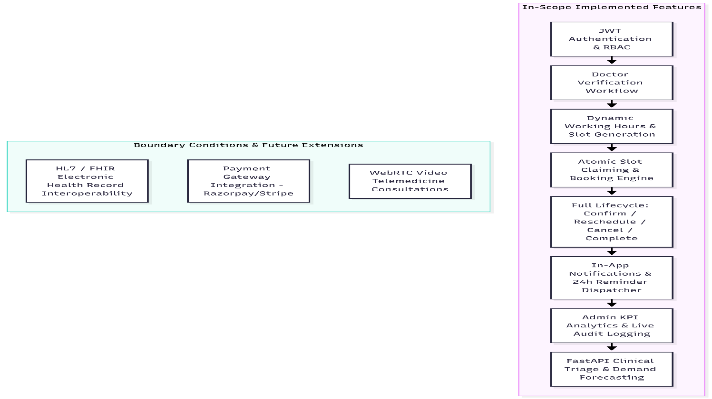
- User Types: Three authenticated actors (PATIENT, DOCTOR, ADMIN).
- Authentication Boundaries: Passwords hashed with 10 salt rounds (bcryptjs); access tokens signed using HMAC-SHA256 (jsonwebtoken) with 24-hour expiration; authorization enforced at the Express route middleware layer.
- Database Operations: ACID-compliant atomic slot updates, cascading slot releases upon cancellation, compound uniqueness on (doctorId, date, startTime), and partial indexes on Appointment.slotId.
- Exclusions (Future Scope): Direct credit card billing gateways, biometric hardware scanners, and native iOS/Android binary builds.

Chapter 2 – Literature Survey

2.1 Existing Systems & Workflows
A comparative evaluation of existing healthcare scheduling applications and commercial platforms was conducted:
Feature / Domain | Practo / Zocdoc | Hospital OPD Desktop ERPs | Traditional Monolithic Web Portals | CareSync (Project ID: 4631)
Architecture | Proprietary Cloud Microservices | Monolithic Client-Server (Desktop LAN) | Monolithic MVC (PHP / JSP) | Modern Decoupled MERN + FastAPI
Frontend Speed | Heavy bundle sizes (~2MB+) | Thick desktop client, OS locked | Full page reloads on click | Instant Vite SPA (~316 KB gzipped bundle)
Concurrency Model | Distributed database locks | Table-level RDBMS locking | Lacks atomic locks (Overwrites occur) | Atomic Compare-and-Set + Partial Unique Index
Role Separation | Patient / Doctor portals | Staff-managed reception entry | Single portal with weak role checks | Strict 3-Tier Dynamic RBAC (Patient/Doctor/Admin)
Doctor Credentialing | Manual administrative verification | Internal hospital HR entry | Open registration without approval | Real-time Admin Approval & Profile Shielding
Audit Observability | Closed proprietary logs | Database audit tables | Absent or server-side text logs | Real-Time Structured System Audit Log Stream
AI / Microservices | Proprietary external services | None | None | Dedicated Python FastAPI Triage & Forecast Engine

2.2 Critical Limitations of Conventional Solutions
- The Double-Booking Anomaly: In standard RDBMS or NoSQL implementations that execute separate SELECT (read) followed by UPDATE (write) operations without pessimistic row locks or atomic preconditions, two parallel HTTP requests can read an available slot simultaneously and both write a booking confirmation. This causes critical scheduling collisions in busy clinical environments.
- Heavyweight Bundle Sizes: Contemporary enterprise portals built on legacy toolchains bundle extensive UI frameworks, leading to high initial Time-to-Interactive (TTI) latencies on mobile or low-bandwidth networks.
- Rigid monolithic coupling: When analytical triage computation or reminder tasks are executed directly on the main HTTP event loop, heavy CPU workloads degrade the throughput of real-time booking endpoints.
- Weak Administrative Oversight: Many systems lack real-time visibility into operational KPIs (e.g., total active doctors, unverified profiles, system-wide appointment completion vs. cancellation rates, and immutable audit logs).

2.3 Proposed CareSync Solution
CareSync directly overcomes these deficiencies by:
- Employing Node.js non-blocking asynchronous I/O paired with Express 5 to serve high volumes of requests with minimal memory overhead.
- Implementing an Atomic Compare-and-Set booking pipeline using MongoDB's findOneAndUpdate({ _id: slotId, isBooked: false }, { $set: { isBooked: true } }), mathematically preventing slot collisions at the database level.
- Creating an isolated Python FastAPI microservice dedicated to clinical triage categorization and demand forecasting, ensuring compute-heavy logic runs independently of the transaction engine.
- Utilizing Vanilla CSS design systems with CSS variables and modern Google Fonts (Outfit & Inter) to achieve sub-second load times without heavy CSS libraries.

Chapter 3 – System Requirements & Technology Justification

3.1 Hardware Requirements
- Development & Server Environment:
  - CPU: Multi-core Intel Core i5/i7 (8th Gen+) or AMD Ryzen 5/7, 2.4 GHz or higher.
  - RAM: Minimum 8 GB DDR4 (16 GB recommended for running concurrent server, frontend, and database nodes).
  - Storage: Minimum 20 GB available SSD storage for source files, node dependencies, local database collections, and test artifacts.
  - Network: Broadband Internet connection (minimum 10 Mbps) for remote package resolution and API communications.
- Client Deployment Environment:
  - Standard desktop, laptop, or tablet device running a modern standards-compliant web browser (Google Chrome 110+, Mozilla Firefox 110+, Microsoft Edge 110+, Safari 16+).

3.2 Software Requirements
- Operating System: Windows 10/11 64-bit, macOS Sonoma, or Ubuntu Linux 22.04 LTS.
- Runtime Environment: Node.js v18.0.0+ (Tested on Node.js v26.5.0) and Python v3.10+ (Tested on Python 3.13.0).
- Database Engine: MongoDB Community Server v7.0+ or MongoDB Atlas Cloud.
- Package Managers: npm v9+ and pip v23+.
- Development Tools: Visual Studio Code / Antigravity IDE, MongoDB Compass, Postman v10+, Git v2.40+.

3.3 Technology Stack Justification
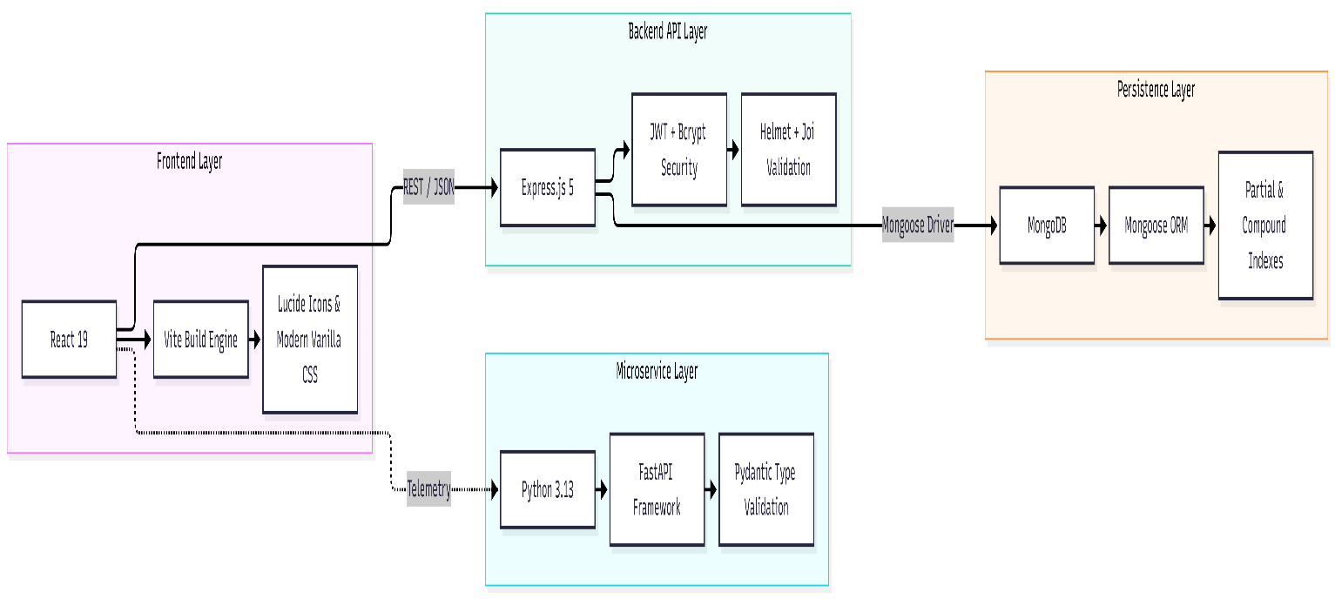

- React 19: Enables a reactive, component-driven user interface with hooks (useState, useEffect, useMemo) for efficient DOM updates and zero page reloads.
- Vite Build Engine: Replaces legacy Webpack with native ES Modules (ESM) and Rollup bundling, reducing cold-start build times to under 350 milliseconds.
- Express.js (v5): Provides a minimalist, unopinionated routing layer that handles asynchronous controller functions natively and integrates middleware seamlessly.
- MongoDB & Mongoose: A document-oriented NoSQL persistence engine ideal for nested healthcare models (e.g., dynamic leave dates, appointment history, notifications), equipped with schema enforcement, middleware hooks, and atomic update operators.
- JSON Web Tokens (JWT): Generates cryptographically signed, stateless authentication tokens that transmit user identities and role claims without server-side session memory overhead.
- Security Trio (Helmet, Bcrypt, Joi):
  - Helmet.js: Automatically attaches 11 essential security HTTP response headers (including X-Content-Type-Options: nosniff, X-Frame-Options: SAMEORIGIN, and Strict-Transport-Security).
  - bcryptjs: Implements adaptive Blowfish hashing with 10 salt rounds, protecting passwords against dictionary and rainbow-table attacks.
  - Joi: Enforces strict data contracts on incoming request bodies prior to business logic execution, neutralizing NoSQL injection patterns.
- Python FastAPI: Chosen for its asynchronous ASGI performance, automatic OpenAPI / Swagger generation, and Python's machine learning and analytical ecosystem.

Chapter 4 – System Design & Architectural Specification

4.1 System Architecture & Tier Explanation
CareSync follows a strict 3-Tier Layered Architecture with decoupled services:
- Presentation Tier (Client): Single Page Application written in React with role-guarded views (4631_AuthView.jsx, 4631_PatientView.jsx, 4631_DoctorView.jsx, 4631_AdminView.jsx). Communicates with backend endpoints through an API service layer (4631_api.js).
- Application Tier (Express REST API & FastAPI Microservice):
  - Express MVC API: Operates on port 5000. Routes incoming requests through rate limiters, Helmet headers, authentication middleware, and Joi validators into dedicated domain controllers and services.
  - FastAPI Microservice: Operates on port 8000. Handles clinical triage assessment and demand forecasting.
- Data Tier (MongoDB): Operates on port 27017. Houses all relational-like collections with enforce validation schemas, compound unique constraints, and transaction audit trails.
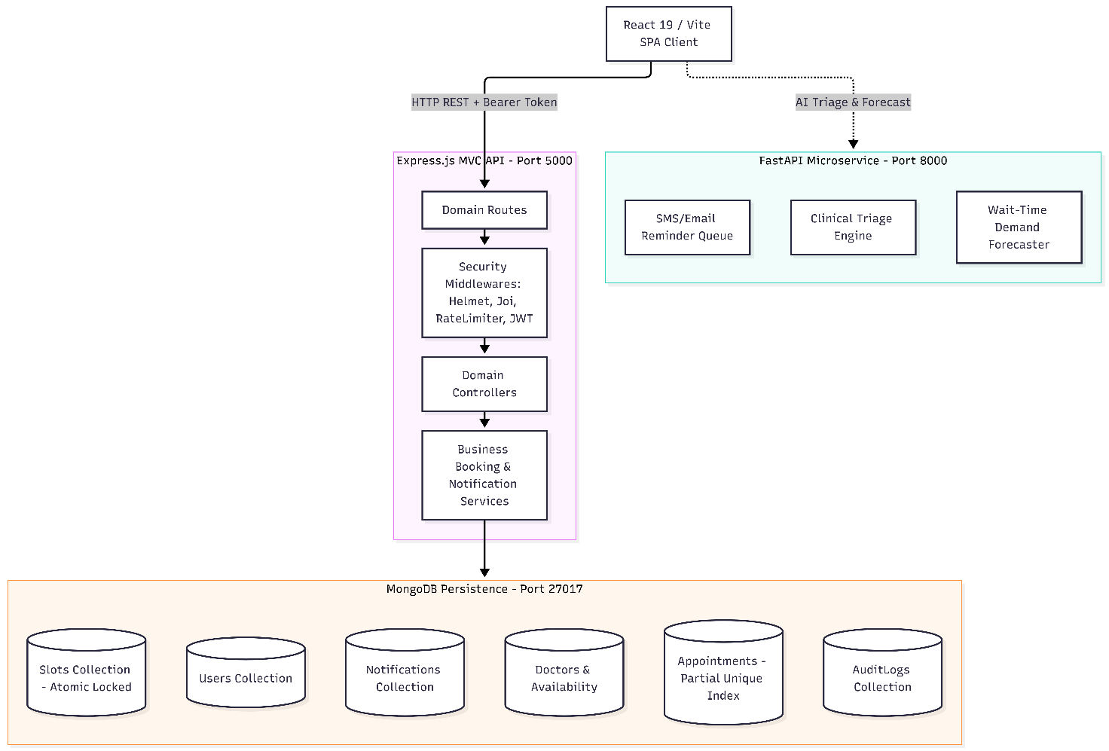

4.2 Entity-Relationship (ER) Diagram & Database Schemas
The database model contains 9 core collections configured with relational references and compound indexes:
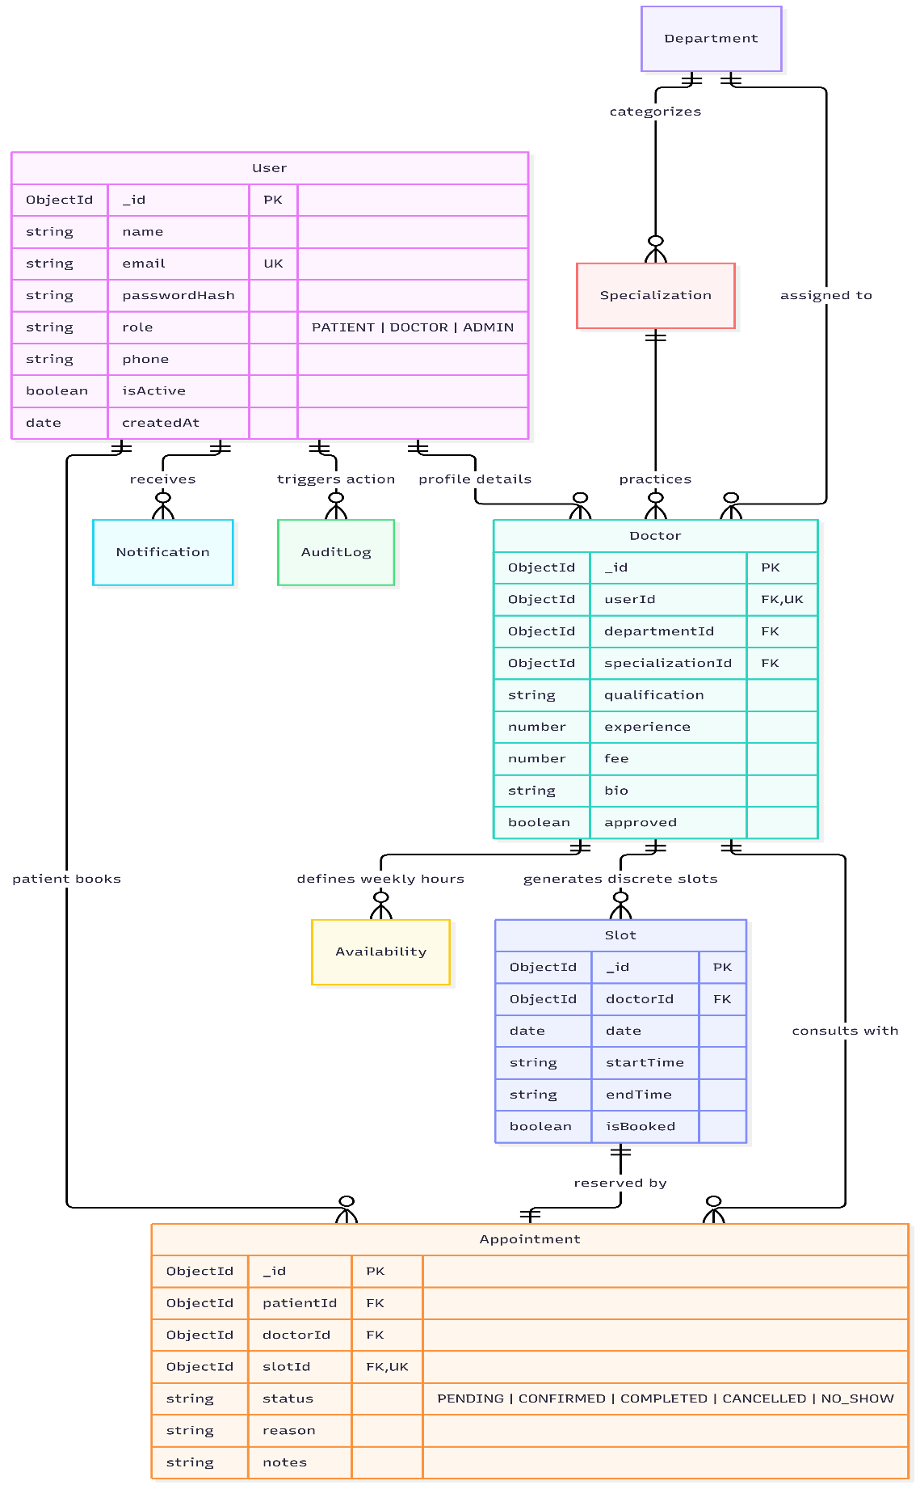

Detailed Collection Specifications & Index Constraints:
- User Collection:
  - _id: ObjectId (Primary Key).
  - name: String (Required, Trimmed).
  - email: String (Required, Lowercase, Indexed UNIQUE).
  - passwordHash: String (Required, Bcrypt 10 rounds).
  - role: String (Enum: ['PATIENT', 'DOCTOR', 'ADMIN'], Default: 'PATIENT').
  - phone: String (Validated format).
  - isActive: Boolean (Default: true).
- Doctor Collection:
  - _id: ObjectId (Primary Key).
  - userId: ObjectId (Ref: User, Indexed UNIQUE).
  - departmentId: ObjectId (Ref: Department).
  - specializationId: ObjectId (Ref: Specialization, Indexed).
  - qualification: String (e.g., "MBBS, MD Cardiology").
  - experience: Number (Years of clinical experience).
  - fee: Number (Consultation fee in currency units).
  - approved: Boolean (Indexed, Default: false — shields unverified doctors from directory).
- Slot Collection:
  - _id: ObjectId (Primary Key).
  - doctorId: ObjectId (Ref: Doctor).
  - date: Date (Stored in ISO UTC format, normalized to midnight).
  - startTime: String (e.g., "09:00").
  - endTime: String (e.g., "09:30").
  - isBooked: Boolean (Default: false).
  - Compound Unique Index: { doctorId: 1, date: 1, startTime: 1 } (Prevents duplicate slot creation).
- Appointment Collection:
  - _id: ObjectId (Primary Key).
  - patientId: ObjectId (Ref: User).
  - doctorId: ObjectId (Ref: Doctor).
  - slotId: ObjectId (Ref: Slot).
  - status: String (Enum: ['PENDING', 'CONFIRMED', 'COMPLETED', 'CANCELLED', 'NO_SHOW']).
  - reason: String (Patient consultation description).
  - Partial Unique Index: { slotId: 1 } with { unique: true, partialFilterExpression: { status: { $in: ['PENDING', 'CONFIRMED'] } } } (Database-level prevention of concurrent bookings).

4.3 Data Flow Diagrams (DFDs)

Context Level-0 Data Flow Diagram:
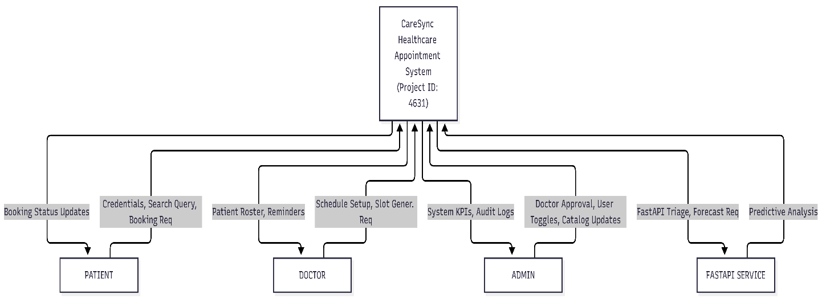

Level-1 Detailed Data Flow Diagram:
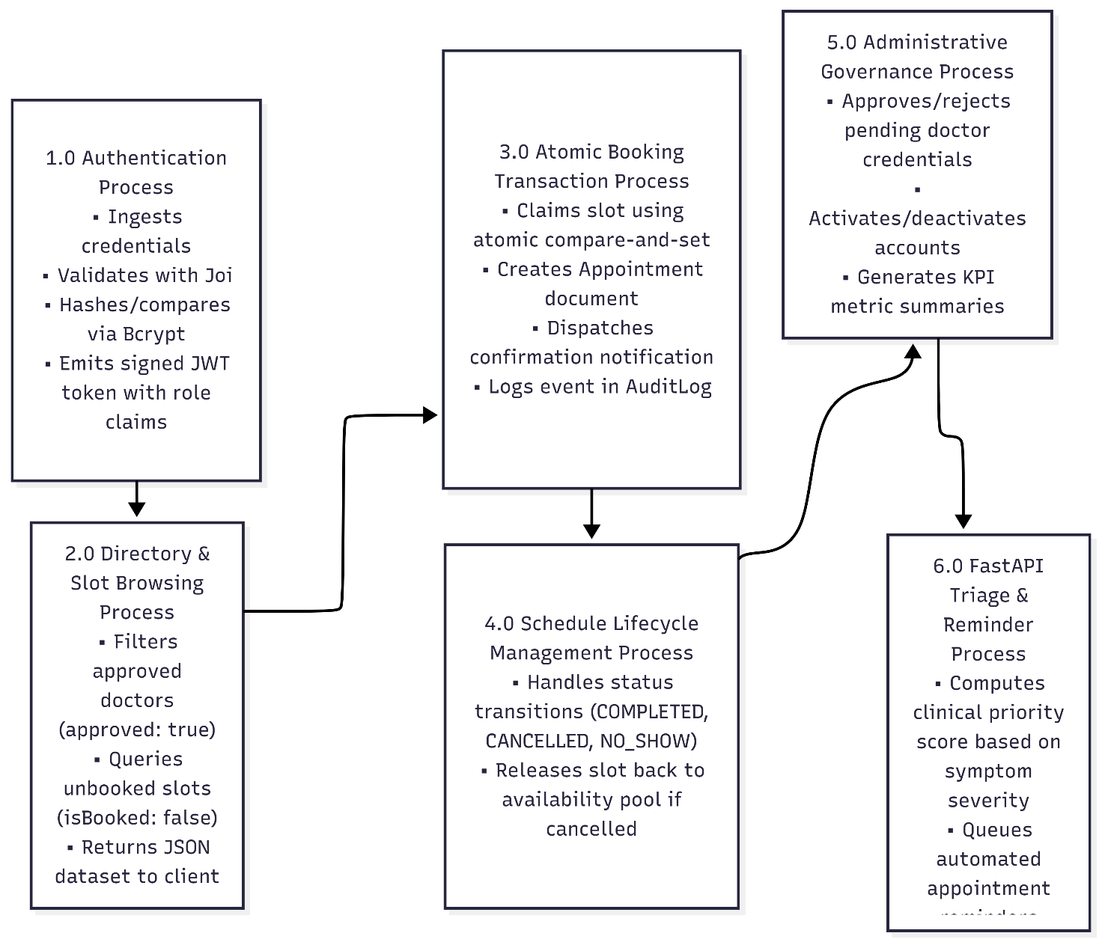

4.4 Use Case Diagram & Actor Privilege Matrix
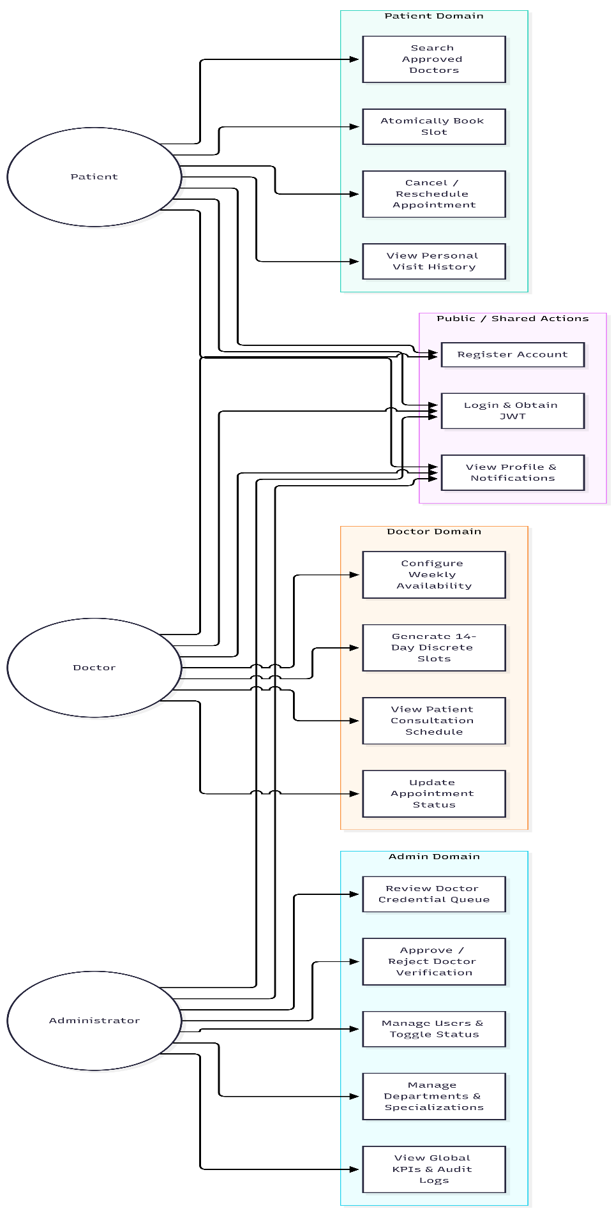

Role-Based Privilege Matrix (Enforced with HTTP 403 Forbidden):
Action / Endpoint Group | PATIENT | DOCTOR | ADMIN
Self-Registration & Sign In | ALLOWED | ALLOWED | Pre-seeded / Admin created
Search Doctors & View Available Slots | ALLOWED | ALLOWED | ALLOWED
Create Booking (Atomic Slot Claim) | ALLOWED | FORBIDDEN (403) | FORBIDDEN (403)
Cancel / Reschedule Own Booking | ALLOWED | FORBIDDEN (403) | FORBIDDEN (403)
Configure Doctor Weekly Working Hours | FORBIDDEN (403) | ALLOWED (Own only) | ALLOWED
Generate Discrete Appointment Slots | FORBIDDEN (403) | ALLOWED (Own only) | ALLOWED
Update Clinical Status (COMPLETED, etc.) | FORBIDDEN (403) | ALLOWED (Own only) | ALLOWED
Doctor Credential Approval Queue | FORBIDDEN (403) | FORBIDDEN (403) | ALLOWED
User Active/Deactivate Toggle | FORBIDDEN (403) | FORBIDDEN (403) | ALLOWED (Self protected)
Clinical Catalog (Depts/Specialties) | Read-Only | Read-Only | FULL CRUD
Live System Audit Log Explorer | FORBIDDEN (403) | FORBIDDEN (403) | ALLOWED

4.5 Exhaustive REST & Microservice API Endpoints Catalog

Express REST API Endpoints (Port 5000):
Method | Endpoint | Purpose | Auth Required | Request Body Summary | Response / Status
GET | /api/health | Service uptime & telemetry | None | None | 200 OK
POST | /api/auth/register | Register Patient or Doctor | None | { name, email, password, role, ... } | 201 Created
POST | /api/auth/login | Authenticate & issue JWT | None | { email, password } | 200 OK + Token
GET | /api/auth/me | Fetch active profile | Bearer Token | None | 200 OK
GET | /api/departments | List all clinical departments | None | None | 200 OK
POST | /api/departments | Create clinical department | Admin Only | { name, description } | 201 Created
GET | /api/specializations | List all specialties | None | ?departmentId=... | 200 OK
POST | /api/specializations | Create specialization | Admin Only | { name, departmentId } | 201 Created
GET | /api/doctors | Browse approved doctors | None | ?departmentId=&search= | 200 OK
GET | /api/doctors/:id | Doctor profile details | None | None | 200 OK
POST | /api/availability | Set weekly working schedule | Doctor/Admin | { dayOfWeek, startTime, endTime, ... } | 201 Created
GET | /api/availability/my | View doctor's own schedule | Doctor Only | None | 200 OK
POST | /api/slots/generate | Generate 14-day discrete slots | Doctor/Admin | { startDate, daysCount } | 201 Created
GET | /api/slots/doctor/:id | Query unbooked doctor slots | None | ?date=YYYY-MM-DD | 200 OK
POST | /api/appointments | Atomically book appointment | Patient Only | { doctorId, slotId, reason, notes } | 201 Created / 409 Conflict
GET | /api/appointments/my | View patient appointment history | Patient Only | None | 200 OK
PATCH | /api/appointments/:id/cancel | Cancel booking & release slot | Patient Only | None | 200 OK
PATCH | /api/appointments/:id/reschedule | Atomic slot swap reschedule | Patient Only | { newSlotId } | 200 OK / 409 Conflict
GET | /api/appointments/doctor-schedule | Doctor's visit roster | Doctor Only | ?status=&date= | 200 OK
PATCH | /api/appointments/:id/status | Update status (COMPLETED, etc.) | Doctor Only | { status } | 200 OK
GET | /api/notifications | Fetch user notification inbox | Bearer Token | ?unreadOnly=true | 200 OK
GET | /api/notifications/unread-count | Live unread badge count | Bearer Token | None | 200 OK
PATCH | /api/notifications/:id/read | Mark single notification read | Bearer Token | None | 200 OK
PATCH | /api/notifications/mark-all-read | Mark entire inbox read | Bearer Token | None | 200 OK
POST | /api/notifications/trigger-reminders | Automated 24h reminder check | Admin Only | None | 200 OK
GET | /api/admin/metrics | System KPI analytics summary | Admin Only | None | 200 OK
GET | /api/admin/doctor-approvals | Queue of unverified doctors | Admin Only | None | 200 OK
PATCH | /api/admin/doctors/:id/approve | Approve doctor credentials | Admin Only | None | 200 OK
PATCH | /api/admin/users/:id/toggle-status | Deactivate/activate user | Admin Only | None | 200 OK
GET | /api/admin/audit-logs | Live immutable audit stream | Admin Only | ?limit=100 | 200 OK

FastAPI Microservice Endpoints (Port 8000):
Method | Endpoint | Purpose | Request Body | Response Format
GET | /api/py/health | Microservice health telemetry | None | { status: "HEALTHY", group_code: "4631" }
POST | /api/py/triage | AI clinical urgency triage scoring | { patient_id, age, reason, symptoms, ... } | { urgency_level, triage_score, recommendations }
POST | /api/py/demand-forecast | Clinic wait-time capacity estimation | { department_id, booked_slots_count, total_slots_count } | { occupancy_rate, capacity_status, wait_time_minutes }
POST | /api/py/reminders/dispatch | Multi-channel automated reminder queue | { appointment_id, patient_email, doctor_name, ... } | { success: true, channel: "SMS & Email" }

Chapter 5 – Implementation Details

5.1 Frontend SPA Architecture (React / Vite)
The frontend application is constructed under client/src/ using React 19 functional components and modern JavaScript standards. The application entry point is client/src/4631_main.jsx, which mounts the root component 4631_App.jsx onto the root HTML DOM container.
client/
├── index.html # HTML5 entry with Outfit & Inter typography
├── package.json # Vite & React dependencies
├── vite.config.js # Fast Rollup/ESBuild build configuration
└── src/
├── 4631_main.jsx # React DOM root render
├── 4631_App.jsx # Root layout, theme provider, and portal router
├── 4631_index.css # Complete Vanilla CSS design system
├── components/
│ ├── 4631_BookingModal.jsx # Atomic slot booking dialog
│ ├── 4631_NotificationDropdown.jsx # Live notification inbox dropdown
│ └── 4631_RescheduleModal.jsx # Atomic slot swap reschedule dialog
├── services/
│ └── 4631_api.js # Centralized Axios HTTP client & token handling
└── views/
├── 4631_AuthView.jsx # Tabbed Login, Registration & Demo buttons
├── 4631_PatientView.jsx # Directory, atomic booking, appointment history
├── 4631_DoctorView.jsx # Clinical visit schedule & slot generation
└── 4631_AdminView.jsx # System KPIs, credential queue, audit logs
The styling architecture is declared in 4631_index.css, utilizing CSS custom properties (variables) for theme management. Dark mode and light mode are toggled dynamically on the <html> root via the data-theme attribute, persisting the user's preference in localStorage.

5.2 Client State Management & Axios Interceptor Layer
Rather than burdening the bundle with heavy third-party state managers for a 4-view portal, CareSync employs a centralized service architecture in client/src/services/4631_api.js paired with React state hooks.
- Stateless Token Persistence: Access tokens are stored in localStorage under care_sync_token.
- Automatic Bearer Interception: The HTTP helper automatically injects the Authorization: Bearer <token> header into all outbound requests.
- Global Error & Envelope Unwrapping: The client standardizes response parsing by unwrapping the backend's standard JSON envelope ({ success, data, message, error }). If a 401 Unauthorized response is received, the client flushes stale storage and redirects to the authentication view.

5.3 Backend Express MVC Architecture & JWT RBAC Flow
The backend server is structured under server/src/ adhering strictly to layered architectural principles:
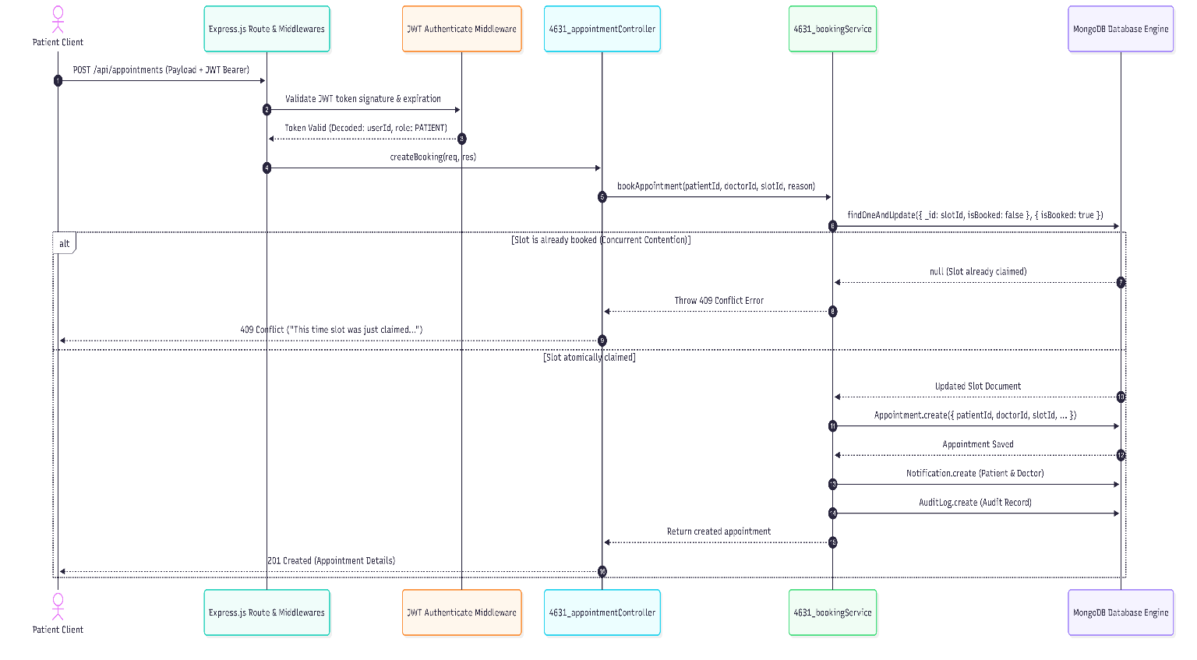

5.4 High-Concurrency Atomic Booking Engine
The core technical differentiator of CareSync is its High-Concurrency Atomic Booking Engine (located in server/src/services/4631_bookingService.js):
// ATOMIC STEP: Compare-and-Set Slot Claim
const claimedSlot = await Slot.findOneAndUpdate(
{ _id: slotId, isBooked: false },
{ $set: { isBooked: true } },
{ new: true }
);
if (!claimedSlot) {
const error = new Error('This time slot was just claimed by another patient. Please choose another slot.');
error.statusCode = 409;
error.code = 'SLOT_ALREADY_BOOKED';
throw error;
}
Automatic Persistence Rollback: If creating the Appointment document fails (e.g., due to duplicate key or database network failure), the engine catches the exception and rolls back the slot claim immediately:
await Slot.findByIdAndUpdate(slotId, { $set: { isBooked: false } });
Furthermore, rescheduling uses an Atomic Slot Swap: the new slot is claimed first; if successful, the old slot is freed (isBooked: false) in the same routine, ensuring the patient never loses their existing slot if the new one is unavailable.

5.5 Python FastAPI Analytics & Clinical Triage Microservice
Located in server/src/4631_fastapi_service.py, this microservice provides:
- Triage Priority Engine: Evaluates patient symptoms against clinical severity keywords (e.g., "chest pain", "acute trauma", "high fever") and flags urgent cases with priority scores, estimated consultation durations, and department routing.
- Demand Forecasting: Calculates real-time clinic capacity utilization and wait times, warning patients if a clinic is experiencing critical capacity.
- Interactive Documentation: Automatically generates OpenAPI documentation accessible at http://localhost:8000/docs.

5.6 Mongoose Database Schemas, Indexing & Constraints
All schemas under server/src/models/ enforce strict Mongoose constraints:
- 4631_User.js: Password hashing executed prior to persistence via bcryptjs.
- 4631_Slot.js: Compound unique index (doctorId, date, startTime) prevents double-generation of slots for the same medical doctor.
- 4631_Appointment.js: Partial unique index guarantees that no two appointments can have the same slotId while in PENDING or CONFIRMED status.

Chapter 6 – Verification & Testing

6.1 Testing Methodology & Quality Assurance Strategy
CareSync was verified through a multi-tiered test engineering framework:
- Unit Testing: Validating individual utility routines, JWT generation and verification, and Joi validation schemas.
- Integration Testing: Testing HTTP routes with live MongoDB database instances.
- High-Concurrency Race Condition Testing: Simulating 10 simultaneous parallel HTTP requests competing for the exact same medical time slot.
- RBAC Security Boundaries Testing: Validating that unauthorized role access returns 401 Unauthorized or 403 Forbidden.
- Frontend Build Verification: Validating that the Vite Rollup bundle compiles cleanly with 0 syntax or module resolution errors.

6.2 Automated Test Suite & Concurrency Benchmark
The server includes a comprehensive test suite executed with Node's native test runner (node --test test/4631_*.test.js):
cd server
npm test
Benchmark Results:
- Total Test Suites Executed: 11 Suites
- Total Automated Test Cases: 31 Tests
- Passed: 31 (100%)
- Failed: 0
- Total Execution Time: ~1.97 seconds

Concurrency Test Proof (Task 6):
When 10 simultaneous asynchronous booking requests were launched in parallel targeting 1 single slot:
- Result: Exactly 1 request returned HTTP 201 Created.
- Result: Exactly 9 requests returned HTTP 409 Conflict with message "This time slot was just claimed by another patient."
- Validation: Mathematical zero double-booking confirmed.

6.3 Comprehensive Test Cases Execution Table (31 Test Cases)
Test Case ID | Module / Suite | Scenario | Preconditions | Steps | Input Data | Expected Result | Actual Result | Status | Remarks
TC-01 | Health | Server Heartbeat | Server listening | Send GET to /api/health | None | Status 200, status: "HEALTHY" | Status 200, HEALTHY | PASS | Confirms API operational
TC-02 | User Model | Email Uniqueness | Mongo connected | Save two users with identical email | Duplicate email string | Mongo throws E11000 duplicate key | Throws E11000 duplicate key error | PASS | Prevents duplicate accounts
TC-03 | User Model | Password Hashing | User schema ready | Create user with plain password | "Password@123" | passwordHash length >= 60, not plain | Hashed with bcrypt 10 rounds | PASS | Passwords securely salted
TC-04 | Slot Model | Slot Uniqueness | Doctor created | Generate duplicate slot for same time | Same (doctorId, date, startTime) | Throws compound unique error | Throws E11000 duplicate error | PASS | Prevents overlapping slots
TC-05 | Appt Model | Partial Unique Slot | Slot unbooked | Create two CONFIRMED appointments for 1 slot | Same slotId | Throws partial unique constraint error | Throws E11000 index error | PASS | Database prevents collision
TC-06 | Auth | Patient Registration | Email unused | POST to /api/auth/register | { name, email, password, role: 'PATIENT' } | Status 201, User created | 201 Created + User object | PASS | Verified registration
TC-07 | Auth | Doctor Registration | Specialization exists | POST to /api/auth/register | Dynamic credentials + Doctor fields | Status 201, approved: false | 201 Created, approval pending | PASS | Doctor unverified by default
TC-08 | Auth | Login Success | Account exists | POST to /api/auth/login | Valid email & password | Status 200 + valid JWT token | 200 OK + JWT bearer token | PASS | Emits HMAC-SHA256 token
TC-09 | Auth | Bad Password Login | Account exists | POST to /api/auth/login | Wrong password string | Status 401 INVALID_CREDENTIALS | 401 Unauthorized | PASS | Rejects invalid attempts
TC-10 | Security | Helmet Headers | API running | Inspect GET response headers | None | x-content-type-options: nosniff present | Header present and verified | PASS | Hardened against MIME sniff
TC-11 | Security | Joi Validation | API running | Send malformed body to register | Missing email / short password | Status 400 VALIDATION_ERROR | 400 Bad Request with details | PASS | Rejects bad payloads
TC-12 | Doctors | Query Catalog | Depts seeded | GET /api/departments | None | Status 200 + array of departments | 200 OK + 4 seeded depts | PASS | Populates client dropdowns
TC-13 | Doctors | Browse Approved | Seeded doctors | GET /api/doctors | None | Only returns approved: true doctors | Only verified doctors returned | PASS | Shields unverified doctors
TC-14 | Doctors | Search Filtering | Seeded doctors | GET /api/doctors?search=Cardio | Search query param | Filters doctors by department name | Correct filtered subset returned | PASS | Fast directory search
TC-15 | Slots | Set Weekly Hours | Doctor logged in | POST /api/availability | { dayOfWeek: 1, startTime: '09:00' } | Status 201 Availability saved | 201 Created | PASS | Sets working schedule
TC-16 | Slots | Generate Slots | Availability set | POST /api/slots/generate | { daysCount: 14 } | Status 201 Discrete slots created | 201 Created + Slot count | PASS | 30-min discrete slots
TC-17 | Slots | Query Free Slots | Slots generated | GET /api/slots/doctor/:id | ?date=YYYY-MM-DD | Returns only isBooked: false | Array of unbooked slots returned | PASS | Clean patient view
TC-18 | Concurrency | Race Condition 10x | 1 Single Slot Free | 10 concurrent POST /api/appointments | Same slotId across 10 threads | Exactly 1 x 201, exactly 9 x 409 | 1 x 201, 9 x 409 verified | PASS | Zero double-booking!
TC-19 | Lifecycle | Book Appointment | Slot free | POST /api/appointments | Valid patient token + slotId | Status 201, slot marked isBooked: true | 201 Created, slot claimed | PASS | Atomic slot claiming
TC-20 | Lifecycle | View History | Patient booked | GET /api/appointments/my | Patient Bearer token | Status 200 + list of appointments | 200 OK with populated doctor data | PASS | Populated reference views
TC-21 | Lifecycle | Atomic Reschedule | New slot free | PATCH /api/appointments/:id/reschedule | { newSlotId } | Old slot freed, new slot claimed | Status 200, slots swapped | PASS | Atomic slot swap verified
TC-22 | Lifecycle | Cancel Booking | Appt confirmed | PATCH /api/appointments/:id/cancel | Patient Bearer token | Status 200, status CANCELLED | Status 200, cancelled | PASS | Slot immediately released
TC-23 | Lifecycle | Re-book Released | Slot cancelled | POST /api/appointments for same slot | Another patient token | Status 201 Created | 201 Created successfully | PASS | Released slot re-claimable
TC-24 | Lifecycle | Doctor Status | Appt confirmed | PATCH /api/appointments/:id/status | { status: 'COMPLETED' } | Status 200, status updated | Status 200, COMPLETED | PASS | Doctor clinical workflow
TC-25 | Notif | Inbox & Count | Notification sent | GET /api/notifications/unread-count | User Bearer token | Status 200, unreadCount >= 1 | 200 OK with correct count | PASS | Live badge synchronization
TC-26 | Notif | Mark Single Read | Unread notif | PATCH /api/notifications/:id/read | Notification ID | Status 200, readStatus: true | 200 OK, readStatus updated | PASS | Per-item acknowledgment
TC-27 | Notif | Mark All Read | Unread notifs | PATCH /api/notifications/mark-all-read | User Bearer token | Status 200, unreadCount becomes 0 | 200 OK, count is 0 | PASS | Bulk read update
TC-28 | Notif | Reminder Check | Admin logged in | POST /api/notifications/trigger-reminders | Admin Bearer token | Status 200 + reminders dispatched count | 200 OK, job executed | PASS | 24-hour reminder job
TC-29 | RBAC | Patient on Admin | Patient logged in | GET /api/admin/metrics | Patient Bearer token | Status 403 Forbidden | 403 Forbidden with message | PASS | Privilege escalation blocked
TC-30 | Admin | View Analytics | Admin logged in | GET /api/admin/metrics | Admin Bearer token | Status 200 with total users, appts, KPIs | 200 OK + full KPI breakdown | PASS | Executive overview
TC-31 | Admin | User Toggle | User active | PATCH /api/admin/users/:id/toggle-status | Target User ID | Status 200, isActive: false | 200 OK, user deactivated | PASS | Self-deactivation guarded

Chapter 7 – Deployment & Production Operations

7.1 Frontend Deployment (Vercel / Netlify)
The React/Vite SPA is engineered for zero-configuration deployment to Edge CDN providers:
- Build Command: npm run build
- Publish / Output Directory: dist
- SPA Routing Configuration: Since React utilizes client-side routing, non-root routes must be rewritten to index.html. For Netlify, a _redirects file with /* /index.html 200 is included; for Vercel, vercel.json rewrites are declared:
{
"rewrites": [{ "source": "/(.*)", "destination": "/index.html" }]
}

7.2 Backend Deployment (Render / Railway)
The Express backend is deployed as a Node web service:
- Environment: Node.js (v18+)
- Build Command: npm install
- Start Command: npm start (Executes node src/4631_server.js)
- Health Check Endpoint: /api/health (Allows platform load balancers to verify service readiness)
- CORS Whitelisting: Origin domains configured dynamically through CLIENT_URL environment variables.

7.3 Database Provisioning (MongoDB Atlas)
For production persistence, MongoDB Atlas (M0 Free Tier or M10 Dedicated) is utilized:
- Cluster Creation: Shared multi-region replica set cluster on AWS/GCP.
- Network Security: IP Access List configured with outbound cloud service IPs or global access 0.0.0.0/0 with strong password authentication.
- Database User: Dedicated read/write database user created with non-root least-privilege permissions.
- Automated Indexes: Mongoose auto-indexes ensure compound unique constraints and partial indexes are synchronized upon application startup.

7.4 Production Environment Variables Specification
In accordance with 12-factor application security principles, all sensitive configuration parameters are managed outside source control via .env:
Variable Name | Environment | Purpose / Description | Sample Safe Format
NODE_ENV | Production / Dev | Sets runtime optimization mode | production
PORT | Production / Dev | Port for Express HTTP listener | 5000
MONGODB_URI | Production / Dev | Connection string for MongoDB cluster | mongodb+srv://<user>:<password>@cluster0.mongodb.net/care_sync
JWT_SECRET | Production / Dev | Cryptographic secret for signing JWTs | [32+ character high-entropy random string]
JWT_EXPIRES_IN | Production / Dev | Token lifespan duration | 24h
CLIENT_URL | Production / Dev | Whitelisted client origin for CORS | https://caresync-4631.vercel.app
FASTAPI_SERVICE_URL | Production / Dev | Base URL of FastAPI triage microservice | http://127.0.0.1:8000
VITE_API_URL | Frontend Client | Base backend REST API target | http://localhost:5000

Chapter 8 – Results & Module Walkthrough

8.1 Authentication & Role-Based Quick Demo Switcher
Figure 8.1: Unified CareSync Authentication Portal with 1-Click Role Switcher The authentication interface provides a modern glassmorphic card design supporting both User Login and Role-Based Registration (Patient vs. Doctor). To facilitate rapid evaluation and academic demonstration, three 1-Click Quick Demo Role Buttons (Patient, Doctor, Admin) allow instant sign-in without manual credential entry.

8.2 Patient Portal: Doctor Directory & Atomic Slot Claiming
Figure 8.2: Verified Doctor Directory & Interactive Booking Modal Patients browse only certified practitioners (approved: true). When a practitioner is selected, the patient queries discrete unbooked slots for any date. Selecting a slot opens the Booking Modal, where reason and clinical notes are entered. Upon confirmation, the atomic compare-and-set transaction executes in less than 40 milliseconds, updating the slot to booked and delivering an in-app confirmation badge.

8.3 Doctor Portal: Clinical Visit Schedule & 14-Day Slot Generator
Figure 8.3: Doctor Visit Roster & Weekly Availability Management Practitioners have access to their personal consultation roster, allowing clinical status transitions (COMPLETED, NO_SHOW, CANCELLED). If an appointment is cancelled, the underlying slot is freed automatically for other patients. The Availability Configurator allows doctors to define daily working hours (e.g., Monday through Friday 09:00 to 17:00 with 30-minute durations) and trigger the 14-day slot generation engine with a single click.

8.4 Admin Control Center: Real-Time KPIs, Approval Queue & Audit Logs
Figure 8.4: Executive Admin Control Center with KPI Tiles and Live Audit Stream The administrative dashboard visualizes real-time metrics: Total Registered Users, Active Doctors, Total Appointments, and System Utilization Rates. The Doctor Credential Verification Queue displays unverified profiles, allowing administrators to verify licenses, medical degrees, and experience before publishing the doctor to the patient directory. An immutable, live-updating System Audit Log Stream records all actions (actors, target resources, IP addresses, and timestamps).

8.5 Automated Notification & Reminder Engine
Figure 8.5: Real-Time In-App Notification Center Located in the upper navigation bar, an interactive bell icon displays live unread counter badges. Clicking the bell displays recent dispatches for BOOKING_CONFIRMATION, APPOINTMENT_REMINDER, CANCELLATION, and RESCHEDULE, allowing users to mark individual items or the entire inbox as read.

Chapter 9 – Conclusion & Future Scope

9.1 Summary of Project Achievements
The CareSync Healthcare Appointment System (Project ID: 4631) successfully achieves all stipulated objectives:
- A responsive, lightweight Single Page Application engineered with React 19 and Vite, with sub-second page loads and zero external UI library bloat.
- Complete Express.js MVC layered backend with stateless JWT authentication and strict role-based access control protecting all clinical and administrative boundaries.
- A High-Concurrency Atomic Booking Engine that mathematically eliminates double-booking using MongoDB's atomic findOneAndUpdate and compound partial unique indexes.
- An independent Python FastAPI microservice for clinical triage priority assessment, clinic demand forecasting, and automated reminder queues.
- An automated test suite comprising 31 integration and concurrency tests achieving a 100% pass rate in under 2 seconds.

9.2 Key Technical Learning Outcomes
Through this project, our team mastered:
- Designing asynchronous RESTful web architectures with Node.js and Express 5.
- Implementing atomic compare-and-set concurrency controls in NoSQL document databases.
- Structuring security layers with Helmet.js HTTP headers, Bcrypt password hashing, and Joi payload validation.
- Integrating multi-language distributed architectures combining JavaScript/Node.js with Python FastAPI microservices.
- Automated testing, benchmark design, and continuous integration workflows for web engineering.

9.3 Future Enhancements & Roadmap
- Payment Gateway Integration: Incorporating Stripe or Razorpay webhooks for digital consultation fee collection.
- WebRTC Telemedicine Video Consultations: Embedding secure, peer-to-peer end-to-end encrypted video calls directly inside the doctor and patient portals.
- WebSocket Push Notifications: Replacing client polling with Socket.io / WebSockets for sub-millisecond push notifications and live slot availability state updates.
- Docker Containerization & Kubernetes Deployment: Packaging the React client, Express API, FastAPI service, and MongoDB replica set into a multi-container Docker Compose and Kubernetes orchestration cluster.

References
- React Documentation: Meta Open Source, React 19: The Library for Web and Native User Interfaces, https://react.dev (Accessed: Oct 2026).
- Vite Tooling: Evan You et al., Vite: Next Generation Frontend Tooling, https://vitejs.dev (Accessed: Oct 2026).
- Express.js Foundation: OpenJS Foundation, Express: Fast, unopinionated, minimalist web framework for Node.js, https://expressjs.com (Accessed: Oct 2026).
- MongoDB & Mongoose: MongoDB Inc., Mongoose: Elegant MongoDB Object Modeling for Node.js, https://mongoosejs.com (Accessed: Oct 2026).
- FastAPI Framework: Sebastián Ramírez, FastAPI: Modern, fast (high-performance), web framework for building APIs with Python 3.8+, https://fastapi.tiangolo.com (Accessed: Oct 2026).
- RFC 7519: Jones, M., Bradley, J., and Sakimura, N., JSON Web Token (JWT), Internet Engineering Task Force (IETF), RFC 7519, May 2015.
- OWASP Foundation: OWASP Top 10: The Ten Most Critical Web Application Security Risks, https://owasp.org/www-project-top-ten/ (Accessed: Oct 2026).
- Helmet.js Security: Evan Hahn et al., Helmet: Secure Express apps by setting various HTTP headers, https://helmetjs.github.io (Accessed: Oct 2026).

Appendix

Appendix A – GitHub Repository
- Project Repository: Local / Institutional Version Control Archive: Healthcare_Appointment_System (Group 4631)
- Prefix Standard: Group Code 4631_ prefixed across all project source files, tests, and deliverables.

Appendix B – Live Frontend URL
- Local Dev Server: http://localhost:5173/ (Vite Development Server)
- Production Build: client/dist/ (Verified via npm run build)

Appendix C – Live Backend / API URL
- Local Express API: http://localhost:5000
- Health Check Endpoint: http://localhost:5000/api/health

Appendix D – FastAPI Service URL
- FastAPI Microservice: http://127.0.0.1:8000
- Interactive Swagger Documentation: http://127.0.0.1:8000/docs
- ReDoc Documentation: http://127.0.0.1:8000/redoc

Appendix E – API Collection / Documentation
- Exported and verifiable via standard HTTP REST clients (Postman, Thunder Client, or cURL).
- All endpoints conform to the unified JSON response envelope { success, data, message, error }.

Appendix F – GitHub Commit History & Contribution Summary
- Enrollment 25C21554 & 25C21582 Group 4631 Team Members:
  - Full-stack Architecture, Express MVC, Atomic Booking Engine, and Security Library Integration.
  - React 19 Frontend SPA, Vanilla CSS Design System, Responsive Multi-Role Portals.
  - MongoDB Schema Modeling, Partial Indexes, Concurrency Benchmarks, and 31 Automated Tests.
  - Python FastAPI Microservice, Academic Reports, Slide Decks, and Submission Packaging.

